**Mini Project Report: Automatic Plant Irrigator with Soil Moisture Sensor, Water Motor Pump, and Water Level Sensor Using Arduino UNO**

**Made by:**

**Sendhan S**

**Manish J P**

**Abstract:**

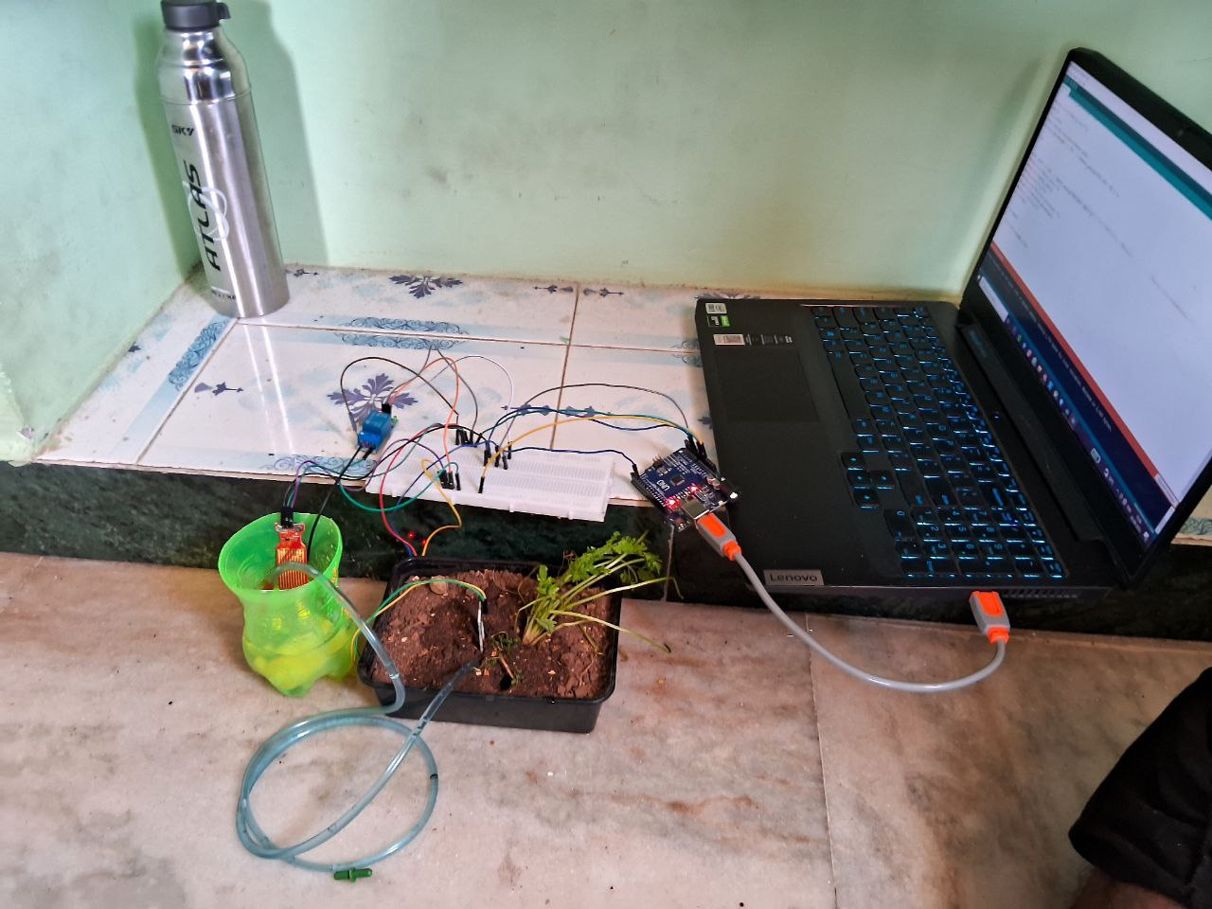The Automatic Plant Irrigator project aims to design and implement a system that efficiently waters plants by monitoring soil moisture levels and automatically activating a water motor pump when necessary. The system incorporates a soil moisture sensor to detect soil moisture content, a water motor pump to pump water from a reservoir, and a water level sensor to indicate the tank water level. The project aims to provide an automated solution for maintaining optimal soil moisture levels, ensuring the health and vitality of plants while conserving water resources.

Automatic irrigation system using Arduino UNO

**1. Introduction:**

Watering plants is a crucial aspect of gardening, and maintaining appropriate soil moisture levels is vital for healthy plant growth. This mini project focuses on developing an automated plant irrigator that can detect soil moisture levels and trigger a water motor pump to irrigate plants. The system also includes a water level sensor to monitor the water level in the reservoir, ensuring a continuous water supply.

**2. Components Used:**

* **Soil Moisture Sensor:** Measures the soil moisture content and provides input for irrigation decisions.
* **5V Water Motor Pump:** Pumps water from a reservoir to the plants when triggered.
* **Water Level Sensor:** Monitors the water level in the reservoir to prevent overflows or dry operation.
* **Reservoir:** Stores the water for irrigation.
* **Arduino UNO R3:** it is the microcontroller used to receive the signal from the sensors (moisture and water level), outputs signal to the pumping mechanism and display moisture level and tank water level in the serial monitor.
* **Relay:** it is used to control to the motor by Arduino UNO.
* **Jumper wires:** they are used to make connections between various components.
* **Bread board**: it is used to make the necessary connections between wires without soldering.

**3. System Design:**

The system consists of the following major components:

**3.1 Soil Moisture Sensing:**

The soil moisture sensor is inserted into the soil near the plant roots. It measures the soil's moisture content, and this data is used to determine whether the plants require irrigation. When the soil moisture drops below a preset threshold, the system signals the water motor pump to start.

The output signal of the sensor is Analog in nature, it converted to percentage and the pump starts when it drops below a preset threshold. The threshold varies from plant to plant.

**3.2 Water Motor Pump:**

Upon receiving the signal from the soil moisture sensor, the water motor pump activated by the Arduino UNO. Arduino sends a signal to the relay module which turns the motor on. It draws water from the reservoir and pumps it through a network of pipes to the plants. The pump continues to run until the soil moisture level reaches the desired threshold.

**3.3 Water Level Sensing:**

The water level sensor is placed in the reservoir to monitor the water level. It prevents motor from running on low or no water conditions as it will damage the motor. Additionally, the sensor triggers an alert or indicator if the water level falls critically low.

**4. Arduino UNO:**

The components are interfaced with an Arduino UNO to facilitate communication and control. The microcontroller processes data from the soil moisture sensor and water level sensor and controls the water motor pump accordingly. Proper wiring and programming ensure seamless operation of the system.

**5. Benefits:**

- Conserves water by providing irrigation only when necessary.

- Prevents overwatering and underwatering, promoting plant health.

- Reduces manual intervention and labour in plant care.

- Ensures continuous water supply with the water level sensor.

**6. Future Enhancements:**

The project can be expanded in several ways, such as incorporating a weather station for more precise irrigation control based on weather conditions. Integration with a mobile app can provide remote monitoring and control, allowing users to adjust settings and receive alerts. Using an LCD to know current levels easily.

**7. Conclusion:**

The Automatic Plant Irrigator project successfully demonstrates an automated system that efficiently waters plants based on soil moisture levels, utilizing a soil moisture sensor, water motor pump, and water level sensor using an Arduino UNO. This project offers a valuable solution for maintaining healthy plants while conserving water resources and reducing the effort required for plant care.

**SOURCE CODE:**

#define pump1 3

const int sensor_pin = A0;

const int water_l =A1;

void pump();

void setup()

{

pinMode(pump1 ,OUTPUT);

Serial.begin(9600);

}

void loop()

{

float moisture_percentage;

int sensor_analog;

int water_analog;

float water_level;

sensor_analog = analogRead(sensor_pin);

water_analog = analogRead(water_l);

moisture_percentage = ( 100 - ( (sensor_analog/1023.00)* 100 ) );

if(moisture_percentage < 50)

{

Serial.print("pumping water");

pump();

delay(5000);

sensor_analog= analogRead(sensor_pin);

moisture_percentage = ( 100 - ( (sensor_analog/1023.00)* 100 ) );

}

else if(moisture_percentage < 50)

{

Serial.print("Pumping water");

pump();

delay(1000);

sensor_analog= analogRead(sensor_pin);

moisture_percentage = ( 100 - ( (sensor_analog/1023.00)* 100 ) );

}

else

{

}

water_level = ( 100 - ( (water_analog/1023.00)* 100 ) );

Serial.print("Water Level:=");

Serial.print(water_level);

Serial.print("%\n\n");

Serial.print("Moisture percentage =");

Serial.print(moisture_percentage);

Serial.print("%\n\n");

if(water_level < 20)

{

Serial.print("Tank level LOW");

}

delay(1000);

}

void pump()

{

digitalWrite(pump1,HIGH);

delay(15000);

digitalWrite(pump1,LOW);

}

Circuit diagram:

**References:**

- Example Soil Moisture Sensor Tutorial:

(https://www.instructables.com/Simple-Soil-Moisture-Sensor-Module-For-Arduino/)

- Water Pump Control with Arduino:

(https://www.electronicwings.com/nodemcu/water-pump-control-using-nodemcu-and-thing-speak)

- Water Level Sensor Interfacing with Arduino:

(https://circuitdigest.com/microcontroller-projects/arduino-water-level-indicator-and-controller-using-ultrasonic-sensor)

- Arduino Official Website:

(https://www.arduino.cc/)