《Embedded System and Microcomputer Principle》Project Report
Topic | Intelligent car control system
Group No. | 1
Member 1 | SID | 12110813 | NAME | 刘圣鼎 | Coefficient | 0.25
Member 2 | SID | 12111114 | NAME | 高自然 | Coefficient | 0.25
Member 3 | SID | 12213043 | NAME | 杨若谷 | Coefficient | 0.25
Member 4 | SID | 12210907 | NAME | 陈锦源 | Coefficient | 0.25
- System Function (1%)
I've designed an intelligent car control system whose functionalities are as follows:
1. Wireless Communication: The system communicates wirelessly via Bluetooth or 2.4GHz module between the STM32 Mini development board and the car's control board. Upon successful connection, simple prompt messages are displayed.
2. LCD Touchscreen Control: The control board features a 7-button interface on the LCD touchscreen, controlling the car's movement, including functions like forward, backward, left/right move, rotate left/right, and stop.
3. Distance Measurement: An ultrasonic sensor measures the distance to obstacles ahead of the car, with the distance displayed in real-time on the LCD.
4. Route Planning: The system allows users to set the start and end points, as well as obstacles, via touchscreen. The car automatically navigates the planned route while avoiding obstacles.
5. Environmental Detection: The car automatically explores the environment to detect obstacles, marking their positions on the LCD screen and alerting via a buzzer.
- System Design (2%)
1. Working Principle

(a) Wireless Communication: The system uses Bluetooth or 2.4GHz wireless modules to establish a communication link between the control board (STM32 Mini) and the car's control board. Once connected, the user can send control signals to the car via a mobile or external device, with feedback displayed on the LCD.

(b) LCD Touchscreen Control: The LCD touchscreen allows the user to interact with the system through seven control buttons: forward, backward, left, right, rotate left, rotate right, and stop. Each button sends a corresponding signal to the car's control system, which then processes the movement commands and drives the motors accordingly.

(c) Distance Measurement: The ultrasonic distance sensor continuously measures the distance between the car and the nearest obstacle. This information is sent to the STM32 control board and displayed in real-time on the LCD touchscreen. The car adjusts its movement based on the detected distance.

(d) Route Planning and Autonomous Navigation: The system enables users to set a start point, an endpoint, and obstacles on a grid displayed on the LCD touchscreen. After the user plans the route, the car autonomously navigates the environment by avoiding obstacles based on the route map. The car ultrasonic sensors for obstacle detection and adjusts its movement in real-time to follow the planned route.
2. system frame diagram
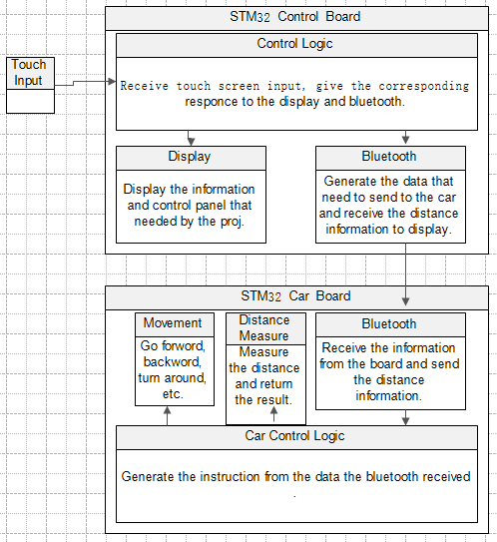
3.Sub-module design
The control board is divided into 4 parts:
      - touch input: get the torch input.
      - control logic: receive touch screen input, give the corresponding responce to the display and bluetooth.
      - Display: display the information and control panel that needed by the proj.
      - Bluetooth: generate the data that need to send to the car and receive the distance information to display.
The car is divided into 4 parts:
      - Movement: go forward, backward, turn around, etc.
      - distance measure: measure the distance and return the result.
      - car control logic: receive the information from the board and send the distance information.
      - Bluetooth: generate the instruction from the data the bluetooth received .
- Results (screenshots and hardware photos) (1%)
- Control board result:
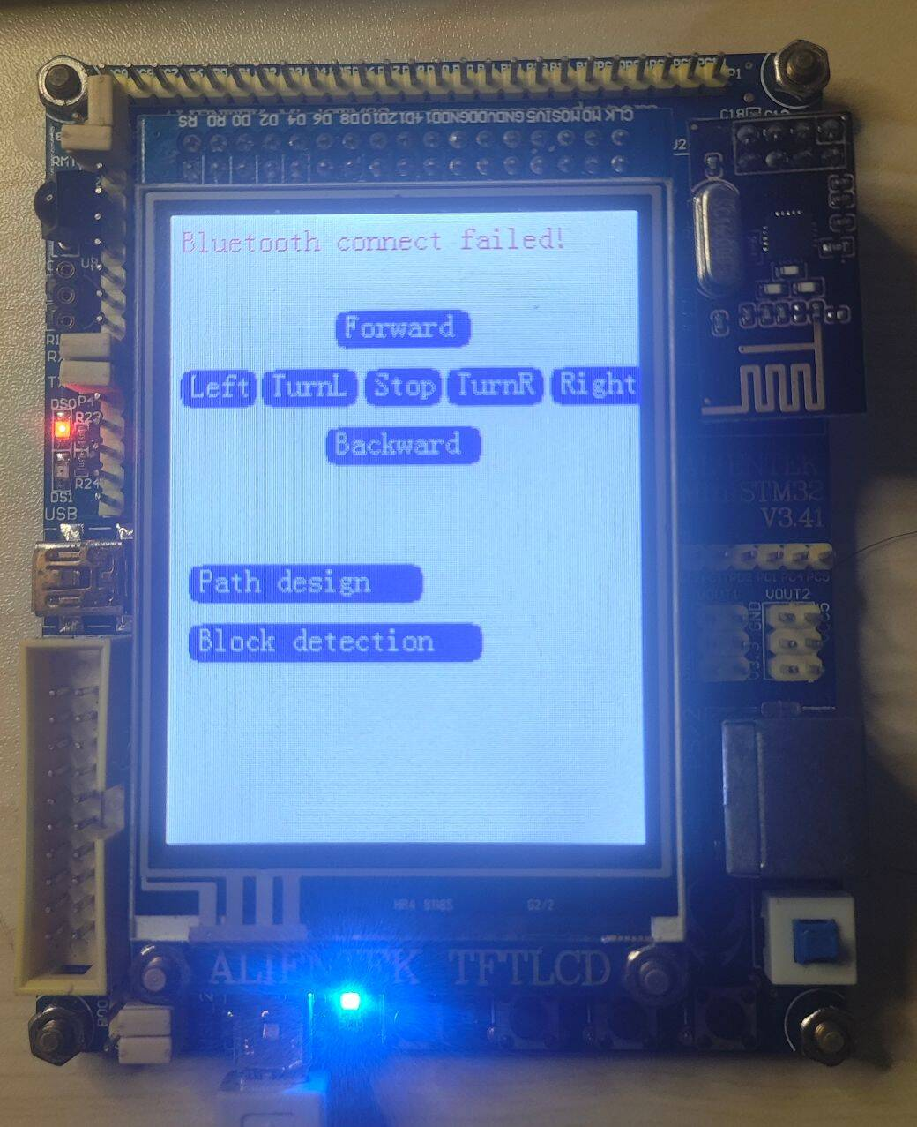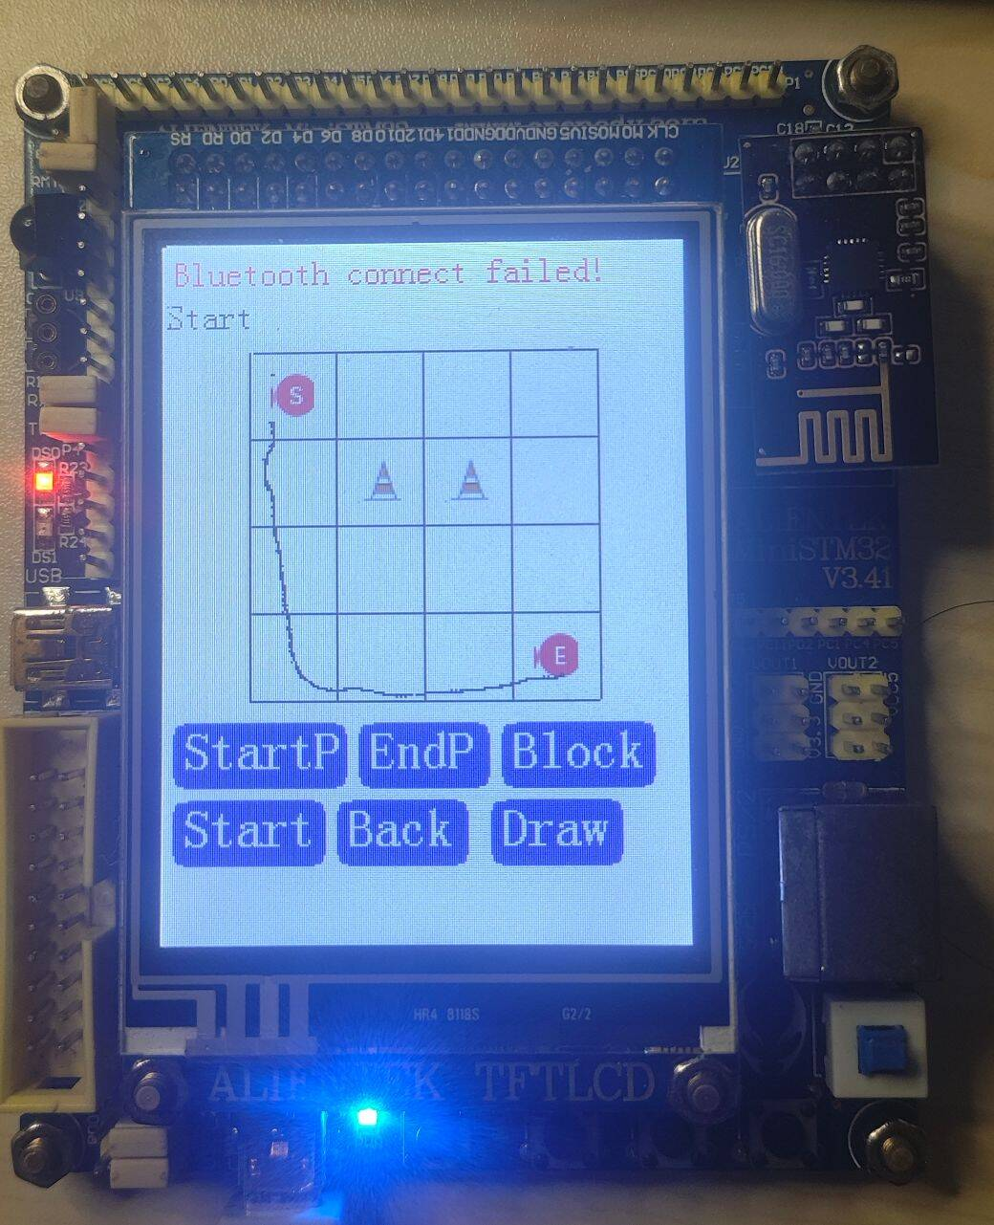
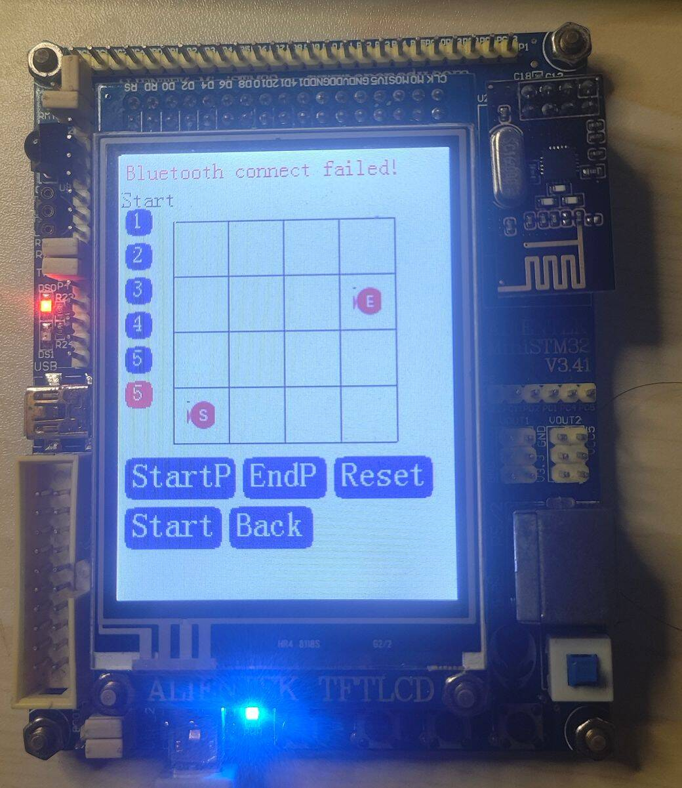
- Work allocation description (1%)
Member1：刘圣鼎, design the Bluetooth connection and protocol.
Member2：高自然, design the control board system and functions.
Member3：杨若谷, design the control systems for T3 and bonus part.
Member4：陈锦源, design the control systems for T4 and bonus part.
- Problems encountered and solutions (1%)
Problem 1: 2.4g module cannot use interrupt to receive the signal
Solution: Use TIM interrupt

Problem 2: 2.4g module cannot use setup properly on the car.
Solution: Use Bluetooth instead
- Personal proposal （4%）
Simple MiniSTM32-Based Quadcopter Control System
Design a simplified quadcopter control system using MiniSTM32 to control the basic movement of the quadcopter by adjusting motor speeds, enabling basic up/down, forward/backward movement.

Design Requirements:

1. Core Control System:
- Use MiniSTM32 as the main controller to manage the motor speeds and basic movement of the quadcopter.
- Implement simple control using buttons or a slider to adjust the quadcopter’s movements (up, down, forward, backward).
2. Sensor Module:
- Gyroscope Sensor: Use a basic MPU6050 sensor for basic motion detection (acceleration and orientation), but avoid complex attitude control.
- No advanced attitude stabilization algorithms—basic motor speed adjustments will be used for movement control.
3. Motor Control:
- Use PWM signals to control four motors for movement.
- Each motor will be controlled by PWM signals generated from the MiniSTM32’s GPIO pins.
4. Communication Interface:
- Use bluetooth to send basic control commands from an external device (like a PC or smartphone).
- No need for complex wireless communication modules, just basic UART commands for up, down, forward, and backward commands.
5. Control Interface:
- Use buttons, switches, or simple serial commands for control.
- The user will input commands through a serial terminal or GUI, and the quadcopter will execute the corresponding action (e.g., ascend, descend, move forward, move backward).
[1]:Hardware design is suggested by GPT chatgpt.com
1.MPU6050 (IMU Sensor)
Model: MPU6050
Specifications: MPU6050 Product Specifications
2.HC-SR04 (Ultrasonic Distance Sensor)
Model: HC-SR04
Specifications: HC-SR04 Product Specifications
3.Motor Driver Module:
Model: L298N Motor Driver Module
Specifications: L298N Product Specifications

