|  |  |  |  |
| --- | --- | --- | --- |
|  | Universidade de Aveiro  2022/2023 | Departamento de Eletrónica,  Telecomunicações e Informática | |
| Gonçalo Daniel Almeida Junqueira | Augmented Reality for Enhanced Data and Information Visualization in Robotics Research  Realidade Aumentada para a Visualização de Dados e Informação Melhorada na Investigação Robótica | |



|  |  |  |  |
| --- | --- | --- | --- |
|  | Universidade de Aveiro  2022/2023 | Departamento de Eletrónica,  Telecomunicações e Informática | |
| Gonçalo Daniel Almeida Junqueira | Augmented Reality for Enhanced Data and Information Visualization in Robotics Research  Realidade Aumentada para a Visualização de Dados e Informação Melhorada na Investigação Róbotica | |
|  | Dissertação apresentada à Universidade de Aveiro para cumprimento dos requisitos necessários à obtenção do grau de Mestre em (designação do Mestrado), realizada sob a orientação científica do Doutor (nome do orientador), Professor (categoria do orientador) do Departamento de (designação do departamento) da Universidade de Aveiro. TODO all of the above | |



# Contents

I. Contents iv

II. List of Acronyms v

1 Introduction 54

1.1 Goals and Contributions 55

1.2 Dissertation Outline 56

2 State of the Art 57

2.1 Augmented Reality 57

2.2 Augmented Reality and Robotics 58

3 Work Plan 62

3.1 Tasks 62

3.2 Gantt Diagram 62

3.3 Tools 62

3.3.1 Unity 62

3.3.2 Vuforia 62

3.3.3 ROS 62

4 Bibliography 63

Figure 1 – Mixed Reality demonstrating all types of Virtual Reality from Real World to full Virtual Environment 59

Figure 2 – Example of Virtual Reality. Virtual world can be seen to the right. 59

Figure 3 – Augmented Reality in the game “Pokemon Go” 60

Figure 4 – Stations from an assembly line with a virtual button to call the robot over. 61

Figure 5 – Example of programming using augmented Reality where we use it to tell the robot where we want it to be. A) is the before photo and B) is the after once we send the command for the robot to move. 62

Figure 6 – Another example of programming using augmented Reality where we use it to tell the robot where we want it to be. A) is the before photo and B) is the after once we send the command for the robot to move. 62

Figure 7 – Image of an operation failure occurring. A) pop-up screen giving information about it and b) Virtual button to quickly solve the issue so the robot can go back to working. 62

Figure 8 – Pie-chart showing the participants opinions regarding the AR system. 63

Figure 9 – Various Augmented Reality tools for the expert to leave instructions to the participants. 64

Figure 10 – Graph showing the call duration and task completion time side by side from Fully Assisted (FA) and Partially Assisted (PA) tasks. 65

Figure 11- Gantt Diagram of the work plan 66

# List of Acronyms

**AR** – Augmented Reality

**HRI** – Human-Robot Interaction

**HRC** – Human-Robot Collaboration

# Introduction

* Talk about the usage of robots in life or work with a couple of examples
* Bring attention to the complexity of the system that makes a robot
* Connect the previous text to difficulties developers might face when creating their robot and its software
* Start talking about robotic competitions where it’s a place people might put their skills and knowledge to the test against others. Give one or two examples of competitions
* Connect the examples mentioned above to some cases where the audience might want to learn more about the robot but can’t
* Introduction to AR and how it’s development and evolution allows it to become a valid method to solve the problems

For many years now, robots have been present in our lives in one way or another. We can see it on the vacuum cleaners that have been around for some time now as one of the first few, widely known, robots available for everyday use. This isn’t to say that robots didn’t exist before those, in factories, it’s quite normal to have a few to help with assembly of parts (Aivaliotis et al., 2022; Lotsaris et al., 2020)).

But with the market becoming more fast-moving and complex, the need for automation in the industrial environment rose with it. (Soares et al., 2021). This becomes more apparent when noted the large variety of the same product along with their reduced lifecycle making it all the more relevant their need in assembly lines (Blankemeyer et al., 2018).

Designing and creating a robot isn’t easy, there are many challenges that await when attempting the task if the goal is a robust and functional robot. Some of the challenges can go down all the way to which power source is the best[1]. Another challenge is the noise, by this, we mean the wrong readings in sensors or just the physical aspect of the components of the robot. Even if a set of motors are made by the same manufacturers, made with the same materials and applied the same force to them, we can rarely guarantee that they will move exactly the same amount every time in controlled environments, much less out in the field. A simple pebble in the way of the robot can be enough to derange it’s system if proper measures aren’t prepared.

Robotic competitions are a way for engineers from all over the world to meet and test their knowledge in the field with their appearance dating back to the 1970s (Cabral Renato, n.d.).

One such example of the competition is the maze challenge, where robots are to find a way through the maze as fast as possible. Even on this challenge, research already exists to try and improve it (Youssefi & Rouhani, 2021).

Let’s say that you find yourself in the maze competition as a spectator and wish to learn more about the robot, the paths its choses and the reasoning behind it; as it stands, the audience doesn’t have access to this information, best they could hope for is to get a hold of the team behind the robot and ask for it.

Similar problems might occur during the development of the robot. With so many variables and information being fed into the robot, it can become overwhelming to properly manage and understand it, especially when attempting to solve problems that might occur from coding errors or lack of foresight.

Augmented Reality (AR) can be a solution to this problem, able to present virtual and physical objects simultaneously in a real-world environment, allowing the user to interact with both of them (Aivaliotis et al., 2022).

If we combine the flexibility of adding information in an organized matter and present it in the real-world, we can use AR to help solve or alleviate some of the problems mentioned above.

## Goals and Contributions

* Propose the application of AR within the field of robotics
* Mention it a easily available, valid option that is readily available at about any situation imaginable (Everyone tends to have a smartphone with them at all times)

In this dissertation, we explore the potential use of AR within the robotics field, with a focus on how it can aid in development and information visualization.

The increasing affordability and capabilities of smartphones have made AR technology more widely accessible, and as a result, it has become a viable option in a variety of situations, given the prevalence of smartphone usage.

We believe that both developers and spectators in robotic competitions could benefit from the utilization of AR if it proves to be a useful tool in achieving their objectives.

**Goals:**

* Understand the needs and motivations of everyone that as an interest in robotics
* Filter out unnecessary information and focus on relevant data based on the user’s needs, as there is a large amount of information that must be analysed by robots while they are active
* Propose AR methods for presenting desired information in a clear and easily understandable manner.

**Expected results(leave for last):**

* ……..

## Dissertation Outline

Excluding this one, 5 chapters compose this document:

* Chapter 2 describes the state of the art associated to our system and provides a theoretical introduction to the concepts of ….

# State of the Art

* Mentioned that it’s still a field with little knowledge and time put in to it so most of what is coming out is still new and in testing phase
* Talk about the growth of robotic and AR interest with the amount of research papers coming out
* Mention that the few tests used have shown positive results proving that the combination of AR and robotics as a future

Falar mais de robotica aqui que ainda não falei nada dela até este ponto

Robotics

- Areas de aplicação

HRI -> AR

Assembly factories, also known as assembly plants or assembly lines, are industrial facilities where products are manufactured by assembling various components and parts together. Assembly factories are typically characterized by a high degree of automation, with specialized machines and robots performing various tasks such as welding, painting, and assembly. These facilities are designed to be efficient and cost-effective, allowing manufacturers to produce large quantities of products quickly and consistently.

With the use of robots becoming more prominent in society, it was only natural that human-robot interaction (HRI) would grow in popularity. It is the field that focuses on the design, evaluation, and application of robotic systems that interact with humans, studying the human factor in these interactions. It looks to design robots that can interact with humans in a natural, efficient and safe way.

Along with HRI, Human-Robot Collaboration(HRC) was also born. While HRI focuses on the communication between the two, HRC focuses more on the collaboration part of things, how to optimize and make the teamwork between man and machine more intuitive and simple.

Both HRI and HRC are key studies in the field of robotics as they are the key to achieve dynamic adjustable and highly versatile manufacturing environment (Lotsaris et al., 2020) and thus became grew into a more popular concept over the years (Aivaliotis et al., 2022).

Major fields already use robots, such as medical, military, manufacturing. Within these fields, AR has also been getting introduced, including education (Aivaliotis et al., 2022). Although robotics and AR have been around for some time, the application of AR in the robotics field is relatively new, with much of the work being experimental. However, there is significant interest in this topic, as evidenced by the rising number of papers published on the subject, particularly in the 2000s (Suzuki et al., 2022). One factor contributing to this interest is the widespread use of AR in both industry and academia, which has led to an increased need for research and exploration in this area (Aivaliotis et al., 2022).

Test results have generally been positive when AR is combined with robotics, as it has been shown to speed up progress in assembly lines and improve efficiency for workers (Aivaliotis et al., 2022; Calandra et al., 2021; Lotsaris et al., 2020).

## Augmented Reality

* Explain what AR is and how it affects the world
* What type of tools people usually use for AR (Headmounts; phones; etc)
* Example of AR (Pokemon go)

Usar mais imagens a demonstrar o AR e pokemon go

Explicar que AR faz parte de mixed reality e dá uma breve introdução de VR (usa a imagem que já encontraste) mas foca em AR

Virtual continuum is a term used to describe a model for the continuum of virtuality, it can range from fully immersive virtual reality to the fully real world (Milgram, 1994). It helps understand the different levels of immersion in an organised matter as seen in Fig 1. Virtual Reality (VR) is a computer-generated simulation of a three-dimensional environment, it is the most immersive environment available today Fig 2.

Augmented reality (AR) is a technology that enhances the real-world environment by overlaying virtual objects and information on top of it. It utilizes computer-generated images, sound, or other sensory input to augment or enhance the user's perception of the physical world. AR does not seek to replace the real world, but rather to supplement it (Azuma, 1997).

AR is often experienced through a head-mounted device, such as glasses or a headset, or on mobile devices, such as smartphones and tablets, which have become more affordable and capable in recent years. One notable example of AR on mobile devices is the game "Pokemon Go", which became popular among younger users for its use of AR to allow players to find and capture virtual Pokemon in the real-world Fig 3. This illustrates the increasing awareness and acceptance of AR as a technology.

Figure 1 – Mixed Reality demonstrating all types of Virtual Reality from Real World to full Virtual Environment

Figure 2 – Example of Virtual Reality. Virtual world can be seen to the right.

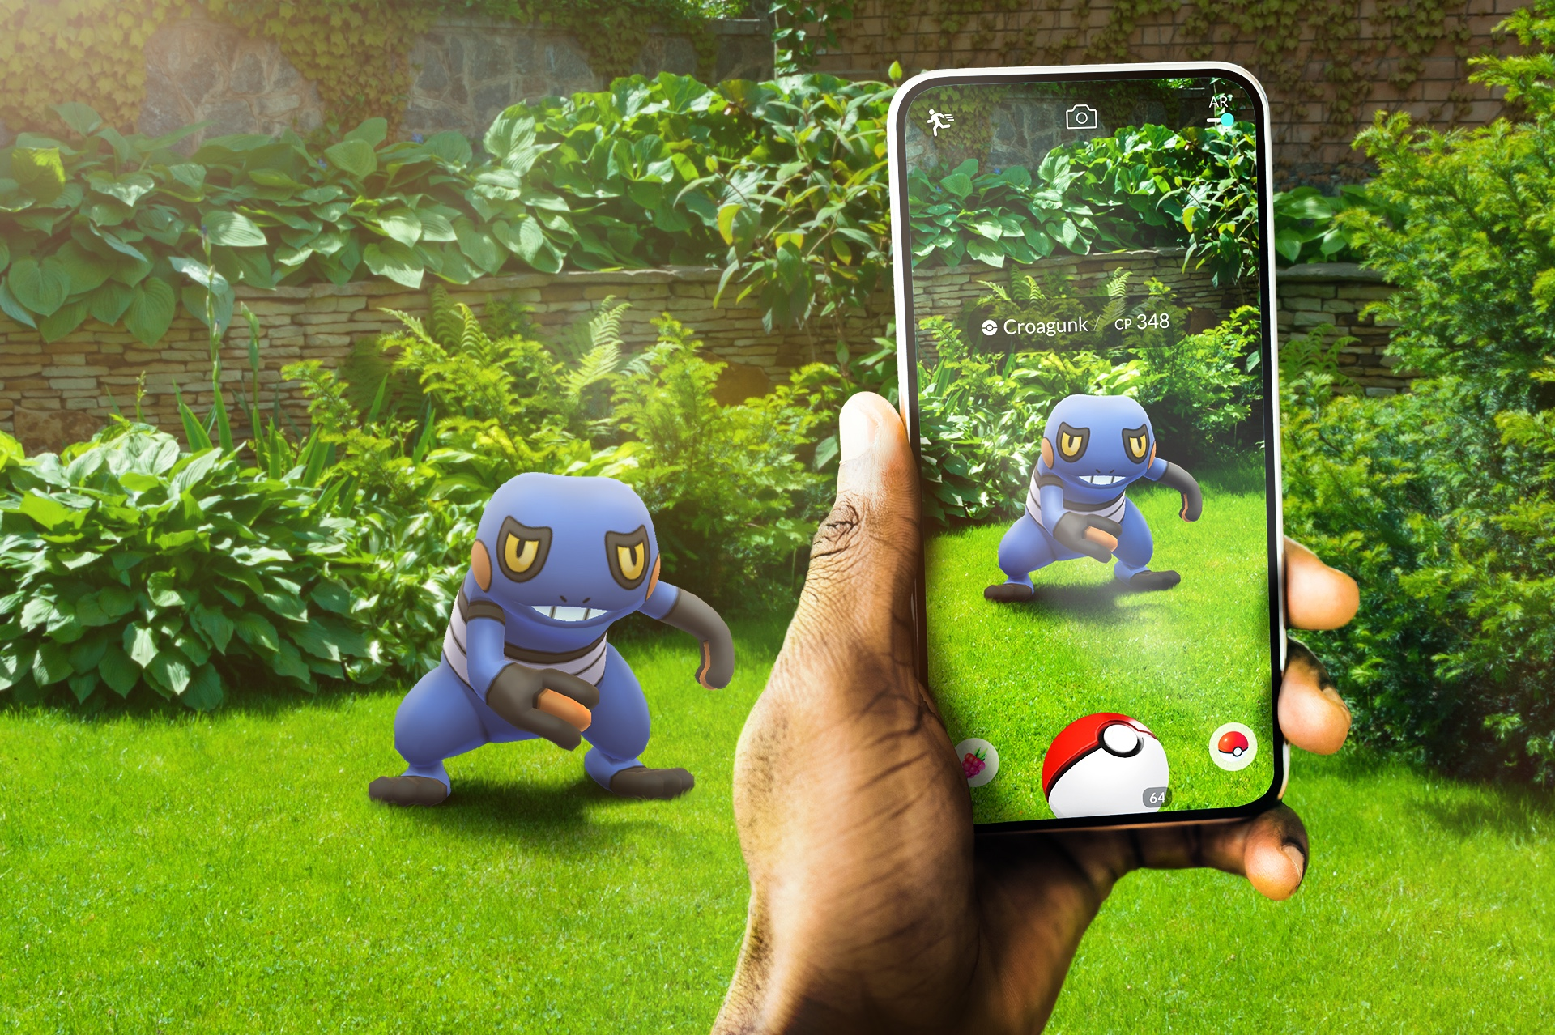

Figure 3 – Augmented Reality in the game “Pokemon Go”

## Augmented Reality and Robotics

* Explain how assembly factories are and what type of robots can be found there and how they are integrated in the factory
* Mention of some past papers and their experiment with utilizing AR in said factories
  + How it was organized
  + What was done
  + Results
* Conclusion of weather or not AR seems like a viable option for robotic research

Various experiments have already proven successful when adding AR to their work-life. In the paper “An augmented reality software suite enabling seamless human robot interaction” (Aivaliotis et al., 2022) they created an approach that with the use of AR the workers could see danger-zones around the robot, these zones were designed to help workers avoid work-place accidents. They didn’t stop there, however, it also had features that helped the workers to quickly solve unexpected events as seen in Fig 7, even providing a one click button to get the robot back on its track seen in A) and B) the workers as gone back to work. If it wasn’t for this feature, they would have to call the manager or engineer to handle the situation which would cost to much time and considering that one robot was shared among workers, it costed productivity and money for the company.

Another feature worth mentioning in this study, is the “Easy robot programming”, where they would use the virtual hologram to dictate how they wanted the robot to move as seen in both Fig 5and Fig 6, where A) is the initial state and what they intend to do and B) is the state of the robot upon completion of the programming. It helps shave out a lot of time of having to manually code it or teach the robot. This also allowed less knowledgeable workers to perform the same task as those that were.

The assembly line is also divided in zones. Each zone as a specific task associated with it and with the use of AR, a virtual button was placed on each zone to call over the robot Fig 4, again, shaving off some time when the workers are performing their tasks. This approach was also tested with new workers and how efficiently they could learn the tasks.

According to the survey done at the end of the experiment, most workers liked the system and made the work more productive as we can see in Fig 8.

Figure 4 – Stations from an assembly line with a virtual button to call the robot over.

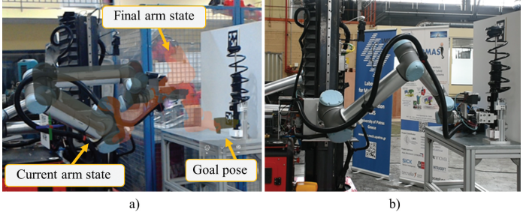

Figure 5 – Example of programming using augmented Reality where we use it to tell the robot where we want it to be. A) is the before photo and B) is the after once we send the command for the robot to move.

Figure 6 – Another example of programming using augmented Reality where we use it to tell the robot where we want it to be. A) is the before photo and B) is the after once we send the command for the robot to move.

Figure 7 – Image of an operation failure occurring. A) pop-up screen giving information about it and b) Virtual button to quickly solve the issue so the robot can go back to working.

Figure 8 – Pie-chart showing the participants opinions regarding the AR system.

The system does come with its flaws, namely, the headset gear weight being a major setback to the adoption of the entire system. Short usage is fine but prolong one becomes uncomfortable.

When it comes to assembly lines, it has proven effective and mostly positive (Aivaliotis et al., 2022; Baroroh et al., 2021; Blankemeyer et al., 2018; Costa et al., 2022; Lotsaris et al., 2020). This comes to show that investing more resources in this area will likely net a positive outcome and save even more resources in the long run. It allows both experience and inexperience workers to perform identical tasks at nearly the same speed if not outright faster.

It was also proven useful in other aspects other then just assembly line, such as remote assistance (Calandra et al., 2021). It also shows to make the one requiring assistance work faster and better and reduce time spent by the one helping, allowing him to use his time more efficiently.

In this work, participants first collect data through troubleshooting before calling for assistance. Once all the data was collected, the assistant would prepare instructions using AR which had a series of tools at their disposal as seen in Fig 9, the call would end and the participant would attempt to solve the problem. If need be, the participant would call a second time for further instructions but based on the results, that was a rare occurrence.

The participants were separated in two groups:

* Fully Assisted: Step-By-Step
* Partially Assisted – Gives all the instructions at the start then ends the call. If need be, more calls can be made.

Both groups would utilize AR and the results show that Partially Assisted can significantly reduce the time of the remote expert as can be seen in Fig 10.

There have been numerous experiments conducted to explore the use of AR in the robotics field, and the results of these studies suggest that the integration of AR technology has the potential to significantly enhance the capabilities and performance of those diving in the field. As interest in AR applications in robotics continues to grow, it is reasonable to expect that the use of AR in this field will become increasingly widespread and contribute to the ongoing development and improvement of robotics technology.

Overall, the integration of AR technology in robotics has the potential to drive significant advancements in a wide range of applications, including manufacturing, logistics, healthcare, and more. As such, it is likely that the use of AR in robotics will continue to be a focus of research and development efforts in the coming years.

Figure 9 – Various Augmented Reality tools for the expert to leave instructions to the participants.

Figure 10 – Graph showing the call duration and task completion time side by side from Fully Assisted (FA) and Partially Assisted (PA) tasks.

# Work Plan

## Tasks

* Explain all the tasks that will be done throughout the dissertation

In the early stages, a review of the scientific papers was conducted to get a sense of what was and was not being done in the areas we will be working with (AR and robotics), along with what is working. In this state, various ideas were taken that could become a potential feature in the work, such as but not limited to:

- Danger zone

- Virtual button to summon the robot

- Virtual button to handle exceptions and errors better and faster

It was also noted what the participants' opinions were about these different experiences, their effectiveness and their complaints, as this will help point us in the right direction.

Once the bulk of the information has been gathered about what has been done, we will define our methodology to ensure our work is robust, effective, and useful. This is accomplished through various meetings to ensure the techniques are effective.

After that, it's time to design potential solutions for implementation and show them to different people to get their opinions on what's right, what's not right, and what can be done better. It will help keep the solutions focused on the needs of those who will be using them.

As the ideas solidify along with the plan, we will start connecting ROS and Vuforia so that we can work with real robots instead of just simulating one. We can then verify whether the solutions implemented up to that date work in real environments or not and optimize accordingly.

After spending some time implementing all the solutions and interfaces thought up in the previous point, we proceed to user testing, where we allow different people (experts and non-professionals) to use the system, tell us their opinion and their performance to complete various tasks. Improvements are made taking into account the results of these user tests, followed by another user test to examine the effectiveness of the new improvements and re-doing the process again until we are happy with the results.

Eventually, after the work is done, the dissertation will come back into focus until the end of the remaining time.

## Gantt Diagram

Figure 11- Gantt Diagram of the work plan

## Tools

In this section, we will be discussing the various tools used throughout the thesis and give an idea of what they are used for or why they were chosen. There were three main tools used, those being: Unity, Vuforia and ROS. All three of those will be working together to bring to life our idea and solutions.

### Unity

* Brief explanation of what Unity is
* Some of it’s uses
* Why we will use it

### Vuforia

* Explain what it is(That it’s the technology that will allow us to create software for AR)
* Why we chose it

### ROS

* What it is
* How it’s typically used
* How we will use it

# Bibliography

Aivaliotis, S., Lotsaris, K., Gkournelos, C., Fourtakas, N., Koukas, S., Kousi, N., & Makris, S. (2022). An augmented reality software suite enabling seamless human robot interaction. *International Journal of Computer Integrated Manufacturing*. https://doi.org/10.1080/0951192X.2022.2104459

Baroroh, D. K., Chu, C. H., & Wang, L. (2021). Systematic literature review on augmented reality in smart manufacturing: Collaboration between human and computational intelligence. *Journal of Manufacturing Systems*, *61*, 696–711. https://doi.org/10.1016/j.jmsy.2020.10.017

Blankemeyer, S., Wiemann, R., Posniak, L., Pregizer, C., & Raatz, A. (2018). Intuitive Robot Programming Using Augmented Reality. *Procedia CIRP*, *76*, 155–160. https://doi.org/10.1016/J.PROCIR.2018.02.028

Cabral Renato. (n.d.). *RobARtics: Assisting in robotics competitions using Augmented Reality*.

Calandra, D., Cannavò, A., & Lamberti, F. (2021). *Evaluating an Augmented Reality-based Partially Assisted Approach to Remote Assistance in Heterogeneous Robotic Applications*. https://doi.org/10.1109/ICVR51878.2021.9483849

Costa, G. de M., Petry, M. R., & Moreira, A. P. (2022). Augmented Reality for Human–Robot Collaboration and Cooperation in Industrial Applications: A Systematic Literature Review. *Sensors*, *22*(7). https://doi.org/10.3390/s22072725

Lotsaris, K., Fousekis, N., Koukas, S., Aivaliotis, S., Kousi, N., Michalos, G., & Makris, S. (2020). Augmented Reality (AR) based framework for supporting human workers in flexible manufacturing. *Procedia CIRP*, *96*, 301–306. https://doi.org/10.1016/j.procir.2021.01.091

Milgram, P. (1994). A TAXONOMY OF MIXED REALITY VISUAL DISPLAYS. *IEICE Transactions on Information Systems*, *12*. http://vered.rose.utoronto.ca/people/paul_dir/IEICE94/ieice.html

Soares, I., Petry, M., & Moreira, A. P. (2021). Programming robots by demonstration using augmented reality. *Sensors*, *21*(17). https://doi.org/10.3390/s21175976

Suzuki, R., Karim, A., Xia, T., Hedayati, H., & Marquardt, N. (2022). Augmented Reality and Robotics: A Survey and Taxonomy for AR-enhanced Human-Robot Interaction and Robotic Interfaces. *Conference on Human Factors in Computing Systems - Proceedings*. https://doi.org/10.1145/3491102.3517719

Youssefi, K. A. R., & Rouhani, M. (2021). Swarm intelligence based robotic search in unknown maze-like environments. *Expert Systems with Applications*, *178*, 114907. https://doi.org/10.1016/J.ESWA.2021.114907

1. https://www.therobotreport.com/10-biggest-challenges-in-robotics/ (14/01/2023: 10/01/2023)