|  |  |  |  |
| --- | --- | --- | --- |
|  | Universidade de Aveiro  2016 | Departamento de Eletrónica,  Telecomunicações e Informática | |
| Nome completo | Título ENG  Título PT | |



|  |  |  |  |
| --- | --- | --- | --- |
|  | Universidade de Aveiro  2016 | Departamento de Eletrónica,  Telecomunicações e Informática | |
| Nome completo | Título ENG  Título PT | |
|  | Dissertação apresentada à Universidade de Aveiro para cumprimento dos requisitos necessários à obtenção do grau de Mestre em Engenharia de Computadores e Telemática, realizada sob a orientação científica do Professor Doutor José Maria Amaral Fernandes, Professor auxiliar do Departamento de Electrónica, Telecomunicações e Informática da Universidade de Aveiro e da Doutora Susana Manuela Martinho dos Santos Baía Brás, Investigadora do IEETA, Departamento de Eletrónica Telecomunicações e Informática da Universidade de Aveiro. | |



|  |  |  |  |
| --- | --- | --- | --- |
|  | |  | |
|  | |  | |
| o júri / the jury | |  | |
| presidente / president | Prof. Doutor Joaquim João Estrela Ribeiro Silvestre Madeira  Professor Auxiliar do Departamento de Eletrónica, Telecomunicações e Informática da Universidade de Aveiro | |
|  |  | |
| vogais / examiners committee | Prof. Doutor Miguel Tavares Coimbra  Professor Auxiliar do Departamento de Ciências de Computadores da Faculdade de Ciências da Universidade do Porto | |
|  |  | |
|  | Prof. Doutor José Maria Amaral Fernandes  Professor Auxiliar do Departamento de Eletrónica, Telecomunicações e Informática da Universidade de Aveiro | |
|  | |  | |
|  | |  | |
|  | |  | |
|  | |  | |
|  | |  | |
|  | |  | |
|  | |  | |
|  | |  | |

|  |  |
| --- | --- |
|  | ….. |
| acknowledgements |
|  |

|  |  |  |  |
| --- | --- | --- | --- |
|  | |  | |
| palavras-chave | ... | |
| resumo | … | |

|  |  |
| --- | --- |
|  |  |
| keywords | …. |
| abstract | … |
|  |  |

# 

# Contents

**I. Contents** i

**II. List of figures** iii

**III. List of tables** v

**IV. List of Acronyms** vii

**1 Introduction** 1

1.1 Goals and Contributions 3

1.2 Dissertation Outline 4

**2 State of the Art** 5

2.1 Exposure Therapy (ET) 6

2.2 Digital realities 9

2.2.1 Virtual Reality 10

2.2.2 Augmented Reality 13

**3 Catch The Spiders** 15

3.1 Unity 16

3.2 The spider 16

3.3 Mobile Augmented Reality game 17

3.3.1 The game 17

3.3.2 Vuforia 20

3.3.3 Markers 20

3.4 Why Virtual Reality and not Augmented Reality 22

3.5 Interaction using Leap Motion 22

3.6 Catch The Spiders: Virtual Reality game 23

3.6.1 The 8-Ball 24

3.6.2 The virtual hand 24

3.6.3 Game Levels 25

**4 Veracity: The System** 29

4.1 The architecture 29

4.2 The current system Hardware 31

4.3 Overall Workflow 32

4.4 The Bitalino version (version 1) 34

4.5 The VJ version (version 2) 35

4.6 The synchronization messages and the game remote controller 37

4.6.1 Remote controller technical decisions and implementation 38

4.7 Game controller and Biosignal management 40

4.8 Game related information 42

4.9 Data management 43

**5 Case Study** 45

5.1 Experimental Setup 46

5.2 User acceptance assessment 48

5.3 Data Analysis 51

**6 Conclusions and future work** 55

6.1 Further work 56

**References** 57

**A Appendices** 61

A.1 Augmented Reality game 61

A.2 Virtual Reality game 62

A.2.1 Rules and Levels 62

A.2.2 VR Game Narrative 64

A.3 Public Presentations 66

# List of figures

Figure 2 - Exposure Therapy cycle - The exposure to anxiety elemnets triggers memory, sensations, feelings and thoughts, allowing the sufferer to learn coping strategies, which will allow a gradual decrease in anxiety. 1

Figure 3 - Exposure therapy is commonly used to treat phobias, gradually increasing anxiety-triggering stimuli. Source: goo.gl/gQjkXD. 6

Figure 4 - …..

# List of tables

Table 1 - Demographic information of the case study participants. 46

# List of Acronyms

**API** – Application Programming Interface

**AR** – Augmented Reality

**ECG** – Electrocardiography

**ET** – Exposure Therapy

**HDR** – High Dynamic Range

**HR** – Heart Rate

**IP** – Internet Protocol address

**MR** – Mixed Reality

**OS** – Operating System

**PC** – Personal Computer

**RR** – Respiratory Rate

**SDK** – Software Development Kit

**TTS** – Text to Speech

**USB** – Universal Serial Bus

**VE –** Virtual Environment

**VJ** – Vital Jacket

**VR** – Virtual Reality

**VRT** – Virtual Reality Therapy

**VRET** – Virtual Reality Exposure Therapy

**Wi-Fi** – Wireless Fidelity, Wireless Internet

# Introduction

Algumas dicas:

* Usem o Mendeley para tratar da gestão dos artigos, surveys, livros, etc
  + Automaticamente conseguem inserir a referencia no Word e mais tarde gerar as referencias automaticamente (Facilita bastante).
* Sempre que começarem um novo capítulo, este deve iniciar numa página impar
* Todas as figuras e tabelas devem ter uma legenda minimamente auto-explicativa
* Ao longo do document tentem ao maximo contra uma história e interligar os capitulos
* cada capitulo deve ter (se possível) uma pequena introdução, depois todo o detalhe associado e no final pequenas conclusoes ou observações – que por sua vez ligam ao próximo capítulo and so on!
* Tentem ao máximo mostrar todas as features / aspectos positivos do vosso trabalho com imagens, e detalhes
  + Aspectos negativos também são trabalho, por exemplo:
    - experimentamos a tecnologia A e B – concluimos que eram más porque XPTO
    - Então decidimos antes usar a tecnologia C, porque tem a vantage de XYZW
* Aproveitem o trabalho future para mostrar critica ao vosso proprio trabalho, mostrando que sabem como continuar o mesmo, ou que aspectos merecem ser melhorados. Caso seja possível, adicionem sugestões em conjunto com os aspectos que apontarem.
* Aproveitem aqueles momentos de menos inpiração ou bloqueios para escrever os agradecimentos e fazer possiveis alterações caso escrevam em ENG.
* O document, mesmo o provisorio que vão entregar para o dia da Apresentação deve conter o nome do arguente e do president de mesa. Falem com os vossos orientadores para saber essa info.
* Vejam os PDF’s do zip para mais detalhe

Exposure Therapy (ET) is a therapy where participants are encouraged to repeatedly approach the phobic element and ultimately results in the extinction of fear through inhibitory learning mechanisms (Figure 1) [5]. blablablabla Bernardo is Awesome!!!!

…..

Figure 1 - Exposure Therapy cycle - The exposure to anxiety elemnets triggers memory,   
sensations, feelings and thoughts, allowing the sufferer to learn coping strategies, which will allow a gradual decrease in anxiety.

## Goals and Contributions

In this dissertation, we propose ……,

**Goals:**

* ……

**Contributions:**

* ……..

## Dissertation Outline

Excluding this one, 5 chapters compose this document:

* Chapter 2, describes the state of the art associated to our system and provides a theoretical introduction to the concepts of ….
* Chapter 3, starts by describing the
* Chapter 4, describes all the details related to the implementation of the system,
* Chapter 5, defines our case studies, and the obtained results and interpretation.
* Finally, Chapter 6 summarizes the conclusions drawn from the development and testing stages, as well as a subsequent analysis of the proposed solution and the possible improvements and future research.

Quoting, Xavier Palomer, co-founder of Psious[1], a Spanish startup that uses VR and AR to design phobia treatment scenarios for fear of flying, needles, crowds, heights, spiders and cockroaches: "Virtual worlds allows you to have the same or very, very similar experience you're having in the real world, but you have some control". VRET treatments provide main advantages, and more control is certainly one of those, allowing the phobic individual to experience adequate levels of anxiety, while ensuring they’re safety. The field can be considered still young, but early results are positive.

At Newcastle University's Institute of Neuroscience, a program headed by Dr. Morag Maskey[2] is developing virtual reality simulations, in order to treat children with autism spectrum disorders who suffer from phobias. So far, in their first study, four out of nine children completely achieve to overcome their respective phobias. Besides, two learned to learn how to face their anxiety enough, which result in the ability to functional normally, not possible before the study.

# Case Study

……. (Table 1).

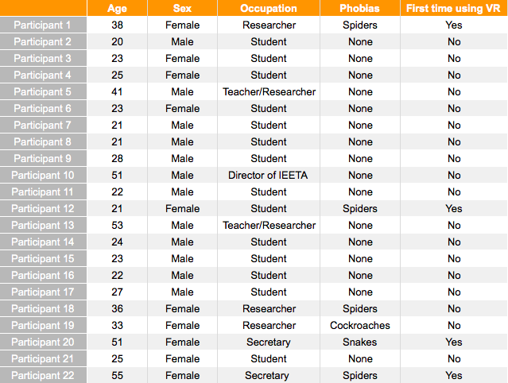

Table 1 - Demographic information of the case study participants.

## Data Analysis

For data analysis the Matlab® software was used, …….. Figure 44,

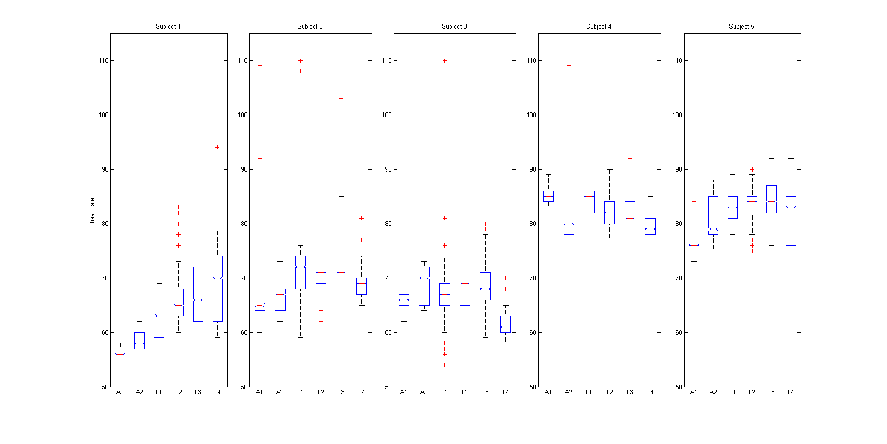

Figure 44 - Statistical analysis - Participants boxplot representing the smooth-heart rate values (vertical axis) over the adaptation and active game levels (horizontal axis), regarding the participant overall study. A1/ A2 are the adaptation levels 1 and 2. L1/ L2/ L3/ L4 are the active levels, with phobic stimulus exposure.

# Conclusions and future work

In this dissertation, we propose and describe ……, a generic system to provide an end-to-end solution, able to …..

## Further work

Subsequently, ….

# References

[1] BE SMART - USE MENDELEY

[2] R. T. LeBeau, D. Glenn, B. Liao, H.-U. Wittchen, K. Beesdo-Baum, T. Ollendick, and M. G. Craske, “Specific phobia: a review of DSM-IV specific phobia and preliminary recommendations for DSM-V.,” *Depress. Anxiety*, vol. 27, no. 2, pp. 148–67, Feb. 2010.

[3] A. Ohman and S. Mineka, “Fears, phobias, and preparedness: toward an evolved module of fear and fear learning.,” *Psychol. Rev.*, vol. 108, no. 3, pp. 483–522, Jul. 2001.

[4] “Diagnostic and Statistical Manual of Mental Disorders: DSM Library.” [Online]. Available: http://dsm.psychiatryonline.org/doi/book/10.1176/appi.books.9780890425596. [Accessed: 01-Apr-2016].

[5] M. G. Craske, M. Treanor, C. C. Conway, T. Zbozinek, and B. Vervliet, “Maximizing exposure therapy: an inhibitory learning approach.,” *Behav. Res. Ther.*, vol. 58, no. 1, pp. 10–23, Jul. 2014.

[6] ….

# Appendices A

## A.1 Augmented Reality game

In Figure 45, it is possible to view ….

1. goo.gl/NBq5jY
2. goo.gl/lPCseZ