**Team 7- Clover Traffic Connections**

**Project Proposal and Plan**

**1. Introduction**

*Describe in one or two paragraph the idea of and motivation for the project.*

The goal of this project would be to provide traffic data to the citizens of the City of Bloomington. The customer would be city officials of Bloomington because this application would add value to their city by offering such useful insights.

**1.1 Project Overview and Statement of Proposal**

*Provide an overview of the project and then make a statement of proposal.*

The application would allow users to determine better routes to their destination as well as planning for the timing of their activities. The application would be a fun and easy way to keep the citizens of Bloomington informed.

**Statement of Proposal:** *We propose to make an application that would allow for the citizens of Bloomington to have easy access to traffic data insights.*

**1.2 Project Scope and Objectives**

*Define the scope of the project and the objectives to be satisfied by this project.*

Major features would be displaying interesting statistics about past incidents and showing trends over time. Then people can make informed decisions about their modes of transportation.

**2. Plan**

*This section contains is a list of tasks and deliverables associated with the project, a Gantt chart*

*depicting task durations, dependencies and completion dates, and a summary of resource*

*requirements and assignments for each task.*

**2.1 Timeline Chart**

Gantt Chart (with dates). Consider the following milestones:

* Proposal (this one)
* First Demo
* Final Demo/Presentation
* Final Delivery

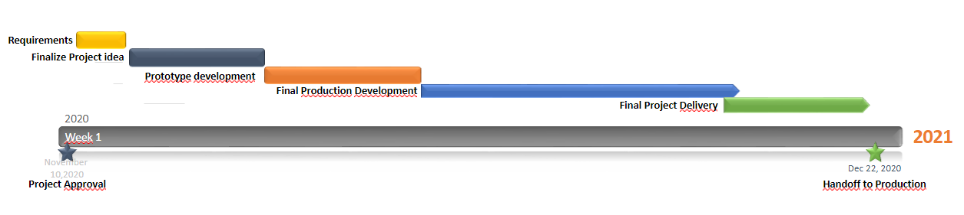

**2.2 Task Descriptions**

Task 1 - Find all open data sources we can find on traffic information in Bloomington

Task 2 - Compile database of traffic information for the city of Bloomington

Task 3 - Create a website that can accurately display information in different graphs

Task 4 - Refine database and website through demo and feedback before releasing final version

**2.3 Resource Table**

|  |  |  |  |
| --- | --- | --- | --- |
| **Task** | **People** | **Hardware & Software** | **Special** |
| **1** | **all group members** | **computer per member** | **N/A** |
| **2** | **all group members** | **computer per member** | **N/A** |
| **3** | **all group members** | **computer per member** | **N/A** |
| **4** | **all group members** | **computer per member** | **N/A** |

**3. Project Resources**

**3.1 Group Members**

1. Rachel Tomas
2. Matthew Raycroft
3. Keith White
4. Eduardo Vazquez*

*we have been having issues getting in contact with our group member

**3.2 Hardware and Software Resources**

We anticipate needing a computer for each group member.

**3.3 Special Resources**

We do not require any special resources for this project.

**4. Appendices**

This section contains any additional information that you would like to include in the project proposal and plan.