Autonomous Navigation of TurtleBot3 Burger in Gazebo (ROS 2 Jazzy)
IE4060 Robotics and Intelligent Systems — Assignment 02
Student: Seneth Jayathilaka · Department: Computer Systems Engineering, Faculty of Computing, SLIIT
GitHub repository: TODO-REPO-LINK · Date: 18 October 2026
Software: ROS 2 Jazzy, Gazebo Sim Harmonic, Nav2, SLAM Toolbox, TurtleBot3 Burger
All numbers in this report come from logged simulation runs. Benchmark data: docs/test_summary.csv, docs/test_results.csv, docs/raw_trials.csv. Longer technical notes, including every mapping run and the debugging history, are in docs/report/extended_notes.md.

1. Introduction
The goal is a TurtleBot3 Burger that drives itself to any clicked point of the maze given in the assignment brief, quickly and without collisions. The system has four ROS 2 packages: maze_world (Gazebo world and robot bring-up), maze_navigation (SLAM, Nav2 and localisation), goal_interface (clicked goals and the measured 3-goal demonstration) and maze_dqn (the Deep Q-learning agent). Three navigation methods are compared on the same goals: Nav2 with the NavFn planner in Dijkstra mode, Nav2 with NavFn in A* mode, and Deep Q-learning (DQN). Figure 1 shows how the packages connect. Gazebo publishes the robot’s sensors through ros_gz_bridge; mapping turns them into a saved map; Nav2 or the DQN then drives the robot to goals clicked in RViz. Nav2 and the DQN are never run together, because both react to clicked goals.
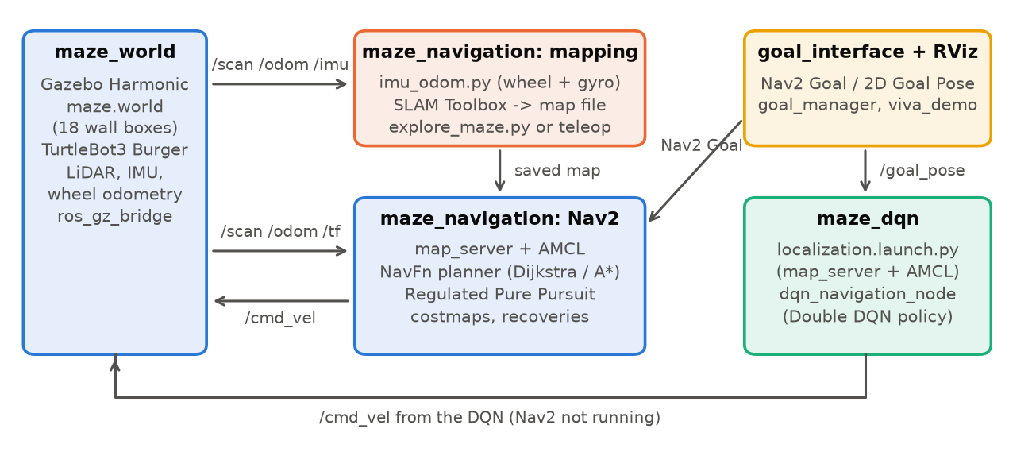
Figure 1 — System architecture: packages, main nodes and the topics between them.
Package | Main files | Started with
maze_world | worlds/maze.world, launch/maze_world.launch.py | ros2 launch maze_world maze_world.launch.py
maze_navigation | config/nav2_params.yaml, config/slam_params.yaml, maps/maze_map.*, scripts/imu_odom.py, launch/{navigation,slam,localization}.launch.py | ros2 launch maze_navigation navigation.launch.py [use_astar:=true] · slam.launch.py · localization.launch.py odom:=imu
goal_interface | goal_manager.py, viva_demo.py | ros2 run goal_interface viva_demo
maze_dqn | maze_env.py, dqn_model.py, train_dqn.py, dqn_navigation_node.py, models/*.npz | ros2 run maze_dqn dqn_navigation_node
scripts/ | explore_maze.py, align_map_origin.py, pad_map.py, collect_metrics.py | python3 scripts/<name>.py
The README gives every command step by step, one terminal tab at a time.

2. Maze Design
The arena is 3 m × 3 m with its origin at the centre, divided into 6 × 6 cells of 0.5 m. Walls are static boxes 0.05 m thick and 0.5 m high (taller than the 0.19 m LiDAR, so every wall is seen). The layout reproduces Figure 1 of the brief exactly: all 48 half-metre wall segments were checked against it. Collinear segments are merged into 18 boxes in maze_world/worlds/maze.world. The maze is a perfect maze: a breadth-first search over the cells finds all 36 cells connected by exactly one route between any two. Corridors are 0.45 m wide, so the Burger (radius about 0.1 m) has only about 0.125 m of clearance on each side.
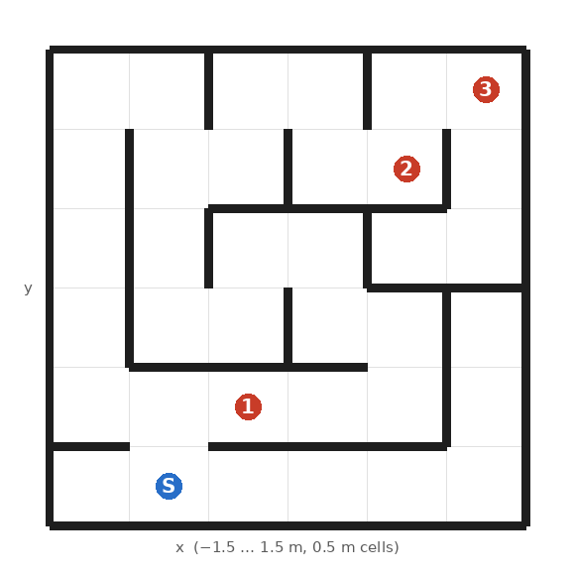
Figure 2 — Maze layout (from maze.world). S = spawn (−0.75, −1.25); goals G1 (−0.25, −0.75), G2 (0.75, 0.75), G3 (1.25, 1.25).
maze_world.launch.py follows the TurtleBot3 Jazzy launch structure: it starts Gazebo with the world (with the Physics, Sensors, IMU, UserCommands and SceneBroadcaster systems), spawns the Burger at S, and bridges /scan, /odom, /imu, /tf, /clock and /cmd_vel (geometry_msgs/TwistStamped) to ROS 2.

3. Mapping (SLAM) and Localisation
Exploration. SLAM Toolbox (online asynchronous mode, slam.launch.py) builds the map while the robot visits all 36 cells. It can be driven by hand with teleop_twist_keyboard, or by scripts/explore_maze.py, which does a depth-first tour of the cell graph with slow stop–turn–drive motion. The script steers using the simulator’s pose between moves so that it never hits a wall; SLAM itself only sees the robot’s own sensors.
Odometry. In this world the Burger’s wheels slip on in-place turns: a 90° turn at 1.2 rad/s loses about 12° of heading that wheel odometry never sees, and even slow turns lose about 3°. Over a 7-minute exploration wheel odometry drifted 0.44 m and 18°. The simulated IMU gyro is far more accurate (0.1° error after a series of fast turns), so imu_odom.py combines wheel speed with the gyro heading. Its odometry stayed within 4 cm of the true position over the same run.
SLAM settings (config/slam_params.yaml, otherwise SLAM Toolbox defaults): gyro odometry; laser range limited to 1.5 m, so a small heading error cannot smear distant walls; 2.5 cm grid, because the walls are only 5 cm thick; and scan matching and loop closure off. In this repetitive maze the scan matcher sometimes registered scans several centimetres off, which doubled walls and dropped part of the outer wall, while the gyro odometry alone was accurate to a few centimetres. The map is still built entirely from the LiDAR scans.
Map quality, measured against the true walls of maze.world:
Run | Odometry | Scan matching | Other setting | Mean wall error | Wall pixels ≤ 10 cm | Walls mapped | Stray pixels
1 | wheel | on | — | 2.1 cm | 96.2 % | 97.3 % | 37
2 | wheel | on | repeat of run 1 | 4.0 cm | 91.4 % | 88.6 % | 212
5 | wheel + gyro | on | — | 6.0 cm | 75.2 % | 76.1 % | 320
6 | wheel + gyro | on | repeat of run 5 | 3.3 cm | 95.2 % | 93.0 % | 147
8 | wheel + gyro | off | — | 2.4 cm | 100 % | 99.9 % | 4
9 (installed) | wheel + gyro | off | 2.5 cm grid | 1.8 cm | 100 % | 100 % | 5
All runs: same exploration route, laser range 1.5 m, 5 cm grid unless noted. Runs 3, 4 and 7 (other settings, all worse) are in extended_notes.md.
With scan matching on, results varied widely from run to run, even with identical settings (runs 1–2 and 5–6), and even the best of those maps was missing 0.7 m of the east outer wall and had a doubled wall in one dead end; both broke navigation on the right side of the maze. The installed map has every wall and no doubled walls. A small offset of about 2–4 cm remains, mostly from grid quantisation (a wall face falls at an arbitrary position inside a cell); it was not corrected, because that would mean fitting the map to the ground truth.
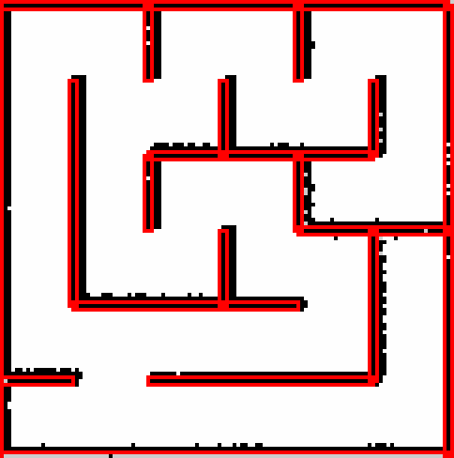
Figure 3 — Installed SLAM map (black) with the true wall outlines from maze.world (red).
Map frame and padding. The saved map’s origin is shifted by the spawn position (align_map_origin.py) so that map and world coordinates coincide, and a 2.5 m border of unknown cells is added (pad_map.py, Section 4.3).
Localisation. AMCL uses the likelihood-field model with 500–2000 particles and starts at the spawn pose. The TurtleBot3 default laser model let the estimate drift by about 0.35 m in the narrow corridors, so it was sharpened (sigma_hit 0.08, z_rand 0.2, 120 beams).

4. Navigation with Nav2
Global planner: Dijkstra vs A*. NavFn computes a navigation function over the global costmap. With use_astar: false it expands a Dijkstra wavefront; with use_astar: true it adds a Euclidean heuristic. Both find optimal paths on the same costmap; A* only expands fewer cells. The mode is selected at launch (navigation.launch.py use_astar:=true|false) and was confirmed on the running planner for every benchmark.
Local controller. The TurtleBot3 default DWB controller cut corners and scraped walls in the 0.45 m corridors, so it was replaced by Regulated Pure Pursuit with a short 0.15 m lookahead and 0.15 m/s cruise speed. It follows the corridor-centred path closely and pivots in place at 0.5 rad/s, below the wheel-slip threshold. Angular speed and acceleration limits were lowered in the velocity smoother and recovery behaviours for the same reason.
Costmaps. Robot radius 0.10 m; inflation radius 0.30 m with cost scaling 6.0. This keeps the corridor centre line well below lethal cost while pulling paths onto it. The global costmap uses only the static map and inflation (live scan hits a few centimetres off the mapped walls sealed whole corridors once inflated); the local costmap still uses the LiDAR for unexpected obstacles.
Key parameters (config/nav2_params.yaml):
Component | Setting | Value | Why
Planner (NavFn) | use_astar / allow_unknown / tolerance | false or true / false / 0.5 m | Dijkstra or A*; no paths through unmapped space
Controller (RPP) | speed / lookahead / pivot speed | 0.15 m/s / 0.15 m (0.12–0.25) / 0.5 rad/s | tight corridors, no wheel slip
Velocity smoother | max ω / angular acceleration | 1.0 rad/s / 2.0 rad/s² | wheel slip on fast turns
Costmaps | robot radius / inflation / cost scaling | 0.10 m / 0.30 m / 6.0 | open 0.45 m corridors, centred paths
Global / local costmap | layers / resolution | static + inflation / 2 m rolling window with LiDAR | map resolution 0.025 m; local 0.05 m
Goal checker | xy / yaw tolerance | 0.10 m / 0.25 rad | goals are cell centres 0.5 m apart
AMCL | particles / sigma_hit / z_rand / beams | 500–2000 / 0.08 / 0.2 / 120 | sharper laser model for narrow corridors
Long routes. At first every goal more than about 6 m of driving away failed. NavFn traces its final path in half-cell steps and gives up after 4 × (map width in cells) steps, so a path cannot be longer than about twice the map width, 6.2 m for the 3.1 m map, while the longest route in the maze is about 12 m. Padding the map with the 2.5 m unknown border makes the costmap 8.1 m wide, raising the limit to about 16 m; allow_unknown: false keeps paths out of the border. Before the fix, all of the long goals in the test below failed. The test drives two three-leg sequences with each planner; every leg after the first is a 9.4–9.9 m route around most of the maze, including between two adjacent cells, (1.25, 0.25) and (1.25, −0.25), that a wall separates:
Sequence | Planner | Legs reached | Distance driven per leg (m) | Time per leg (s) | Min. clearance (m)
S → (1.25, −0.25) → (0.75, 0.25) → (1.25, −0.25) | Dijkstra | 3/3 | 2.8 / 9.9 / 9.8 | 31 / 150 / 147 | 0.150
same | A* | 3/3 | 2.8 / 9.8 / 9.7 | 37 / 149 / 142 | 0.143
S → (1.25, 0.25) → (1.25, −0.25) → (1.25, 0.25) | Dijkstra | 3/3 | 6.8 / 9.5 / 9.5 | 111 / 139 / 139 | 0.152
same | A* | 2/3 | 5.4 (failed) / 7.5 / 9.4 | 106 / 108 / 143 | 0.000
11 of 12 legs reached their goal, ending 0.07–0.11 m from it (true position). The one failure touched a wall on the way, stopped 1.03 m short and was aborted by Nav2; the next leg then started from where it stopped, which is why it was shorter.
Goal interfaces. In RViz, Nav2 Goal sends a goal to Nav2, and 2D Goal Pose publishes /goal_pose, which both Nav2 and the DQN accept. goal_manager also forwards Publish Point clicks after a bounds check. viva_demo sends the three test goals in sequence and records travel time, path length, collisions and clearance for each leg.
Performance optimisation (travel time and smoothness). The brief asks for minimal travel time with smooth, safe motion; in 0.45 m corridors these pull in opposite directions, and the tuning was driven by measurements:
- Short paths. Inflation pulls the global path onto the corridor centre, and the 0.15 m lookahead lets the robot round each 90° bend without stopping at the cell centre. Nav2’s paths were only 8–16 % longer than the shortest possible safe path (η = 86–92 %, Section 6).
- Reliable long trips. Padding the map removed the 6 m planning limit, so far goals are reached directly instead of failing or needing intermediate goals.
- Speed vs safety. Cruise speed is 0.15 m/s, below the Burger’s 0.22 m/s maximum. Faster, sharper motion was measurably worse: DWB (faster turning, wider sampling) scraped walls, and turns above 0.5 rad/s made the wheels slip and AMCL lose the robot, both of which cost far more time (recoveries, failed goals) than the slower speed.
- Smoothness. The velocity smoother limits acceleration (1.0 m/s², 2.0 rad/s²) and RPP slows down on tight curves and near the goal, so the robot accelerates and stops without jerks.
The DQN shows the other side of this trade-off: it drives faster (0.18 m/s, no slowing for corners). The original DQN was quicker on the long leg but came into contact with walls; the retrained one keeps its distance and is the fastest method on the long task (Section 6).

5. Deep Q-Learning Navigation
Training environment. maze_env.py is a 2D kinematic model of the same 18 walls (10 Hz, unicycle motion) with a simulated 360-beam LiDAR. A collision is counted when the robot centre comes within 0.12 m of a wall.
MDP. State (39 values): the LiDAR min-pooled into 36 sectors of 10°, the distance and bearing to the target, and the previous action. Actions (5): forward 0.18 m/s, rotate in place ±1.0 rad/s, soft turns (0.14 m/s, ±0.35 rad/s). Reward: +30 at the goal, −20 for a collision, −5 at timeout, otherwise 10 × the progress along the maze corridors (not straight-line distance, which would reward driving into walls) − 0.05, and −0.2 near walls. Two variants were trained: the final-goal DQN, whose target is the goal itself, and the subgoal DQN, whose target is the next cell centre on the shortest grid route (a learned local controller under a simple route planner).
Algorithm. Double DQN with a NumPy network (39-128-128-64-5, ReLU), Huber loss, Adam (learning rate 5 × 10⁻⁴), γ = 0.98, batch 64, 100 000-transition replay buffer, target network update every 1000 steps, ε decaying from 1.0 to 0.05 per episode, and a curriculum that starts with goals one cell away. The best evaluated weights are kept. The first version never succeeded; the causes were ε decaying per gradient step instead of per episode, episodes too short for the far goals, no true in-place turn, and a straight-line progress reward.
Training results (2D model, dqn_final_evaluation.csv; Goals A–C = G1–G3 from the spawn):
Variant | Goal A | Goal B | Goal C | Random 1–2 cells | 3–5 cells | 8–10 cells | 22–24 cells
Final-goal DQN (3000 episodes) | 0/1 | 0/1 | 0/1 | 39/50 | 16/50 | 0/50 | 0/50
Subgoal DQN (2200 episodes) | 0/1 | 1/1 | 1/1 | 44/50 | 30/50 | 25/50 | 22/50
Subgoal DQN, retrained (0.15 m margin) | 0/1 | 1/1 | 1/1 | 47/50 | 39/50 | 43/50 | 48/50
The final-goal DQN handles nearby goals but gets trapped when the goal is behind a wall, rotating back and forth in place. The subgoal DQN reaches far goals because the route planner always gives it a reachable next cell. Figure 4 shows that training was unstable: the subgoal agent peaked at episode 1300 and degraded again as the curriculum moved to longer routes, so the best evaluation was kept rather than the last weights.
Retraining with a safety margin. The original agents counted a collision only when the robot centre came within 0.12 m of a wall, barely outside the Burger’s body (radius about 0.105 m), so they learned to run close to walls. The subgoal DQN was therefore retrained from scratch with the margin raised to 0.15 m, in-place turns slowed from 1.0 to 0.5 rad/s (below the wheel-slip threshold of Section 3) and the wall penalty starting at 0.20 m. Four seeds were trained in parallel; seed 1 was chosen by its random full-maze success (82 % at episode 2200, against 38 % for the original), not by the three test goals, which are the benchmark goals. Its evaluation (last table row) is stronger at every distance despite the stricter margin, most of all on long routes (48/50 against 22/50). dqn_navigation_node -p model:=safe loads it, with its settings read from dqn_subgoal_safe_weights.json.
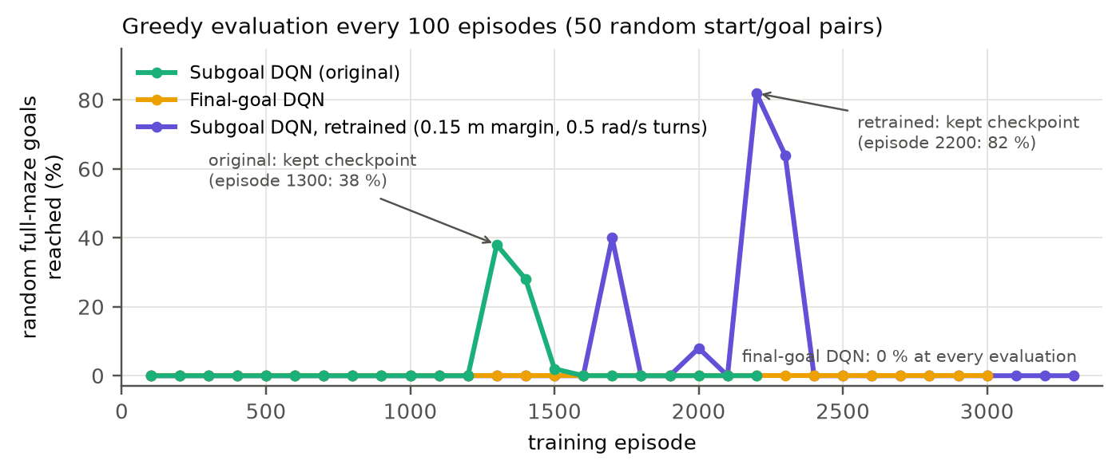
Figure 4 — DQN evaluation during training (*_eval_log.csv): share of 50 random full-maze start/goal pairs reached.
Deployment. dqn_navigation_node builds the same state from /scan and the robot pose and publishes velocity commands at 10 Hz. Its pose comes from AMCL started on its own (localization.launch.py, map server + AMCL only, so Nav2 does not also react to the goals), using the gyro odometry, because the DQN’s wall contacts and fast turns make the wheels slip.
Safety shield. A first attempt without retraining (safety_shield:=true) used action masking: the DQN still ranks the actions, but moves towards an obstacle within 0.25 m ahead or 0.17 m to the side are removed and commands are slowed near walls (evaluated in Section 6).

6. Results
Protocol. Every method runs the same three tasks three times: S → G1, G1 → G2 and G2 → G3. Before each leg the test harness (viva_demo fixed_starts:=true) places the robot at exactly the same start pose in Gazebo, tells AMCL that pose and clears Nav2’s costmaps, so all trials of a task are identical (the navigation stack never uses the simulator’s pose). Time is simulation time to the result; a leg fails after 240 s (Nav2) or 180 s (DQN). Path is the distance driven (from odometry). The reference length is the shortest collision-free path for a robot of radius 0.10 m (the Nav2 footprint) from the start to the success circle around the goal (0.10 m for Nav2, 0.15 m for the DQN), computed exactly from the walls of maze.world with a visibility graph (collect_metrics.py). Efficiency η = reference ÷ path, so a robot that keeps 0.10 m from the walls scores at most 100 %; above 100 % means it cut closer than that. A collision event is a LiDAR range below the sensor’s 0.12 m minimum.
DQN judged against ground truth. A DQN leg counts as reached when its AMCL pose is within 0.15 m of the goal. Every DQN leg was also checked against the simulator’s true position (for measurement only): AMCL stayed within 0.15 m of it while driving, the subgoal DQN’s legs truly ended 0.13–0.21 m from the goal, and failed legs ended 0.7–1.2 m from the goal. An earlier run, in which the localisation launch silently failed to load the map, reported false successes and was discarded.
Table — mean ± standard deviation over successful trials (all on the installed map):
Method | Task | Success | Time (s) | Path (m) | Ref. (m) | η (%) | Collisions | Min. clearance (m)
Nav2 Dijkstra | S → G1 | 3/3 | 15.1 ± 0.2 | 0.75 ± 0.02 | 0.68 | 90.1 ± 1.9 | 0 | 0.170
Nav2 Dijkstra | G1 → G2 | 3/3 | 88.1 ± 2.0 | 5.35 ± 0.02 | 4.61 | 86.2 ± 0.3 | 0 | 0.146
Nav2 Dijkstra | G2 → G3 | 3/3 | 15.1 ± 0.2 | 0.75 ± 0.01 | 0.68 | 89.6 ± 1.4 | 0 | 0.169
Nav2 A* | S → G1 | 3/3 | 15.3 ± 0.1 | 0.75 ± 0.01 | 0.68 | 89.6 ± 1.3 | 0 | 0.163
Nav2 A* | G1 → G2 | 3/3 | 85.9 ± 0.5 | 5.30 ± 0.02 | 4.61 | 87.0 ± 0.3 | 0 | 0.136
Nav2 A* | G2 → G3 | 3/3 | 14.9 ± 0.3 | 0.76 ± 0.02 | 0.68 | 89.3 ± 2.7 | 0 | 0.167
DQN subgoal | S → G1 | 3/3 | 14.1 ± 3.1 | 0.66 ± 0.02 | 0.63 | 94.9 ± 3.0 | 0 | 0.138
DQN subgoal | G1 → G2 | 3/3 | 68.3 ± 3.1 | 5.25 ± 0.03 | 4.56 | 86.9 ± 0.4 | 17 | 0.000
DQN subgoal | G2 → G3 | 3/3 | 10.6 ± 1.4 | 0.73 ± 0.03 | 0.63 | 85.5 ± 3.5 | 3 | 0.120
DQN subgoal + shield | S → G1 | 3/3 | 17.2 ± 7.2 | 0.65 ± 0.05 | 0.63 | 96.8 ± 8.1 | 0 | 0.133
DQN subgoal + shield | G1 → G2 | 0/3 | — | — | 4.56 | — | 37 | 0.000
DQN subgoal + shield | G2 → G3 | 3/3 | 14.3 ± 4.4 | 0.71 ± 0.01 | 0.63 | 88.0 ± 1.8 | 0 | 0.125
DQN subgoal, retrained | S → G1 | 3/3 | 10.7 ± 0.4 | 0.68 ± 0.00 | 0.63 | 91.4 ± 0.6 | 0 | 0.128
DQN subgoal, retrained | G1 → G2 | 3/3 | 54.7 ± 0.9 | 5.43 ± 0.04 | 4.56 | 84.0 ± 0.6 | 0 | 0.125
DQN subgoal, retrained | G2 → G3 | 3/3 | 9.2 ± 0.2 | 0.70 ± 0.01 | 0.63 | 89.4 ± 1.6 | 0 | 0.166
DQN final goal | S → G1 | 3/3 | 7.1 ± 0.9 | 0.62 ± 0.02 | 0.63 | 101.7 ± 2.8 | 0 | 0.141
DQN final goal | G1 → G2 | 0/3 | — | — | 4.56 | — | 86 | 0.000
DQN final goal | G2 → G3 | 3/3 | 8.2 ± 5.1 | 0.91 ± 0.47 | 0.63 | 79.4 ± 31.6 | 1 | 0.000
Collisions are summed over three trials. Min. clearance is the smallest LiDAR range over all three trials (0.000 = a reading below the 0.12 m sensor minimum).
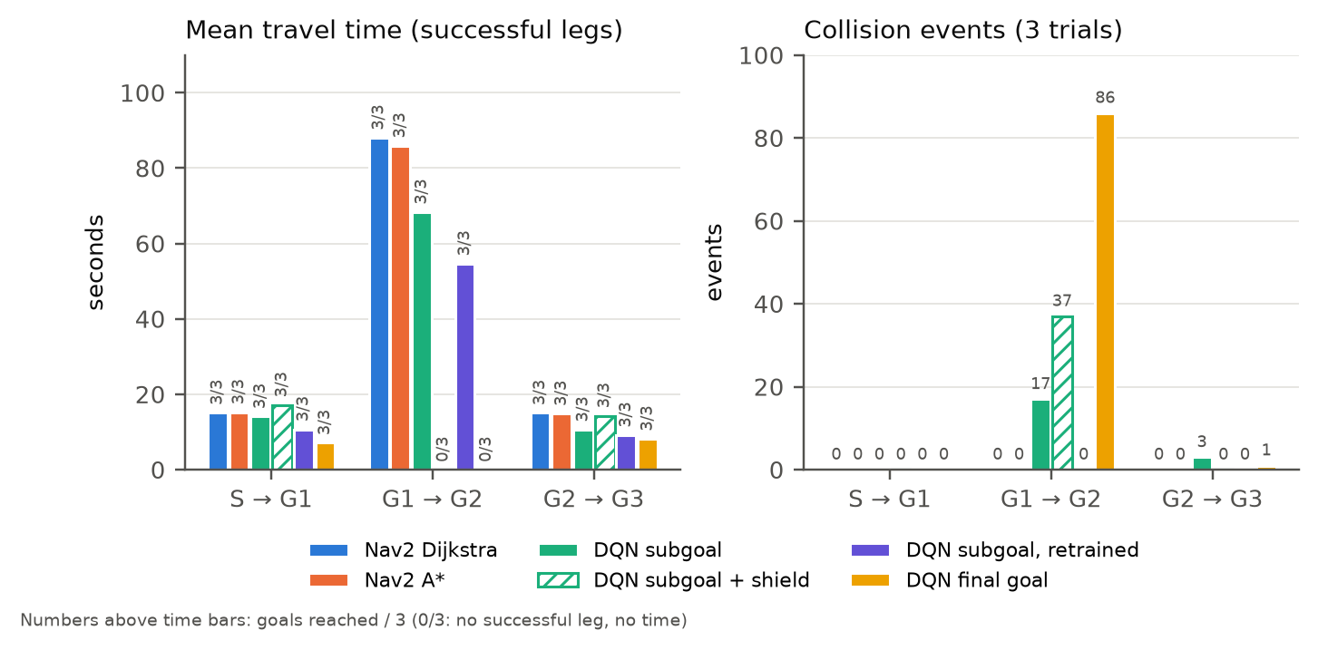
Figure 5 — Mean travel time (with goals reached out of 3) and collision events per method and task, from docs/test_summary.csv.
Discussion.
- Dijkstra vs A*. With identical starts both planners are very repeatable (time spread 0.1–2 s) and found the same routes: mean path lengths differ by at most 0.05 m and times by at most 2.2 s. In a maze this small, A*’s smaller search gives no measurable gain in travel time or path length; its advantage would show in planning time on much larger maps. Both were collision-free (minimum clearance 0.136 m) and drove paths only 8–16 % longer than the shortest safe path.
- Original DQN vs Nav2. The original subgoal DQN reached all 9 goals and was faster than Nav2 on the long task (68 s against 86–88 s; it drives at 0.18 m/s and does not slow for corners), but had 20 collision events (17 on the long task) against 0: in training a collision only counted when the robot centre came within 0.12 m of a wall.
- Safety shield. The shield did not solve this. It kept the short tasks contact-free, but on G1 → G2 it failed all three trials (37 events): with a wall close on one side, blocking forward motion left the robot rotating slowly in place against that wall. A diagnostic run showed that most contacts with the shield happened during in-place rotations, which the shield cannot forbid without leaving the robot stuck. Masking actions after training cannot give a policy a safety margin it never learned; the margin has to be in the training.
- Retrained DQN (the final DQN result). Training with the 0.15 m margin and 0.5 rad/s turns fixed it: 9/9 goals, 0 collision events (minimum clearance 0.125 m). It was faster than Nav2 on every task (S → G1 10.7 s, G1 → G2 54.7 s, G2 → G3 9.2 s, against about 15, 86–88 and 15 s) and the fastest of all methods on the long task, with very small spread across trials. Its paths are slightly longer than Nav2’s on the long task (η 84 % against 86–87 %), because it stays nearer the corridor centre while driving faster. The ground-truth check confirmed every leg ended 0.15–0.20 m from the goal (the success rule is 0.15 m on the AMCL pose, itself about 0.1 m off).
- Final-goal DQN. It reached the two goals in direct view (S → G1, G2 → G3, and faster than any other method there, driving straight at the goal) but never the goal behind walls (G1 → G2, 0/3, 86 events). A purely reactive policy cannot solve a maze; this is the baseline that motivates the subgoal design, where a route planner supplies reachable targets.
Summary of the methods.
 | Nav2 Dijkstra | Nav2 A* | DQN subgoal | + shield | DQN retrained | DQN final goal
Goals reached (9 legs) | 9 | 9 | 9 | 6 | 9 | 6
Long task G1 → G2, mean time | 88.1 s | 85.9 s | 68.3 s | — (0/3) | 54.7 s | — (0/3)
Collision events (9 legs) | 0 | 0 | 20 | 37 | 0 | 87
Path efficiency η (task means) | 86–90 % | 87–90 % | 86–95 % | 88–97 % | 84–91 % | —
Needs training | no | no | yes | yes | yes | yes
Plans a global route | yes | yes | grid route + learned control | same | same | no
Limitations. Three trials per task show the spread but are too few for significance tests; all results are from simulation; the DQN was trained in a simplified 2D model; and the collision measure also counts near-contacts. Results of the earlier protocol (chained legs, cell-centre reference) are kept in extended_notes.md.

7. Challenges and Solutions
- Bring-up on Jazzy. The world lacked Gazebo system plugins, the robot was not spawned, and Nav2 in Jazzy needs extra servers and TwistStamped commands; all were added.
- Wheel slip and odometry drift. Fast turns lost up to 12° per 90°. Turns were slowed everywhere, and mapping uses wheel speed plus gyro heading.
- Unreliable SLAM maps. Maps from repeated runs ranged from 2.1 to 6.0 cm mean error, with missing or doubled walls. Gyro odometry with scan matching off gave a complete map in both runs.
- Narrow corridors. DWB scraped walls and live scan obstacles sealed corridors; the controller, inflation and global costmap were changed as described in Section 4.
- Goals over 6 m away failed. NavFn’s path-length limit, fixed by padding the map.
- DQN training and deployment. Four training bugs were fixed (Section 5). In Gazebo, a launch problem left AMCL without a map, so the DQN silently fell back to drifting odometry and reported false successes; checking every leg against the true position exposed and fixed it.
- Honest, fair measurement. An earlier benchmark script produced numbers from fixed multipliers; it was replaced by measurement inside viva_demo. A first measured protocol chained the legs (each started where the last ended) and used the cell-centre route as the reference, which gave unequal starts and efficiencies above 100 %; it was replaced by fixed starts and the shortest safe path as the reference.
- DQN safety. An action-masking shield was added and measured; it did not remove the contacts (Section 6). Retraining with a 0.15 m collision margin and 0.5 rad/s turns did: the retrained DQN reached all goals with no contact.

8. Possible Improvements
- Use the retrained subgoal DQN as a Nav2 controller plugin on the NavFn path, keeping Nav2’s recovery behaviours, and stabilise its training (it peaked at episode 2200 and degraded afterwards), e.g. with a lower learning rate or prioritised replay.
- Train in Gazebo (or model wheel slip and LiDAR noise in the 2D environment) to close the gap between simulators.
- Fuse the IMU into the odometry used by Nav2 and AMCL too (e.g. a robot_localization EKF).
- Raise Nav2’s cruise speed towards the Burger’s 0.22 m/s limit on straight sections, compare Smac planners and MPPI, and remove the 2–4 cm map offset with sub-cell wall fitting.

References
- Macenski, S., Martín, F., White, R., Ginés Clavero, J. (2020). The Marathon 2: A Navigation System. IROS 2020.
- Macenski, S., Jambrecic, I. (2021). SLAM Toolbox: SLAM for the dynamic world. JOSS, 6(61), 2783.
- Mnih, V., et al. (2015). Human-level control through deep reinforcement learning. Nature, 518, 529–533.
- van Hasselt, H., Guez, A., Silver, D. (2016). Deep Reinforcement Learning with Double Q-learning. AAAI.
- Open Navigation LLC. Nav2 documentation (Jazzy). https://docs.nav2.org/
- ROBOTIS. TurtleBot3 e-Manual. https://emanual.robotis.com/

