Mbre Inyang Rafting Site Plan

Folder: wwr.

## 

## Logo

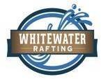

**Style Guide**

## Color Schema

Color palette URL: ***coolors.co/969A97-D6D1CD-E5ECE9-C60F7B***

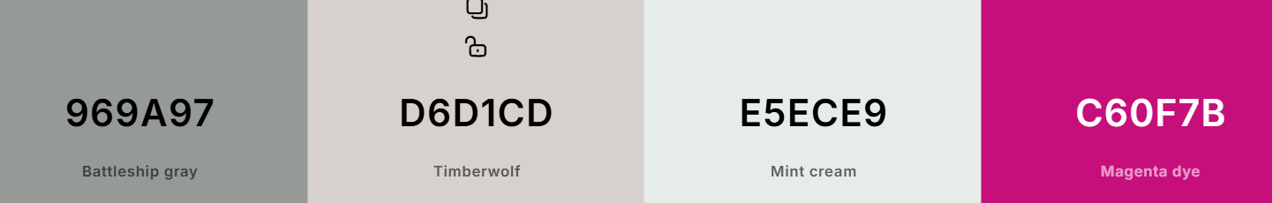

***Primary color: #E5ECE9***

***Secondary color: #D6D1CD***

***Accent 1 color: #969A97***

***Accent 2 color: #C60F78***

## Typography

**Headings**: [Open Sans - Google Fonts](https://fonts.google.com/specimen/Open+Sans) https://fonts.google.com/specimen/open+san

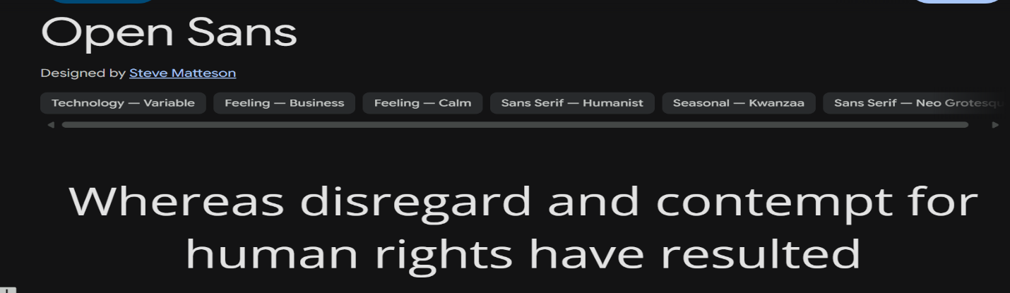

**Body**: [Montserrat - Google Fonts](https://fonts.google.com/specimen/Montserrat) https://fonts.google.com/specimen/montserrat

