Whitewater Rafting Site Plan

# Purpose

To create an immersive and user-friendly online platform that showcases the thrill of whitewater rafting, while providing a seamless experience for customers to plan and book their adventures. The main

message is that rafting is a fun activity and to come and experience it for yourself and bring your family.

## Goals

* **Increase Online Visibility:** Establish a strong web presence to attract new customers and increase brand awareness.
* **Showcase Adventures:** Highlight the excitement and beauty of whitewater rafting through engaging visuals, videos, and testimonials.
* **Provide Essential Information:** Offer clear and concise details on trips, pricing, safety guidelines, and company policies.
* **Build Community:** Foster a sense of community among customers and guides through social media integration and customer reviews.
* **Drive Sales:** Convert website visitors into paying customers through targeted promotions, special offers, and loyalty programs.

# Target Audience

* + **Demographics**: Adventure-seekers, outdoor enthusiasts, and nature lovers
  + **Psychographics**: Individuals seeking excitement, challenge, and connection with nature
  + **User personas**: First-time rafters, experienced rafters, families, and corporate groups

## Scenarios

The website should answer the following scenario questions:

* + Information on trip levels and difficulty
  + Detailed descriptions of what to expect during the trip
  + Testimonials and reviews from previous customers
  + Information on family-friendly trips and age restrictions
  + Details on safety measures and equipment provided
  + Options for booking a private guide or group trip
  + Recommendations for nearby activities and attractions for non-rafters
  + High-quality photos and videos showcasing the trip
  + Options for customizing the trip (e.g., private guides, camping)

# Site Map

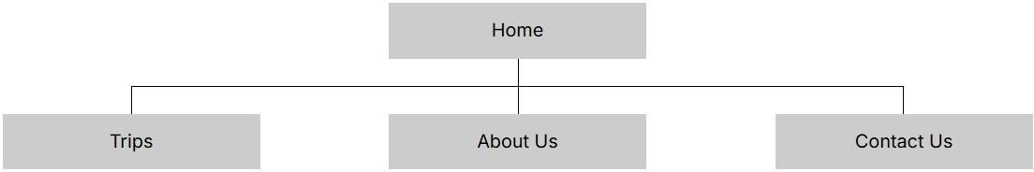

Branding

## Logo

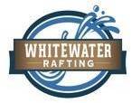

**Style Guide**

## Color Schema

Color palette URL: ***coolors.co/505033-264969-cfc@4-b4cde4***

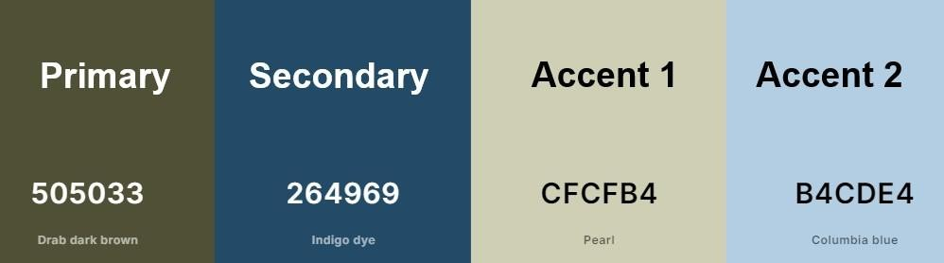

## Typography

**Headings**: **Georgia 400, 700, and Black**

**Body**: Roboto 400 and 700

# Wireframes

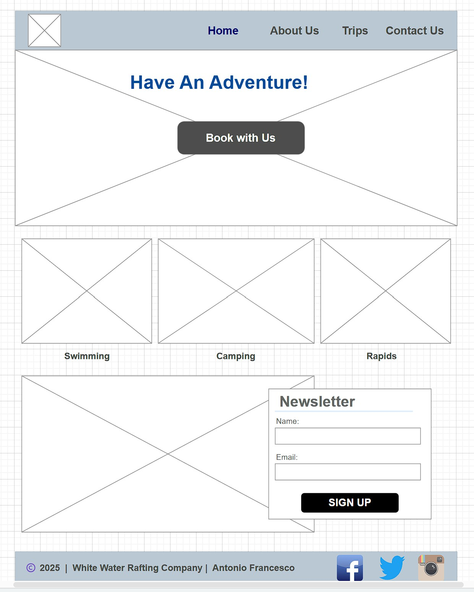These are just mockup **examples** of a couple of pages on the wwr website.

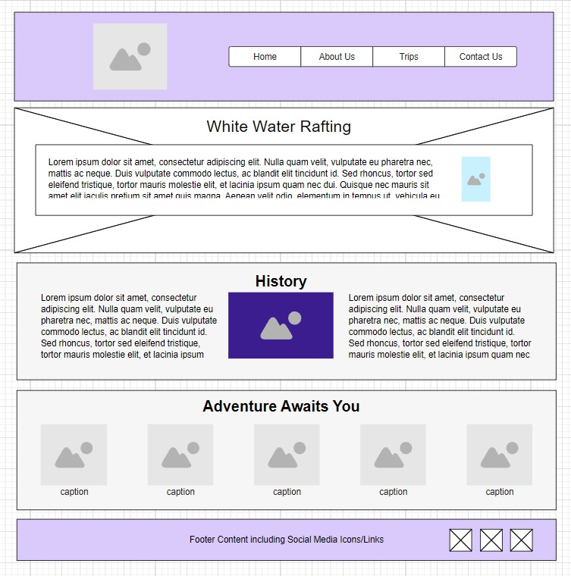**About Us Page**