**Penguin Chat JS**

A Penguin Chat 2 emulator, written in Node.js with the use of Express to imitate PHP's long polling technique. Penguin Chat 2 originally used long polling, but we can use this in Node.js as well!

[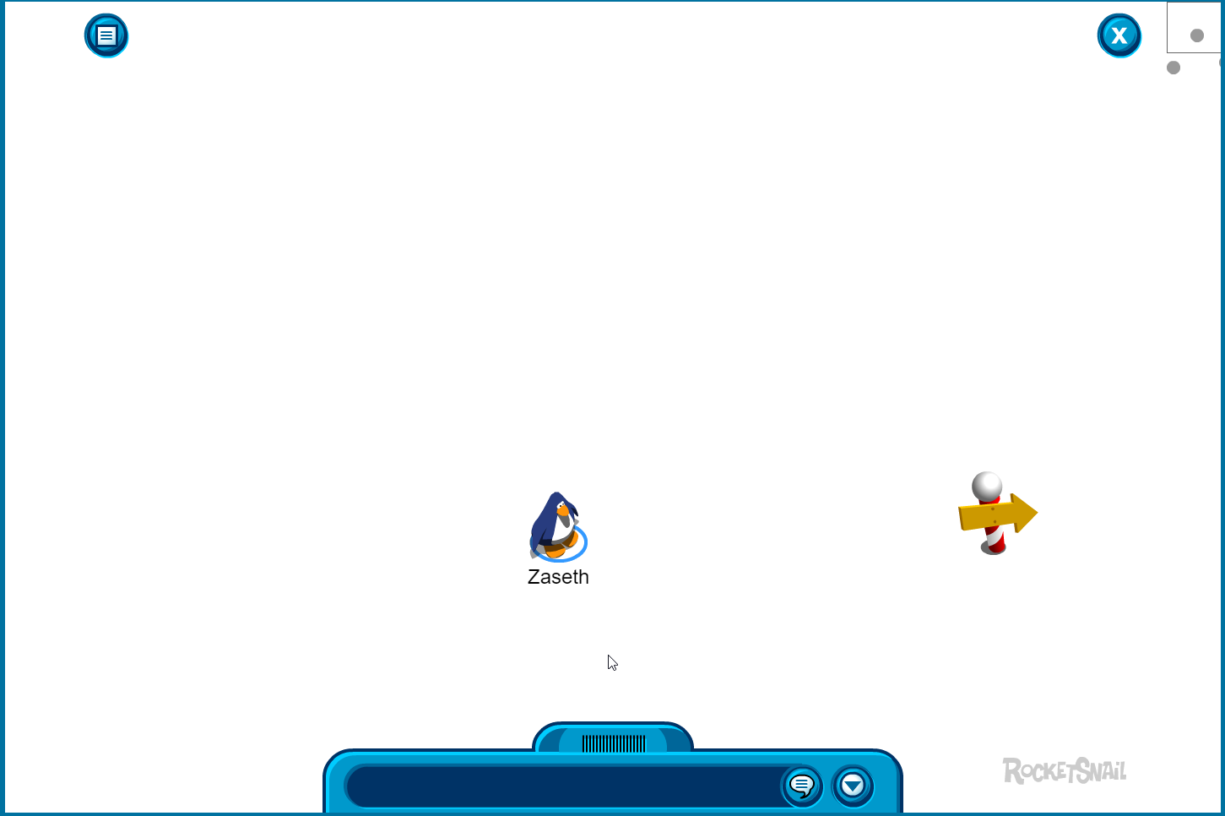](https://camo.githubusercontent.com/304a40cc21901f88b2075ae71557a4180d5d381b/68747470733a2f2f692e696d6775722e636f6d2f7366483034466e2e706e67)

**NOTE - FIGURING OUT THE SWF ISSUES, STAY TUNED.**

**Installation**

1. If you're running this on a VPS, install [NGINX](https://www.nginx.com/) and set this in the config of NGINX: **proxy_set_header X-Forwarded-For $remote_addr;**
2. Download this repository
3. Download & install [Node.js](https://nodejs.org/en/)
4. Run the following command in CMD: **npm install express knex mysql2**
5. Download & install MySQL for your OS (Windows, Linux etc)
6. Download & install [MySQL Workbench](https://www.mysql.com/products/workbench/) to **import**, browse and edit the database

**Run server**

1. Make sure you did everything in **Installation** and **have MySQL running**
2. Open CMD
3. Use the [CD](https://ss64.com/nt/cd.html) command to CD to the folder where **Run.js** is located
4. Enter the command: **node Run.js**
5. Open a new webpage and browse to: [**http://localhost/**](http://localhost/)

**TODO**

Make the database class async and await?