SMALL IoT RESEARCH PROJECT
PROJECT PROPOSAL
DROWSY GUARD
A Low-Cost IoT System for Driver Drowsiness Detection
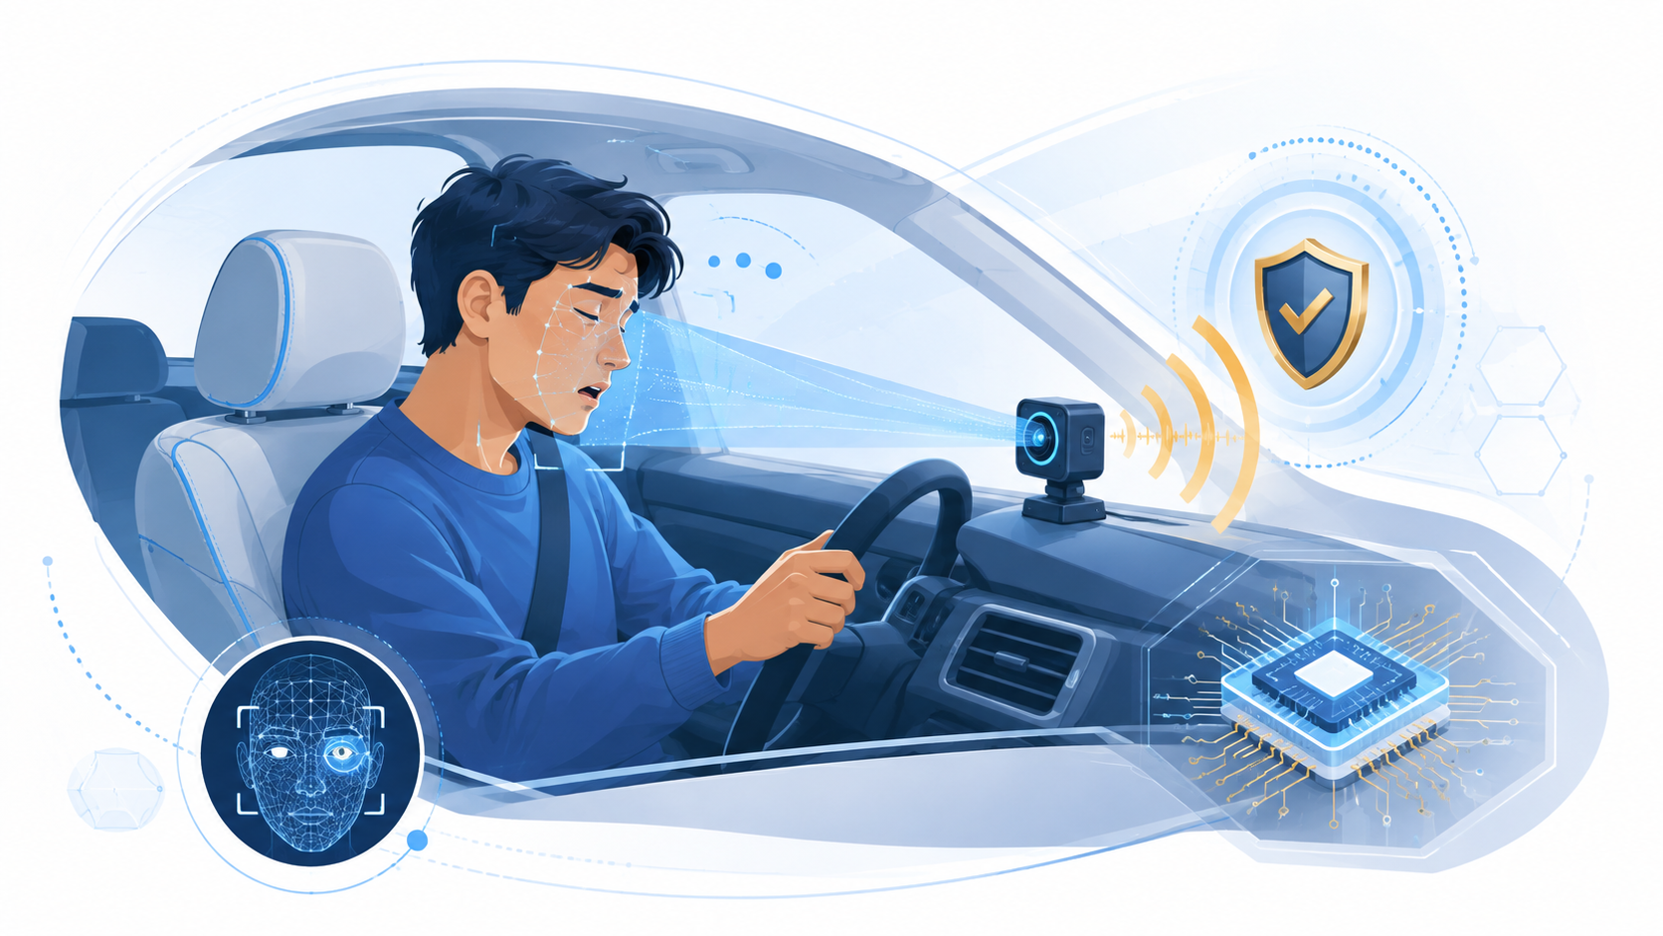
Project Title | Drowsy Guard
Project Code
Research Area | Driver Drowsiness Detection
Subject | IoT: Technology and Application
Program | Master of Information Technology Engineering (MITE)
MITE Cohort | 19
Shift | Evening - Weekdays
Lecture by | Dr. Chey Chan Oeurn
Project Leader | Seng Phirum
Project Members | Seang Chanviwath  Suon Mesa  Theng Rathrongroeung  Lov Kimheng
Project Duration | September-December 2026 (proposed)
Pilot Location
Prepared: 24 August 2026

1. Executive Summary
Drowsy Guard is a low-cost IoT research prototype that watches for visible signs of driver drowsiness and gives a local audio warning. An OV5640 camera captures the driver's face, while an ESP32-S3 processes the video on the device. The system checks eye closure, long blinks, yawning and head nodding, then combines these signs over time before deciding to alert. A MAX98357A amplifier and 4 ohm / 3 W speaker provide the warning. A Wi-Fi dashboard supports testing and calibration, but the alert works without internet access.
The research will improve the current PLXY_DrowsyGuard prototype, train and evaluate a compact eye-state model, and test the complete system with public data and controlled volunteer sessions. We will measure accuracy, false alerts, response time, frame rate, memory, power and stability. The expected result is a working prototype, a documented dataset and test report, and clear evidence about what must improve before any real-road product development.

2. Background and Problem Statement

2.1 Background
Drowsiness can reduce attention and reaction time. Common signs include slow blinking, long eye closure, repeated yawning and head dropping. Newer vehicles may include driver-monitoring features, but many older vehicles in Cambodia do not. A small edge-IoT device is suitable because it can be installed as a retrofit, process video locally and give a warning even when mobile data or cloud service is unavailable.

2.2 Problem Statement
A single closed-eye image is not enough to confirm drowsiness. Normal blinks, looking down, glasses, low light and temporary face loss can cause false warnings. The project therefore needs an affordable method that combines several signs, observes them over time and still runs fast enough on an ESP32-S3.

2.3 Research Gap
Existing research often uses computers, cloud processing or datasets collected outside Cambodia. The current repository already proves camera, PSRAM, audio, Wi-Fi dashboard and face-tracking functions, but the visible-light eye model and alert thresholds still need improvement and local validation. There is also limited published evidence about long-duration performance and false alerts on this low-cost hardware.

3. Research Objectives

General Objective
To design and evaluate an affordable edge-IoT prototype that detects common signs of driver drowsiness and gives a timely local audio warning.

Specific Objectives
- Build and integrate the ESP32-S3, OV5640 camera, MAX98357A amplifier and speaker.
- Improve the compact eye-state model using subject-independent training and testing.
- Combine PERCLOS, long blinks, yawning and head nodding to reduce false warnings.
- Measure accuracy, false-alert rate, alert delay, frame rate, memory, power and stability.
- Document privacy, safety limitations and a practical scale-up plan.

4. Research Hypothesis (if applicable)
- H1: The full multi-cue method will achieve at least 0.80 overall F1-score and at least 0.85 recall for drowsiness-related events on unseen participants.
- H2: The full method will produce no more than one false alert per awake-control hour and at least 30% fewer false alerts than eye-only detection.
- H3: The ESP32-S3 prototype will process at least 10 frames per second, alert within two seconds after sustained risk is reached, and run continuously for four hours without a crash.

5. Conceptual / System Architecture
The design has one main safety path and two support paths. The main path runs completely on the device: capture, analyze, measure, decide and warn. The offline workstation is used to prepare and deploy a tested model. The dashboard is used only to view status and support experiments.
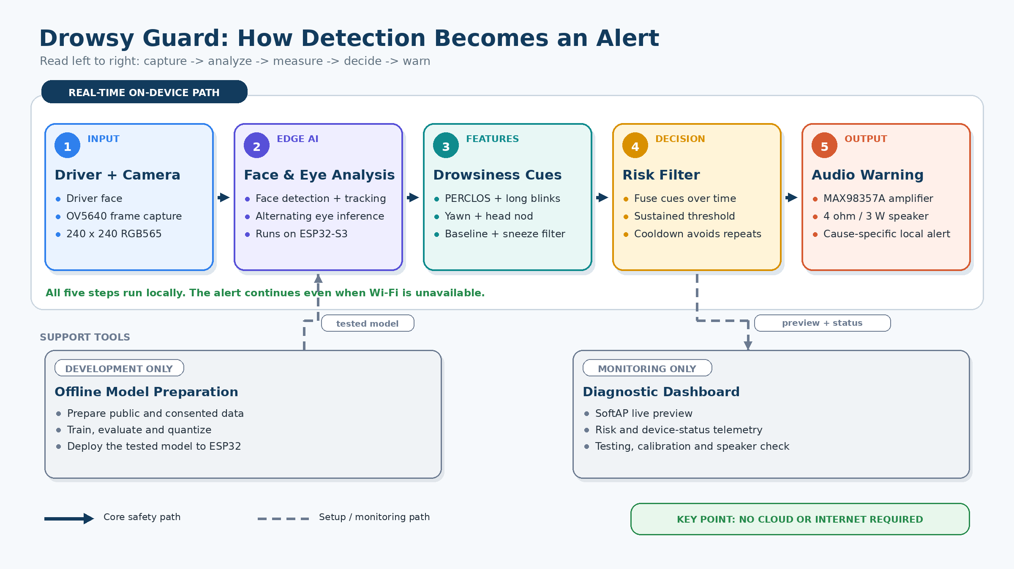
Figure 1. Drowsy Guard detection and alert flow
Simple explanation: The camera sees the driver, the ESP32-S3 checks several drowsiness signs, a time-based filter confirms the risk, and the speaker warns the driver.

6. System Design

6.1 Hardware
Category | Component | Purpose
Microcontroller / camera | ESP32-S3-WROOM-1 N16R8 with integrated OV5640 | Capture, edge inference and Wi-Fi
Actuator | MAX98357A I2S amplifier and 4 ohm / 3 W speaker | Local audio warning
Communication | Integrated Wi-Fi SoftAP | Local dashboard and telemetry
Power | Regulated 5 V USB supply | Prototype power
Prototype assembly | Breadboard, jumper wires, USB cable and mount | Safe testing and repeatable placement

6.2 Software and IoT Platform
- Firmware: ESP32-S3 camera capture, face detection/tracking, eye inference, behavior cues, temporal risk filter and audio control.
- AI/ML: compact eye-state classifier trained on public and controlled data, then quantized for the ESP32-S3.
- Communication: local HTTP/MJPEG and status data over the device's SoftAP; no cloud dependency in the alert path.
- Dashboard: live preview, risk and device status, test logs, threshold tuning and speaker self-test.
- Data handling: experiment results are saved on the research workstation using participant codes and versioned model/firmware information.

7. Research Methodology
Phase 1 - Literature Review: Review drowsiness indicators, PERCLOS, blink detection, compact edge-AI models and related safety work.
Phase 2 - System Design: Confirm the detection flow, hardware connections, alert rule, data plan and safety controls.
Phase 3 - Prototype Development: Complete the firmware, eye model, multi-cue logic, dashboard and speaker warning.
Phase 4 - Laboratory Testing: Test camera quality, audio, timing, memory, power, model agreement and error cases.
Phase 5 - Field Deployment: Run supervised parked-vehicle or simulator sessions; no induced drowsiness on public roads.
Phase 6 - Data Analysis: Calculate classification, event, alert and device-performance metrics.
Phase 7 - Evaluation: Compare results with the hypotheses, explain limitations and recommend the next development stage.

8. Experimental Design
Element | Design
Independent variables | Lighting, glasses, head pose, camera distance and detection method (eye-only or full multi-cue).
Dependent variables | Precision, recall, F1-score, false alerts/hour, alert delay, FPS, memory, power and stability.
Control variables | Camera resolution, mounting position, firmware/model version, alert volume and test instructions.
Sample size | About 20 consenting adults, supported by subject-independent public datasets.
Frequency | Eye and risk data per processed frame; status summary each second; behavior and alert data per event.
Session duration | Four short 10-15 minute conditions per participant and one four-hour stability test.
Comparison | Eye-only baseline, PERCLOS-only logic and the full multi-cue method.
Participants may perform normal blinking, longer eye closure, yawning and head nodding when instructed. Testing will use a laboratory, simulator or parked vehicle. The project will not request sleep deprivation or drowsy driving on a public road.

9. Data Collection Plan
Parameter | Sensor / Method | Sampling Interval | Unit | Target
Eye state | Model probability and labeled eye image | Processed frame | Score / class | Recall at least 0.85
PERCLOS | Rolling eye-closure calculation | Frame; 1 s summary | Ratio 0-1 | Stable coverage
Behavior events | Long blink, yawn and head-nod rules | Per event | Count / seconds | Event detection result
Alert | Risk score, trigger and cause | Frame / event | Score / time | No more than 1 false alert/hour
Device performance | Firmware timing and status | Frame; 1 s summary | FPS / ms | At least 10 FPS
Environment | Lighting, glasses, pose and distance | Session / change | Category / cm | Complete metadata
Each record will include a participant code, session ID, timestamp, test condition, firmware version and model version. Names will not be stored in the analysis file.

10. Data Analysis
- Use confusion matrices, precision, recall, specificity, F1-score and balanced accuracy for eye-state and event detection.
- Measure false alerts per awake hour and the delay between a sustained-risk condition and the warning.
- Compare eye-only, PERCLOS-only and full multi-cue methods on the same test sessions.
- Report results for unseen participants and review errors by lighting, glasses, head pose and camera distance.
- Summarize median and worst-case processing time, FPS, memory use, power and four-hour stability.

11. Key Performance Indicators (KPIs)
KPI | Target
Detection quality | Overall F1-score at least 0.80 and drowsiness-event recall at least 0.85
False warnings | No more than 1 false alert per awake-control hour
Response | Alert within 2 seconds after the sustained-risk condition is reached
Real-time speed | At least 10 processed frames per second on ESP32-S3
Reliability | Four-hour continuous run without crash or unrecovered memory decline
Cost | Complete research prototype within approximately USD 35

12. Expected Outputs

12.1 Research Outputs
- A de-identified dataset or annotation extension with participant-independent splits.
- A final MITE project report and a short calibration/testing report.
- Results suitable for a demonstration, poster or later thesis/paper development.

12.2 Technology Outputs
- A working ESP32-S3/OV5640 drowsiness-detection prototype with local audio warning.
- A compact eye-state model, multi-cue detection logic and local diagnostic dashboard.
- Version-controlled firmware, training/evaluation tools and setup documentation.

12.3 Innovation Outputs
- A low-cost retrofit demonstrator for older vehicles and driver-training environments.
- A practical plan for infrared support, automotive power, enclosure design and larger trials.
- An evidence base for possible technology transfer or a future local product.

13. Expected Impact
Economic: Demonstrates an affordable prototype using commonly available parts and may support lower-cost retrofit research.
Environmental: Uses local edge processing instead of continuous cloud video transfer and can support longer use of older vehicles.
Social: Raises awareness of drowsiness-related behavior and provides a practical driver-safety education tool.
Research: Builds local skills in embedded AI, IoT, computer vision, responsible data collection and system evaluation.

14. Work Plan
M1 = September, M2 = October, M3 = November and M4 = December 2026.
Activity | M1 | M2 | M3 | M4
Literature review | X
System design | X | X
Hardware development | X | X
Software development | X | X | X
Laboratory testing |  | X | X
Controlled field deployment |  |  | X | X
Data analysis |  |  | X | X
Report / publication |  |  |  | X
Demonstration |  |  |  | X

15. Sustainability and Scale-Up
- Stage 1 - Research prototype: improve labels and thresholds, finish power/stability tests and complete the controlled 20-person study.
- Stage 2 - Field-ready pilot: add infrared lighting, an automotive power supply, a protective enclosure and larger simulator/closed-course trials.
- Stage 3 - Product assessment: complete safety engineering, cybersecurity, EMC/environmental testing, regulatory consultation and product-liability review before commercial use.
The code, model files, wiring guide and test procedure will remain version-controlled so another student team can reproduce and improve the system.

16. Research-to-Innovation Pathway
Step | Stage | Outcome
1 | Problem identification | Older vehicles lack affordable driver monitoring.
2 | IoT prototype | ESP32-S3, OV5640 camera and local speaker alert.
3 | Controlled experiment | Laboratory, simulator or parked-vehicle sessions.
4 | Real-world dataset | Consented, coded eye/behavior data with test conditions.
5 | Data analytics / AI | Compact eye model, PERCLOS and multi-cue logic.
6 | Performance evaluation | Accuracy, false alerts, delay, speed, power and stability.
7 | Research publication | MITE report, demonstration and possible paper/poster.
8 | Product transition | Field pilot, safety work and technology-transfer assessment.

17. Project Deliverables
No. | Deliverable
1 | IoT prototype
2 | Circuit and system design
3 | Firmware and training/evaluation source code
4 | Local IoT diagnostic dashboard
5 | De-identified research dataset or annotation extension
6 | Testing and calibration report
7 | Controlled field-experiment report
8 | Final research report
9 | Demonstration and presentation

18. References
[1] World Health Organization. (2024). Road safety Cambodia 2023 country profile. Available online
[2] Dinges, D. F., Mallis, M. M., Maislin, G., & Powell, J. W. (1998). Evaluation of techniques for ocular measurement as an index of fatigue. NHTSA. Available online
[3] Weng, C.-H., Lai, Y.-H., & Lai, S.-H. (2016). Driver drowsiness detection via a hierarchical temporal deep belief network. Available online
[4] Soukupova, T., & Cech, J. (2016). Real-time eye blink detection using facial landmarks. Available online
[5] Espressif Systems. ESP32-S3 Series Datasheet. Available online
[6] Espressif Systems. ESP-DL documentation. Available online
[7] SengPhirum. (2026). PLXY_DrowsyGuard project repository. Available online

Appendix A. Hardware / Equipment Table
Component | Specification | Qty. | Purpose | Est. Cost (USD)
ESP32-S3 camera board | N16R8, integrated OV5640 | 1 | Camera, AI and Wi-Fi | 7.50
I2S amplifier | MAX98357A | 1 | Drive speaker | 2.00
Speaker | 4 ohm / 3 W | 1 | Audio warning | 0.75
Communication | Integrated Wi-Fi SoftAP | 1 | Dashboard / telemetry | Included
Breadboard | MB102, 830-point | 1 | Prototype assembly | 1.50
Jumper wiring | Dupont wires / headers | 1 set | Power and I2S | 2.00
USB-C data cable | Data-capable, 5 V | 1 | Programming and power | 1.50
Power supply | Regulated 5 V USB adapter | 1 | Prototype power | 2.00
Power meter | Inline USB meter | 1 | Power measurement | 5.00
Enclosure / mount | Prototype materials | 1 | Stable placement | 5.00
Estimated total: USD 27.25. Laptop and phone are excluded because the team will use existing devices.

Appendix B. Data Collection Table
Parameter | Sensor / Method | Sampling Interval | Unit | Target / Reference
Eye state | Model score + label | Processed frame | Score / class | Recall at least 0.85
PERCLOS | Rolling closure | Frame; 1 s summary | Ratio 0-1 | Stable coverage
Long blink / yawn / nod | Event rules + labels | Per event | Count / seconds | Event accuracy
Risk and alert | Firmware log | Frame / event | Score / ms | No more than 1 false alert/hour
Timing | Stage timers | Frame; 1 s summary | FPS / ms | At least 10 FPS
Memory and power | Device status + meter | Boot / 1 s / end | Bytes / W | No unrecovered decline
Environment | Light, glasses, pose, distance | Session / change | Category / cm | Complete record

Appendix C. Work Plan
Activity | M1 | M2 | M3 | M4
Literature review | X
System design | X | X
Hardware development | X | X
Software development | X | X | X
Laboratory testing |  | X | X
Controlled field deployment |  |  | X | X
Data analysis |  |  | X | X
Report / publication |  |  |  | X
Demonstration |  |  |  | X

