1. **Create Table Command for employees.**

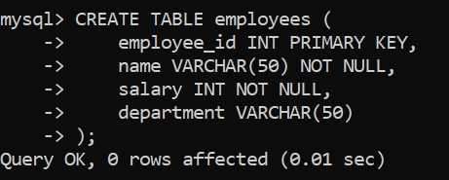

1. **Insert Data into the Table.**

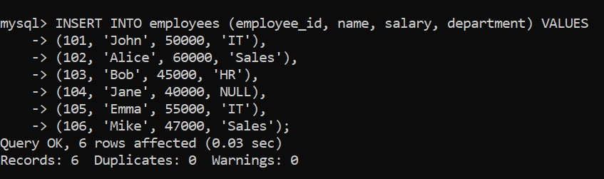

1. **Verify Table Creation**

To check if the table was created and populated correctly:

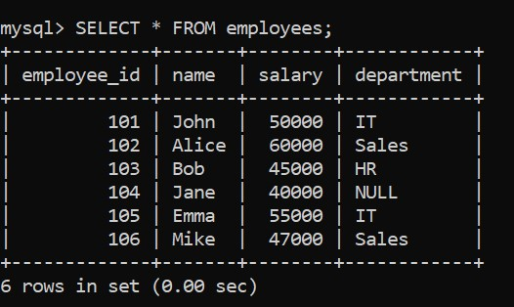

# 4.Study about COMMIT and ROLLBACK commands.

• **Description**: COMMIT saves all changes made to the database, while ROLLBACK undoes changes since the last COMMIT.

# COMMIT table-

# COMMIT table employees;

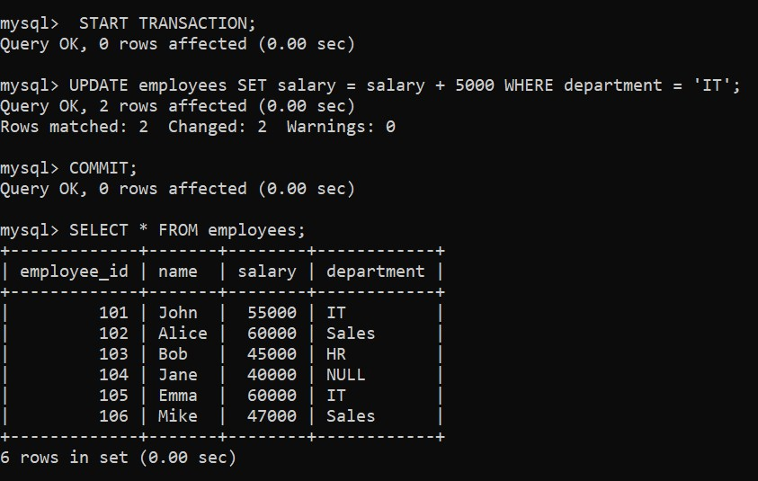

# ROLLBACK table-

ROLLBACK table employees;

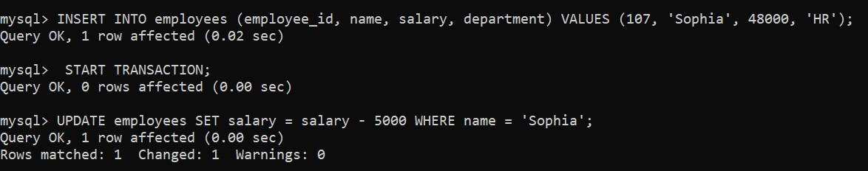

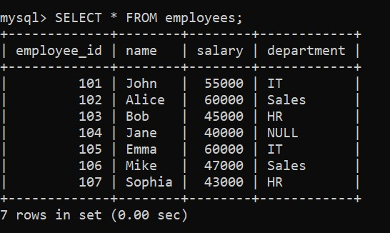

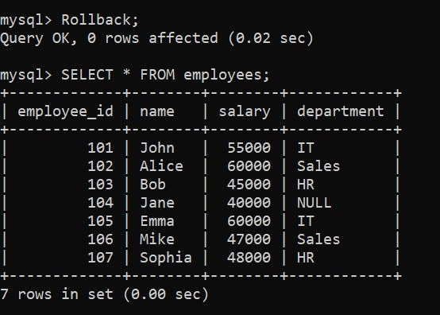

**5.Write a command for COUNT,SUM and AVG**.

# a. Here’s the COUNT command syntax.

• **Description**: COUNT returns the number of rows matching a condition.

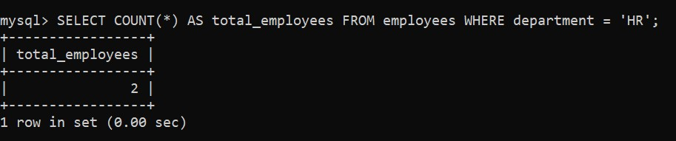

# b. Here’s the SUM command syntax.

• **Description**: Calculates the total sum of a numeric column.

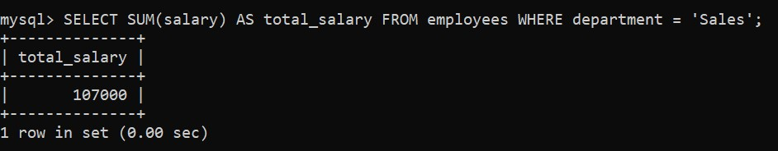

# c. Here’s the AVG command syntax.

• **Description**: Calculates the average of a numeric column.

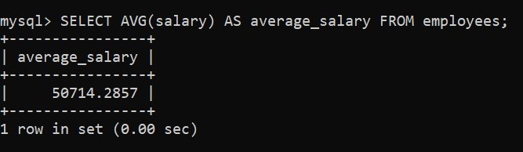

# 6.Write a command for LIMT.

# . Here’s the LIMIT command syntax.

• **Description**: Limits the number of rows returned by a query

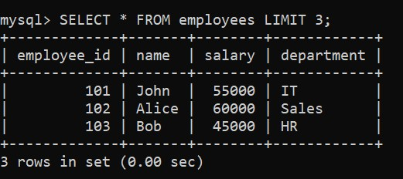

# 7.Write a command for DISTINCT,UNION and INTERSECT.

# a. Here’s the DISTINCT command syntax.

• : Removes duplicate values from the result set.

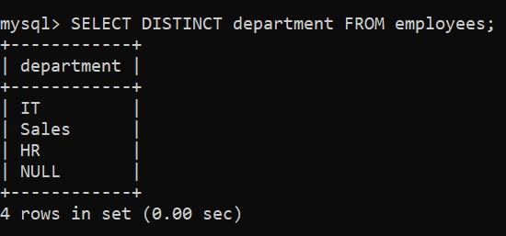

# b. Here’s the UNION command syntax.

• **Description**: Combines the results of two queries.

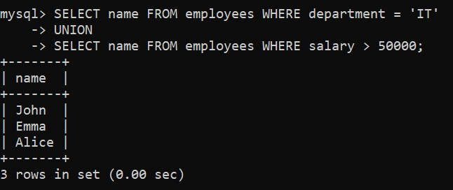

# c. Here’s the INTERSECT command syntax.

• **Description**: Returns common rows between two queries.

**Example:**

SELECT name FROM employees WHERE department = 'IT'

INTERSECT

SELECT name FROM employees WHERE salary > 50000;

**8.Write a command EXCEPT,PROJECTION.**

**a. Here’s the EXCEPT command syntax**.

• : Returns rows from the first query that are not in the second query.

**Example:**

SELECT name FROM employees

EXCEPT

SELECT name FROM employees WHERE department = 'HR';

# b. Here’s the PROJECTION command syntax.

•

**Description**

:

Selects specific columns.

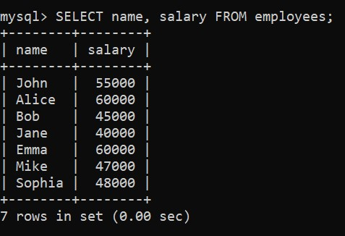

**9.Write a Command SELECTION and LIKE.**

**a. Here’s the SELECTION command syntax.**

• **Description**: Filters rows based on a condition.

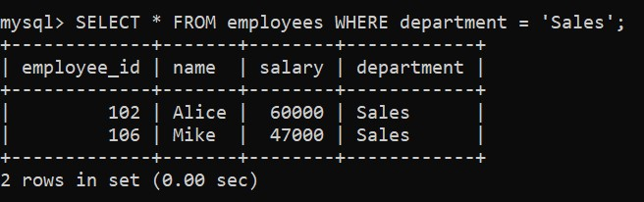

# b. Here’s the LIKE command syntax.

• : Filters rows using patterns.

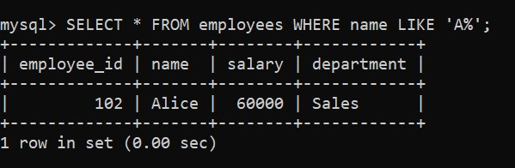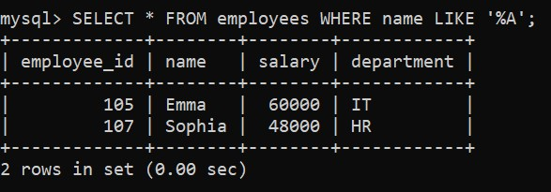

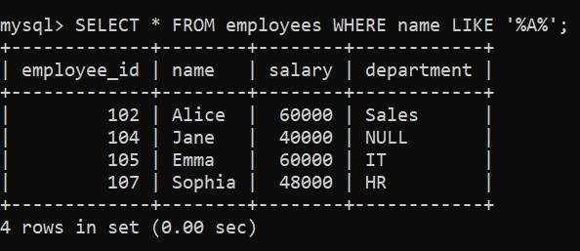

# 10.Write a command IN, MIN , MAX and AS command.

# a. Here’s the IN command syntax.

• : Filters rows based on a list of values.

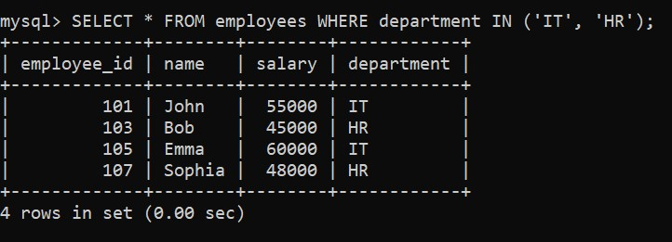

# b. Here’s the MIN and MAX command syntax.

* **Description**: Returns the smallest or largest value in a column.

**c.Here’s the AS command syntax.**

**.** SELECTION **aaaHHHhasAS**

**aaAS**

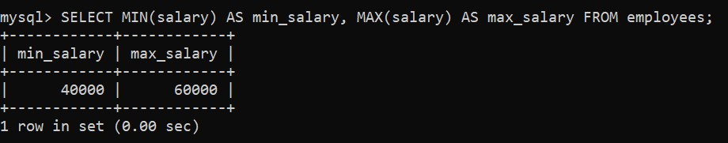

* **Description**: Renames a column or table.

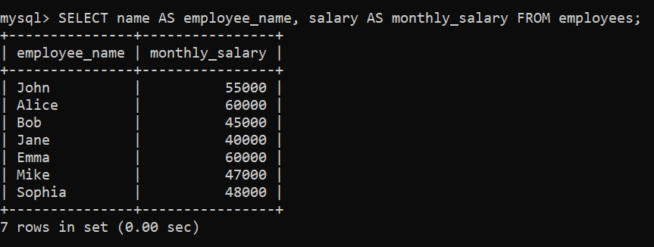

# 11.Write a command BETWEEN,IS NULL,NOT NULL and OR.

# a. Here’s the BETWEEN command syntax.

• : Filters rows within a range.

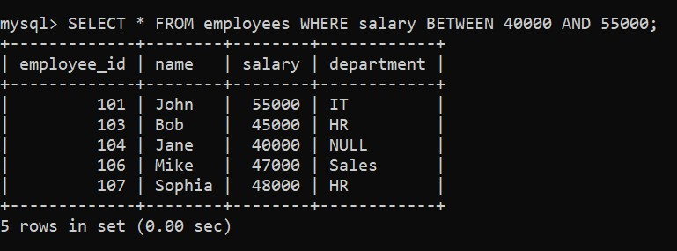

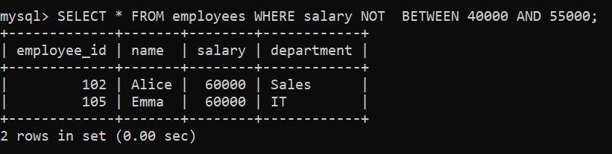

# b. Here’s the IS NULL and NOT NULL command syntax.

• **Description**: Filters rows with NULL or non-NULL values.

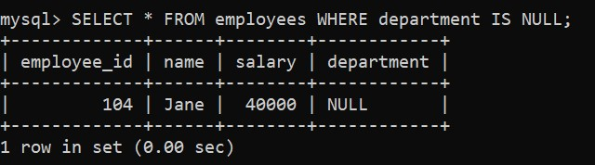

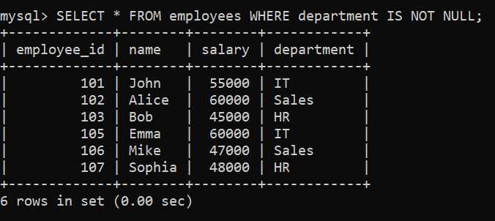

# c. Here’s the OR command syntax.

• **Description**: Combines multiple conditions

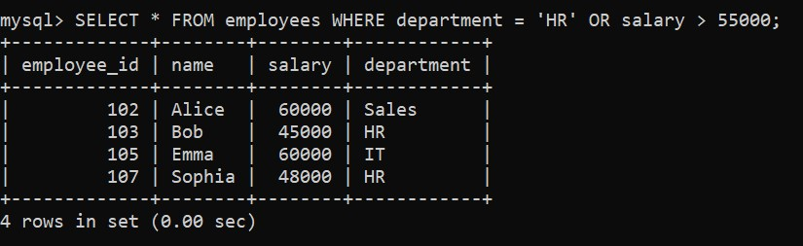

**19. Study and use of TRIGGER command.**

A trigger in SQL is a database object that automatically executes a predefined action in response to certain events (such as INSERT, UPDATE, or DELETE) on a table. Triggers are useful for enforcing business rules, maintaining audit trails, or validating data.

**Creating a Trigger in MySQL .**

Syntax for Creating a Trigger :

CREATE TRIGGER trigger_name

AFTER | BEFORE INSERT | UPDATE | DELETE

ON table_name

FOR EACH ROW

BEGIN

-- SQL statements to execute

END;

# Trigger Scenario in MySQL.

We want to record new employee insertions into a log table called employee_log, which contains the following details:

* log_id (unique identifier)
* employee_id
* name
* action
* log_time

# Step 1: Create the Log Table

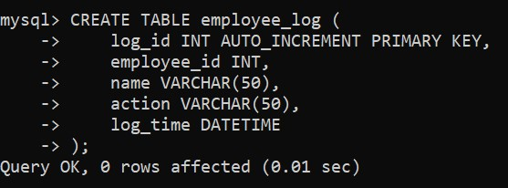

# Step 2: Create the Trigger

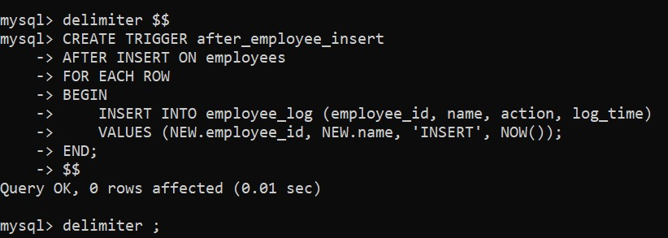

# Step 3: Test the Trigger

1. **Insert a New Employee into the employees Table:**

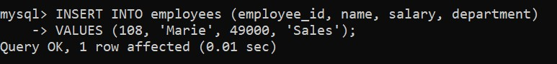

1. **Check the employee_log Table:**

