CS 2043 Software Engineering

Team Project

Final submission

Date : 9TH December 2025

Team 10:

Abdullah Tauqir

Ayman Malik

Sanjida Shakhayet

Senil Macwan

Modified Requirements :

FR2. The software should be able to load test case where a test case is made from a .txt file at given path, and it should be able to save test case to a certain location
This FR is changed because it talked about loading the test case only and not saving the test case

FR4. The assignments submitted by students must be in .java extension and the software should be able to handle more than one file submitted
This FR initially asked to submit only one .java file per student but as per latest modification it can handle multiple files

FR 8-9 : The software should be able to store the results in serializable format after the result are once generated and can re-visualize them as needed.
These FR talked about only storing the result and generating a unique ID so now changed to store and reload results

FR10 : The software should be able to run the same test suite on a different folder of student codes.
This FR is added new as the concept just got introduced in version 2

FR11: The software should be able to generate a success rate

Modified Use Cases :
- Create test case
- Load test case
- Save test case
- Create test suite
- Add test case to test suite
- Run test suite
- Load result
- Run test suite on other folder
Our initial test cases were not actions so this is corrected test cases, also modification for load and save test case, load result and run test suite on other folder are added new the rest is change of words to make it correct.

Modified Class Diagrams :

New Classes :
- StudentResults :
Responsibilities : stores info about the result like student name, success rate, total test and total test case passed
Collaborators : CodeTesterUI

- SuccessRate :
Responsibilities : calculates success rate which is the ratio of test case passed and total test case
Collaborators : COORD, TestSuite, ListTS

- SuccessRateCalculator :
Responsibilities : calculates and compares success rate for 2 students by finding the main method file
Collaborators : TestSuite, ListTS, ExecuteTestSuite

MODIFIED USE CASE DIAGRAM :
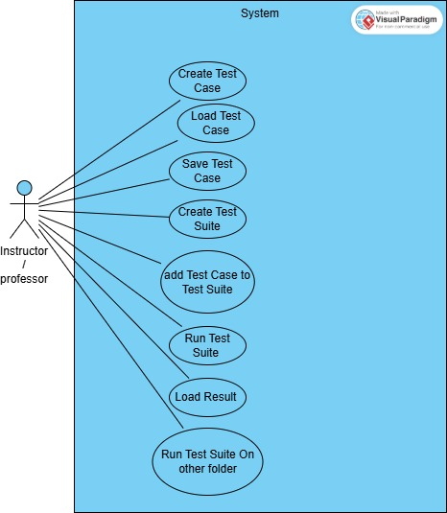

SEQUENCE DIAGRAM FOR MODIFIED CODE :
Create test suite & add test suite

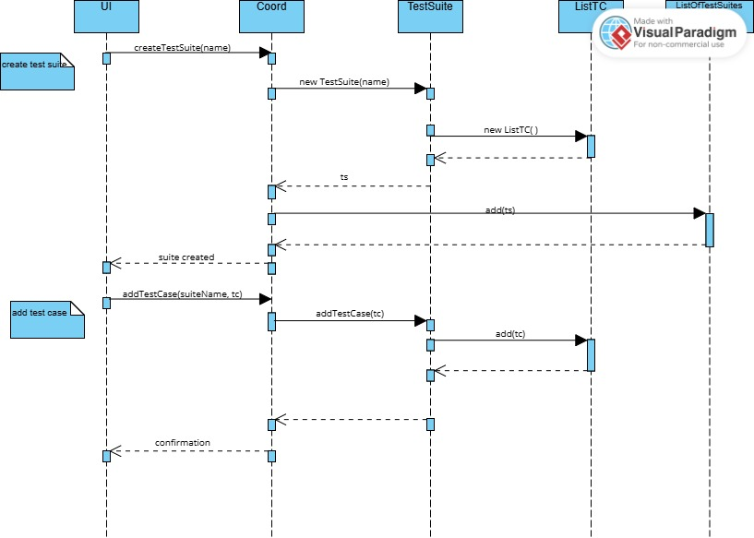

Compare student success rates :
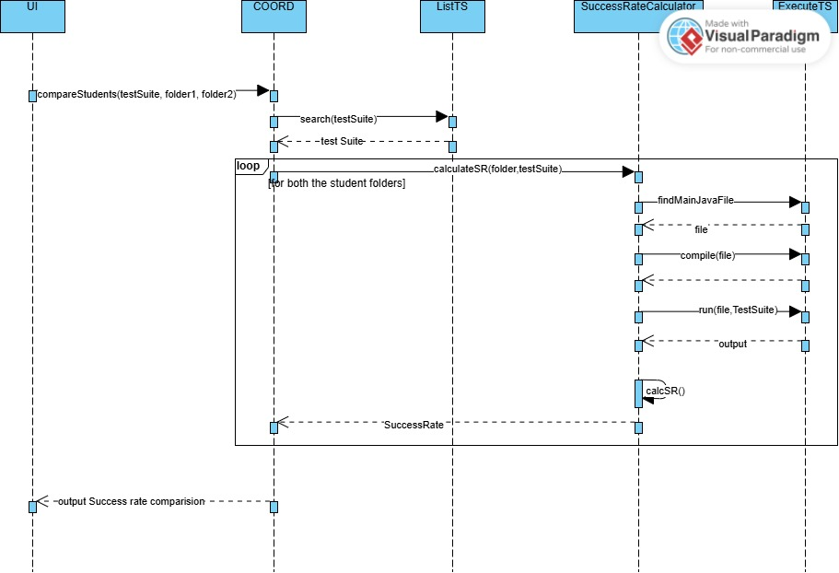

Multiple files handling :

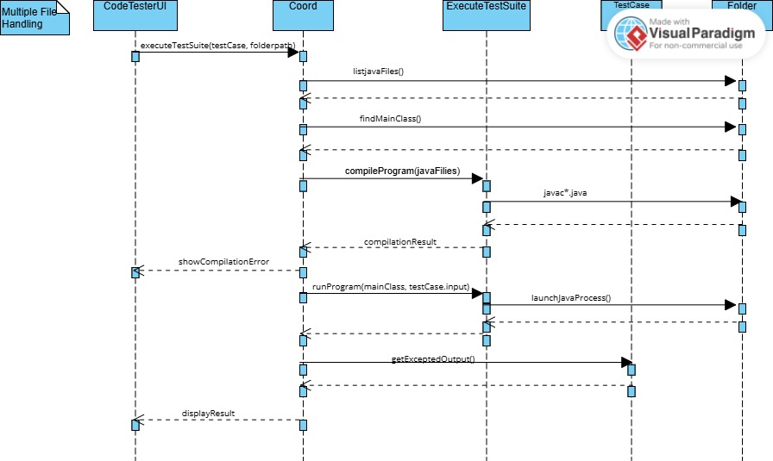

Run test suite on another folder & load result :
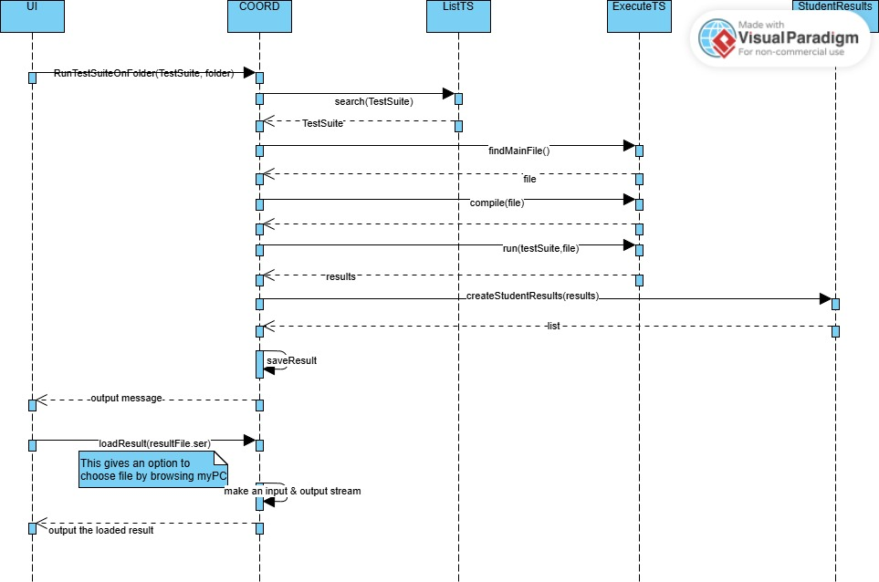

SCENARIO:
1.Start the Application
User Action : Launch the Code Tester JavaFX application.
System Response : The main UI appears with buttons such as Create Test Case, Load Test Case, Create Test Suite, Save Test Case, Add Test Case to Test Suite, etc.

2.Create a Test Suite
User Action:Click “Create Test Suite” to initialize a new TestSuite object.
System Response:The system creates an empty TestSuite (as required by the professor—only one TestSuite is used in Version 1).
A message or UI indicator confirms the suite has been created.

3. Add Test Cases to the Test Suite
Before running anything, the user must define test cases.

Option A – Create Test Case Manually
User Actions:Click “Create Test Case”.
Enter the input value.
Enter the expected output value.
Click “Add Test Case to Test Suite”.
System Response:A TestCase object is created and added to the TestSuite’s list.

Option B – Load Test Case From File
User Actions:Click “Load Test Case”.
Select a file that contains input and expected output paths.
After loading, click “Add Test Case to Test Suite.
System Response:
The loaded test case is inserted into the TestSuite.
The TestSuite must contain at least one test case before executing the suite.
Set the Root Folder
The execution process requires a root folder that contains student program directories.
User Actions:
Enter the root folder path into the UI textbox.
Click “Confirm Root Folder” (or the button your team uses).
System Response:
The system stores the root folder.
All subdirectories will be treated as individual programs (e.g., ProgramA, ProgramB).
Each folder is assumed to contain exactly one .java file representing the main class.

4.Execute the Test Suite
User Action:
Click “Execute Test Suite” (the button triggered by your team).
System Response (following the professor’s sequence diagram):
The system scans the root folder for program subdirectories.
For each program:
Load its .java file
Compile it
Run it once for each TestCase
For each test case:
Input file → program
Capture program output
Compare output with expected output
Compiler or runtime errors are collected using the Error, Result, and FinalResult classes.
Store Results
User Actions:
Click Store Results.
Enter a filename (e.g., results_v1.ser) and confirm.
System Response:
Results of the test suite execution are serialized and saved.
UI confirms: "Results saved successfully".

5.Execute Test Suite on Resubmission Folder
User Actions:
Enter path to second folder containing resubmissions (e.g., ./StudentPrograms_v2).
Click Confirm Root Folder for the new folder.
Click Execute Test Suite.
Store results as results_v2.ser.
System Response:
System executes all test cases on resubmitted programs.
Results saved and displayed in the same UI format.
Reload Stored Results
User Actions:
Click Reload Results.
Select previously saved result file (e.g., results_v1.ser or results_v2.ser).
System Response:
UI displays all results from the selected file in a read-only text area.
Compare Success Rates Between Two Submissions

User Actions:
Click Compare Success Rates.
Select two result files (e.g., results_v1.ser and results_v2.ser).
System Response:
UI displays a side-by-side comparison for each student:
Number of test cases passed in each version / total number of test cases.
Special messages if:
Student did not resubmit → "No Submission"
Program failed to compile → "Compile Error"

6.save result :
User Action :
make sure there is a set of result generated
click save result
system response:
it will create a serializable object and store it in the same folder as of your software files
Load Result :
User Action:
User clicks the “Load Results” button.
The system opens a FileChooser window.
User selects a results file (e.g., results_v1.ser).
User confirms the selection.
System Response :
The UI calls COORD.loadStudentResults(filePath, debug).
COORD opens and deserializes the .ser file.
COORD returns a List<StudentResults> back to the UI.
UI formats the results (student name, passed/total, success %).
UI displays the formatted results in the output area.

7.Compare Success Rate:
User Action :
User clicks “Compare Success Rate” button.
User is prompted to enter:
Test Suite name
Student 1 folder path
Student 2 folder path
User provides both folder paths and confirms.
System Response:
UI calls
COORD.compareStudents(suiteName, folder1, folder2)
COORD loads the TestSuite and runs all its test cases on Student 1’s program.
COORD records number of tests passed by Student 1.
COORD repeats the process for Student 2.
COORD calculates pass rate for both.
COORD constructs a text comparison summarizing:
Passed tests
Total tests
Success percentages
Who performed better
UI displays the comparison in the output area.

8.Student Success Rate :
User Action:
User clicks “Check Single Student Success Rate” (your new button).
User is prompted for:
Test Suite name
Student folder path
User selects the folder and confirms the input.
System Response:
UI calls
COORD.calculateStudentSuccessRate(suiteName, studentFolder)
COORD finds the .java file with a main method in that folder.
COORD compiles the program (via ExecuteTestSuite).
COORD runs each Test Case from the chosen Test Suite.
For each Test Case:
Program is executed
Output is captured
PASS/FAIL is determined
COORD counts passed tests and total tests.
COORD calculates:
successRate = (passed / total) * 100
COORD returns the formatted success rate string.
UI displays:
Number of tests
Passed tests
Percentage success

