Effect of Base Recommendation Algorithm

The effectiveness of an attack on a recommendation system heavily depends on the type of recommendation algorithm being used. Different algorithms exhibit varying levels of susceptibility to different attack strategies. Here’s a breakdown of how different algorithms respond to attacks and why certain attacks are more effective on some algorithms than others.

User-Based vs. Item-Based Collaborative Filtering

1. User-Based Collaborative Filtering
Vulnerability: Highly susceptible to most attack types.
Reason: These algorithms rely on the similarity between user profiles. Fake profiles that are carefully crafted can easily mimic genuine user profiles, thereby influencing recommendations.
- Effective Attacks: Almost all types of attacks (e.g., random attack, average attack, bandwagon attack, love/hate attack) are effective.

2. Item-Based Collaborative Filtering:
- Vulnerability: Generally more robust against attacks.
- Reason: These algorithms focus on the similarities between items rather than users. The target users own ratings play a significant role, which cannot be directly manipulated by fake profiles.
- Effective Attacks: Only specific attacks like the reverse bandwagon attack and segment attack show effectiveness. Many others, like the love/hate attack, are ineffective.

Model-Based Collaborative Filtering

Model-based algorithms use statistical models to make recommendations and are generally more robust to attacks compared to neighborhood-based methods.

1. Types of Model-Based Algorithms:
-Clustering-Based Algorithms: Group similar users or items into clusters.
- PCA-Based Methods: Use Principal Component Analysis to reduce dimensionality and find patterns.
- LSA-Based Methods: Use Latent Semantic Analysis to uncover latent relationships.
- Association Rule Methods: Identify item co-occurrences.

Vulnerability:
General Robustness: Model-based algorithms tend to be more robust against attacks. This is because they often use more complex representations of user-item interactions that are harder to manipulate with simple profile injections.
- Variation Among Algorithms: Some model-based methods are more vulnerable than others. For instance, clustering-based algorithms might be more susceptible if fake profiles can significantly alter the clusters.

3. Hybrid Approaches:
- Increased Robustness: Combining different algorithms (e.g., hybridizing user-based and item-based methods) can increase robustness. Incorporating external domain knowledge, which is immune to fake profile injections, also enhances resistance to attacks.
Implicit Feedback Data Sets
Attack strategies can also be applied to implicit feedback data sets, where user actions (e.g., clicks, views) rather than explicit ratings are considered.

1.Mechanism:
- Fake Actions: Instead of fake profiles, attackers inject fake actions. Automated crawlers simulate user behavior by visiting specific combinations of web pages to influence recommendations.
- Popular Page Attack: An example where the target page is visited along with other popular pages to increase its visibility in recommendations. This is similar to the bandwagon attack but applied to implicit data.

Summary

- User-Based Algorithms: Highly susceptible to most attack types.
- Item-Based Algorithms: More robust, with only specific attacks being effective.
- Model-Based Algorithms: Generally more robust, with hybrid approaches offering increased protection.
- Implicit Feedback Data Sets: Vulnerable to attacks like fake actions, which mimic popular user behaviors.

Detecting Attacks on Recommender Systems
- An adversarial relationship exists between attackers and the designers of recommender systems.
- From the point of view of maintaining a robust recommender system, the best way to thwart attacks is to detect them.
- Detection allows corrective measures (such as the removal of fake user proﬁles) to be taken.
- However, the removal of fake proﬁles is a mistake-prone process, in which genuine proﬁles might be removed.
- It is important not to make too many mistakes, because the removal of authentic proﬁles can be counter-productive.
- On the other hand, the inability to remove fake proﬁles is also undesirable. This results in a natural trade-oﬀ between the precision and recall of fake proﬁle removal.
Attack detection algorithms may be either supervised or unsupervised.
- Unsupervised attack detection algorithms:
  - In this case, ad hoc rules are used to detect fake proﬁles. For example, if a proﬁle (or signiﬁcant portion of it) is identical to many other proﬁles, then it is likely that all these proﬁles have been injected for the purpose of creating an attack.
  - The basic idea in this class of algorithms is to identify the key characteristics of attack proﬁles that are not similar to genuine proﬁles. Such characteristics can be used to design unsupervised heuristics for fake proﬁle detection.
- Supervised attack detection algorithms:
  - Supervised attack detection algorithms use classiﬁcation models to detect attacks.
  - Individual user proﬁles or groups of user proﬁles are characterized as multidimensional feature vectors.
  - A binary classiﬁer can then be trained in which known attack proﬁles are labeled as +1, and the remaining proﬁles are labeled as −1.
  - The trained classiﬁer is used to predict the likelihood that a given proﬁle is genuine.

- Supervised attack detection algorithms are generally more eﬀective than unsupervised methods because of their ability to learn from the underlying data.
- Attack detection methods are either individual proﬁle detection methods or group proﬁle detection methods.
- When detecting individual attack proﬁles, each user proﬁle is assessed independently to determine whether or not it might be an attack.
- In the case of group detection, a set of proﬁles is assessed as a group.
- Both the unsupervised and supervised methods can be applied to either individual or group proﬁle detection.

Individual Attack Proﬁle Detection
- Individual attack-proﬁle detection is also referred to as single attack-proﬁle detection.
- In this technique, a set of features is extracted from each user proﬁle.
- The features are such that unusually high or unusually low values are indicative of an attack, depending on the feature at hand.
- In many cases, these features measure the consistency of a particular proﬁle with other proﬁles in the system.
- Therefore, the fraction of features that take on abnormal values can be used as a measure to detect attacks. Other heuristic functions can also be used in conjunction with these features, which can enumerated as follows:
  - Number of prediction diﬀerences (NPD): For a given user, the NPD is deﬁned as the number of prediction changes after removing that user from the system. Generally, attack proﬁles tend to have larger prediction diﬀerences than usual, because the attack proﬁles are designed to manipulate the system predictions in the ﬁrst place.

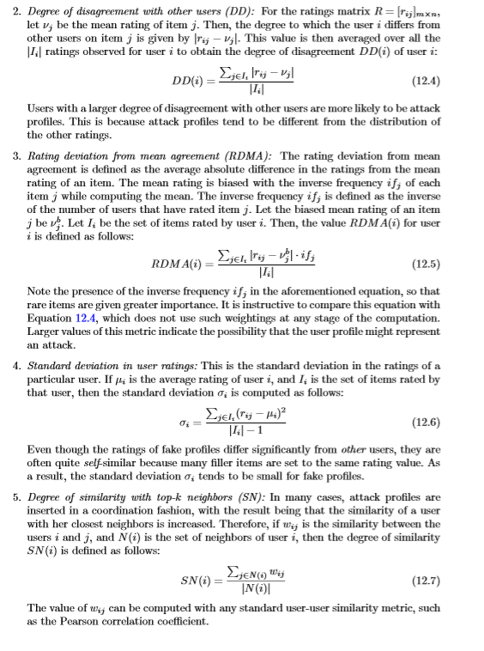

Group Attack Profile Detection
- Group attack profile detection focuses on identifying clusters of similar attack profiles rather than individual fake profiles.
- The methods can be categorized into preprocessing methods and online methods.

1. Preprocessing Methods
These methods detect and remove fake profiles before the recommendation process begins.

a)Clustering-Based Methods
- Attack profiles tend to form tight clusters due to their similar ratings.
- Clustering: Use techniques like PLSA (Probabilistic Latent Semantic Analysis) to perform soft clustering, which is then converted to hard clustering.
- Cluster Analysis: Calculate the average Mahalanobis radius for each cluster. The cluster with the smallest radius is likely to contain fake profiles.
- Assumptions: Works well for overt attacks but may struggle with subtle attacks.

b)PCA-Based Methods
- Principle: Fake profiles exhibit high covariance among themselves and low covariance with authentic users.
Process
- Covariance Analysis: Normalize the ratings matrix and compute the covariance matrix of its transpose.
- Eigenvector Analysis: Identify users (dimensions) with small contributions in the smallest eigenvectors.

2. Online Methods
These methods detect fake profiles during the recommendation process.

a) Neighborhood-Based Detection
- Principle: Split the neighborhood of the active user into two clusters to identify discrepancies.
- Process
  - Clustering During Recommendation: Form two clusters from the active user's neighborhood.
  - Variance Analysis: Compare the average ratings of the target item in both clusters.
  - Attack Cluster Identification**: The cluster with smaller variance for the target item is considered the attack cluster, and its profiles are removed.
  - Integration: This method can be integrated into attack-resistant recommendation algorithms, providing robust recommendations by removing fake profiles in real-time.

Strategies for Robust Recommender Design
1. Preventing Automated Attacks with CAPTCHAs
- Automated Attacks: Often require a large number of fake profiles (3-5% of authentic profiles).
- CAPTCHAs: Used to differentiate between human users and automated systems.
- Implementation: Present distorted text that humans can read but machines cannot.
- Application: Prompt for CAPTCHAs during rating entry, especially from the same IP address.

2. Using Social Trust
- Social Trust Integration: Utilizes trust relationships among users to influence ratings.
- Trust Relationships: Based on users' experiences with others' ratings.
- Effectiveness: Reduces impact of fake profiles as users are unlikely to trust them.
- Influence Limiter Algorithm: Proposes using reputation scores in recommendations.
- Reputation Scores: Based on the accuracy of users' rating predictions.
- Theoretical Boun: Establishes limits on the impact of negative attacks.

3. Designing Robust Recommendation Algorithms
- Incorporating Clustering in Neighborhood Methods
- Clustering Techniques: PLSA and k-means used to cluster user profiles.
- Aggregate Profiles: Created from each cluster, representing average ratings.
- Prediction Method: Uses closest aggregated profiles for recommendations.
- Robustness: Clustering limits the influence of attack profiles by mapping to single clusters.

4.Fake Profile Detection During Recommendation Time
- Neighborhood Partitioning: Splits active user's neighborhood into two clusters.
- Attack Detection: Suspected when active item has very different average ratings in the two clusters.\
- Attack-Cluster Identification: Cluster with smaller radius is considered the attack-cluster.
- Profile Removal: Fake profiles from attack-cluster are removed.
- Dual Purpose: Functions as both attack-detection and robust recommendation algorithm.

Combining CAPTCHAs, social trust mechanisms, clustering techniques, and real-time fake profile detection can significantly enhance the robustness of recommender systems against various types of attacks. These strategies ensure that recommendations remain accurate and reliable, even in the presence of adversarial activities.

