**Compilers & Languages**

**Compiler Implementation**

Project - Final Report

**Team 4**

|  |  |  |  |  |
| --- | --- | --- | --- | --- |
| **Name** | **Sec** | **BN** | **ID** | **Email** |
| بموا عريان عياد | 1 | 17 | 9202391 | bemoi.tawadros00@eng-st.cu.edu.eg |
| مارك ياسر نبيل | 2 | 14 | 9203106 | mark.ibrahim00@eng-st.cu.edu.eg |
| بيتر عاطف فتحي | 1 | 18 | 9202395 | peter.zaki00@eng-st.cu.edu.eg |
| كريم محمود كمال | 2 | 12 | 9203076 | karim.mohamed003@eng-st.cu.edu.eg |

**1. Project Overview**

Our project is implementing a compiler for a language closely resembling C++ using Lex and Yacc, aiming to tokenize source code, construct an abstract syntax tree, perform semantic analysis, generate intermediate representation code.

**2. Tools & Technologies**

Lexical Analysis : Flex

Parsing : Bison

GUI : Python (PyQt5 library)

**3. List of tokens and a description of each**

|  |  |
| --- | --- |
| Tokens | Description |
| INTEGER_DATA_TYPE FLOAT_DATA_TYPE BOOL_DATA_TYPE STRING_DATA_TYPE VOID_DATA_TYPE |  |
| IDENTIFIER |  |
| IF ELSE ELSE_IF |  |
| FOR WHILE REPEAT UNTIL |  |
| ENUM |  |
|  |  |

**4. List of quadruples and a description of each**

|  |  |
| --- | --- |
| Quadruple | Description |
| PROC |  |
| ENDPROC |  |
| CALL |  |
| RET |  |
| PUSH |  |
| POP |  |
| JMP EndLabel_LABLE |  |
| JF EndLabel_LABLE |  |
| Label_LABLE |  |
| StartLabel_LABLE |  |
| ENUM |  |
| ENDENUM |  |
|  |  |

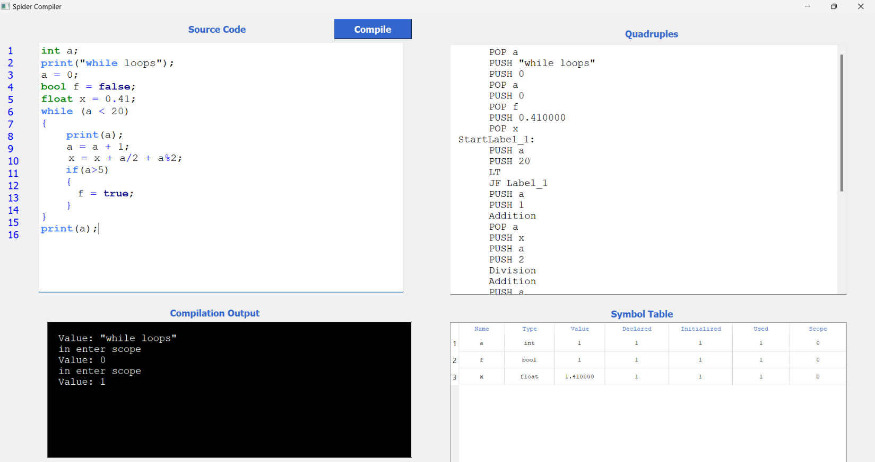**GUI**