**Remote Sensing and Satellite Imagery**

**Change Detection**

Project - Final Report

**Team 4**

|  |  |  |  |  |
| --- | --- | --- | --- | --- |
| **Name** | **Sec** | **BN** | **ID** | **Email** |
| بموا عريان عياد | 1 | 17 | 9202391 | bemoi.tawadros00@eng-st.cu.edu.eg |
| مارك ياسر نبيل | 2 | 14 | 9203106 | mark.ibrahim00@eng-st.cu.edu.eg |
| بيتر عاطف فتحي | 1 | 18 | 9202395 | Peter.zaki00@eng-st.cu.edu.eg |
| كريم محمود كمال | 2 | 12 | 9203076 | kairm.mohamed003@eng-st.cu.edu.eg |

**1. Deep Learning Results**

**Preprocessing**

In the majority of our tried models, preprocessing was unnecessary, except for the basic UNet. This particular model only accepts one image as input, thus we preprocessed the input by taking the absolute difference between the image before and after.

|  |  |  |
| --- | --- | --- |
| **Model** | **Jaccard Score** | |
| **Training** | **Validation** |
| **Basic UNet** | 79% | 73% |
| **Diff UNet (our idea)** | 80% | 74% |
| **Siamese Nested UNet** | 88% | 80.5% |
| **Siamese Nested UNet (full dataset)** | 97% (overfit) | - |

**Loss Function**

BCEWithLogitsLoss (Sigmoid + BCEloss)

**Hyper Parameters:**

In each we tuned the hyper parameters and we found that these parameters fit the best

*Number of Epochs:* around 35 epoch

*Learning Rate:* Start with 0.001 and the reduced each 10 steps with gamma = 0.2

*Threshold:* 0.3 (threshold on the predicted pixel probability)

**Remarks:**

1- after a certain number of epochs the model starts to overfit because the Siamese Nested UNet is very large (~13 million parameters), so the solution was early stopping.

2- The dataset is unbalanced (67% pure black masks) and has a lot of changes that are incorrect which will definitely reduce the generalization error.

**Model Architectures**

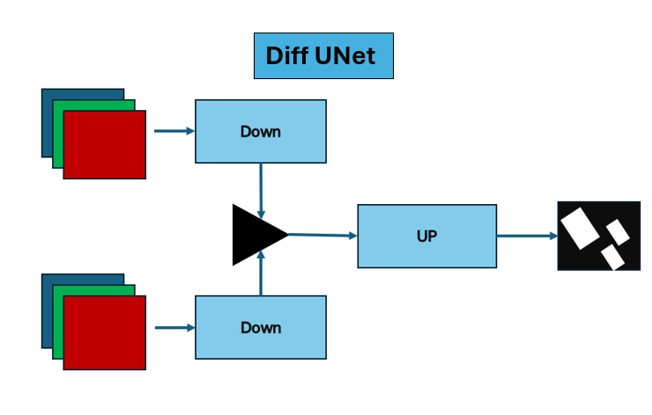

**2. Classical Techniques**

**Preprocessing**

* CLAHE Enhancement: Contrast Limited Adaptive Histogram Equalization (CLAHE) was applied to enhance the contrast of images, with a clip limit of 2.0 and a tile grid size of 8x8.
* Normalization: The intensity range of the images was normalized to ensure consistency and standardization.
* Gaussian Blur: Gaussian Blur was applied to each image to effectively reduce noise and improve image quality.
* Gamma Correction: Each image undergoes gamma correction using the provided gamma values to adjust brightness and contrast.
* Increase Saturation: Each image's saturation is boosted by a specified factor using the HSV color space.

**Feature Extraction**

**- RGB Color Distribution Analysis:**

* 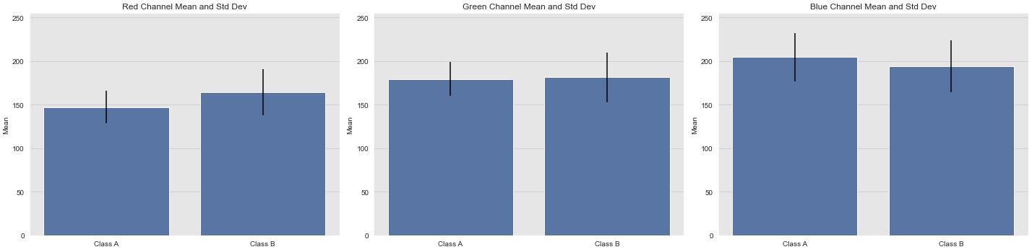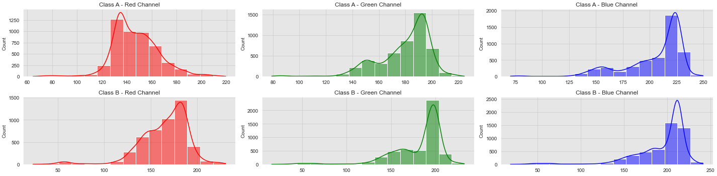Discriminative Power: Differences in RGB color distributions between change and no-change areas indicate landscape changes. Analyzing these differences helps distinguish between the two classes.

Mean and Standard Deviation for each channel in each class

counting means of each channel for each class

**- Histogram Difference:**

* 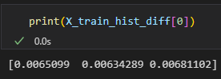Histogram normalized differences between corresponding RGB channels of before and after images reveal variations in pixel intensity distributions. These differences serve as discriminative features for distinguishing between change and no-change areas in the landscape.

Small values indicating no change

**Reasons:**

* Histogram normalized differences highlight changes in the distribution of pixel intensities between corresponding RGB channels of before and after images.
* These differences serve as discriminative features for distinguishing between change and no-change areas in the landscape.

**- Clustered Histogram of Oriented Gradients (HOG):**

* HOG captures the distribution of gradient orientations, providing a representation of both texture and shape.

**Reasons:**

* HOG features are inherently rotationally invariant, enabling robust detection and classification regardless of image orientation.
* HOG features offer a compact and efficient representation of image content, suitable for machine learning algorithms.
* 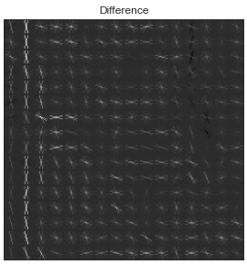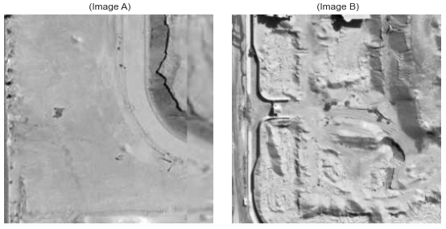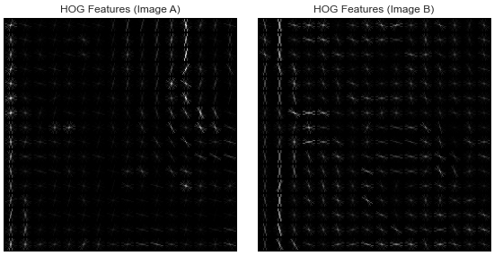K-Means Clustering: 5 clusters

**- Gray-Level Co-occurrence Matrix (GLCM):**

* GLCM features, including contrast, dissimilarity, homogeneity, energy, and correlation, are computed for each pair of before and after grayscale images. These features capture texture properties and spatial relationships between pixel intensities, providing valuable information for distinguishing between different classes in satellite imagery analysis.
  + Contrast: indicates the number of local variations present in the image. Higher contrast values imply that there are significant differences between adjacent pixel values, while lower contrast values suggest that the pixel values are more uniform or similar. In texture analysis, contrast can help distinguish between textures with varying degrees of local variation.
  + Dissimilarity: It reflects how different neighboring pixel values are from each other. Higher dissimilarity values indicate higher variation between adjacent pixel values, while lower dissimilarity values suggest more similarity between neighboring pixels. Dissimilarity can be useful for identifying regions in an image with varying textures or spatial patterns.
  + Homogeneity: Homogeneity measures the closeness. Higher homogeneity values indicate that the pixel values are closer to each other, while lower homogeneity values suggest that the pixel values are more dispersed. Homogeneity can help identify regions in an image with consistent texture or spatial patterns.
  + Energy: Higher energy values indicate more uniform distributions of gray-level pairs, while lower energy values suggest more irregular or non-uniform distributions. Energy can help characterize the overall texture complexity of an image.
  + Correlation: Correlation measures the linear dependency between gray-level pairs in the image. It indicates how correlated or related the pixel values are to each other. Positive correlation values indicate a linear relationship between pixel values, while negative correlation values suggest an inverse relationship. Correlation can help capture the spatial patterns and structures present in an image.

**Reasons:**

* Texture Analysis: GLCM captures texture properties in images, which can be crucial for distinguishing between different land cover types or changes in land use. Changes in texture, such as the appearance of new structures or vegetation, can indicate changes in the landscape.
* Spatial Relationships: GLCM quantifies the spatial relationships between pixel intensities, allowing us to analyze patterns of change across the images. Changes in spatial patterns, such as the appearance of roads or deforestation, can be indicative of significant changes in the area.
* Invariance to Intensity Variations: GLCM features are often invariant to changes in overall image intensity, making them robust to variations in lighting conditions or sensor settings. This ensures that the features extracted focus on the underlying texture and spatial patterns rather than variations in brightness.

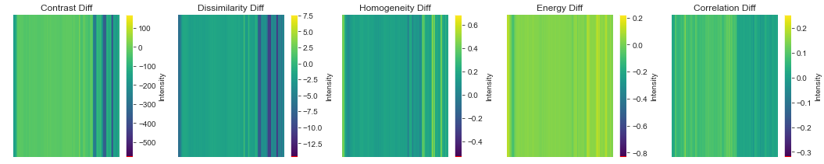

GLCM

**- Histogram Difference + Cluster HOG + GLCM:**

* Histogram Difference, Cluster HOG, GLCM features offers a comprehensive approach to classify change or no change between two images and their corresponding labels.
* Complementary Information:
  + Histogram Difference captures global changes in pixel intensity distributions between images a and b, providing insight into overall changes in the scene.
  + Cluster HOG extracts local gradient orientation information, which is effective for detecting object boundaries and finer texture changes.
  + GLCM features analyze spatial relationships between pixel intensities, capturing textural changes and patterns that may not be evident from pixel-wise comparisons alone.
* Robustness:
  + Each feature type contributes to the classification task in a unique way, enhancing the robustness of the model to different types of changes in the scene.
  + By combining multiple features, the model becomes less sensitive to noise or outliers in individual feature representations.
* Discriminative Power:
  + Histogram Difference, Cluster HOG, and GLCM features provide complementary discriminative information, allowing the model to better distinguish between change and no change instances.
  + The combination of features enables the model to capture both global and local variations in the scene, improving its ability to generalize across diverse scenarios.
* Enhanced Classification Accuracy:
  + Integrating multiple feature types often leads to improved classification accuracy compared to using any single feature type in isolation.
  + By leveraging the strengths of each feature type, the combined approach increases the likelihood of capturing relevant information for accurate change detection.
* Adaptability:
  + The combined feature set is adaptable to different types of changes in satellite imagery, including variations in illumination, terrain, and object appearances.
  + The flexibility of the approach allows it to be applied across various satellite imaging scenarios without significant modification.

**PCA + K-Means:**

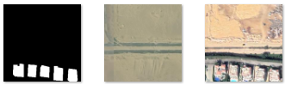

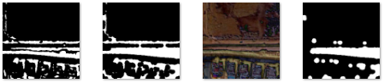

B

A

Label

Open Map

Difference

Close Map

Change Map

Steps:

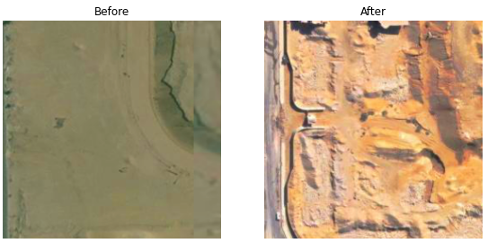- Image Preprocessing:

* Increase the saturation of before and after images using the defined factor.
* Preprocess the images using the defined gamma values.

- Data Splitting:

* Use 80% of the data for training and 20% for testing.

- Training Set Iteration:

* Iterate over the training set.
* Resize images to a smaller size.
* Calculate the difference image and perform PCA.
  + Computing the difference image helps to highlight areas of change between before and after images, which is essential for change detection.
  + Principal Component Analysis (PCA) is employed to reduce the dimensionality of the feature space, capturing the most significant variations in the data.
* Build the Feature Vector Space (FVS) and perform clustering.
  + The Feature Vector Space (FVS) is constructed to represent each image pair in a format suitable for machine learning algorithms.
  + Clustering is performed to group similar features together, potentially separating regions of change from background noise.
* Post-process the change map and calculate the Jaccard index (IOU).
* Fit the classifier on the training data.

- Testing Set Iteration:

* Iterate over the testing set.
* Resize images to a smaller size.
* Calculate the difference image and perform PCA.
* Build the Feature Vector Space (FVS) and predict the change map.
* Post-process the predicted change map and calculate the Jaccard index (IOU).

Find Feature Vector:

* divide the new image size into non-overlapping blocks of size 5x5, ensuring efficient processing.
* Each block is then flattened into a 1D array to form a feature vector, capturing local information about changes in the image.
* These feature vectors are aggregated to form the vector set, representing the entire difference image in terms of feature vectors.
* The mean vector is computed across the vector set, providing information about the average feature values.
* Finally, mean normalization is performed on the vector set, ensuring that the data is centered around zero.

Feature Vector Space:

* The function iterates over the difference image, extracting 5x5 blocks centered at each pixel, ensuring that at least 2 pixels are available on all sides.
* Each block is flattened into a feature vector and appended to a feature vector set, capturing local information about changes in the image.
* The Feature Vector Space (FVS) is computed by dot product this feature vector set with the Eigen Vector Space (EVS), representing the entire difference image in terms of feature vectors.
* Finally, mean normalization is applied to the FVS using the provided mean vector, ensuring that the data is centered around zero.

Clustering:

* initializes a K-Means clustering model with the specified number of components.
* It fits the K-Means model to the Feature Vector Space (FVS), clustering the feature vectors into 'components' clusters.
* Cluster labels are predicted for each feature vector.
* Then counts the occurrences of each cluster label to find the index of the cluster with the least number of elements, potentially representing unchanged regions.
* Finally, it reshapes the cluster labels into a change map, where each pixel corresponds to a cluster label, indicating the region of change.

**Results**

|  |  |  |  |
| --- | --- | --- | --- |
| **Model** | **Feature Extraction** | **Jaccard Score** | |
| **Training** | **Validation** |
| Random Forest | **Histogram Difference** | 0.73 | 0.53 |
| SVC | **Histogram Difference** | 0.57 | 0.52 |
| Random Forest | **Clustered HOG** | 0.78 | 0.38 |
| Random Forest | **GLCM** | 0.94 | 0.78 |
| Random Forest | **Histogram Difference + Cluster HOG + GLCM** | 0.94 | 0.80 |
| Random Forest | **K-Means + PCA** |  |  |

**Hyper Parameters:**

- Histogram Difference + Random Forest:

- Number of Estimators: 100

- Maximum Depth: 10

- Random State: 42

- Histogram Difference + SVC:

- C = 100

- Grid Search for Random Forest:

- Number of Estimators: [50, 100, 150]

- Maximum Depth: [5, 10, 15]

**5. Workload Distribution**

|  |  |
| --- | --- |
| **Name** | **Workload** |
| Mark Yasser | Deep learning models |
| Bemoi Erian |
| Karim Mahmoud Kamal | Classical Techniques |
| Peter Atef |