**Remote Sensing and Satellite Imagery**

**Change Detection**

Project - Final Report

**Team 4**

|  |  |  |  |  |
| --- | --- | --- | --- | --- |
| **Name** | **Sec** | **BN** | **ID** | **Email** |
| بموا عريان عياد | 1 | 17 | 9202391 | bemoi.tawadros00@eng-st.cu.edu.eg |
| مارك ياسر نبيل | 2 | 14 | 9203106 | mark.ibrahim00@eng-st.cu.edu.eg |
| بيتر عاطف فتحي | 1 | 18 | 9202395 | peter.zaki00@eng-st.cu.edu.eg |
| كريم محمود كمال | 2 | 12 | 9203076 | kairm.mohamed003@eng-st.cu.edu.eg |

**1. Deep Learning Results**

**Preprocessing**

In the majority of our tried models, preprocessing was unnecessary, except for the basic UNet. This particular model only accepts one image as input, thus we preprocessed the input by taking the absolute difference between the image before and after.

|  |  |  |
| --- | --- | --- |
| **Model** | **Jaccard Score** | |
| **Training** | **Validation** |
| **Basic UNet** | 79% | 73% |
| **Diff UNet (our idea)** | 80% | 74% |
| **Siamase Nested UNet (UNet++)** | 88% | 81% |
| **Siamase Nested UNet (with random splits)** | 92% | - |

**Loss Function**

BCEWithLogitsLoss (Sigmoid + BCEloss)

**Hyper Parameters:**

In each we tuned the hyper parameters and we found that these parameters fit the best

*Number of Epochs:* around 45 epoch

*Learning Rate:* Start with 0.001 and the reduced each 10 steps with gamma = 0.2

*Threshold:* 0.3 (threshold on the predicted pixel probability)

**Model Architectures**

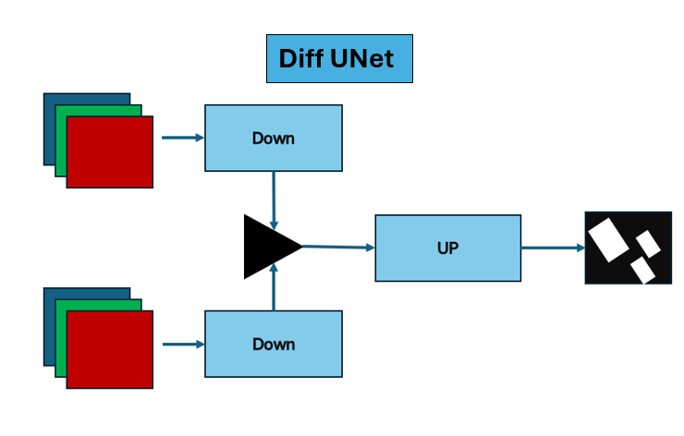

**2. Classical Techniques**

**Preprocessing**

bla bla bla

**Results**

|  |  |  |  |
| --- | --- | --- | --- |
| **Model** | **Feature Extraction** | **Jaccard Score** | |
| **Training** | **Validation** |
| KMeans |  |  |  |
| GLCM |  |  |  |
|  |  |  |  |

**Hyper Parameters:**