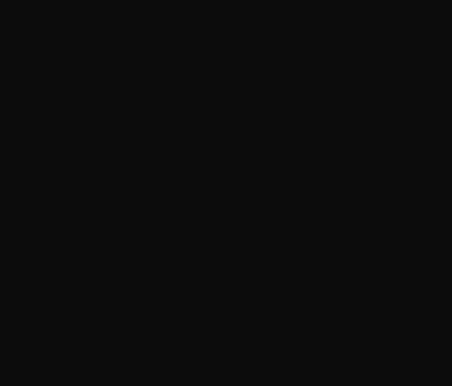

`



Image Processing Library
Milestone 1

Submitted to :
Eng. Mohammed Mouhana
Eng. Sara

Abdelghaffar Essam 2100428
Omar Aymen Barakat 2000328

CSE473s Machine Vision

Table of Contents

Table of Contents 2
Table of Figures 4
Project Structure 5
1.1 Folder Layout 5
1.2 Module Dependency Flow 5
Code Quality & Engineering 6
2.1 Docstrings 6
2.2 Input Validation 6
2.3 2.3 Performance Practices 6
2.4 Modularity 7
API Reference 7
3.1 utils.py — Foundation Functions 7
3.2 io.py — Image I/O 7
3.3 color.py — Color Conversion 7
3.5 thresholding.py — Thresholding 8
3.7 transforms.py — Geometric Transforms 9
3.9 drawing.py — Drawing Primitives 10
3.10 init .py & setup.py 10
Math & Algorithmic Foundation 11
4.1 Color Conversion — ITU-R BT.601 11
4.2 Normalization 11
4.3 Padding Modes 11
4.4 2D Convolution 12
4.5 Gaussian Filter 12
4.6 Sobel Edge Detection 12
4.7 Otsu Thresholding 14
4.8 Adaptive Threshold Error! Bookmark not defined.
4.9 Bit-Plane Slicing 15
4.10 Histogram Equalization 15
4.11 Contrast Stretching 15
4.12 Laplacian Sharpening 16
4.13 Bilinear Resize 16
4.14 Rotation — Inverse Mapping Error! Bookmark not defined.
4.15 Hu Moments 16
4.16 HOG Error! Bookmark not defined.
4.17 LBP Error! Bookmark not defined.
4.18 Bresenham's Line Error! Bookmark not defined.
4.19 4.19 Scanline Polygon Fill Error! Bookmark not defined.
Implementation Notes 19
5.1 dtype Conventions 20
5.2 Canvas Clipping — _fill_rect() 20
Results & Verification 21
6.1 I/O & Color Conversion (nb01) 21
RGB and Grayscale Loading 21
Color Conversion 21
6.2 Core Operations (nb02) 22
Normalization Modes 22
Clipping Modes 22
Padding Modes 23
2D Convolution 23
Padding Mode Effect on Convolution 24
6.3 6.3 Filtering & Thresholding (nb03) 24
Mean Filter 24
Gaussian Filter 24
Median Filter 25
Noise Removal Comparison 25
Global Threshold 25
Otsu Threshold 26
Adaptive Threshold 26
All Thresholds Compared 26
6.4 Techniques (nb04) 27
Bit-Plane Slicing 27
Histogram 27
Histogram Equalization 28
Contrast Stretching 28
Laplacian Sharpening 29
Comparison Between all techniques 29
6.5 Geometric Transforms (nb05) 30
Resize 30
Rotation 30
Translation 31
6.6 Feature Descriptors (nb06) 31
Color Histogram Descriptor 31
Hu Moments Descriptor 32
HOG Descriptor 32
LBP Descriptor 33
Feature Vector Comparison 33
6.7 Drawing Primitives (nb07) 34
draw_point 34
draw_line (Bresenham) 34
draw_rectangle — Interactive 35
draw_polygon — Interactive 35
draw_text — Interactive 36
Boundary Clipping Stress Test 36
All Primitives Combined 37
6.9 Key Verification Checks 38
Project Repo 38

Table of Figures
Figure 1: nb01_RGB and Greyscale 21
Figure 2: nb01_rgb to grey & grey to rgb 21
Figure 3: nb02_ normalization panel: original, minmax, zscore and unit8. 22
Figure 4: Clipping Comparison. 22
Figure 5: Padding Comparison. 23
Figure 6: convolution: identity, Laplacian and sharpen kernels 23
Figure 7: conv boundary comparison: constant, reflect and replicate 24
Figure 8: nb03_mean filter: k=3, k=7 and k = 15 24
Figure 9: nb03 — Gaussian filter: k=5 σ=1, k=11 σ=3 and k=21 σ=5 24
Figure 10: nb03_median filter on noisy image: k=3, k=7 and k=15 25
Figure 11: nb03_filter comparison on noisy: mean, Gaussian and median 25
Figure 12: nb03_global threshold: t=64, t=128 and t=192 25
Figure 13: nb03_Otsu result with computed t value 26
Figure 14: nb03_adaptive: mean vs Gaussian method 26
Figure 15: : nb03_threshold comparison panel 26
Figure 16: nb04_Bit Planes 27
Figure 17: nb04_Image and its histogram 27
Figure 18: nb04_equalization: original vs equalized and their histograms 28
Figure 19: nb04_contrast stretching result 28
Figure 20: nb04_Laplacian sharpening for greyscale and rgb images 29
Figure 21: nb04_enhancment techniques comparison 29
Figure 22: nb05_resize 30
Figure 23: nb05_rotation 30
Figure 24: nb05_translation 31
Figure 25: color histogram descriptor for each channel RGB 31
Figure 26: nb06_Hu moments bar chart 32
Figure 27:nb06_HOG visualization with gradient arrows 32
Figure 28:nb06_LBP map and histogram 33
Figure 29:nb06_Feature Vector Comparison 33
Figure 30:nb07_point drawing 34
Figure 31: nb07_draw a line 34
Figure 32: nb07_draw a rectangle 35
Figure 33: nb08_draw a polygon 35
Figure 34: nb07_Text 36
Figure 35: nb07_clipping test 36
Figure 36: nb07_combined drawings 37

Project Structure
minicv is organized as an installable Python package. The inner minicv/ folder contains all algorithm modules. The notebooks/ folder contains interactive demonstration notebooks built with ipywidgets. Everything shares the same package.

Folder Layout
Project/
minicv/ <- installable package root
minicv/ <- Python package
__init__.py <- public API
io.py <- read_image, save_image
utils.py <- validate, clip, normalize, pad, convolve2d
color.py <- rgb_to_gray, gray_to_rgb
filtering.py <- mean, gaussian, median, sobel
thresholding.py <- global, otsu, adaptive
techniques.py <- bit_plane, histogram, equalization, extras
transforms.py <- resize, rotate, translate
features.py <- color_hist, hu_moments, hog, lbp
drawing.py <- point, line, rect, polygon, text
notebooks/
nb01_io_and_setup.ipynb
nb02_core_operations.ipynb
nb03_filtering_and_thresholding.ipynb
nb04_techniques.ipynb
nb05_transforms.ipynb
nb06_features.ipynb
nb07_drawing.ipynb
setup.py
README.md

Module Dependency Flow
Module | Imports From | Purpose
utils.py | (none — foundation) | validate_image, normalize, pad, convolve2d
io.py | utils, color | Read/write image files
color.py | utils | RGB  Grayscale
filtering.py | utils, color | Mean, Gaussian, Median, Sobel
thresholding.py | utils, color, filtering | Global, Otsu, Adaptive
techniques.py | utils, color | Bit-plane, Histogram, Extras
transforms.py | utils | Resize, Rotate, Translate
features.py | utils, color, filtering | HOG, LBP, Color Hist, Hu
drawing.py | utils | Point, Line, Rect, Polygon, Text

Code Quality & Engineering

Docstrings
Every public function carries a NumPy-style docstring covering: description, parameters with types, return value and shape, raised exceptions, and notes on expected input ranges and dtypes.
def gaussian_filter(image, kernel_size=5, sigma=1.0, pad_mode='constant'):
"""
Parameters
----------
image : np.ndarray — shape (H,W) or (H,W,3)
kernel_size : int — positive odd integer
sigma : float — must be > 0
pad_mode : str — 'constant' | 'reflect' | 'replicate'

Returns
-------
np.ndarray — same shape as input, dtype float64

Raises
------
TypeError — if kernel_size is not an int
ValueError — if kernel_size is even or sigma <= 0
"""

Input Validation
Exception | Condition | Example message
TypeError | Wrong type passed | kernel_size must be an int, got str.
ValueError | Invalid value | sigma must be > 0, got -1.
ValueError | Wrong image shape | image must be 2D or 3D, got shape (64,).

2.3 Performance Practices
Function | Strategy
convolve2d | stride_tricks sliding window + tensordot — no pixel loops
median_filter | stride_tricks window + np.median on axis — loop justified (non-linear)
resize | meshgrid + vectorized index mapping — no loops
rotate | inverse mapping with boolean valid mask — no loops
lbp_descriptor | outer loop over n_points only (8 iters) — inner fully vectorized
histogram_equalization | lookup table — single vectorized index operation
draw_* | all use _fill_rect() — NumPy slice assignment, no pixel loops

Modularity
- validate_image() and validate_kernel() — centralized in utils.py, called by all modules
- _fill_rect() — centralized in drawing.py, all drawing primitives route through it
- pad() and convolve2d() — centralized in utils.py, used by filtering, thresholding, techniques
- rgb_to_gray() — centralized in color.py, imported where grayscale conversion is needed

API Reference

utils.py — Foundation Functions
utils.py is the backbone of the entire library. It provides four core building blocks that every other module relies on:
Function | What It Does
validate_image() | Checks that input is a NumPy array with 2D or 3D shape
validate_kernel() | Checks kernel is 2D, numeric, non-empty, and has odd dimensions
clip_pixels() | Clamps pixel values to a [low, high] range
normalize() | 3 modes: minmax [0,1], zscore zero-mean/unit-std, uint8 [0,255]
pad() | 3 modes: constant (zero), reflect (mirror), replicate (edge repeat)
convolve2d() | True 2D convolution using NumPy stride_tricks (no Python loops)

io.py — Image I/O
io.py provides two functions to load and save images using Matplotlib (no OpenCV or Pillow required).
Function | Parameters | Description
read_image() | path, mode="rgb" | Load PNG/JPG NumPy uint8. Auto-handles float32 PN
save_image() | image, path | Save NumPy array (gray or RGB) as PNG/JPG.

Important normalization note: Matplotlib reads PNG images as float32 in [0.0, 1.0] but JPEG images as uint8 in [0, 255]. The read_image() function detects this and converts everything to uint8 for consistency.

color.py — Color Conversion
color.py implements bidirectional grayscale/RGB conversion.
Function | Formula / Method
rgb_to_gray() | Y = 0.2989·R + 0.5870·G + 0.1140·B (ITU-R BT.601 luminance)
gray_to_rgb() | Stack [gray, gray, gray] along channel axis shape (H,W,3)
The BT.601 weights reflect human eye sensitivity: green is weighted most (~59%) because the human eye has more green cone cells, followed by red (~30%), then blue (~11%).

  - filtering.py — Spatial Filters
filtering.py implements all convolution-based filtering. It uses the convolve2d() from utils.py as its engine and adds higher-level filter functions:
Function | Kernel / Algorithm | Key Notes
spatial_filter() | Custom kernel (any) | Handles gray & RGB (per-channel for RGB)
mean_filter() | 1/(k²) uniform matrix | Box filter — equal weight to all neighbors
gaussian_kernel() | G(x,y) = exp(-(x²+y²)/(2²)) | Normalized to sum=1
gaussian_filter() | Uses gaussian_kernel() | Larger  = more blur
median_filter() | Sliding window median | Uses stride_tricks, no pixel loop; non-linear
sobel_gradients() | Kx & Ky 3×3 kernels | Returns Gx, Gy, magnitude

Sobel kernels detect edges: Kx detects vertical edges (horizontal gradient), Ky detects horizontal edges (vertical gradient). The magnitude = √(Gx² + Gy²) combines both into a full edge strength map.
Median filter loop justification: The median is a non-linear operation. It cannot be expressed as a dot-product, so a convolution kernel is impossible. The implementation avoids pixel-level Python loops by using stride_tricks to extract all windows at once, then calls np.median() on the window axis (fully vectorized).

thresholding.py — Thresholding
thresholding.py converts grayscale images to binary (black/white) using three strategies:
Method | How It Works
global_threshold(t) | Pixels > t = 255; Pixels < t = 0
otsu_threshold() | Finds t that maximizes inter-class variance ²b(t) =
adaptive_threshold() | Each pixel gets its own local threshold = mean(neigh
Otsu Math: The algorithm sweeps all 256 intensity levels t, computing the between-class variance for each. The t with the highest variance is chosen. Implementation is fully vectorized using np.cumsum();
Adaptive threshold supports two variants: "mean" uses a uniform box kernel (equal weights) and "gaussian" uses a Gaussian-weighted kernel (center pixels have more influence). Gaussian reduces haloing artefacts at edges.

  - techniques.py — Image Techniques
techniques.py contains additional image processing operations including the two extra techniques required beyond the core list:
Function | Description
bit_plane_slice(plane) | Extracts bit plane 0-7. Uses bitwise AND mask: (img & 2^plane) >> plane
histogram() | Computes intensity histogram using np.histogram (256 bins, range [0,255])
histogram_equalization() | CDF-based LUT: s = round(255 · CDF(r)). Fully vectorized lookup table
contrast_stretching() | (Extra 1) Linear rescale: s = (r - in_low)/(in_high - in_low) · 255
laplacian_sharpening() | (Extra 2) output = image + strength · Laplacian(image). K=[[0,-1,0],[-1,4,-1],[0,-1,0]

transforms.py — Geometric Transforms
transforms.py implements all three required geometric transformations. All are fully vectorized using NumPy meshgrids.

Function | Algorithm | Interpolation
resize(out_h, out_w) | Map output coords to input: src = out · (in_size-1)/(out_size- | Nearest or Bilinear
rotate(angle) | Inverse mapping: src = R■¹ · (dst - center) + center | Nearest or Bilinear
translate(sx, sy) | Integer shift via NumPy array slicing (no interpolation neede | dN/A (integer shift)
Bilinear interpolation for resize: Each output pixel is a weighted average of four neighboring input pixels. Weights are proportional to the fractional distance from each neighbor: out = (1-dy)(1-dx)·I(y0,x0) + (1-dy)(dx)·I(y0,x1) + ... This produces smoother results than nearest-neighbor.
Rotation uses inverse mapping: For each output pixel location (x', y'), we compute where it came from in the source image using the inverse rotation matrix. This prevents holes in the output that forward mapping would create.

  - features.py — Feature Descriptors
features.py implements four feature descriptors — two global and two gradient-based:
Descriptor | Type | Output Size | Description
color_histogram_descriptor() | Global | 32×C dims | Normalized color histogram per channels
hu_moments_descriptor() | Global | 7 dims | Rotation/scale/translation invariant moments
hog_descriptor() | Gradient | cells × bins dims | Histogram of Oriented Gradients
lbp_descriptor() | Gradient | 256 dims | Local Binary Pattern texture histogram

HOG divides the image into cells, computes Sobel gradients, bins the orientations into 9 bins [0°–180°), and L2-normalizes each cell. The loop is over cells (e.g. 8×8 = 64 iterations), not over pixels, so it is acceptable per the project requirements.
LBP samples n_points neighbors on a circle of given radius around each pixel, compares each to the center value, encodes as a binary number, and builds a histogram. The outer loop is over n_points (8 iterations), with all pixel comparisons vectorized.
Hu Moments are 7 combinations of normalized central moments that are invariant to translation, scale, and rotation. Log-transform is applied for numerical stability.

drawing.py — Drawing Primitives
drawing.py draws directly onto NumPy arrays. All functions modify the image in-place and return the array. Canvas clipping is applied everywhere.

Function | Algorithm | Supports
draw_point(x, y) | Fills a thickness×thickness square at (x,y) | Gray + RGB, any thickness
draw_line() | Bresenham integer algorithm — no floating poin | Gray + RGB, two vertices, any thickness
draw_rectangle() | filled: NumPy slice; outline: four draw_line() calls | Filled or outline, position thickness
draw_polygon() | outline: draw_line() per edge; filled: scanline ras | User specified number of vertices, Filled or outline, Gray + RGB
draw_text() | 5×7 bitmap font, hardcoded bitmask per ASCII | Gray + RGB, size

Bresenham's line algorithm uses only integer addition to step from one endpoint to another, deciding at each step whether to step horizontally, vertically, or diagonally based on an accumulated error term. This is the classic algorithm used in all GPU rasterizers.
Scanline fill (for polygon): For each row y in the bounding box, find all x intersections of y with the polygon edges, sort them, and fill between pairs. This is the standard polygon rasterization technique.

init .py & setup.py
init .py
imports all 30+ public functions and lists them in all . This makes the entire library importable with a single import minicv. All imports use relative syntax (e.g. from .filtering import ...) to support proper package behavior.
setup.py
uses setuptools to make the package installable via pip install -e .. It declares numpy, matplotlib, and pandas as dependencies and requires Python

Math & Algorithmic Foundation

Color Conversion — RGB to Greyscale
The human eye has unequal sensitivity across color channels. The ITU-R BT.601 standard provides the following weighted sum that matches perceived luminance:
$$Y = 0.2989 R + 0.5870 G + 0.1140 B$$
Green receives the highest weight (0.587) because human photoreceptors are most sensitive to mid-wavelength light. The output is a single-channel (H × W) array of the same dtype as the input.

Normalization
Three modes are provided to map pixel values to a target range or statistical distribution, making images comparable across different sensors and lighting conditions.

Min-Max — output in [0, 1]
Shifts and linearly scales the full dynamic range to [0, 1]. The minimum pixel maps to 0; the maximum maps to 1. The shape of the intensity histogram is preserved.
$$x' = \frac{x - x_{min}}{x_{max} - x_{min}}$$

Z-Score — zero mean, unit standard deviation
Centers the intensity distribution at zero and normalizes its spread by the standard deviation. Useful for comparing images with different absolute brightness or contrast.
$$x' = \frac{x - μ}{σ}$$

Uint8 — output in [0, 255]
Identical to min-max rescaling but the result is multiplied by 255 and cast to uint8, producing a standard 8-bit image ready for display or saving to disk.
$$x' = \frac{x - x_{min}}{x_{max} - x_{min}} × 255$$

2D Convolution
Convolution slides kernel K across image I and computes a weighted dot product at every position. The kernel is flipped before sliding (true convolution, not cross-correlation). The image is padded before the operation so the output shape always equals the input shape.
$$O(x, y) = ∑_{m=-h}^{h} ∑_{n=-h}^{h} I(x + m, y+ n) ⋅ K(-m, -n)$$
Three padding modes are available: constant (zeros), reflect (mirror at edge), and replicate (repeat edge pixel). The image I is padded by h pixels. The padding width equals ⌊k/2⌋ for a kernel of size k.
Implementation: NumPy stride_tricks constructs a sliding-window view of shape (H, W, kH, kW). A single tensordot call then computes all dot products at once — no Python loop over pixels.

Spatial Filters

Mean / Box Filter
Replaces each pixel with the arithmetic mean of its k × k neighborhood. The kernel is a uniform matrix whose every entry equals 1 / k², giving equal weight to all neighbors. Larger k produces stronger blurring.

1/k² | 1/k² | ⋯ | 1/k²
1/k² | 1/k² | ⋯ | 1/k²
⋮ | ⋮ | ⋱ | ⋮
1/k² | 1/k² | ⋯ | 1/k²
K_mean (k × k) — all elements equal 1/k²

Gaussian Filter
Weights each neighbor by a 2D Gaussian function of its distance from the center pixel. Closer neighbors contribute more than distant ones, producing a smoother and more natural blur than the box filter. The kernel is normalized to sum to 1 so average brightness is unchanged.
$$G(x, y) = exp\left(-\frac{x² + y²}{2σ²}\right), K = \frac{G}{∑∑ G}$$

G(−2,−2) | G(−1,−2) | G(0,−2) | G(1,−2) | G(2,−2)
G(−2,−1) | G(−1,−1) | G(0,−1) | G(1,−1) | G(2,−1)
G(−2, 0) | G(−1, 0) | G(0, 0) | G(1, 0) | G(2, 0)
G(−2, 1) | G(−1, 1) | G(0, 1) | G(1, 1) | G(2, 1)
G(−2, 2) | G(−1, 2) | G(0, 2) | G(1, 2) | G(2, 2)
K_gaussian (5 × 5 example) — values peak at G(0,0) and decay radially

Median Filter
Replaces each pixel with the median value of its k × k neighborhood. The median is a non-linear statistic that cannot be expressed as a convolution, so it must be computed by examining all neighborhood values directly.
$$O(x, y) = median\left\{I(x+m, y+n) ∀ m, n ∈ [-⌊k/2⌋, ⌊k/2⌋]\right\}$$
Loop justification: stride_tricks builds the full (H, W, k, k) window array without iterating over pixels. np.median() is then called once along the last two axes — vectorized across all positions simultaneously. This avoids a pixel-level Python loop while still computing the non-linear median correctly.

Sobel Edge Detection
Two 3 × 3 kernels measure the intensity gradient in the horizontal and vertical directions. Their design amplifies the central row or column to reduce noise sensitivity. The gradient magnitude combines both into a single edge-strength map.

−1 | 0 | +1
−2 | 0 | +2
−1 | 0 | +1
K_x — responds to vertical edges (left–right intensity change)

−1 | −2 | −1
0 | 0 | 0
+1 | +2 | +1
K_y — responds to horizontal edges (top–bottom intensity change)
$$G_x = I * K_x , G_y = I * K_y$$
$$M(x, y) = \sqrt{{G_x}^{2} + {G_y}^{2}}$$
Replicate padding is used so border pixels are not artificially suppressed to zero.

Thresholding

Global Threshold
A single fixed value t applied uniformly to every pixel. Pixels at or above t become 255 (foreground); pixels below become 0 (background). Simple and fast but fails when illumination varies across the image.
$$f'(x, y) = 255 if f(x, y) ≥ t , 0 otherwise$$

Otsu’s Method — Automatic Optimal Threshold
Sweeps all 256 candidate thresholds and selects the one that best separates pixel intensities into two groups by maximizing the variance between the groups. No manual tuning is required.
For a candidate threshold t, let ω₀ and ω₁ be the fraction of pixels below and above t, and μ₀, μ₁ their respective mean intensities. The inter-class variance is:
$${σ_{B}}^{2}(t) = ω₀(t) · ω₁(t) · {\left(μ₀(t) - μ₁(t)\right)}^{2}$$

The optimal threshold is selected as:
$$t* = arg max σ_{B}{}^{2}(t) , t ∈ \{0, 1, …, 255\}$$
Computed using cumulative sums over the 256-bin histogram — fully vectorized with no explicit loop over threshold values.

Adaptive Threshold
Computes a spatially varying threshold for each pixel from the statistics of its local neighborhood. This handles images with non-uniform illumination where a single global threshold would fail.
$$t(x, y) = LocalMean(x, y) - C$$
Two strategies: mean mode uses a uniform box kernel for LocalMean; Gaussian mode uses a Gaussian-weighted kernel, giving more weight to pixels near the center and reducing haloing artifacts at edges. C is a user-supplied constant that controls sensitivity.

Bit-Plane Slicing
Each pixel is stored as an 8-bit integer. Extracting bit plane n reveals which pixels have that bit set. Higher planes (6, 7) carry most of the visual information; lower planes (0–2) encode fine intensity differences that appear as noise.
The extraction uses a bitwise AND with a power-of-two mask, then a right shift to produce a 0/1 image scaled to [0, 255]:
$$B_{n}(x, y) = \left(\frac{I(x, y) ∧ 2^{n}}{2^{n}}\right) × 255$$

Histogram Equalization
Redistributes pixel intensities so the output histogram is approximately uniform across all levels, maximizing global contrast. The transform is derived from the cumulative distribution function (CDF) of the input histogram.
Let h(i) be the count of pixels at intensity i and N the total number of pixels. The normalized CDF is:
$$CDF(r) = ∑_{i = 0}^{r} \frac{h(i)}{N}$$
Each input intensity r is mapped to output intensity s:
$$s = round\left(255 · CDF(r)\right)$$
Implemented as a 256-entry lookup table: lut[r] = s. Applied in one vectorized NumPy index call across the entire image — no pixel loops.

Contrast Stretching
Linearly maps a specified input intensity range [r_low, r_high] to a target output range [out_low, out_high]. Unlike histogram equalization, the shape of the histogram is preserved.
$$s = \frac{r - r_{low}}{r_{high} - r_{low}} × \left({out}_{high} - {out}_{low}\right) + {out}_{low}$$
Pixels outside [r_low, r_high] are clipped to the output range boundaries.

Laplacian Sharpening
The Laplacian is the sum of second-order spatial derivatives. It produces a large response at edges (rapid intensity change) and zero response on flat uniform regions. Adding a scaled Laplacian back to the original amplifies those edges, sharpening the image.

0 | −1 | 0
−1 | 4 | −1
0 | −1 | 0
K_lap — discrete Laplacian kernel (approximates ∂²I/∂x² + ∂²I/∂y²)
$$Output = I + α · \left(I * K_{lap}\right)$$
Strength parameter α controls the sharpening intensity. Values above 2.0 begin to amplify noise alongside edges.

Geometrics Transforms

Resize — Nearest Neighbor
Maps each output pixel (x′, y′) back to the nearest source pixel by scaling the coordinates proportionally. Fast but produces blocky artifacts when upscaling because multiple output pixels can map to the same source pixel.
$${src}_{x} = round\left(x' · \frac{W - 1}{W' - 1}\right) , {src}_{y} = round\left(y' · \frac{H - 1}{H' - 1}\right)$$

Resize — Bilinear Interpolation
Each output pixel is computed as a weighted blend of its four surrounding source pixels. The fractional distances d_x and d_y from the top-left neighbor determine the blend weights, producing smooth results at the cost of slight blurring.
$$O = (1-d_y)(1-d_x) I(y₀, x₀) + (1-d_y) d_x I(y₀, x₁) + d_y(1-d_x) I(y₁, x₀) + d_y d_x I(y₁, x₁)$$
Fully vectorized: output pixel grids are built with np.meshgrid; floor/ceil indices and fractional weights are computed in batch NumPy operations — no pixel loops.

Rotation — Inverse Mapping
For every output pixel (x′, y′), the corresponding source pixel is found by applying the inverse rotation matrix centered on the image center (c_x, c_y). Inverse mapping is used instead of forward mapping to guarantee no holes in the output.
cos θ | sin θ
−sin θ | cos θ
Inverse rotation matrix R⁻¹ (θ = rotation angle)
$$\left[x_src ; y_src\right] = R⁻¹ · \left[x' - c_x ; y' - c_y\right] + \left[c_x ; c_y\right]$$
Source coordinates are then used for bilinear or nearest-neighbor sampling. Pixels mapping outside the source image boundary are filled with zero.

Translation
Shifts the entire image by integer offsets (Δx, Δy). No interpolation is needed because the shift is exact at the pixel level. Content shifted off the canvas is discarded; the exposed region is filled with zero.
$$O(y + Δy , x + Δx) = I(y , x)$$
Implemented with NumPy slice assignment — a single operation covering the entire visible region with no loops.

Feature Descriptors

Color Histogram Descriptor (Global)
A normalized frequency histogram is computed independently for each color channel, then concatenated into one vector. Normalization by total pixel count makes the descriptor independent of image size. The descriptor captures global color distribution but discards all spatial information.
$$h_{c}(b) = \frac{count of pixels in bin b, channel c}{total pixels}$$
Output shape: (bins × C,) where C = 1 for grayscale, C = 3 for RGB. Each channel sub-vector sums to 1.0.

Hu Moment Invariants (Global)
Spatial moments encode the intensity distribution of an image. Three levels of moments are computed, each removing one type of geometric variability:
$$M_{pq} = ∑_x ∑_y xᵖ yᵣ I(x, y) (raw — location-dependent)$$
$$μ_{pq} = ∑_x ∑_y (x - x̅)ᵖ (y - y̅)ᵣ I(x, y) (central — translation-invariant)$$
$$η_{pq} = \frac{μ_{pq}}{{μ_{00}}^{1 + (p+q)/2}} (normalized — scale-invariant)$$
The seven Hu invariants are specific algebraic combinations of the η values that are additionally invariant to rotation. A log transform is applied before use as ML features to compress the wide dynamic range:
$${h'}^{(i)} = - sign(hⁿ) · log₁₀\left(|hⁿ| + ε\right)$$

HOG — Histogram of Oriented Gradients (Gradient)
HOG describes local shape by the distribution of gradient orientations inside small spatial cells. It is sensitive to edges and contours while being relatively robust to lighting changes.
Step 1 — compute gradient magnitude and unsigned orientation via Sobel:
$$M(x, y) = \sqrt{{G_x}^{2} + {G_y}^{2}} , θ(x, y) = arctan\left(\frac{|G_y|}{G_x}\right) ∈ [0°, 180°)$$
Step 2 — divide the image into non-overlapping cells of size s × s. For each cell, build a weighted histogram of orientations where the gradient magnitude is the vote weight. Step 3 — L2-normalize each cell histogram. Step 4 — concatenate all cell histograms into one feature vector.

LBP — Local Binary Pattern (Texture)
LBP encodes the local texture around each pixel by comparing its intensity to a circular set of neighbors. The binary comparison results are packed into a decimal code whose histogram over the whole image is the descriptor.
Neighbor sample coordinates on a circle of radius R with P points:
$$x_{i} = x + R · cos\left(\frac{2π i}{P}\right) , y_{i} = y - R · sin\left(\frac{2π i}{P}\right)$$
LBP code at each center pixel:
$$LBP(x, y)= ∑_{i = 0}^{P - 1} s(nᵢ - nᶜ) · 2^{i} , s(u) = \left\{1 if u ≥ 0 , 0 otherwise\right\}$$
Neighbor values at non-integer coordinates are sampled by bilinear interpolation. The outer loop iterates over P neighbors only (default P = 8 iterations).

Drawing Algorithms

Bresenham’s Line Algorithm
Determines the minimal set of pixels that best approximates a straight line between two integer-coordinate endpoints, using only integer addition and comparison — no floating point, no trigonometry. A decision variable e tracks the accumulated deviation between the ideal line and the pixel grid. At each step, e determines whether to advance in x, y, or both:
$$e = dx - dy$$
$$if 2e > -dy : step x , e -= dy$$
$$if 2e < dx : step y , e += dx$$
All pixel placement is routed through the central _fill_rect() helper which clips coordinates to canvas boundaries, preventing out-of-bounds writes and eliminating negative-index wraparound artifacts.

Scanline Polygon Fill
For each horizontal scanline y within the polygon’s bounding box, all edge–scanline intersection x-coordinates are computed analytically using linear interpolation along each edge, then pixels are filled between consecutive intersection pairs.
Intersection x-coordinate for scanline y crossing the edge from (x₀, y₀) to (x₁, y₁):
$$x_{int} = x₀ + \frac{(y - y₀)(x₁ - x₀)}{y₁ - y₀}$$
Intersections per scanline are sorted, then pixels are filled between pairs (x₀ → x₁), (x₂ → x₃), … via NumPy slice assignment routed through _fill_rect().

Implementation Notes

dtype Conventions
Module group | Output dtype
read_image | uint8
filtering | float64
thresholding | uint8 binary
transforms | float64
features | float64 normalized
drawing | in-place, any dtype

Canvas Clipping — _fill_rect()
All drawing primitives route through a single _fill_rect() helper. This is the fix for the negative-coordinate wraparound bug without it, a point at x=-10 would produce an incorrect horizontal stripe across the canvas.
def _fill_rect(image, r0, r1, c0, c1, color):
H, W = image.shape[:2]
r0c = max(0, r0); r1c = min(H, r1)
c0c = max(0, c0); c1c = min(W, c1)
if r0c >= r1c or c0c >= c1c: return
image[r0c:r1c, c0c:c1c] = color

Results & Verification
All notebooks use ipywidgets @interact for interactive exploration. Each cell provides real-time parameter control via sliders, dropdowns, and checkboxes. Screenshots below show representative outputs — replace placeholders with actual captures.

I/O & Color Conversion (nb01)

RGB and Grayscale Loading
read_image() loads any PNG/JPG into a NumPy array. Both RGB (H,W,3) and grayscale (H,W) modes are verified by printing shape and dtype.
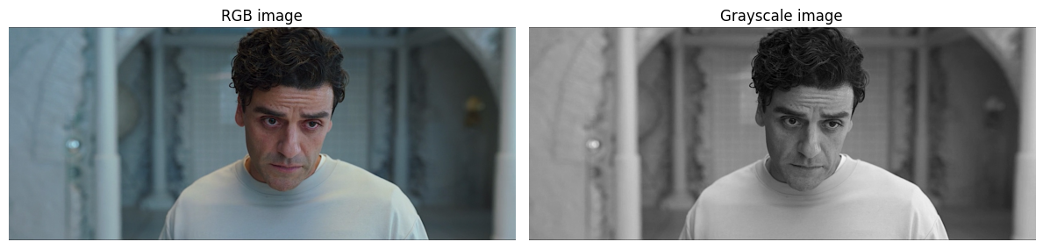
Figure 1: nb01_RGB and Greyscale

Color Conversion
rgb_to_gray() applies the ITU-R BT.601 luminance formula. gray_to_rgb() stacks the single channel three times — the result is visually gray but is a valid (H,W,3) array.
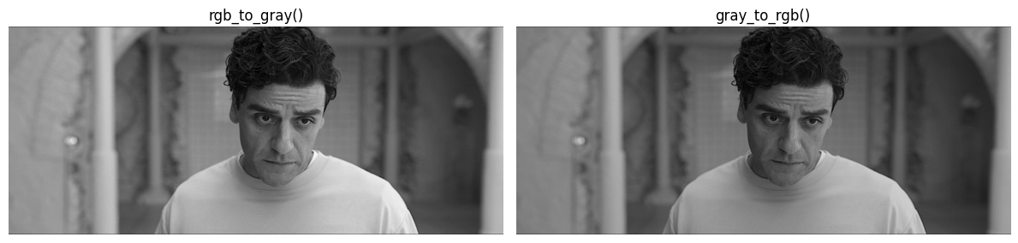
Figure 2: nb01_rgb to grey & grey to rgb
Note: The grayscale output of rgb_to_gray retains the same perceived brightness as the original RGB image because the weights match human visual sensitivity.

Core Operations (nb02)

Normalization Modes
Three modes are demonstrated side by side: minmax (range [0,1]), zscore (mean~0, std~1), and uint8 (range [0,255]). An interactive slider controls the input image.
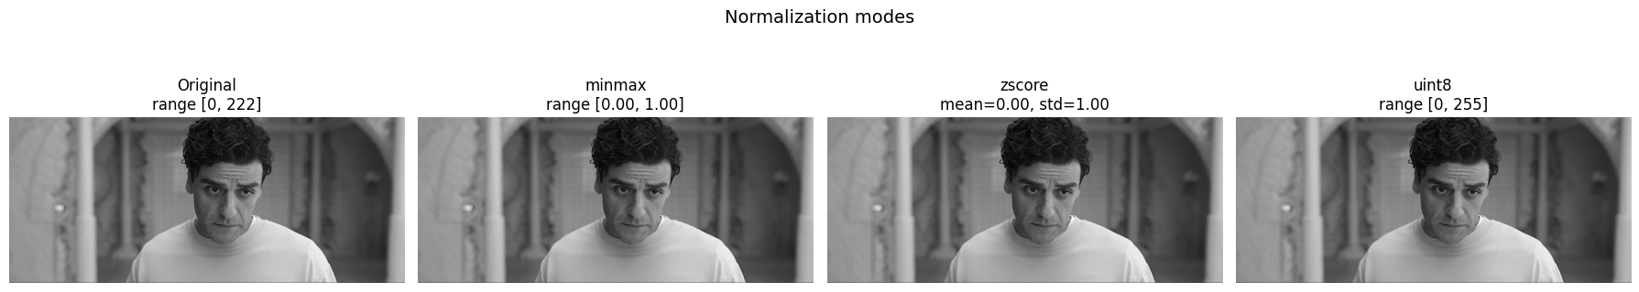
Figure 3: nb02_ normalization panel: original, minmax, zscore and unit8.
Comparison: minmax preserves the visual appearance of the image and is preferred for display. zscore produces negative values and requires a symmetric colormap. uint8 is identical to minmax but returned as an integer array use this when passing into functions that expect uint8 input.

Clipping Modes
Three clipping variations are demonstrated side-by-side to illustrate dynamic range restriction: Low-clipping (threshold at 100), High-clipping (threshold at 150), and Dual-clipping (range [80, 180]).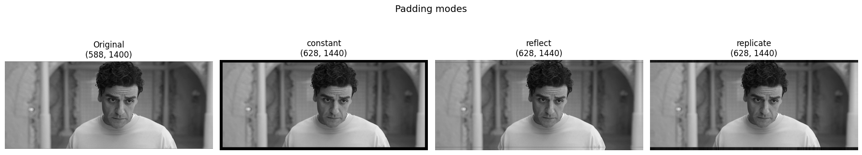
Figure 4: Clipping Comparison.
Comparison: Reflect and replicate produce smoother, more natural transitions at the borders than constant padding, which introduces a sharp artificial edge. For convolution and deep learning tasks, replicate padding is often preferred to avoid "dark border" artifacts or ringing effects in the filtered output, as it maintains the local intensity of the image edges.

Padding Modes
constant, reflect, and replicate padding are shown on the same image with the same pad size. The border region visually distinguishes the three strategies.

Figure 5: Padding Comparison.
Comparison: reflect and replicate produce smoother borders than constant (zero) padding. For convolution, replicate padding is preferred at edges to avoid dark border artifacts in filtered output.

2D Convolution
Three kernels are demonstrated: identity (output = input), Laplacian (edge detection), and sharpen. The identity kernel verifies that convolve2d is numerically correct.
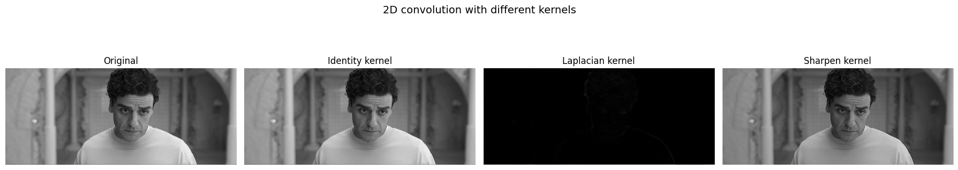
Figure 6: convolution: identity, Laplacian and sharpen kernels

Padding Mode Effect on Convolution
The same edge-detection kernel is applied with all three padding modes. Differences are visible at the image boundaries.
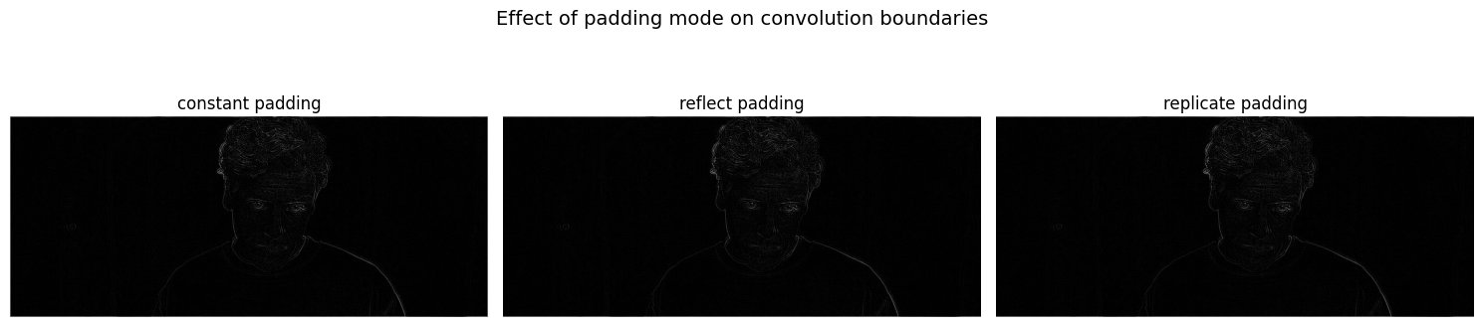
Figure 7: conv boundary comparison: constant, reflect and replicate
Comparison: constant padding causes a dark ring at the border (zeros pulled into the kernel). reflect and replicate both avoid this — replicate is generally preferred for edge-preserving filters.

6.3 Filtering & Thresholding (nb03)

Mean Filter
Box blur applied at three kernel sizes (3, 7, 15). Larger kernels produce more smoothing at the cost of sharpness. Interactive slider controls kernel size in real time.
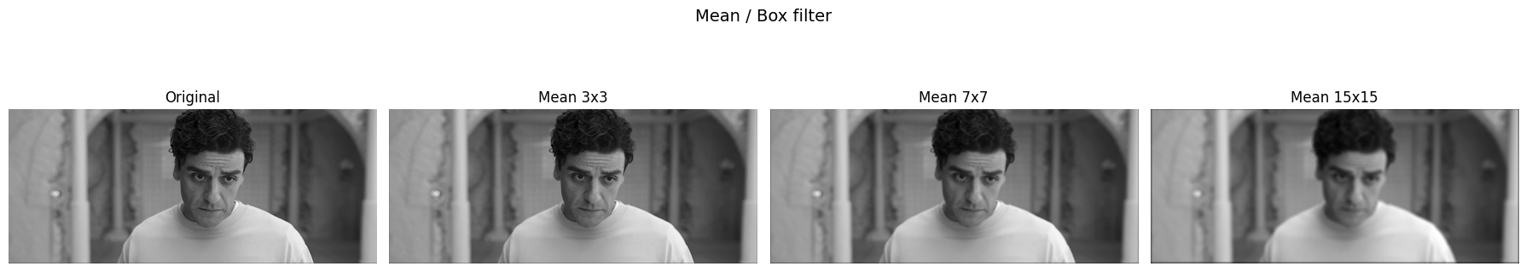
Figure 8: nb03_mean filter: k=3, k=7 and k = 15
Comparison: The mean filter blurs uniformly in all directions. It is fast but does not preserve edges — strong edges become soft gradients at larger kernel sizes.

Gaussian Filter
Gaussian blur applied at three (kernel_size, sigma) pairs. Both kernel_size and sigma are controllable interactively. The Gaussian kernel is displayed alongside the output.
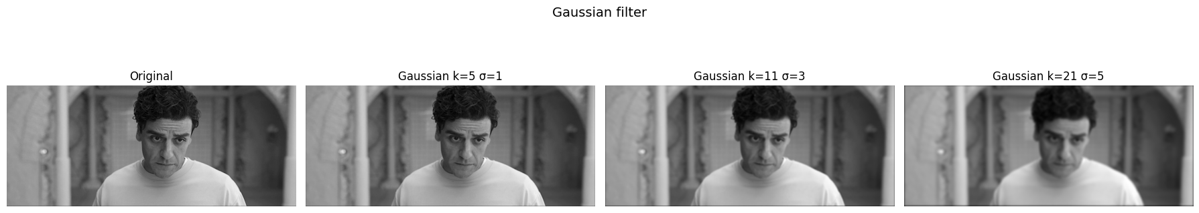
Figure 9: nb03 — Gaussian filter: k=5 σ=1, k=11 σ=3 and k=21 σ=5
Comparison: Gaussian blur is smoother than mean blur because it weights central pixels more heavily. At the same kernel size, Gaussian produces less ringing and better preserves coarse structure.

Median Filter
Median filter demonstrated on a salt-and-pepper noisy image at three kernel sizes. The noise is artificially added (5% salt, 5% pepper) for clear verification.
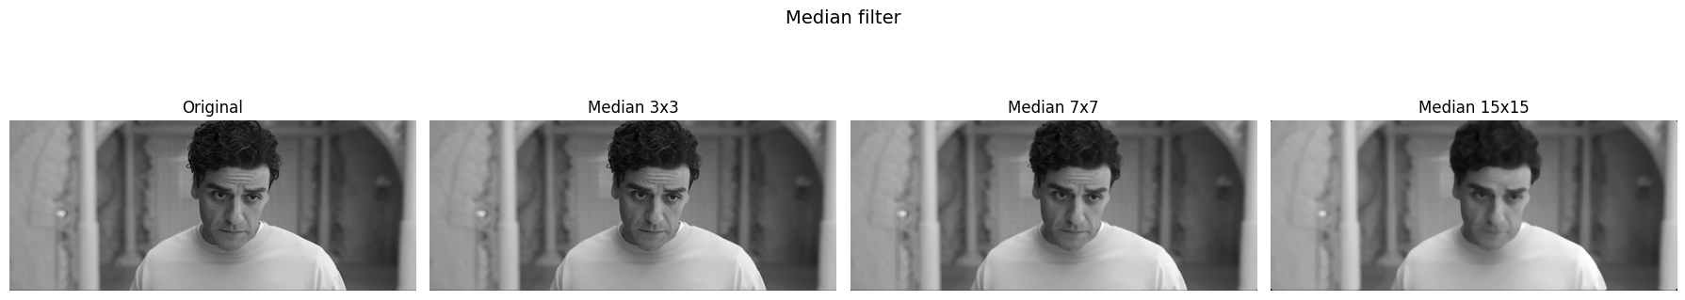
Figure 10: nb03_median filter on noisy image: k=3, k=7 and k=15
Comparison: Median excels at removing impulse (salt-and-pepper) noise while preserving edges — unlike mean or Gaussian, it does not average in the noise values. This is why a median at k=3 outperforms mean or Gaussian at the same size for impulse noise.

Noise Removal Comparison
All three filters applied to the same noisy image at their default sizes for a direct visual comparison.
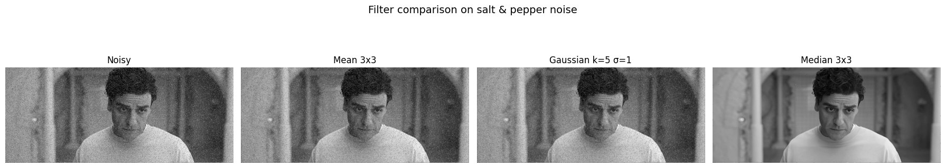
Figure 11: nb03_filter comparison on noisy: mean, Gaussian and median

Global Threshold
Binary output at three fixed thresholds (64, 128, 192). Pixels above the threshold become 255, below become 0.
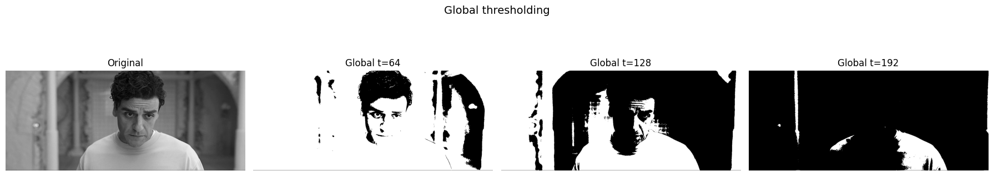
Figure 12: nb03_global threshold: t=64, t=128 and t=192
Comparison: Higher threshold values produce sparser foreground (more black pixels). The correct threshold depends on the image histogram — for bimodal histograms, any value in the valley between peaks works well.

Otsu Threshold
Otsu automatically selects the threshold that maximizes inter-class variance. The computed threshold value t is displayed in the title.
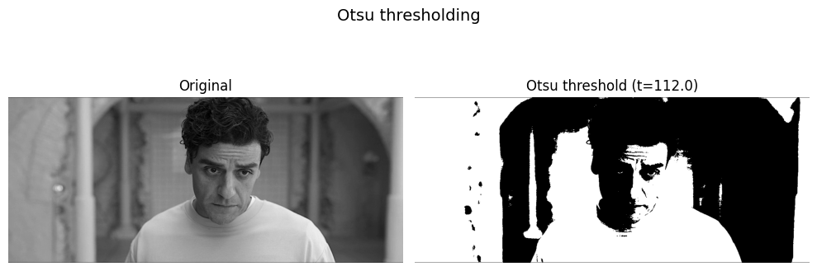
Figure 13: nb03_Otsu result with computed t value
Comparison: Otsu performs best on images with clear bimodal histograms. It requires no manual tuning and consistently finds a near-optimal threshold. For images with uneven illumination, adaptive thresholding outperforms Otsu.

Adaptive Threshold
Mean and Gaussian adaptive thresholding compared. block_size and C are interactive. Smaller blocks handle finer illumination variation.
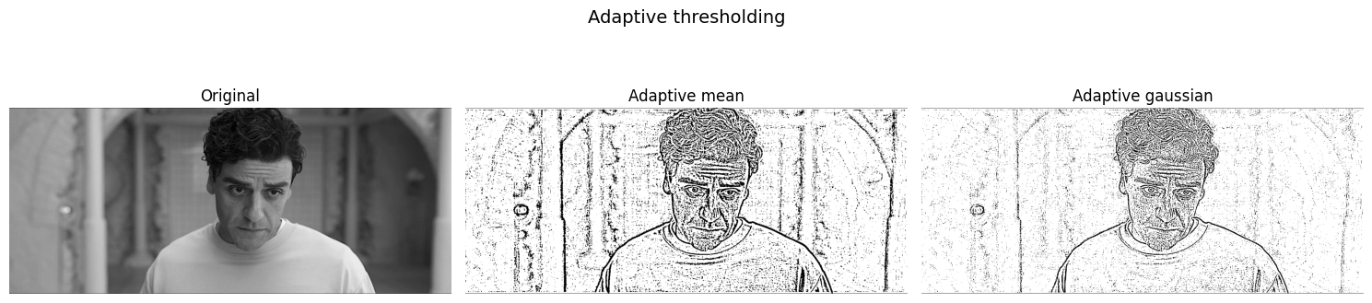
Figure 14: nb03_adaptive: mean vs Gaussian method
Comparison: Adaptive mean uses a uniform local average as the threshold — it treats all pixels in the neighborhood equally. Adaptive Gaussian weights central pixels more heavily, which reduces the haloing effect visible around edges with the mean method.

All Thresholds Compared
Global (t=128), Otsu, adaptive mean, and adaptive Gaussian shown side by side on the same image. 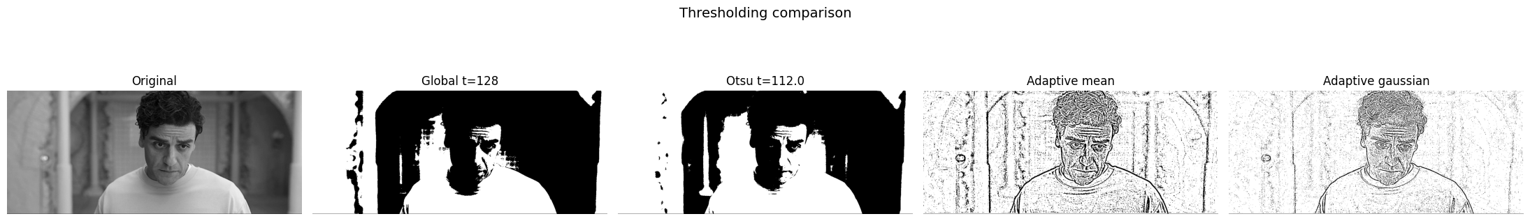
Figure 15: : nb03_threshold comparison panel

Techniques (nb04)

Bit-Plane Slicing
All 8 bit planes (0–7) displayed as binary images. An interactive slider selects the plane. Plane 7 (MSB) carries the majority of visual information.
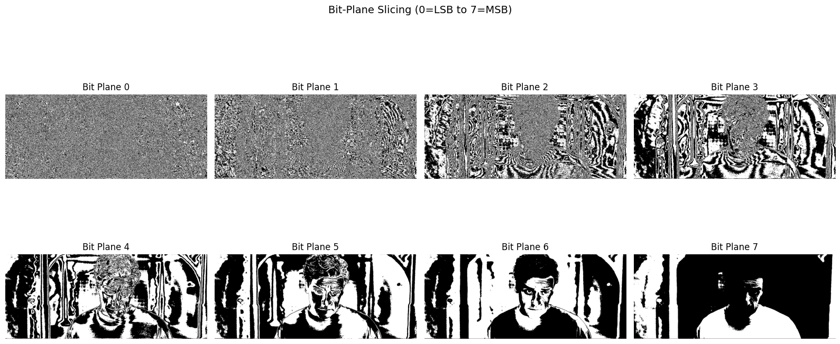
Figure 16: nb04_Bit Planes
Comparison: Planes 6 and 7 together reconstruct a visually recognizable image. Planes 0–2 appear as noise — they encode fine intensity differences that are invisible to the eye but affect numerical precision.

Histogram
Pixel intensity histogram shown as a bar chart alongside the image. Interactive slider controls bin count (8 to 256).
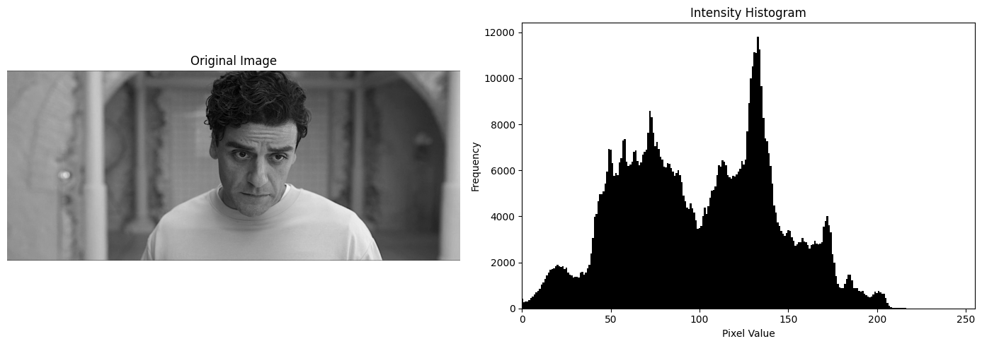
Figure 17: nb04_Image and its histogram
Note: A histogram spanning the full [0,255] range with uniform distribution indicates good contrast. A narrow histogram clustered around mid-values indicates low contrast — a prime candidate for equalization.

Histogram Equalization
Before and after histograms shown alongside the images. The equalized image has a noticeably flatter histogram.
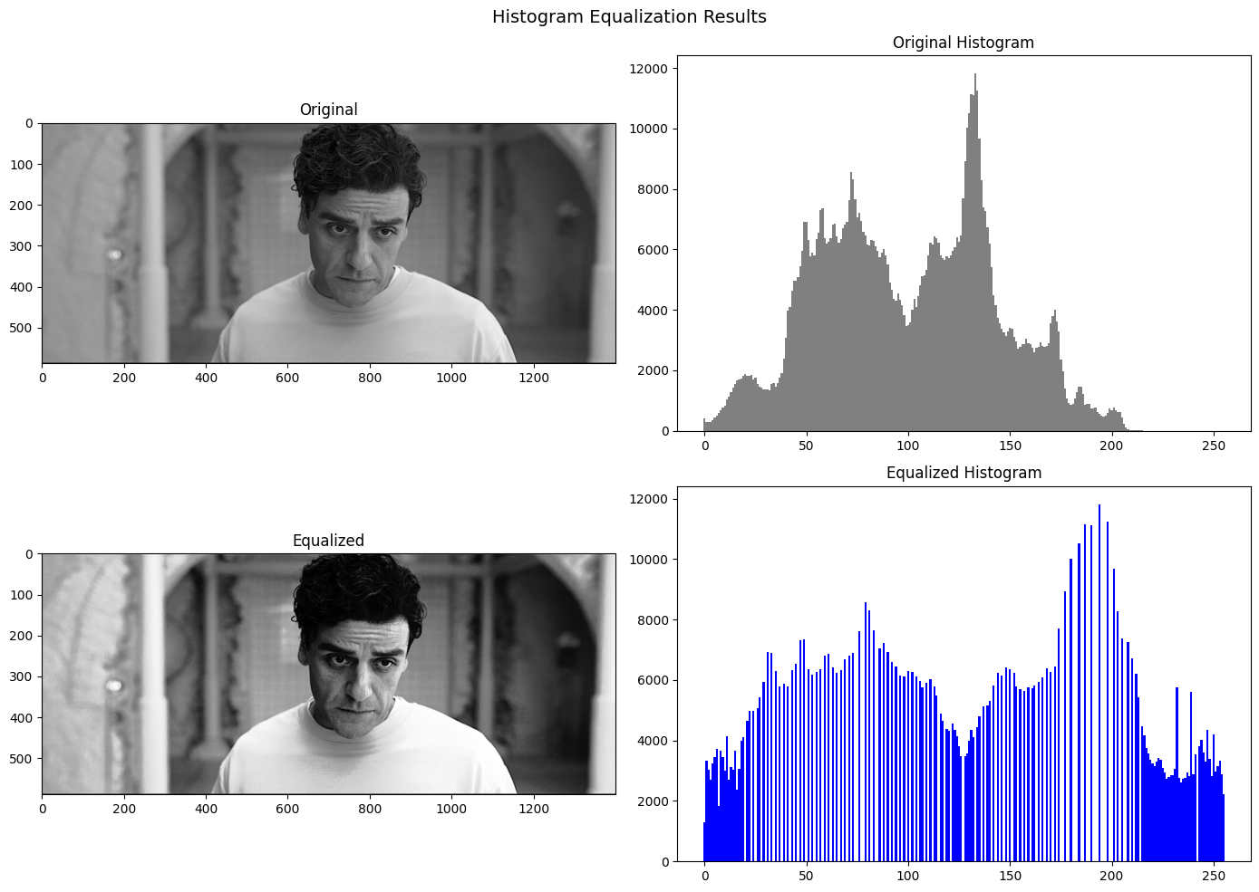
Figure 18: nb04_equalization: original vs equalized and their histograms
Comparison: Histogram equalization maximizes global contrast but can over-enhance noise in already well-exposed images. It is most effective on images with narrow histograms (low dynamic range).

Contrast Stretching
Input and output range are interactive. The linear stretch maps [in_low, in_high] to [0, 255].
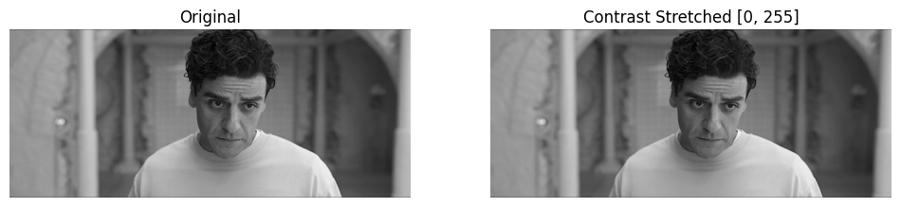
Figure 19: nb04_contrast stretching result
Comparison: Contrast stretching preserves the histogram shape (just rescales it), whereas histogram equalization redistributes pixel values to achieve a flat histogram. Stretching is more predictable and less aggressive.

Laplacian Sharpening
Sharpening strength is interactive. The Laplacian highlights edges; adding it back to the original amplifies those edges.
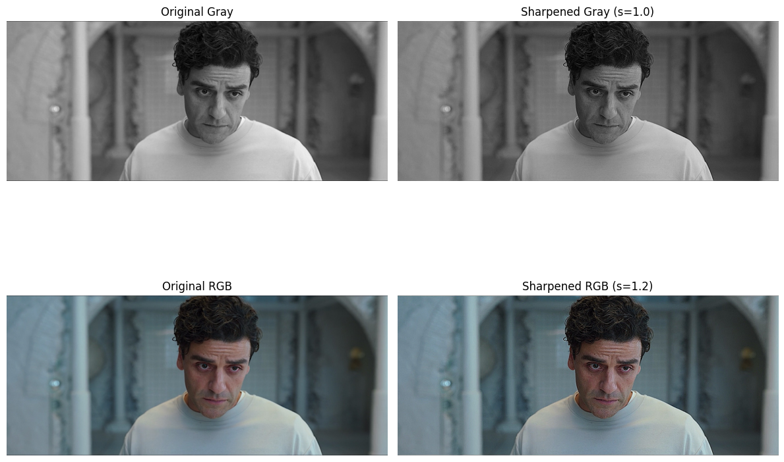
Figure 20: nb04_Laplacian sharpening for greyscale and rgb images
Comparison: Low strength (0.5–1.0) produces subtle sharpening. High strength (>2.0) begins to amplify noise and create ringing artifacts around edges.

Comparison Between all techniques
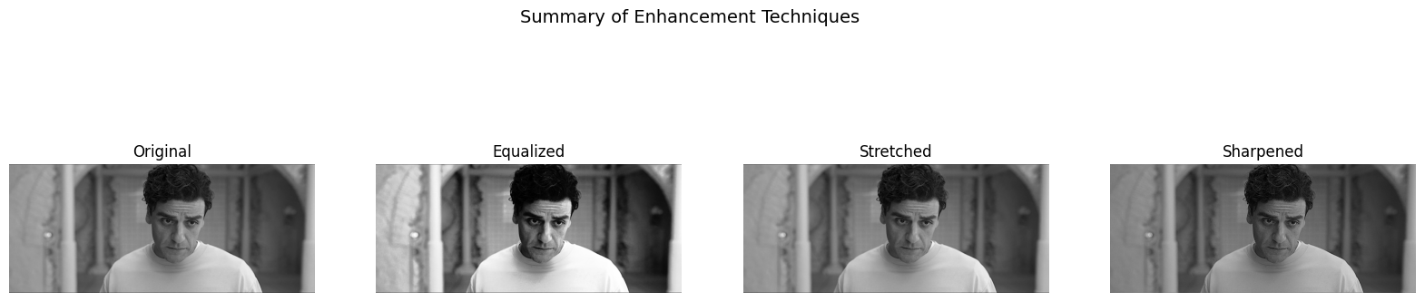
Figure 21: nb04_enhancment techniques comparison

Geometric Transforms (nb05)

Resize
Target height and width are controlled by sliders (range: 10 to 2x original). Interpolation method (bilinear / nearest) is selectable via dropdown. Output shape is printed in the title.
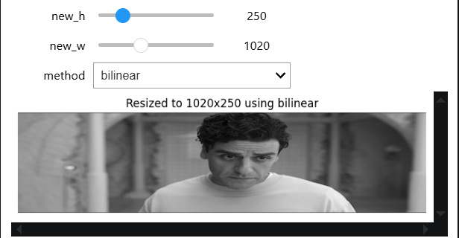
Figure 22: nb05_resize
Comparison: Nearest-neighbor produces blocky artifacts when upscaling (pixel replication). Bilinear interpolation blends four neighboring pixels and produces smoother upscaled output. For downscaling, the difference is less visible but bilinear remains preferred.

Rotation
Rotation angle is controlled by a slider (-180° to +180°). Interpolation method is selectable. The output canvas is the same size as the input — corners are filled with zero.
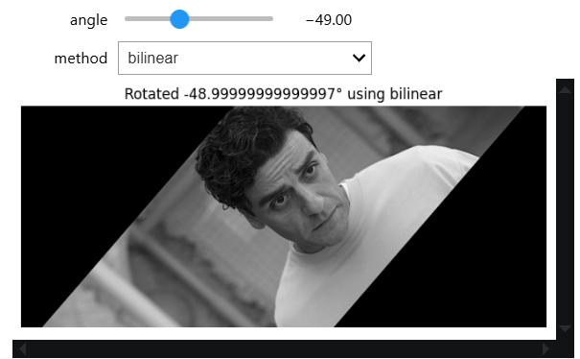
Figure 23: nb05_rotation
Comparison: Nearest-neighbor rotation shows jagged diagonal edges (aliasing). Bilinear rotation blends between source pixels along the rotated path, producing smoother diagonal edges at the cost of slight blurring.

Translation
shift_x and shift_y are controlled by sliders. Positive shift_x moves right, positive shift_y moves down. Content shifted off canvas is discarded.
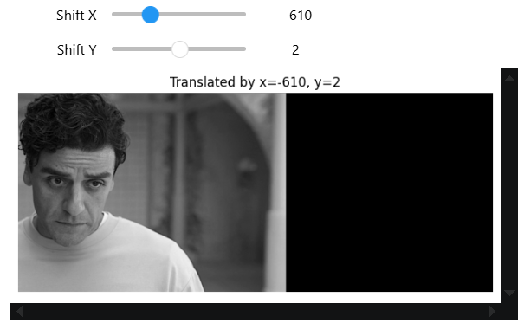
Figure 24: nb05_translation
Note: Translation is implemented via NumPy array slicing — no interpolation is needed because shifts are integer pixel offsets. The operation is exact and lossless for the visible region.

Feature Descriptors (nb06)

Color Histogram Descriptor
Normalized histogram per channel (R, G, B) displayed as bar charts. bin count is interactive. The full descriptor vector is the three histograms concatenated.
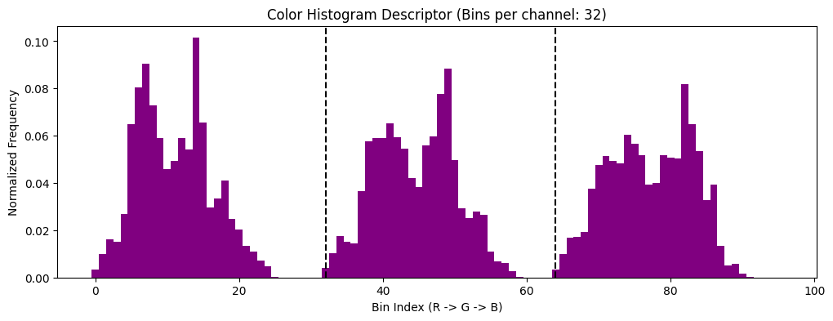
Figure 25: color histogram descriptor for each channel RGB
Note: Each channel histogram sums to 1.0. The concatenated vector has shape (bins*3,). This descriptor captures global color distribution but is not spatially aware — two images with the same colors in different positions produce identical descriptors.

Hu Moments Descriptor
Seven Hu moment invariants displayed as a bar chart. The log-transformed values compress the dynamic range for usability as ML features.
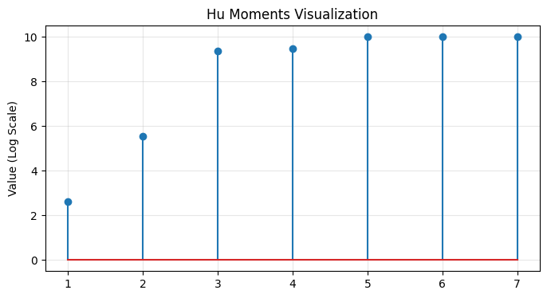
Figure 26: nb06_Hu moments bar chart
Comparison: Hu moments are invariant to translation, rotation, and scale — the same object at different positions/orientations produces the same descriptor. This makes them useful for shape-based recognition but insensitive to texture.

HOG Descriptor
HOG cell grid visualized as gradient arrows overlaid on the image. cell_size and bins are interactive. The descriptor vector dimensionality is printed.
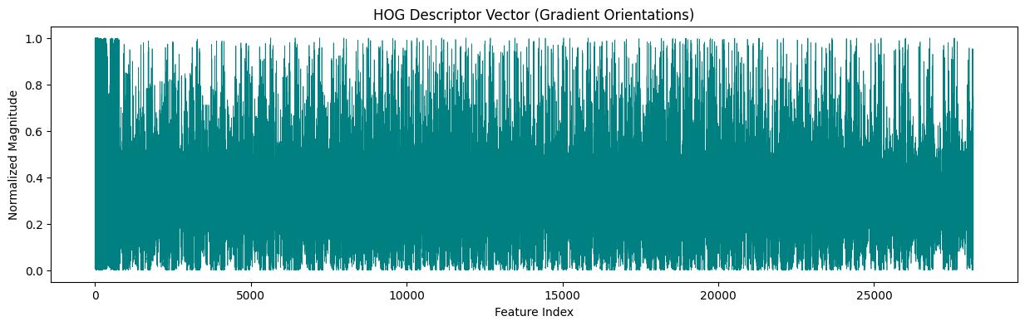
Figure 27:nb06_HOG visualization with gradient arrows
Comparison: HOG captures local gradient structure — it is sensitive to shape and edges within each cell, making it effective for object detection. Unlike global descriptors, it retains spatial information through the cell grid layout.

LBP Descriptor
LBP code map displayed as a grayscale image alongside the normalized histogram. radius and n_points are interactive.
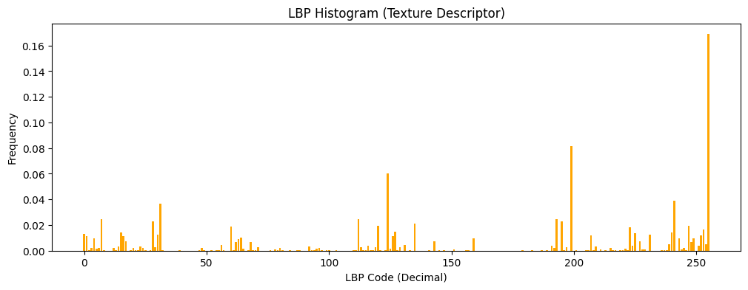
Figure 28:nb06_LBP map and histogram
Comparison: LBP captures local texture patterns — repeated textures (fabric, wood grain) produce distinctive histogram peaks. It is rotation-variant in its basic form but computationally cheap. Larger radius captures coarser texture; smaller radius captures fine-grained patterns.

Feature Vector Comparison

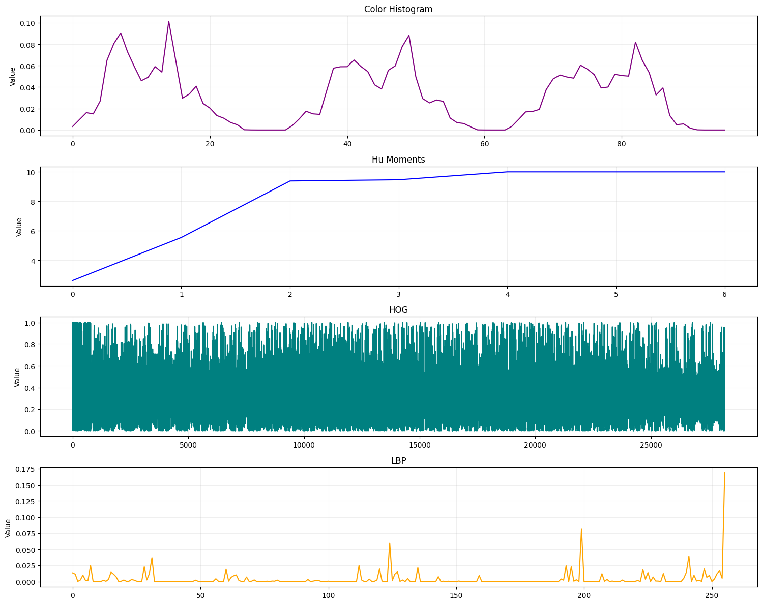
Figure 29:nb06_Feature Vector Comparison

Drawing Primitives (nb07)

draw_point
x, y, thickness, and color (RGB or grayscale intensity) are all controlled interactively. The canvas updates in real time. Red dashed lines mark the canvas boundary (x=0, y=0).
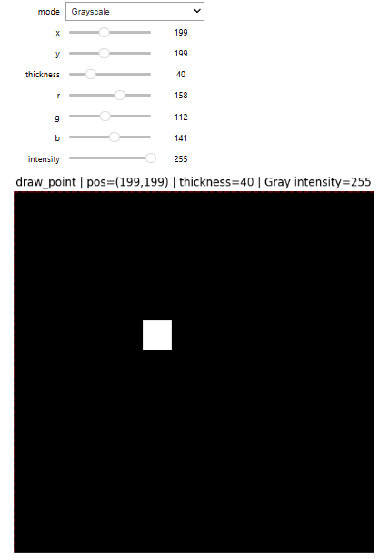
Figure 30:nb07_point drawing
Note: When x or y is negative, the point is partially or fully outside the canvas. The _fill_rect() clipping correctly draws only the visible portion — no wraparound artifact occurs.

draw_line (Bresenham)
Start and end coordinates, thickness, and color are all interactive. Lines extending outside the canvas are automatically clipped.
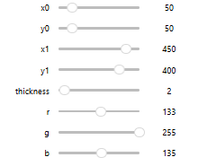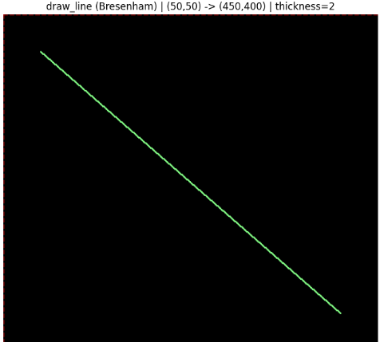
Figure 31: nb07_draw a line
Note: Bresenham's algorithm uses integer arithmetic only. The line passes through the expected sequence of pixels with no gaps or diagonal jumps.

draw_rectangle — Interactive
All four corners, thickness, fill mode, and color are interactive. When x0 >= x1 or y0 >= y1, the plot displays a clear validation error message instead of crashing.
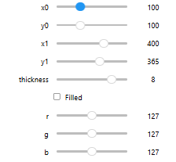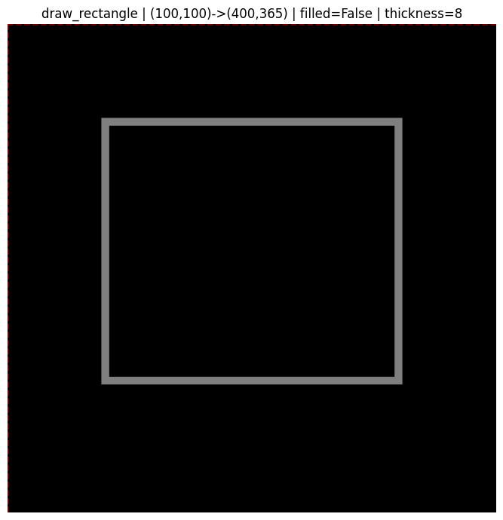
Figure 32: nb07_draw a rectangle
Comparison: Filled rectangle uses a single NumPy slice assignment — O(1) in implementation complexity. Outline rectangle draws four lines using draw_line, inheriting Bresenham clipping at each edge.

draw_polygon — Interactive
The apex vertex is controlled interactively. Fill mode and color are selectable. Both RGB and grayscale modes are supported. As the function is for any polygon you can specify the number of vertices.
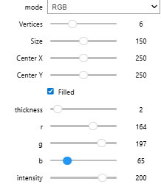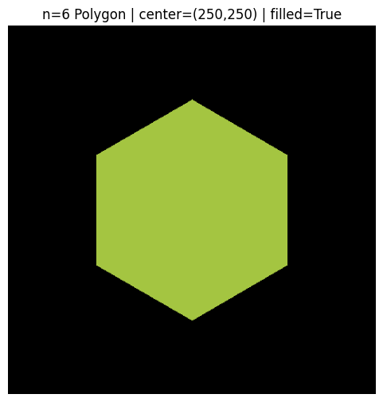
Figure 33: nb08_draw a polygon
Comparison: Outline polygon connects vertices with Bresenham lines — clipping happens per-segment. Filled polygon uses a scanline algorithm — intersections are computed per row and filled via _fill_rect().

draw_text — Interactive
Text content, position, scale, and color are all interactive. The 5x7 bitmap font scales by integer multiples. Canvas boundary is shown with red dashed lines.
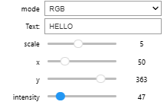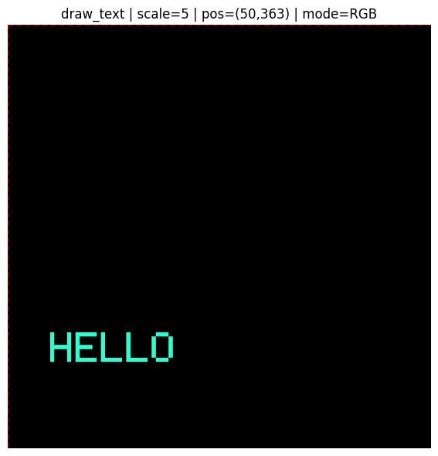
Figure 34: nb07_Text
Note: Characters not in the font (lowercase letters are auto-uppercased; symbols outside the defined set are skipped silently). The font covers A-Z, 0-9, and common punctuation.

Boundary Clipping Stress Test
A 200x200 rectangle is moved across the canvas using offset sliders. As it moves outside the boundary, it is correctly clipped — no artifacts, no crashes. Status is printed in the plot title.

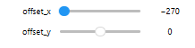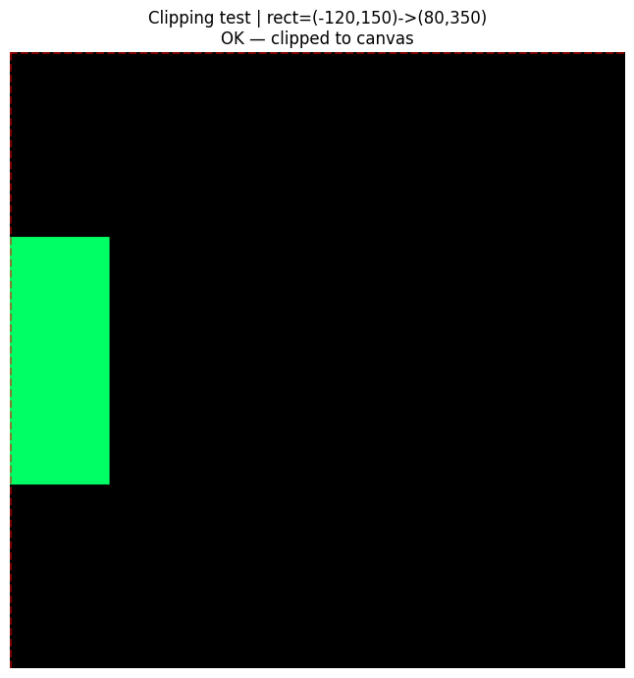
Figure 35: nb07_clipping test

All Primitives Combined
A single static canvas demonstrating all five drawing primitives together: a dark filled background, outline rectangle, crosshair lines, filled and outline triangles, a center point, and text label.
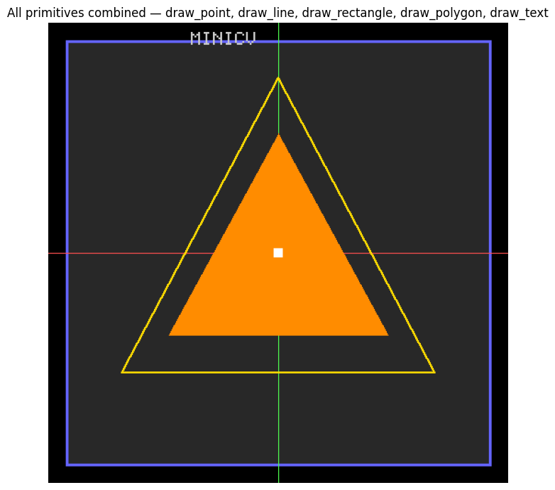
Figure 36: nb07_combined drawings

6.8 Automated Test Suite
A test script (test_minicv.py) runs shape assertions, dtype checks, and value range checks on all 9 modules using synthetic random images. All tests pass.
Module | Tests performed | Status
utils | normalize 3 modes, clip, pad 3 modes, convolve2d shape | PASS
io | save + reload RGB and gray, shape check | PASS
color | rgb_to_gray shape, gray_to_rgb shape | PASS
filtering | mean/gaussian/median shapes, Sobel output shapes | PASS
thresholding | binary values subset of {0,255}, Otsu t in [0,255] | PASS
techniques | all 8 bit planes, histogram length, equalization dtype | PASS
transforms | resize/rotate/translate shapes for gray and RGB | PASS
features | descriptor shapes, normalization sum = 1.0 | PASS
drawing | all primitives run without error on gray and RGB | PASS

Key Verification Checks
- Gaussian kernel: sum = 1.0 within 1e-6 tolerance
- Otsu threshold: t always in [0, 255]
- All binary threshold outputs: values only in {0, 255}
- Color histogram and LBP histogram: each channel sums to 1.0
- Identity kernel convolution: output numerically equal to input
- Resize output shape: exactly matches requested (out_h, out_w)
- Rotate output shape: identical to input shape
- draw_point at negative coords: no wraparound, correct clipping
- draw_rectangle when x0>=x1: clear error message shown, no crash

Project Repo
Github_repo

