# UnityEditorScript(UES) Document

**UnityEditorScript(UES) is so easy to creat EditorWindow.It’s looks like ActionScript3.You can find help in “Tools/UnityEditorScript”.**

UnityEditorScript(UES)是灵活简便实现EditorWindow界面的插件。它的实现与ActionScript3比较相似。你可以在顶部菜单Tools/UnityEditorScript查看相关内容。

Window

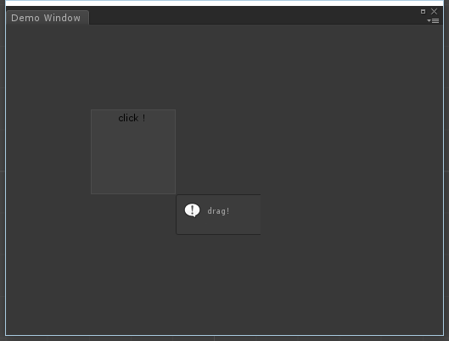

DisplayObject

Stage

1. **Creat Window**

**Your custom EditorWindow need inherited USEWindow.**

创建窗体

自定义窗口需要继承自UESWindow

public class UESDemoWindow : UESWindow

{

//Open window

[MenuItem("Tools/UnityEditorScript/Demo")]

static void Init()

{

var window = EditorWindow.GetWindow<UESDemoWindow>();

window.titleContent = new GUIContent("Demo Window");

window.Show();

}

1. **Creat DisplayObject**

创建显示对象

一般情况在Awake()中创建显示对象，使用AddChild添加对象。

protected override void Awake()

{

base.Awake(); //Important!Window initialize(初始化)

var box = UESTool.Create<UESBox>(this); //Create display object(创建对象)

box.Rect = new Rect(100,100,100,100); //Set size and position(设置尺寸位置)

box.Mask = new Rect(-20, -20, 220, 300); //Support mask(支持遮罩)

stage.AddChild(box); //Important!Add to stage for rendering(添加到舞台才能显示)

}

1. **Add Listener**

**It’s different between Target and CurrentTarget.**

添加事件监听

注意Target与CurrentTarget的区别！

**...**

stage.AddEventListener(UESMouseEvent.MOUSE_CLICK, OnMouseClick); //舞台添加鼠标点击监听

void OnMouseClick(UESEvent obj)

{

var display = obj.Target as UESDisplayObject;

Debug.Log(display.Name);

}

**4.DisplayObject List**

显示对象列表

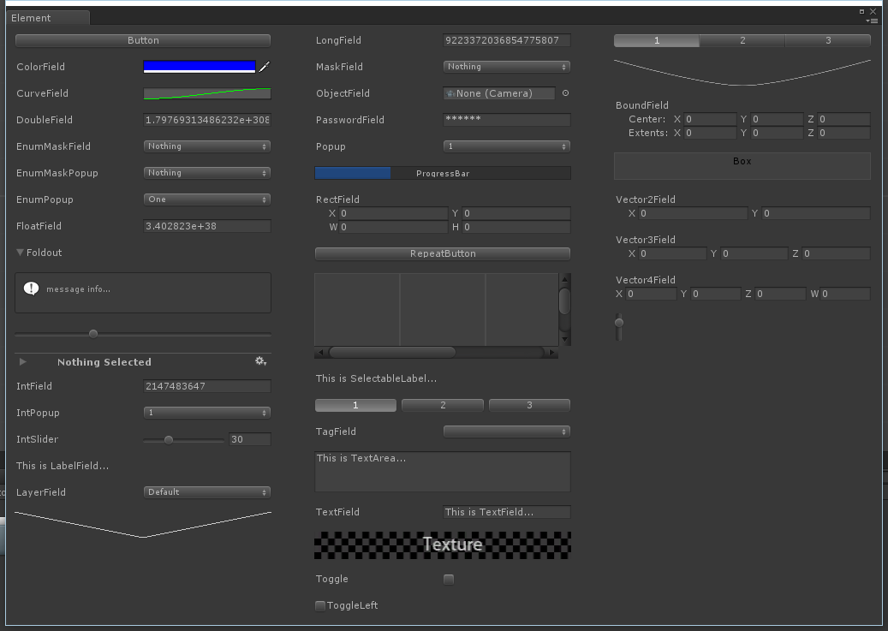

**V1.0**

1.Easy to creat EditorWindow.

2.You can add ui element on stage;