**Sergeyev K.G.**

**Program Guide**

**"Escape from tarkov item editor"**

**Moscow 2022**

**Contents**

1. Introduction 3

2 General information about the program 4

2.1 Flowchart of actions 4

2.2 First launch 5

2.3 Settings window 8

3. Working with subject editors 11

3.1 Item selection window 11

3.2 Editing item characteristics

and global settings 14

4. Working with presets 17

4.1 Creating a Preset, Adding Items and

characteristics to a preset, change the created preset 17

4.2 Loading Presets into the Game 22

**1. Introduction**

SPT-AKI Escape From Tarkov items editor (here in after EFT editor) is made as a free licensed third-party software allowing to change the open files of the game in SPT AKI, with this program you can change the characteristics of items in items. json (size of munitions, ammunition penetration, etc.) and editing global characteristics in globals. json (speed of experience, character's Hp, etc.). The program allows after the first start and selection of the main game directory to change the characteristics of items in open game files semi-automatically.

The application works as a stand-alone without writing data in the PC registry and runs from a shortcut, also the application has a test opportunity to save the necessary changes in the file and transfer between users through the created file in the folders Application/save/FileChanges/Game*/* and Application/save/Presets/*.

This manual will describe how the application functions and will consistently explain what, where, where, and for whom.

The program while the test then will be redone on the code will be finished interface and optimized work with the loading of the subject. The main recommendation for the system requirements - this processor i5 and above. Technically it should work on weaker processors, but I have not checked.

¯\_(ツ)_/¯

**2. general information about the program**

**2.1 Action structure chart**

Creating a Preset

Changing characteristics

Switching on the preset creation mode with sidebar replacement

Launching an application

Selecting the mode for adding an item to a preset

Initial configuration of folder paths

Selecting an item and adding its characteristics to the sidebar

Opening the main window in the EFT editor

Selecting multiple features or an object within a feature list (string with [ or {) followed by adding

Pressing the "Settings" button on the menu tab

Selecting the language, selecting the animation panels, creating a copy of the game files to change the characteristics save settings and exit to the main window via "Ok"

Confirming the creation of a preset

Opening the presets loading window in the "Working with presets" menu tab via the "Load preset" button

Selecting an item to replace the characteristics in the "Select an item & create a preset" panel

Add the desired presets from the "Available presets" list to the "Added presets" list

Hide the menu tab, change item characteristics and/or global characteristics in the editor

Load a preset into the game using the "Load Preset" button

Save changes to the item via the right sidebar to backup (a copy of the game file for later replacement)

If you want to change an already created preset, press the "Change preset" button in the "Work with presets" menu tab, and change the name and description of the preset at the very beginning (when selecting a preset to change)

Save all changes to items/global settings from the selected backup file to the game file through the sidebar by selecting the appropriate editor

**2.2 First Run**

The first launch of the "Escape from tarkov item editor" application is designed to automatically select the game's directories and fill the folders with the necessary files. The v.0 version automatically creates:

1. The sources of the game to restore by copying from the game directories.
2. Source copy files containing characteristics for subsequent game file replacements.
3. The basic settings of the application are set automatically

Below is a flowchart explaining the role of copy files for replacements.

Replacement is done by pressing the "Restore" button in the tinctures window

File source application to restore the original game file

Loading the raid and starting the game session

File copy with modified characteristics to replace the main game file

The main game file with characteristics

Editing a copy file via the editor, then saving it to a copy file via the sidebar

Replace by clicking the "Save to Game" button on the sidebar

Block diagram 1: Principle of Character Substitution via Game Files

At the first start of the application a semi-automatic configuration of the application for further work will be made. It starts with the user being prompted to select the Launcher.exe file (Image 1) in the game directory, and the SPT AKI version is not important, as the application is created with different types of architecture in mind.

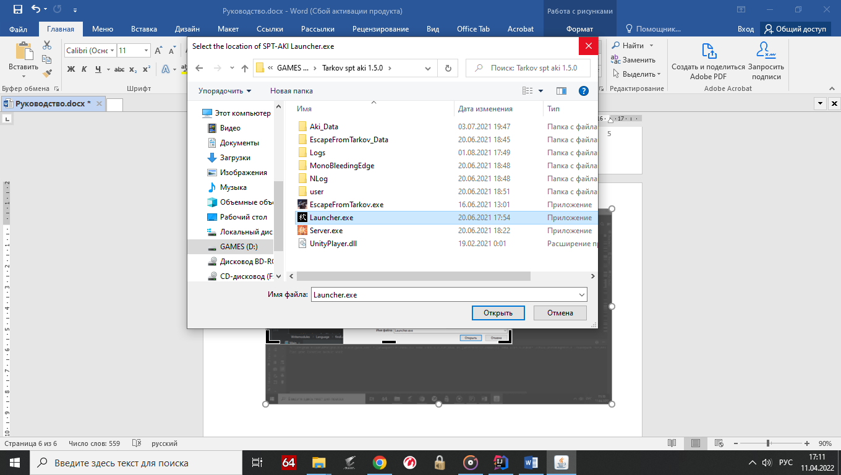Image 1. Selecting Launcher. exe

Once the game directory is selected, the application will automatically set the paths to the game directories, then it will read the game files to be restored into the folders at the path save/backup/*/* and make the files-copies for editing at the path save/FileChanges/*/*/*.

It is worth noting two important facts, users only need the backup files to work. The files in the backup folder are best left untouched. The program is able to partially recover from damaged directories and loss of Settings. txt. For example, if you need a different version of the game, delete Settings. txt and then select the desired directory SPT-AKI.

Damaged directories are also recreated, but the files in them are not restored.

After that, the main program window will open (Image 2).

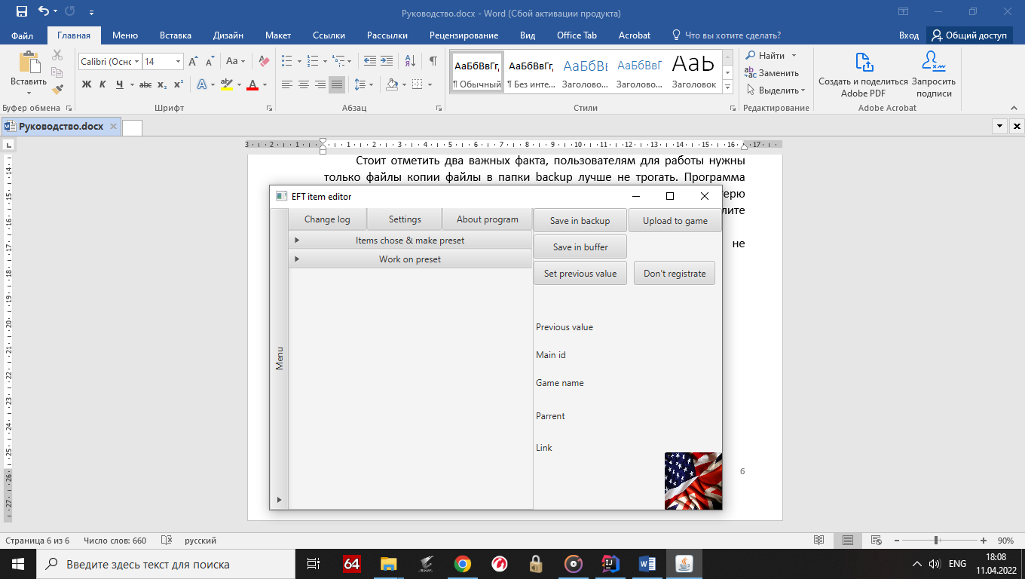Image 2: Main application window

8

7

6

5

4

3

2

1

The main application window is a group of modules marked with numbers, except for module 1 all other modules work and perform certain functions:

1. In the future, the module will show the changes made and allow you to roll back to a certain point
2. Settings button that allows you to configure applications and work with files to replace
3. Button about the program
4. File selection and preset mode activation module
5. Module for working with presets, both created and ready-made
6. Window in which modules 4 and 5 are located
7. Hidden menu bar, which closes the item editors, it has a window under the number 6
8. Sidebar for working with item editors, can be replaced by the panel for adding items to a preset

For the final configuration of the application, go to Settings and change the language to Russian, then you can disable the smooth animation of hiding some panels (menus as an option). And create files for replacement with the desired name.

**2.3 Settings window**

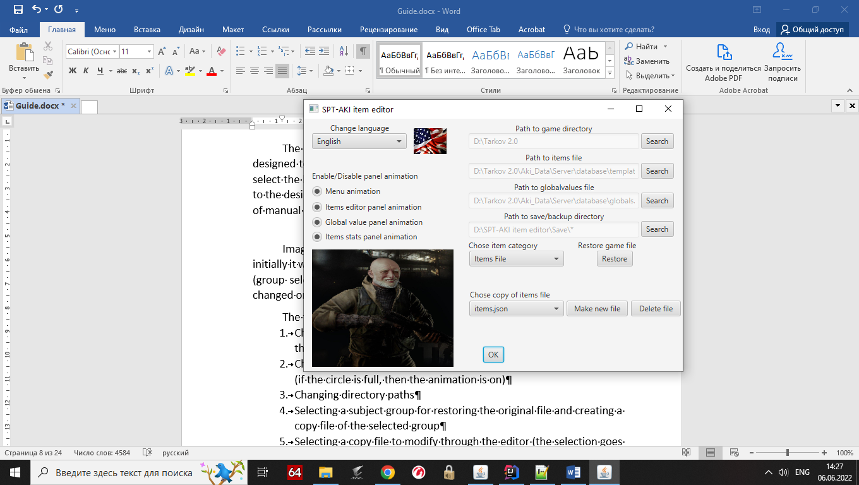The settings window (Image 3) in the test version of the application is designed to create and delete files, to change the operation of the panels, and to select the language. You can also select directory paths manually to save changes to the desired folder rather than the game folder, but there is a nuance in the form of manual restoration of settings.

Image 3: The settings window with Eng language

Image 3 shows the window with the Russian language already selected, initially it will be in English. Also for optimization, all settings except work with items (group selection, restore the original file and work with the copy file) will be changed only after you click on Ok.

The following functions are implemented in the settings window:

1. Changing the language by selecting the language with the country flag in the pull-down list
2. Changing the panel animation through the button with a click indication (if the circle is full, then the animation is on)
3. Changing directory paths
4. Selecting a subject group for restoring the original file and creating a copy file of the selected group
5. Selecting a copy file to modify through the editor (the selection goes through groups)
6. Creating and deleting copies of files (the creation comes from the source file in the application folder or from the selected file when the button is pressed)

For example, a block diagram (block diagram 2) and step-by-step work with editable files will be shown.

Selected group of items

Source of the selected group in the application folder

Button to create a new file for editing

Button to delete the selected file for editing

Selecting available files for editing from the application folders

List of files for further editing

Button to restore the original game file

Available files for editing

The main game file of the selected group

Selected file for editing

Feature Editors

Block diagram 2. How the settings work

The principle of selecting files to replace characteristics follows the following logic. In total in the program there is an n-th number of groups of files used for replacement, the user for work with a certain group selects it in the list of groups, for example, Itemsfile, it means that the module of work with files works with items. json in the directory of the game and the files replacing the main file will be selected from the application directory save/FileChanges/Gameitems/*, where * is the selected file.

In the "Select File Copy" file list, the user can select a file to replace the characteristics later and replace the game file, while all other files in the same group do not participate in the process of changing characteristics. This is done so that there are different local presets of characteristics, for example, in one file shotguns and grenades are useless, in another only they can do significant damage.

Then there are buttons to delete a file and to create a file. If you click the delete button, the selected file will be deleted, but a warning will be displayed before it.

If the Create File button is selected, the text box will be enabled (Image 4).

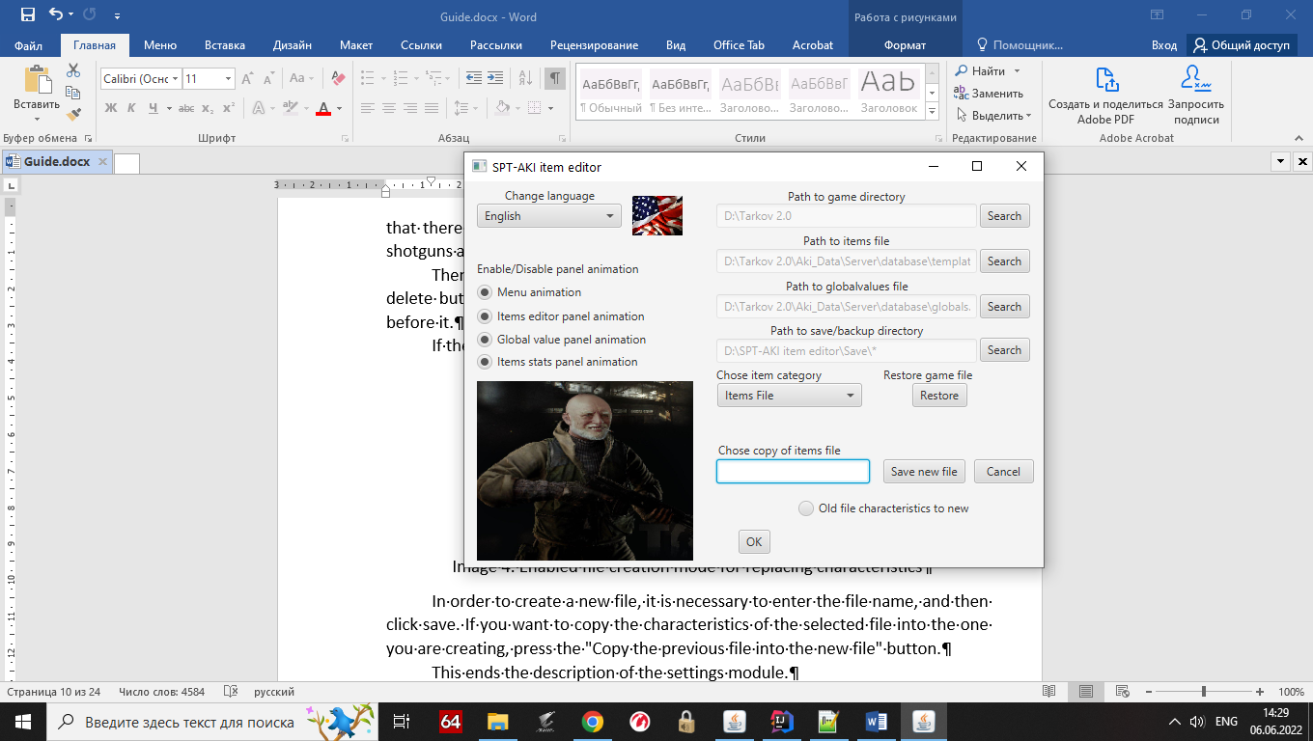

Image 4. Enabled file creation mode for replacing characteristics

In order to create a new file, it is necessary to enter the file name, and then click save. If you want to copy the characteristics of the selected file into the one you are creating, press the "Copy the previous file into the new file" button.

This ends the description of the settings module.

**3. Working with subject editors**

**3.1 Item selection window**

The Select Item Selection window for changing characteristics (Image 5) is used to select an item to be loaded into the characteristics editor and added to a preset (this property is described in the Creating a Preset chapter).

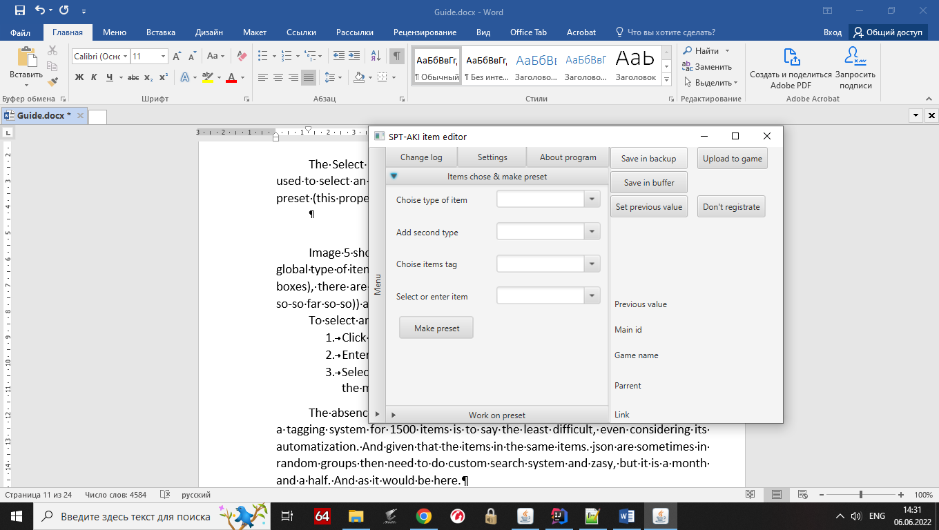

Image 5: Selecting Subject & Creating a Preset

Image 5 shows a window with 4 items. Their principle is as follows, there is a global type of item (Ammunition) there is a secondary type of item (Rounds, Ammo boxes), there are tags (RUS, 5.45x39 (Tags are still English, but the system is test so-so far)) and the item itself which is picked up by these limiters.

To select an item you can do the following things:

1. Click on the item list arrow and select the desired
2. Enter the name of the subject in the selection field in English
3. Select the type of item (ammo can also be selected by tags in view of the made test system) then perform 1 or 2 points

The absence of tags for most of the items is explained by the fact that doing a tagging system for 1500 items is to say the least difficult, even considering its automatization. And given that the items in the same items. json are sometimes in random groups then need to do custom search system and zasy, but it is a month and a half. And as it would be here.

The most difficult thing in this window is the selection of tags so will be given an explanation of the principle of purely nominal, for the average user, I advise to skip the description and read the next chapter (if anyone at all decided to read the documentation).

The tagging system is a modular, semi-automated system that allows you to add, modify, delete and view tags.

Description in brief. In the tag field to enter characters and is a selection of tags containing matches on the type, if you beat 9 then will give out all the tags that contain 9, taking into account the limitations of the main and second group. Therefore, if you enter 9x19 and selected Gear, then in the things of the character cartridge he will not find and respectively will be an empty selection window.

Once the tag or tags have been selected (9x19 and 5.45x39 will be taken for example) the following functions can be used:

1. View selected tags - shows all tags in a popup list, useful when there are more than 2 tags
2. Match items - starts selection of an item based on the entered tags, if the tagged items are 0, then the item cannot be selected
3. Change tag - convenient tag replacement mode, allows you to select a tag already added and replace it with another one available
4. Delet tag - allows you to delete a tag through a list
5. Delete all tags - allows you to delete all tags, used in combination with Match items if you want to reset the selection of items

Next comes the secondary selection system, for this you need to change any tag tag and the process of replacing the tag will begin, at the end of which several options will be offered:

1. Rewrite tag name - if such a tag already exists, you cannot add it and the function allows you to enter another one
2. Add new tag - adds a new
3. Rewrite other tag - rewrites the selected tag from the provided list
4. Do nothing - return the tags to their original state
5. Delet other tag - removes the selected tag from the list

An example of filling out the selection window can be seen in Image 6.

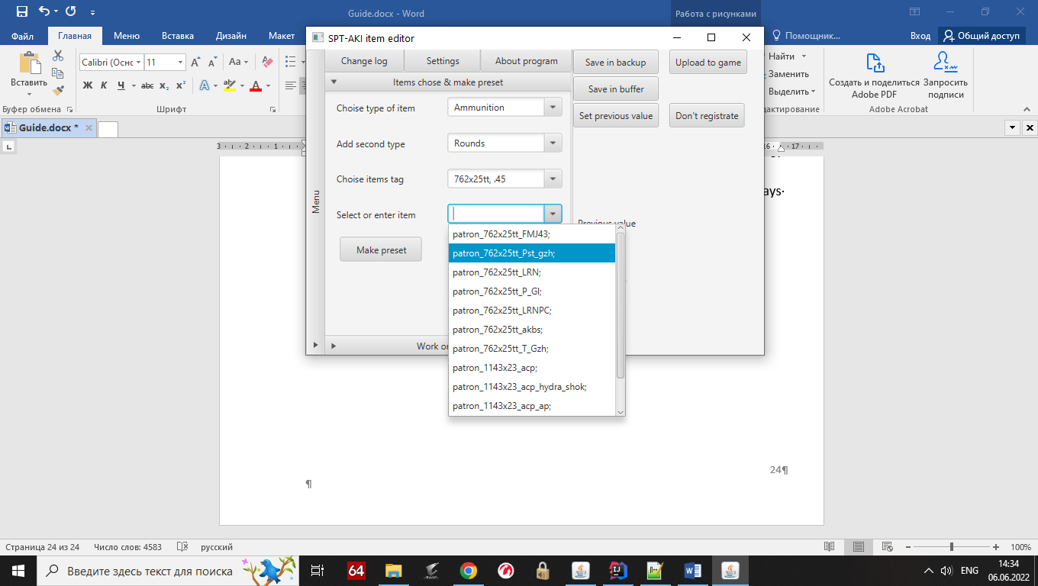

Image 6. Filled item selection window

In this example, set the limiters of the item selection and tag in the main group Ammunition (ammo) and the additional group Rounds (bullets), then selected tags and pressed Match items, based on which the list and made cartridges 7.62x25tt and .45ACP (in the game is registered as 1143x23_acp).

In case you want to remove the limiter + tags (their selection remains but not applied Match items) you can select an empty space in the main type selection, it means no limiter.

**3.2 Editing item characteristics and global settings**

This chapter describes how to edit an in-game item, but if you want to edit global characteristics, you can skip the description of item selection.

To start editing an item, select the item in the selection module, and then you can start editing, the right panel, which lists the selected item in the naming block, serves as an indicator of the selected item (Image 7).

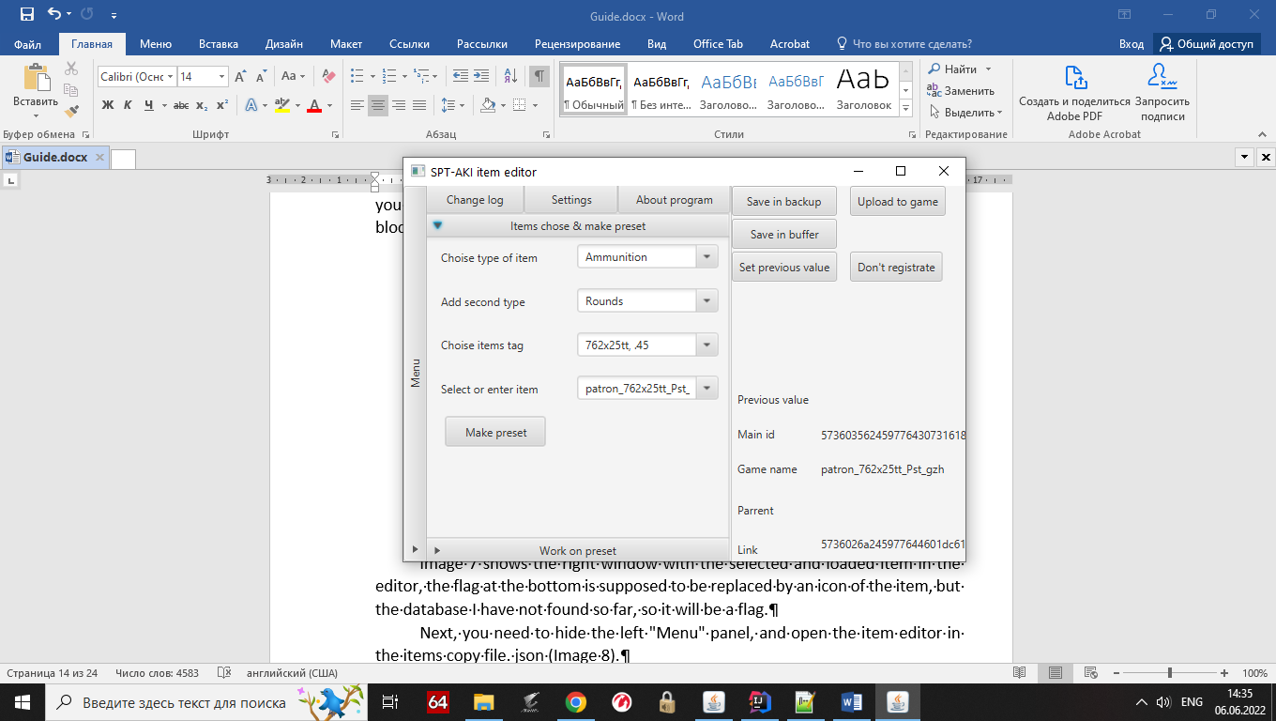

Image 7. The selected item is shown in the left pane

Image 7 shows the right window with the selected and loaded item in the editor, the flag at the bottom is supposed to be replaced by an icon of the item, but the database I have not found so far, so it will be a flag.

Next, you need to hide the left "Menu" panel, and open the item editor in the items copy file. json (Image 8).

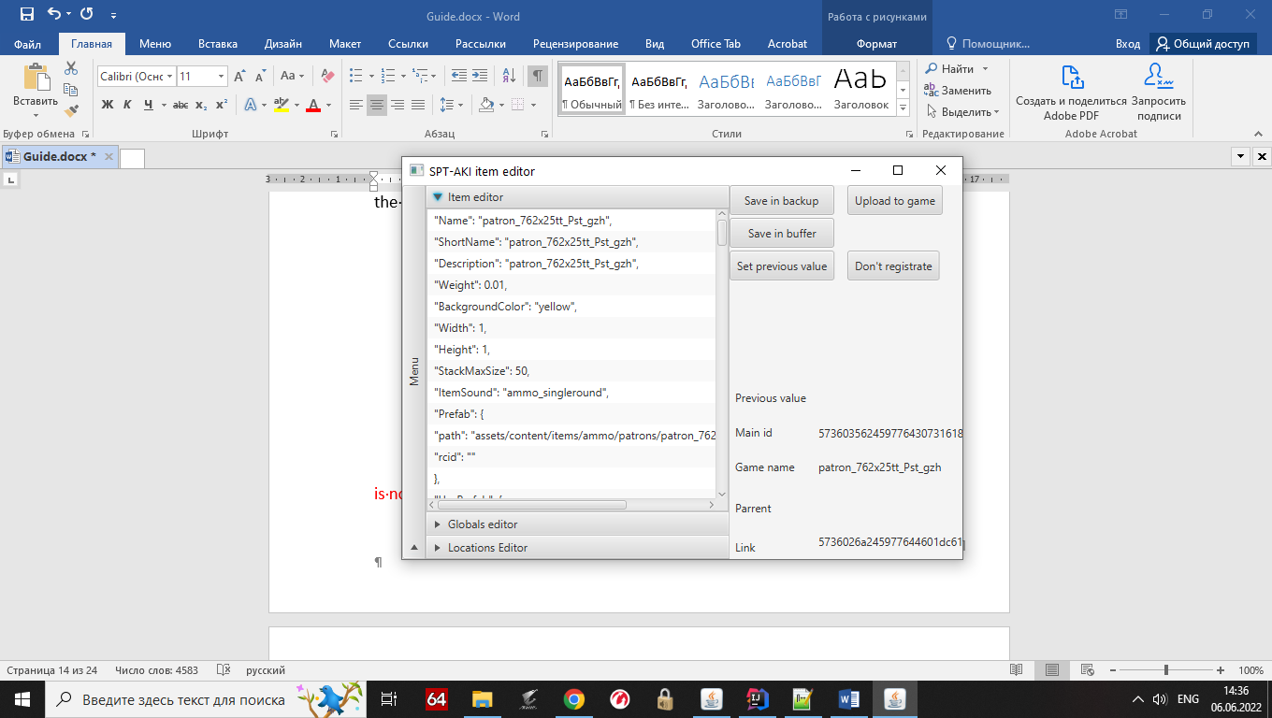

Image 8. The selected item is shown in the right pane

Or open the Globals.json editor to edit global characteristics (item selection is not needed for it yet).

The principle of the editor is as follows, the right sidebar shows the part of the object responsible for all characteristics, starting from parrent and ending with Proto (Link). The main characteristics of the object are placed in the left panel for convenience.

In order to begin editing the characteristic, you must double-click on any cell containing the value, it contains "", then the automation itself will select the value and give it in the window cutting off unnecessary things, for example by double-clicking in the cell with the Name will only cartridge name that can be changed (Image 9).

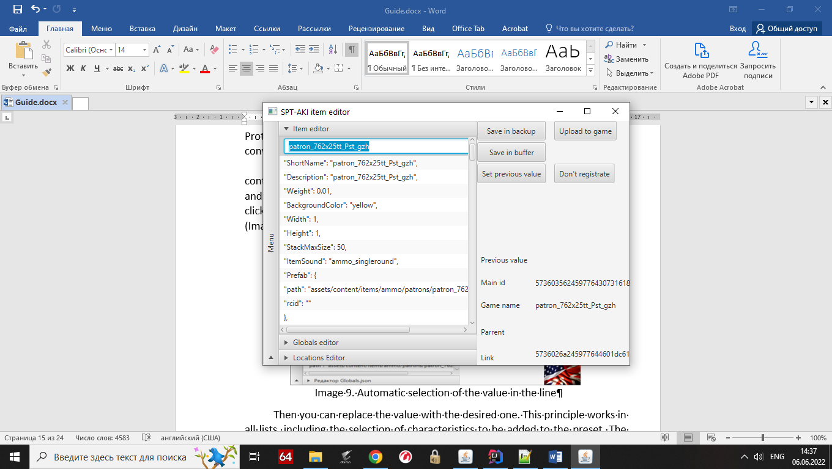

Image 9. Automatic selection of the value in the line

Then you can replace the value with the desired one. This principle works in all lists, including the selection of characteristics to be added to the preset. The following is a description of the functions of the right sidebar:

1. Save to backup - saves the changed characteristics to a file for editing, roll back by pressing the button do not register or restore the value, and then save again. It is important not to click the save to buffer button.
2. Save to game - replaces the game file with a copy file for editing from the EFT Item redactor application folder
3. Save to Clipboard - used to save changes to the list without interacting with the edited file. Changes the list to restore the settings
4. Restore value - restores the value in the selected cell from the restore list buffer
5. Do not register - allows you to reset the entire list to a list from the list restore buffer

The global settings editor (Image 10) differs only in an additional list that allows you to select a group of global values (experience, ragfair, etc.). For now, the test version, then will be finalized.

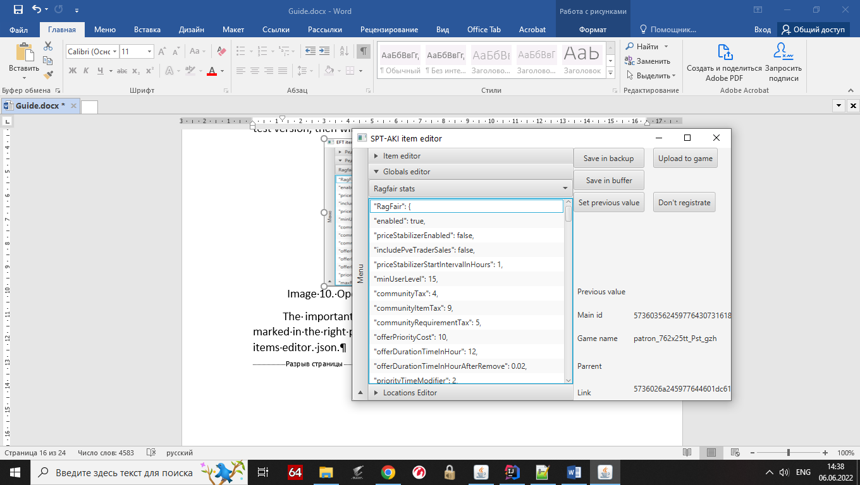

Image 10. Open Globals.json editor with selected ragfair stats group

The important point here is that the selection of the global group is not marked in the right panel. In this case, the principle works the same way as in the items editor. json.

**4. Working with presets**

**4.1 Creating a preset, adding items and characteristics to a preset, changing a created preset**

To start creating a preset, press the "Create Preset" button, then the right sidebar will be replaced, this panel allows only to add characteristics and change them, delete the added need to be in the "Working with presets" window.

Also, the create preset button will be hidden, and in its place will appear the add type selection and the search button. At this point only the selected item can be added, so we select the item (in the example 762x25tt_Pst_gzh), then select the adding type "This item" and press search, then the program looks for the item in the copy file and adds it to the preset + reads the list of its characteristics (picture 11). The indicator of addition will be the filled list in the right panel with the characteristics of the item and the discolored addition type with the search button.

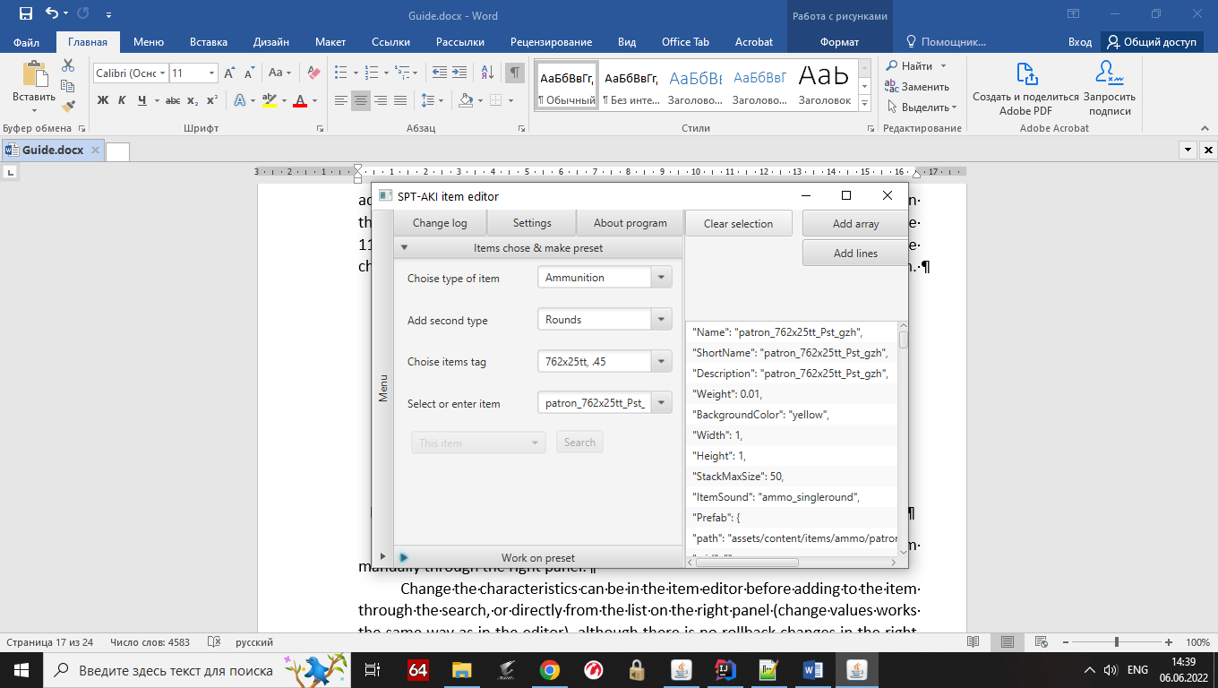

Image 11. Turning on preset replacement mode and adding an item to a preset

The added item in the preset has no characteristics, so you have to add them manually through the right panel.

Change the characteristics can be in the item editor before adding to the item through the search, or directly from the list on the right panel (change values works the same way as in the editor), although there is no rollback changes in the right panel, but in version 0.1 will be added (in about a month).

Next, open the window for working with presets (Image 12).

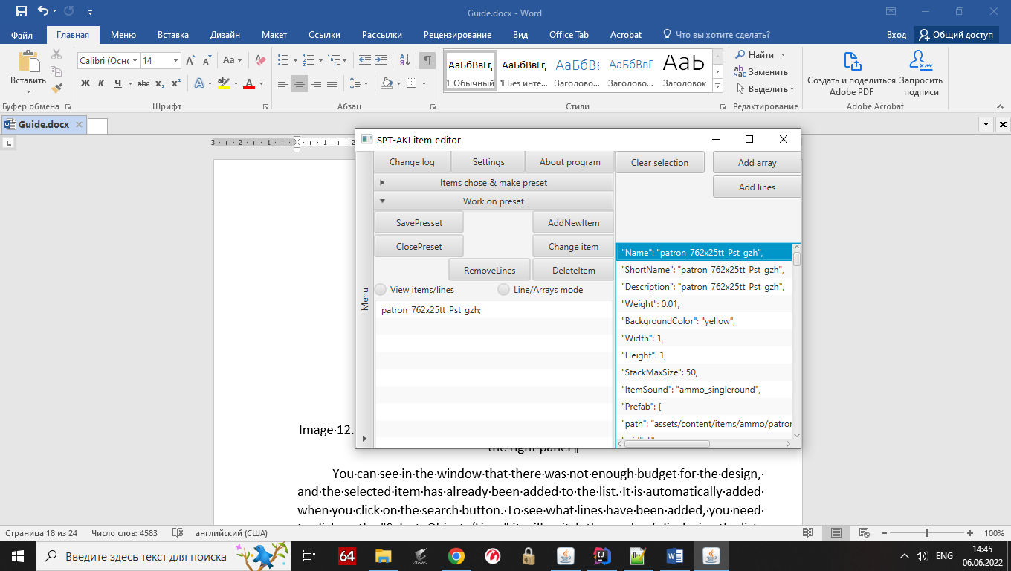

Image 12. The open window with the added object and the changed name field in the right panel

You can see in the window that there was not enough budget for the design, and the selected item has already been added to the list. It is automatically added when you click on the search button. To see what lines have been added, you need to click on the "Select. Objects/Lines" it will switch the mode of displaying the list, in case you want to display the added arrays inside the characteristic, you need to click additionally on the "Lines/Assets" button (Image 13). The already added characteristic lines are shown.

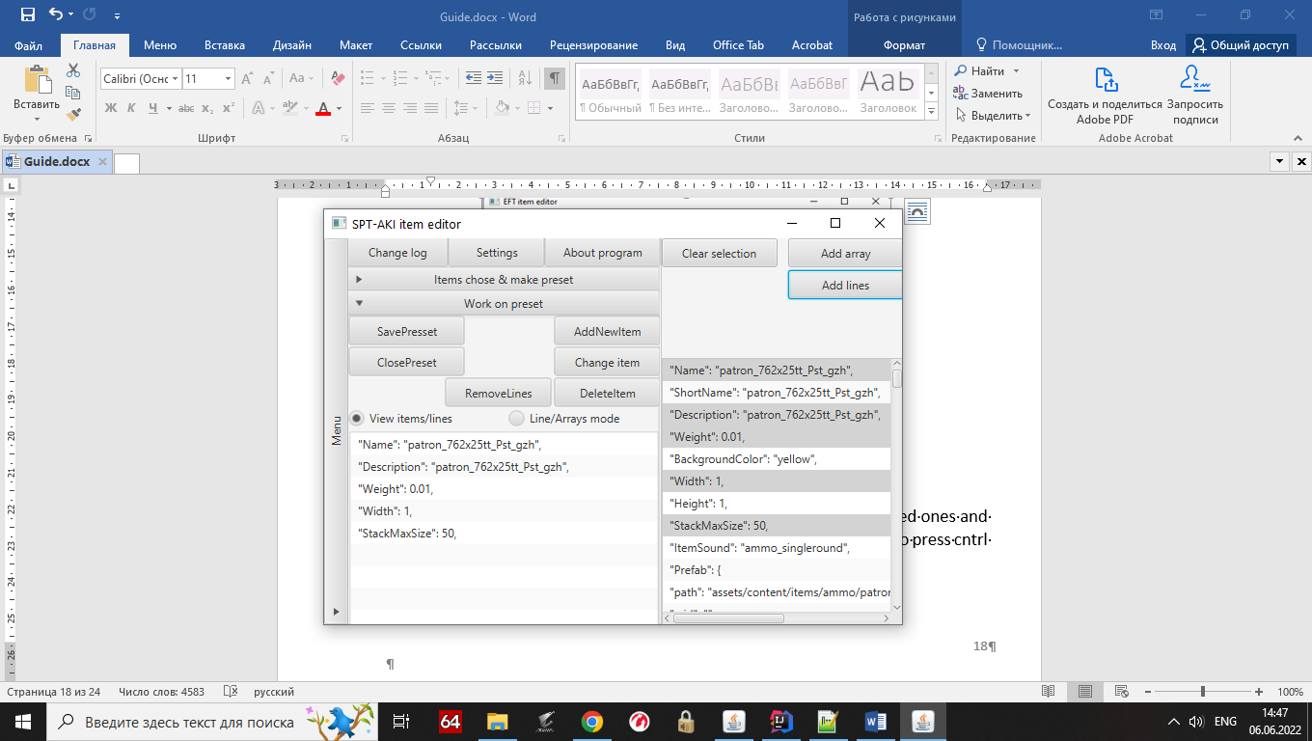

Image 13. Added 5 lines at a time

To add characteristics to the preset you need to select the desired ones and press the appropriate buttons, to add several characteristics you need to press cntrl when adding.

An important point is that the addition of characteristics is in ascending order, and this applies to items (added by group level in the items.json file) and characteristics (added by level in the list).

Also, to add an array, the string must contain the symbol { or [, then the program will automatically analyze the array and add it. If several arrays have been selected, all arrays that meet the conditions will be added. For example, if 1 of the 3 arrays does not have { or [, it will not be added, but the other 2 arrays (objects inside the object) will be added to the preset. On the example of Image 14 the principle will be explained.

3

1

2

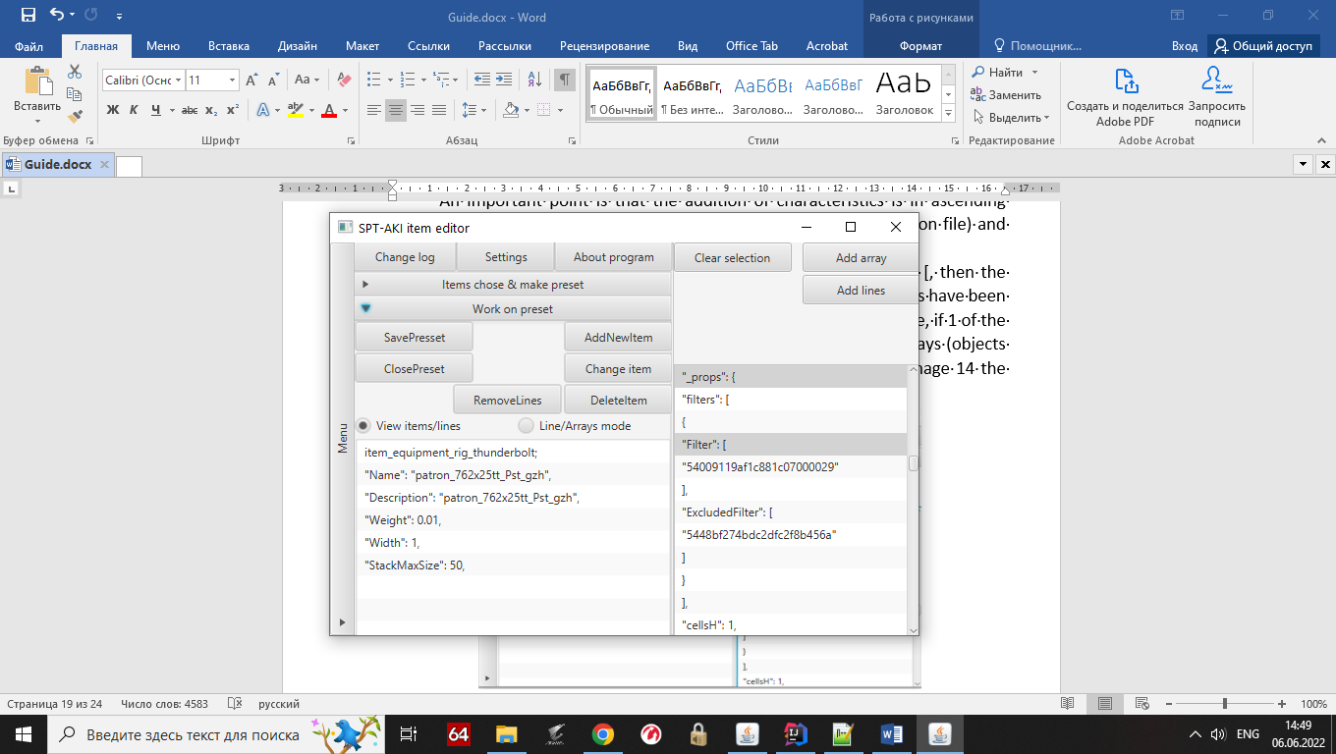

3

2

Image 14. Adding thunderbolt unloading as a second item to the preset and adding 2 arrays

The image above shows the added item, it is a thunderbolt offload and it is the 2nd item in the list, the reason why it is lower is because in items. json all unloads go before ammo and if the preset will change the file more optimized will not pass 10 times to replace groups, but 1-2.

Then in the right pane added 2 arrays, under the numbers 1 and 2 respectively 1 array means pocket 4 of this unloading, and contains all the characteristics of the pouch its ending is behind the user's view so its end is not visually visible, while the number 3 shows that another level is added by a similar character { hence to finish reading the program character }, the example of 2 array shows the beginning and end of the link to the processing inside the 4 pockets.

1. The remove object and remove lines buttons work on the principle that if the corresponding mode is selected, you can remove the object/line, so if you selected to display lines, you cannot remove the object.
2. Replace item button - allows you to replace the selected item to be changed, if it is in the list of the "Working with presets" window
3. Add item button - completes adding characteristics to the preset item and allows you to add a new item to the preset (test limiter)

Once a preset is created and all necessary items have been added, you can either save the preset or close it when it is not needed. In the example, the save preset button is pressed.

When you click the button, the right panel will be hidden, and the "Working with presets" window will replace the content with a window for saving, in which you need to name the preset and optionally add a description. Image 15 shows an example of how to fill it in.

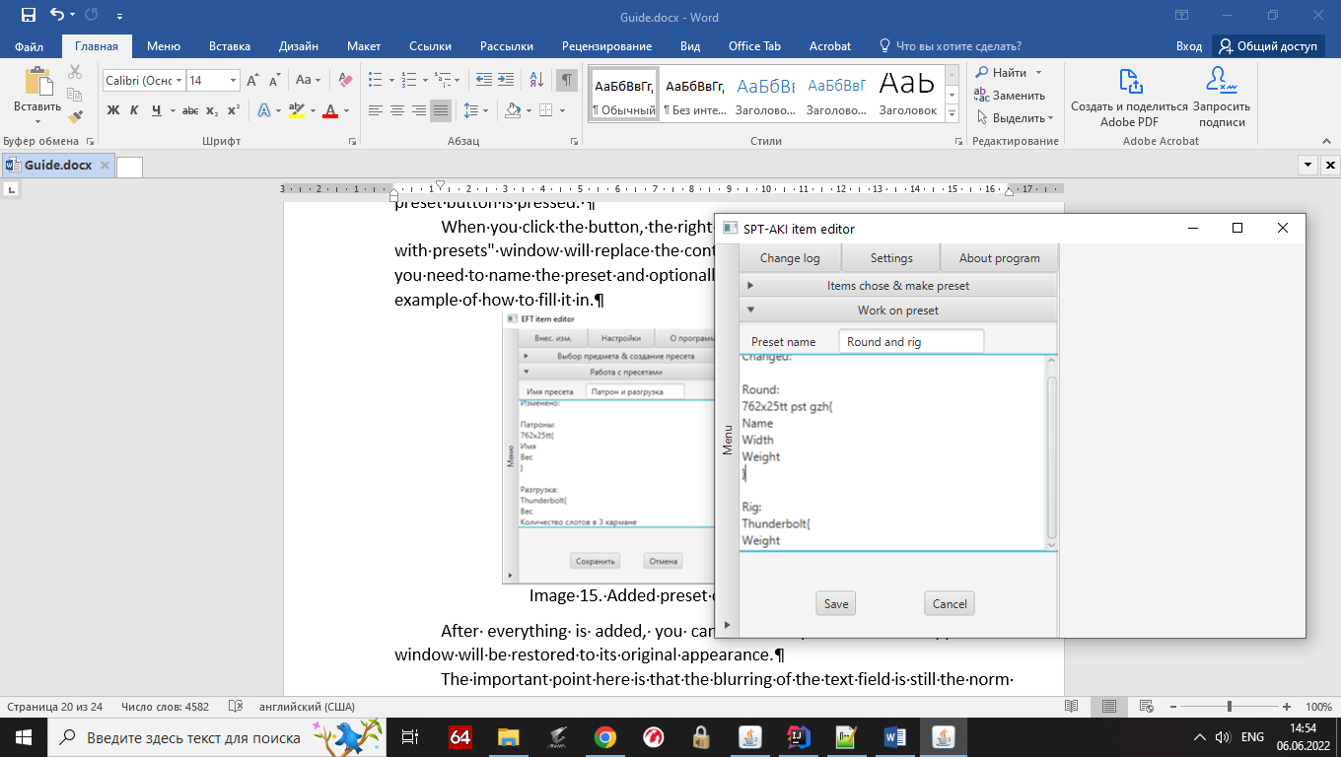

Image 15. Added preset description and name

After everything is added, you can save the preset and the application window will be restored to its original appearance.

The important point here is that the blurring of the text field is still the norm for this language, but a solution has been found, and will be done in v0.2 where multithreading will be added.

If you want to change an already created preset, press the "Change preset" button in the "Working with presets" window, after pressing it the preset selection window will open (Image 16).

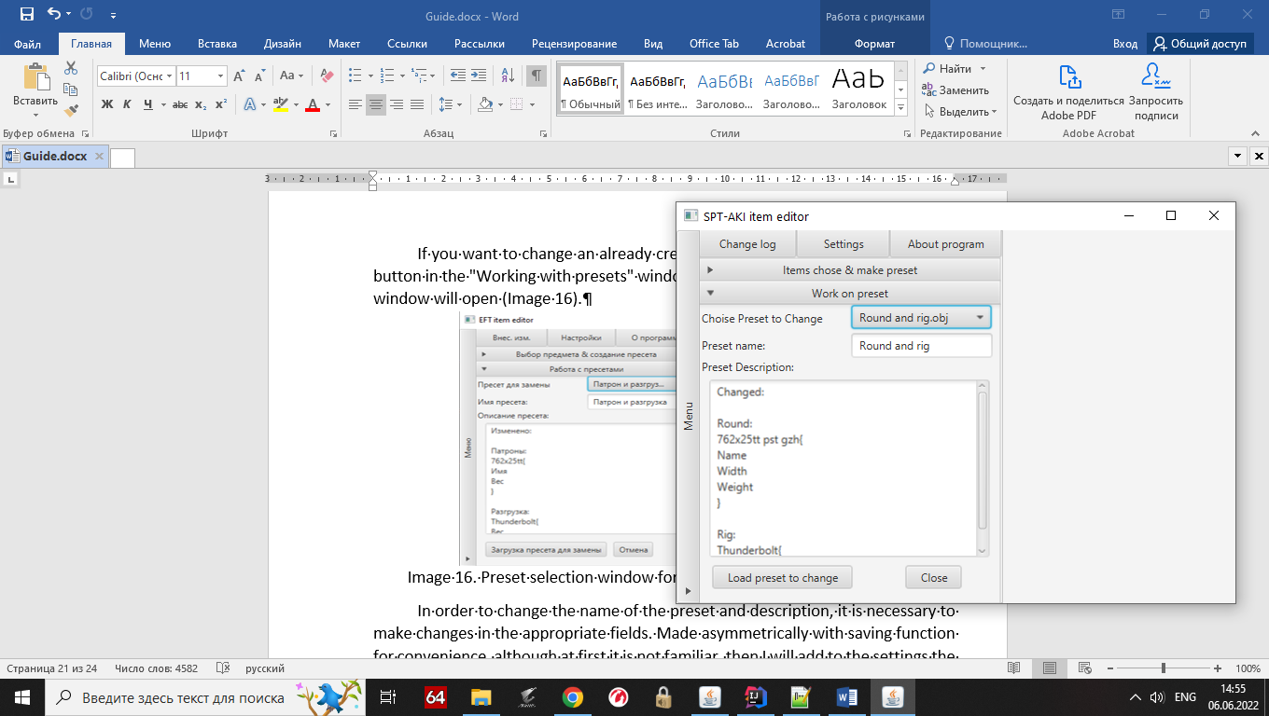

Image 16. Preset selection window for changing with the selected preset

In order to change the name of the preset and description, it is necessary to make changes in the appropriate fields. Made asymmetrically with saving function for convenience, although at first it is not familiar, then I will add to the settings the ability to work identically with saving (first adding the characteristics, then saving with a change of name and description).

Then the functionality is the same as when you create a preset, after clicking on the load preset button.

**4.2 Loading Presets into the Game**

To start loading presets into the game, click the "Load Presets" button in the "Working with Presets" window (Image 17).

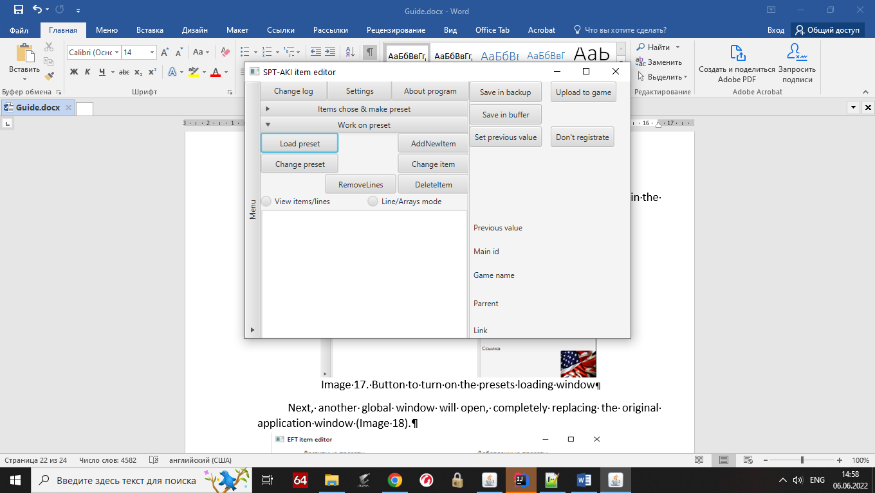

Image 17. Button to turn on the presets loading window

Next, another global window will open, completely replacing the original application window (Image 18).

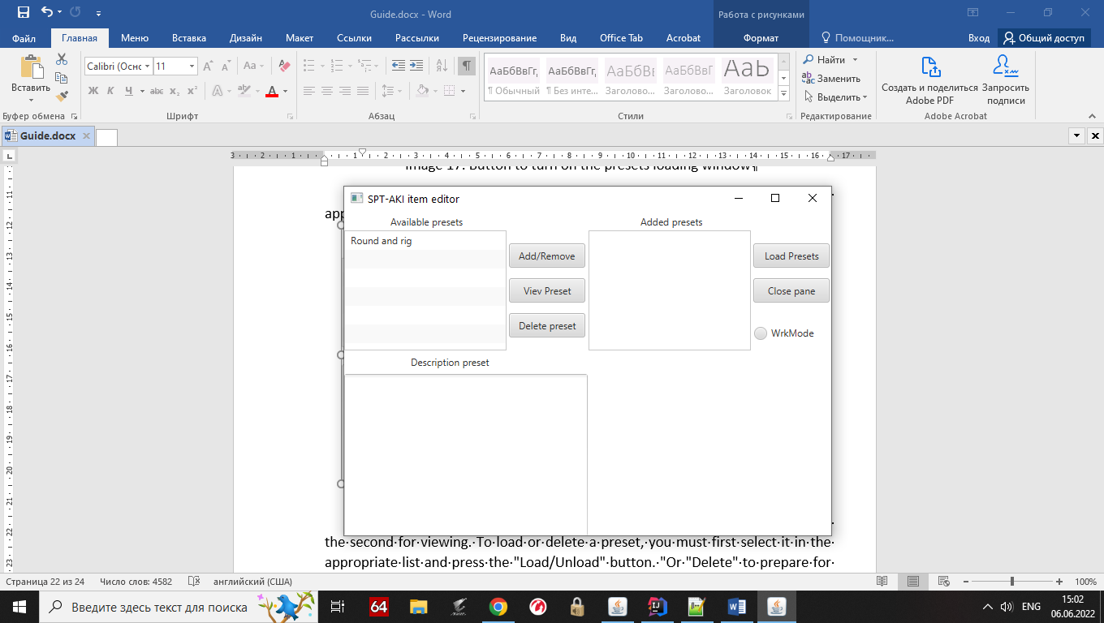

Image 18. The global presets loading window

In the window globally there are two modules, the first for downloading and the second for viewing. To load or delete a preset, you must first select it in the appropriate list and press the "Load/Unload" button. "Or "Delete" to prepare for action.

The loading and unloading itself will begin only after pressing the "Load preset" button, if you want to remove the preset from the download, just select the desired preset and press the "Load/Upload" button. "After that the preset will be removed from the recording queue. The program is able to automatically determine what to load and what to unload, the order corresponds to the user's actions.

The important point is that 1 preset change causes 1 overwrite of the file, i.e. 5 presets cause 5 overwrites of the Items file. json file, it is necessary for the program to remember the data before writing.

For example, there are two presets affecting a similar object, cartridge 762x25tt pst gzh, therefore, the first will remember the settings of the object from the studio BSG, and the second preset will remember overwritten characteristics of the object from the user. BUT the nuance is that the program can not yet understand which preset first and which second, so unload it must be in the order of loading (Then the functionality will be greatly expanded and will automatically analyze and replace all + will be able to replace the characteristics in the group, etc.)).

Next comes the preset view. Its functionality is divided into 2 windows. To use it, first select 1 preset from any list and click the "View" button, then the preset will be loaded into the view subsystem and its description will be displayed in the first window of the preset view module (Image 19).

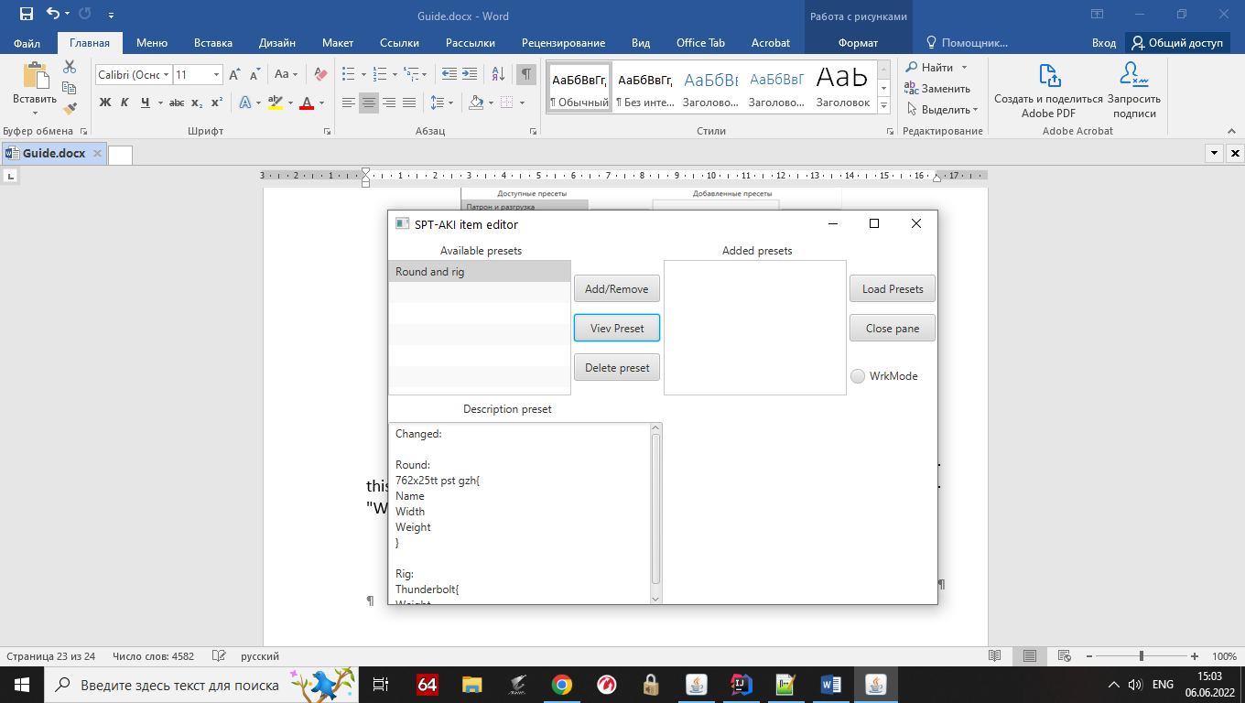

Image 19. Enabled preview of the 'Cartridge and Unload' preset

The second window allows you to view the items added to the preset, for this after clicking on the view button switches to display mode by pressing the "Work Mode" button, and two lists will be shown (Image 20).

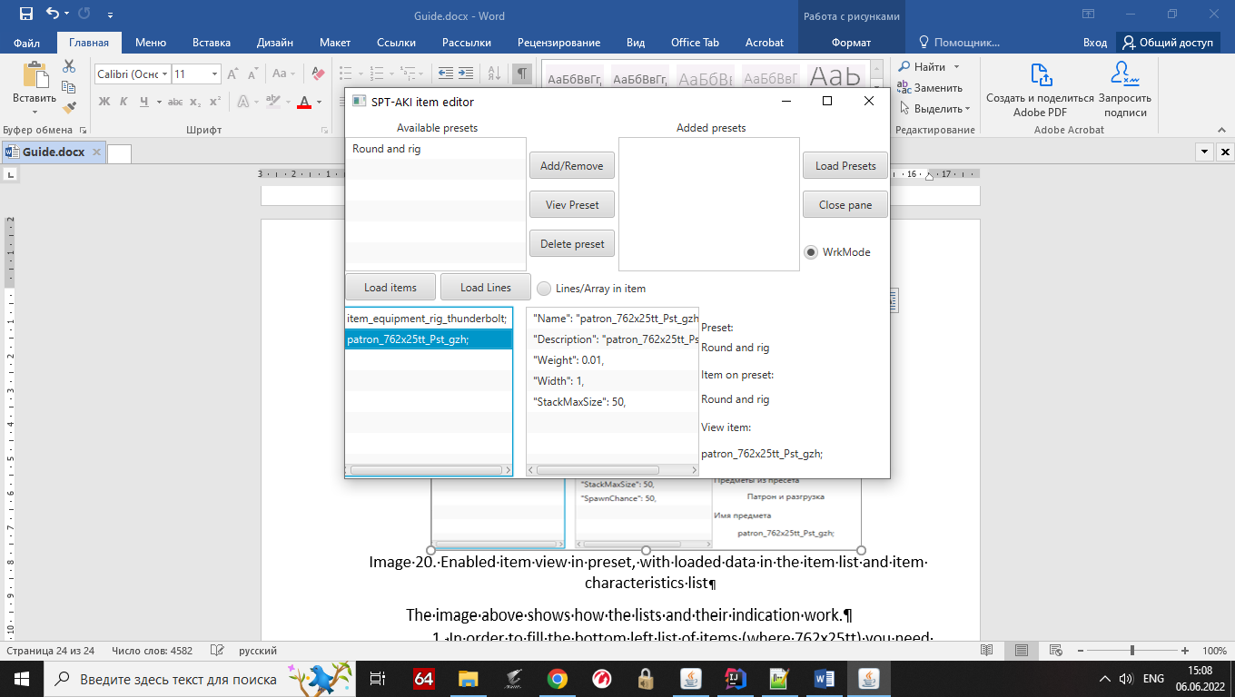

Image 20. Enabled item view in preset, with loaded data in the item list and item characteristics list

The image above shows how the lists and their indication work.

1. In order to fill the bottom left list of items (where 762x25tt) you need to click 'Load Item' button, and the items are loaded automatically from the loaded preset, which is shown below the inscription preset on the right. And the display of already loaded items below the inscription 'Items from preset'.
2. In order to fill in the list of characteristics of the item, you must select the item in the list (in the example 762x25tt) and click on "Load lines" then the program will read the data and fill in the list, in the right part of the module will be an indicator showing the loaded item below the inscription 'Name of the item'.
3. If you want to change the characteristics view to the added arrays view, you need to click on the "Lines/Asset in Object" button

This is where the functionality of the program ends.