**FEASIBILITY REPORT** – **ANALOG LINE FOLLOWER**

Analog line following robot’s objective is to follow a white line or a track on the black surface. The project is to implement a fully function analog line follower which is capable of navigating through curvy lines smoothly and should stop at a white line perpendicular to the path Since the use of microcontrollers are prohibited, we must hard wire the behavior of the robot into it’s the electrical circuits using analog components such as Op-Amps, transistors, Sensors, and other basic electronic components.

The line follower will be driven by two motors and a caster wheel is used for balancing of the robot.

**Implementation of the Analog LFR**

To achieve fast and smooth navigation a PID control is used. The following diagram show the basic control loop embedded into line follower hardware.

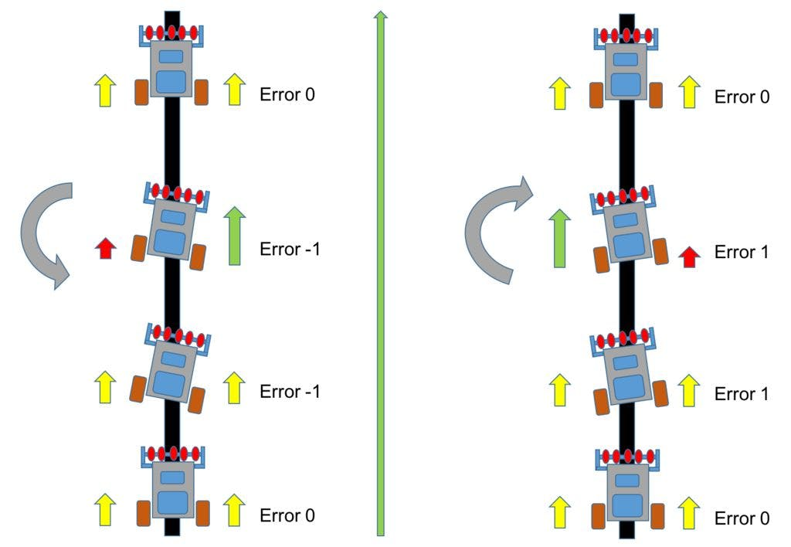

* When line is in the middle of the robot error is zero.
* When line is in the right of the robot error is positive.
* When line is in the left of the robot error is negative.

*Figure 2*

*Figure 1*

First, we need to get the error calculated according to the figure 2. To achieve this, we need a detect the lines using and **IR sensor panel circuit** and an **error signal circuit.** Once the error is calculated it given in to the **PID Circuit**. the PID circuit need to process the error signal an output a desired response signal (Turn rate). Then, the response signal is added or subtracted accordingly to the left and right wheel speed signals. For this we need a **Speed Control circuit.** To drive the motors an PWM signals have to be given to the **Motor drivers circuit**. To generate PWM signals from the speed signal we also need a Triangle wave generator. Therefore, a **Triangle wave generator circu**it and a **PWM generator circuit** is needed. Additionally, we will need a **Stopping control circuit** tostop the robot& **Power Supply Circuit.**

**Sub-Circuits and its Functionality**

|  |  |
| --- | --- |
| **Sub Circuit** | **Functionality** |
| IR Sensor Panel | Detect the white lines – Generate a signal according to the reflectance of the surface. |
| Error Signal Circuit | Calculate the error and generate an analog output signal. |
| PID Circuit | Process the error signal using by proportional, Integral, Derivative circuitry output a control signal |
| Speed Control Circuit | Adjust the speed signal (Addition or Subtraction) of both motors according to the control signal given by the PID circuit |
| Triangular Waveform Generator | Generate a Triangular Wave form |
| PWM Generator | Generate a PWM signal according to the speed signal of the motors |
| Motor Driver Circuit | Amplify the signal from the PWM generator and drive the motors |
| Stop Control Circuit | Stop the LFR at the perpendicular white line |
| Power Supply Circuit | Provide regulated power to the circuit. |

Most of the sub-circuits of the analog LFR requires many mathematical functions such as addition, subtraction, comparators, amplification, integration, and differentiation to be performed on the Analog voltages using electronic circuits. To achieve this different configuration of an Operational Amplifier is used.

**References**

1. [**http://www.will-moore.com/analog-line-follower**](http://www.will-moore.com/analog-line-follower)
2. <https://sites.google.com/site/vjapolitzer/projects/analog-line-follower>
3. <https://www.engineersgarage.com/step-by-step-line-follower-robot-without-microcontroller/>