All code is here

https://github.com/Seniuk-Vi/awscourseproject/tree/serverless

Sub Task 1

1. Create Lambda with CF. snssqstemplate.yaml  
   A screenshot of a computer program

   Description automatically generated
2. Test UploadsNotificationFunction  
   A screenshot of a computer

   Description automatically generated

Sub task 2

1. Skipped

Sub task 3

1. Created Java Lambda function with hibernate  
   A screen shot of a computer program

   Description automatically generated
2. Dependencies used  
   A screen shot of a computer program

   Description automatically generated
3. Update CF template to contain DataConsistency function  
   A screen shot of a computer

   Description automatically generated
4. Moved S3 bucket initialization from code to CF and added lambda trigger  
   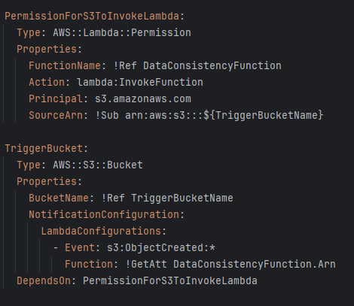
5. Function in AWS  
   A screenshot of a computer

   Description automatically generated
6. Check function logs  
   A screenshot of a computer

   Description automatically generated