

**Artificial Intelligence HITEC University, Taxila**

**BS Artificial Intelligence Program**

**(Batch 2024)**

**DSA**

**Lab Report # 01**

**3rd Semester**

* **Submitted to**

**Mam Fatima Azfar**

* **Submitted by**

| **Name** | **Reg NO** |
| --- | --- |
| **M.Umer Shahzad** | **24-AI-062** |
| **M.Wasif** | **24-Ai-064** |

**Objective**

* The objective of the lab is to revise OOP with Cpp/c++.

**Software**

* [Visual Studio Code.](https://code.visualstudio.com/)
  + [C/Cpp extension pack.](https://code.visualstudio.com/docs/languages/cpp)
  + [CodeSnap.](https://marketplace.visualstudio.com/items?itemName=adpyke.codesnap)
* GNU[/GCC compiler chain.](https://gcc.gnu.org/)

**Lab Tasks**

## **Question 1:**

* Create a class Shape with a function draw() that prints: "Drawing a Shape".
* Create a class Circle (derived from Shape) that overrides draw() to print: "Drawing a Circle".
* Create a class Square (also derived from Shape) that overrides draw() to print: "Drawing a Square".
* In main():
  + Create Shape, Circle, and Square objects.
  + Call the draw() function on each object.

## **Question 2:**

* Create a base class Publication with data members:
  + title (string)
  + price (float)
* Functions:
  + getData() → input values
  + putData() → display values
* Create a derived class Book that adds:
  + pageCount (int)
* Create another derived class Tape that adds:
  + playTime (float, in minutes)
* In main():
  + Create one Book and one Tape object.
  + Input their details using getData().
  + Display them using putData().

## **Question 3:**

* Create a class Book with private members:
  + title (string)
  + author (string)
  + price (float)
* Add public functions:
  + getData() → input values
  + putData() → display values
* In main():
  + Create two Book objects.
  + Call getData() to input values.
  + Call putData() to display values.

Question 1 (Code)

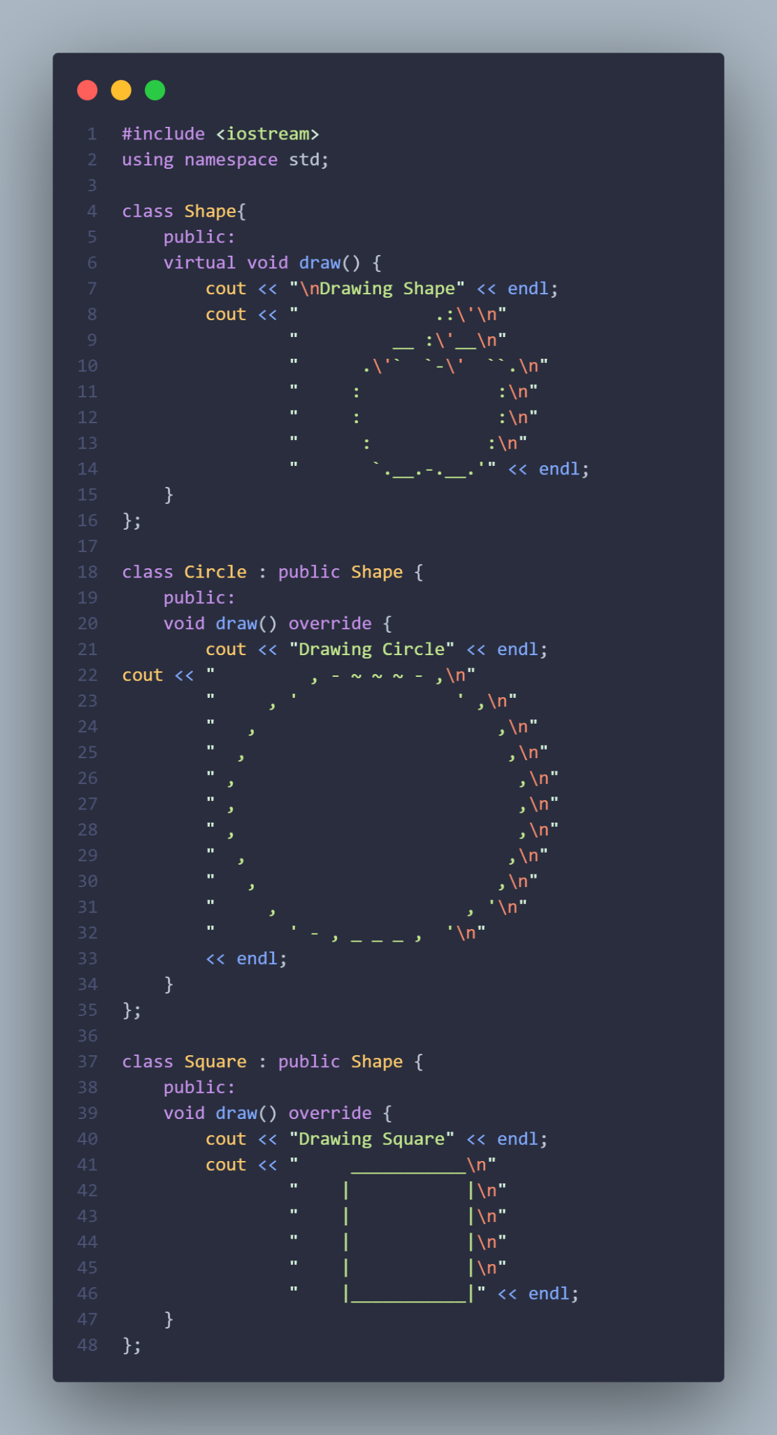

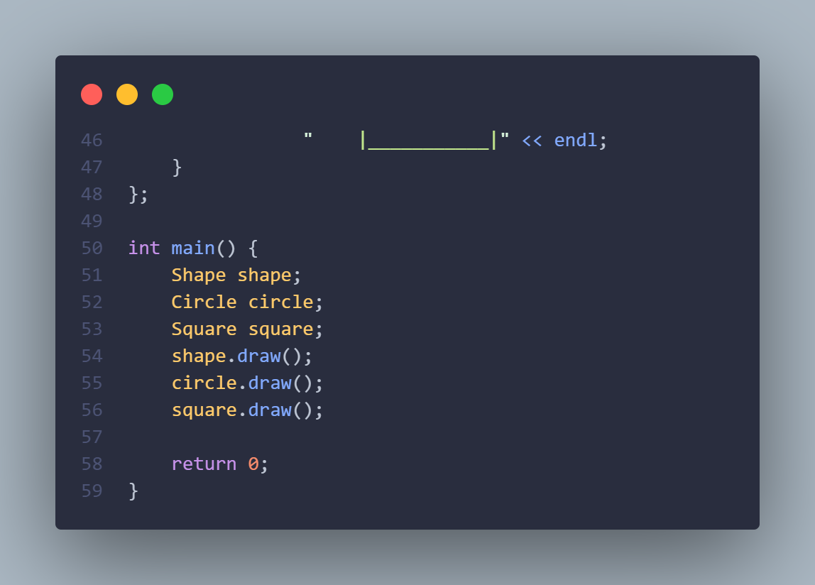

<Output>

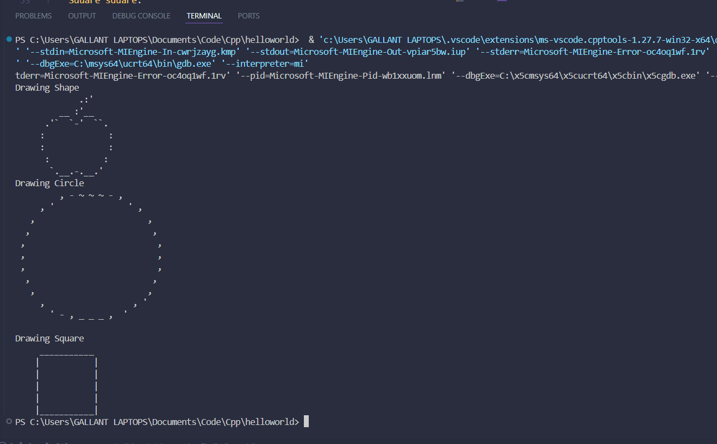

Question 2(Code)

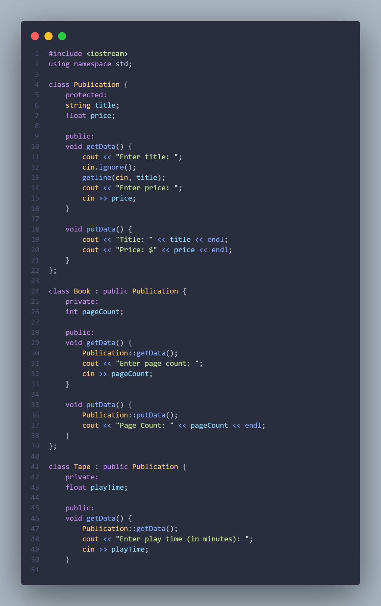

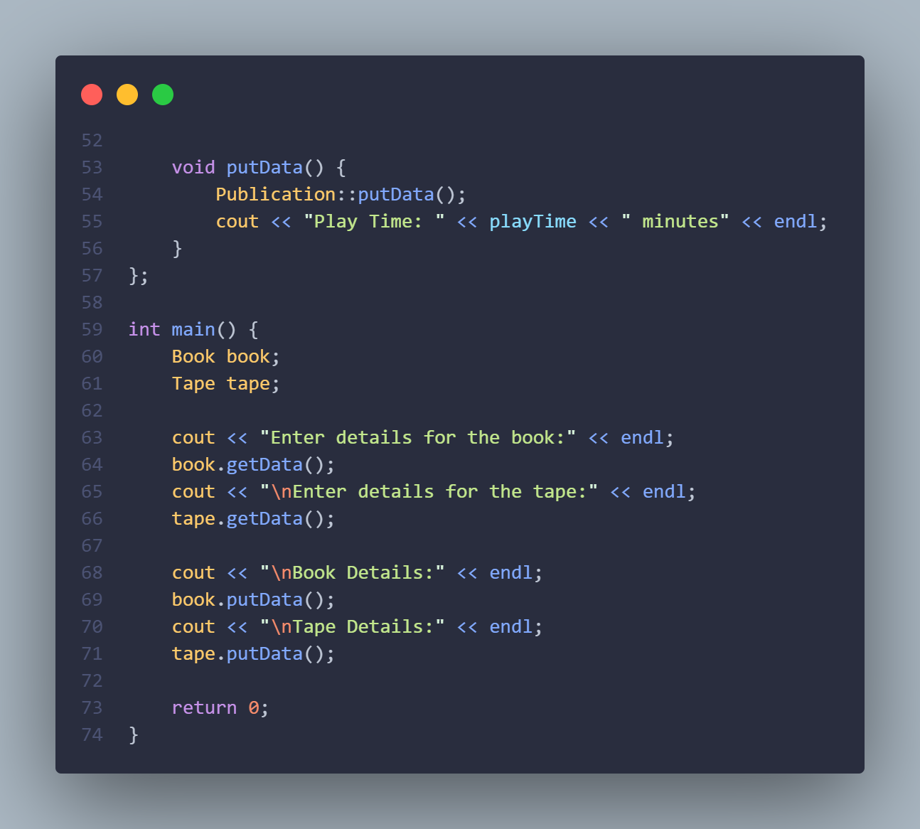

<Output>

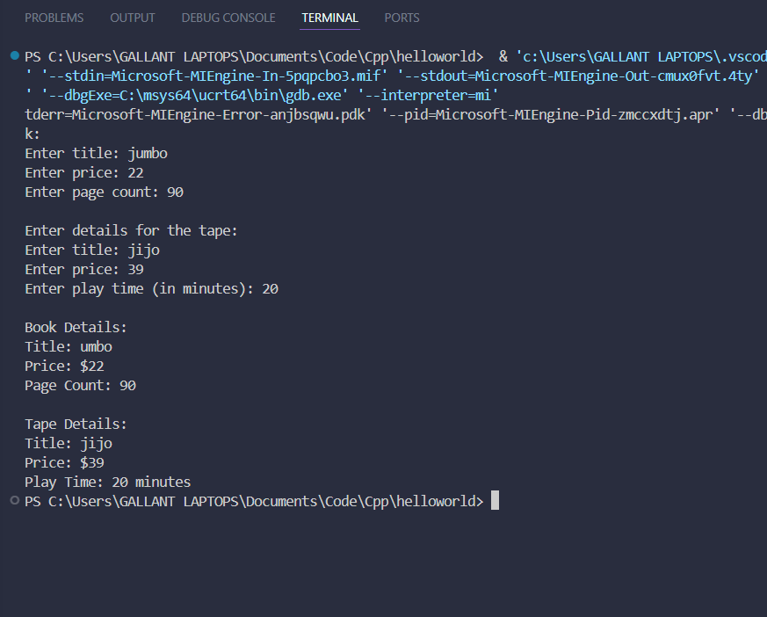

Question 3 (Code)

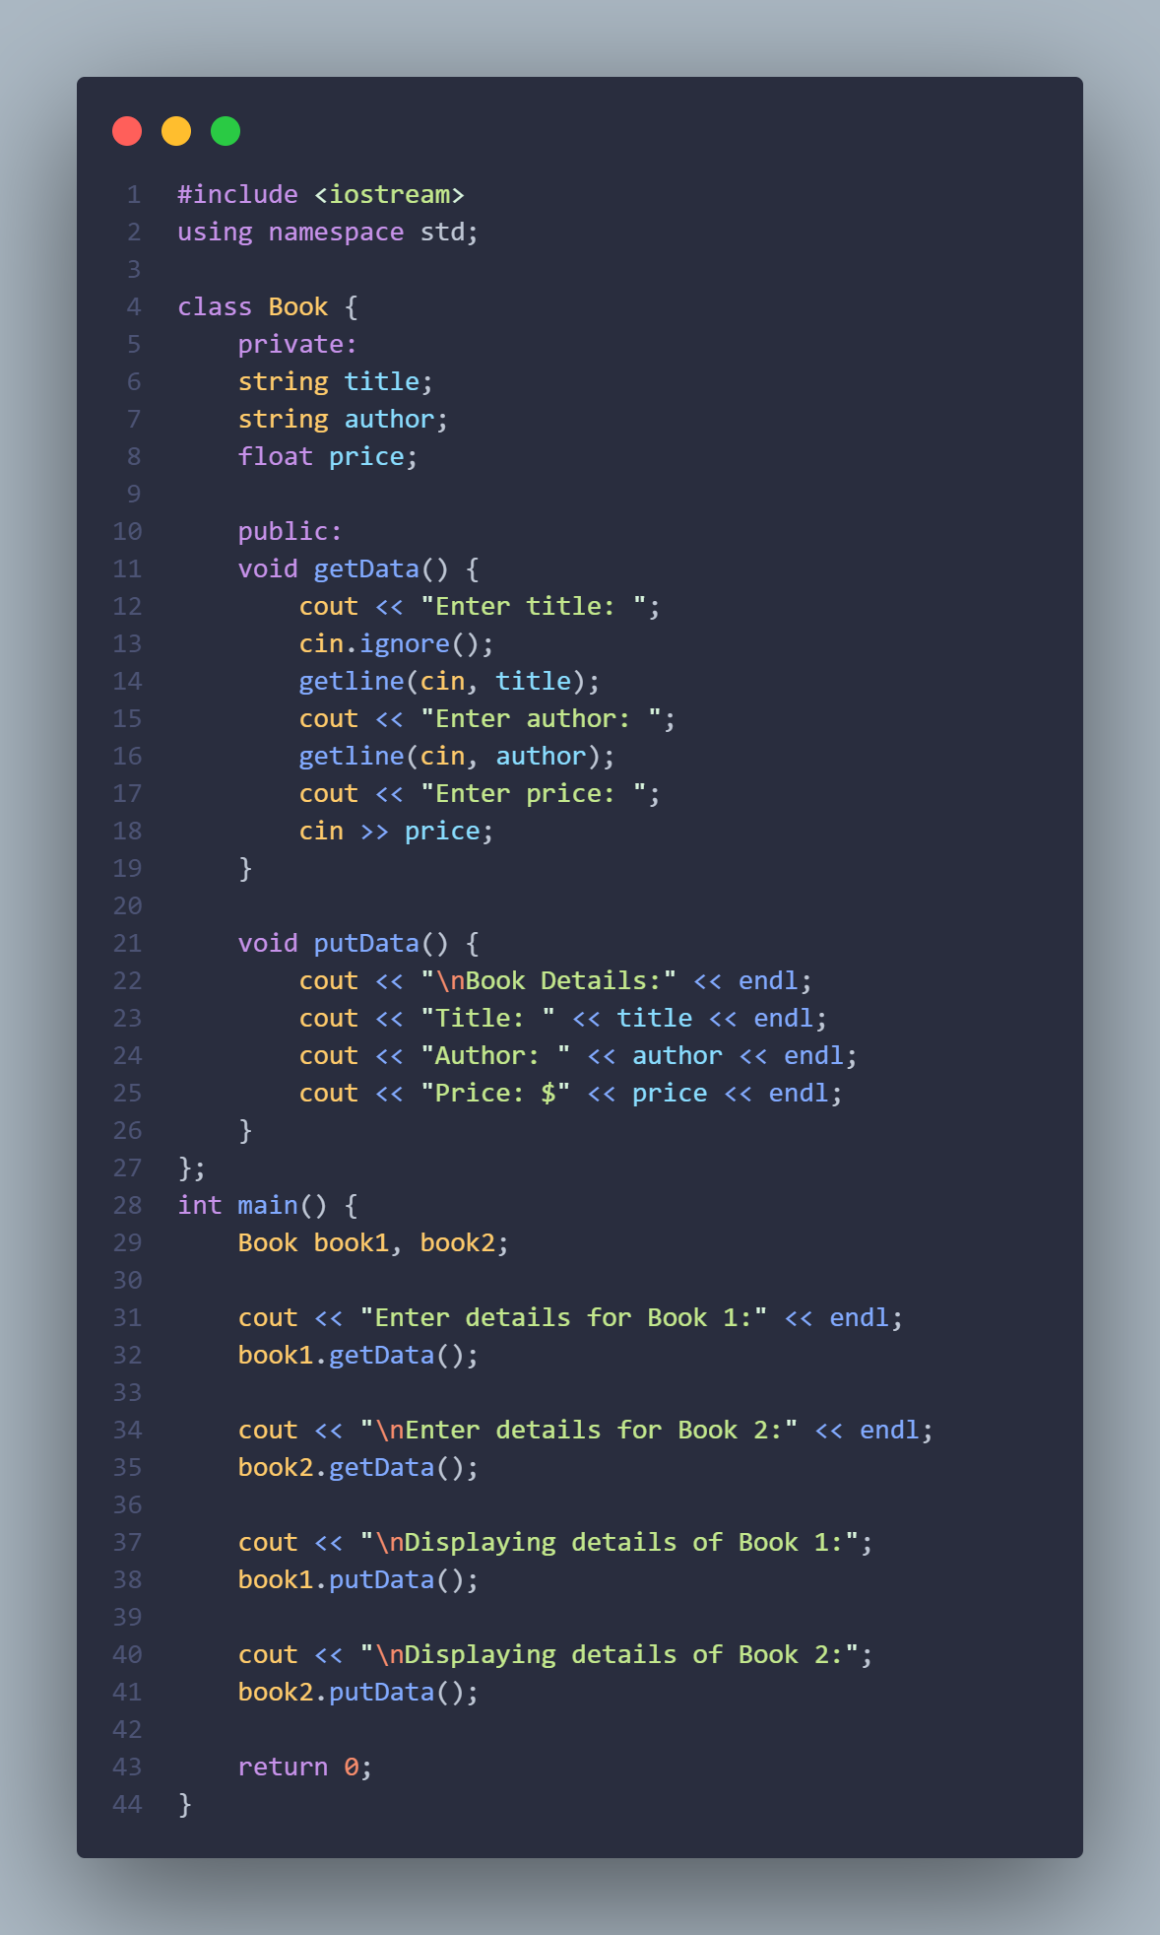

<Output>

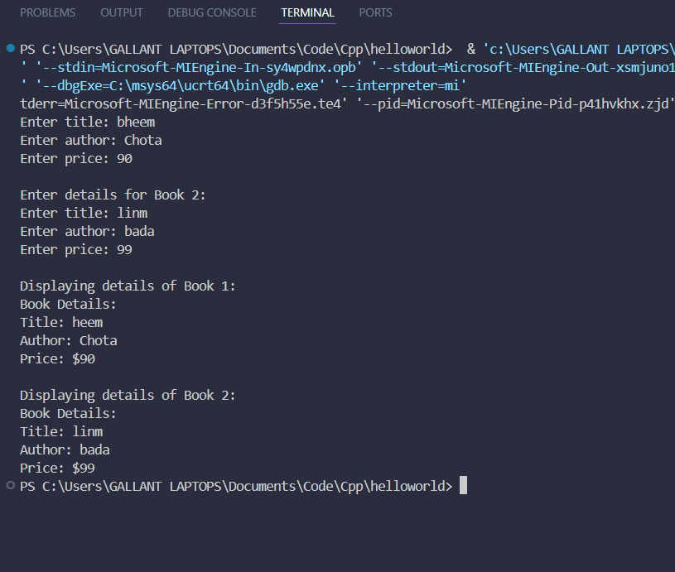

Conclusion  
 This is an easier way to do OOP than Java. We like how C++ has fewer keywords to remember, and most of them are memorized due to previous semesters. Overall, a new subject with its own pros and cons and ups and downs, I hope to learn this subject thoroughly.