

**INSTITUTE OF ENGINEERING & MANAGEMENT**

**SOFTWARE REQUIREMENT SPECIFICATION**

VERSION: 1.0

Team: Problem Solvers

REVISION DATE: 10.03.2017

|  |  |  |  |  |  |  |  |  |
| --- | --- | --- | --- | --- | --- | --- | --- | --- |
| **Approver Name** |  |  | **Title** |  | **Signature** |  |  | **Date** |
|  |  |  |  |  |
|  |  |  |  |  |  |  |  |  |
|  |  |  |  |  |  |  |  |  |
|  |  |  |  |  |  |  |  |  |
|  |  |  |  |  |  |  |  |  |
|  |  |  |  |  |  |  |  |  |

**DEPARTMENT OF COMPUTER SCIENCE &ENGINEERING**

**INSTITUTE OF ENGINEERING & MANAGEMENT**

**CONTENTS**

1. **Product Description**
   1. **Purpose**
   2. **Scope**
   3. **Stakeholders and Users**
   4. **Assumptions**
   5. **Constraints**
2. **Functional Requirements**
   1. **Donor**
      1. **Register**
      2. **Make Pledge**
      3. **Donation**
      4. **Make Profile**
      5. **Check Notification**
   2. **NGO**
      1. **Manage Contribution**
      2. **Confirm Collection**
3. **Interface Requirements**
   1. **User Interfaces**
   2. **Hardware Interfaces**
4. **Use Case Model**
   1. **Use Case Diagram**
   2. **Use Case Description**
5. **Glossary**
6. **Product Description**
   1. **Purpose**

* A lot of people are there who suffer due to proper clothing and proper education while there are people who have ample of it and do not know what to deal with it.
* There is a lack of proper medium of distribution of resources, a medium to take the excess resources and bring it to the needy people.
* A lot of children are deprived from clothes.
  1. **Scope**

To create a website, where the people who have material in excess or would wish to contribute out of goodwill, can put up their availability status.

At a certain time of the day, a notification about the total items available is sent to the collecting party (NGOs / Orphanages) who would be given location of all the items, from where they can collect.

This would save their expenditure of purchase, and they would only have to pay for transportation.

**1.3 Stakeholders and Users**

|  |  |  |  |
| --- | --- | --- | --- |
| **Stakeholders** | **Functions** | **Location** | **Type of Device** |
| **NGO** | Uses the website to manage donations that it receives | Non-Profit Organization | Desktop, Laptop ,any device with internet connection |
| **Donor** | Uses the website to contribute excess stuff | Common People | Desktop, Laptop ,any device with internet connection |

**1.4 Assumptions**

* Ample amount of donors are present to fulfill the requirements and balance the cost of collection.
* Collection unit is always available when required.

**1.5 Constraints**

* Effective internet connection is required for all the actors to be able to use the system.
* User should know how to operate computer and mobile phone.

**2. Functional Requirements**

**2.1** The system shall require the User to sign in or to register new user to perform donation tasks.

**2.2 Register the User**

2.2.1. System shall ask registered user to feed mandatory details about email and password .

2.2.2. System shall ask new user to feed the mandatory details such as full name, email id, address, state, city, Mobile no., Password, Confirm Password.

2.2.3. System registers the user.

**2.3 Make Pledge**

2.3.1. User logs in system by providing mandatory fields.

2.3.2. System loads the new page “Make Pledge” .

2.3.3. System will show the choices “Clothes” and “Books” which will be chosen by the user.

2.3.4. If user chooses “Clothes” .System loads the new page “Clothes Donation”.

2.3.5 .In “Clothes Donation” page, user gets new mandatory choices like categories ,quantity ,description(not mandatory).

2.3.6 If user chooses “Books”. System loads the new page “Books Donation”.

2.3.7 .In “Books Donation” page ,user gets new mandatory choices like subject ,language ,name of the author ,name of books.

**2.4 Manage Contribution**

.

2.4.1 System loads data of Clothes donation or books donation page to “NGO MANAGE CONTRIBUTION” page.

2.4.2 NGO will manage contribution .

2.4.3 If the contribution is acceptable or rejected .Admin will update notification and contact donor .

2.4.4 If NGO wants to logout .They will click “logout” option .

2.4.5After logout button, System will exit.

* 1. **Make Profile**

2.5.1. System loads new page ”Make profile”.

2.5.2. User can update their information.

2.5.3. If he/she wants to logout ,System will exit.

**2.6 Donation**

**2.6.**1. System loads the new pages DONATION of books and Clothes.

2.6.2 User will provide description about their contribution of either book or clothes or both.

2.6.3. System will check if quantity is less .System will pop a message to go to the NGO for contribution.

2.6.4.System loads data of “donation” page to “manage contribution” page.

2.6.5.After submission .System will pop a message regarding continue or logout.

2.5.6.If continue button is clicked .System will redirect page to “Make pledge “page.

* 1. **Check Notification**

2.7.1 User login to its profile.

* + 1. System loads “Make Profile” page.

2.7.3 Notification will be updated on user profile page.

2.7.4. User will check notification.

* + 1. If user wants to logout .he/she will click on logout button.
    2. System will exit the page.

**2.8 Confirmation**

2.8.1 NGO will confirm donor about contribution while updating notification or by call.

**3.Interface Requirements**

* 1. **User Interfaces**

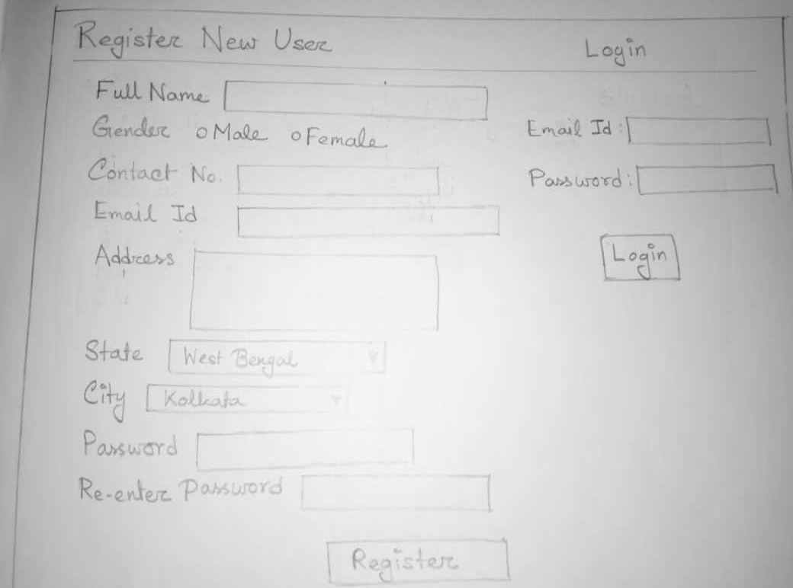

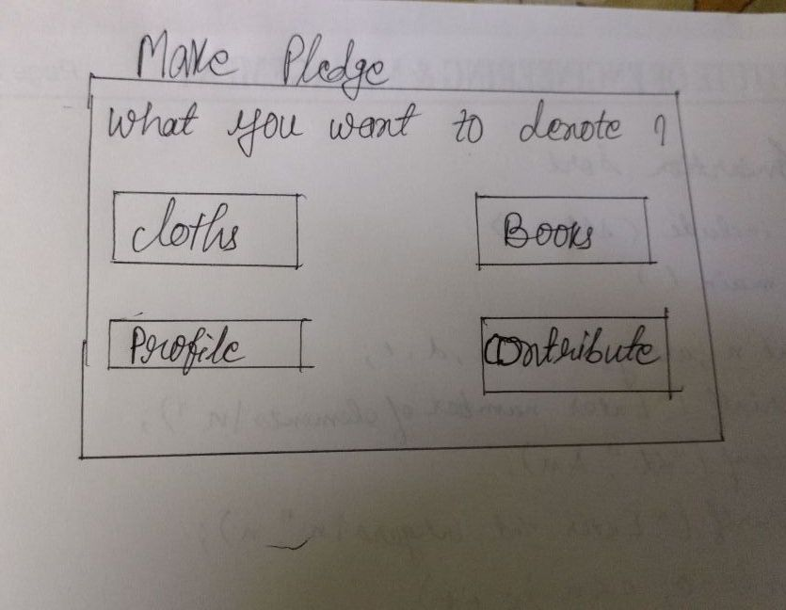

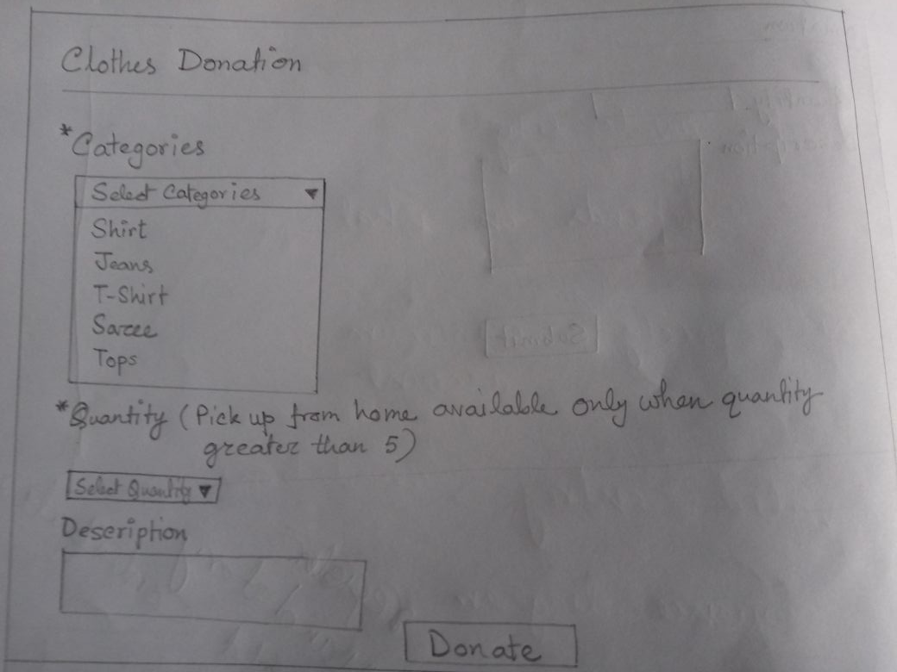



* 1. **Hardware Interface**

All devices that can be connected to the internet will be the hardware interface for the system.

1. **Use Case Model**

**3.1 Use Case Diagram**

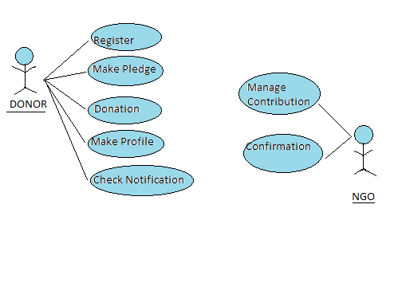

* 1. **. Use Case Description**

|  |  |  |  |
| --- | --- | --- | --- |
| Use Case ID: | 1 | | |
| Use Case Name: | **Register** | | |
| Created By: | Senjuti Gupta | Last Updated By: | Senjuti Gupta |
| Date of Creation: | 01-03-2018 | Date of Last Update: | 07-03-2018 |

|  |  |
| --- | --- |
| Actor: | Donor |
| Description: | The use case is used by the donors to Register before pledging anything. |
| Preconditions: | * Donor has a contact number. * Donor has an email id. * Donor has proper internet connection. |
| Post conditions: | * Donor is registered with the system. * Donor details are uploaded in the system. |
| Priority: | * Donor registration form is created. * Form is opened when user clicks the Sign Up button. |
| Frequency of Use: | Registration is required only once. The very first time when user visits the website. |
| Trigger: | Clicking on Sign Up button. |
| Flow of Events: | 1. Donor enters the name. (Mandatory). 2. Donor enters the Email ID. (Mandatory 3. Donor enters the address. (Mandatory). 4. Donor enters the mobile number. (Mandatory) 5. Donor enters password. (Mandatory). 6. Donor re-enters password for confirmation. 7. System matches password and confirmed password for equality. 8. Donor selects Register. 9. System updates database with the new donor details. 10. The registration process is complete. |
| Alternative Flows: | 1. Donor skips any entries. 2. System warns the donor of incomplete form. 3. System asks for valid entries in each field. |
| Exceptions: | - |
| Includes: | - |
| Special Requirements: | Access to internet. |
| Assumptions: | * Donor has internet access and he/she is able to operate the system. * Donor is willing to use the platform. |
| Notes and Issues: | - |

|  |  |  |  |
| --- | --- | --- | --- |
| Use Case ID: | 2 | | |
| Use Case Name: | **Make Pledge** | | |
| Created By: | Ranita Saha | Last Updated By: | Ranita Saha |
| Date of Creation: | 02-03-2018 | Date of Last Update: | 06-03-2018 |

|  |  |
| --- | --- |
| Actor: | Donor |
| Description: | When the Donor wishes to donate then he/she enters what they intend to donate. |
| Preconditions: | Donor is registered. |
| Post conditions: | System loads donation page. |
| Priority: | - |
| Frequency of Use: | Multiple times. |
| Trigger: | The Donor selects Make Pledge. |
| Flow of Events: | 1. System loads the register form. 2. User logins its detail. 3. System loads “Make Pledge “ page.  * User selects item names added by the NGO. * User will click on contribute buttion . * System loads “Donation of Book or Clothes” page. |
| Alternative Flows: | 1.if he/she wants to cancel their contribution.They can click cancel button. |
| Exceptions: | 1. Donor stops donations. 2. Loss of internet connection. 3. Website crashes. |
| Includes: | - |
| Special Requirements: | Access to internet. |
| Assumptions: | * Donor has internet access and he/she is able to operate the system. * Donor is willing to use the platform. |
| Notes and Issues: | - |

|  |  |  |  |
| --- | --- | --- | --- |
| Use Case ID: | 3 | | |
| Use Case Name: | **Donation** | | |
| Created By: | Senjuti Gupta | Last Updated By: | Senjuti Gupta |
| Date Created: | 07-03-2018 | Date Last Updated: | 09-03-2018 |

|  |  |
| --- | --- |
| Actor: | Donor |
| Description: | Donor will select the quantity and write description (not mandatory) about quantity. |
| Preconditions: | * User will click on “Contribute” button . * System loads “Donation ” page. |
| Post conditions: | * User will update details regarding quantity giving its description. * User clicks on the “Submit” button. * System loads data of Donation(Clothes Donation & Book Donation) page to Manage Contribution page. |
| Priority: | 1. Collection is confirmed by the NGO. |
| Trigger: | A collection request is confirmed by the NGO. |
| Flow of Events: | 1. User will update details regarding quantity giving its description. 2. User clicks on the “Submit” button. 3. System loads data of Donation page to Manage Contribution page. 4. System will pop up a message “if you want to Log out or continue”. 5. If user clicks continue, system will open the Make pledge page. 6. If user clicks logout ,system exit.. |
| Alternative Flows: | - |
| Exceptions: | - |
| Includes: | - |
| Special Requirements: | Access to internet connection. |
| Assumption: | - |
| Notes and Issues: | - |

|  |  |  |  |
| --- | --- | --- | --- |
| Use Case ID: | 4 | | |
| Use Case Name: | **Make Profile** | | |
| Created By: | Senjuti Kundu | Last Updated By: | Senjuti Kundu |
| Date of Creation: | 04-03-2018 | Date of Last Update: | 09-03-2018 |

|  |  |
| --- | --- |
| Actor: | Donor |
| Description: | Donor checks their profile . They can update any information. |
| Preconditions: | Donor has registered with the system |
| Post conditions: | * The Donor’s profile is updated |
| Priority: |  |
| Trigger: | Clicking on Make Profile button |
| Flow of Events: | 1.Donor clicks on “Make Profile Button”  2.system will update information once clicked update. |

|  |  |  |  |
| --- | --- | --- | --- |
| Use Case ID: | 5 | | |
| Use Case Name: | **Manage contribution** | | |
| Created By: | Tithi Chatterjee | Last Updated By: | Tithi Chatterjee |
| Date Created: | 01.03.2018 | Date Last Updated: | 04.03.2018 |

|  |  |
| --- | --- |
| Actor: | NGO |
| Description: | NGO representative manages the list of donations pledged. |
| Preconditions: | Donations have been pledged by donar. |
| Postconditions: | Donor will be confirmed about their contribution . |
| Priority: |  |
| Frequency of Use: |  |
| Trigger: | The NGO administrator accesses manage contribution section. |
| Flow of Events: | * The NGO administrator is logged in to the portal and clicks on the manage contribution button. * The list of pledged donation is shown. * The representative shall select the donations which NGO wants to confirm and click on confirm button. |
| Alternative Flows: |  |
| Exceptions: |  |
| Includes: |  |
| Special Requirements: |  |
| Assumptions: |  |
| Notes and Issues: |  |

|  |  |  |  |
| --- | --- | --- | --- |
| Use Case ID: | 6 | | |
| Use Case Name: | **Check Notification** | | |
| Created By: | Sonam Gupta | Last Updated By: | Sonam Gupta |
| Date of Creation: | 01-03-2018 | Date of Last Update: | 05-03-2018 |

|  |  |
| --- | --- |
| Actor: | DONOR |
| Description: | The use case is used by donor to check confirmation regarding their contribution. |
| Preconditions: | Donor has to submit their information. |
| Post conditions: | * Confirmation of the request. |
| Priority: | - |
| Frequency of Use: | In a frequent interval |
| Trigger: | - |
| Flow of Events: | * Donor checks for the notification,   If their contribution has been granted or not.  . |
| Special Requirements: | Access to internet. |
| Assumptions: | - |
| Notes and Issues: | - |

|  |  |  |  |
| --- | --- | --- | --- |
| Use Case ID: | 7 | | |
| Use Case Name: | **Confirmation** | | |
| Created By: | Sonam Gupta | Last Updated By: | Sonam Gupta |
| Date of Creation: | 01-03-2018 | Date of Last Update: | 05-03-2018 |

|  |  |
| --- | --- |
| Actor: | NGO |
| Description: | This use case is used for the confirmation of their contribution process. |
| Preconditions: | * Donor is successfully registered with the system * Donor has successfully submitted donation page. |
| Post conditions: | * Donor will be confirmed either by updated notification or call. |
| Priority: | * Donor registration form is created. * Form is opened when user clicks the Sign Up button. * Donor has a contact number. * Donor has an email id. * Donor has proper internet connection. |
| Frequency of Use: | Confirmation is send to the donor as they submitted donation form successfully. |
| Flow of Events: | 1. Registration process is complete. 2. Confirmation of their pledge is successfully confirmed by NGO. 3. They are confirmed about their request either by notification or call. |
| Alternative Flows: | 1. They skips any entries. 2. System warns them of incomplete form. 3. System asks for valid entries in each field. |
| Exceptions: | - |
| Includes: | - |
| Special Requirements: | Access to internet. |
| Assumptions: | * Donor has internet access and he/she is able to operate the system. * Donor are willing to use the platform. * Donor are successfully registered. |
| Notes and Issues: | - |

1. **Glossary**

|  |  |  |  |
| --- | --- | --- | --- |
| **Term** | | **Meaning** |  |
| **C** | |  |  |
| **Collection:** | | Gathering of donated items from the pickup |  |
|  | | locations (specified by the donors) by the |  |
|  | | collection unit. |  |
| **Collection unit** | | The team of people appointed by the NGO for |  |
|  | | collecting items from the donor/s. |  |
| **Category** | | Types of items that can be donated by the |  |
|  | | donor (Example: Food, Clothes etc.).This is set |  |
|  | | by the NGO. |  |
| **D** | |  |  |
| **Default address** | | The address given by a donor at the time of |  |
|  | | registration with the system. |  |
| **Details** | | Any additional information that the donor wants |  |
|  | | to give about any product. This is a mandatory |  |
|  | | input for the donor when he/she chooses |  |
|  | | “Other” as item name. |  |
| **Donor** | | Any individual who wishes to contribute to the |  |
|  | | NGO through our system by giving items like |  |
|  | | food, clothes. |  |
| **Donation** | | An act of voluntary contribution of items (food, |  |
|  | | clothes etc.) from a donor to an NGO. |  |
| **I** | |  |  |
| **Item** | | Donatable material required by an NGO and is |  |
|  | | characterized by its name, its category and the |  |
|  | | quantity in which it is required. |  |
| **M** | |  |  |
| **Make pledge** | | A donor pledges a donation by providing |  |
|  | | donation related information such as item |  |
|  | | name, quantity, detail(optional),alternative |  |
|  | | pickup location(optional). |  |
| **Manage profile** | | NGO representative manages own profiles by |  |
|  | | specifying items it needs and setting a minimum |  |
|  | | limit before it receives notifications. |  |
| **Manage donation** | | NGO representative manages the list of pledged |  |
|  | | donations and marks those which are ready for |  |
|  | | collection. |  |
| **Minimum limit** | | A threshold set by the NGO representative such |  |
|  | | that when the net donation corresponding to a |  |
|  | | given item is met, the NGO is notified about it. |  |
| **N** | |  |  |
| **NGO** | | A charitable organization working for the |  |
|  | | betterment of the needy. |  |
| **Notifications** | | App notifications will be served to several actors |  |
|  | | under some conditions : |  |
|  | | 1. System notifies NGO about when the |  |
|  | | minimum limit is met. |  |
|  | | 2. System notifies donor receives notification |  |
|  | | about the status of donation.   1. System notifies collection unit. |  |
|  |
| **P** | |  |  |
| **Pickup Location** | | Collection unit collects donated items from the donor from this location. It can be same as default address or the Donor can provide an alternative address as well. |  |
| **R** | |  |  |
| **Register** | | Donors must register with the system before pledging any donation. |  |
| **S** | |  |  |
| **System** | | Application working along with server and database. |  |
|  | |  | |
|  | |  | |
|  | |  | |