UNIVERSIDAD EAFIT
School of Applied Sciences and Engineering · Mechanical Engineering
PROJECT PROPOSAL – FINAL SUBMISSION
Monitoring platform assisted by computer vision and neural networks for identifying potential landslides and reducing disaster-prevention costs
Engineering Project Formulation · Group 5
SUBMITTED BY
David Amell Osorio
Kevin Giraldo Pérez
Juan José González Guzmán
Tomás Vásquez Campuzano
Santiago Alberto Vélez Casallas
David Zuluaga Henao
PROFESSOR
Leonel Francisco Castañeda Heredia
Medellín, November 2024
Table of contents
1. Technical system identification 1
1.1. Description of the technical system 1
2. Proposal identification 3
2.1. Proposal title 3
2.2. Proposing entity and allied entities 3
2.3. Location (focus of the proposal) 3
2.4. Place of execution 3
2.5. Duration 3
2.6. Team composition 3
2.7. Alignment with public policy 4
2.7.1. Sustainable Development Goals (SDGs) 4
2.7.2. National Development Plan 2022-2026 “Colombia, World Power of Life” (Law 2294 of 2023) 5
2.7.3. Departmental Development Plan “Por Antioquia firme” 2024-2027 5
2.7.4. Municipal Development Plan of San Francisco 2024-2027 6
3. Executive summary 7
4. Background 8
5. Stakeholder analysis 11
5.1. Management strategies for opponents and adversely affected parties 13
6. Problem analysis 14
6.1. Central problem 14
6.2. Causes and effects 14
6.3. Problem tree 14
6.4. Description of the problem and the existing situation 15
6.5. Magnitude of the problem 16
7. State of the art 22
7.1. Regulatory and normative framework 22
7.2. Scientific articles 23
7.3. Books and other literature 24
7.4. Patents 26
7.5. Synthesis and proposed solution 27
8. Objective analysis 28
9. Alternatives analysis 31
9.1. Selection matrix 31
9.2. Reasons for discarding the other alternatives 32
9.3. Technical analysis of the selected alternative 32
10. Objectives 34
10.1. General objective 34
10.2. Specific objectives 34
10.3. Relationship between the objectives and the objective tree 34
11. Project work breakdown structure 36
11.1. Expected products 36
12. Methodology 39
13. Logical framework matrix 47
14. Impacts 51
15. Dissemination strategy 52
16. Schedule 53
17. Budget 55
17.1. Human resources 55
17.2. Equipment and software 55
17.3. Training and events 56
17.4. Services and testing 57
17.5. Materials, supplies and documentation 57
17.6. Travel expenses 57
17.7. Infrastructure 58
17.8. Administrative expenses 58
17.9. Budget summary 59
17.10. Budget cash flow 61
18. Financial evaluation 63
18.1. Income 63
18.2. Benefits 63
18.3. Investment costs 64
18.4. Operation and maintenance costs 64
18.5. Loans, amortization and interest 65
18.6. Salvage value 65
18.7. Net cash flow 65
18.8. Financial indicators 66
18.9. Sensitivity analysis 67
18.10. Conclusion of the financial evaluation 67
19. Conclusions 68
References 69

List of tables
Table 1. Technical system identification 1
Table 2. Team composition 4
Table 3. Alignment with the Sustainable Development Goals 5
Table 4. Stakeholder analysis 11
Table 5. Causes and effects of the central problem 14
Table 6. Technical standards and regulations consulted 22
Table 7. Indexed-journal articles reviewed 24
Table 8. Books and other literature consulted 26
Table 9. Patents reviewed 27
Table 10. Objective tree 28
Table 11. Solution alternatives 31
Table 12. Alternatives selection matrix 32
Table 13. Relationship between specific objectives, means and ends 35
Table 14. Project work breakdown structure 36
Table 15. Expected products (MGA product catalog) 38
Table 16. Methodology: activities, responsible parties, tasks, results and means of verification 39
Table 17. Logical framework matrix 47
Table 18. Project impacts 51
Table 19. Dissemination strategy 52
Table 20. Project schedule (Gantt chart) 53
Table 21. Human-resources budget 55
Table 22. Equipment and software budget 55
Table 23. Training and events budget 56
Table 24. Services and testing budget 57
Table 25. Materials, supplies and documentation budget 57
Table 26. Travel expenses budget (Medellín – United States) 58
Table 27. Infrastructure budget 58
Table 28. Administrative expenses budget 59
Table 29. Budget summary by item and funding source (COP) 59
Table 30. Budget cash flow by two-month period (thousands of COP) 61
Table 31. Detailed cash flow by item and two-month period 62
Table 32. Project income (millions of COP) 63
Table 33. Project benefits (millions of COP) 63
Table 34. Investment costs at economic prices 64
Table 35. Annual operation and maintenance costs 64
Table 36. Net cash flow at economic prices (millions of COP) 65
Table 37. Financial evaluation indicators 66
Table 38. Sensitivity analysis 67

List of figures
Figure 1. Classification of landslide risk areas based on planimetric data 10
Figure 2. Problem tree 15
Figure 3. Distribution of landslides by type in Colombia (left) and relationship between mean annual precipitation and number of landslides (right) 17
Figure 4. Types of mass movements 17
Figure 5. Percentage of landslides by distance to roads, before and after the Gorkha earthquake 18
Figure 6. Resources allocated to immediate disaster response in 2022 versus the 2002-2021 period, by region 19
Figure 7. People seriously affected by natural events, by department, 1998-2021 20
Figure 8. Evolution of departmental per-capita spending on disaster response and prevention, 2012-2020 20
Figure 9. Deaths, injuries and missing persons by type of natural event, 1998-2021 21
Figure 10. Risk management process according to ISO 31000:2018 46
Figure 11. Budget distribution by item 60
Figure 12. Annual net cash flow and cumulative present value 66

1. Technical system identification
The technical system is broken down from the industry level to the monitored element, as shown in Table 1.
Table 1. Technical system identification
Level | Description
Industry | Road infrastructure industry
Business line | Monitoring of potential landslides
Plant / facility | Road network of the Department of Antioquia
Production area / unit / asset | at the Municipality of San Francisco, Altavista rural district.  Road monitoring for landslide prediction on Route 60 (the Medellín–Bogotá highway). 5.950459, -74.861388 in the jurisdiction of San Francisco, Antioquia. An area of 1 km around the road section will be considered to assess landslide risk in this region.
System | Alto de Pavas
Subsystem | Route 60, Medellín–Bogotá Highway, DeviMed concession.
Device / mechanism | Section 05
Component | Curved section with a back slope at Alto de Pavas, latitude and longitude 5.950459, -74.861388
Element | Mean displacement of faults and erosion, rainfall in the area, history of mass movements.
Note. Own elaboration.

1.1. Description of the technical system
Given the nature of the problem addressed —the prediction of and warning about landslides affecting road infrastructure— the technical system corresponds to a road section and its surrounding territory, whose landslide history is comparatively critical and shows a recurrence pattern over time (NASA, 2024). In addition, this history should ideally show evidence of slides caused by the rainy season as well as others not directly related to it, pointing to geological faults in the area; these are two of the main variables NASA uses in its LHASA (Landslide Hazard Assessment for Situational Awareness) detection system (Emberson et al., 2020; NASA, 2024).
The basic element of this system is the pavement and the surrounding soil section, on which the relevant measurements in the infrared spectrum will be taken. The monitoring dimensions of this element correspond to the average resolution of the optical instruments in the satellite constellations that will be used for monitoring. In addition, a curved road section was chosen as the study component in which to monitor this pavement section, since the literature indicates that curves carry a higher landslide risk because of possible water-drainage difficulties and possible geological impacts from building the curve, inherent to the topography the works leave on the ground, which is more complex than in straight sections (Federal Highway Administration, 2002). The curved section must also have a back slope: mountain-cut sections that further increase the impact of the works on the geological stability of the area.
Finally, the macro units of the system are a departmental route, a concession-operated highway within that route, and a mountainous section where curves and back slopes are most common.

2. Proposal identification

2.1. Proposal title
Monitoring platform assisted by computer vision and neural networks for identifying potential landslides and reducing disaster-prevention costs.

2.2. Proposing entity and allied entities
The proposal involves one proposing entity and one allied entity (one in total):
- Proposing entity: Universidad EAFIT. Higher-education institution based in Medellín, responsible for the formulation and technical execution of the project through its School of Applied Sciences and Engineering.
- Allied entity No. 1: URBAM – Center for Urban and Environmental Studies of Universidad EAFIT. Contributes its track record in hillside landslide risk management (e.g., Rehabitar la ladera) and its links with public entities and communities.

2.3. Location (focus of the proposal)
- Region: Eastern Antioquia.
- Department: Antioquia.
- Municipalities: San Francisco (monitoring focus, Alto de Pavas sector), with influence on Cocorná and San Luis.
- Road section: Route 60, Medellín–Bogotá Highway, San Luis – Cocorná toll section (Devimed concession). The study focus is located at Alto de Pavas (5.950459, −74.861388), with an area of influence of 1 km around the road.
- Populated center: rural.
- Indigenous reserve: not applicable.

2.4. Place of execution
Universidad EAFIT, Medellín (Antioquia), with field and validation activities on the road section described in Section 2.3.

2.5. Duration
Twenty-four (24) months.

2.6. Team composition
Table 2 lists the team members with their dedication, duration and role, consistent with the human-resources budget (Table 21).
Table 2. Team composition
Position | Qty. | Dedication (h/week) | Duration (months) | Role in the project
Project manager | 1 | 12 | 24 | Oversee all project phases, coordinate teams and resources, and manage risks.
Database developer | 1 | 30 | 14 | Develop and maintain the geospatial and meteorological database based on the LHASA algorithm and integrate satellite data.
Software developer | 1 | 30 | 18 | Develop the software modules, integrate the neural-network model and configure the alerts.
Platform developer | 1 | 30 | 24 | Design, develop and integrate the monitoring platform (interface, reports and connection with external services).
Senior computer vision specialist | 1 | 30 | 16 | Test and optimize the computer vision algorithms for landslide detection.
Junior computer vision specialist | 1 | 30 | 12 | Implement and optimize the computer vision algorithms.
Junior data analyst | 1 | 30 | 12 | Collect data for the initial database, design it and standardize the project's communication protocols.
Senior data analyst | 1 | 30 | 18 | Interpret the collected data, develop predictive models and generate reports.
Administrative assistant | 1 | 20 | 24 | Support the administrative management of the project, document handling and logistics.
Platform administrator | 1 | 20 | 6 | Register, update and verify the correct operation of the platform.
Note. Own elaboration. Personnel hired under service contracts for audits, technical advice and other activities described in Table 16 (Methodology) and Table 17 (Logical framework matrix) are not included.

2.7. Alignment with public policy

2.7.1. Sustainable Development Goals (SDGs)
The proposal is aligned with the 2030 Agenda targets and indicators presented in Table 3.
Table 3. Alignment with the Sustainable Development Goals
SDG | Target | Indicators
SDG 11: Sustainable cities and communities | Target 11.5: significantly reduce the number of deaths and the number of people affected by disasters, including water-related disasters, and reduce the direct economic losses caused by disasters, with a focus on people in vulnerable situations. | 11.5.1: number of deaths, missing persons and directly affected persons attributed to disasters per 100,000 population (UNDRR).  11.5.2: direct economic loss attributed to disasters in relation to global GDP (UNDRR).
SDG 13: Climate action | Target 13.1: strengthen resilience and adaptive capacity to climate-related hazards and natural disasters in all countries. | 13.1.2: number of countries that adopt and implement national disaster risk reduction strategies in line with the Sendai Framework 2015-2030 (UNDRR).  13.1.3: proportion of local governments that adopt and implement local disaster risk reduction strategies (UNDRR).
SDG 3: Good health and well-being | Target 3.d: strengthen the capacity of all countries, in particular developing countries, for early warning, risk reduction and management of health risks. | —
SDG 9: Industry, innovation and infrastructure | Target 9.1: develop quality, reliable, sustainable and resilient infrastructure to support economic development and human well-being, with affordable and equitable access for all. | 9.1.1: proportion of the rural population who live within 2 km of an all-season road (World Bank).
SDG 15: Life on land | Target 15.1: ensure the conservation, restoration and sustainable use of terrestrial and inland freshwater ecosystems and their services, in particular forests, wetlands and mountains. | —
Note. Own elaboration based on the 2030 Agenda targets and indicators (UNEP, 2024).

2.7.2. National Development Plan 2022-2026 “Colombia, World Power of Life” (Law 2294 of 2023)
- Transformation: Productive transformation, internationalization and climate action.
- Catalyst: Economic transition to achieve carbon neutrality and consolidate climate-resilient territories.
- Project contribution: a science, technology and innovation tool for disaster risk management in the road network, in line with Law 1523 of 2012 (National Disaster Risk Management Policy).

2.7.3. Departmental Development Plan “Por Antioquia firme” 2024-2027
- Strategic line 3: Investment built on trust.
- Component 3.1: Infrastructure for equity and competitiveness.

2.7.4. Municipal Development Plan of San Francisco 2024-2027
The project supports the municipal actions for disaster risk knowledge and reduction in the Medellín–Bogotá Highway corridor, in coordination with DAGRAN and the Municipal Risk Management Council, and contributes to the road connectivity on which the municipality's economy depends.

3. Executive summary
Landslides are a problem that affects the infrastructure of mountainous countries, especially during rainy seasons. These events can cause serious damage to a region's road infrastructure, interrupt traffic and endanger the safety of road users. Identifying areas of potential risk therefore becomes a crucial task that allows preventive measures to be taken to minimize the impacts of these events (United Nations Office for Disaster Risk Reduction, 2018; Paisaje Cultural Cafetero PCC, 2021).
To address this problem, a monitoring system is proposed that can warn of potential landslides that may affect a region's road infrastructure. This project proposes developing a tool based on a computer vision algorithm that will identify landslide-prone areas using NASA satellite data. The tool will build on the LHASA algorithm, which analyzes satellite imagery to measure ground temperature and detect fluctuations that could indicate an imminent landslide (Kirschbaum et al., 2020). By combining this technology with a historical analysis of occurrences, the aim is to create an early warning system that allows local authorities to implement prevention and risk-mitigation plans, safeguarding the integrity of the road infrastructure and the safety of its users (Cruz et al., 2022; FEMA, 2020).
The project methodology consists of using computer vision to monitor landslide-prone areas, taking into account drainage problems and specific geological characteristics. This requires access to the data provided by NASA, identifying areas with a history of recurrent landslides. This will make it possible to train the algorithm to identify behavior patterns that precede landslides, which will facilitate the prediction of future events (Zhou et al., 2023; Amatya et al., 2021).
The project arises from the need to improve landslide warning systems, together with road safety and disaster prevention. Expected results include the identification of high-risk areas, with detailed mapping of landslide-prone road sections and their classification by risk level. Preventive strategies will also be developed, such as recommendations to improve drainage on critical sections and proposals for engineering measures to stabilize slopes and soils (Giri et al., 2019). An early warning system will be implemented, creating alert protocols based on real-time data and coordinating with local authorities for a fast and effective response (UNDRR, 2022).
In addition to this background, the proposing entity, Universidad EAFIT, has carried out several initiatives on landslide risk, especially through its Center for Urban and Environmental Studies (URBAM). A highlight is the work done jointly with the Harvard Graduate School of Design, Re Habita la ladera (Echeverri et al., 2012), a study that reflects the landslide risk on the hillsides of the Aburrá Valley.
Ultimately, this proposal is expected not only to improve the safety of road users, but also to contribute to the continuity and efficiency of road transport, reducing the economic costs related to logistics and the transport of valuable goods in vulnerable regions (World Bank, 2021).

4. Background
Landslides or “mass movements” are a phenomenon of high recurrence and impact; so much so that, despite being events confined to smaller disaster areas, according to World Bank figures (Campos et al., 2012) they have caused a greater cumulative number of deaths throughout history than earthquakes. Their mitigation is therefore of global importance, as can be seen in Section 2 of this document under Sustainable Development Goal target 11.5 (UNEP, 2024), which specifies the need to reduce human deaths caused by this natural phenomenon.
In Colombia the situation is no different from the one referenced by the SDG: the risk map produced by the Colombian Geological Survey in 2018 places more than 80% of the Colombian population in areas of “High” mass-movement risk. Historically, according to the UNGRD (2020), more than 11,800 landslides have occurred in Colombia alone in the last 100 years, claiming the lives of about 7,590 people and affecting approximately 239,740 families in some way. The region with the most records in this history is the Department of Antioquia, with 1,393 cases. Notably, Antioquia is affected even in its most populated area, the Aburrá Valley, where the geomorphological formation, lithological composition, crust, slopes, climatic factors, current and growing urban occupation, and informal occupation and construction all favor landslides. These affect the integrity and functionality of the roads, which represents high costs for the department's economy, loss of human life and damage to its logistics capacity (Restrepo, 2023).
This situation has been studied on several occasions by the Center for Urban and Environmental Studies (URBAM) of Universidad EAFIT, which has built an outstanding track record in researching and managing risks associated with landslides, mass movements and slope failures. Since its founding in 2010, URBAM has worked at the intersection of academia, institutions and communities, focusing on creating sustainable and inclusive urban and rural environments.
Its flagship project in the assessment of landslide risks and losses is “Rehabitar la ladera” (Echeverri et al., 2012), a scientific work that, in addition to studying these landslide risks, proposes urban and social strategies to take advantage of this risk situation, eliminate the risk and turn it into an advantage. This project has evolved into more recent ones such as “Rehabitar la montaña” (Echeverri et al., 2013).
URBAM has also collaborated with various government entities and non-governmental organizations in implementing disaster mitigation and prevention strategies. A notable example is the “Urban Resilience Program” (Olarte, 2014), which seeks to strengthen the capacity of communities to respond to and adapt to natural disasters, including landslides. URBAM has also carried out the “Community Education and Awareness Project”, which aims to educate local communities about landslide risks and the preventive measures they can take within the framework of “Rehabitar la ladera”. This project has included workshops, awareness campaigns and the distribution of educational materials1.
In Antioquia, departmental initiatives that bring together the state and academia stand out, such as the Early Warning System of Medellín and the Aburrá Valley (SIATA), which uses cameras and sensors to monitor hydrometeorological and air-quality variables, making it possible to manage landslide-related risks.
Internationally, the implementation of monitoring systems for landslide identification has gained relevance in recent years. Research published in high-impact scientific journals such as Stochastic Environmental Research and Risk Assessment and Multimedia Tools and Applications has demonstrated the effectiveness of deep-learning models in predicting the occurrence and location of these geological events. This research laid the foundations for increasingly sophisticated and accessible technological tools, such as hierarchical neural networks and lightweight deep-learning models. These tools have enabled the early identification of vulnerable areas, significantly improving the capacity to respond to landslide events (Benavides, 2019). One of the most notable examples of these capabilities is the Landslide Hazard Assessment for Situational Awareness (LHASA) system, whose team has over the years become a reference on several assumptions used in the study of these phenomena, such as the relationship between landslides and the El Niño phenomenon (Emberson et al., 2021), logical frameworks for characterizing these phenomena (Emberson et al., 2020) within the free catalog they offer to the general public, and open-source tools for detecting mass movements (Amatya et al., 2021).
The use of computer vision for detecting landslides is supported by precedents such as Aguilera et al. (2022), which highlights the usefulness of hierarchical neural networks for predicting the occurrence and size of landslides. Their research presents planimetric landslide data classified into different risk categories, reflecting the ability of these technologies to identify vulnerable areas and anticipate possible geological events. The attached image illustrates the classification of different areas by landslide risk level, with a clear distinction between risk classes (Class 0 to Class 3), which shows the accuracy of the proposed model in identifying critical areas.
These experiences, combined with the advances reported in other studies, underline the importance of advanced monitoring systems that can identify early signs of slope instability. The proposed technology seeks not only to prevent disasters, but also to protect human lives and property, which is crucial in regions prone to these natural phenomena.
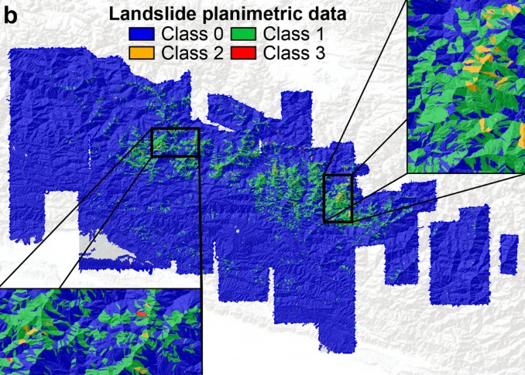
Figure 1. Classification of landslide risk areas based on planimetric data
Note. Taken from Aguilera et al. (2022).

5. Stakeholder analysis
Table 4 identifies the stakeholders, their position with respect to the project (executor, funder, authority, beneficiary, cooperating party, opponent and adversely affected party), their interests and their possible contribution or management.
Table 4. Stakeholder analysis
Entity data | Position | Interests or expectations | Contribution or management
Actor: National  Entity: MinCiencias | Cooperating party | Contribute to knowledge generation, solutions for the community and innovation in science. | - Fund the project with resources from the Science, Technology and Innovation Fund (FCTeI) of the General Royalties System (SGR).
Actor: National  Entity: Fondo Adaptación  Agency: Ministry of Finance | Funder | Execute comprehensive risk-management and climate-change adaptation projects with a multisectoral and regional approach, as well as those related to the La Niña phenomenon. | - Fund the project with resources from the Fondo Adaptación National Bank of Investment Programs and Projects.  - Supervise the project.
Actor: Academic  Entity: Urbam Center for Urban and Environmental Studies  Universidad EAFIT.  Position: Executor | Executor | - Participate in the implementation of the proposed monitoring and prediction tools.  - Produce relevant scientific material and have a positive impact on society. | - Formulate and execute the project.  - Establish the mechanism for operating the project  - Supervise and carry out the technical and financial monitoring of the project.
Actor: National  Entity: National Unit for Disaster Risk Management (UNGRD) | Authority | Mitigation of mass-movement risks. | Monitoring and control of the execution of the proposal
Actor: Departmental  Entity: Administrative Department for Disaster Risk Management of Antioquia (DAGRAN) | Authority | Mitigation of mass-movement risks. | Monitoring and control of the execution of the proposal
Actor: National  Entity: INVIAS | Authority | Mitigation of road maintenance costs. | Monitoring and control of the execution of the proposal
Actor: National  Entity: Ministry of Transport and Infrastructure | Authority | Mitigation of damage to national infrastructure and solutions for logistics efficiency. | Monitoring and control of the execution of the proposal
Actor: National  Entity: National Infrastructure Agency (ANI) | Authority | Mitigation of damage to national infrastructure | Mitigation of damage to national infrastructure and solutions for logistics efficiency.
Farming and merchant community of eastern Antioquia (near San Francisco) | Beneficiary | Better income and access to services thanks to improved road conditions. | - Feedback on the monitoring process and its results.  - Qualitative experiences that help identify possible quantitative parameters for a more robust evaluation of the proposal.
Communities living at the foot of and near the Medellín–Bogotá Highway | Beneficiary | Survival. Improved well-being and quality of life for their community and families. | - Feedback on the monitoring process and its results.  - Qualitative experiences that help identify possible quantitative parameters for a more robust evaluation of the proposal.
Actor: Private  Entity: Devimed, the concession in charge of the section proposed for monitoring | Beneficiary | Lower costs for maintenance and for works to mitigate mass-movement damage. | First-hand technical information on disaster behavior, causes and concrete consequences.
Actor: National  Entity: Colombian State | Beneficiary | Reduction of material and non-material costs from deaths and injuries. | Provides the legal framework and funding for developing the proposed monitoring.
Actor: National  Entity: IDEAM | Cooperating party | Good use of the environmental data it collects for better decision-making. | Provide information on environmental variables at or near the monitoring site.
Actor: Foreign/International  Entity: NASA | Cooperating party | Interest in expanding its database for detecting mass movements (LHASA) | - Provide free real-time satellite information on the environmental variables of the monitoring site.  - Provide free tools and conceptual frameworks for the early detection of possible mass movements with satellite imagery.
Actor: National  Entity: SIATA | Cooperating party | Interest in the good use of the environmental information it collects to improve the well-being of the region's inhabitants. | Provide free, real-time information on environmental variables (especially rainfall) in the area of interest.
Actor: National  Entity: IGAC | Cooperating party | Interest in the use of its geography and land-property catalogs | Provide free complementary information from its environmental and physical-geography data portal.
Actor: Foreign/International  Entity: Group on Earth Observations (GEO) | Cooperating party | Interest in improving the quality of life of communities and making better decisions with satellite imagery. | - Provide free real-time satellite information on the environmental variables of the monitoring site.
Third-party companies that carry out road maintenance. | Opponent /  Adversely affected | Receive payment for sporadic maintenance, as well as for the periodic maintenance associated with the rainy season. Also, receive a contract for disaster-preventive maintenance. | Take action so that their capital is not compromised by the solution for detecting mass movements.
Local population | Adversely affected | Interest in not having their lives, dignity and honor affected by the prevention of these disasters | Interventions on the infrastructure may require the use of productive land, homes and businesses.
Local fauna and flora | Adversely affected | Maintain their integrity for the full development of their life. | If preventive actions are taken on the infrastructure, they face the risk of being physically affected.
Note. Own elaboration.

5.1. Management strategies for opponents and adversely affected parties
To prevent the third-party companies hired by the concessions and/or the state to mitigate mass-movement damage on the roads from becoming adversely affected parties, it is proposed to turn them into direct beneficiaries of the monitoring system. The activities of this proposal must include a work plan to make them companies specialized in carrying out prevention actions rather than damage-mitigation actions. This is very plausible because, as explained in the next section, according to data from the Banco de la República (Ayala et al., 2013), departmental governments already invest more in disaster prevention than in disaster response. The capital is therefore already in preventive services, and these road risk-management companies can become companies dedicated to responding to the alerts issued by the monitoring system, focusing their preventive efforts more efficiently. They could even become direct clients of the system when the concession is not interested in disaster prevention because it legally assigns all of this responsibility to third parties.
To avoid possible harm to residents, action must be taken within the legal framework. One of the reasons that justify the project is SDG 11, indicator 11.5.1, which explicitly refers to reducing harm to the population, including its displacement. Therefore, if the population has to be relocated to prevent injury or even death, adequate facilities for temporary housing, or the relevant legal and financial arrangements for relocation, must be included in the budget of the prevention task triggered by the monitoring system's alarm.
As for wildlife, the executables of the entity intervening on the ground must include a program to evacuate as many of these animals as possible, including activities to verify and delimit the area. For flora, if the preventive activities include clearing forests, this must be offset by replanting in new locations or by purchasing carbon credits, as established by current policies and laws.

6. Problem analysis

6.1. Central problem
Landslides in geologically critical areas of the road infrastructure that threaten the safety, economy and integrity of the population that depends on it.

6.2. Causes and effects
Four direct causes —technical, economic, environmental and design-related— were identified from the central problem, together with their indirect causes, and four direct effects with their indirect effects (Table 5).
Table 5. Causes and effects of the central problem
Level | Social / urban | Economic | Environmental | Technical
Indirect effects | Displacement of communities | Higher transport costs  Loss of income | Contamination of water bodies  Loss of biodiversity | Higher repair costs  Prolonged interruption of road connectivity
Direct effects | Risks to road users | Interruption of economic activities | Ecosystem degradation | Deterioration of road infrastructure
Central problem | Landslides in critical areas that threaten the safety and integrity of road infrastructure
Direct causes | Unplanned urban development | Lack of investment in maintenance | Deforestation and heavy rainfall | Inadequate design of slopes and drainage
Indirect causes | Occupation of unstable land  Informal construction | Poorly managed budget priorities  Cumulative wear of infrastructure | Accelerated soil erosion  Reduced water-absorption capacity | Water accumulation in the ground  Unsafe slopes
Note. Own elaboration.

6.3. Problem tree
Figure 2 shows the relationship between the causes, the central problem and the effects.
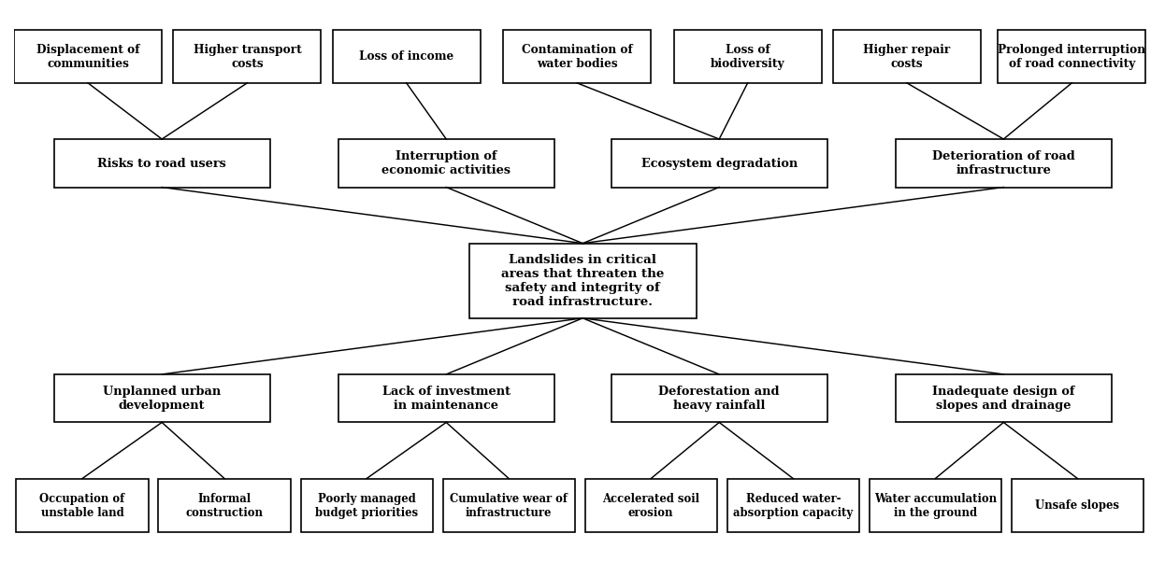
Figure 2. Problem tree
Note. Own elaboration.

6.4. Description of the problem and the existing situation
As set out in the selection of the technical system, the site must be a curve with a back slope, which increases the likelihood of landslides (Federal Highway Administration, 2002). It must also have a history of landslides in the area, especially periodic ones. This is the case of the Medellín–Bogotá Highway, Cocorná Toll – Route 45 junction, DeviMed concession, San Luis – Cocorná Toll section, in the municipality of San Francisco, the municipality with the most landslides in the Department of Antioquia according to the DAGRAN records from 1992 to 2022 (Gómez, 2023).
This area was chosen because of the causes and effects mentioned: it suffers from heavy seasonal rainfall and runoff is a common sight; activities such as limestone mining, livestock farming and agriculture can be seen along the road; there is the Río Claro canyon, an example of the natural erosion of the area; and, finally, the social problems left by the armed conflict in Colombia have resulted in unplanned urbanization, with many homes along the roadside at direct risk from mass movements. The little or no action taken by governments to relocate or improve these Colombian homes can be understood as a consequence of insufficient monitoring and failures in the early warning system. Examples are the San Luis landslides of October 2020 (Colombia Reports, 2020), which left 2 dead and 3 injured, and, more recently, the landslide of 22 June 2024 that completely closed the highway but fortunately did not claim any lives (El Colombiano, 2024).
Although monitoring systems and warning alarms exist, they have been insufficient to prevent disasters; improvement initiatives have been limited and have not been able to fully address the magnitude of the problem.

6.5. Magnitude of the problem
This section identifies the magnitude of the problem using metrics that corroborate the correlation with the main causes of landslides and their effects, presenting in particular the upward trend of these phenomena in the country where the proposal will be carried out, Colombia. To do so, the causes with the greatest weight in the expert literature are identified first: as described by NASA's Hydrological Sciences Laboratory (NASA Global Precipitation Measurement Mission, 2024), the main natural causes of landslides are heavy rainfall and earthquakes, and there are two artificial causes: infrastructure construction and mining, both closely linked to the modification of an area's geology.
To analyze the causes of the problem, and therefore to evaluate the effectiveness of the proposal, a metric for these causes is needed. Among the natural causes, earthquakes have been studied as triggers of landslides (Vega, 2013); however, they have not yet been modeled, and the literature has not found a correlation between the number or intensity of earthquakes and other natural phenomena over the years. This is unlike the rainfall load of an area, especially in Colombia, which is explained by phenomena such as La Niña and intensified over time by global warming.
This correlation was recently studied by Universidad de Medellín professor Johnny Vega and his co-authors (Vega et al., 2024), who found an upward trend in landslides over the years even though the five-year rainfall cycles (El Niño and La Niña) remain constant, as shown in Figure 3. The same study found that most landslides occurred in June, July and August in La Niña years, which was evident in 2022, when there were more than 300 landslides in that month.
The study correlated not only mud and debris avalanches with rainfall in the Colombian Andean region, but also other related phenomena such as creep (slow-flow failure), Fall (rockfall), Flow (earth flow), Slide (debris slide), L. Spread (lateral spread) and Topple, differences illustrated in Figure 4.
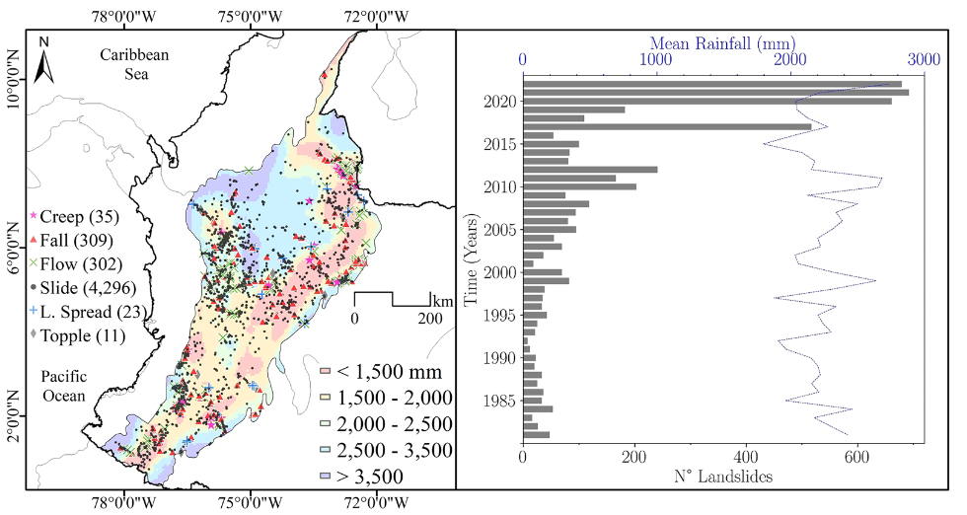
Figure 3. Distribution of landslides by type in Colombia (left) and relationship between mean annual precipitation and number of landslides (right)
Note. Taken from Vega et al. (2024).
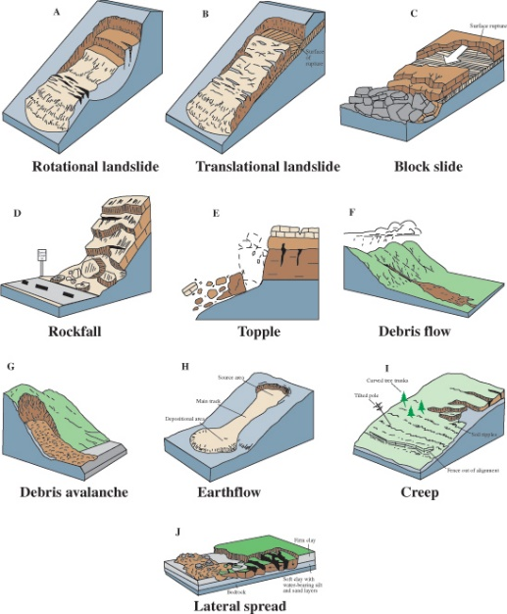
Figure 4. Types of mass movements
Note. Taken from Highland (2004), U.S. Geological Survey.
As for artificial causes, adapting mountainous terrain for infrastructure construction can greatly affect landslide incidence. This is shown by the study by McAdoo et al. (2018) on the increased landslide risk caused by building tertiary roads in western Nepal; these works have smaller effects than the paved roads studied in this proposal, but a correlation is still found, as shown in Figure 5.
McAdoo's study saw promise in analyzing this area because of the combination of the two natural causes mentioned above: the high rainfall due to the monsoons and the then-recent Gorkha earthquake that struck that region of Asia in 2015. The study compares the distance between landslides and tertiary roads to verify the correlation between infrastructure works and increased avalanche risk.
Assuming that the rains caused the same number of landslides with the same periodicity, the study focuses on the earthquake as an event that marks a before and after in the area's geology: if the pre-earthquake trend of more landslides closer to the roads continued after the earthquake, then the roads could be directly linked as a cause of probable landslides. The study concluded that in the areas most advanced in terms of infrastructure, landslide risk increased by up to 100% —double— compared with areas where tertiary roads were minimal or non-existent.
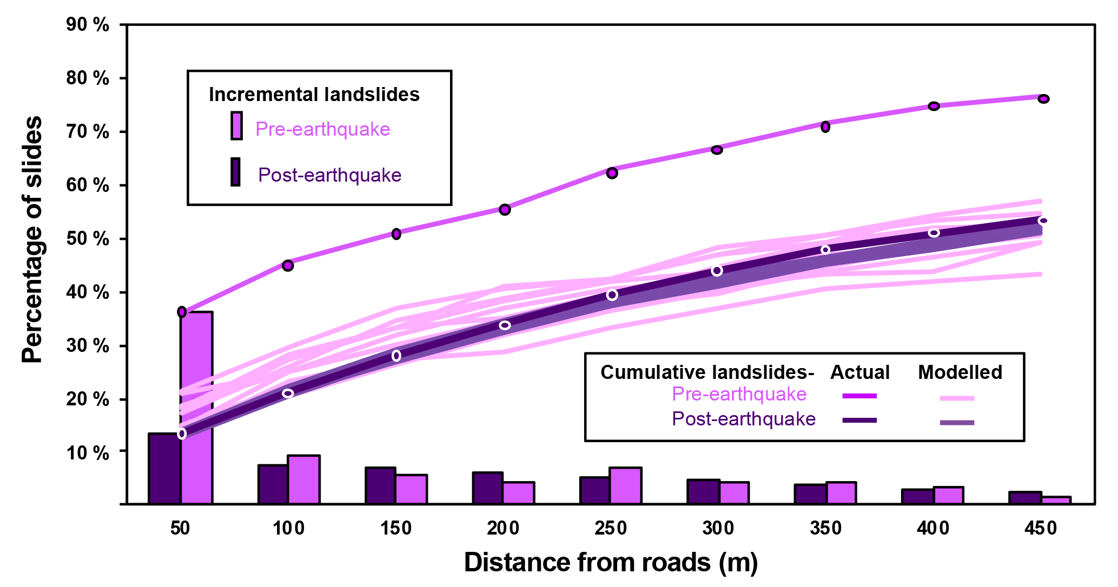
Figure 5. Percentage of landslides by distance to roads, before and after the Gorkha earthquake
Note. Taken from McAdoo et al. (2018).
To conclude this section, the main metrics of the effects of these causes are presented: the loss of human life and the injection of emergency resources to mitigate these disasters rather than to prevent them. This is reflected in Figure 6 (Marín et al., 2024), which shows that the money spent on immediate disaster response in 2022 alone was much higher than the total spent between 2002 and 2021, and also highlights the excessive increase in these losses in the Americas compared with the rest of the world.
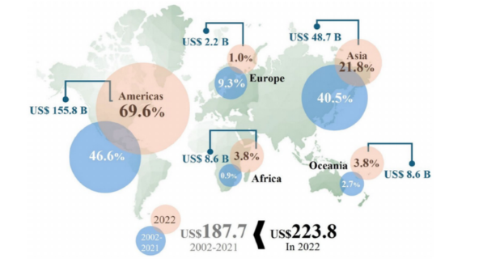
Figure 6. Resources allocated to immediate disaster response in 2022 versus the 2002-2021 period, by region
Note. Taken from Marín et al. (2024).
Between 1970 and 2019, natural disasters cost the world more than 2 million deaths and USD 3.64 trillion in economic losses (Douris and Kim, 2021). In Colombia, more than 37,590 people have lost their lives to landslides in the last 100 years (García-Delgado et al., 2022). Most of these victims are in the study area, the Department of Antioquia, according to the latest study by the Banco de la República with UNGRD data (Ayala and Ospino, 2023), as shown in Figure 7. Regarding monetary losses, the Banco de la República estimates an average departmental loss for disaster response of up to COP 5,000,000,000, which is considerably lower than what the departments are willing to pay for prevention, as shown in Figure 8. The same study shows that landslides are the leading cause of deaths from natural disasters in Colombia, accounting for 40% of them (Figure 9).
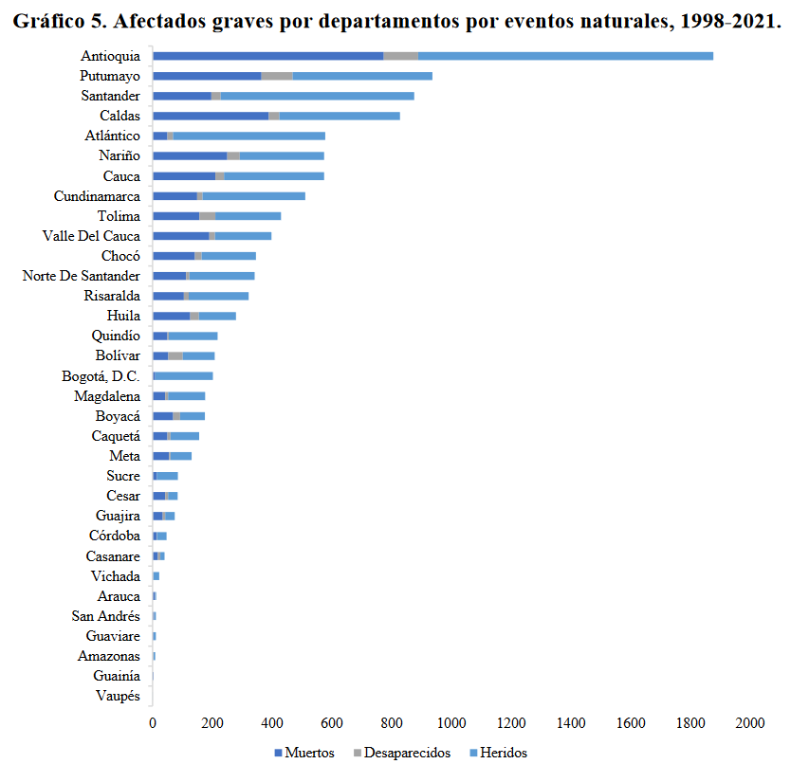
Figure 7. People seriously affected by natural events, by department, 1998-2021
Note. Taken from Ayala and Ospino (2023), with UNGRD data.
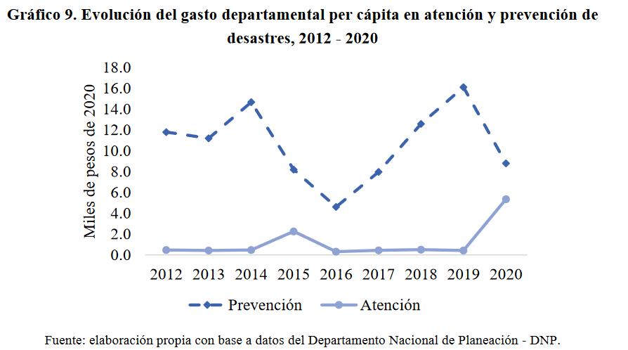
Figure 8. Evolution of departmental per-capita spending on disaster response and prevention, 2012-2020
Note. Taken from Ayala and Ospino (2023), with data from the National Planning Department.
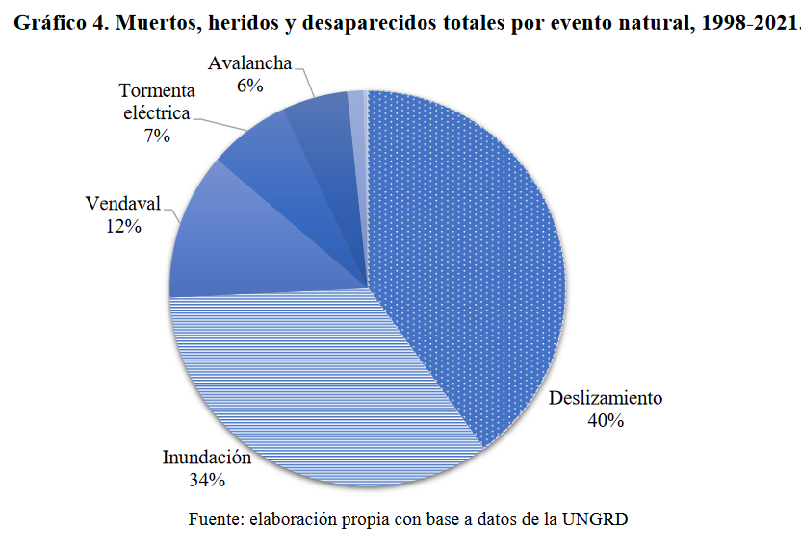
Figure 9. Deaths, injuries and missing persons by type of natural event, 1998-2021
Note. Taken from Ayala and Ospino (2023), with UNGRD data.
In summary, the reference indicators of the problem are: more than 11,800 landslides recorded in Colombia in the last 100 years, with Antioquia as the department with the most records (1,393 cases; UNGRD, 2020); landslides as the leading cause of deaths from natural events in the country (40%; Ayala and Ospino, 2023); and departmental spending on disaster response that consistently exceeds spending on prevention.

7. State of the art
Permanently and promptly monitoring the condition of a region's road infrastructure is an extremely demanding and costly task for the administrative and government entities and the users of that infrastructure. In addition, factors such as climate change, deforestation and longer periods of intense drought followed by heavy rainfall increase the risk of landslides in vulnerable areas. With the aim of developing a monitoring system assisted by computer vision to identify potential landslides, the following state of the art was prepared, covering current progress, local and international regulations, relevant scientific studies, patents and pertinent advances.

7.1. Regulatory and normative framework
Regarding the regulatory framework, infrastructure risk management in Colombia is governed by the Slope Stability Manual – Road Geotechnics (INVIAS, 2015) and Decree 1807 of 2014, which set out the technical criteria and responsibilities for disaster risk management in road infrastructure. Law 1523 of 2012 requires contingency plans to be integrated for risk management and the protection of road infrastructure, ensuring that infrastructure is designed and maintained under strict safety criteria.
Internationally, standards such as ISO 19111 define models for accurately describing and structuring geotechnical information, while ISO/IEC 27001:2022 and ISO/IEC 24762:2008 ensure the protection, confidentiality and integrity of data, and other standards such as ISO/DIS 37179:2023 set out the importance of infrastructure and technology capable of identifying risks in order to reduce them.
For Latin America, guidelines from the Economic Commission for Latin America and the Caribbean (ECLAC, 2017) and Eurocode 7 (CEN, 2004) provide frameworks for reducing landslide risk in transport infrastructure, promoting structural safety by analyzing unstable areas and carrying out corrective measures.
ISO 37179 (2023) is a draft standard under development that aims to establish a baseline framework for disaster risk reduction, providing practices for allocating and optimizing resources, disseminating technologies, ensuring the robustness and redundancy of the model to be implemented, and the necessary integration of the parties.
Table 6 summarizes the national and international technical standards and regulations consulted.
Table 6. Technical standards and regulations consulted
Standard / regulation | Issuer | Application in the project
Law 1523 of 2012 | Congress of Colombia | Adopts the National Disaster Risk Management Policy and creates the National Risk Management System.
Decree 1807 of 2014 | Presidency of the Republic | Regulates the incorporation of risk management into land-use plans.
Law 2294 of 2023 | Congress of Colombia | National Development Plan 2022-2026; policy framework for climate-resilient territories.
Slope Stability Manual – Road Geotechnics | INVIAS | Technical criteria for the study, design and stabilization of road slopes.
EN 1997-1:2004 + A1:2013 (Eurocode 7) | CEN | Geotechnical design: general rules for the stability analysis of slopes and embankments.
ISO 19111 | ISO | Geographic information: spatial referencing by coordinates.
ISO 19157 | ISO | Geographic information: data quality.
ISO/IEC 27001:2022 | ISO/IEC | Information security management systems (protection of platform data).
ISO/IEC 24762:2008 | ISO/IEC | Guidelines for ICT disaster recovery services.
ISO 37179 (draft, 2023) | ISO | Smart community infrastructure: continuity of urban services in the face of disasters.
ISO 22475-2 | ISO/CEN | Geotechnical investigation and testing: sampling methods and groundwater measurements.
ISO 31000:2018 | ISO | Risk management: principles and guidelines (basis of the process in Figure 10).
ISO/IEC 25010:2011 | ISO/IEC | Software product quality model (basis of the pilot tests).
Note. Own elaboration.

7.2. Scientific articles
Kirschbaum et al. (2020) and Akosah et al. (2024) highlight Big Data and deep-learning technologies for monitoring structures, showing that these technologies outperform traditional monitoring methods by generating early warnings from the integration of remote-sensing and environmental data that feed deep neural networks. These advances offer more accurate predictions and faster responses to prevent or reduce the impact of potentially dangerous events, improving risk management in road infrastructure.
Zhang and Wang (2024) highlight how hybrid deep-learning frameworks that combine spatial and temporal approaches improve the accuracy and reliability of landslide monitoring and prediction. Spatial frameworks are effective at classifying, detecting and segmenting data on the study space or area, while temporal-sequence frameworks process data related to variations in those environmental characteristics. This algorithm configuration enables more complex tasks in analyzing landslide dynamics, improving the accuracy of early warning systems.
Brunetti et al. (2021) describe how rainfall, specifically the analysis of rainfall thresholds (intensity and duration), influences landslides, using information obtained from satellites and sensors. They also highlight that this prediction method is more effective than ground observations for predicting landslides.
Ghorbanzadeh, Xu, Ghamisi, Kopp and Kreil (2022) address landslide detection using deep learning (DL) and remote-sensing data. The paper evaluates 11 DL segmentation models and concludes that combining multiple optical and topographic layers obtained with technologies such as Sentinel-2 is important for better detection.
Table 7 summarizes the indexed-journal articles reviewed and their contribution to the proposal.
Table 7. Indexed-journal articles reviewed
Authors (year) | Journal | Contribution to the proposal
Akosah et al. (2024) | Remote Sensing | Systematic review of the use of artificial intelligence and remote sensing to detect and predict landslides.
Aguilera et al. (2022) | Stochastic Environmental Research and Risk Assessment | Hierarchical neural networks to predict the occurrence and size of landslides.
Amatya et al. (2021) | Engineering Geology | Landslide mapping with object-based image analysis and open tools.
Brunetti et al. (2021) | Hydrology and Earth System Sciences | Satellite rainfall products outperform ground observations for predicting landslides.
Emberson et al. (2020) | Natural Hazards and Earth System Sciences | Global characterization of landslide exposure (LHASA team).
Emberson et al. (2021) | Nature Communications | Global relationship between El Niño and landslide impacts.
García-Delgado et al. (2022) | Landslides | Inventory of fatal landslides in Colombia and their socioeconomic impacts.
Ghorbanzadeh et al. (2022) | IEEE Transactions on Geoscience and Remote Sensing | Landslide4Sense: benchmark data and 11 deep-learning models for detection.
Hungr et al. (2014) | Landslides | Update of the Varnes classification of landslide types.
McAdoo et al. (2018) | Natural Hazards and Earth System Sciences | Relationship between road construction and increased landslides in Nepal.
Mignan and Broccardo (2020) | Seismological Research Letters | Meta-analysis of the limitations of neural networks in earthquake prediction.
Tehrani et al. (2022) | Natural Hazards | Advances and applications of machine learning in landslide studies.
Vega et al. (2024) | Landslides | Spatio-temporal relationship between landslides, rainfall and ENSO in the Colombian Andes.
Zhang and Wang (2024) | Remote Sensing | Spatio-temporal deep-learning frameworks with remote sensing and geo-environmental data.
Note. Own elaboration.

7.3. Books and other literature
The book Landslide Hazard and Environment Risk Assessment, a compilation of articles from MDPI's journal Land edited by Miccadei, Carabella and Paglia (2022), highlights the article Definition of Environmental Indicators for a Fast Estimation of Landslide Risk at National Scale (Segoni and Caleca, 2021), which provides a “classic” natural-hazard risk-probability model adapted to mass movements:
R = H × V × E (1)
Here, R represents the risk probability, H the hazard probability associated with a specific type of mass movement, V the vulnerability or degree of expected losses in the event of a disaster, and E the value of those losses. These three parameters are essential for building a model that can predict risks effectively.
It is crucial to size these parameters correctly, starting from the classification of mass-movement types by Varnes (1978), which remains a reference today (Hungr et al., 2014). From this classification, the hazard probability can be calculated and the possible damage assessed, which makes it possible to determine the risk probability using only information from satellite imagery. These images require suitable processing algorithms to generate timely alerts.
The use of neural networks as the main tool for automatically processing satellite images related to mass movements is widely documented in the scientific literature. Among various sources, chapter 9 of the book Building Computer Vision Applications Using Artificial Neural Networks: With Step-by-Step Examples in OpenCV and TensorFlow with Python stands out; it addresses the industrial application of real-time defect detection. This chapter presents the development of neural networks with the TensorFlow library, based on a Single Shot MultiBox Detector (SSD) model pre-trained on an image dataset.
The books, chapters and other technical literature consulted are listed in Table 8.
Table 8. Books and other literature consulted
Authors (year) | Type | Work and contribution
Ansari (2020) | Book | Building Computer Vision Applications Using Artificial Neural Networks (Apress). Implementing detectors with TensorFlow and OpenCV.
Miccadei, Carabella and Paglia (Eds.) (2022) | Book | Landslide Hazard and Environment Risk Assessment (MDPI). Classic risk model R = H × V × E.
Ahmed and Alam (Eds.) (2022) | Book | Remote Sensing of Natural Hazards (MDPI). Remote sensing applied to natural hazards.
Cruden and Varnes (1996) | Book chapter | Landslides: Investigation and Mitigation (TRB). Landslide types and processes.
Varnes (1978) | Book chapter | Landslides, analysis and control (TRB). Classification of slope movements.
INVIAS (n.d.) | Technical manual | Manual de Estabilidad de Taludes – Geotecnia Vial (Slope Stability Manual – Road Geotechnics). Design and stabilization of road slopes.
Lund University (2012) | Academic material | Introduction to Remote Sensing and Geographical Information Systems. Fundamentals of remote sensing and GIS.
Campos and Holm-Nielsen (Eds.) (2012) | Report | Análisis de la gestión del riesgo de desastres en Colombia (Analysis of disaster risk management in Colombia, World Bank).
Note. Own elaboration.

7.4. Patents
“Landslide early warning method and device for linear engineering and electronic equipment” describes a landslide early warning method based on warning devices designed for linear infrastructure or roads. The model is fed with geological variables such as terrain slope and lithology obtained from satellite data, which are then evaluated in a risk matrix; the vulnerability of the area is defined from the result.
Patents such as US 11,610,466 B2 (Ramesh et al., 2023) describe the operation of landslide early warning systems based on multiple levels of risk assessment; that patent highlights the use of sensors and real-time analysis that issue alerts based on critical thresholds of rainfall and ground movement. There are also patents such as WO 2018/027332 A1 (Comercial e Industrial Geosecology, 2018), which focuses on the predictive analysis of slope stability in open-pit mines. These innovations enable proactive responses to possible infrastructure failures, contributing to risk reduction, the protection of human lives and shorter emergency response times.
The patents reviewed are summarized in Table 9.
Table 9. Patents reviewed
Patent | Holder | Scope
US 11,610,466 B2 (2023) | Amrita Vishwa Vidyapeetham | Multilevel rapid warning system for landslide detection (rainfall, soil moisture, pore pressure and movement).
WO 2018/027332 A1 (2018) | Comercial e Industrial Geosecology Ltda. | Method and system for analyzing and generating early warnings of slope stability in open-pit mines.
CN 118379853 A (2024) | Chinese application | Landslide early warning method and device for linear works (roads) based on geological variables and a risk matrix.
Note. Own elaboration.

7.5. Synthesis and proposed solution
This project focuses on developing software to predict landslides on Route 60, section 5, specifically on the Medellín–Bogotá highway. The study section runs from coordinates 5.951316, -74.865089 to 5.950459, -74.861388, both in the jurisdiction of San Francisco, Antioquia, in a sector known as El Alto de Pavas, located at kilometer 87 heading towards Medellín. An area of 1 km around the road section will be considered to assess landslide risk in this region.
To do so, a deep-learning neural network will be implemented that uses images to feed a computer vision system. This system will identify spatial and temporal parameters that could compromise the structural integrity of the road section. The software will be able to access public databases such as NASA's landslide catalogs, the Group on Earth Observations catalog, IGAC's geological information and SIATA's rainfall information for the Department of Antioquia.
The algorithm will incorporate a hybrid model to identify state conditions such as geological, geographical and topographic conditions, rainfall, land use and other climatic variables. These conditions will be linked to a temporal model that records and compares changes in the state variables to identify patterns and anomalies that may increase landslide risk in these areas.
The model will support decision-making based on risk matrices derived from a classic risk-probability model described by Segoni and Caleca (2021). These matrices will be fed with the historical records of the Colombian Geological Survey and updated with the information available in the public databases provided by satellite services.
The software leverages the ability of neural networks to process large volumes of data accurately, generating objective early warnings that allow intervention in risk areas. This facilitates better resource management and disaster prevention, in line with the ISO 37179 standard.

8. Objective analysis
This section presents the objective tree (Table 10) and the actions to achieve the objectives through their respective indirect means, leading to the alternatives (Table 11): subsets of these actions aligned to solve the problems set out in Section 6 from technical, social, environmental and financial points of view.
The objective tree (Table 10) turns the negative conditions of the problem tree into desired situations: the central problem becomes the central objective, the causes become means and the effects become ends.
Table 10. Objective tree
Indirect ends | 1.1. Reduce loss of life within the framework of  SDG 11, target 5,  Indicator 11.5.1 “Number of deaths, missing persons and directly affected persons attributed to disasters per 100,000 population  issued by the UNDRR.” and SDG 3: Good health and well-being  Target 3.d “Strengthen the capacity of all countries, in particular developing countries, for early  warning, risk reduction and management of national and global health risks.” | 2.1. Reduce fluctuations in  the costs of  transport resulting from traffic interruptions caused by landslides, in  line with  Component 3.1.  of the Departmental  Development Plan:  “Infrastructure for  equity and  competitiveness.”  2.2. Reduce the loss of  income of  communities and the  Nation due to natural disasters, under  line with  SDG 11, Indicator  11.5.2 “Direct  economic loss  attributed to  disasters in  relation to  global gross  domestic product (GDP)  issued by the  UNDRR.” | 3.1. Recovery  of water  bodies, in  accordance with  SDG 15, target  15.1 “ensure the  conservation,  restoration and sustainable use of  terrestrial and  inland freshwater ecosystems and the services  that they provide,  in particular  forests,  wetlands,  mountains and  drylands, in  line with obligations under international agreements.”  3.2. Conservation  of biodiversity. | 4.1. Tools  that help reduce maintenance costs. In line with SDG 13, Indicator 13.1.3 Proportion of local governments that adopt  and implement  local disaster  risk reduction  strategies  in line with  national  disaster  risk reduction  strategies  issued by the  (UNDRR).  4.2. Ensure continuous road connectivity.
Direct ends | 1. Reduce risks for road users. | 2. Continuity of economic activities  and of the development of the communities  that depend on the road. | 3. Conservation  of the ecosystem. | 4. Conservation of road infrastructure.
Central objective | Increased STI capacity to predict and prevent mass movements that threaten the lives, economy and development of the inhabitants and travelers of Antioquia's road infrastructure.
Direct means (specific objectives) | 1. Increased capacity for planning  urban development. | 2. Smart  investment in  prevention and  mitigation of  risks in the road network. | 3. Implementation  of strategies  for detecting and preventing risk factors due to heavy rainfall and poor land management. | 4. Development of tools that facilitate the proper design of slopes and drainage for Antioquia's geography, climate and geology.
Indirect means  & actions | 1.1. Monitoring and updating of the cadastre in line with SDG 13 Indicator 13.1.3.  Actions:  1.1.1. Integration of the computer vision software with the cadastral database to update information on critical areas.  1.1.2. Development of an interactive dashboard to visualize geographical changes automatically.  1.2. Early warnings in high-risk areas, in line with Article 38 of the National Development Plan on the “strategy (…)  for human  resettlement”, and with  Program 3.1.1 of the departmental plan,  “Urbanism for development”.  Actions:  1.2.1. Risk simulations using predictive models based on neural networks.  1.2.2. Issuing early warnings that suggest relocations based on patterns detected by the system.  1.2.3. Training local authorities and communities on preventive measures based on data generated by the monitoring system. | 2.1. Studies on maintenance needs in sections of interest.  Actions:  2.1.1. Forming a work team to evaluate the sections with the highest recurrence of mass movements according to historical records.  2.1.2. Study of the area using conventional geophysical techniques.  2.1.3. Issuing of opinions and findings by the work team with a suggested maintenance schedule.  2.2. Investment in monitoring the condition of road infrastructure for better maintenance.  Actions:  2.2.1. Installation of cameras and drones for routine inspection of roads and bridges.  2.2.2. Acquisition of satellite databases for remote monitoring of roads and bridges.  2.2.3. Automated diagnosis of possible structural failures using computer vision.  2.2.4. Integration with GIS systems to keep an up-to-date record of the condition of the road infrastructure.  2.3. Creation of neighborhood networks for  disaster  prevention  2.3.1. Together with the public sector, create warning networks among the inhabitants of the sections of interest to inform the authorities of possible imminent risks. | 3.1. Development of technological tools that contribute to the  disaster  prevention of disasters within the  framework of ISO 37179.  Actions:  3.1.1. Development of landslide detection algorithms that analyze changes in visual patterns and environmental variables.  3.1.2. Training of the computer vision neural-network model with historical images to improve accuracy in early risk detection.  3.1.3. Implementation of climate-prediction modules integrating meteorological and geological data.  3.2. Training producers on runoff prevention  Actions:  3.2.1. Creation of interactive tutorials and educational videos using visual data captured by the monitoring system.  3.2.2. Organization of local workshops presenting the analyses generated by the system.  3.3. Real-time  characterization of the condition of the  soils  Actions:  3.3.1. Deployment of underground sensors and cameras to measure moisture, stability and changes in soil composition.  3.3.2. Development of a digital platform that issues alerts based on sudden changes detected by the AI system.  3.3.3. Feeding public databases with findings generated in real time for use by researchers and authorities.  3.3.4. Comparison with the soil condition predicted by multispectral satellite instrumentation. | 4.1. Development of risk models based on historical failure records and local geological variables that serve as a guide for slope-design decisions.  Actions:  4.1.1. Feeding the system with historical records of geological failures to improve the predictive models.  4.1.2. Development of visual simulations showing possible landslide scenarios.  4.1.3. Periodic updating of the system with the detected events to adjust the algorithms and reduce false positives.
Note. Own elaboration.

9. Alternatives analysis
In this section, 4 sets of the actions presented in the objective tree are taken to form 4 alternatives focused on achieving the central objective (Table 11). These alternatives are evaluated in the selection matrix in Table 12 in order to choose one of them for the project.
Table 11. Solution alternatives
Alternative name | Brief justification of the alternative
Alternative 1  Relocation plans for the population at risk from landslides. | Develop a comprehensive urban resettlement program for communities in risk areas, combining investment in sustainable infrastructure with the social and economic strengthening of the relocated communities. (Actions 1.2.1, 1.2.2, 1.2.3, 4.1.1, 4.1.2 & 4.1.3)
Alternative 2  Geographic information monitoring system with Industry 4.0 technology for preventing natural disasters affecting road infrastructure. | Implement an early warning system based on computer vision for real-time predictive analysis of areas at risk of landslides. (Actions 1.1.1, 1.1.2, 2.2.1, 2.2.2, 2.2.3, 2.2.4, 3.1.1, 3.1.2, 3.1.3, 3.3.1, 3.3.2, 3.3.3, 3.3.4 & 4.1.3)
Alternative 3  Training for landowners on proper land and watershed management. | Develop a comprehensive, practical training program that teaches producers soil-management and runoff-control techniques, including terraces, live barriers and vegetation cover, together with the promotion of regenerative agricultural practices that protect hillsides and reduce erosion in areas near the road infrastructure. (Actions 3.2.1 & 3.2.2)
Alternative 4  Manual of historical failure records and local soil conditions to support slope and drainage design. | Develop a manual with historical failure records and geological information that makes it possible to recognize environmental variables and past and present risk areas, facilitating the optimal selection of locations for new projects and guiding decision-making in slope and drainage design. (Actions 1.1.1, 1.1.2, 2.3.1, 4.1.1, 4.1.2 & 4.1.3)
Note. Own elaboration.

9.1. Selection matrix
Selection criteria: The criteria used to select the solution alternative are based on the requirements for technology products, grouped into the categories of functionality, innovation, usability and stability in relation to the stakeholders of the problem. The following criteria were therefore selected by category.
- Functionality: implementation of Industry 4.0 technologies.
- Innovation: innovative component.
- Usability: impact on the population.
- Stability: commercial viability.
Criteria weighting: Each of the selection criteria described above was assigned a weight between 1 and 5 according to how closely the criterion corresponds to the Sustainable Development Goals and the territorial development plan presented in Section 2.7 (alignment with public policy), where 1 is very weakly related and 5 is strongly related.
Rating: Similarly to the criteria weighting, each solution alternative is rated against each criterion with a value between 1 and 5 that expresses how well the alternative matches the criterion with respect to the Sustainable Development Goals and the policy-aligned development plan.
Table 12. Alternatives selection matrix
Alternative | Industry 4.0 technologies (w = 5) |  | Innovative component (w = 3) |  | Impact on the population (w = 4) |  | Commercial viability (w = 3) |  | Total
Alternative | r | r × w | r | r × w | r | r × w | r | r × w | Total
Alt. 1: Relocation of the population at risk | 2 | 10 | 1 | 3 | 5 | 20 | 1 | 3 | 36
Alt. 2: Geographic information monitoring system | 5 | 25 | 5 | 15 | 4 | 16 | 4 | 12 | 68
Alt. 3: Soil-management training | 3 | 15 | 3 | 9 | 2 | 8 | 3 | 9 | 41
Alt. 4: Manual of historical failure records | 4 | 20 | 3 | 9 | 1 | 4 | 2 | 6 | 39
Note. Own elaboration. r: rating (1-5); w: criterion weight (1-5). Maximum possible score: 75.
Alternative 2 obtains the highest score (68 out of 75 possible points), followed by Alternative 3 (41), Alternative 4 (39) and Alternative 1 (36). Correction note: in the previous version the r × w product had been calculated with the weight of the first criterion for all columns; the totals were recalculated and the selected alternative does not change.

9.2. Reasons for discarding the other alternatives
- Alternative 1 (relocation of the population): it has a high social impact, but it is reactive, very costly, creates conflicts with residents (adversely affected parties in Table 4), does not incorporate Industry 4.0 technologies and does not protect the road infrastructure, which is the object of the technical system.
- Alternative 3 (training): it is complementary and low-cost, but its effect depends on voluntary adoption by landowners, it does not anticipate events, and its impact on the road network is indirect and hard to measure. It is therefore included as a dissemination activity (Table 19) rather than as the main solution.
- Alternative 4 (manual of historical records): it provides information for slope design, but it is a static product that is not updated in real time and does not generate alerts. Its data are integrated as an input to the Alternative 2 database.

9.3. Technical analysis of the selected alternative
A real-time geographic monitoring system is a crucial tool for preventing and mitigating natural disasters. It integrates various technologies to collect, process and analyze geographic data in real time, enabling the early identification of patterns and anomalies that may indicate an imminent disaster.
Technical characteristics:
- Data collection: geospatial data (digital maps, digital elevation models – DEM, land use) and meteorological data (NASA, SIATA, IDEAM, IGAC).
- Data processing: machine-learning algorithms and neural networks to identify patterns and trends.
- Visualization: intuitive graphical interfaces, interactive georeferenced maps and customized dashboards to monitor multiple variables in real time.
- Communication: early warning system for authorities and the population at risk, and application programming interfaces (APIs) to integrate with other information systems.
Advantages: early and accurate detection, real-time information, wide coverage, intuitive visualization, integration with other systems and process automation.

10. Objectives

10.1. General objective
Develop a monitoring platform for collecting and analyzing geospatial and meteorological data for risk management in road infrastructure, generating early warnings through computer vision assisted by neural networks.

10.2. Specific objectives
- Design and implement a geospatial and meteorological database capable of storing and managing data in real time to facilitate its analysis and support the monitoring platform.
- Develop a dynamic risk matrix that integrates multiple variables (terrain stability, weather conditions, among others) to identify vulnerable areas and prioritize preventive decision-making.
- Implement a neural-network algorithm trained to detect critical patterns and predict landslides, optimizing the accuracy of early warnings.
- Develop and integrate a monitoring software platform that combines real-time data visualization, automatic report generation and configurable alerts to support risk management.
- Carry out pilot tests and iterate the system with real data, adjusting the software's algorithms and functions to ensure its effectiveness and scalability in different operating contexts.
- Generate automated reports and technical recommendations based on the analyzed information to facilitate timely decision-making by road-infrastructure and disaster-prevention managers.

10.3. Relationship between the objectives and the objective tree
Table 13 shows how each specific objective responds to the means of the objective tree and contributes to the ends of the project; the purpose corresponds to the central objective of the tree.
Table 13. Relationship between specific objectives, means and ends
Specific objective | Objective-tree means | End it contributes to
1. Geospatial and meteorological database | Means 1.1: monitoring and updating of the cadastre | End 1: reduce risks for road users
2. Dynamic risk matrix | Means 4.1: risk models based on historical failure records | End 4: conservation of road infrastructure
3. Neural-network algorithm | Means 3.1: technological tools for disaster prevention | Ends 1 and 3: fewer risks and ecosystem conservation
4. Monitoring software platform | Means 2: smart investment in prevention and mitigation in the road network | End 2: continuity of economic activities
5. Pilot tests with real data | Means 3: strategies for detecting and preventing risk factors | End 4: conservation of road infrastructure
6. Technical reports and recommendations | Means 1: urban development planning capacity | Ends 1 and 2
Note. Own elaboration. Purpose: increased STI capacity to predict and prevent mass movements that threaten the lives, economy and road infrastructure of Antioquia.

11. Project work breakdown structure
The work breakdown structure (Table 14) organizes the project into four hierarchical levels: ends, purpose, components (MGA catalog products) and activities.
Table 14. Project work breakdown structure
Level | Content
Ends | Reduce risks for road users · Continuity of the communities' economic activities · Ecosystem conservation · Conservation of road infrastructure
Purpose | Increased STI capacity to predict and prevent mass movements that threaten the lives, economy and road infrastructure of Antioquia
Specific objectives | 1. Geospatial and meteorological database | 2. Dynamic risk matrix | 3. Neural-network algorithm | 4. Monitoring software platform | 5. Pilot tests and iteration | 6. Technical reports and recommendations
Components (MGA products) | 390200103 – Information services for implementation | 020700901 – Monitoring service for risk management | 390300205 – Support service for technological development and innovation | 230208601 – Information services for the Digital Government Strategy  390300504 – Support service for knowledge and technology transfer | 390100705 – Information services for STI | 320400601 – Real-time forecast and alert information service
Activities | 1.1 Requirements analysis  1.2 Database design  1.3 Configuration  1.4 Data migration  1.5 Testing  1.6 Documentation  1.7 Deployment and maintenance | 2.1 Definition of context and parameters  2.2 Risk assessment  2.3 Risk treatment  2.4 Implementation in the monitoring cycle  2.5 Communication and consultation  2.6 Recording and reporting | 3.1 Algorithm training  3.2 Validation  3.3 Implementation on the platform | 4.1 Requirements gathering  4.2 Design  4.3 Software development  4.4 Integration  4.5 Adjustments | 5.1 Test planning  5.2 Execution  5.3 Iteration and optimization  5.4 Final validation  5.5 Training for DAGRAN  5.6 Presentation to authorities | 6.1 Logical report commands  6.2 Conference presentation  6.3 Awareness campaign
Note. Own elaboration. Details of tasks, responsible parties and means of verification are in Table 16, and the schedule in Table 20.

11.1. Expected products
Table 15 below shows the products expected from this project, how and by what parameter their successful achievement will be measured, and their indicators according to the DNP product catalog attached to the formulated proposal. The main product, the software platform combining the monitoring algorithm, corresponds to product 390300205 of the Science, Technology and Innovation sector, which covers any verified and certified technological product, notably software. In addition, its final display in an interface combining all the proposed functions promises a product aligned with code 230208601 of the Information and Communication Technologies sector. This product is mainly supported by a geospatial and meteorological database corresponding to product 390200103 “Information services for implementation”, also from the STI sector, verified by the number of databases created for experimental projects, in this case one. In addition, the algorithm will feed a risk matrix (product 020700901, “Disaster risk prevention and mitigation”, from the Presidency sector) from which the status of the monitored areas will be issued as bulletins and, when necessary, alerts and forecasts (product 320400601, “Real-time forecast and alert information service”, from the Environment and Sustainable Development sector).
Finally, the successful execution of these products and services requires additional products that certify the quality of the deliverables and protect the intellectual property produced. For this, reports will be produced under product 390100705 “Information services for STI”, measured by the Digital Government Index, a measure that identifies good implementation practices, opportunities for improvement and targeted support strategies. It is calculated from the data collected through the Single Management Progress Report Form (FURAG) and then applying an Item Response Theory model known as the Graded Response Model (GRM) (MinTIC, 2022).
To protect the authorship of the main product, the platform, product 390300504 “Support service for knowledge and technology transfer” is needed, which “comprises a set of actions carried out by different institutions for the development, exploitation, use, modification and dissemination of new technologies and innovations. It is supported by in-house or externally generated methodologies, tools and/or techniques related to improving productivity and operational efficiency. It also includes support for companies resulting from research + creation that are innovative and of high added value, especially those that can be protected by Intellectual Property rights.”
Table 15. Expected products (MGA product catalog)
Code | Product | Measured through | Product indicator | Target
390300205 | Support service for technological development and innovation | Number of information systems | Information systems updated | 1
390300504 | Support service for knowledge and technology transfer. | Number of organizations. | Licensing of intellectual property assets. | 1
020700901 | Monitoring service for risk management | Number of bulletins | Monitored coverage (for hydrological, meteorological and climatic phenomena) | 4
230208601 | Information services for the implementation of the Digital Government Strategy | Number of technological tools | Digital Government technological tools created | 5
320400601 | Real-time forecast and alert information service. | Number of reports | Forecast and alert reports generated. | X>1 per hour
390100705 | Information services for STI. | Online Government Index score | Functional and non-functional test reports completed. | 1
390200103 | Financial support service for generating new knowledge | Number of databases | Projects funded for experimental development | 1
Note. Own elaboration based on the DNP product catalog.

12. Methodology
Table 16 describes, for each specific objective, the activities, responsible parties, tasks, results and means of verification. Risk management in the dynamic matrix follows the ISO 31000:2018 process (Figure 10).
Table 16. Methodology: activities, responsible parties, tasks, results and means of verification
Specific objective | Activity | Responsible | Tasks | Activity results | Means of verification
Objective 1: Design and implement a geospatial and meteorological database capable of storing and managing data in real time to facilitate its analysis and support the monitoring platform. (ISO/IEC 9075:2016) | 1. Requirements analysis | Database developer – Project director. | 1.1. Identify data requirements.  1.2. Define data types and structures. Unify data formats and quality.  1.3. Determine security and access requirements. | Geospatial and meteorological knowledge classified and categorized. | - Data integrity report (with open tools such as Google Data Validation Tool)
 | 2. Database design | Database developer | 2.1. Create an entity-relationship (ER) diagram.  2.2. Define tables, columns and relationships.  2.3. Establish primary and foreign keys.  2.4. Design indexes for performance optimization | Database for generating new geospatial and meteorological knowledge designed. | - Number of databases designed.
 | 3. Database configuration | Database developer | 3.1. Install and configure the database management system (DBMS).  3.2. Create the database schema.  3.3. Configure user roles and permissions. | Database for generating new geospatial and meteorological knowledge operational. | - Number of databases configured.
 | 4. Data migration | Data analyst | 4.1. Plan the data migration strategy.  4.2. Extract, transform and load (ETL) data from existing sources.  4.3. Validate data integrity and accuracy. | Dynamic database for generating new geospatial and meteorological knowledge: able to connect to and disconnect from data feeds at will. | - Number of dynamic databases.  - Verification of access from remote tools with the SQL protocol
 | 5. Database testing | Data analyst | 5.1. Perform unit tests on the database components.  5.2. Perform integration tests with other systems.  5.3. Validate performance and scalability. | Tests successfully completed as an STI information service. | Test report with the corresponding Digital Government Index score.
 | 6. Documentation | Database developer | 6.1. Document the design and configuration procedures of the database.  6.2. Create user manuals and training materials.  6.3. Hold training sessions for database users. | Protocol for using the database as an STI information service. | Technical documentation rated with the Digital Government Index.
 | 7. Deployment and maintenance | Technician operating the final platform | 7.1. Deploy the database in the production environment  7.2. Monitor database performance and security | Database at full operational capacity | - Number of databases in operation.
 | 1. Disaster risk management training | Third-party company for the project director and data analysts.
Objective 2: Develop a dynamic risk matrix that integrates multiple variables (terrain stability, weather conditions, among others) to identify vulnerable areas and prioritize preventive decision-making. (Based on the risk-treatment process of ISO 31000:2018, shown in Figure 9.) | 2. Definition of context, parameters and scope | Third-party risk analyst – Data analyst. | 2.1. Define natural factors: define parameters and their respective ranges: geographical, environmental and climatic.  2.2. Define artificial factors: assess the vulnerability to landslides created by human actions on the infrastructure and its surroundings, including the infrastructure itself.  2.3. Define risk criteria: establish criteria to assess the significance of landslide risks, such as the potential impact on human lives, property and the environment. | Parameters defined. | Definitions document.
 | 3. Risk assessment | Third-party risk analyst – Data analyst. | 3.1. Risk identification: identify landslide-prone areas, possible triggers (heavy rainfall, earthquakes, artificial causes) and possible consequences.  3.2. Risk analysis: analyze the probability of landslides and their potential impact on the organization and surrounding areas. (H in equation 1)  3.3. Risk evaluation: compare the results of the risk analysis with the criteria established in equation 1 to determine the significance of the risks. | Risk model developed. | Model and calculations documented. Coverage monitored with the models.
 | 4. Risk treatment approach | Third-party risk manager | 4.1. Identify risk treatment options: consider options such as land-use planning, engineering solutions (e.g., retaining walls) and early warning systems.  4.2. Evaluate risk treatment options: assess the feasibility, cost and effectiveness of each treatment option. | Model validated. | Validation report.
 | 5. Implementation of the matrix in the continuous monitoring cycle | Software developer | 5.1 Monitor risk treatment: continuously monitor the effectiveness of the treatments chosen and carried out by the entity alerted through the platform.  5.2. Review the risk management framework: regularly review and update the risk management framework to ensure it remains effective in managing landslide risks. | Matrix implemented and functional. | Technical documentation.
 | 6. Communication and consultation | Third-party risk manager | 6.1. Stakeholder participation: involve local communities, government agencies and other stakeholders to secure their input and cooperation.  6.2. Risk reporting: communicate risk information and updates to stakeholders clearly and promptly. | Protocol agreement between the parties. | Meeting records.
 | 7. Recording and reporting | Technician operating the final platform | 7.1. Document the risk management process: keep detailed records of risk assessments, treatment plans and monitoring activities.  7.2. Report on risk management: provide regular reports on the status of landslide risk-management activities and results. | Risk report. | Technical documentation.
 | 8. Training in geographic information systems (GIS) | Third party for the software developer and computer vision analysts
Objective 3: Implement a neural-network algorithm trained to detect critical patterns and predict landslides, optimizing the accuracy of early warnings. | 1. Algorithm training. | Computer vision analysts. | Select a suitable dataset  1.2. Preprocess the data  1.3. Train the model using backpropagation. | Highly accurate trained model | Training results documented
 | 2. Algorithm validation | Software developer | 2.1. Split data into validation sets  2.2. Tune hyperparameters 2.3. Validate the model to avoid overfitting | Model optimized and validated | Accuracy and performance report
 | 3. Implementation on the platform | Software developer – Computer vision analyst. | 3.1. Integrate the model into the platform 3.2. Configure prediction-based alerts | Model operational in a real environment | Integration tests completed
Objective 4: Develop and integrate a monitoring software platform for road infrastructure. | 1. Requirements gathering | Data analyst | 1.1. Identify the actors and monitoring needs. 1.2. Define the key functions of the software. | Document with the functional specifications. | Requirements report approved.
 | 2. Platform design | Platform developer | 2.1. Create a UML model of the functions. 2.2. Establish the graphical user interface (GUI). | Prototype of the platform design. | Prototype presentation validated.
 | 3. Software development | Platform developer | 3.1. Program the main modules. 3.2. Implement databases. | Functional monitoring module. | Successful functional tests.
 | 4. Platform integration | Platform developer | 4.1. Connect the platform with external services. 4.2. Carry out integration tests. | Functional integrated platform. | System integration report.
 | 5. Adjustments | Project director – Software developer – Platform developer | 5.1. Train end users. 5.2. Collect feedback for final improvements. | Platform ready for implementation. | Attendance list and improvements report.
Objective 5: Carry out pilot tests and iterate the system with real data (ISO/IEC 25010:2011: standard for software quality evaluation; ISO/IEC 9126-4: evaluation of system performance and quality metrics) | 1. Pilot test planning | Third-party developer/tester | 1.1. Define test scenarios 1.2. Select a real test dataset 1.3. Establish evaluation metrics | Test plan defined | Test plan approved
 | 2. Pilot test execution | Platform developer | 2.1. Run the system with real data 2.2. Document the results obtained 2.3. Identify failures or necessary improvements | Results obtained and documented | Pilot test report
 | 3. Iteration and optimization | Software developer | 3.1. Adjust algorithms and system 3.2. Implement improvements based on test results | System iterated and optimized | Iterations report
 | 4. Final system validation | Project director | 4.1. Validate the complete operation of the system 4.2. Ensure compliance with the defined objectives | System validated | Final validation report
 | 5. Training DAGRAN professionals on the platform | Platform developer | Train 10 DAGRAN staff members to use the platform developed. | Staff trained. | Number of staff who passed the training
 | 6. Presentation of results to the competent authorities | Project director – Platform developer – Computer vision analyst – Data analyst. | Demonstration of the software to government entities for its integration into landslide risk-management plans | Number of agreements signed and documents approved for implementation | Meeting minutes, agreement documents and signed memoranda of understanding.
Objective 6: Generate automated reports and technical recommendations. | 1. Develop logical commands linking reports with recommendations. | Platform developer – Geologist – Civil engineer. | Collect and prepare data for instant response to the client. | Responses for all the scenarios considered. | Logical commands and response dictionary.
 | 2. Presentation at an international conference | Software developer – Database developer – Platform developer. | Presentation of results at geoscience and environmental technology conferences | Conference presentation on the patent/license developed. | Number of events attended.
 | 3. Community awareness campaign | Project director – Administrative assistant – Final platform technician – Local government. | Raising public awareness of landslide risk and of the software's usefulness in preventing it | Informed community | Number of attendees at community awareness workshops
Note. Own elaboration.
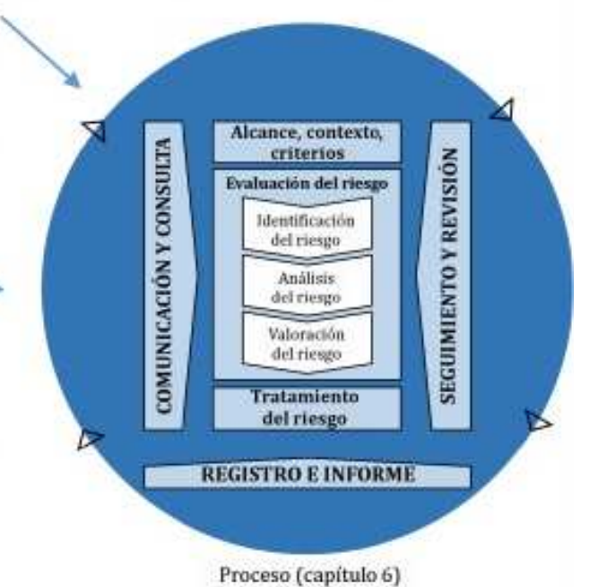
Figure 10. Risk management process according to ISO 31000:2018
Note. Adapted from ISO 31000:2018.

13. Logical framework matrix
Table 17. Logical framework matrix
Level | Narrative summary | Indicators | Means of verification | Assumptions
Goal | Develop a system that reduces road risks for the different actors involved, allowing the continuity of the economic and development activities that depend on the road, while preserving the existing infrastructure and ecosystem. | 1. By the midpoint of the investment payback period: (SDG indicator 11.5.1: number of deaths, missing persons and directly affected persons attributed to disasters per 100,000 population, issued by DAGRAN.  2. Days of normal freight traffic on the Medellín–Bogotá highway.  3. Functional monitoring platform within 24 months.  4. Kilometers of road that no longer need regular maintenance compared with the previous period (evaluated over the 10 investment payback periods) | 1. Reports issued by DAGRAN during the 10 investment payback periods.  4. Traffic-flow statistics issued by INVIAS for the monitored roads over the 10 budget payback periods defined in the net cash flow, for the study site.  2. Simulations of the beta software carried out by the risk consultancy between months 21 and 22 to evaluate its performance under real monitoring conditions in its area of operation.  6. Annual report of the Ministry of Transport on national road maintenance (evaluated over the 10 investment payback periods) | 1. Road authorities and disaster-management teams will receive adequate training in the use of the monitoring software, ensuring they understand how it works and how to interpret the alerts generated.  2. The responsible entities will have the necessary technical resources, including computers, servers, mobile devices and reliable internet access, to operate the software in their facilities or in the field.  3. The monitoring software will be integrated into operational disaster-response protocols, so that the alerts and analyses generated are used as a key source of information for decision-making.  4. Road authorities and disaster-management teams will actively use the software as part of their daily monitoring routine, improving coordination and response capacity to possible landslides.
Purpose | Develop software based on image processing with a neural network, aimed at identifying risk patterns in vulnerable areas by analyzing satellite images and historical records to generate early warnings. | 1. SDG indicator 11.5.1: number of deaths, missing persons and directly affected persons attributed to disasters per 100,000 population, issued by DAGRAN.  2. Software design suitable for regional use (interconnected operation with big data and functional alert systems) within a maximum of 24 months.  3. Functional monitoring system that provides safety and saves time and resources for users traveling on the intermunicipal road studied. | 1. Record of the system's implementation in the database during month 24.  2. Performance reports on the alerts on the digital platform during the 10 budget-benefit payback periods defined in the net cash flow, for the study site.  3. On-site user surveys (road authorities) during the 10 budget-benefit payback periods defined in the net cash flow, for the study site. | 1. The sensor infrastructure and satellite data will be available.  2. The quality of the data provided by external sources will be maintained.  3. The data will be delivered in real time
Components | This section presents the products expected from this project, together with additional products to certify their quality. Detailed information is given in Section 11.1 and in Table 8 of this document. | 390300205: Support service for technological development and innovation.  390300504: Support service for knowledge and technology transfer.  020700901: Monitoring service for risk management.  230208601: Information services for the implementation of the Digital Government Strategy.  320400601: Real-time forecast and alert information service.  390100705: Information services for STI.  390200103: Financial support service for generating new knowledge.  Training on the platform. | 1. The means of verification required by the DNP is the number of information systems (software) completed by month 16 according to the schedule.  2. Number of third-party organizations exploiting the license/patent rights, according to the DNP. It will be verified during the 10 investment recovery periods after the project.  3. The means of verification required by the DNP is the number of bulletins issued by the service. It will be verified during the 10 investment recovery periods after the project.  4. The means of verification required by the DNP is the number of information technology tools (in this case the interface platform) by month 18 of the schedule.  5. The means of verification required by the DNP is the number of reports issued by the service. It will be verified during the 10 investment recovery periods after the project.  6. The reports produced during project execution will be verified with the Digital Government Index score, as required by the DNP. These reports will be produced and delivered at the completion of each objective, in months 4, 12, 16, 18 and 22 of the schedule.  7. The means of verification required by the DNP is the number of databases produced, by month 4 according to the schedule.  8. 10 DAGRAN staff members trained in the use of the platform from month 22 to 24. | 1. Historical records and geological data will be sufficient to train the model.  2. Access to external databases will be guaranteed and up to date, without significant interruptions.  3. The servers and systems used for monitoring must be operational 24/7 with a support system.
Activities | The activities to be carried out are described according to the schedule in Table 2 of this document, together with the budget breakdown by subsystem and the corresponding process monitoring. | 1. 20%: Licenses and acquisition of databases (non-free sources).  2. 35%: Employee salaries (data scientists, software engineers, risk analysts, etc.).  3. 15%: Enterprise licenses for the YOLO v5 neural network.  4. 20%: Servers for deploying and processing the developed software (including cloud storage and processing costs).  5. 10%: Miscellaneous expenses (software maintenance, technical support, etc.). | As indicated in the budget, the executing entity will be supervised by a third-party accounting firm that will audit its compliance. The specific means of verification for the activities can be found in the methodology section, Table 9. Payments are made on delivery: once the means of verification of the products are approved, the executor is paid. | 1. The algorithm tests will reflect the scenarios.  2. The costs of software licenses and commercial databases are included in the budget, avoiding implementation delays.  3. The development team must be fully available to test and adjust the system as needed without affecting project deadlines.  4. The project must be 100% delivered on the stipulated date.
Note. Own elaboration.

14. Impacts
The impacts are classified according to the categories of the course methodology —environment and society, science and technology, and productivity and competitiveness— with their indicator, means of verification and time frame (Table 18). Short term means up to 2 years (execution period), medium term between 3 and 5 years, and long term more than 5 years after the project ends.
Table 18. Project impacts
Type of impact | Indicators | Means of verification | Time frame
Environment and society | Reduction in the number of deaths, missing persons and directly affected persons attributed to disasters per 100,000 population. | DAGRAN reports on damage reduction or disasters avoided, for period 5 of the investment payback. | Long term
Science and technology | Neural-network service for technological development and innovation, trained with geological, geotechnical and hydrological analysis and validated in 16 months. | Number of information systems (software) completed by month 16 according to the schedule. | Medium term
Productivity and competitiveness | Days of normal freight traffic on the Medellín–Bogotá highway. | Traffic-flow statistics issued by INVIAS for the monitored roads over the 10 budget payback periods defined in the net cash flow, for the study site. | Medium term
Productivity and competitiveness | Expanded use of the software in other geographical areas, subject to demand | Number of reports issued by the service. It will be verified during the 10 investment recovery periods after the project. | Medium term
Productivity and competitiveness | Kilometers of road that no longer need regular maintenance compared with the previous period | Annual report of the Ministry of Transport on national road maintenance (evaluated over the 10 investment payback periods) | Medium term
Science and technology | Development and licensing of computer-vision monitoring methodologies | Number of third-party organizations exploiting the license/patent rights. | Short term
Note. Own elaboration.

15. Dissemination strategy
The dissemination strategy (Table 19) combines products for the social appropriation of knowledge and for scientific dissemination, each with its expected result, indicator, beneficiaries and means of verification.
Table 19. Dissemination strategy
Type of product | Expected result | Indicator | Beneficiary | Means of verification
Conference presentation | Presentation of the software's results and functions at geoscience and environmental technology conferences | Number of attendees, groups and entities at the presentation, and positive feedback | Scientific community and environmental authorities | Participation certificates and conference proceedings supporting the presentation of the work. The presentation is proposed for the PIARC 2026 congress of the World Road Association, at a cost of COP 10,000,000 per speaker (three speakers are planned), contributed in kind by EAFIT
Presentation of results to the competent authorities | Demonstration of the software to government entities for its integration into landslide risk-management plans | Number of agreements signed and documents approved for implementation | Risk-management authorities, municipalities and NGOs | Meeting minutes, agreement documents and signed memoranda of understanding. One event with the community action board of the selected road section is estimated at COP 15,000,000
Training DAGRAN professionals on the platform | Training of 10 DAGRAN risk-management professionals in the use of the software for predictive landslide analysis | Number of training sessions held and assessment of the skills acquired | Risk-management teams, civil engineering professionals and community members | Training reports and satisfaction surveys assessing learning and the applicability of the software. Considering a cost of COP 2,500,000 per student.
Community awareness campaigns | Raising public awareness of landslide risk and of the software's usefulness in preventing it | Number of people reached and attendees at awareness workshops | Vulnerable communities, especially in landslide-prone areas | Pre- and post-campaign surveys measuring the change in risk perception and knowledge of how to use the software. A total cost of COP 15,000,000 is estimated for holding these workshops with the community.
Note. Own elaboration.

16. Schedule
The schedule (Table 20) distributes the activities over the 24 months of execution, grouped into two-month periods.
Table 20. Project schedule (Gantt chart)
Specific objective | Activity | Start (month) | End (month) | Duration (months) | Two-month period
 |  |  |  |  | 1-2 | 3-4 | 5-6 | 7-8 | 9-10 | 11-12 | 13-14 | 15-16 | 17-18 | 19-20 | 21-22 | 23-24
SO1. Geospatial and meteorological database | 1.1 Requirements analysis | 1 | 2 | 2
SO1. Geospatial and meteorological database | 1.2 Database design | 1 | 4 | 4
SO1. Geospatial and meteorological database | 1.3 Database configuration | 3 | 6 | 4
SO1. Geospatial and meteorological database | 1.4 Data migration | 3 | 6 | 4
SO1. Geospatial and meteorological database | 1.5 Database testing | 3 | 6 | 4
SO1. Geospatial and meteorological database | 1.6 Documentation | 1 | 24 | 24
SO1. Geospatial and meteorological database | 1.7 Deployment and maintenance | 1 | 24 | 24
SO2. Dynamic risk matrix | 2.1 Definition of context, parameters and scope | 5 | 6 | 2
SO2. Dynamic risk matrix | 2.2 Risk assessment | 5 | 8 | 4
SO2. Dynamic risk matrix | 2.3 Risk treatment approach | 5 | 8 | 4
SO2. Dynamic risk matrix | 2.4 Implementation in the monitoring cycle | 7 | 12 | 6
SO2. Dynamic risk matrix | 2.5 Communication and consultation | 7 | 12 | 6
SO2. Dynamic risk matrix | 2.6 Recording and reporting | 7 | 14 | 8
SO3. Neural-network algorithm | 3.1 Algorithm training | 9 | 14 | 6
SO3. Neural-network algorithm | 3.2 Algorithm validation | 11 | 16 | 6
SO3. Neural-network algorithm | 3.3 Implementation on the platform | 13 | 16 | 4
SO4. Software platform | 4.1 Requirements gathering | 5 | 18 | 14
SO4. Software platform | 4.2 Platform design | 5 | 18 | 14
SO4. Software platform | 4.3 Software development | 5 | 18 | 14
SO4. Software platform | 4.4 Platform integration | 5 | 18 | 14
SO4. Software platform | 4.5 Adjustments | 15 | 20 | 6
SO5. Pilot tests | 5.1 Pilot test planning | 17 | 18 | 2
SO5. Pilot tests | 5.2 Pilot test execution | 19 | 20 | 2
SO5. Pilot tests | 5.3 Iteration and optimization | 19 | 22 | 4
SO5. Pilot tests | 5.4 Final system validation | 21 | 22 | 2
SO6. Reports and dissemination | 6.1 Logical report commands | 23 | 24 | 2
SO6. Reports and dissemination | 6.2 Presentation at an international conference | 23 | 24 | 2
SO6. Reports and dissemination | 6.3 Awareness campaign | 23 | 24 | 2
Note. Own elaboration. Dark blue: development activities; light blue: continuous operational activities.

17. Budget
The total project budget amounts to COP 2,020,666,816 for the 24 months of execution. Each budget item is described below with its funding sources: the ally URBAM, the Universidad EAFIT counterpart contribution (in kind and in cash) and the funder (cash resources from the STI Fund of the General Royalties System or from Fondo Adaptación).

17.1. Human resources
Corresponds to the staff in Table 2. The cost is calculated as the salary with benefits (a factor of 1.55 on the base salary) multiplied by the number of months and by the fraction of weekly dedication over a 48-hour working week. This item totals COP 601,787,500 (29.8% of the total) and is fully covered by the funder.
Table 21. Human-resources budget
Position | h/week | Months | Monthly salary | Salary + benefits | Total (funder)
Project manager | 12 | 24 | $ 7,000,000 | $ 10,850,000 | $ 65,100,000
Database developer | 30 | 14 | $ 4,500,000 | $ 6,975,000 | $ 61,031,250
Software developer | 30 | 18 | $ 4,500,000 | $ 6,975,000 | $ 78,468,750
Platform developer | 30 | 24 | $ 4,500,000 | $ 6,975,000 | $ 104,625,000
Junior computer vision specialist | 30 | 12 | $ 4,500,000 | $ 6,975,000 | $ 52,312,500
Senior computer vision specialist | 30 | 16 | $ 4,500,000 | $ 6,975,000 | $ 69,750,000
Junior data analyst | 30 | 12 | $ 4,200,000 | $ 6,510,000 | $ 48,825,000
Senior data analyst | 30 | 18 | $ 4,200,000 | $ 6,510,000 | $ 73,237,500
Administrative assistant | 20 | 24 | $ 2,500,000 | $ 3,875,000 | $ 38,750,000
Platform administrator | 20 | 6 | $ 2,500,000 | $ 3,875,000 | $ 9,687,500
Total |  |  |  |  | $ 601,787,500
Note. Own elaboration. Quantity: one person per position.

17.2. Equipment and software
Includes the assets needed to develop and operate the software: high-performance computers, computer vision licenses (YOLOv5), geotechnical and slope-stability modeling software, cloud servers and geographic information systems. It totals COP 155,588,800 (7.7%): COP 64,191,403 in kind from the counterpart and COP 91,397,397 from the funder.
Table 22. Equipment and software budget
Description | Qty. | Unit value | Total | In kind (counterpart) | Funder
High-performance computers | 9 | $ 5,000,000 | $ 45,000,000 | $ 45,000,000 | —
Ultralytics HUB Pro license (YOLOv5) | 6 | $ 2,000,000 | $ 12,000,000 | — | $ 12,000,000
Geotechnical modeling software (simulations on the APOLO system) | 7 | $ 2,741,629 | $ 19,191,403 | $ 19,191,403 | —
Data management system (Microsoft Azure servers) | 1 | $ 19,200,000 | $ 19,200,000 | — | $ 19,200,000
Data analysis software | 2 | $ 1,400,000 | $ 2,800,000 | — | $ 2,800,000
Geographic information system (GIS) | 9 | $ 1,000,000 | $ 9,000,000 | — | $ 9,000,000
Cloud server (OneDrive) | 1 | $ 1,800,000 | $ 1,800,000 | — | $ 1,800,000
Access to ArcGIS or QGIS | 1 | $ 1,800,000 | $ 1,800,000 | — | $ 1,800,000
Slope-stability software (Rocscience) | 1 | $ 44,797,397 | $ 44,797,397 | — | $ 44,797,397
Total |  |  | $ 155,588,800 | $ 64,191,403 | $ 91,397,397
Note. Own elaboration.

17.3. Training and events
Covers team training in GIS (COP 16,100,000) and in disaster risk management (COP 10,500,000), the training of 10 DAGRAN professionals (COP 25,000,000, of which COP 15,000,000 is an in-kind contribution from URBAM), the presentation of results to the authorities (COP 15,000,000), the presentation at an international conference (COP 30,000,000, cash contribution from URBAM) and the community awareness campaign (COP 15,000,000). This item totals COP 111,600,000 (5.5%).
Table 23. Training and events budget
Topic or event | Qty. | Unit cost | Total | In kind (URBAM) | Cash (URBAM) | Funder
Training in geographic information systems (GIS) | 1 | $ 16,100,000 | $ 16,100,000 | — | — | $ 16,100,000
Training in disaster risk management | 1 | $ 10,500,000 | $ 10,500,000 | — | — | $ 10,500,000
Training DAGRAN professionals on the platform | 10 | $ 2,500,000 | $ 25,000,000 | $ 15,000,000 | — | $ 10,000,000
Presentation of results to the competent authorities | 1 | $ 15,000,000 | $ 15,000,000 | — | — | $ 15,000,000
Presentation at an international conference | 3 | $ 10,000,000 | $ 30,000,000 | — | $ 30,000,000 | —
Community awareness campaign | 1 | $ 15,000,000 | $ 15,000,000 | — | — | $ 15,000,000
Total |  |  | $ 111,600,000 | $ 15,000,000 | $ 30,000,000 | $ 66,600,000
Note. Own elaboration.

17.4. Services and testing
Groups the internet service (in-kind contribution), the platform's SSL certificate (cash from the counterpart), the geotechnical studies of the study area, the risk consultancy to evaluate the final product and the audit of budget execution. It totals COP 334,513,891 (16.6%).
Table 24. Services and testing budget
Service | Total | In kind (counterpart) | Cash (counterpart) | Funder
Internet service (24 months) | $ 4,800,000 | $ 4,800,000 | — | —
SSL certificate | $ 1,200,000 | — | $ 1,200,000 | —
Geotechnical services (geological study of the area) | $ 50,000,000 | — | — | $ 50,000,000
Risk consultancy (evaluation of the final product) | $ 128,513,891 | — | — | $ 128,513,891
Audit of budget execution | $ 150,000,000 | — | — | $ 150,000,000
Total | $ 334,513,891 | $ 4,800,000 | $ 1,200,000 | $ 328,513,891
Note. Own elaboration. Correction: the audit (COP 150,000,000) was included in the total but had no assigned source; it is assigned to the funder.

17.5. Materials, supplies and documentation
Includes stationery for the geotechnical studies, technical documentation, safety materials and emergency kits for fieldwork. It totals COP 7,500,000 (0.4%).
Table 25. Materials, supplies and documentation budget
Description | Qty. | Unit cost | Total | In kind (counterpart) | Funder
Stationery for geotechnical studies | 4 | $ 1,000,000 | $ 4,000,000 | $ 1,000,000 | $ 3,000,000
Technical documentation | 1 | $ 700,000 | $ 700,000 | $ 500,000 | $ 200,000
Safety materials | 2 | $ 800,000 | $ 1,600,000 | $ 800,000 | $ 800,000
Emergency kits | 3 | $ 400,000 | $ 1,200,000 | $ 400,000 | $ 800,000
Total |  |  | $ 7,500,000 | $ 2,700,000 | $ 4,800,000
Note. Own elaboration.

17.6. Travel expenses
Corresponds to participation in an international conference in Massachusetts (United States): flights, travel insurance, accommodation, transport and meals. It totals COP 25,400,000 (1.3%), paid by the funder.
Table 26. Travel expenses budget (Medellín – United States)
Item | Total (funder)
Flights Medellín – Massachusetts | $ 5,000,000
Travel insurance | $ 600,000
Accommodation (5 nights) | $ 13,500,000
Transport | $ 1,500,000
Meals | $ 4,800,000
Total | $ 25,400,000
Note. Own elaboration. Total values for three travelers.

17.7. Infrastructure
Includes the rental and fit-out of the development office, utilities for 24 months, furniture, the meeting room, the geotechnical testing laboratory, cleaning and physical security at Universidad EAFIT's facilities (El Poblado, Medellín). It totals COP 288,080,000 (14.3%).
Table 27. Infrastructure budget
Description | Total | In kind (counterpart) | Cash (counterpart) | Funder
Office rental for developers | $ 60,000,000 | — | — | $ 60,000,000
Electricity (24 months) | $ 1,680,000 | — | $ 840,000 | $ 840,000
Water supply (24 months) | $ 67,200,000 | — | $ 33,600,000 | $ 33,600,000
Furniture (10 workstations) | $ 8,000,000 | $ 8,000,000 | — | —
Meeting room | $ 12,000,000 | $ 12,000,000 | — | —
Geotechnical testing laboratory | $ 57,600,000 | $ 57,600,000 | — | —
Cleaning | $ 38,400,000 | $ 38,400,000 | — | —
Physical security | $ 43,200,000 | $ 43,200,000 | — | —
Total | $ 288,080,000 | $ 159,200,000 | $ 34,440,000 | $ 94,440,000
Note. Own elaboration. Correction: utilities are funded equally by the counterpart and the funder on the value of the 24 months (previously only the monthly value had been recorded in the sources).

17.8. Administrative expenses
Cover the space for project administration, the technical maintenance staff, the occupational health and safety (OHS) service, the environmental audit, financial control and general administration. They total COP 496,196,625 (24.6%): COP 180,000,000 in kind from the counterpart and COP 316,196,625 from the funder.
Table 28. Administrative expenses budget
Item | Justification | Total | In kind (counterpart) | Funder
Legal | Physical space for project administration | $ 50,000,000 | $ 50,000,000 | —
Technical | Staff who maintain the spaces in use | $ 60,000,000 | $ 60,000,000 | —
Occupational health and safety (OHS) | Third party in charge of OHS | $ 66,196,625 | — | $ 66,196,625
Environmental | Third-party environmental audit | $ 50,000,000 | — | $ 50,000,000
Financial | Financial control and management staff (accountants and auditors) | $ 70,000,000 | $ 70,000,000 | —
Project administration | Salaries of the management team, planning and resource management | $ 200,000,000 | — | $ 200,000,000
Total |  | $ 496,196,625 | $ 180,000,000 | $ 316,196,625
Note. Own elaboration. Correction: the OHS value was adjusted to COP 66,196,625 so that the item matches the summary and the cash flow (COP 496,196,625).

17.9. Budget summary
Table 29 consolidates the budget items and their sources. The funder contributes COP 1,529,135,413 (75.7%), the Universidad EAFIT counterpart COP 446,531,403 (22.1%) and the ally URBAM COP 45,000,000 (2.2%). The largest items are human resources, administrative expenses, and services and testing (Figure 11).
Table 29. Budget summary by item and funding source (COP)
Item | Ally URBAM |  | EAFIT counterpart |  | Funder | Total | %
Item | In kind | Cash | In kind | Cash | Funder | Total | %
Human resources | — | — | — | — | 601,787,500 | 601,787,500 | 29.8 %
Equipment and software | — | — | 64,191,403 | — | 91,397,397 | 155,588,800 | 7.7 %
Training | 15,000,000 | 30,000,000 | — | — | 66,600,000 | 111,600,000 | 5.5 %
Services and testing | — | — | 4,800,000 | 1,200,000 | 328,513,891 | 334,513,891 | 16.6 %
Materials, supplies and documentation | — | — | 2,700,000 | — | 4,800,000 | 7,500,000 | 0.4 %
Travel expenses | — | — | — | — | 25,400,000 | 25,400,000 | 1.3 %
Infrastructure | — | — | 159,200,000 | 34,440,000 | 94,440,000 | 288,080,000 | 14.3 %
Administrative | — | — | 180,000,000 | — | 316,196,625 | 496,196,625 | 24.6 %
Total | 15,000,000 | 30,000,000 | 410,891,403 | 35,640,000 | 1,529,135,413 | 2,020,666,816 | 100.0 %
Note. Own elaboration. Correction: the funding sources for services, materials, travel expenses, infrastructure and administrative expenses were adjusted so that each row adds up to its total; the total project value does not change.
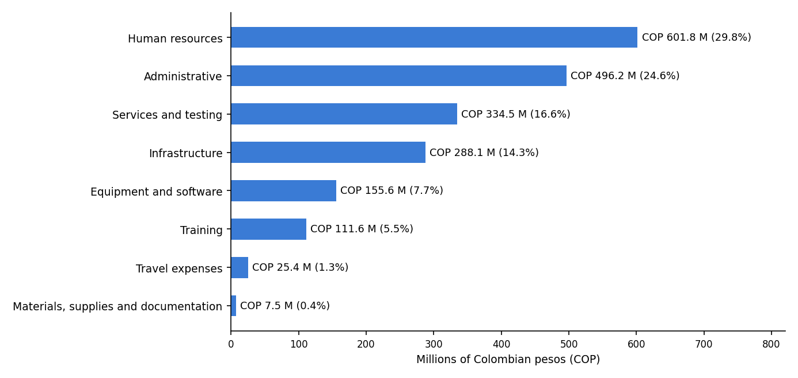
Figure 11. Budget distribution by item
Note. Own elaboration.

17.10. Budget cash flow
Table 30 distributes budget execution by two-month period and shows the funder's expected disbursements; Table 31 presents the detail by item.
Table 30. Budget cash flow by two-month period (thousands of COP)
Item (thousands of COP) | 1-2 | 3-4 | 5-6 | 7-8 | 9-10 | 11-12 | 13-14 | 15-16 | 17-18 | 19-20 | 21-22 | 23-24 | Total
Human resources | 34,229 | 34,229 | 34,229 | 53,410 | 72,093 | 72,093 | 63,956 | 55,237 | 55,237 | 58,466 | 39,285 | 29,321 | 601,788
Equipment and software | 134,589 | — | — | — | — | — | 21,000 | — | — | — | — | — | 155,589
Training | — | — | 10,500 | — | — | 16,100 | — | — | — | — | 40,000 | 45,000 | 111,600
Services and testing | 1,600 | 400 | 400 | 400 | 400 | 12,900 | 12,900 | 82,528 | 82,528 | 70,028 | 70,028 | 400 | 334,514
Materials and supplies | 3,750 | — | — | — | — | — | 3,750 | — | — | — | — | — | 7,500
Travel expenses | — | — | — | 25,400 | — | — | — | — | — | — | — | — | 25,400
Infrastructure | 72,020 | — | — | 72,020 | — | — | 72,020 | — | — | 72,020 | — | — | 288,080
Administrative | 41,350 | 41,350 | 41,350 | 41,350 | 41,350 | 41,350 | 41,350 | 41,350 | 41,350 | 41,350 | 41,350 | 41,350 | 496,197
Cash flow | 287,538 | 75,979 | 86,479 | 192,580 | 113,843 | 142,443 | 214,976 | 179,115 | 179,115 | 241,865 | 190,663 | 116,071 | 2,020,667
Disbursements | — | — | 449,995 | — | — | — | 663,842 | — | 358,231 | — | 432,528 | 116,071 | 2,020,667
% of total | — | — | 22.3 % | — | — | — | 32.9 % | — | 17.7 % | — | 21.4 % | 5.7 % | 100.0 %
Note. Own elaboration. Administrative expenses are rounded to thousands; the total for the item is COP 496,196,625.
Table 31. Detailed cash flow by item and two-month period
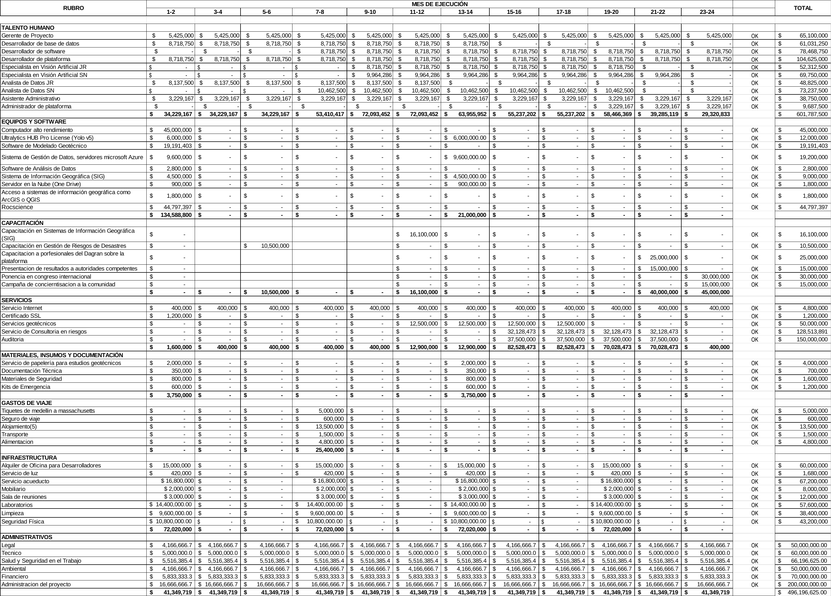
Note. Own elaboration.

18. Financial evaluation
The evaluation uses a horizon of 10 years of operation after the 24 months of execution (year 0), at economic prices (applying shadow-price conversion factors to costs) and with a discount rate of 12% per year. Income, benefits, investment costs, operation and maintenance costs, loans, amortization, interest and salvage value are identified, and the net present value (NPV), internal rate of return (IRR) and benefit/cost ratio (B/C) are calculated.

18.1. Income
Income from avoided maintenance (road rehabilitation). Predictive monitoring allows preventive intervention and avoids rehabilitating the road every two years. Savings of COP 510,000,000 are estimated in even years, equivalent to 50% of the cost of rehabilitating one kilometer (COP 1,020,000,000).
Income from the monitoring service. Licensing of the service to concessions and road authorities: one annual contract of COP 100,000,000 for 10 years.
Table 32. Project income (millions of COP)
Year | 1 | 2 | 3 | 4 | 5 | 6 | 7 | 8 | 9 | 10 | Total
Avoided maintenance | 0.0 | 510.0 | 0.0 | 510.0 | 0.0 | 510.0 | 0.0 | 510.0 | 0.0 | 510.0 | 2,550.0
Monitoring service | 100.0 | 100.0 | 100.0 | 100.0 | 100.0 | 100.0 | 100.0 | 100.0 | 100.0 | 100.0 | 1,000.0
Total income | 100.0 | 610.0 | 100.0 | 610.0 | 100.0 | 610.0 | 100.0 | 610.0 | 100.0 | 610.0 | 3,550.0
Note. Own elaboration. Maintenance: savings of COP 510 million per kilometer rehabilitated every two years. Service: one annual license of COP 100 million.

18.2. Benefits
Benefits to the community from productivity and trade. An average of 15 days of road closure per year is avoided, with commercial losses of COP 1,800,000 per day: COP 27,000,000 per year.
Benefits to the State from reduced fatalities. Based on an average of 35 deaths per year per 100,000 inhabitants, an increasing number of avoided victims is estimated (0 in the first year, 5 in years 2 to 4, 10 in year 5 and 12 from year 6), valued at COP 32,500,000 per victim in compensation and care costs.
Table 33. Project benefits (millions of COP)
Year | 1 | 2 | 3 | 4 | 5 | 6 | 7 | 8 | 9 | 10 | Total
Victims avoided | 0 | 5 | 5 | 5 | 10 | 12 | 12 | 12 | 12 | 12 | 85
Compensation savings | 0.0 | 162.5 | 162.5 | 162.5 | 325.0 | 390.0 | 390.0 | 390.0 | 390.0 | 390.0 | 2,762.5
Productivity and trade | 27.0 | 27.0 | 27.0 | 27.0 | 27.0 | 27.0 | 27.0 | 27.0 | 27.0 | 27.0 | 270.0
Total benefits | 27.0 | 189.5 | 189.5 | 189.5 | 352.0 | 417.0 | 417.0 | 417.0 | 417.0 | 417.0 | 3,032.5
Note. Own elaboration.

18.3. Investment costs
The investment corresponds to the total project budget (COP 2,020,666,816), converted to economic prices with the shadow-price conversion factor of each item. The investment at economic prices is COP 1,458,108,104 and is recorded in year 0.
Table 34. Investment costs at economic prices
Item | Market value (M COP) | CF | Economic value (M COP)
Human resources | 601.8 | 0.610 | 367.1
Equipment and software | 155.6 | 0.753 | 117.2
Training | 111.6 | 0.800 | 89.3
Services and testing | 334.5 | 0.710 | 237.5
Materials, supplies and documentation | 7.5 | 0.600 | 4.5
Travel expenses | 25.4 | 0.710 | 18.0
Infrastructure | 288.1 | 0.790 | 227.6
Administrative | 496.2 | 0.800 | 397.0
Total | 2,020.7 |  | 1,458.1
Note. Own elaboration. CF: shadow-price conversion factor.

18.4. Operation and maintenance costs
Once the platform is delivered, its operation requires a platform administrator, cloud servers, computer vision and GIS licenses, and internet with an SSL certificate. These costs total COP 42,475,000 per year at market prices and COP 29,084,050 at economic prices. In addition, the high-performance computers (5-year useful life) are expected to be replaced in year 5 for COP 33,885,000 at economic prices.
Table 35. Annual operation and maintenance costs
Item | Annual market value (M COP) | CF | Annual economic value (M COP)
Platform administrator (20 h/week, 12 months) | 19.4 | 0.610 | 11.8
Microsoft Azure servers | 9.6 | 0.753 | 7.2
Ultralytics HUB Pro licenses (YOLOv5) | 6.0 | 0.753 | 4.5
GIS licenses | 4.5 | 0.753 | 3.4
Internet and SSL certificate | 3.0 | 0.710 | 2.1
Annual total | 42.5 |  | 29.1
Note. Own elaboration based on the unit values in the budget (Tables 21, 22 and 24).

18.5. Loans, amortization and interest
The project is funded with non-reimbursable resources (STI Fund of the General Royalties System or Fondo Adaptación) and with contributions from Universidad EAFIT and URBAM. Therefore, no loans are taken out and amortization and interest are zero in all periods.

18.6. Salvage value
At the end of the evaluation horizon (year 10), the equipment replaced in year 5 is fully depreciated and the software licenses have no residual value. The salvage value is estimated at zero, a conservative assumption.

18.7. Net cash flow
Table 36. Net cash flow at economic prices (millions of COP)
Item (M COP) | 0 | 1 | 2 | 3 | 4 | 5 | 6 | 7 | 8 | 9 | 10
(+) Income | — | 100.0 | 610.0 | 100.0 | 610.0 | 100.0 | 610.0 | 100.0 | 610.0 | 100.0 | 610.0
(+) Benefits | — | 27.0 | 189.5 | 189.5 | 189.5 | 352.0 | 417.0 | 417.0 | 417.0 | 417.0 | 417.0
(−) Investment | -1,458.1 | — | — | — | — | — | — | — | — | — | —
(−) Operation and maint. | — | -29.1 | -29.1 | -29.1 | -29.1 | -29.1 | -29.1 | -29.1 | -29.1 | -29.1 | -29.1
(−) Equipment replacement | — | — | — | — | — | -33.9 | — | — | — | — | —
(+) Loans | — | — | — | — | — | — | — | — | — | — | —
(−) Amortization and interest | — | — | — | — | — | — | — | — | — | — | —
(+) Salvage value | — | — | — | — | — | — | — | — | — | — | —
Net cash flow | -1,458.1 | 97.9 | 770.4 | 260.4 | 770.4 | 389.0 | 997.9 | 487.9 | 997.9 | 487.9 | 997.9
Present value (12%) | -1,458.1 | 87.4 | 614.2 | 185.4 | 489.6 | 220.7 | 505.6 | 220.7 | 403.0 | 175.9 | 321.3
Note. Own elaboration.
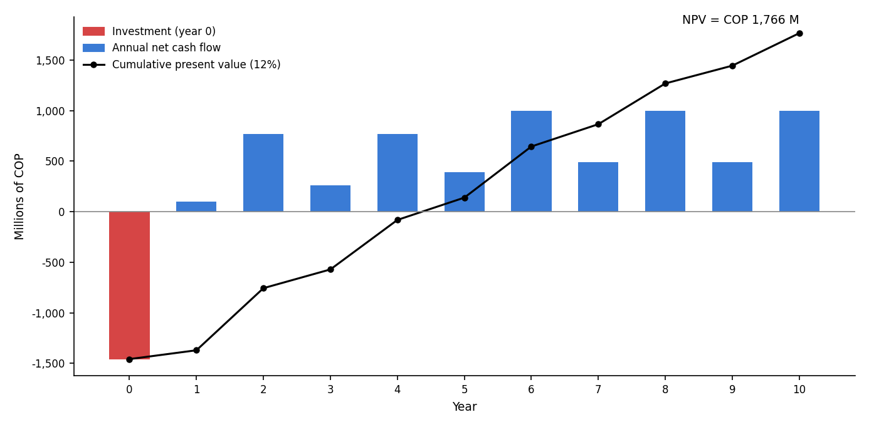
Figure 12. Annual net cash flow and cumulative present value
Note. Own elaboration.

18.8. Financial indicators
Table 37. Financial evaluation indicators
Indicator | Result | Criterion | Decision
Net present value (NPV, 12%) | $ 1,765,781,332 | NPV > 0 | Accepted
Internal rate of return (IRR) | 31.8 % | IRR > 12% | Accepted
Benefit/cost ratio (B/C) | 2.08 | B/C > 1 | Accepted
Discounted payback period | 4.4 years | < 10 years | Accepted
Note. Own elaboration.
The NPV at a 12% rate is COP 1,765,781,332, the IRR is 31.8% and the benefit/cost ratio is 2.08. In other words, for every peso invested and spent on operation, the project generates 2.08 pesos of income and benefits in present value, and the investment is recovered, in present value, after 4.4 years of operation.
Correction note: in the previous version, the net flow for years 6, 8 and 10 omitted the maintenance income and was discounted over a single period, the fatality benefit for year 1 did not match the benefits table, operating costs were not included, and the investment at economic prices did not correspond to the final budget. With these corrections, the NPV rises from COP 1,523 million to COP 1,766 million and the IRR from 27.9% to 31.8%.

18.9. Sensitivity analysis
Table 38. Sensitivity analysis
Scenario | NPV (M COP) | IRR
Base scenario | 1,765.8 | 31.8 %
Benefits and income −20% | 1,084.3 | 25.0 %
Benefits and income −40% | 402.8 | 17.3 %
Investment and operating costs +20% | 1,437.4 | 26.2 %
No income from avoided maintenance | 406.5 | 17.1 %
Discount rate 9% | 2,288.8 | 31.8 %
Discount rate 15% | 1,341.2 | 31.8 %
Note. Own elaboration.
The project keeps a positive NPV in all the scenarios evaluated. Income and benefits could fall by up to 52% before the NPV becomes negative. The most sensitive assumption is the maintenance saving: without it, the NPV drops to COP 406,529,566 and the IRR to 17.1%, still above the discount rate.

18.10. Conclusion of the financial evaluation
The project is financially and economically viable: with a positive NPV, an IRR above the discount rate and a B/C ratio greater than 2, the benefits for the State, the concessions and the communities far exceed the investment and operating costs. Its main source of value is prevention: fewer road rehabilitations and fewer victims. It is therefore recommended to document the events avoided and the maintenance costs from the pilot tests onwards, in order to validate these assumptions and strengthen the sustainability of the service by licensing it to other concessions in the country.

19. Conclusions
- Landslides on the Medellín–Bogotá Highway (Route 60) are a high-magnitude problem for the safety, economy and connectivity of eastern Antioquia, and public spending remains focused on response rather than prevention.
- The state of the art —14 indexed articles, 13 standards and regulations, 8 books and other sources, and 3 patents— supports the use of remote sensing, satellite rainfall data and neural networks to anticipate mass movements.
- Among four alternatives, the geographic information monitoring platform with Industry 4.0 technologies obtained the highest score (68/75) and is the basis of the project's six specific objectives.
- The project runs for 24 months, with a budget of COP 2,020,666,816, 75.7% of which is provided by the funder and 24.3% by Universidad EAFIT and URBAM.
- The financial evaluation at economic prices yields an NPV of COP 1,766 million, an IRR of 31.8% and a B/C ratio of 2.08, so the project is viable and resilient to reductions of up to 50% in its benefits.

References
Aguilera, Q., Lombardo, L., and Tanyas, H. (2022). On the prediction of landslide occurrences and sizes via hierarchical neural networks. Stochastic Environmental Research and Risk Assessment, 36(8), 2031–2048. https://doi.org/10.1007/s00477-022-02215-0
Ahmed, B., and Alam, A. (Eds.). (2022). Remote sensing of natural hazards. MDPI.
Akosah, S., Gratchev, I., Kim, D., and Ohn, S. (2024). Application of artificial intelligence and remote sensing for landslide detection and prediction: Systematic review. Remote Sensing, 16(16), 2947. https://doi.org/10.3390/rs16162947
Alcaldía de Cali. (2024). Alcaldía de Cali implementa herramienta de inteligencia artificial para pronosticar el riesgo de deslizamientos de tierra [Cali City Hall implements an artificial intelligence tool to forecast landslide risk]. https://www.cali.gov.co/tic/publicaciones/181895/
Amatya, P., Kirschbaum, D., Stanley, T., and Tanyas, H. (2021). Landslide mapping using object-based image analysis and open-source tools. Engineering Geology, 282, 106000. https://doi.org/10.1016/j.enggeo.2021.106000
Ansari, S. (2020). Building computer vision applications using artificial neural networks: With step-by-step examples in OpenCV and TensorFlow with Python. Apress. https://doi.org/10.1007/978-1-4842-5887-3
Ayala, J., and Ospino, K. (2023). Desastres naturales en Colombia: un análisis regional [Natural disasters in Colombia: A regional analysis]. Banco de la República.
Benavides Pinilla, C. H. (2019). Identificación automática de nubes a partir de imágenes tomadas por cámara hemisférica y su relación con la radiación solar incidente en el Valle de Aburrá [Automatic cloud identification from hemispherical camera images and its relationship with incident solar radiation in the Aburrá Valley] [Master's thesis, Universidad Nacional de Colombia].
Brunetti, M. T., Melillo, M., Gariano, S. L., Ciabatta, L., Brocca, L., Amarnath, G., and Peruccacci, S. (2021). Satellite rainfall products outperform ground observations for landslide prediction in India. Hydrology and Earth System Sciences, 25(6), 3267–3279. https://doi.org/10.5194/hess-25-3267-2021
Campos, A., and Holm-Nielsen, N. (Eds.). (2012). Análisis de la gestión del riesgo de desastres en Colombia: un aporte para la construcción de políticas públicas [Analysis of disaster risk management in Colombia: A contribution to building public policy]. World Bank.
Comercial e Industrial Geosecology Ltda. (2018). Método y sistema para el análisis y generación de alertas tempranas o predictivas de estabilidad de taludes en minas a rajo abierto [Method and system for analyzing and generating early or predictive slope-stability warnings in open-pit mines] (Patent WO 2018/027332 A1). World Intellectual Property Organization.
Economic Commission for Latin America and the Caribbean [ECLAC]. (2017). Directrices para la reducción del riesgo de deslizamientos de tierra en infraestructuras de transporte [Guidelines for reducing landslide risk in transport infrastructure]. ECLAC.
Congreso de la República de Colombia. (2012). Ley 1523 de 2012, por la cual se adopta la política nacional de gestión del riesgo de desastres y se establece el Sistema Nacional de Gestión del Riesgo de Desastres [Law 1523 of 2012, adopting the national disaster risk management policy and establishing the National Disaster Risk Management System].
Congreso de la República de Colombia. (2023). Ley 2294 de 2023, por la cual se expide el Plan Nacional de Desarrollo 2022-2026 “Colombia, potencia mundial de la vida” [Law 2294 of 2023, issuing the National Development Plan 2022-2026].
Cruden, D. M., and Varnes, D. J. (1996). Landslide types and processes. In A. K. Turner and R. L. Schuster (Eds.), Landslides: Investigation and mitigation (Special Report 247, pp. 36–75). Transportation Research Board.
Cruz, M. (2022). Mitigating infrastructure risks from climate change: A comprehensive approach. Annual Review of Environment and Resources. https://www.annualreviews.org/content/journals/10.1146/annurev-environ-112320-101903
Departamento Administrativo de la Presidencia de la República. (2014). Decreto 1807 de 2014, por el cual se reglamenta el artículo 189 del Decreto Ley 019 de 2012 en lo relativo a la incorporación de la gestión del riesgo en los planes de ordenamiento territorial [Decree 1807 of 2014, on the incorporation of risk management into land-use plans].
Douris, J., and Kim, G. (2021). The atlas of mortality and economic losses from weather, climate and water extremes (1970–2019) (WMO-No. 1267). World Meteorological Organization.
Echeverri, A., Vélez, A., and Werthmann, C. (2012). Rehabitar la ladera: operaciones en áreas de riesgo y asentamiento precario en Medellín [Re-inhabiting the hillside: Operations in risk areas and informal settlements in Medellín]. Universidad EAFIT.
Echeverri, A., and Orsini, F. (Eds.). (2013). Rehabitar la montaña: memorias del seminario internacional [Re-inhabiting the mountain: Proceedings of the international seminar]. Universidad EAFIT.
El Colombiano. (2024, July 2). Cierre total en la autopista Medellín-Bogotá tras deslizamiento [Medellín–Bogotá highway fully closed after landslide]. El Colombiano.
Emberson, R., Kirschbaum, D., and Stanley, T. (2020). New global characterisation of landslide exposure. Natural Hazards and Earth System Sciences, 20(12), 3413–3424. https://doi.org/10.5194/nhess-20-3413-2020
Emberson, R., Kirschbaum, D., and Stanley, T. (2021). Global connections between El Niño and landslide impacts. Nature Communications, 12. https://doi.org/10.1038/s41467-021-22398-4
European Committee for Standardization [CEN]. (2004). Eurocode 7: Geotechnical design – Part 1: General rules (EN 1997-1:2004 + A1:2013). CEN.
Federal Highway Administration. (2002). Geotechnical engineering circular No. 5: Evaluation of soil and rock properties. U.S. Department of Transportation.
Federal Emergency Management Agency [FEMA]. (2020). Hazard mitigation planning: A guide for communities. FEMA.
García-Delgado, H., Petley, D. N., Bermúdez, M. A., and Sepúlveda, S. A. (2022). Fatal landslides in Colombia (from historical times to 2020) and their socio-economic impacts. Landslides, 19, 1689–1716. https://doi.org/10.1007/s10346-022-01870-2
Ghorbanzadeh, O., Xu, Y., Ghamisi, P., Kopp, M., and Kreil, D. (2022). Landslide4Sense: Reference benchmark data and deep learning models for landslide detection. IEEE Transactions on Geoscience and Remote Sensing, 60, 1–17.
Giri, P., Ng, K., and Phillips, W. (2019). Wireless sensor network system for landslide monitoring and warning. IEEE Transactions on Instrumentation and Measurement, 68(4), 1210–1220.
Gómez, J. (2023, August 30). Cada 5 días ocurrió un derrumbe en Antioquia en los últimos 30 años [A landslide occurred every 5 days in Antioquia over the last 30 years]. El Colombiano. https://www.elcolombiano.com/antioquia/cada-5-dias-ocurrio-un-derrumbe-en-antioquia-en-los-ultimos-30-anos-KH18799388
Gobernación de Antioquia. (2024). Plan de Desarrollo “Por Antioquia firme” 2024-2027 [Departmental Development Plan 2024-2027]. https://www.antioquia.gov.co/plan-desarrollo-2024-2027
Highland, L. (2004). Landslide types and processes (Fact Sheet 2004-3072). U.S. Geological Survey.
Hölbling, D. (2022). Data and knowledge integration for object-based landslide mapping: Challenges, opportunities and applications [Conference presentation].
Hungr, O., Leroueil, S., and Picarelli, L. (2014). The Varnes classification of landslide types, an update. Landslides, 11, 167–194. https://doi.org/10.1007/s10346-013-0436-y
Instituto Nacional de Vías [INVIAS]. (n.d.). Manual de estabilidad de taludes: geotecnia vial [Slope stability manual: Road geotechnics]. Ministerio de Transporte.
International Organization for Standardization [ISO]. (2003). Geographic information — Spatial referencing by coordinates (ISO 19111:2003).
International Organization for Standardization [ISO]. (2013). Geographic information — Data quality (ISO 19157:2013).
International Organization for Standardization [ISO]. (2018). Risk management — Guidelines (ISO 31000:2018).
International Organization for Standardization [ISO]. (2023). Smart community infrastructures — City service continuity against disasters (ISO/DIS 37179, draft for public comment).
International Organization for Standardization [ISO] and European Committee for Standardization [CEN]. (2006). Geotechnical investigation and testing — Sampling methods and groundwater measurements — Part 2 (ISO/TS 22475-2:2006).
International Organization for Standardization [ISO] and International Electrotechnical Commission [IEC]. (2008). Information technology — Security techniques — Guidelines for information and communications technology disaster recovery services (ISO/IEC 24762:2008).
International Organization for Standardization [ISO] and International Electrotechnical Commission [IEC]. (2011). Systems and software engineering — Systems and software Quality Requirements and Evaluation (SQuaRE) — System and software quality models (ISO/IEC 25010:2011).
International Organization for Standardization [ISO] and International Electrotechnical Commission [IEC]. (2022). Information security, cybersecurity and privacy protection — Information security management systems — Requirements (ISO/IEC 27001:2022).
Jocher, G. (2020). ultralytics/yolov5 [Software]. GitHub. https://github.com/ultralytics/yolov5
Kirschbaum, D., Stanley, T., Emberson, R., Amatya, P., Khan, S., and Tanyas, H. (2020). Global landslide hazard assessment for situational awareness (LHASA) version 2: New activities and future plans [Abstract, EGU General Assembly 2020]. https://doi.org/10.5194/egusphere-egu2020-11012
López, A. (2023, July 25). ¿Por qué en Colombia ocurren frecuentes deslizamientos y derrumbes? [Why are landslides so frequent in Colombia?]. El Tiempo.
Lund University, Department of Physical Geography and Ecosystem Science. (2012). Introduction to remote sensing and geographical information systems. Lund University.
Marín, N., Vega, J., Betancurt, O., González, J., and Botero, S. (2024). Towards an understanding of landslide risk assessment and its economic losses: A scientometric analysis. Landslides.
McAdoo, B. G., Quak, M., Gnyawali, K. R., Adhikari, B. R., Devkota, S., Rajbhandari, P. L., and Sudmeier-Rieux, K. (2018). Roads and landslides in Nepal: How development affects environmental risk. Natural Hazards and Earth System Sciences, 18, 3203–3210. https://doi.org/10.5194/nhess-18-3203-2018
Miccadei, E., Carabella, C., and Paglia, G. (Eds.). (2022). Landslide hazard and environment risk assessment. MDPI.
Mignan, A., and Broccardo, M. (2020). Neural network applications in earthquake prediction (1994–2019): Meta-analytic and statistical insights on their limitations. Seismological Research Letters, 91(4), 2330–2342.
Ministerio de Ambiente y Desarrollo Sostenible. (2020). Estudio sobre el impacto del cambio climático en la economía colombiana [Study on the impact of climate change on the Colombian economy].
Ministerio de Tecnologías de la Información y las Comunicaciones [MinTIC]. (2022). Metodología para la formulación de proyectos en el marco de la política Colombia TIC [Methodology for formulating projects under the Colombia ICT policy]. https://colombiatic.mintic.gov.co/679/articles-63403_metodologia.pdf
National Aeronautics and Space Administration [NASA]. (2023). Earth Observing System Data and Information System (EOSDIS). NASA Earthdata.
National Aeronautics and Space Administration [NASA]. (2024). Global Landslide Catalog. NASA.
National Aeronautics and Space Administration [NASA]. (n.d.-a). LHASA: Landslide Hazard Assessment for Situational Awareness [Software]. GitHub. https://github.com/nasa/LHASA
National Aeronautics and Space Administration [NASA] Global Precipitation Measurement Mission. (n.d.-b). Landslides @ NASA. NASA.
United Nations Office for Disaster Risk Reduction [UNDRR]. (2018). Global assessment report on disaster risk. UNDRR.
United Nations Office for Disaster Risk Reduction [UNDRR]. (2022). Global assessment report on disaster risk reduction 2022. UNDRR.
Olarte, M. (2014). Resiliencia urbana: otra forma de abordar [Urban resilience: Another approach]. Universidad EAFIT. https://www.eafit.edu.co/social/informate/Paginas/resiliencia-urbana-otra-forma-de-abordar.aspx
Paisaje Cultural Cafetero. (2021). Cambio climático 2021: impactos, adaptación y vulnerabilidad [Climate change 2021: Impacts, adaptation and vulnerability].
Ramesh, M. V., Pullarkatt, D., Thirugnanam, H., Kumar M., N., and Rangan, P. V. (2023). Multilevel rapid warning system for landslide detection (U.S. Patent No. 11,610,466 B2). U.S. Patent and Trademark Office.
Restrepo, J. (2023). Valle de Aburrá: una de las zonas más afectadas y propensas a deslizamientos en Colombia [Aburrá Valley: One of the areas most affected by and prone to landslides in Colombia]. Periódico Alma Máter.
Segoni, S., and Caleca, F. (2021). Definition of environmental indicators for a fast estimation of landslide risk at national scale. In E. Miccadei, C. Carabella and G. Paglia (Eds.), Landslide hazard and environment risk assessment (2022). MDPI.
Tehrani, F. S., Calvello, M., Liu, Z., Zhang, L., and Lacasse, S. (2022). Machine learning and landslide studies: Recent advances and applications. Natural Hazards, 114, 1197–1245. https://doi.org/10.1007/s11069-022-05423-7
Ultralytics. (n.d.). Releases [Software]. GitHub. https://github.com/ultralytics/ultralytics/releases
Unidad Nacional para la Gestión del Riesgo de Desastres [UNGRD]. (2020). Riesgo por movimientos en masa en Colombia [Mass-movement risk in Colombia]. UNGRD.
United Nations Environment Programme [UNEP]. (2024). Goal 11: Sustainable cities and communities. UNEP.
Varnes, D. J. (1978). Slope movement types and processes. In R. L. Schuster and R. J. Krizek (Eds.), Landslides: Analysis and control (Special Report 176, pp. 11–33). Transportation Research Board, National Academy of Sciences.
Vega, J. (2013). Estimación del riesgo por deslizamientos de laderas generados por eventos sísmicos en la ciudad de Medellín usando herramientas de la geomática [Estimation of earthquake-induced landslide risk in Medellín using geomatics tools] [Master's thesis, Universidad Nacional de La Plata].
Vega, J., Barco, J., and Hidalgo, C. (2024). Space-time analysis of the relationship between landslides occurrence, rainfall variability and ENSO in the tropical Andean mountain region in Colombia. Landslides, 21, 1293–1314. https://doi.org/10.1007/s10346-024-02225-9
World Bank. (2021). The economic costs of climate change. World Bank.
Zhang, Q., and Wang, T. (2024). Deep learning for exploring landslides with remote sensing and geo-environmental data: Frameworks, progress, challenges, and opportunities. Remote Sensing, 16(8), 1344. https://doi.org/10.3390/rs16081344
Zhou, X., Zhang, W., Wang, Y., Li, J., and Zhang, Z. (2023). Artificial intelligence and machine learning for landslide prediction. Landslides, 20, 1387–1402.

