Page 1/23
Date
Reviewer
Project: Tripteron XYZ
Calculation: finite element analysis in chassis
Calculator: David Zuluaga Henao

Description

The chassis of the tripteron will be analyzed through finite element analysis (FEA) using the CAD/CAM software SolidWorks. The analysis will include stresses, buckling, displacement and deformation, considering the locations where the guides, lead screws, Nema motors, arms and effector are situated, which exert weight on the chassis beams. Consequently, this study will determine where the mentioned variables are concentrated and how they affect the stability and shape of the chassis.
Objective of the calculation

The objective of the finite element analysis is to find the values of the following variables:
• Shear stresses (MPa)
• Axial Stress (MPa)
• Bending stress (MPa)
• Buckling (AMPES)
• Displacement (mm)
• Strain
This in order to do a find if the stability of the chassis structure assures the correct functionality of the mechanism.
Model calculation variables

Variable Description
F₁ Total weight 1
F₂ Total weight 2
F₃ Total weight 3
Pm Weight of a nemu motor
Pt Weight of a power screw
Pg Weight of a guide
Ph Weight of the arm
Pe Weight of the effector
Table 1. Variables used

The variables used in the finite element analysis where the selected elements connected to the chassis applying a weight force in the beams. F1, F2 and F3 are the total weight applied to each of the beams which have an element in it.
Page 2/23
Date
Reviewer
Project: Tripteron XYZ
Calculation: finite element analysis in chassis
Calculator: David Zuluaga Henao

Image of the calculation model
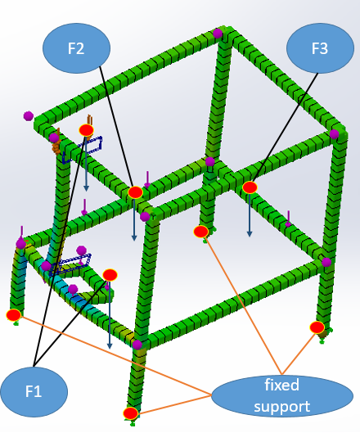
Figure 1. Diagram of applied forces and fixed support in Solidworks simulation
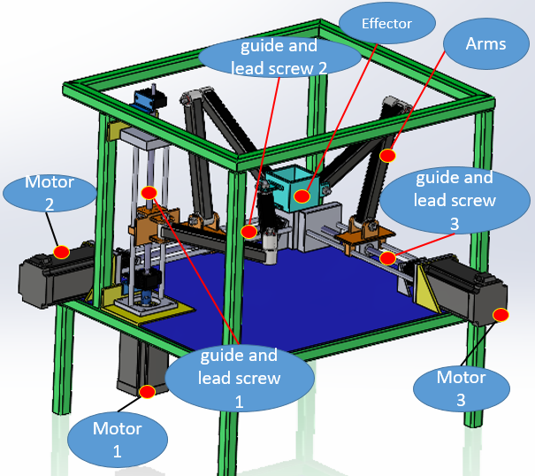
Figure 2. Diagram of elements applying weight on the chassis

As it can be seen in figure 1, the total weights where applied in each of the beams which the elements seem in figure 2 are on.
Page 3/23
Date
Reviewer
Project: Tripteron XYZ
Calculation: finite element analysis in chassis
Calculator: David Zuluaga Henao

Values of the calculation model

Variable Description Values
F₁ Total weight 1 9.762 Kg = 95.75 N
F₂ Total weight 2 9.762 Kg = 95.75 N
F₃ Total weight 3 9.762 Kg = 95.75 N
Pm Weight of a nemu motor 5.216 Kg
Pt Weight of a power screw 1.12 Kg
Pg Weight of a guide 2.53 Kg Ph Weight of the arm 0.322 Kg
Pe Weight of the effector 0.574 Kg
Table 2. data values
Each of the values in table 2 where taken using SolidWorks physical properties option, and the total weights were the sum of the elements which applied a weight to each beam. These weight values are approximate to the real ones, so they have a small error percentage.

Calculation model
For the calculation of the required variables, in the Program SolidWorks the following process was followed:
- The CAD of the chassis was created with the required dimensions, seen in annex 1.
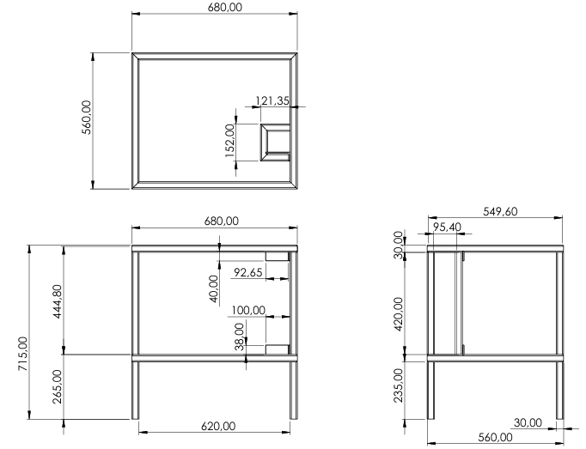
Annex 1. Chassis dimensions in mm.
Page 4/23
Date
Reviewer
Project: Tripteron XYZ
Calculation: finite element analysis in chassis
Calculator: David Zuluaga Henao
- The material was defined as an Alloy Steel for the whole chassis.
- A static analysis was created with the following parameters:
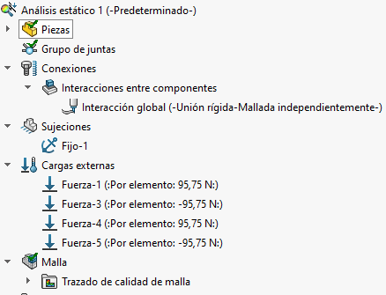
Annex 2. Static analysis parameters
- As it can be seen in annex 1 the following parameters where used:
- Component interaction: Global interaction - rigid joint - independent meshing.
- Fixation: Four fixed restraints. The position can be seen in Figure 1.
- External Loads: Four forces of 95.75 N on their respective beam. The position can be seen in Figure 1.
- The meshed definition was the following:
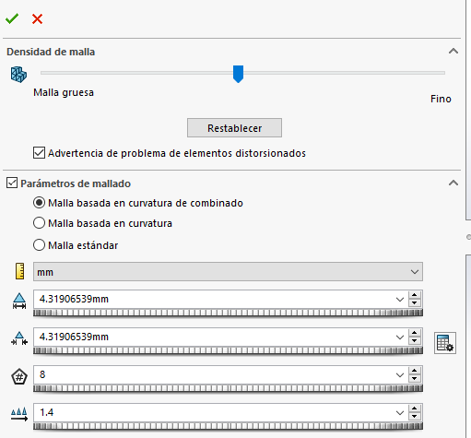
Annex 3. Mesh parameters
- As it can be seen in annex 2 the meshed parameter used was a mesh based on combined curvature with a standard mesh density.
Page 5/23
Date
Reviewer
Project: Tripteron XYZ
Calculation: finite element analysis in chassis
Calculator: David Zuluaga Henao
- The static analysis was executed and the studies were created as can be seen in Annex 3.
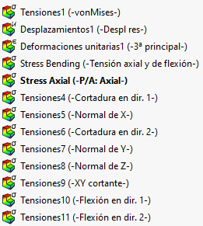
Annex 4. Static analysis studies
- The Bucking analysis was created with the same parameters as the static analysis, as it can be seen in annex 4.
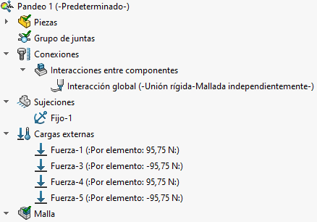
Annex 5. Buckling analysis parameters
- The buckling analysis was executed and the studies were created as can be seen in Annex 5.
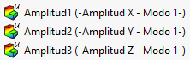
Annex 6. Buckling analysis studies
Page 6/23
Date
Reviewer
Project: Tripteron XYZ
Calculation: finite element analysis in chassis
Calculator: David Zuluaga Henao

- Then the values where taken for each studies using the function identify values in each of the faces of the beams which the forces were located on. As it can be seen in annex 7.
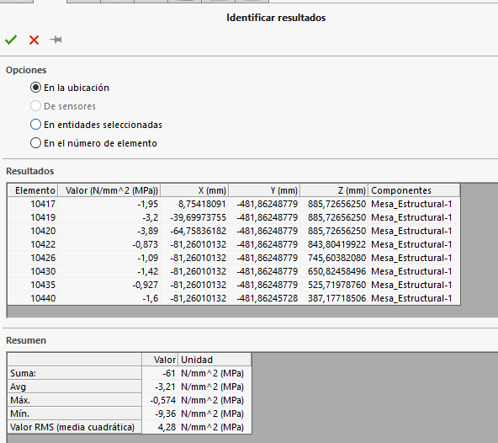
Annex 7. Identify results option

Page 7/23
Date
Reviewer
Project: Tripteron XYZ
Calculation: finite element analysis in chassis
Calculator: David Zuluaga Henao
Results and conclusions of the calculation model

The following results were taken from the static and bucking analysis as it can be seen in figure from 3 to 11.
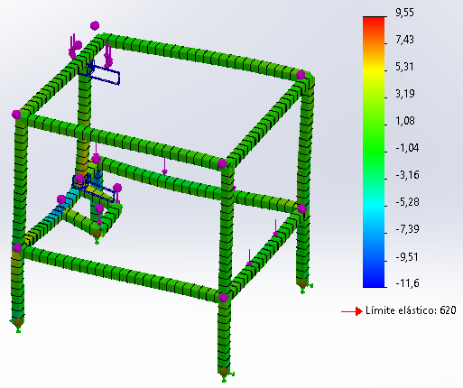
Figure 3. Bending Stress
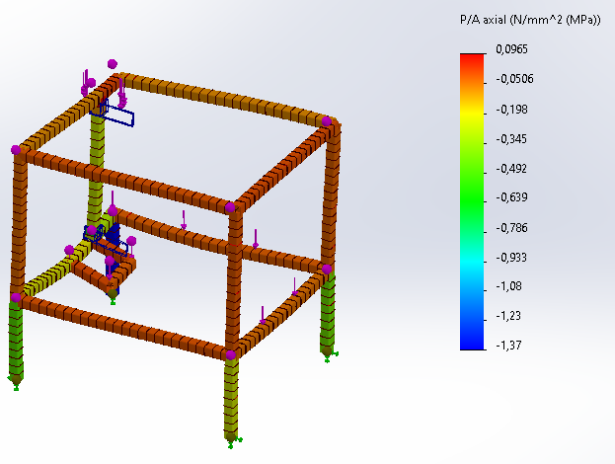

Figure 4. Axial Stress
Page 8/23
Date
Reviewer
Project: Tripteron XYZ
Calculation: finite element analysis in chassis
Calculator: David Zuluaga Henao

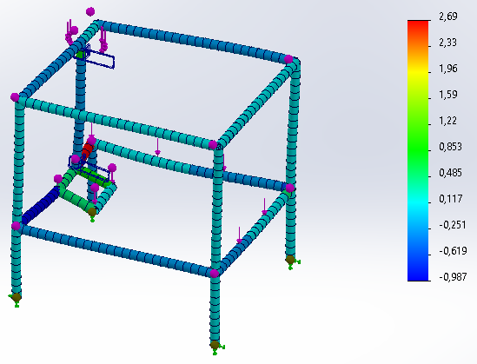
Figure 5. Shear stress dir 1. MPa
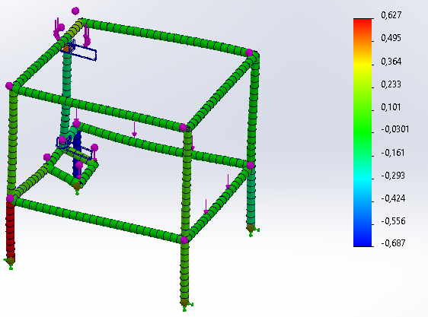
Figure 6. Shear stress dir 2. MPa
Page 9/23
Date
Reviewer
Project: Tripteron XYZ
Calculation: finite element analysis in chassis
Calculator: David Zuluaga Henao
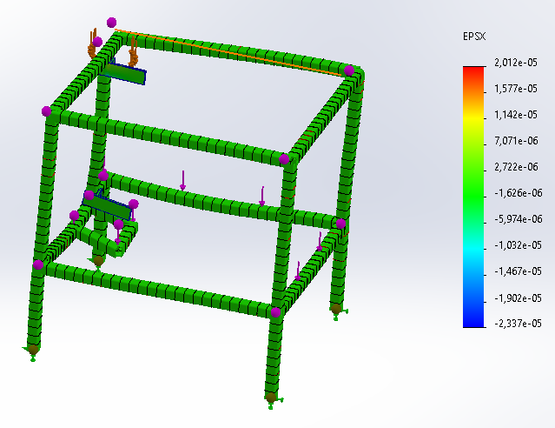
Figure 7. Strain
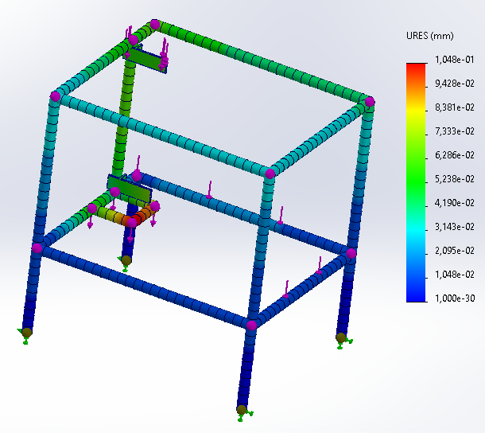
Figure 8. Displacement mm
Page 10/23
Date
Reviewer
Project: Tripteron XYZ
Calculation: finite element analysis in chassis
Calculator: David Zuluaga Henao
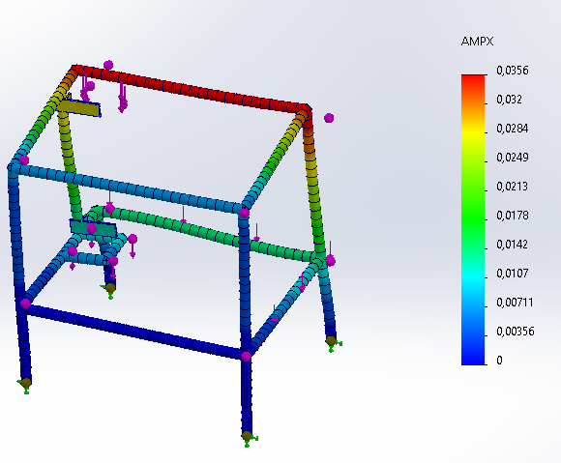
Figure 9. Buckling X
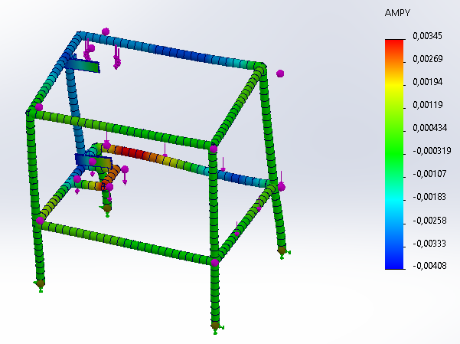
Figure 10. Buckling Y

Page 11/23
Date
Reviewer
Project: Tripteron XYZ
Calculation: finite element analysis in chassis
Calculator: David Zuluaga Henao

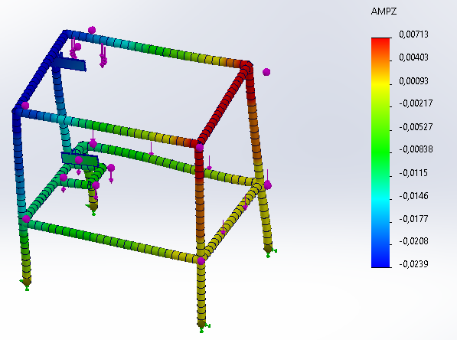
Figure 11. Buckling Z

Page 12/23
Date
Reviewer
Project: Tripteron XYZ
Calculation: finite element analysis in chassis
Calculator: David Zuluaga Henao

Graphic and value tables results
The following results were taken from the static and bucking analysis as it can be seen in figure from 12 to 20 and tables 3 to 12.
- Bending Stress:
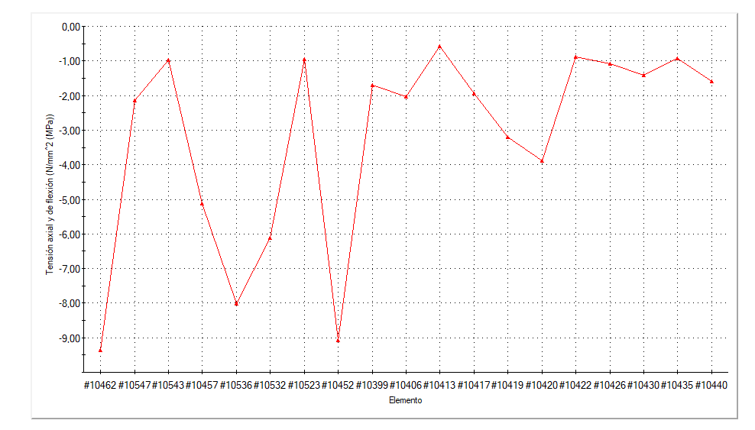
Figure 12. Bending stress graphic
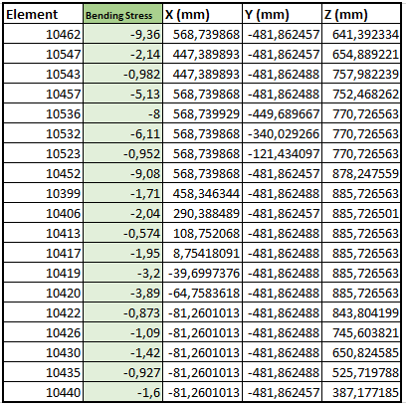
Table 3. Bending stress values
Page 13/23
Date
Reviewer
Project: Tripteron XYZ
Calculation: finite element analysis in chassis
Calculator: David Zuluaga Henao

b) Axial Stress:
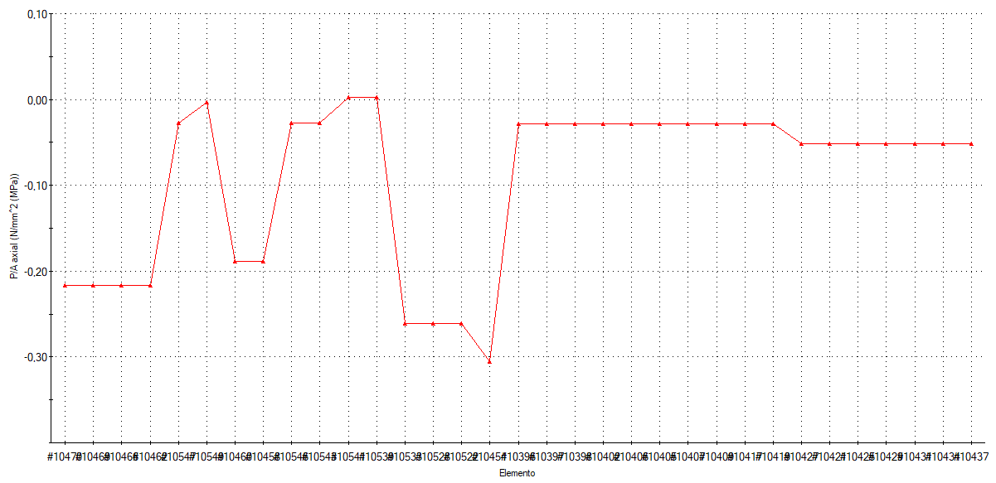
Figure 13. Axial stress graphic

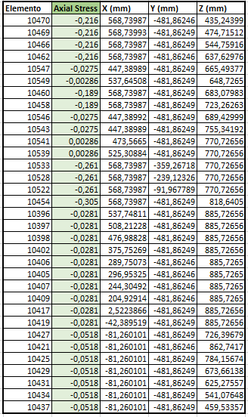
Table 4. Axial stress values
Page 14/23
Date
Reviewer
Project: Tripteron XYZ
Calculation: finite element analysis in chassis
Calculator: David Zuluaga Henao
- Shear stress dir 1.
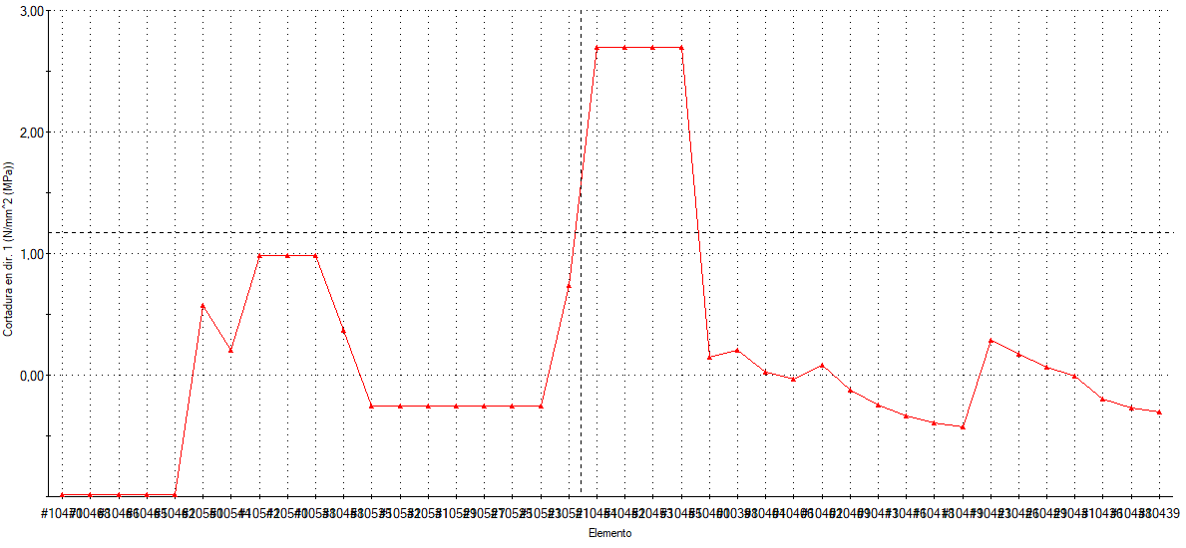
Figure 14. Shear stress dir 1. graphic
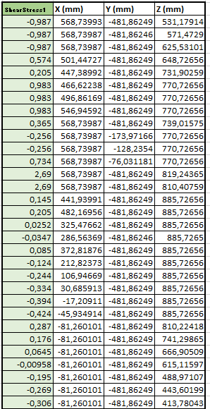
Table 5. Shear stress dir 1. Values
Page 15/23
Date
Reviewer
Project: Tripteron XYZ
Calculation: finite element analysis in chassis
Calculator: David Zuluaga Henao
- Shear stress dir 2.

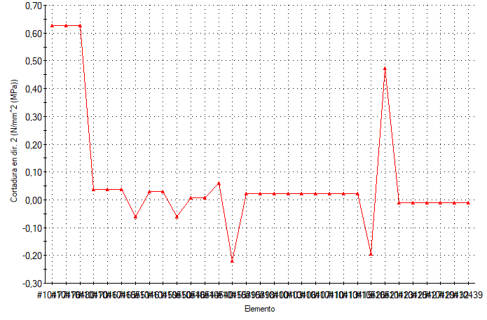
Figure 14. Shear stress dir 2. graphic
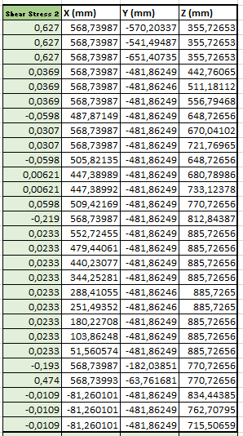
Table 6. Shear stress dir 2. Values
Page 16/23
Date
Reviewer
Project: Tripteron XYZ
Calculation: finite element analysis in chassis
Calculator: David Zuluaga Henao
- Strain

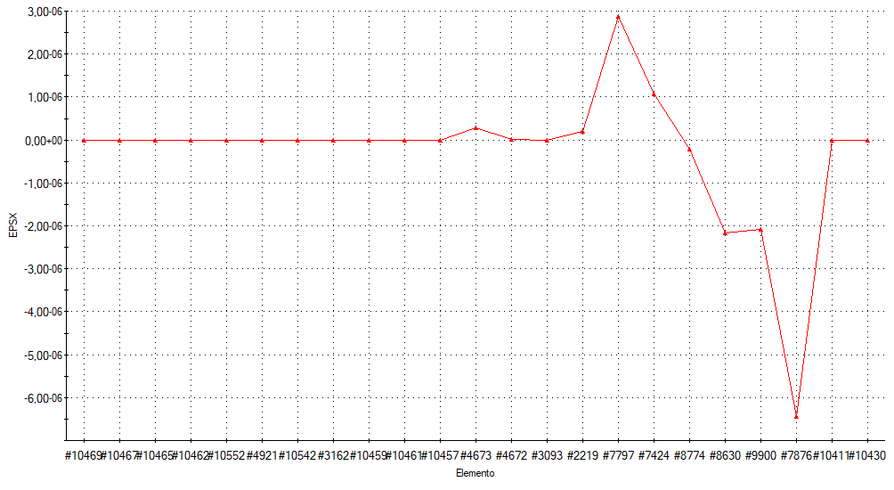
Figure 15. Strain graphic
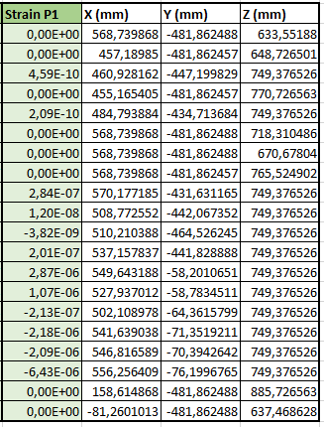
Table 7. Strain Values

Page 17/23
Date
Reviewer
Project: Tripteron XYZ
Calculation: finite element analysis in chassis
Calculator: David Zuluaga Henao
- Displacement
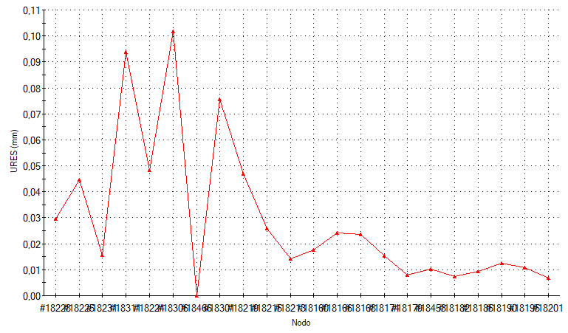
Figure 16. Displacement graphic
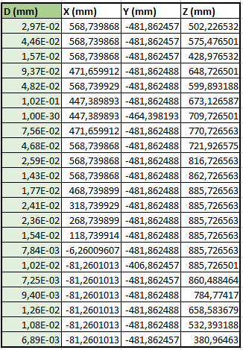
Table 8. Displacement Values

Page 18/23
Date
Reviewer
Project: Tripteron XYZ
Calculation: finite element analysis in chassis
Calculator: David Zuluaga Henao
- Buckling X
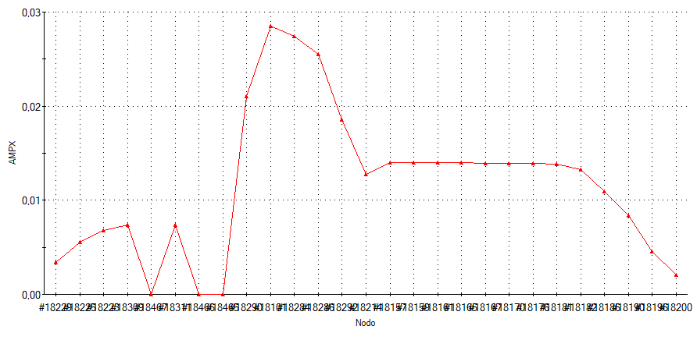
Figure 17. Buckling X graphic
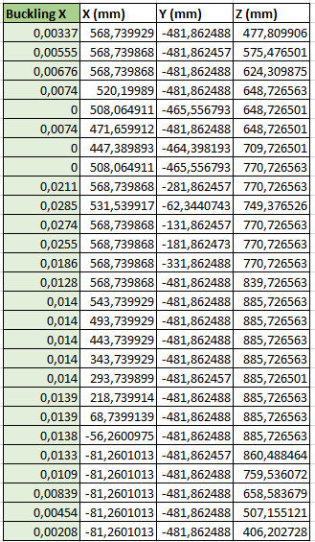
Table 9. Buckling X Values
Page 19/23
Date
Reviewer
Project: Tripteron XYZ
Calculation: finite element analysis in chassis
Calculator: David Zuluaga Henao
- Buckling Y
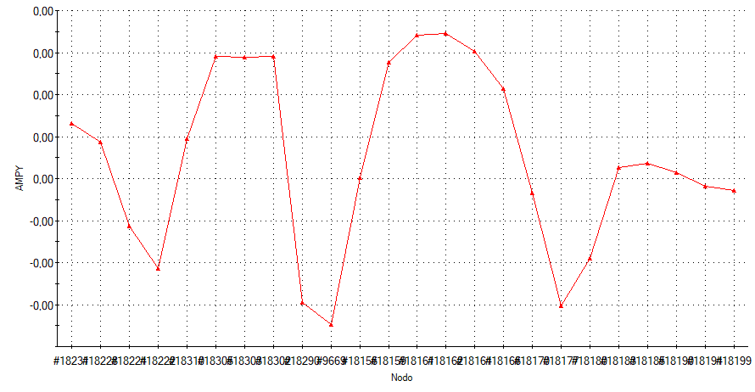
Figure 18. Buckling Y graphic

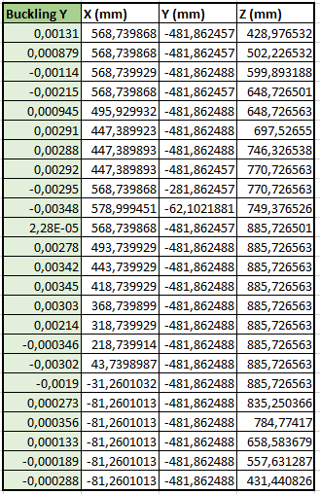
Table 10. Buckling Y Values
Page 20/23
Date
Reviewer
Project: Tripteron XYZ
Calculation: finite element analysis in chassis
Calculator: David Zuluaga Henao
- Buckling Z

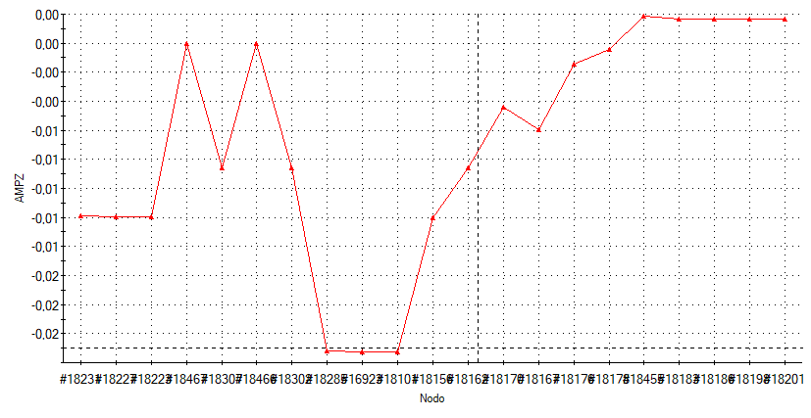
Figure 19. Buckling Z graphic

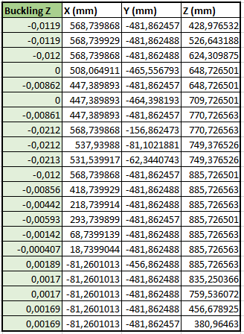
Table 11. Buckling Z Values
Page 21/23
Date
Reviewer
Project: Tripteron XYZ
Calculation: finite element analysis in chassis
Calculator: David Zuluaga Henao
Discussion

Figure 20. Results comparative graphic
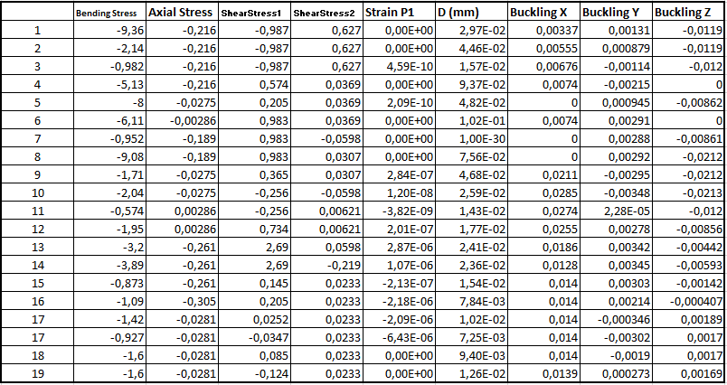
Table 12. Comparative values

Page 22/23
Date
Reviewer
Project: Tripteron XYZ
Calculation: finite element analysis in chassis
Calculator: David Zuluaga Henao

Taking into account figure 20 and table 12 which recompile the data of the figures and tables shown in the results, the following analysis was done by using the data collected:

Stresses Analysis
- Bending Stress:
  - The bending stress values range from -9.36 to -0.574 MPa.
  - The highest bending stress is observed in row 1 (-9.36 MPa), indicating a significant load or moment at this point, which could be a critical location for failure.
- Axial Stress:
  - Axial stress values are relatively low, with a maximum of -0.305 MPa and a minimum of -0.216 MPa.
  - These low axial stresses suggest that the primary loading condition is not purely axial but rather involves significant bending or shear components.
- Shear Stresses:
  - Shear Stress 1 and Shear Stress 2 show variations, with Shear Stress 1 ranging from -0.987 to 0.983 MPa and Shear Stress 2 from 0.0369 to 0.627 MPa.
  - These values indicate the presence of shear forces, which could contribute to potential shearing failures or deformations in the chassis.

Strain Analysis
- Strain P1:
  - Strain values range from -3.82E-09 to 6.43E-06.
  - These low strain values suggest that the material deformation is within the elastic range, implying that the chassis material is not undergoing plastic deformation under the applied loads.

Displacement Analysis
- Displacement (D):
  - Displacements (D) range from 0 to 1.02E-01 mm.
  - The maximum displacement observed is 0.102 mm, which is relatively small, indicating that the chassis maintains its structural integrity without significant deformations.
Page 23/23
Date
Reviewer
Project: Tripteron XYZ
Calculation: finite element analysis in chassis
Calculator: David Zuluaga Henao

Buckling Analysis
- Buckling in X, Y, and Z Directions:
  - Buckling X values range from 0 to 0.0139.
  - Buckling Y values range from -0.00346 to 0.00676.
  - Buckling Z values range from -0.012 to 0.
  - The buckling values are relatively small, with the highest observed buckling value being 0.0139 in the X direction.
  - These values suggest that the chassis is stable under the given loading conditions, with no significant risk of buckling in any direction.
Conclusions
The FEA results for the tripteron machine chassis under various weight loads indicate that:
- The chassis experiences moderate bending stresses, with the highest being -9.36 MPa, which may require attention to ensure these stress levels do not exceed material limits.
- Axial stresses and strains are minimal, indicating that the primary loading conditions involve bending and shear forces.
- Shear stresses are present but within acceptable limits, suggesting that the chassis can handle shear forces without significant risk of shear failure.
- The displacements are minimal, ensuring that the structural integrity and alignment of the chassis are maintained.
- Buckling values are low, indicating that the chassis is stable and not prone to buckling under the applied loads.
Overall, the chassis design appears to be robust and capable of withstanding the applied loads with minimal deformation and a low risk of structural failure. However, attention should be given to areas with the highest bending stresses to ensure they are within safe limits, and further optimization may be considered if necessary.

