Supporting file

Risk Assessment of Perfluorooctane Sulfonate (PFOS) using Dynamic Age Dependent Physiologically based Pharmacokinetic Model (PBPK) across human lifetime
Deepika Deepikaª, Raju Prasad Sharmaª, Marta Schuhmacherª, Vikas Kumar^{a,b*}
ªEnvironmental Engineering Laboratory, Departament d' Enginyeria Quimica, Universitat Rovira i Virgili, Av. Països Catalans 26, 43007 Tarragona, Catalonia, Spain
^{b}IISPV, Hospital Universitari Sant Joan de Reus, Universitat Rovira I Virgili, Reus, Spain

* Corresponding author: Environmental Engineering Laboratory, Departament d'Enginyeria Química, Universitat Rovira i Virgili, Tarragona, Catalonia, Spain. Tel.: +34977558576.

E-mail address: vikas.kumar@urv.cat

Biomonitoring data
Biomonitoring data was collected from three different countries (China, Norway and Australia) across different ages and used to evaluate the dynamic age dependent PBPK model (Haug et al. 2009; Kärrman et al. 2006; Zhang et al. 2010).
Table S1: Biomonitoring data of PFOS (ng/ml) with serum and plasma samples in three different countries (China, Norway and Australia)
Age group | PFOS concentration (ng/ml) | Description | Reference
China Dataª
Infants (n=14) | 2.68 (4.20) | Median (mean) | (Zhang et al. 2010)
Toddlers (n=85) | 2.52 (3.79) | Median (mean) | (Zhang et al. 2010)
Children (n=85) | 5.55 (7.05) | Median (mean) | (Zhang et al. 2010)
Adolescents (n=19) | 4.36 (6.79) | Median (mean) | (Zhang et al. 2010)
Adults (n=42) | 8.07 (15.5) | Median (mean) | (Zhang et al. 2010)
Norway Data^{b}
0-4 years | 1.8 | Mean (1976 year) | (Haug et al. 2009)
5-14 years | 19 | Mean (1987 year) | (Haug et al. 2009)
15-24 years | 24 | Mean (1998 year) | (Haug et al. 2009)
25-59 years | 10 | Mean (2007 years) | (Haug et al. 2009)
Australia Data^{c}
<16 years | 18.0 | Rural (pool 1) | (Kärrman et al. 2006)
16-30 years | 17.9 | Rural (pool 1) | (Kärrman et al. 2006)
31-45 years | 103^{d} | Rural (pool 1) | (Kärrman et al. 2006)
46-60 years | 26.2 | Rural (pool 1) | (Kärrman et al. 2006)
>60 years | 28.2 | Rural (pool 1) | (Kärrman et al. 2006)
<16 years | 20.5 | Rural (pool 2) | (Kärrman et al. 2006)
16-30 years | 17.2 | Rural (pool 2) | (Kärrman et al. 2006)
31-45 years | 22.3 | Rural (pool 2) | (Kärrman et al. 2006)
46-60 years | 25.6 | Rural (pool 2) | (Kärrman et al. 2006)
>60 years | 27.0 | Rural (pool 2) | (Kärrman et al. 2006)
<16 years | 19.9 | Urban (pool 1) | (Kärrman et al. 2006)
16-30 years | 19.8 | Urban (pool 1) | (Kärrman et al. 2006)
31-45 years | 22.2 | Urban (pool 1) | (Kärrman et al. 2006)
46-60 years | 28.9 | Urban (pool 1) | (Kärrman et al. 2006)
>60 years | 25.4 | Urban (pool 1) | (Kärrman et al. 2006)
<16 years | 23.6 | Urban (pool 2) | (Kärrman et al. 2006)
16-30 years | 21.5 | Urban (pool 2) | (Kärrman et al. 2006)
31-45 years | 23.4 | Urban (pool 2) | (Kärrman et al. 2006)
46-60 years | 20.8 | Urban (pool 2) | (Kärrman et al. 2006)
>60 years | 23.8 | Urban (pool 2) | (Kärrman et al. 2006)
a China data with concentration in blood from infants (0-1 years), toddlers (1-5 years), children (5-10 years), adolescents (10-18 years) and adults (18-90 years). b Concentration in pooled serum samples from different age group in Norway. c Australian data with serum samples in age and different region. d PFOS with concentration from 103 ng/ml (age 31-45 years) was omitted for calculation due to extreme value in rural region and pool 1.

Sensitivity analysis
Global sensitivity analysis (GSA) was performed across the age using pksensi package through MCSIM and R (Bois 2009; Hsieh et al. 2018a, 2018b). The age groups include 0-5 years (2.5), 5-10 years (7.5), 10-18 (14) years, 18-55 (25) years, 55-70 (60) years and 70-90 (80) years. The sensitivity of partition coefficient (Figure 1) physiological parameters (Figure 2) and pharmacokinetic parameters (Figure 3) was analysed with respect to the output variables. Sensitive organs like bone marrow, liver, adipose tissue, kidney and plasma (output variables) where PFOS accumulates or are prone to damage was chosen to analyse the influential parameters.
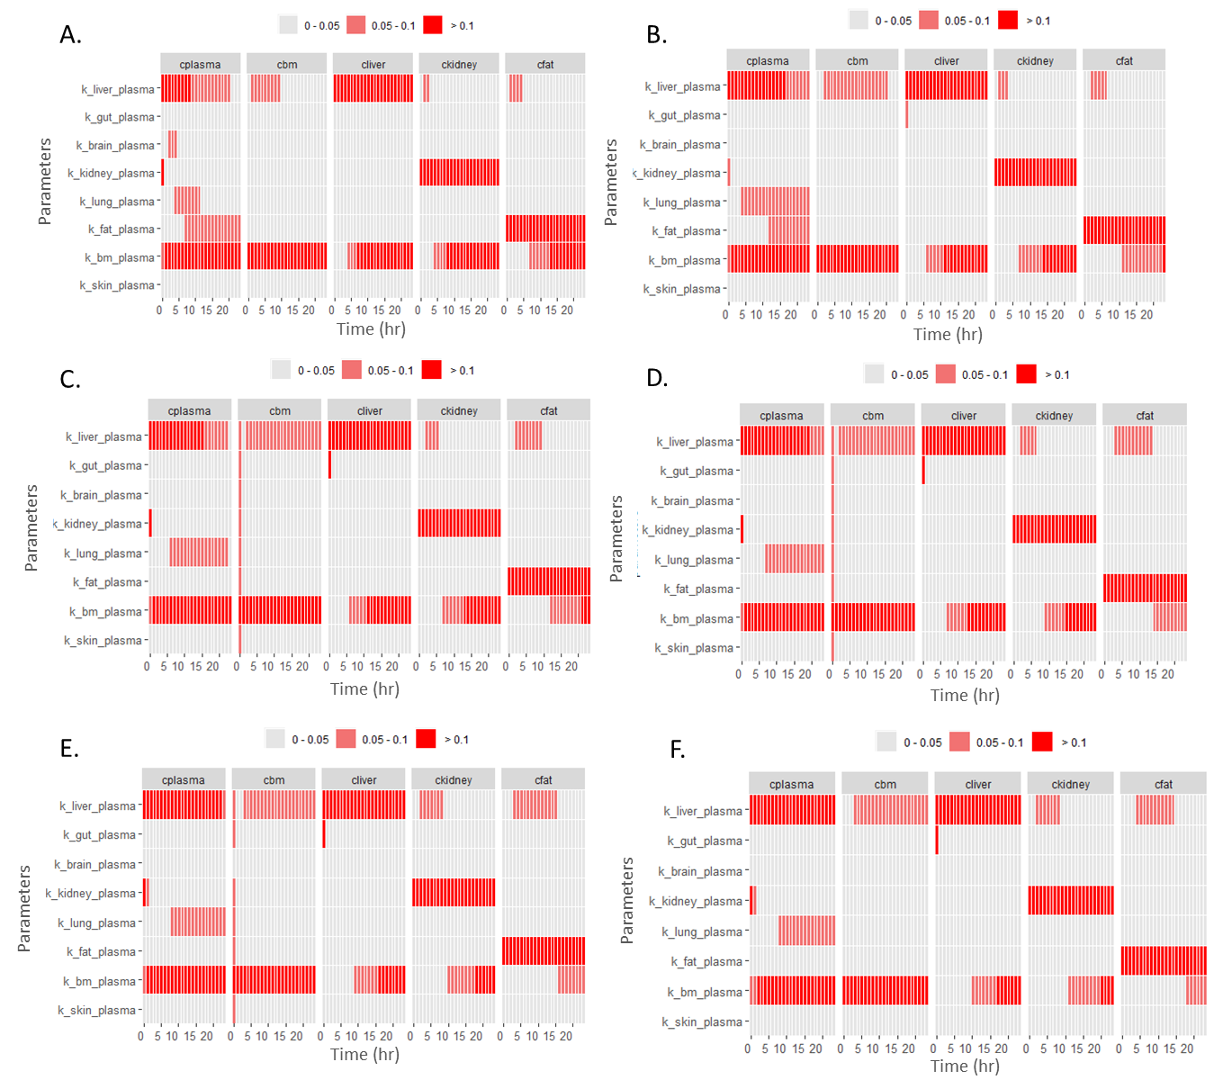
Figure S1: Heat map for sensitivity of partition coefficient to the plasma, bone marrow, liver, kidney and adipose tissue at different ages (A. 2.5 years, B. 7.5 years, C. 14 years, D. 25 years, E. 60 years and F. 80 years).
Here, cplasma refers to concentration in plasma, cbm refers to concentration in bone marrow, cliver refers to concentration in liver, ckidney to concentration in kidney and cfat to concentration in adipose tissue.

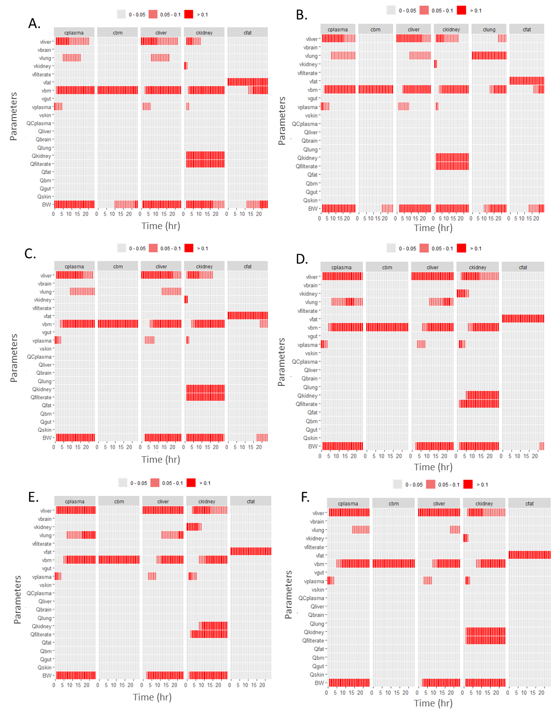
Figure S2: Heat map representing sensitive physiological parameters to the different body organs at different ages (A. 2.5 years, B. 7.5 years, C. 14 years, D. 25 years, E. 60 years and F. 80 years).
Here, cplasma refers to concentration in plasma, cbm refers to concentration in bone marrow, cliver refers to concentration in liver, ckidney to concentration in kidney and cfat to concentration in adipose tissue, Kt refers to affinity constant, Tm for reabsorption, fu is fraction unbound and kurine for urine elimination constant.
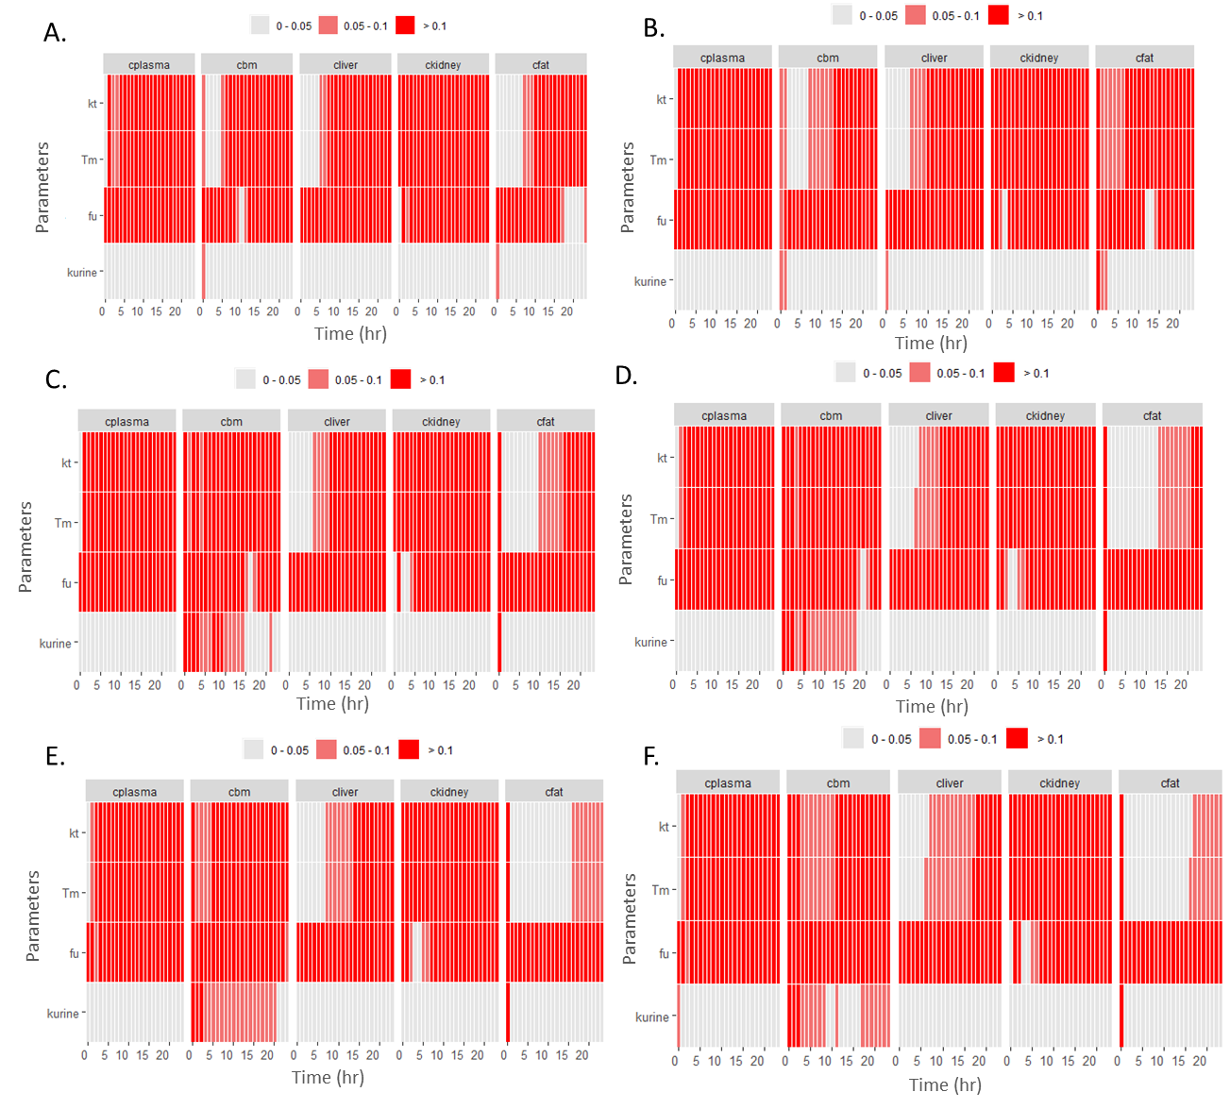
Figure S3: Heat map for sensitivity of pharmacokinetic parameters to the plasma, bone marrow, liver, kidney and adipose tissue at different ages (A. 2.5 years, B. 7.5 years, C. 14 years, D. 25 years, E. 60 years and F. 80 years).
Here, cplasma refers to concentration in plasma, cbm refers to concentration in bone marrow, cliver refers to concentration in liver, ckidney to concentration in kidney and cfat to concentration in adipose tissue, Kt refers to affinity constant, Tm for reabsorption, fu is fraction unbound and kurine for urine elimination constant.

Organ Volume
Data from ICRP 89 and relationship with age, BW and height was used to derive equation for the weight of specific compartment in the general population (Anatomical et al.; Johnson et al. 2005; Ogiu et al. 1997; Price et al. 2003; Stader et al. 2019). Models for predicting weight of particular organ was done by performing linear regression with data obtained from already available equation and biomonitoring data with combination of different variables based on fit. For example, in case of liver, age and body weight were good fit whereas for brain, body weight and height lead to good fit. In similar way relationship was measured between other compartments and volume of different body tissues. As none of the equation in literature was able to cover the age group till 90 years, separate equation was able to simulate the weight and same was validated with available biomonitoring data as shown in figure. In the model, constant density of 1g/l was assumed so that mass in Kg is equal to volume in L.
In all the equation, variability was introduced based on age and Monte Carlo simulation was run for 1000 virtual population at each year. Lower (2.5), middle and higher percentile (97.5) was calculated at respective time to distribute the organ of volume in a range. Results were validated with physiological data (Anatomical et al.; Brown et al. 1962; Johnson et al. 2005; Ogiu et al. 1997; Price et al. 2003; Stader et al. 2019; Valentin and Streffer 2002).
Lungs=-1.454e-02+7.269e-04*a+9.329e-06*a^2+6.430e-03*BW+3.083e-05*BW^2
Table S2: Equations describing the change in organ volume with age
Organs | Male Equation | Female Equation
Liver | -0.0143744-0.0044728*age+0.0264591*BW | 0.0017717-0.0030113*age+0.0253455*BW
Brain | 0.218096-0.001590*age-0.003274*BW+0.008626*HT | 0.3757397-0.0003031*age-0.0021962*BW +0.0065721*HT
Kidney | 5.668e-02-4.962e-04*age+3.501e-03*BW | 0.0458676-0.0003957*age+0.0035115*BW
Adipose tissue | 1.3054356+0.3622685*age-0.0025165*age^2 +0.0906119*BW+0.0001731*BW^2 | 6.132e-01+8.475e-02*age+8.151e-05*age^2 +1.341e-01*BW+2.297e-03*BW^2

Growth related equations
For males and females, body weight equation was taken from Price et al for 0 to 18 years (Price et al. 2003) and another equation used was from Stader et al. (Stader et al. 2019), where they have used the anthropometric data of 106,698 Caucasians to develop equation from year 20 to 90. Considering their equation and variability, regression equation was formed from 0 to 90 years, where equation 1 refers to male body weight and equation 2 denotes female body weight respectively. For validating the equation ICRP 89 dataset (Valentin and Streffer 2002) and another data from Stader et al was used where they have collected the data from 106,698 Caucasians. Similarly, equation for body height was made with introduced variability (E3 for male & E4 for female) (Hermanussen et al. 2012).

BW=3.382e+00+2.866e+00*a+(1.694e-01)*a²-(1.169e-02)*a³+(2.577e-04)*a⁴-(2.484e-06)*a⁵+(8.891e-09)*a⁶ (E1)
BW=2.354+4.050*a-(3.240e-02)*a²-(3.057e-03)*a³+(9.353e-05)*a⁴-(1.022e-06)*a⁵+(3.918e-09)*a⁶ (E2)
HT=(5.869e+01)+(1.265e+01)*a-(4.665e-01)*a²+(7.198e-03)*a³-(3.224e-05)*a⁴-(2.512e-07)*a⁵+(2.071e-09)*a⁶ (E3)
HT=(5.373e+01)+(1.296e+01)*a-(5.506e-01)*a²+(1.113e-02)*a³-(1.106e-04)*a⁴+(4.697e-07)*a⁵-(4.416e-10)*a⁶ (E4)

Blood flow to organs
Limited data on blood flow to organ makes it a challenging task to model these compartments for flow. In case of cardiac output, calculation was done based on body surface area. Body Surface area was calculated by Dubois formula shown in E5 (Du Bois and Du Bois 1989; Redlarski et al. 2016). Variability was incorporated for cardiac output based on normal random distribution accounting for interindividual differences (E6 for female & E7 for male) (Mallick et al. 2019; Stader et al. 2019).
SA= 0.007184*(BW^{0.425}) *(HT^{0.725}) (E5)
QCC=5.528076-(2.834486*age) + (0.012591* age²) + (204.262351*SA) + (19.274290*SA²) (E6)
QCC=6.48370-1.59948*age+214.68572*SA (E7)
For other organs, data from ICRP 89 and Stader et al. was used where they have collected the adult data and data from European population for age group 20 to 90 years. In the compartments where tissue blood flow has been rarely reported, adult blood flow was taken as standard for calculating relative blood flow and simulated data was validated with physiological values (Anatomical et al.; Stader et al. 2019)
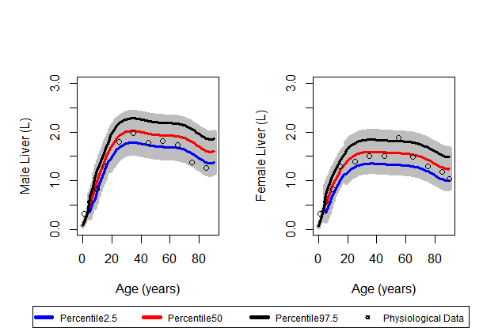
Figure S4: Liver volume (L) in male and female with age from 0 to 90 years
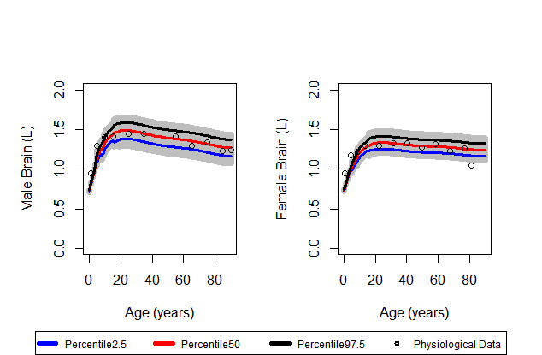
Figure S5: Brain volume (L) in male and female from 0 to 90 years
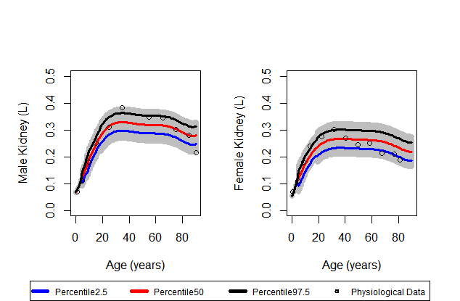
Figure S6: Kidney volume (L) in male and female from 0 to 90 years

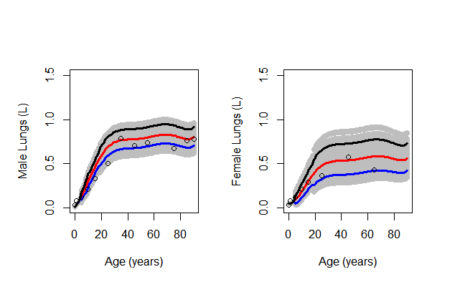
Figure S7: Lungs volume (L) in male and female from 0 to 90 years
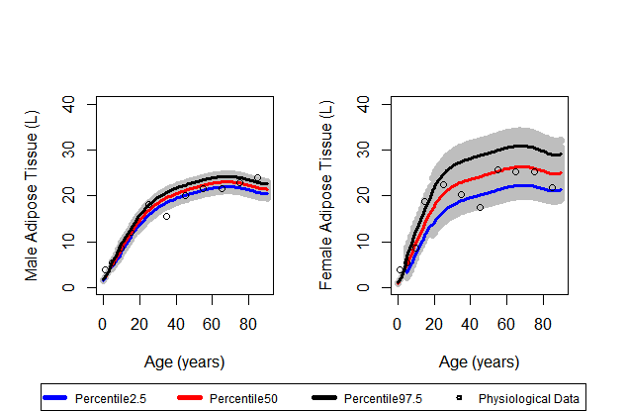
Figure S8: Adipose tissue volume (L) in male and female from 0 to 90 years

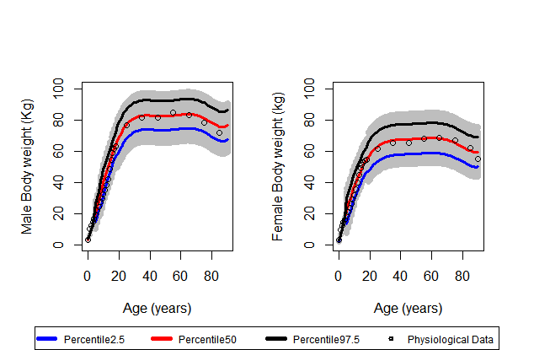
Figure S9:Body weight of the male and female in Kg from 0 to 90 years

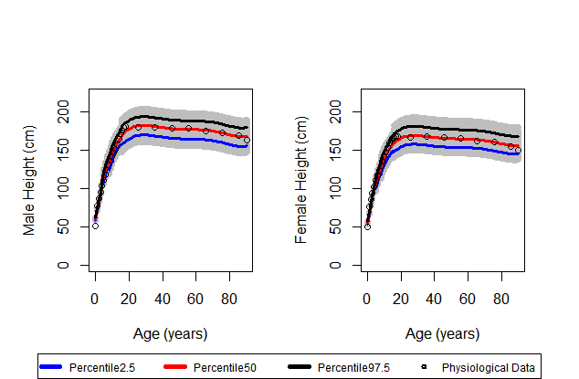
Figure S10: Height of the male and female in cm from 0 to 90 years
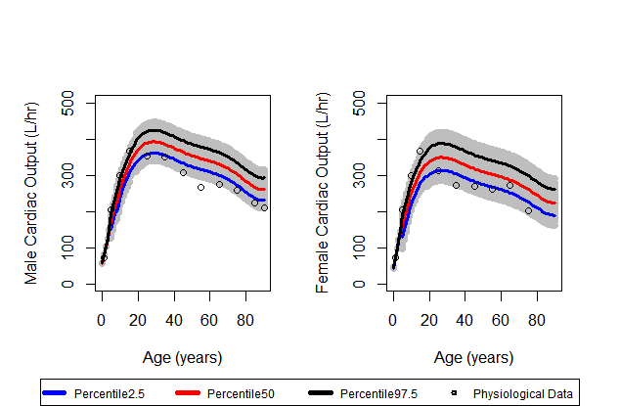
Figure S11: Cardiac output for male and female for 0 to 90 years

Reconstructed Exposure
The dynamic age dependent PBPK model was used to calculate reconstructed exposure for different age groups.
Table S3: Reconstructed exposure from different biomonitoring studies across age groups using dynamic age dependent PBPK model.
Cohort | Age group (years) | Reconstructed exposure* (Mean), (Min,Max)
(Zhang et al. 2010) | 0-1 | 6.8e-5
 | 1-5 | 3.4e-5  (2.9e-5,3.9e-5)
 | 5-10 | 4.6e-5  (3.4e-5,5.4e-5)
 | 10-18 | 2.5e-5  (2e-5,3.1e-5)
 | 18-90 | 2.1e-5  (1.2e-5,3e-5)
(Haug et al. 2009) | 0-4 | 1.8e-5  (1.7e-5,1.9e-5)
 | 5-14 | 8.0e-5  (6.1e-5,1.01e-4)
 | 15-24 | 4.9e-5  (4.6e-5,5.6e-5)
 | 25-59 | 1.4e-5  (1.1e-5,1.8e-5)
(Kärrman et al. 2006) | 0-16© | 6.7e-5  (4.9e-5,9.1e-5)
 | 16-30 | 3.8e-5  (2.8e-5,5.1e-5)
 | 46-60 | 3.6e-5  (2.9e-5,4.4e-5)
 | 61-80 | 3.2e-5  (2.8e-5,4.0e-5)
 | 0-16© | 7.4e-5  (5.0e-5, 1.09e-4)
 | 16-30 | 3.7e-5  (2.7e-5, 5.1e-5)
 | 31-45 | 3.6e-5  (3.0e-5, 4.2e-5)
 | 46-60 | 3.5e-5  (3.0e-5, 4.1e-5)
 | 61-80 | 3.0e-5  (2.5e-5, 4.1e-5)
 | 0-16© | 9.0e-5  (7.0e-5, 1.25e-4)
 | 16-30 | 4.7e-5  (3.9e-5, 5.7e-5)
 | 31-45 | 3.8e-5  (2.8e-5, 4.8e-5)
 | 46-60 | 2.7e-5  (2.5e-5, 3.0e-5)
 | 61-80 | 2.5e-5  (2.1e-5, 3.2e-5)
 | 0-16© | 4.6e-5  (3.3e-5, 6.4e-5)
 | 16-30 | 3.1e-5  (2.5e-5, 3.5e-5)
 | 31-45 | 3.1e-5  (2.4e-5, 3.6e-5)
 | 46-60 | 2.4e-5  (2.1e-5, 3.0e-5)
 | 61-80 | 2.4e-5  (1.9e-5, 3.2e-5)
*Reconstructed exposure is in µg/g body weight per day for each age group.
©Data from Karrman et al. was of 4 pools, data from individual pools for reconstructed exposure was noted down in sequence from pool 1 to pool 4. Reconstructed exposure from pool 1 in 31-45 years was not included as (Kärrman et al. 2006) has not included that data for being an outlier. In this case the exposure value was assumed to be equal to previous exposure.

Adult Model Evaluation
Figure 12 represents the correlation in plasma from dynamic model with the published adult model from Fabrega et al. (Fàbrega et al. 2014, 2016a).
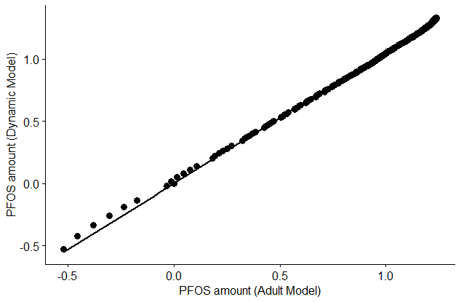
Figure S12: Correlation plot for simulation results from dynamic age dependent and published adult model (Fàbrega et al. 2016b). It represents the scatter plot in a logarithmic scale where output of model simulations from published adult model was compared against the simulations from the current dynamic model through Pearson correlation coefficient test.

References
Anatomical B, Data P, Values R. Annals of the ICRP.
Bois FY. 2009. GNU MCSim: Bayesian statistical inference for SBML-coded systems biology models. Bioinformatics 25:1453–1454; doi:10.1093/bioinformatics/btp162.
Brown E, Hopper J, Hodges JL, Bradley B, Wennesland R, Yamauchi H. 1962. RED CELL, PLASMA, AND BLOOD VOLUME IN HEALTHY WOMEN MEASURED BY RADIOCHROMIUM CELL-LABELING AND HEMATOCRIT*. J Clin Invest 41:2182–2190; doi:10.1172/JCI104677.
Du Bois D, Du Bois EF. 1989. A formula to estimate the approximate surface area if height and weight be known. 1916. Nutrition 5: 303–311; discussion 312.
Haug LS, Thomsen C, Becher G. 2009. Time trends and the influence of age and gender on serum concentrations of perfluorinated compounds in archived human samples. Environ Sci Technol 43:2131–2136; doi:10.1021/es802827u.
Hermanussen M, Aßmann C, Wöhling H, Zabransky M. 2012. Harmonizing national growth references for multi-centre surveys, drug monitoring and international postmarketing surveillance. Acta Paediatr 101:78–84; doi:10.1111/j.1651-2227.2011.02415.x.
Hsieh N, Reisfeld B, Chiu WA. 2018a. pksensi : an R package to apply sensitivity analysis in pharmacokinetic modeling. SoftwareX 2:80521; doi:10.1016/j.softx.2020.100609.
Hsieh NH, Reisfeld B, Bois FY, Chiu WA. 2018b. Applying a global sensitivity analysis workflow to improve the computational efficiencies in physiologically-based pharmacokinetic modeling. Front Pharmacol 9:1–17; doi:10.3389/fphar.2018.00588.
Johnson TN, Tucker GT, Tanner MS, Rostami-Hodjegan A. 2005. Changes in liver volume from birth to adulthood: A meta-analysis. Liver Transplant 11:1481–1493; doi:10.1002/lt.20519.
Kärrman A, Mueller JF, van Bavel B, Harden F, Toms L-ML, Lindström G. 2006. Levels of 12 Perfluorinated Chemicals in Pooled Australian Serum, Collected 2002−2003, in Relation to Age, Gender, and Region. Environ Sci Technol 40:3742–3748; doi:10.1021/es060301u.
Mallick P, Moreau M, Song G, Efremenko AY, Pendse SN, Creek MR, et al. 2019. Development and Application of a Life-Stage Physiologically-Based Pharmacokinetic (PBPK) Model to the Assessment of Internal Dose of Pyrethroids in Humans. Toxicol Sci 173:86–99; doi:10.1093/toxsci/kfz211.
Ogiu N, Nakamura Y, Ijiri I, Hiraiwa K, Ogiu T. 1997. A statistical analysis of the internal organ weights of normal Japanese people. Health Phys 72:368–383; doi:10.1097/00004032-199703000-00004.
Price K, Haddad S, Krishnan K. 2003. Physiological Modeling of Age-Specific Changes in the Pharmacokinetics of Organic Chemicals in Children. J Toxicol Environ Heal Part A 66:417–433; doi:10.1080/15287390306450.
Redlarski G, Palkowski A, Krawczuk M. 2016. Body surface area formulae: An alarming ambiguity. Sci Rep 6:27966; doi:10.1038/srep27966.
Stader F, Siccardi M, Battegay M, Kinvig H, Penny MA, Marzolini C. 2019. Repository Describing an Aging Population to Inform Physiologically Based Pharmacokinetic Models Considering Anatomical, Physiological, and Biological Age-Dependent Changes. Clin Pharmacokinet 58:483–501; doi:10.1007/s40262-018-0709-7.
Valentin J, Streffer C. 2002. Basic anatomical and physiological data for use in radiological protection: Reference values - ICRP Publication 89. Ann ICRP 32:1–277; doi:10.1016/S0146-6453(03)00002-2.
Zhang T, Wu Q, Sun HW, Zhang XZ, Yun SH, Kannan K. 2010. Perfluorinated compounds in whole blood samples from infants, children, and adults in China. Environ Sci Technol 44:4341–4347; doi:10.1021/es1002132.

