MediTalk
(Subject to Change)

Developers: Sean Heintz, Brent Glowinski, Chris Burleigh, Kyle Nissen

Abstract
This application is a web-based system allowing for discussion and sharing of information between members of a hospital community. The system displays information in streams, which act as a medium through which to filter the type of data you’re exposed to. If the user wishes to only view new memos, documents, general discussions, etc; the stream system will handle it. Documents, links, and text information can be shared by posting it to a stream, which will allow for users to collaborate and discuss the topic. The discussion board itself is almost completely self moderated. Through the implementation of a voting system, we allow for the users to decide which content is most relevant to a discussion, and which is inappropriate. The board will incorporate a search function which will allow the user to search for previous discussions on topics which contain information relevant to the user’s search term. Only small portions of this system will require administration from a dedicated administrator, almost removing any maintenance workload from any specific person. Navigation of the site will be done through a simple all-purpose floating bar at the bottom of the screen, which will allow the user to visit their control panel, move between streams on the site, and search for content. Through a combination of sharing, self-moderation, and searching, this system aims to streamline the process of sharing information in a hospital environment.

The priorities of the following requirements are marked with a scale of 1 to 3. 3 indicates that the feature is necessary, 2 indicates that the feature will be implemented if there is sufficient time, and 1 indicates that the feature is not necessary at all.
Functional Requirements
- Ability to create new post threads under category heading. 3
- New posts can contain links to other sites or documents. 3
- Users can edit previous posts made by themselves. 2
- Users can add Meta-tag to posts. 2
- System updates users when new posts are made to ‘watched’ threads. 3
- Instant messaging system which enables real-time communication between logged in users. 1
- Ability to comment on posts on the board. 3
- Posts can be voted up or down to move them up the page. 3
- Users can choose which threads to ‘watch’. 2
- Users can change profile settings (image, contact info, job, etc). 2
- User system - Authentication of users based on a UN/PW system. 3
- Administrator account with ability to add/remove users. 3
- Upload documents to the board and meta-tag. 2
- Ability to stylize posts being made to threads on the board. 2
- Attach images to posts on threads and displayed inline. 2
- The ability to search through threads and posts, based on meta-data and text comments. 3
- Threads are sorted into sections - e.g. Policy Changes, Articles, Research, Discussion, General, etc. 3
- Allow search of specific sections (articles, policies, etc.). 2
- New users are taken to an introduction page, explaining the use of the board. 1
- Notification button on the site shows number of new forum posts in ‘watched’ threads. 2
- Clicking on notification button shows list of new posts which can be clicked on to transfer to message thread. 2
- Users can recommend posts to other users by clicking the ‘recommend’ button. 2
- Posts will be displayed as a Reddit-like “stream” of links to content. 3
- Ability to choose which sections display in the stream. 2
- Stream will be sorted by a combination of popularity, importance, and age. 3
- Stream sorting can be changed to strictly sort by date, popularity, etc. 2
- Posts will be marked by which section they are in (colour coding?) 3
- Date, title, votes, and the start of the body will be displayed in the stream for each post. 3
- Each page will have a bottom bar that has the notification button, buttons to log in/out, and a link to the user profile page. 3
- Posts in stream will indicate if the post is a link, file, or text. 3
- If user doesn’t have an account they are able to request one from the system admin. 2
- The navigation bar has a search field. 3
- The navigation bar has a ‘combo box’ to navigate to different sections of the site. 3
- Stream is dynamically updated. 2
- Can also vote on comments; highest scoring comments at top. 3
- Administrator can create and delete sections. 2
- The server will be configured by a configuration file. 1

Non-Functional Requirements
- Has to be able to support 100+ users. 3
- Administration of the site needs to be simple and efficient to minimize time drain on administrator(s). 3
- The system needs to be easy to use and responsive to ensure timely access to important information. 3
- Posts will be displayed on the page within minimal time (1-2 seconds). 3
- The server will be dynamically configurable. 1
Use Cases
Use Case: User submits a new text post to the board
Primary Actor: User
Preconditions: User is logged in
Guarantees: Once the process is complete, a new thread will be created in the discussion
board.

Main Success Scenario:
Let U be the user and UI be the user interface.
- U uses the “navigation bar” to get to a stream.
- U clicks on the “New Post” button.
- UI updates with the page for posting new links.
- U enters title of post in the “Title” text box.
- U clicks on the “Text Post” button.
- U enters their text into the post body.
- U enters any meta-tags they think are relevant to the post.
- U clicks the “Preview” button. UI updates to show the completed post.
- U clicks the “Submit” button.
- UI updates with the thread in the discussion board corresponding to the submitted post.

Extensions
(4 .. 9)a
- U clicks the Cancel button. UI updates to indicate the post was cancelled.
- U is returned to the stream which s/he was viewing.
7a. U doesn’t enter any meta-tags. Continue normally.
8a. U doesn’t click on the preview button. UI doesn’t update. Continue normally.

Use Case: User logs in to system.
Primary Actor: User
Preconditions: User is not logged in and has an account.
Guarantees: Once the process is complete, user is logged in to their account.

Main Success Scenario:
U is the user logging in. UI is the user interface.

- U clicks the login page button.
- UI displays the login page.
- U enters their username into UI.
- U enters their password into UI.
- U presses login button.
- UI updates to show that U is logged in.
Extensions
1a. U tries to take an action they must be logged in for (ie. make a post).
(3 .. 4)a.
  - U enters invalid credentials into UI.
  - U presses login button.
  - UI displays invalid credentials message and resets fields.

Use Case: Administrator adds a user to the system.
Primary Actor: Administrator
Preconditions: Administrator is logged in, and account is flagged as administrator.
Guarantees: Once the process is complete, the specified user will be registered in the system.

Main Success Scenario:
A is the Administrator. U is the user to be added. UI is the user interface. D is the database.
- A accesses the administrator control panel.
- UI changes display to show the administrator control panel.
- A inputs the username of U in to UI.
- A inputs the email address of U in to UI.
- A selects a user type for U through the UI.
- A presses Submit button on UI.
- UI updates the display to show that U was successfully added.
Extensions
(3, 4, 5, 6)a.
- A presses the Cancel button.
- UI updates the display to show that U was not added, and the add process was canceled.

Use-case: User searches for a document using the search button on the navigation bar
Primary Actor: User
Preconditions: User is logged in.
Guarantees: User locates and opens the document.
Main Success Scenario
Let U be the user and UI be the user interface.
- U types search terms into the search text field on the “navigation bar”.
- U clicks the search button
- UI updates page to show search results
- U clicks on link for document
- UI sends copy of file to U local machine.
Extensions
4a.
- U clicks on ‘Sort by date’ button
- UI changes sorting of search results based on date.

4b
- U does not locate desired document.
- U attempts search again with different keywords.
- UI returns new results from search

Mockups
Sign In Page
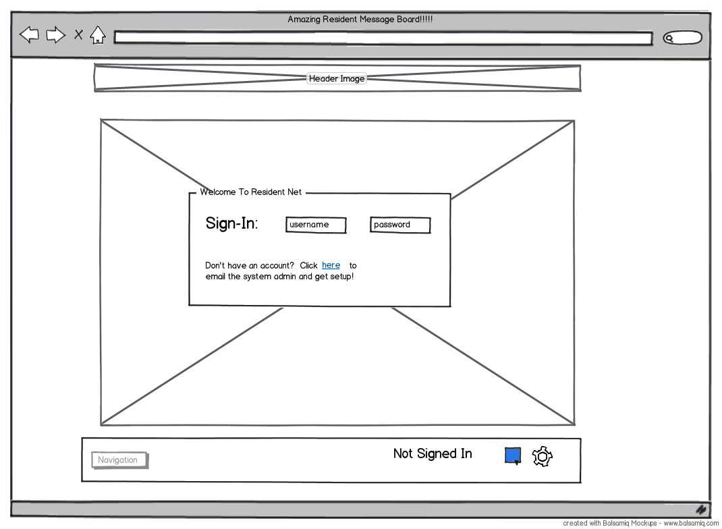

Home Page
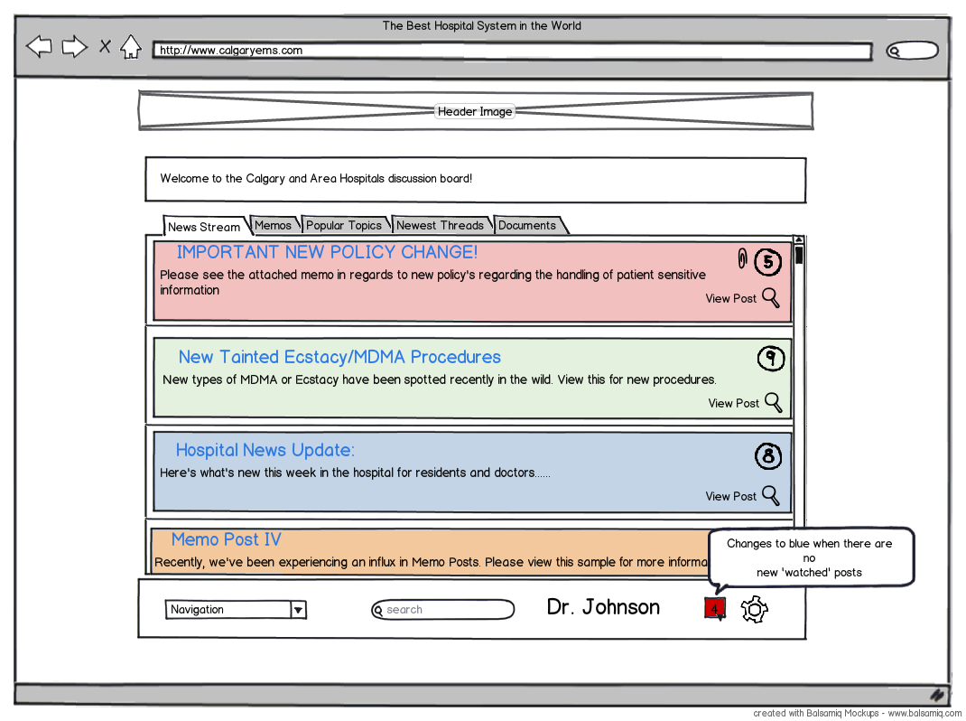

View Post Mockup
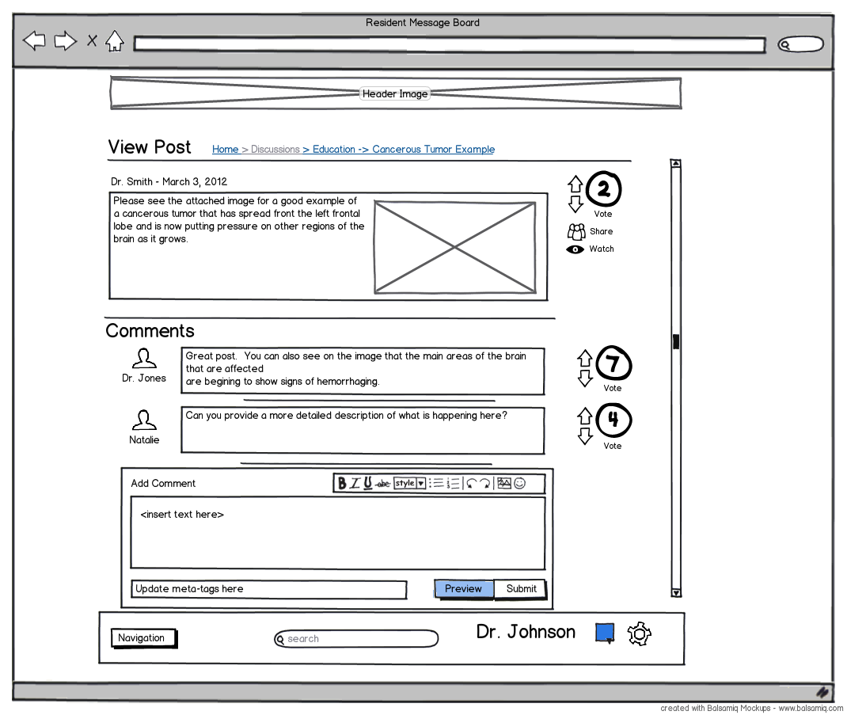
Documents Mockup
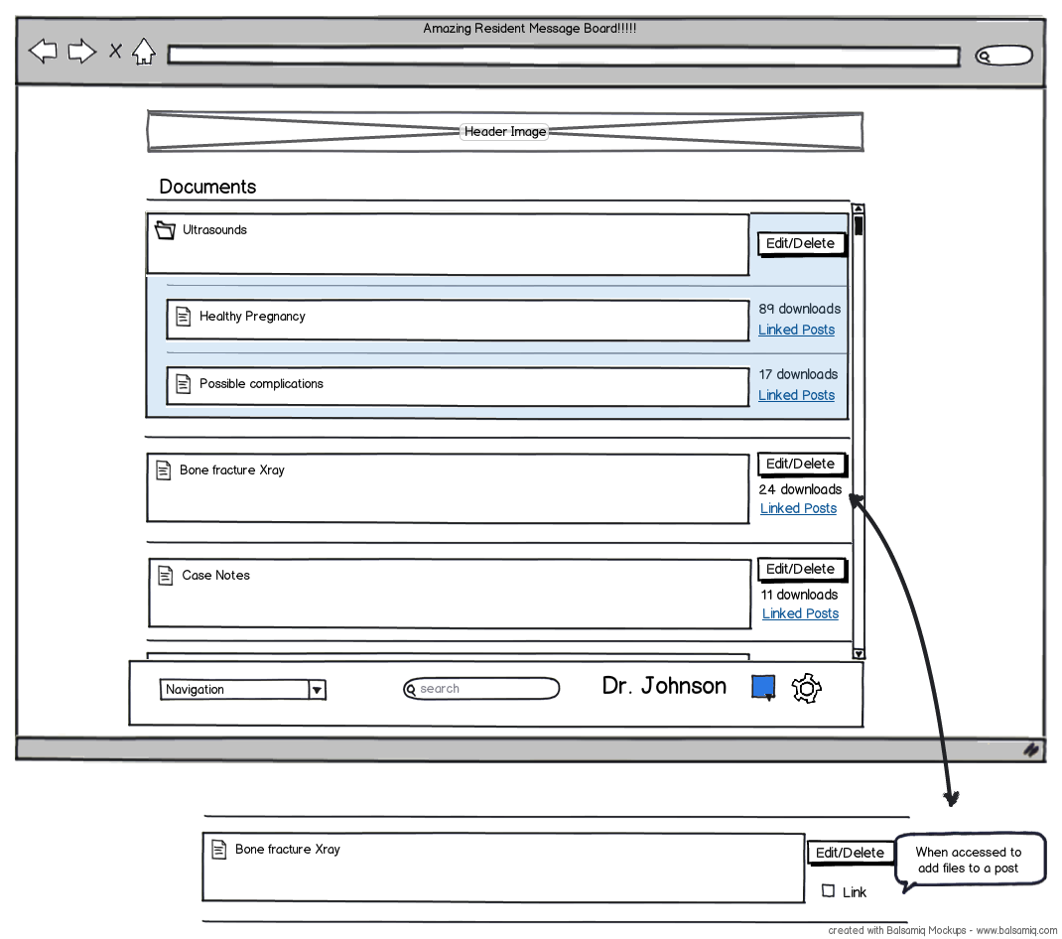
New Post Mockup
