#prod environmet version of our fibonacci app:

Make a github repo and connect travis dockerhub and aws elastic beanstalk.

:

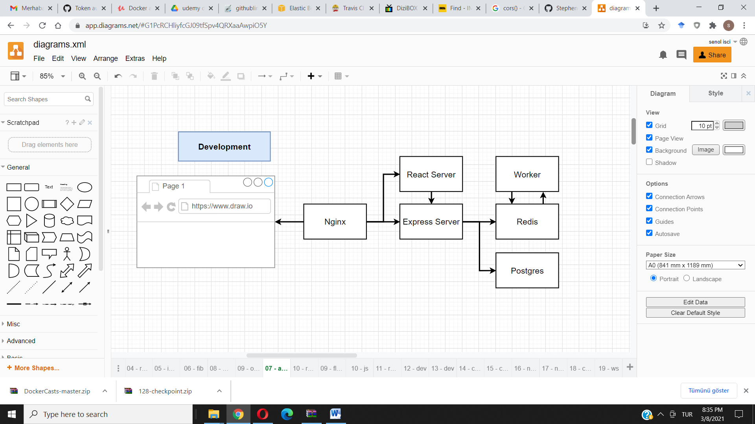

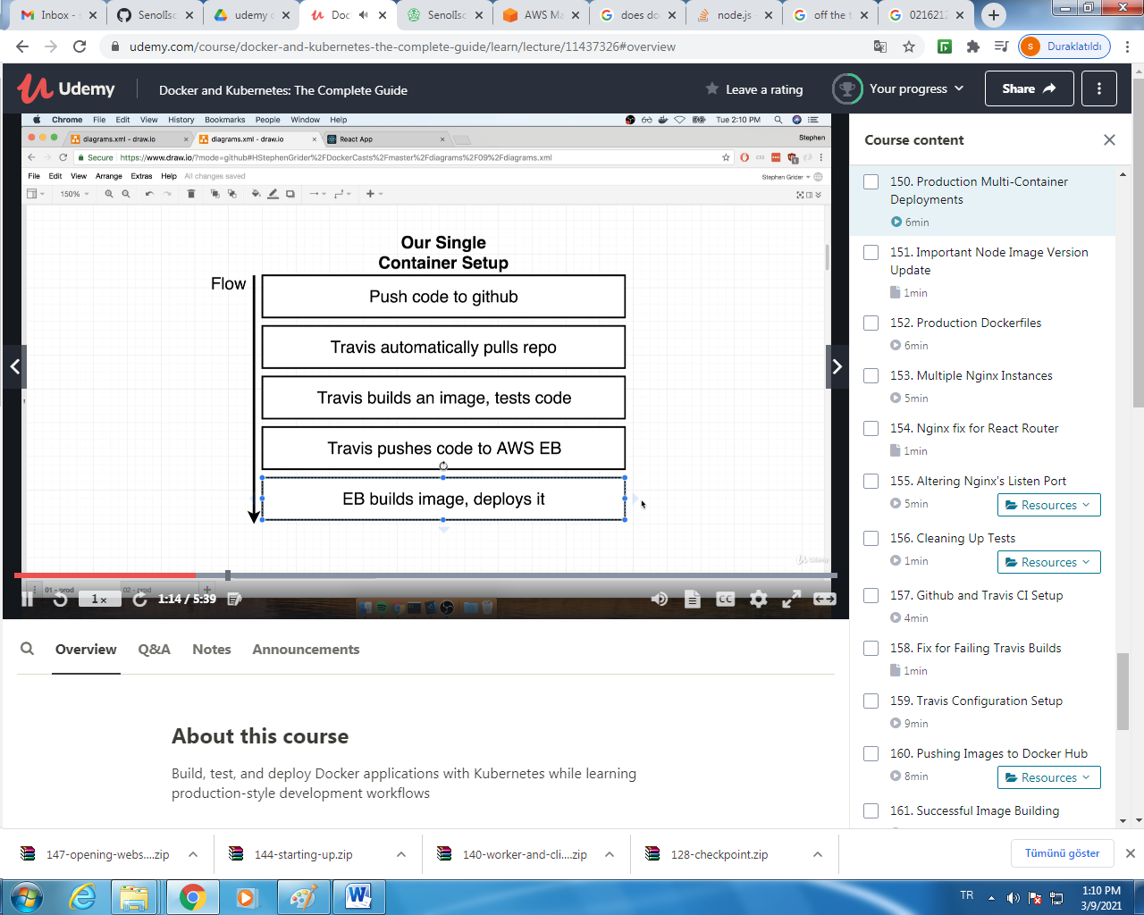

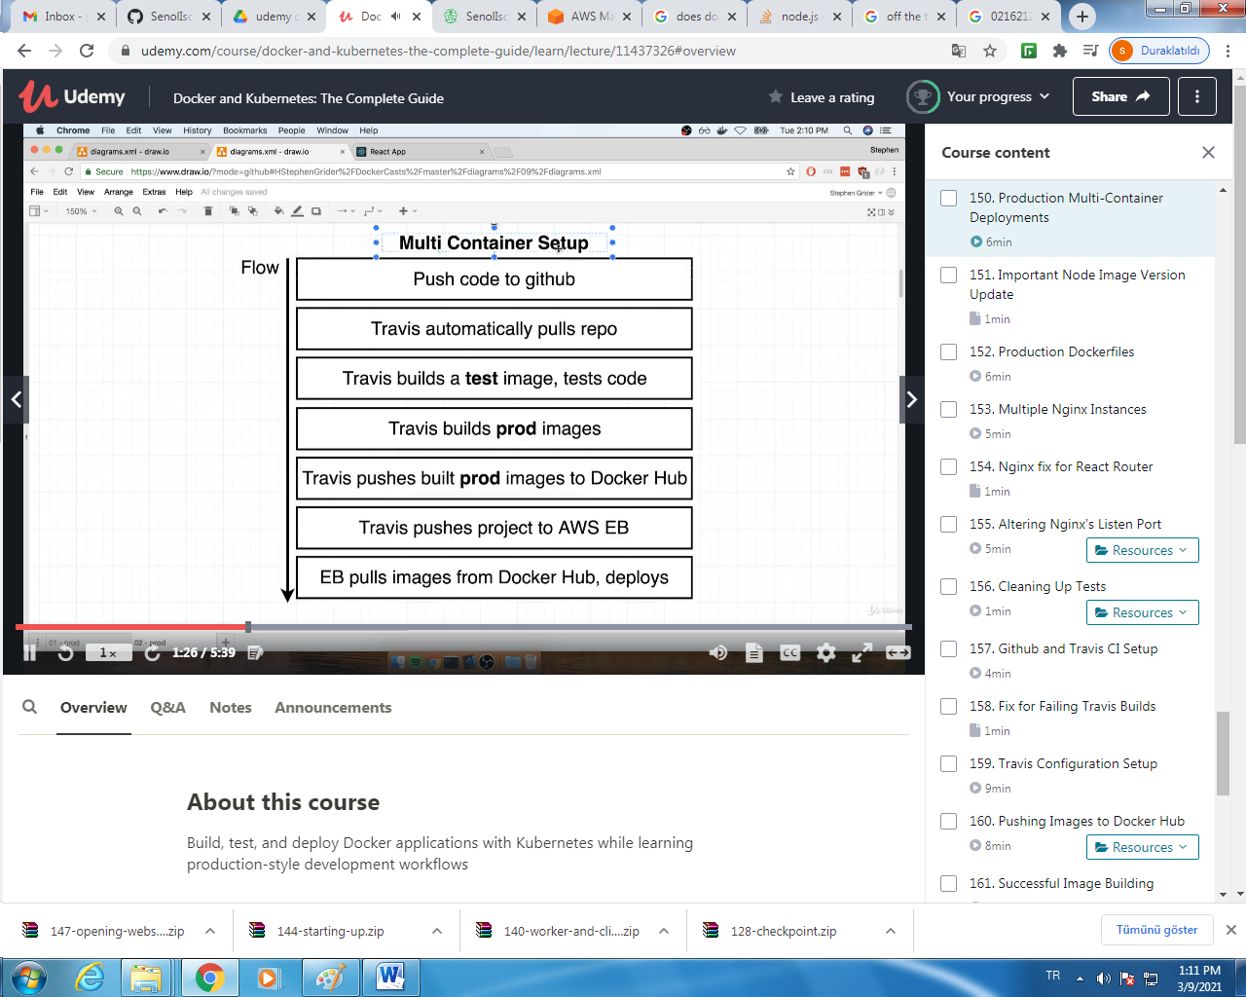

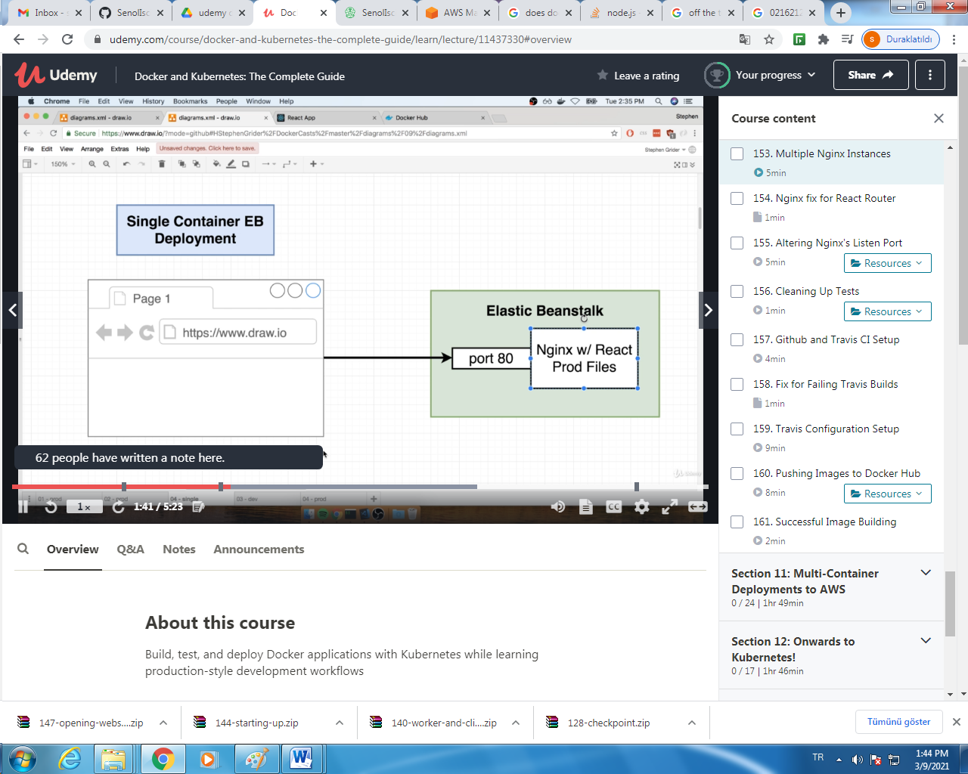

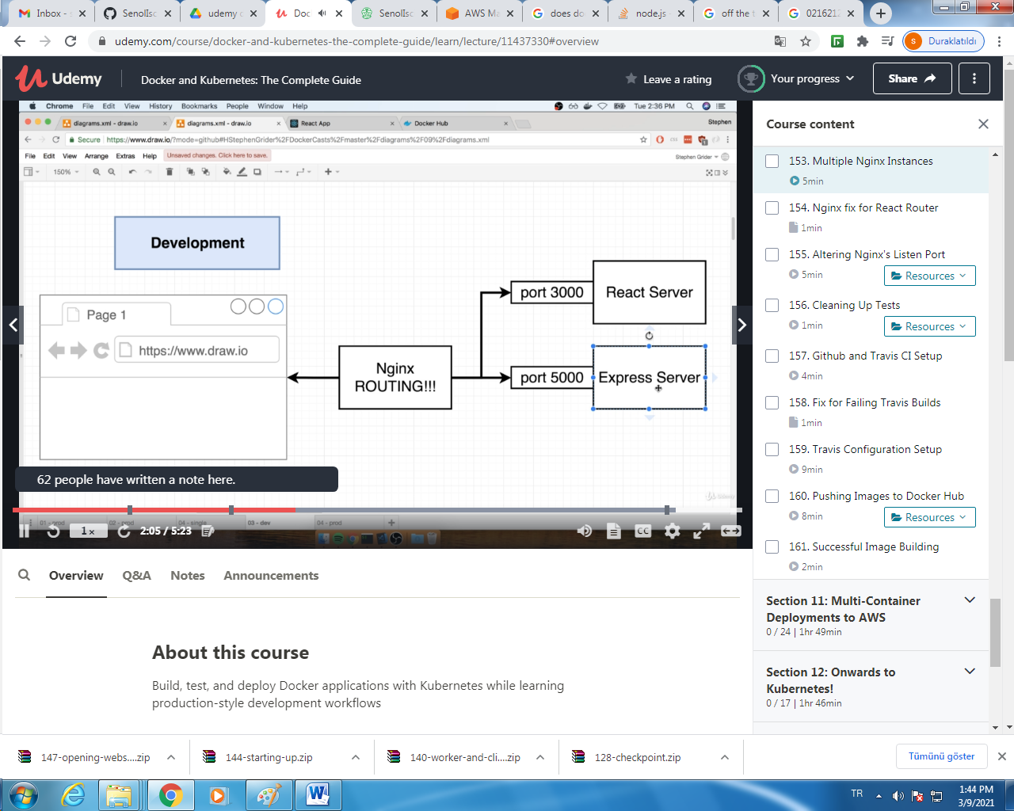

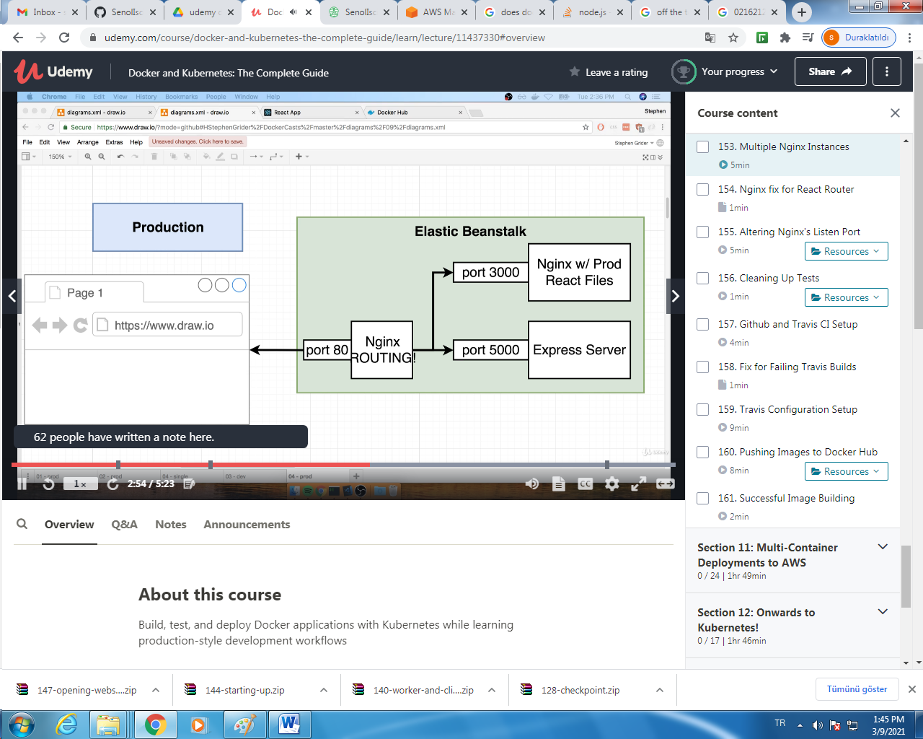

Travis ci conf:

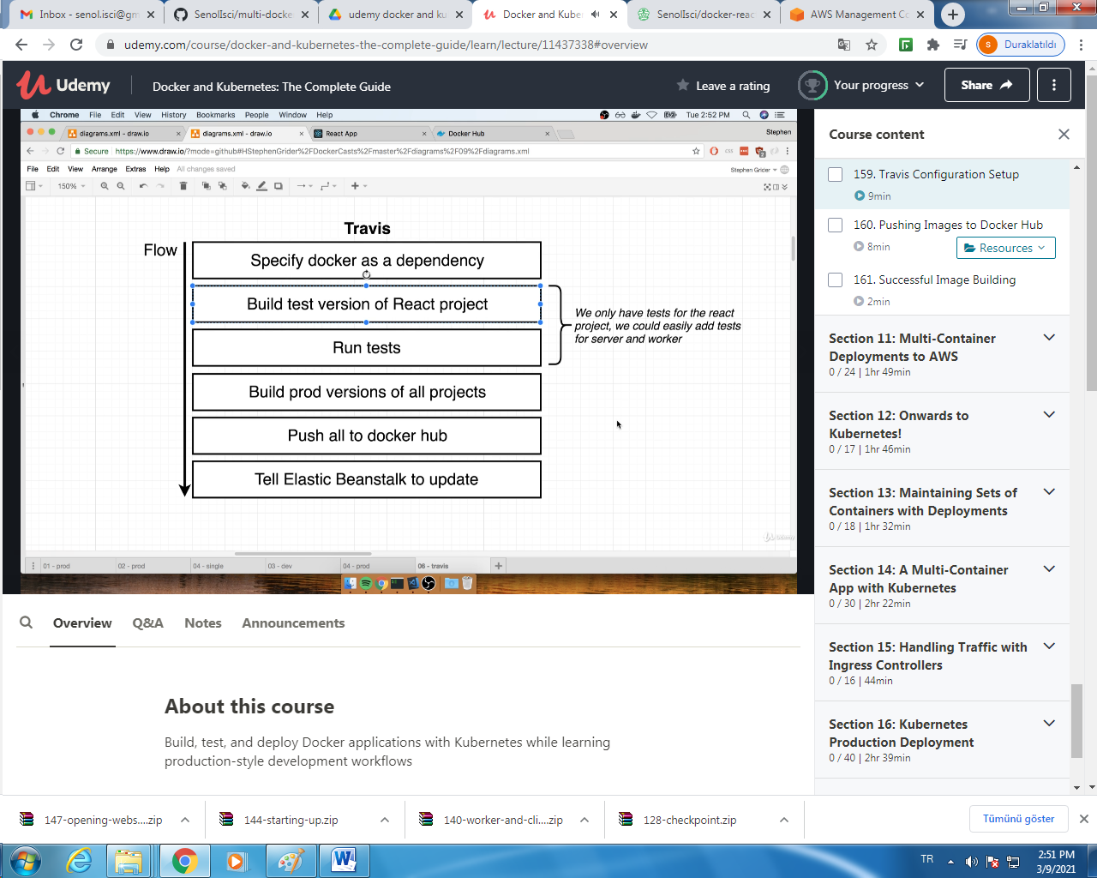

Push images to docker CLI:

$docker login

On travis website on multi-docker Project create env variables DOCKER_ID and DOCKER_PASSWORD

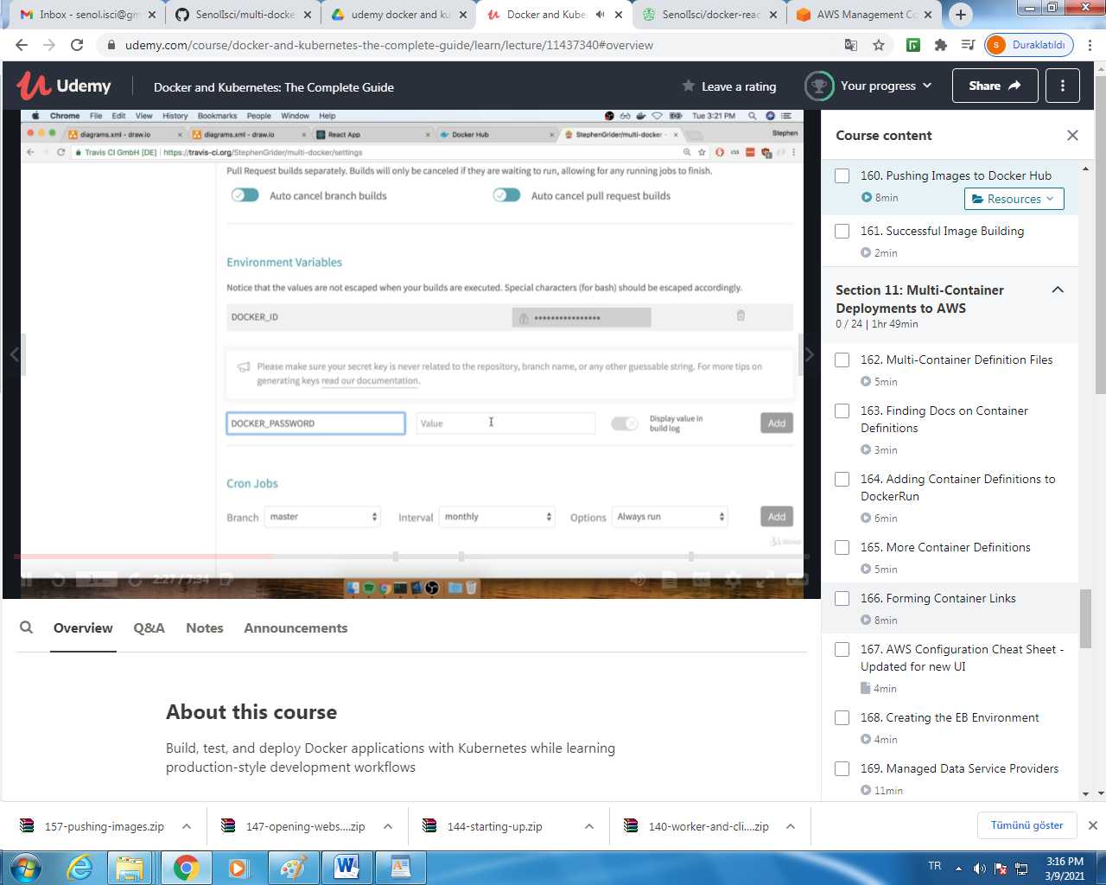

İnsert login command to .travis.yml:

sudo: required

language: generic

services:

- docker

before_install:

- docker build -t stephengrider/react-test -f ./client/Dockerfile.dev ./client

script:

- docker run -e CI=true stephengrider/react-test npm test

after_success:

- docker build -t stephengrider/multi-client ./client

- docker build -t stephengrider/multi-nginx ./nginx

- docker build -t stephengrider/multi-server ./server

- docker build -t stephengrider/multi-worker ./worker

# Log in to the docker CLI

- echo "$DOCKER_PASSWORD" | docker login -u "$DOCKER_ID" --password-stdin

# Take those images and push them to docker hub

- docker push stephengrider/multi-client

- docker push stephengrider/multi-nginx

- docker push stephengrider/multi-server

- docker push stephengrider/multi-worker

AMAZON ELASTIC BEANSTALK:

Config file: Dockerrun.aws.json

Task definition file

