We will put each subproject into containers. React to one container, express to one container, worker to one container. All which are dev environment.

We will make use of nodemon. When a source code is changed. Nodemon will detect change and restart app.

# inside Project folder “complex”

$ docker-compose up build

Docker-compose file will enable coordinated run of each container with conf parameters and provide evn variblaes used by each module.

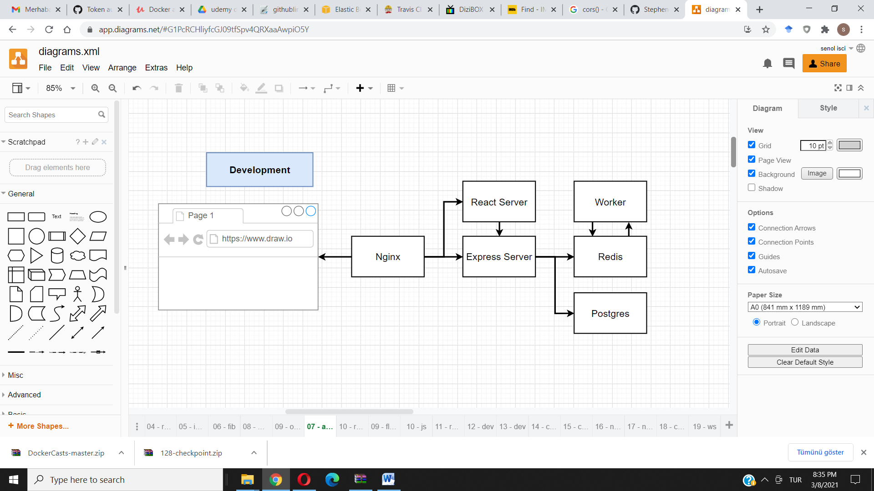

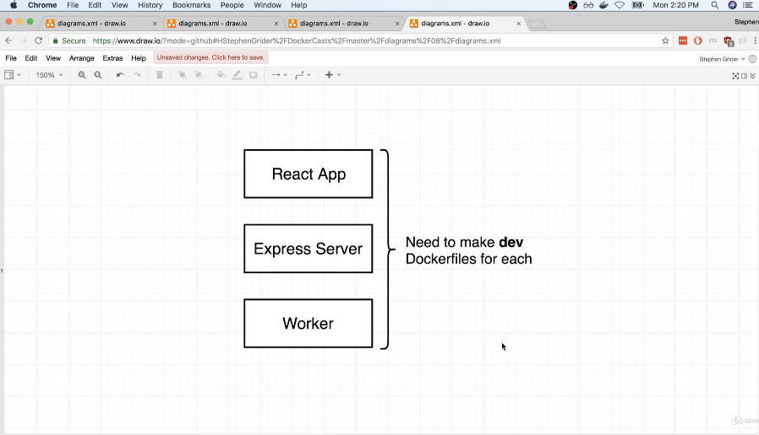

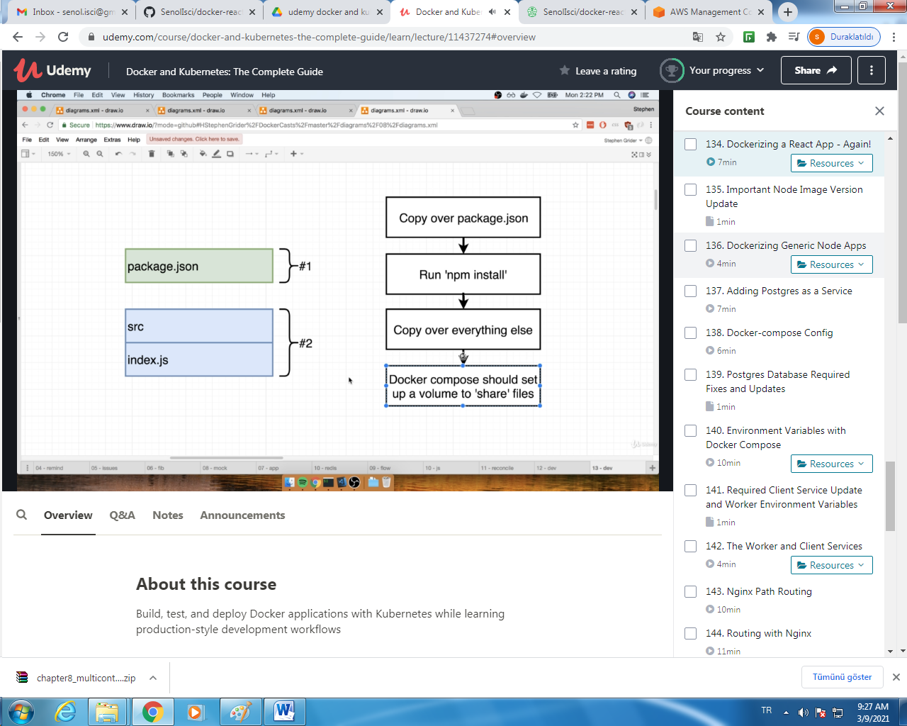

Compose:

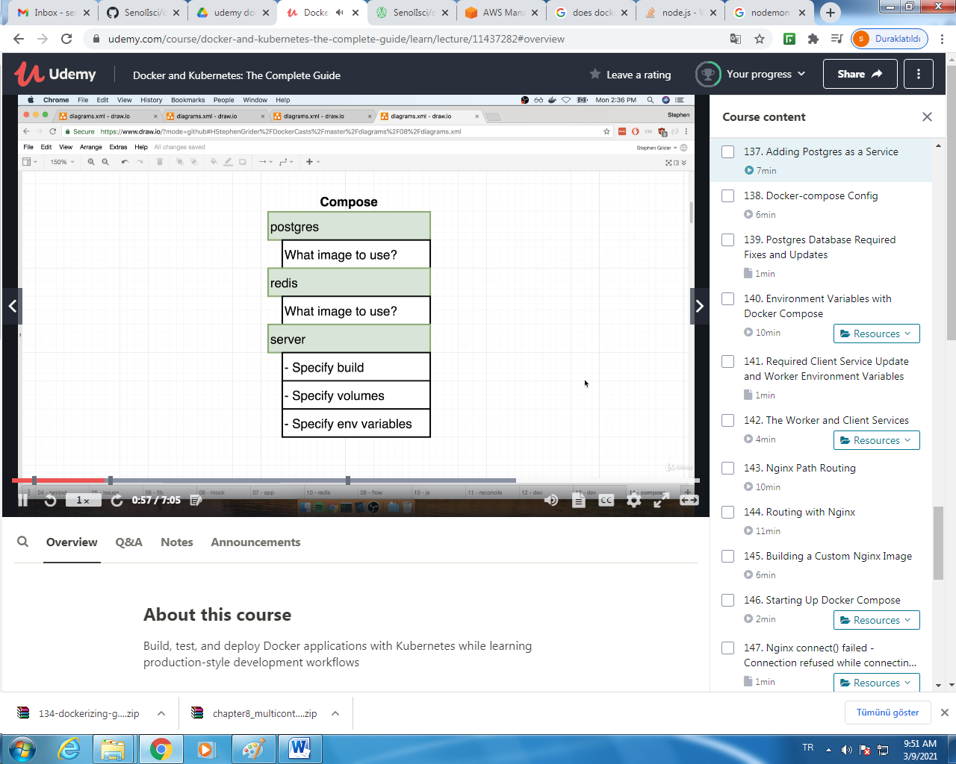

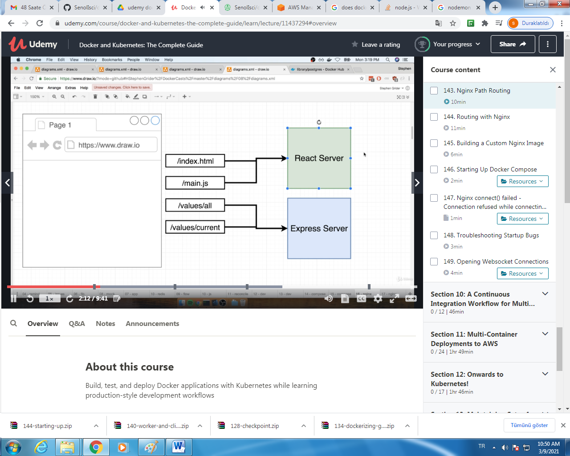

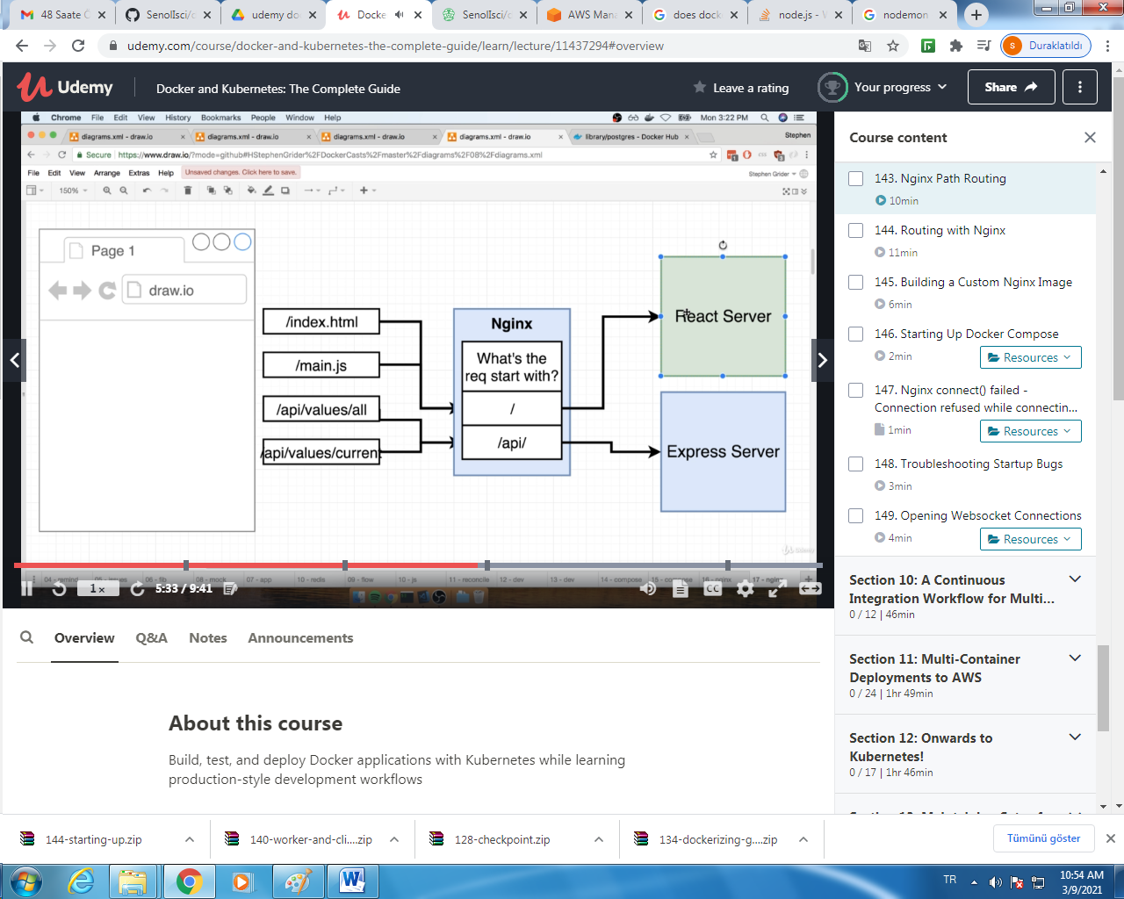

Routing by nginx:

Conf file:

