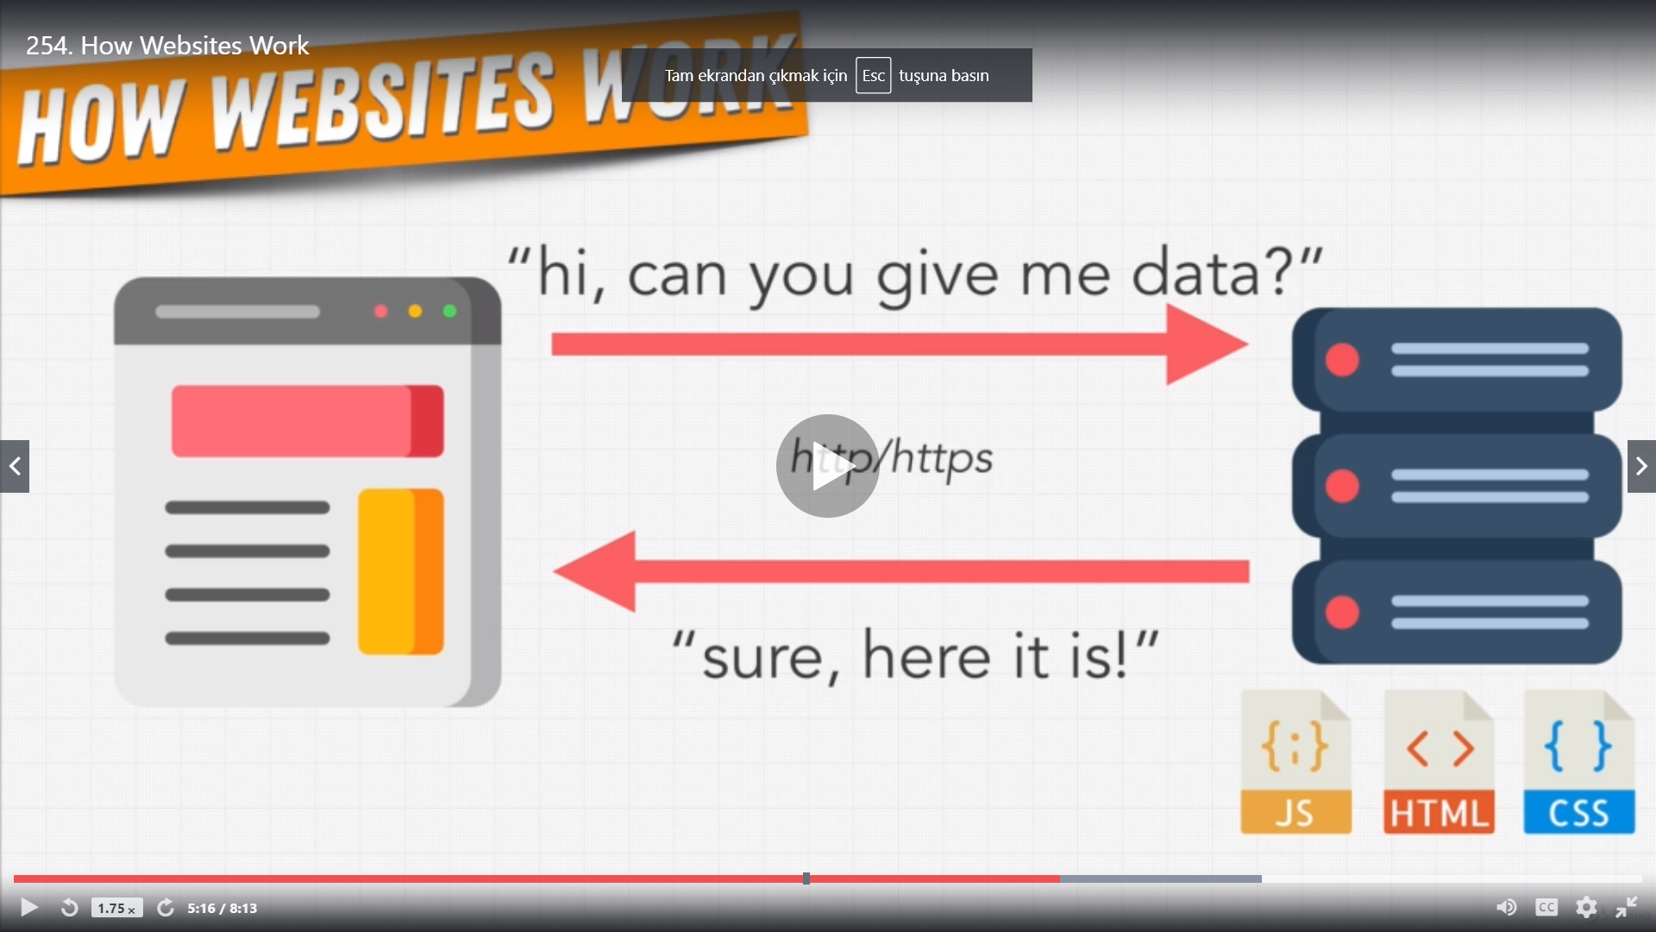

hmtl css js files.

0-) create index.html style.css and script.js files.

Create templates folder and put index.html file into it. (for flask to render_template). Create static folder and put style.css and script.js into it.( for flask to render_template)

1-) create python virtual environment venv and activate

2-)install flask

3-) create flusk app

4-)run flask

FLASK

<https://flask.palletsprojects.com/en/1.1.x/>

Create an environment

Create a project folder and a venv folder within:

$ mkdir myproject

$ cd myproject

$ python3 -m venv venv

On Windows:

$ python -m venv webserver

Activate the environment

Before you work on your project, activate the corresponding environment:

$ . venv/bin/activate

On Windows:

> webserver\Scripts\activate

On anaconda cmd:

.\webserver\Scripts\activate

Install Flask

Within the activated environment, use the following command to install Flask:

$ pip install Flask

A minimal Flask application looks something like this:

**from** flask **import** Flask

app = Flask**(**__name__**)**

@app.route**(**'/'**)**

**def** hello_world**():**

**return** 'Hello, World!'

inside webserver venv:

If you are on Windows, the environment variable syntax depends on command line interpreter. On Command Prompt:

C**:**\path\to\app>set FLASK_APP=hello.py

or on powershell:

$env:FLASK_APP = "server.py"

then run to start the server

> flask run

to start it in debug mode.

on cmd shell:

set FLASK_ENV=development

on powershell

$env:FLASK_ENV = "development"