Project Tracker
Architecture/Design Document

Table of Contents
1 Introduction 3
2 Design Goals 3
3 System Behavior 4
4 Logical View 4
4.1 High-Level Design (Architecture) 4
4.2 Mid-Level Design 5
4.2.1 Detailed Class Design 5
5 Process View 5
6 Development View 6
7 Physical View 6
8 Use Case View 7

Change History
Version: 1.0
Modifier: Michael Rudner
Date: 11/1/14
Description of Change: Initial Publish
______________________________________________________

Introduction

This document provides an architectural overview of the Project Tracker system by using a number of different architectural views to depict it. These architectural views can be used to capture and convey decisions that were made to address the interest and concerns of all major stakeholders. For this application the major stakeholders are:

- Users – The desired architecture will provide users with a system that provides desired functionality and non-functional quality requirements such as usability, reliability, etc.
- Developers – The desired architecture will provide developers a system that minimizes complexity and development efforts.
- Project Manager – The desired architecture will provide project managers with an architecture that divides the system into components of roughly equal size and complexity that can be developed simultaneously with minimal dependencies.

This document details the architecture using the views defined in the “4+1” model [1995 Krutchen]. The views used to describe Project Tracker application are:

- Logical View – major components, their attributes and operations. This view also includes relationships between components and their interactions. When doing OO design, class diagrams and sequence diagrams are often used to express the logical view.
- Process View – the threads of control and processes used to execute the operations identified in the logical view.
- Development View – how system modules map to development organization.
- Physical View – depicts the system from a system engineer’s point of view. It is concerned with the topology of software components on the physical layer.
- Use Case View – the use case view is used to both motivate and validate design activity. At the start of design the requirements define the functional objectives for the design. Use cases are also used to validate suggested designs. It should be possible to walk through a use case scenario and follow the interaction between high-level components. The components should have all the necessary behavior to conceptually execute a use case.

Design Goals

The design priorities for Project Tracker application are:
- The design should minimize complexity and development effort.
- The design should fulfill all specifications needed to create desired functionality.
- The design should allow implementation of basic security:
  - Authentication: Login using at least a user name and password
- The design should provide good reliability. Meaning that the system should be available 24/7 except for scheduled maintenance.
- The design should provide more maintainable code.

System Behavior

Project Tracker will be available on Commerce Bank’s intranet. Users will gain access of this application by using their web browser. Functionality that is provided will be based on user (Admin, Ambassador, Mentor, or Contributor).

For more detailed information about requirements please review our SRS (Software Requirements Specification) document:

https://github.com/cs451/Fall2014Team5

Logical View

High-Level Design (Architecture)
The high-level view or architecture consists of ASP.NET MVC:

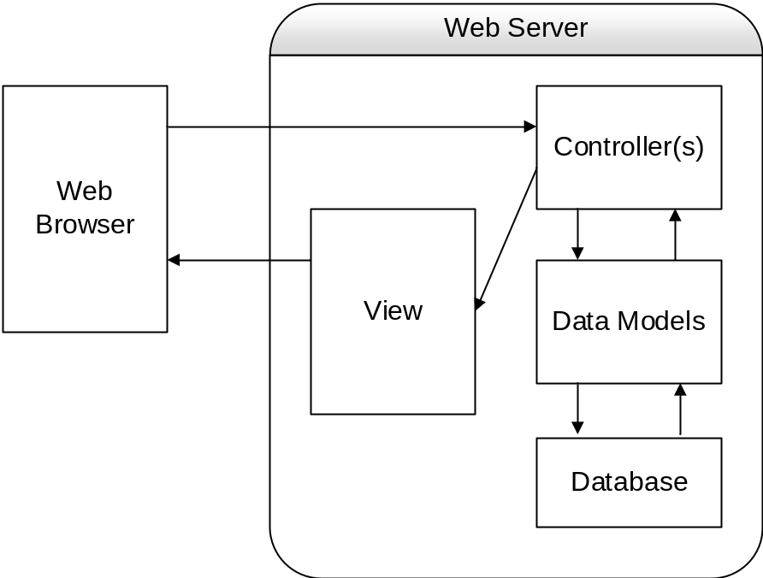

- The Model is the core of the application. An example would be a list of database records.
- The View displays information about the model to user.
- The Controller offers facilities to change the state of the model
- The Database is a central repository for Project Tracker data
- The Web browser is a software application that a user would use for retrieving, presenting and traversing information resources over the intranet.

Mid-Level Design

Detailed Class Design
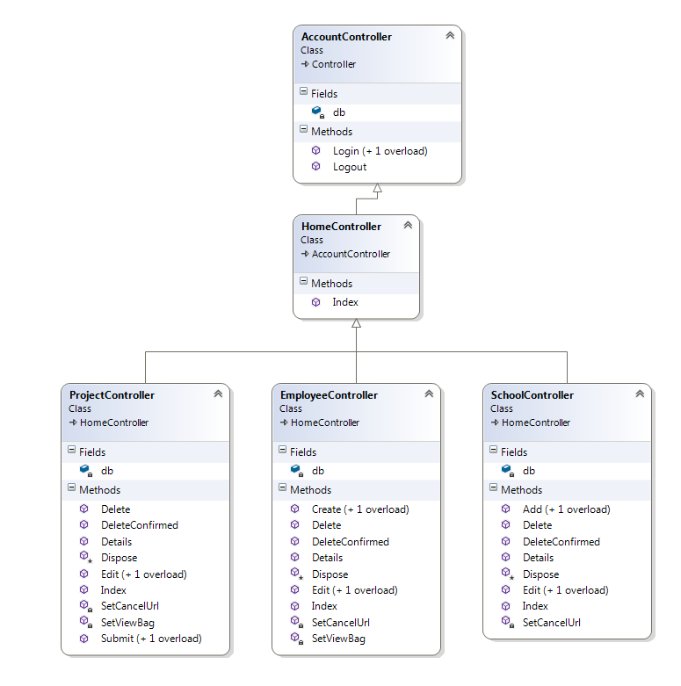

Process View

TBD (To Be Determined)

Development View

TBD (To Be Determined)

Physical View
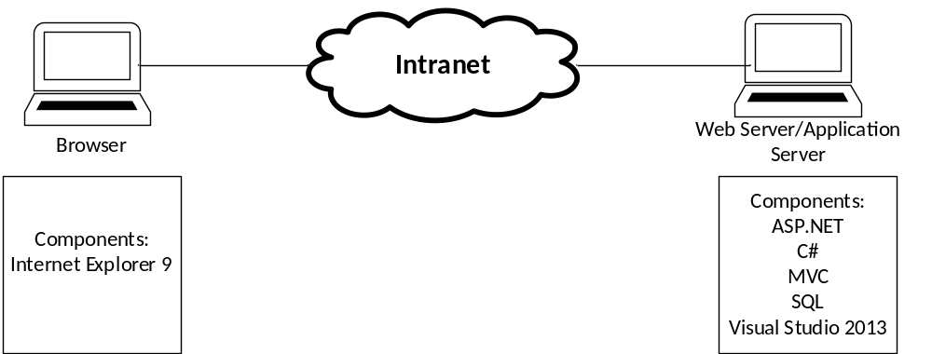

- Web application will be stored on Commerce Bank’s Web/Application server.

Use Case View

