Software Project Management Plan

Team: Infinite Loop
October 17, 2014

Team Members
Joseph Ranney
Michael Rudner
Seiji Suenaga
Matthew Sunderland
Sarah Withee
Document Control

Change History
Revision | Change Date | Description of changes
V1.0 | 10/17/2014 | Initial release

Document Storage
This document is stored in our project’s GitHub repository at:
https://github.com/cs451/Fall2014Team5

Document Owner
Michael Rudner and Matthew Sunderland are responsible for developing and maintaining this document.
Table of Contents
1 Overview 1
1.1 Purpose and Scope 1
1.2 Goals and Objectives 1
1.3 Project Deliverables 2
1.4 Assumptions and Constraints 2
1.4.1 Assumptions: 2
1.4.2 Constraints: 2
1.5 Schedule and Budget Summary 3
1.5.1 Schedule Summary 3
1.5.2 Budget Summary 3
1.6 Success Criteria 3
1.7 Definitions 4
2 Startup Plan 4
2.1 Team Organization 4
2.2 Project Communications 5
2.3 Technical Process 5
2.4 Tools 5
3 Work Plan 6
3.1 Activities and Tasks 6
3.2 Release Plan 6
3.2.1 Plan by Feature 6
3.2.2 Flow Chart Showing Iterative Process 8
3.3 Iteration Plans 8
3.4 Budget 8
4 Control Plan 9
4.1 Monitoring and Control 9
4.2 Configuration Management Plan 10
5 Supporting Process Plans 11
5.1 Risk Management Plan 11
5.2 Verification and Validation Plan 11
5.3 Product Acceptance Plan 11

Overview

Purpose and Scope

Commerce Bank provides project ideas for students at nearby universities. This gives students real-life experience and helps Commerce Bank find local talent. Currently, these projects are being distributed by word of mouth. Our purpose is to provide a more automated approach to connect universities with these ideas.

Team Infinite Loop will provide a web application where Commerce Bank employees can easily find, edit, add, remove, and assign projects. This will help streamline the process by providing a centralized location to find this information.

Goals and Objectives

Project goals:

- Meet all customer requirements
- Provide a web application that is simple and intuitive
- Offer a web application that helps minimize labor and facility cost
- As a student, have a better understanding of how to create a web application

Project objectives:

- Provide employees with a more automated approach to find project ideas. This objective will meet all requirements stated in the Software Requirements Specification (SRS) document.
- Evaluate and understand the tools/technologies needed to create our web application. The tools/technologies we need to understand:

    - Visual Studio
    - C#
    - MVC
    - ASP.NET
    - SQL
    - HTML
    - CSS

Project Deliverables

Team Infinite Loop will provide a working web application, which is compliant with our SRS document. We will deliver all of the software and documentation associated with this product to the client no later than December 10, 2014. The following items will be delivered to the customer:

- Working web application
- User’s Guide
- Project Charter
- Software Project Management Plan
- Software Requirements Plan
- Testing Reports
- Iteration Reports

Assumptions and Constraints

Assumptions:

- Team will work together to complete the project
- The security framework will be provided by Commerce Bank
- The client and professor will respond in a timely manner to all questions from our team

Constraints:

- Web Application must be compatible with Internet Explorer 9 and above
- The technologies needed are ASP.NET, C#, MVC, SQL
- The software must be ready by December 10, 2014.

Schedule and Budget Summary

Schedule Summary

Gantt chart:

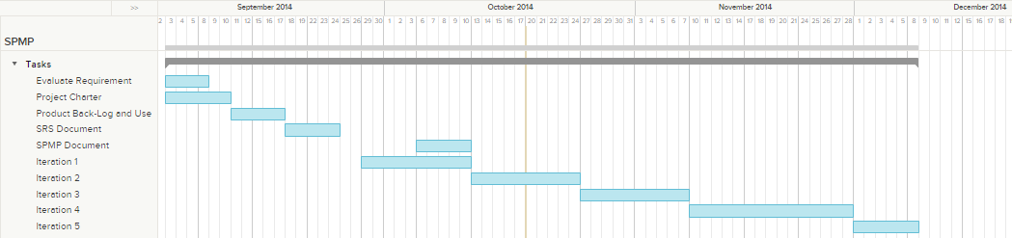

Budget Summary

Work is being performed pro bono in exchange for experience unless deemed useful to the client. Pay is contingent on customer satisfaction with final project.

Quantity | Job Title | Hours Worked per Week | Duration of Project | Total Hours Worked
1 | Project Manager | 4 | 14 weeks | 56
1 | System Architect | 4 | 14 weeks | 56
2 | Software Engineer | 4 | 14 weeks | 112

Estimated Work Total: 224 hours

Success Criteria

- Group members feel that they have gained experience that could be utilized in similar projects either academically or professionally
- All requirement are met on schedule and customer is satisfied with final project
- All high-priority use cases in the requirements specification are delivered before December 8, 2014.

Definitions

Term | Definition
User | A person that uses the application.
Gantt Chart | It is a type of bar chart that illustrates a project schedule.
Actor | User or other software system that receives value from a use case.
Project | Activities that will lead to the production of the product described here. Project issues are described in a separate project plan.
Use Case | Describes a goal-oriented interaction between the system and an actor. A use case may define several variants called scenarios that result in different paths through the use case and usually different outcomes.
Analysis Paralysis | The state of over-analyzing (or over-thinking) a situation so that a decision or action is never taken

Startup Plan

Team Organization

Role | Actor(s) | Responsibility
Project Manager | Sarah Withee | Organize team meetings, assigns tasks, resolve in-team issues, and coordinate communication within the group.
Developers | Joseph Ranney, Michael Rudner, Seiji Suenaga, Matthew Sunderland, Sarah Withee | Develop software based on SRS document.
Testers | Joseph Ranney, Michael Rudner, Seiji Suenaga, Matthew Sunderland, Sarah Withee | Perform unit testing and report issues.
Requirements Engineers | Michael Rudner, Matthew Sunderland | Outline and document project needs and requirements.
Architects | Sarah Withee, Seiji Suenaga | Specify overall internal workings of application.
Database Designer | Joseph Ranney | Design/Create database

Project Communications

Event | Information | Audience | Format | Frequency
Team Meeting | Task status, planning, obstacles, discuss current or next iteration | All Team members | 60 minutes | As needed
Project Status Report | Review finished items, status of prototype, review any problems, programming issues | All team members, customer | E-mail with information or In-person as customer sees fit | Iteration Closeout
Informal Communication | Issues, ideas, status, troubleshooting | All team members | E-mail, Trello, Google Hangouts | As needed

Technical Process

We will be using Scrum, which is an agile methodology, due to its simplicity and flexibility. By using this methodology, we will emphasize feedback, team self-management, and strive to build tested product increments within short iterations.

Tools
- Programming Languages and technologies – C#, ASP.Net, MVC, HTML, CSS, JavaScript, Razor, SQL
- Version Control – GitHub
- Project Organizer - Trello
- IDE (Integrated Development Environment) – Visual Studio 2013

Work Plan

Activities and Tasks
The following attributes will be recorded for each task on our product backlog:
- Task name
- Task description
- Owner
- Effort estimate
- Actual effort
- Planned start
- Planned stop date
- Actual start date
- Actual stop date

Product Backlog is located on Trello. The link is https://trello.com/b/nlQXog5C/cs-451-team-infinite-loop.

Release Plan

Plan by Feature

Name: Iteration #1
Duration: 9-29-2014 to 10-12-2014
Summary: Create MVC and database. Create functionality so users can submit and view project ideas.

Features/Deliverables | Estimated Effort | Actual Effort
As a Contributor, I should be able to view a table of submitted project ideas. | 4 hours | 4~5 hours
As a Contributor, I want to be able to submit a project idea through the site. | 4 hours | 4~5 hours
S18: As a developer, we need to have a database and web server set up. | 2 hours | 2 hours

Name: Iteration #2
Duration: 10-13-2014 to 10-26-2014
Summary: Make website look nicer. Do research on how to implement log-in page.

Features/Deliverables | Estimated Effort | Actual Effort
As a User, I should be able to look at a nice looking site with a good design. | 1 hour | 1 hour
As a User, I should be able to log in to the site and get access to the parts I am allowed to use. | Not implemented in this iteration | Not implemented in this iteration

Name: Iteration #3
Duration: 10-27-2014 to 11-09-2014
Summary: TBD

Features/Deliverables | Estimated Effort | Actual Effort
TBD | TBD | TBD

Name: Iteration #4
Duration: 11-10-2014 to 12-04-2014
Summary: TBD

Features/Deliverables | Estimated Effort | Actual Effort
TBD | TBD | TBD

Name: Iteration #5
Duration: 12-1-2014 to 12-8-2014
Summary: TBD

Features/Deliverables | Estimated Effort | Actual Effort
TBD | TBD | TBD

Flow Chart Showing Iterative Process

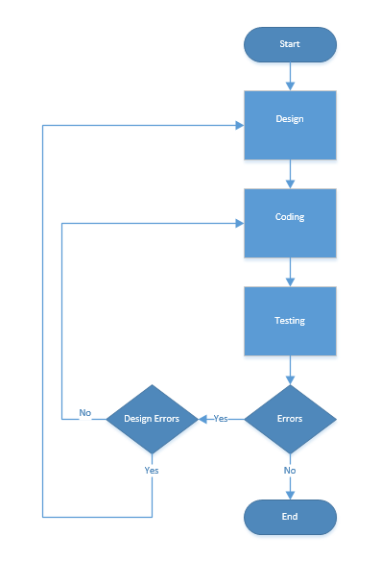

Iteration Plans

A formal iteration plan for each iteration can be found on our GitHub repository. Task details are available on Trello.

Budget

Our project is estimated to take 224 total hours in order for us to complete the web application. With the free software provided by UMKC the project has not cost us any money.

Control Plan

Monitoring and Control

The following list of dates includes formal reviews outside of the Communication Plan. Milestones are included to reference where the project is scheduled to stand as these reviews occur:

Formal Review Schedule

Date | Review / Milestone
Weekly | Team meetings every Wednesday after class and other meetings if needed. Project participants report status, progress and potential problems.
9/3/14 | Requirements Meeting
9/10/14 | Project Charter Complete
9/22/14 | Milestone: Technical Prototype Complete
10/10/14 | Project Plan Complete
10/13/14 | Milestone: Iteration #1 Complete
10/22/14 | Manager's Briefing
10/27/14 | Milestone: Iteration #2 Complete
10/29/14 | Commerce Presentations
11/10/14 | Milestone: Iteration #3 Complete
11/12/14 | Milestone: Test Review Complete
11/19/14 | Inspection
12/1/14 | Milestone: Iteration #4 Complete
12/03/14 | User Guide and System Documentation Complete
12/8/14 | Milestone: Project Complete
12/10/14 | Final Presentations

Configuration Management Plan

The following procedure is to be used when making changes to baseline documents:

- All working projects will be stored on a GitHub repository.
- All baselined documents will have a “Document Control” section with a change history to track initialization and subsequent changes.
- All project work products (documents, source code, test cases, program data, test data, etc.) will be stored in GitHub repository but not all will be baselined and under a configuration control system.
- Items that are subject to change control will be considered baselined after a group review at the end of the initial document creation.
- The following products must go through a change control process before changes can be made:

- Software System Requirements
- Software Project Management Plan
- Source Code

- The change control procedure once a product is baselined:

- Team member or members must notify the team of any changes they are wanting to make. Either by sending an email to all team members or by scheduling a group meeting.
- After team discussion, we will have a majority team vote to see if the change will be made. You can vote in person or by email.
- If a change does take place, the initiator must collaborate with our project manager to update our schedule.

- Including a change history with all documents is encouraged but only required for baselined documents. The change history should be at the front of the work item and include:

- The name of the person making the change,
- Brief description of what has changed,
- Reason for the change, and
- The date the change was integrated.

Supporting Process Plans

Risk Management Plan

Rank | Risk | Probability of Loss | Size of Loss | Risk Exposure | Response
1 | Schedule / Time line delivery / Not meeting milestones / Analysis paralysis | Likely | Major | High | Mitigate: Stick to the schedule.
2 | Learning curve for new tools and technologies are taking longer than expected | Unlikely | Moderate | Moderate | Begin working on a basic prototype early to test out fundamental programming concepts & knowledge
3 | Focusing more on style | Unlikely | Minor | Low | Avoid: Instead of trying to make it look fancy right at the beginning, our team needs everything to function correctly and then implement style

Verification and Validation Plan

The Verification and Validation plan will be available as a separate document. It will be located and maintained accordingly on GitHub:

https://github.com/cs451/Fall2014Team5

Product Acceptance Plan

At the end of each milestone, the prototype created will be tested by a teammate(s) that wasn’t involved in the development. The tester(s) will “pull” the product from GitHub and run the web application from Visual Studio Ultimate 2013. This may result in additional requests for change and improvement.

Details about change plan are given in section 4.2.

