**Lab 05**

**Josh Bussis**

**Engr 220L - A**

**10/09/2019**

**Part 1:**

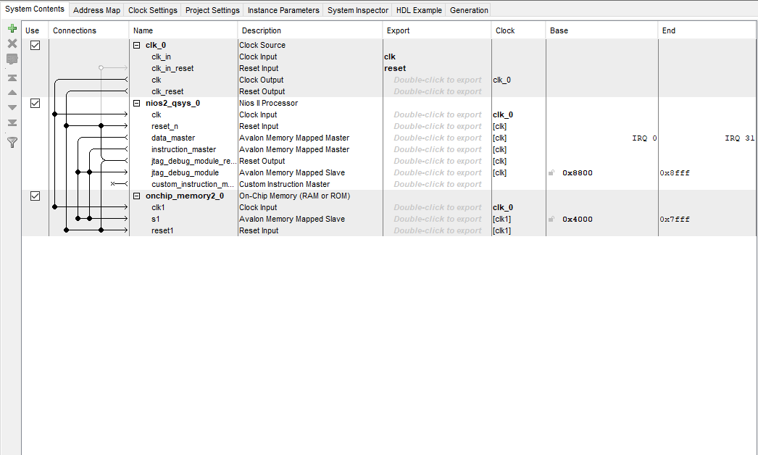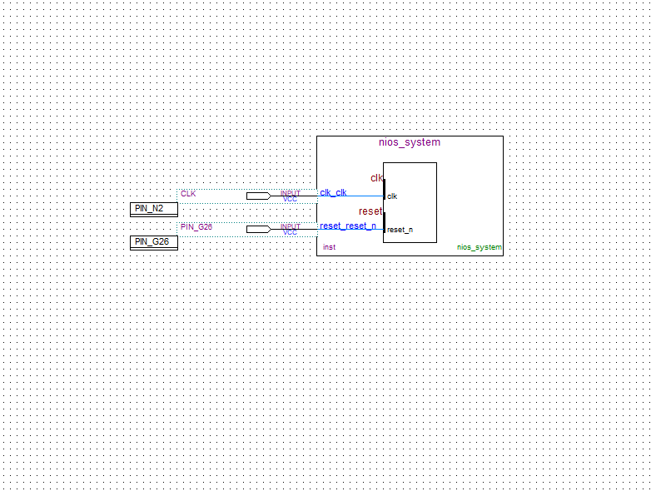

**Part 2:**

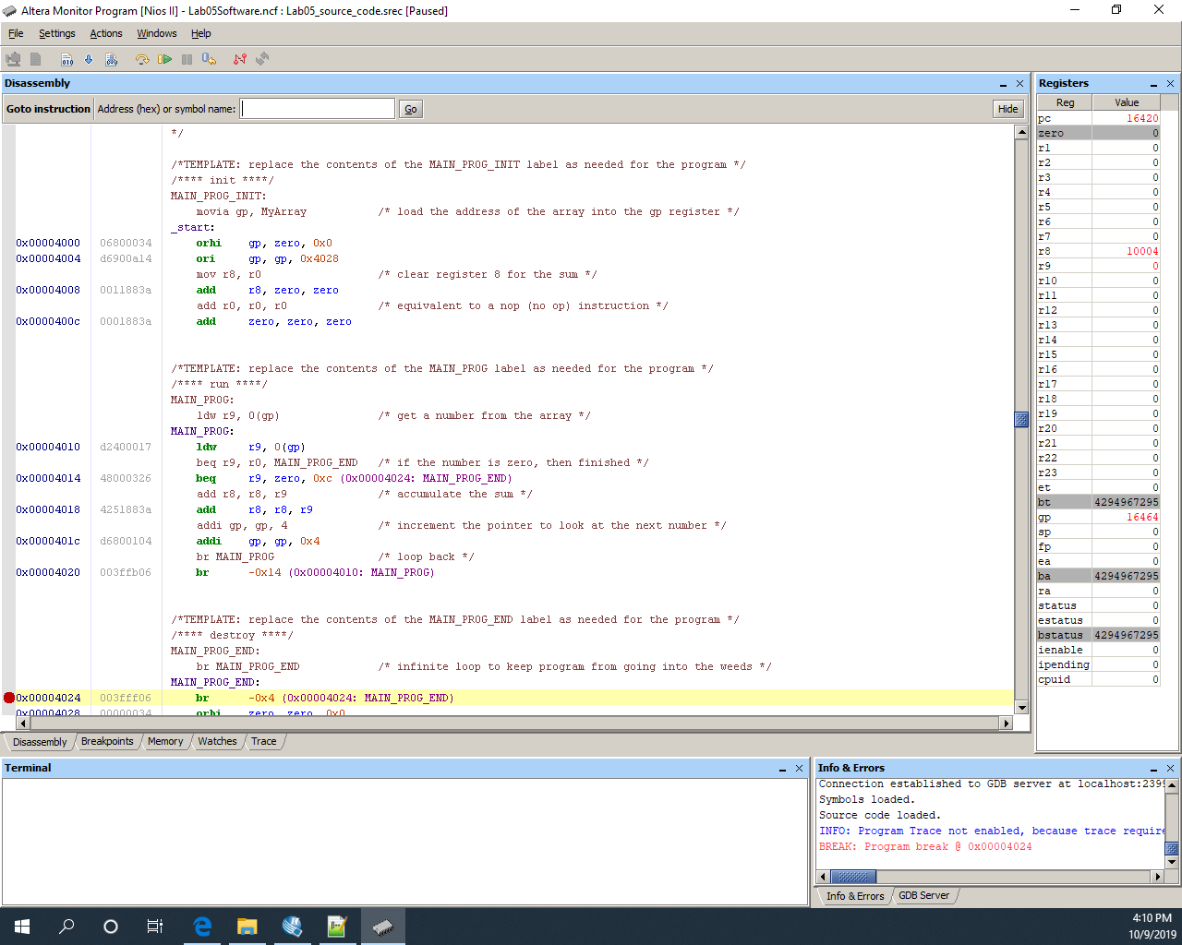

**Movia explanation:**  The movia command was broken down to two different basic functions. The first function, orhi, shifted the address found at 0x0 16 bits left into the gp register, giving a starting point for the program. Then, the ori, added the contents (through “or-ing” the contents with zeros) of 0x4028 to the address in the gp register, thus giving the address for the array to the pointer.

|  |  |  |
| --- | --- | --- |
| **Register Name** | **How used in the program** | **Final Value** |
| r8 | Stored the sum of the array items | 10004 |
| r9 | Stored the current item of the array | 0 |
| PC | Program Counter: held the address of the current instruction | 16420 |
| gp | Pointer for the array | 16464 |

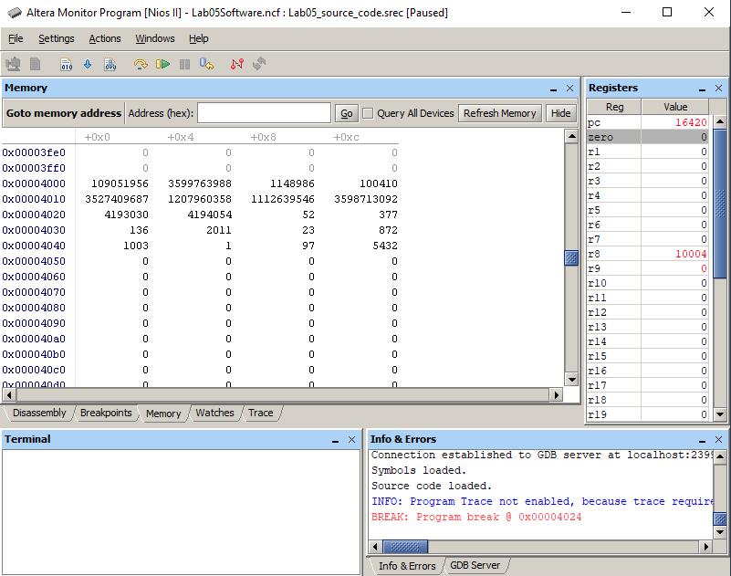

**Explanation:**  This window shows the contents of RAM around the memory value of 0x4000. The values originally stored in the array can clearly be seen starting at memory location 0x4020, offset 0x8. From this point on, until the first zero value, are the values of the array. The values before this point were probably the values of the instructions for the program to execute or other memory locations used to store data.