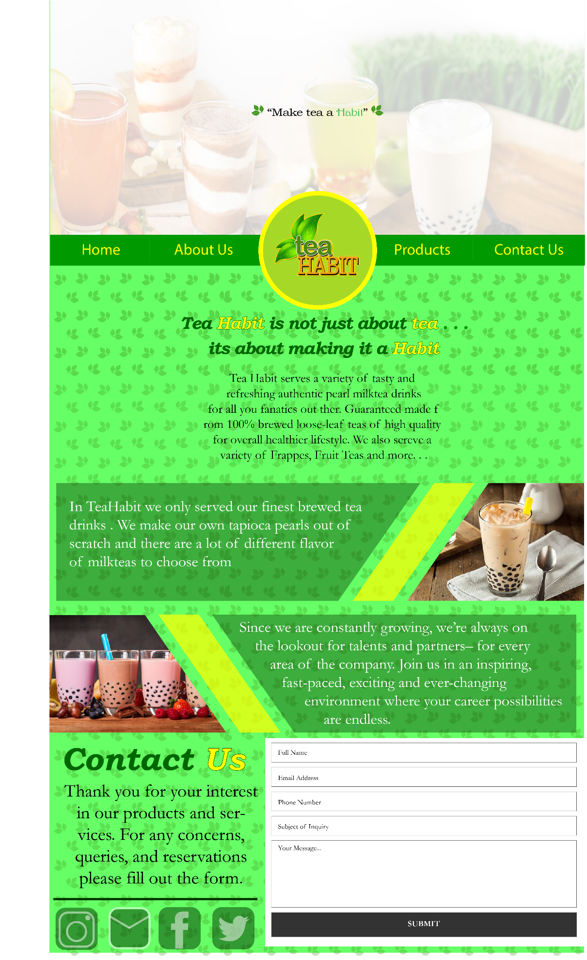

**Marc Joshua G. Carigma BSIT 301**

This is my website design for a Milk tea shop, the uppermost part of the website where there is a picture with a quote in the middle is the home page, right below the home page is the about us page where there is a short description as to how the shop operates and what they can give you, right below the about us page is the products page this is where the shop showcases their products to the customer by showing them the pictures of their products, lastly the bottom part of the website is the contact us page where the customer is presented with the shops Instagram account, Gmail account, Facebook account, and twitter account, the user is also given the chance to voice out their opinions and concerns for the shop which is why the website provided a small form for the user to use.

What I had in mind when I designed this website was everything is on the same page, when you clicked on home it will automatically scroll the website upwards to the home page, when you click on the products button the website will automatically scroll to the products page and so on. I decided to do this because it is easier to access and navigate the website thus applying the HCI principle **Reduce Memory Load** and **Know the user**, know the user also applies to the website because most of the users that will navigate through the website are users that are looking for trendy, affordable and good milk tea shops. **Strive for Consistency Principle** can also be applied to the website design because the font, font colors, and colors of the website are all the same and are used throughout the website.