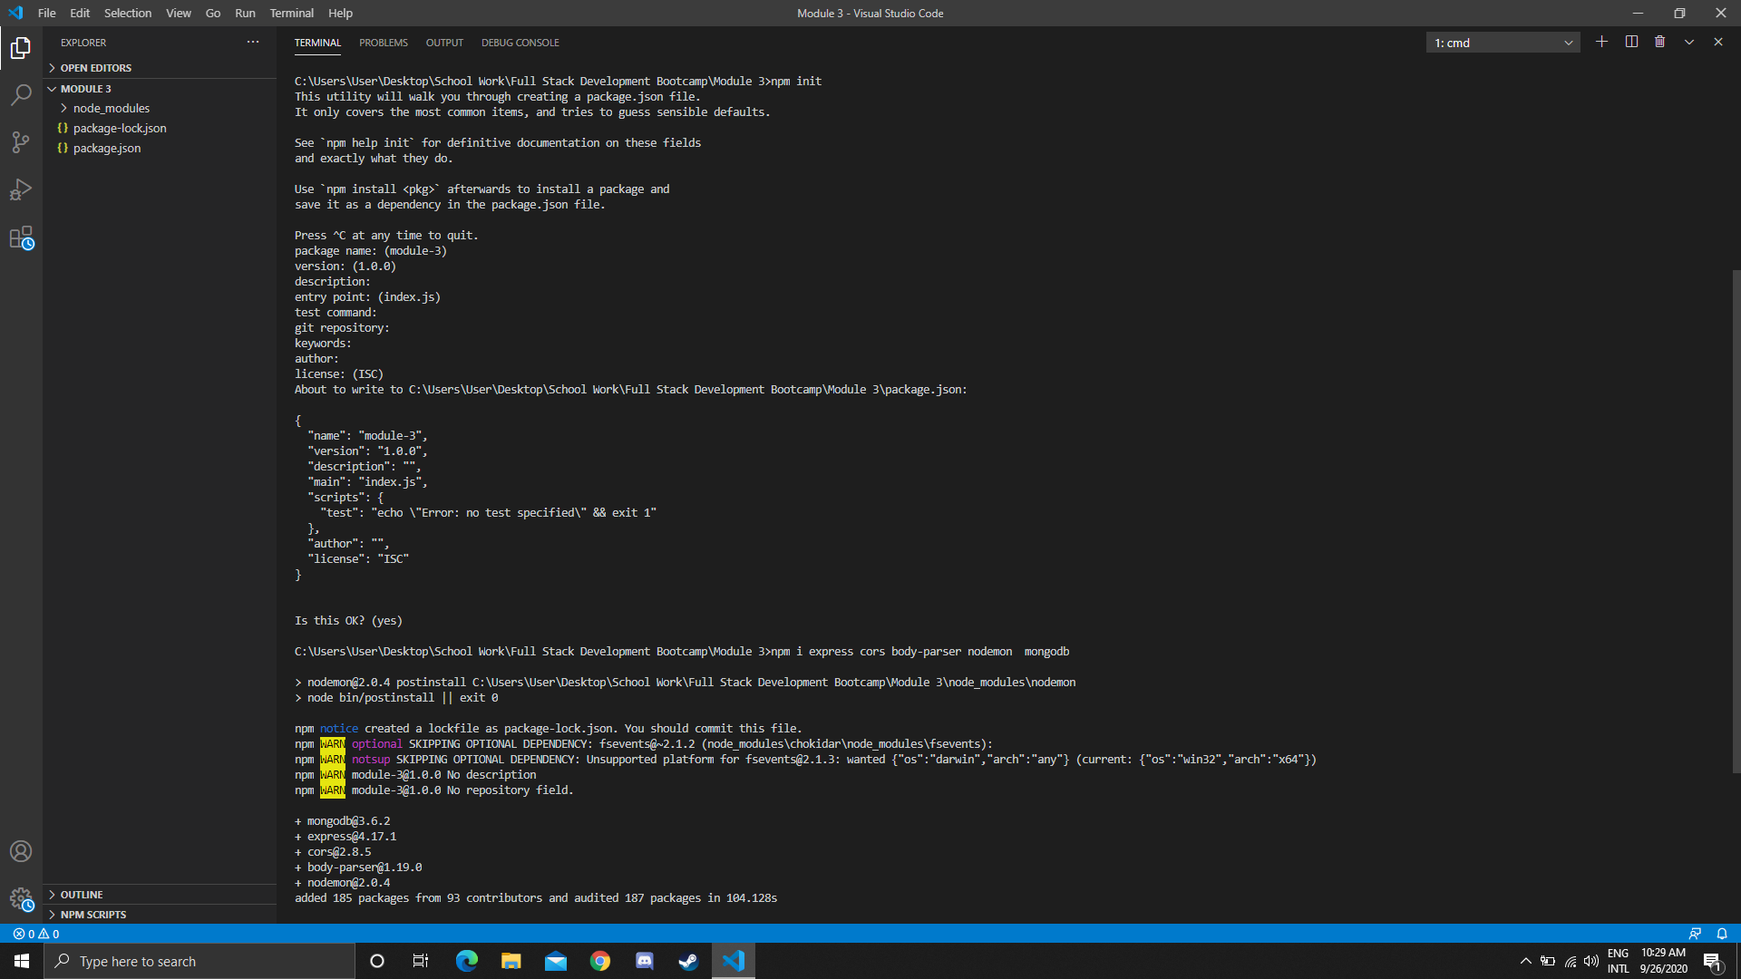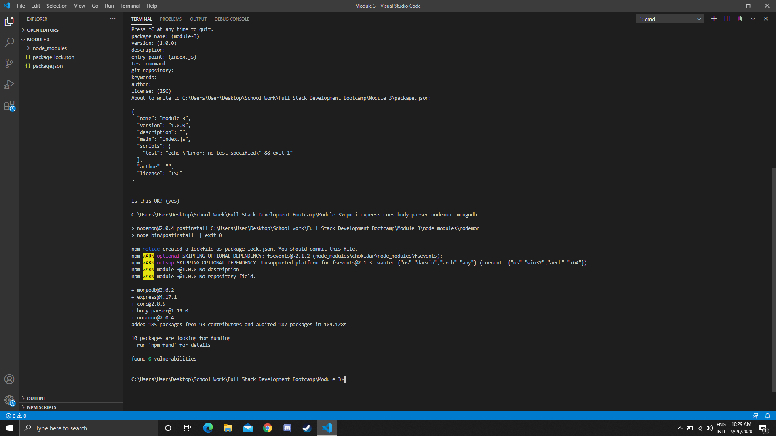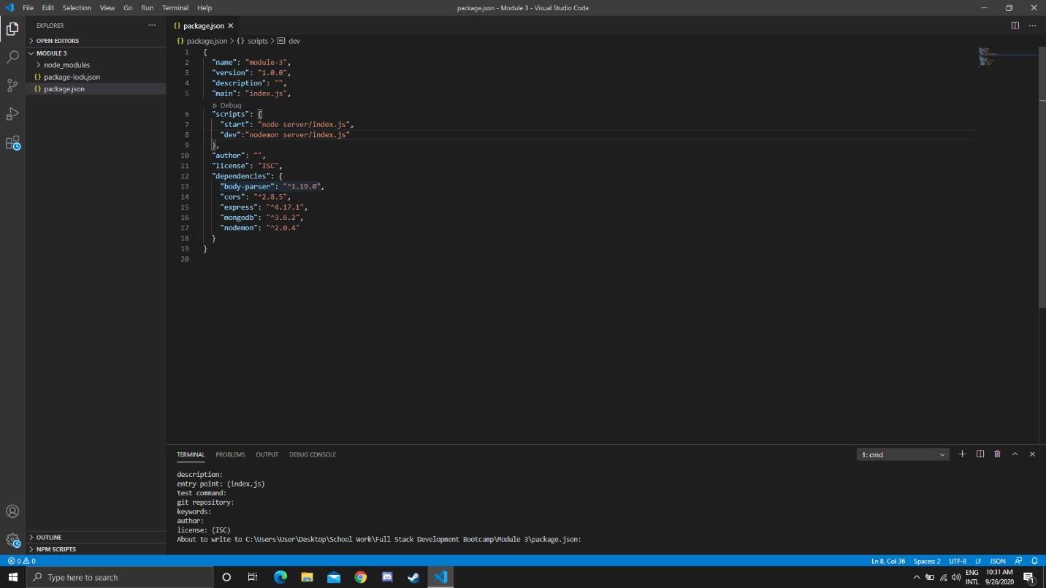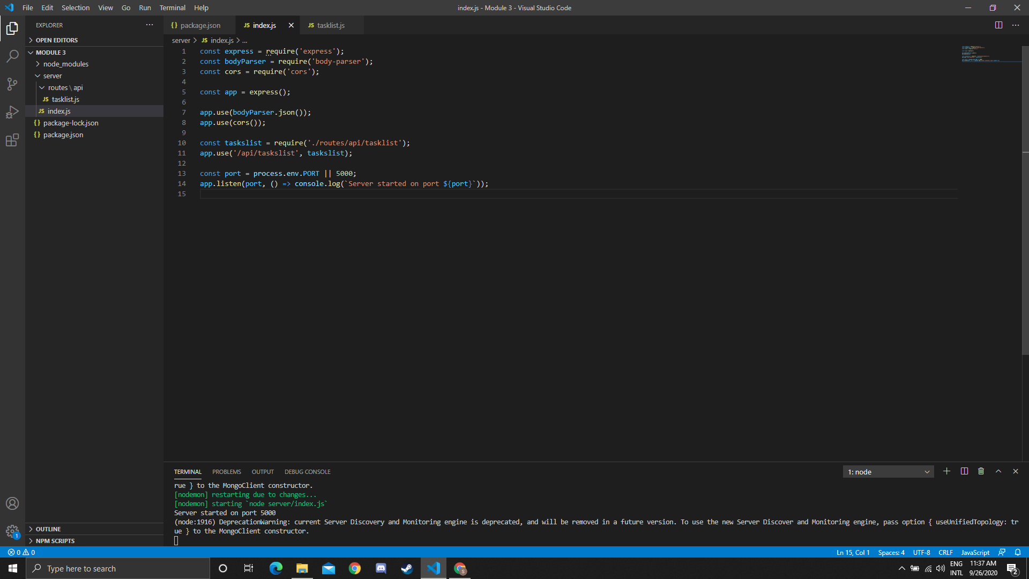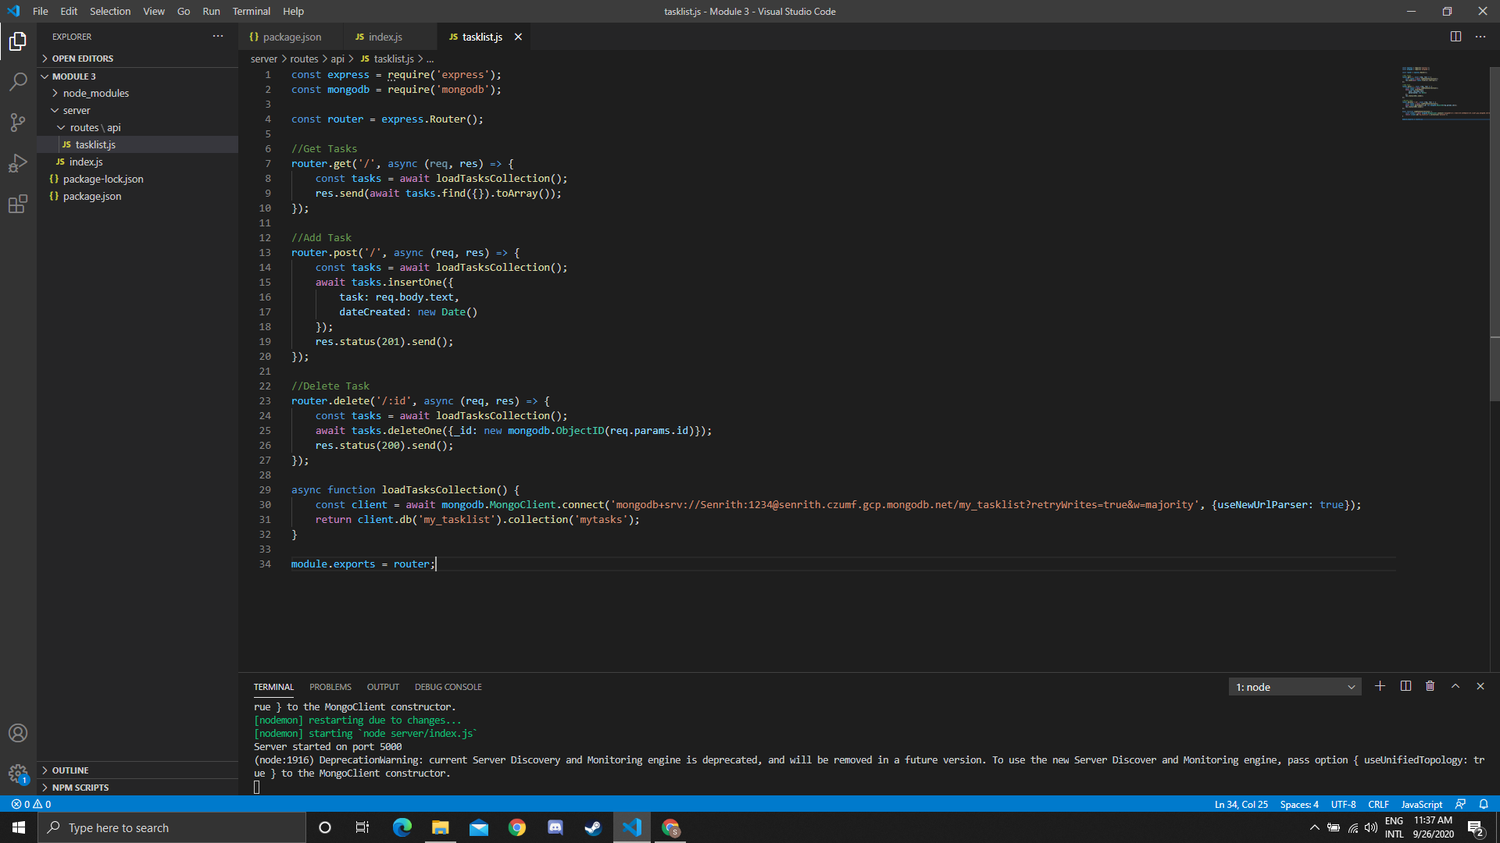

Use case of dependencies:

* Express: a web application framework for Node js to make web application development easier. In the app we use Express for listening to port, do CRUD operation and routing.
* Cors: allow to make request from another domain. In the app, Cors will make the api public which can use from anywhere.
* Body-parser: allow Express to read the data and turn it into JSON object so we can understand. In the app we use body-parser to read data and turn it to JSON.
* Nodemon: automatically restart the application when changes are made. In the app, when ever we make a change, the server automatically restarts.
* Mongodb: use to connect to the database. In the app, we use this dependency to connect to Atlas mongodb database.

Middle ware: software that handle communication between components. For example, the body-parser is the middle ware for Express. It handles the data and parse it to Express.