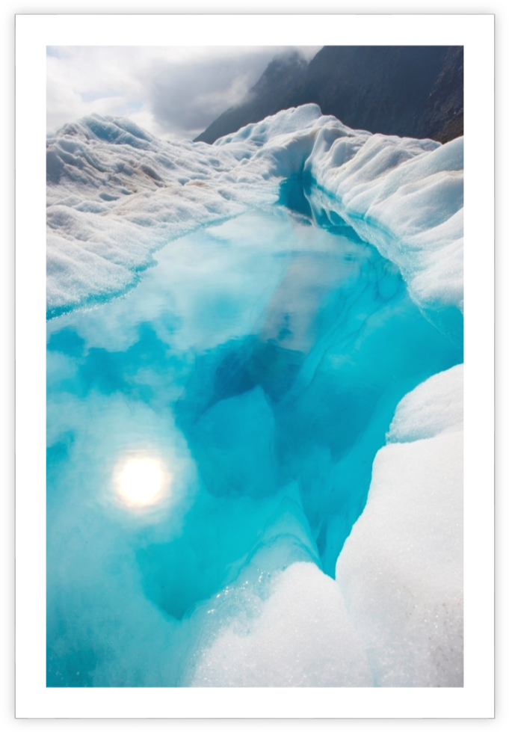
John Doe | Sense/Net | January 1, 2014
Student Report
Student report

Get Started Right Away
When you click this placeholder text, just start typing to replace it all. But don’t do that just yet!
This placeholder includes tips to help you quickly format your report and add other elements, such as a chart, diagram, or table of contents. You might be amazed at how easy it is.

Make It Gorgeous
- Need a heading? On the Home tab, in the Styles gallery, just click the heading style you want. Notice other styles in that gallery as well, such as for a quote or a numbered list.
- You might like the cool, blue ice pond on the cover page as much as we do, but if it’s not ideal for your report, right-click it and then click Change Picture to add your own photo.
- Adding a professional-quality graphic is a snap. In fact, when you add a chart or a SmartArt diagram from the Insert tab, it automatically matches the look of your document.


Give It That Finishing Touch
Need to add a table of contents or a bibliography? No sweat.

Add a Table of Contents
It couldn’t be easier to add a table of contents to your report. On the Insert tab, click Cover Page to see cover page designs that include a table of contents page — look for TOC.
Just click to insert one of these and you’ll be prompted to update the TOC. When you do, text you formatted using Heading 1, Heading 2, and Heading 3 styles is automatically added.

Add a Bibliography
On the References tab, in the Citations & Bibliography group, click Insert Citation for the option to add sources and then place citations in the document.
When you’ve added all the citations you need for your report, on the References tab, click Bibliography to insert a formatted bibliography in your choice of styles.
And you’re done. Nice work!

