Esquema:

<https://www.raspberrypi.org/documentation/hardware/raspberrypi/schematics/rpi_SCH_3b_1p2_reduced.pdf>

Layout raspberry pi 3 b:

<https://www.raspberrypi.org/documentation/hardware/raspberrypi/mechanical/rpi_MECH_3b_1p2.pdf>

layout:

<https://www.hackster.io/the-swiftpi-team/swift-3-0-for-raspberry-pi-gpio-getting-started-393dd4>

relatório 5

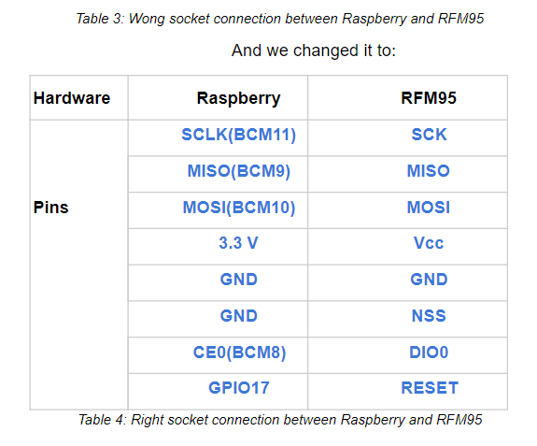

[https://pinout.xyz/#](https://pinout.xyz/?fbclid=IwAR1Fra2CnkkR4mZfPsXOZGjZr1LnaXK4I74MD3BJPUszOUeVSf1tEJ4GH6o)