**PYFOOD**

Contents

**Introduction**: 1

**Main Menu (Common Responsibility):** 2

**Registration Module (Trainee 1):** 2

**Search Restaurant (Trainee 2):** 4

**Item Search Module (Trainee 3):** 5

**Billing Module (Trainee 4):** 7

**Display Details (Common Module):** 8

**Introduction**:

*PyFood* is an application which serves food for customer who has requested for food service.

*PyFood* is a menu based system where the user can choose an option by entering an appropriate menu number.

The overall flow of the system is as follows:

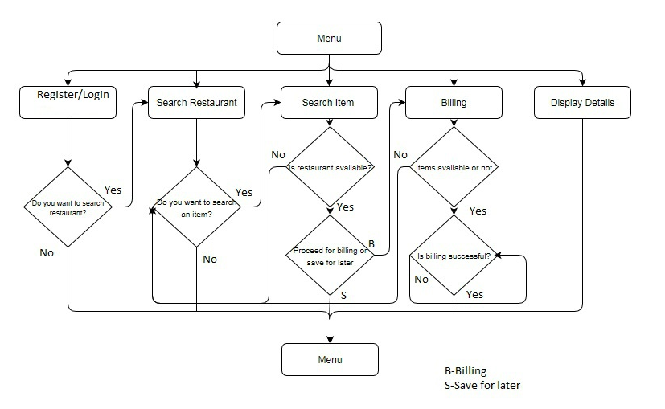

**Main Menu (Comm****on Responsibility):**

On starting the app, a main menu like below will be displayed to the user.

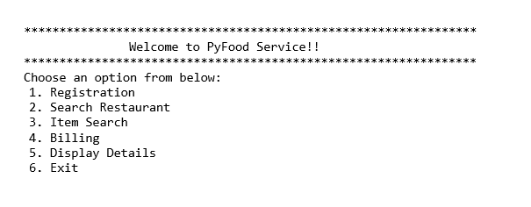

If the user enters an invalid option, display an appropriate error message and display the menu again. If the user enters a valid option, invoke the appropriate module. On selecting EXIT, display a thank you message and quit the system.

**Registration Module (T****rainee 1):**

This module will have three options: login as guest user, login as registered user, and a new registration

**Guest user:**

If the user is a guest user and orders for food services he/she will not be eligible for discounts. It will redirect the user to search for restaurant module. Please find below the execution:

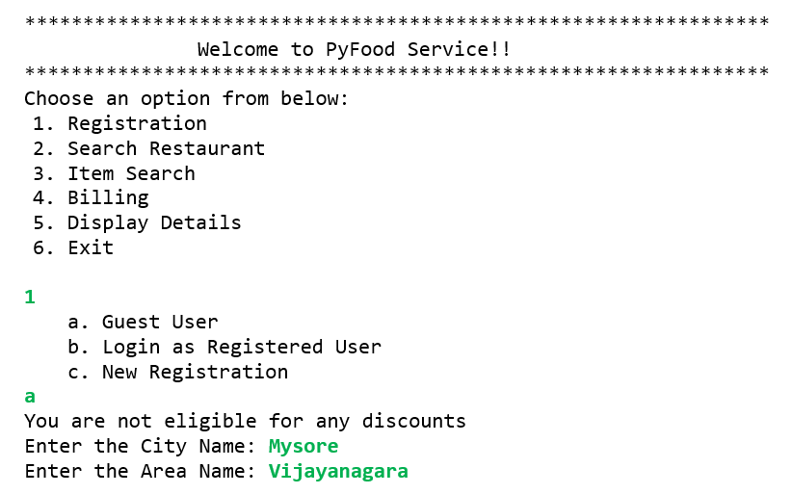

**Login as registered user:**

upon providing the correct login credentials, user will be redirected to search for restaurant module. If the user enters wrong password during login, he/she will be asked to answer the secret question and if it matches then the user can create new password and it should not be an already existing password after which the user can login using new credentials. Please find below the execution:

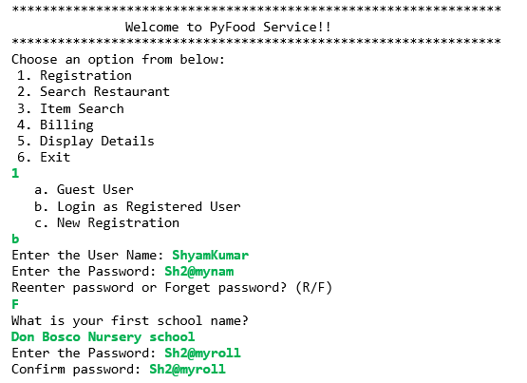

**New registration:**

If a user requests for registration he/she has to provide all the details like user name, mobile number, password, email id, secret question with answer, address details etc. The password must be a combination of alphabets, digits and special characters, if the password does not match the required criteria, the application shall ask the user to reenter the password.

if the user name already exists it should display an error message and ask for user name again. Please find below the execution:

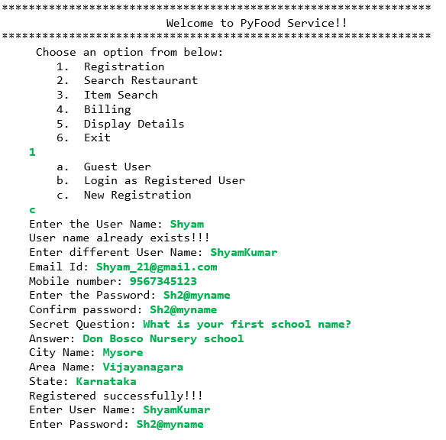

**Search Restaurant (Tr****ainee 2):**

If the user is redirected from guest user from the registration module or from the main menu, the user has to provide city and area details after which the application should display available restaurants in that area along with the type of food available in that restaurant, ratings, total likes and dislikes. If the user comes from the main menu, please find below the execution:

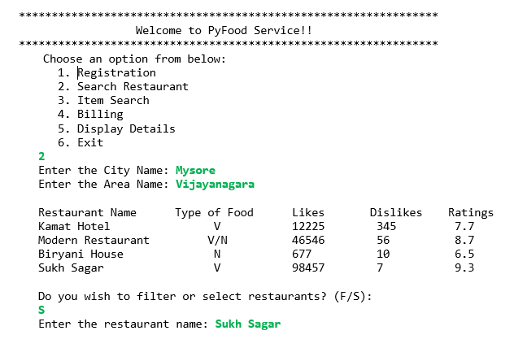

If the user comes from guest user login, please find below execution:

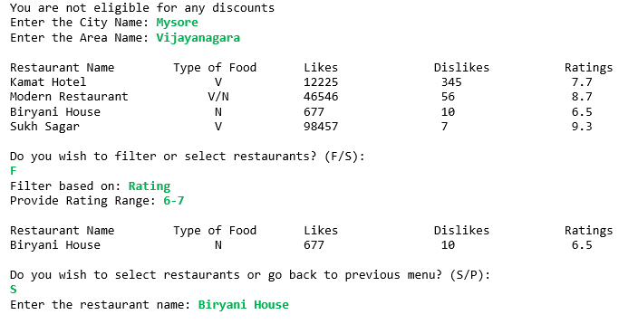

If the user is redirected from login as a registered user or from new registration option from registration module then it should display the restaurants available in that user’s area along with the type of food available in that restaurant, ratings, total likes and dislikes. Please find below the execution:

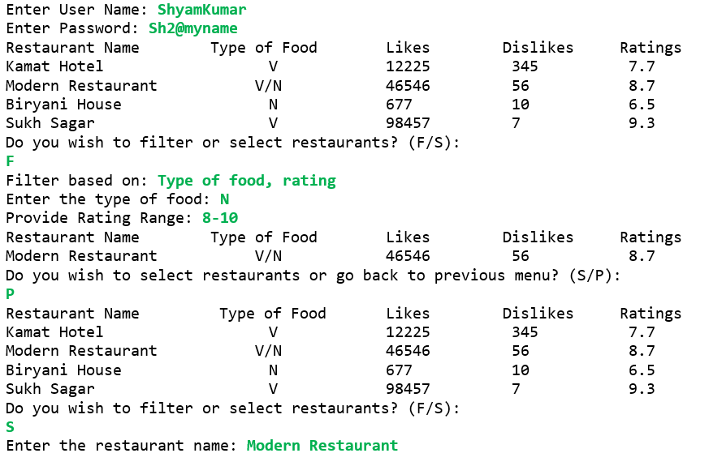

The application should ask the user, whether to filter the restaurants based on rating, type of food etc. to choose a restaurant.

If the user wants to filter the restaurant based on more than one category, it has to be separated by comma.

If the user chooses a particular restaurant, the application should redirect the user to the item search module.

**Item** **Search Module (Trainee 3):**

If the user chooses Item Search from the main menu, the application should ask the user to first choose a restaurant and only then proceed with item search.

This module shall display category of items available in a particular restaurant and if the user chooses a particular category, it should display a list of food items available in that particular category along with availability status and price per quantity. After which It should prompt the user to choose the items and quantity.

If the user wants to choose more than one item, each item has to be separated with commas.

The item and quantity will then be added to the cart. Use appropriate data structure to implement the cart.

Once the items are sent to cart the application shall ask the user to proceed with billing or to remove a selected item. If the user selects proceed with billing option, the application shall redirect to billing module and if the user wants to remove an item it shall ask for the items to be removed. Please find below the execution for cancellation and saving the item for later purchase:

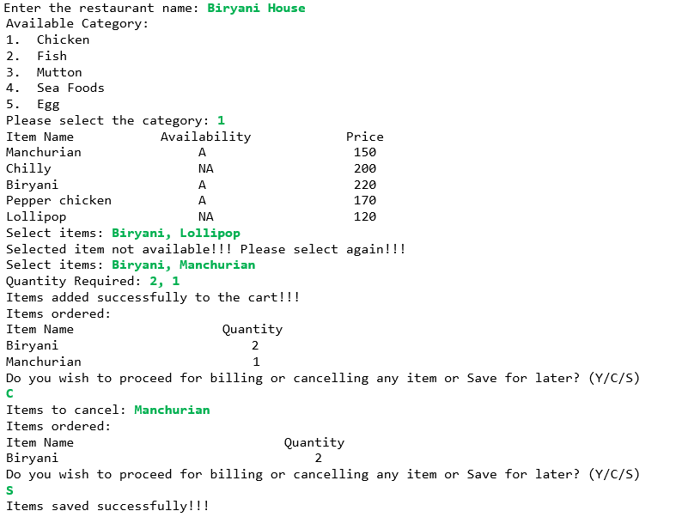

Please find below the execution for redirecting to billing module:

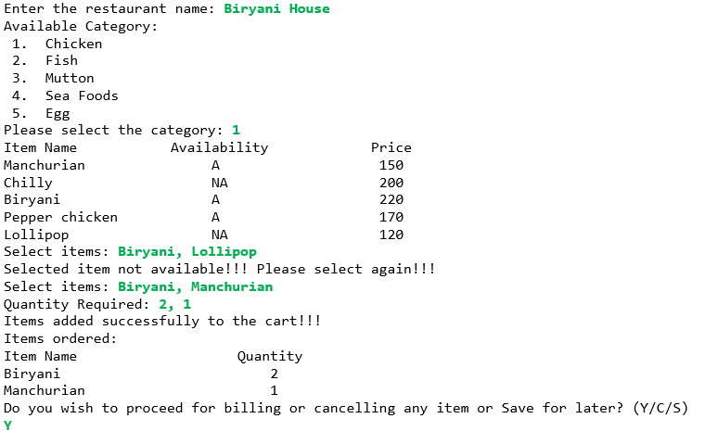

**Billing Modu****le (Trainee 4):**

If the user choses this option from main menu, the application should check for the items. if there are no items in the cart then it shall show an error message and go to the main menu. Please find below the execution if the user doesn’t have any item in the cart:

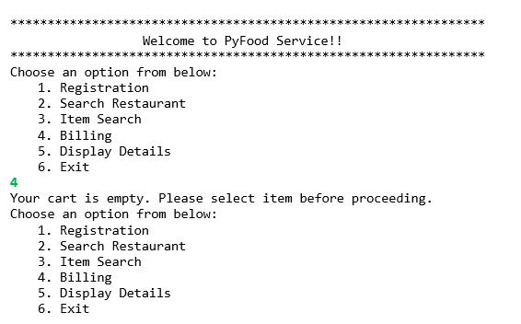

Please find below the execution if the user has item(s) in the cart:

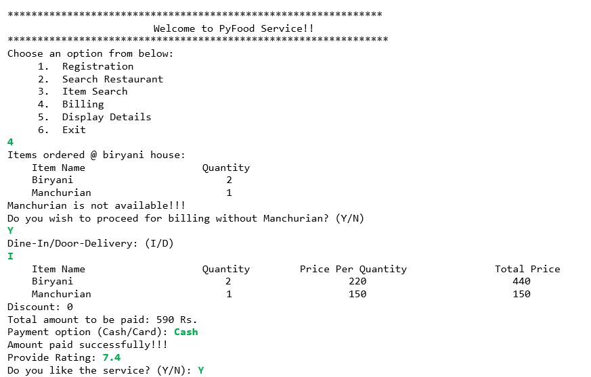

The application shall calculate the bill amount for each item in the cart.

If the user is a registered user, then a discount of 5% is applicable on billing amount.

Orders can be taken in two modes: Dine-in and Home-delivery

For Home delivery, delivery charge is applicable as per the restaurant tariff.

Bill can be paid in two ways either through cash or through debit card.

After successful payment, it shall display a success message and shall ask for user ratings and like or dislike and update it.

Please find below the execution:

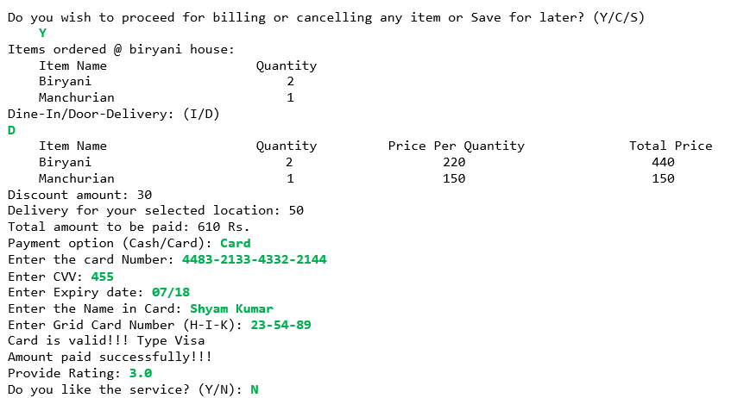

**Display Details (Common Module):**

This module will have 3 options: Display most rated hotel, Display the customer details, Display city wise hotel details.

**Display most rated hotel:**

If the user chooses this option, then it shall display the 5 topmost rated hotel details. Use appropriate data structure to implement this. Please find below the execution:

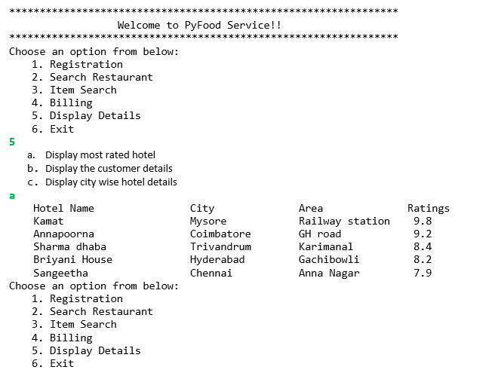

**Display the customer details:**

It will display the customer details who has ordered maximum number of food services. Please find below the execution:

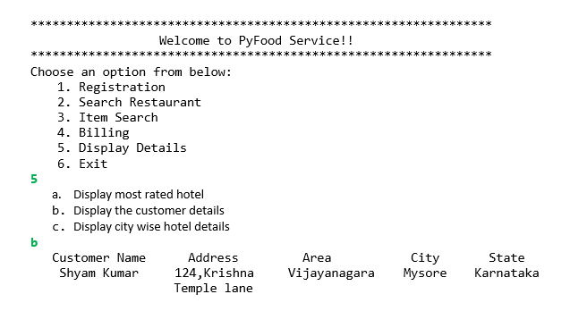

**Display city wise hotel details**:

It shall prompt the user to get the city after which it shall display the hotel details which is booked maximum number of times amongst its branches in the same city. Please find below the execution:

