
UNIVERSITY OF SOUTH ASIA
Department of Computer Science
FINAL YEAR PROJECT RESEARCH PROPOSAL
DocuTrust AI: A Multi-Tenant Workplace Knowledge Assistant with Bilingual RAG, Attendance Tracking, and Automated Workflow Management
Domain: Applied Artificial Intelligence / Natural Language Processing / Enterprise Information Systems
Split: Next.js Web Workspace · Django REST Backend API · Bilingual RAG & Workflow Automation Engine
Submitted by:

Saad Waseem [B-28488]
M Akmal [B-28723]
M Talha Khalid [B-28390]
BS Computer Science (2023–2027)
Supervisor: Ma’am Iqra
1. Background
Small and medium organizations in Pakistan keep most of their rules and procedures in documents such as HR policies, leave rules, expense rules, security guidelines, and handbooks. These files are spread across email, shared drives, personal computers, and paper binders. When employees need an answer, they search several files or ask HR or a colleague, which wastes time and can lead to inconsistent or outdated answers.
Routine office tasks are also handled separately. Attendance is often recorded on paper registers or biometric machines that are not linked to staff accounts, leave applications are typed, printed, and signed by hand, and meetings are arranged over chat and email. These manual steps take staff time and are hard for administrators to track.
Language adds a further problem. Official documents are usually written in English, while many staff communicate in Roman Urdu. Plain keyword search often fails to match a Roman Urdu question to the right English document, so staff who are less comfortable with formal English find it harder to get answers on their own.
Large language models can answer questions written in natural language, but on their own they do not know a company's private documents and may produce answers that sound correct but are wrong. Retrieval-Augmented Generation (RAG) reduces this problem: the system first finds the most relevant passages in the company's own documents and then asks the model to answer using only those passages, with the source files shown to the user. This creates an opportunity for a focused workplace assistant built on a company's own documents.
2. Abstract
Small and medium organizations often lack a single system to organize company documents, answer staff questions, handle routine office requests, and track attendance. This project proposes DocuTrust AI, a multi-tenant web-based workplace assistant that lets employees ask questions about their own company's documents in English or Roman Urdu and receive answers grounded in those documents, with source citations. Each company's data is kept separate, and documents can be limited to the whole company, a department, or named users. Uploaded PDF, Word, PowerPoint, text, and scanned files are converted to text, using OCR for scanned files, and split into overlapping chunks. For each question, the system ranks the chunks the user is allowed to see with a hybrid score that combines vector similarity and BM25 keyword scoring, falling back to keyword scoring alone when embeddings are unavailable, and a hosted model (Google Gemini) or a local model (Ollama) writes the answer. While answering, the assistant detects leave and meeting requests: a leave request produces a filled Word leave application for download, and a meeting request creates a Google Calendar event, when calendar access is configured, and sends email confirmations. The platform also flags messages that contain credentials or sensitive personal data, keeps an append-only audit log, and provides browser-based QR attendance with a rule that adds a strike for three or more absences in a month and freezes an account after three strikes. The system is delivered as a Next.js web workspace and a Django REST backend, and it will be evaluated through unit and integration tests, retrieval and intent-detection benchmarks, tenant-isolation tests, response-time measurement, and a small user acceptance test.
3. Introduction
Company knowledge is usually locked inside many documents that are hard to search. Employees need a quick and reliable way to get correct answers from those documents, in the language they are comfortable with, without seeing data they are not allowed to see. General chatbots cannot do this because they do not know a company's private documents and do not respect its access rules.
Retrieval-augmented generation has become a standard way to ground language model answers in a fixed set of documents. Combining dense vector search with keyword scoring such as BM25 is a common way to make retrieval more reliable, because vector search handles meaning and paraphrase while keyword scoring handles exact terms such as policy names and numbers. Roman Urdu questions against English documents are a harder case that is worth measuring.
DocuTrust AI applies these methods inside a multi-tenant platform and adds three practical office features: chat-driven leave applications, chat-driven meeting scheduling, and browser-based QR attendance. The project does not train a new language model; it uses pretrained models through an API or a local runtime, and the engineering effort goes into permission-aware retrieval, correct handling of actionable requests, and safe separation of company data.
The remainder of this document defines the problem, states the research questions and objectives, and presents the methodology covering the system design, evaluation data, document processing, retrieval, workflow automation, attendance, and the web workspace, followed by a COCOMO-based cost and effort estimate, the testing strategy, the expected results, and the project schedule.
4. Problem Statement
Small and medium organizations in Pakistan lack a simple tool that answers staff questions from the organization's own documents with traceable sources, works for questions written in Roman Urdu as well as English, keeps each organization's data and restricted documents private, and handles routine tasks such as attendance, leave applications, and meeting requests from the same place. General chatbots do not know private company documents and may give made-up answers, keyword search performs poorly on Roman Urdu, and attendance and leave processes are often manual and disconnected from staff accounts.
5. Research Questions
- RQ1: Can a hybrid search that combines vector embeddings with BM25 keyword scoring find the correct document passages for questions written in Roman Urdu against English company documents?
- RQ2: How accurately can leave and meeting requests be detected and their details extracted from informal English and Roman Urdu chat messages using prompt design alone?
- RQ3: Can a browser-based QR check-in track monthly absences and apply a strike rule correctly without special hardware?
- RQ4: How effectively do company separation and document permission rules prevent users from retrieving documents they are not allowed to see?
- RQ5: What is the response-time and answer-quality trade-off between a local model (Ollama) and a hosted model (Gemini) for this workload?
6. Research Objectives
- To build a document pipeline for PDF, DOCX, PPTX, TXT, and scanned files (with OCR) and a hybrid RAG pipeline that combines dense embeddings with BM25 keyword scoring to return cited answers in English or Roman Urdu.
- To implement chat-driven workflows that detect leave and meeting requests, generate a filled leave application (.docx) for download, and create calendar events with email confirmations.
- To implement browser-based QR attendance with business-day absence calculation and an automated 3-strike account-freeze rule.
- To enforce multi-tenant isolation with company-wide, department, and named-user document access, role-based access control (admin, employee, viewer), message moderation, and an append-only audit log in a Next.js web workspace.
- To evaluate the system through unit and integration tests, retrieval and intent-detection benchmarks, tenant-isolation tests, a local versus hosted model response-time comparison, and a small user acceptance test.
7. Implementation / Methodology
7.1 Development Methodology
The project follows an Agile/Scrum process organized into two-week sprints over a 28-week timeline, run in parallel across three workstreams: (1) the Next.js web workspace, (2) the Django backend and database, and (3) the AI pipeline and workflow automation. A shared API contract is agreed early so that the frontend and backend can be developed in parallel, and each sprint ends with a working increment reviewed with the supervisor.
Process Model Selection. Agile/Scrum is adopted because the AI parts of the system, such as retrieval quality and intent detection, cannot be fully specified upfront and need repeated testing and adjustment. Two-week sprints give fast feedback on each prompt and retrieval change, and the backlog can be re-prioritized when evaluation shows which question types or request types are hardest to handle.
Standard Scrum practices (sprint planning, weekly stand-ups, sprint review and retrospective) are applied across the three workstreams, which makes this model suitable for a multi-component Final Year Project with a research element in retrieval and intent detection.
7.2 System Architecture
DocuTrust AI follows a three-tier architecture. The presentation tier is a Next.js web workspace for employees (chat, documents, attendance) and administrators (members, departments, audit log, AI settings). The application tier is a Django REST API that handles JWT sign-in, roles, tenant scoping, document permissions, attendance rules, moderation, and the audit log, together with the retrieval engine and the workflow layer. The data tier is a relational database (PostgreSQL, or SQLite in development), file storage for uploads and generated documents, an SMTP mail server, the Google Calendar API, and the language model provider (Gemini or Ollama). A question follows this path: the user sends a question; the API checks the token and loads the user's company and permissions; the retrieval engine ranks only the chunks the user may see; the top chunks, the question, and today's date are sent to the language model; the answer streams back while a hidden intent block is removed; and if a leave or meeting request was detected, the workflow layer runs the action and returns its result.

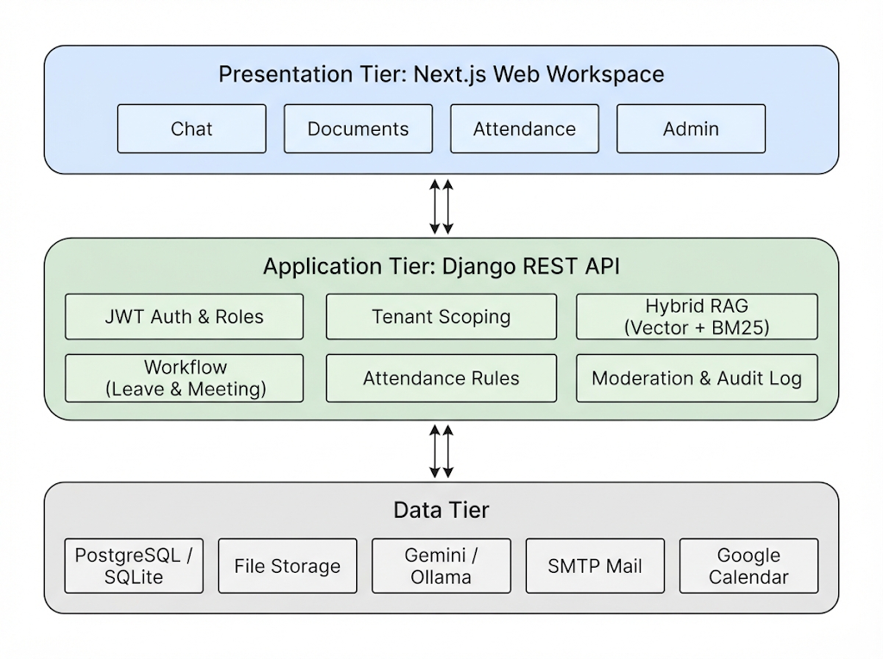
7.3 Evaluation Data Collection
The project does not need a training dataset because it uses pretrained language models. Instead, an evaluation set is prepared by the team: (1) 30 to 50 sample company documents in PDF, DOCX, PPTX, TXT, and scanned form; (2) 100 to 150 question and answer pairs, about half written in Roman Urdu, each linked to the passage that contains the answer; (3) 150 to 200 labelled chat messages for intent detection covering leave requests, meeting requests, and normal questions; (4) 60 to 100 messages that should or should not be flagged by moderation; and (5) 10 to 15 sample months of attendance data for the absence and strike rules. Real confidential company documents are not used without permission, and the final report will state the actual sizes and how the correct answers were labelled.

7.4 Document Processing & Chunking
- Text extraction: PDF files are read directly; PDFs with little or no text are converted to images and read with Tesseract OCR (up to 10 pages).
- Office formats: Word and PowerPoint files are read paragraph by paragraph and slide by slide; image files (PNG, JPG, TIFF, BMP, WEBP) are read with OCR.
- Chunking: text is split along paragraph lines into chunks of about 900 characters with a 150-character overlap.
- Indexing: each chunk is stored with its company and document, and with an embedding vector when the embedding provider is available.
- Background processing: indexing runs in a background thread so that the upload request returns quickly; uploads are limited to 50 MB per file.
7.5 Hybrid Retrieval & Bilingual Answering
For each question, the retrieval engine first builds the list of documents the user may see: their company's company-wide documents, department documents for their department, restricted documents they were granted, and documents shared with them. Each candidate chunk is scored with BM25 keyword scoring and, when embeddings exist, with cosine similarity to the question embedding. The two scores are combined as 70% vector and 30% keyword, and keyword scoring is used alone when embeddings are unavailable or incompatible. The top 4 chunks, together with pinned company notes, are sent to the language model with instructions to answer only from the given text, cite the source file names, and reply in the language of the question (English or Roman Urdu).
7.6 Intent Detection & Workflow Automation
The language model ends each reply with a short machine-readable block that states the intent (leave_request, schedule_meeting, or none) and its details (title, date, time, participants, reason). The prompt includes examples and today's date so that relative dates such as "kal" (tomorrow) can be resolved. The backend removes this block from the visible answer, parses it, and runs an action only when the intent is not none. A leave request fills a Word leave application with the employee's name, company, date, and reason using python-docx and returns a download link. A meeting request creates a Google Calendar event when calendar credentials are configured, otherwise it is recorded as simulated, and confirmation emails are sent to participants over SMTP. Normal questions and greetings trigger no action.
7.7 QR Attendance Design
- Workplace QR code: the office displays a QR code that links to the attendance page of the web workspace.
- Check-in: opening the link while signed in marks the user Present for that day with a server timestamp; only one record per user per day is stored.
- Absence calculation: absences are counted as business days (Monday to Friday) up to today without a Present record.
- Strike rule: when an admin runs the monthly evaluation, three or more absences in a month add one strike, and three strikes freeze the account until an admin restores it.
- Limitation: the QR code is a fixed link, so a check-in does not prove physical presence; a signed daily token is planned as future work.
7.8 Web Workspace (Next.js) Design
- Ask AI screen: chat with streamed answers, source files, leave download links, meeting status, and saved conversation history.
- Documents screen: upload, search, preview, versions, access settings (company, department, or named users), and sharing with users of another company.
- Attendance screen: mark present, monthly absences, strikes, account status, and the workplace QR code.
- Admin screens: members, departments, announcements, analytics, the audit log, and AI provider settings.
- Role-based access control: admins manage the company; employees upload and use permitted documents; viewers have read-only access to documents and chat; every query is scoped to the user's company.
7.9 Technology Stack
Layer | Technology | Purpose
Web Workspace | Next.js 16, React 19, TypeScript, Tailwind CSS | Chat, documents, attendance, and admin screens with streamed answers
Backend API | Django 5, Django REST Framework, SimpleJWT | Sign-in, roles, tenant scoping, document and chat endpoints
Language Models | Google Gemini (hosted), Ollama (local) | Answer generation and text embeddings
Retrieval | NumPy cosine similarity, BM25 | Hybrid ranking of permitted document chunks
Document & OCR | pypdf, python-docx, python-pptx, Tesseract OCR, pdf2image | Text extraction from office files and scanned documents
Database | PostgreSQL (Docker) / SQLite (development) | Companies, users, documents, chunks, attendance, audit log
Workflows | python-docx, Django mail (SMTP), Google Calendar API, qrcode | Leave forms, meeting events, emails, workplace QR code
DevOps | Docker, Docker Compose, gunicorn, GitHub | Containerized deployment and version control
8. Cost Estimation COCOMO Model
Project effort and duration are estimated using the Basic COCOMO (Constructive Cost Model) formulas, applied at the Semi-Detached project level. The Semi-Detached mode is selected rather than Organic because the project combines well-understood web modules (sign-in, document management, attendance) with less familiar AI components (hybrid retrieval, bilingual prompting, and intent parsing) and several integrated sub-systems (web workspace, backend API, retrieval engine, and workflow services).
8.1 Size Estimation (KLOC)
Effort estimation begins with a size estimate in thousands of lines of code (KLOC), broken down by module:
Module | Est. KLOC | Complexity Driver
Next.js web workspace (dashboard, documents, chat, attendance, admin screens) | 4.0 | Medium: UI-heavy, streamed chat, state management
Django API and core services (auth, roles, multi-tenancy, audit log) | 3.5 | Medium: CRUD-heavy, strict tenant and permission rules
Document ingestion and RAG engine (parsing, OCR, chunking, hybrid search) | 2.5 | High: multi-format parsing, scoring, bilingual prompting
Workflows and notifications (leave .docx, meetings, email, attendance rules) | 1.5 | Medium: document generation and external services
DevOps, migrations, and seed data | 0.5 | Low-Medium: configuration and scripts
Total | 12.0 | -
8.2 Basic COCOMO Formulas (Semi-Detached Mode)
Basic COCOMO defines effort (E), development time (D), and average staffing (P) as:
E = a × (KLOC)^b person-months
D = c × (E)^d months
P = E / D average persons required
For the Semi-Detached mode, the standard coefficients are a = 3.0, b = 1.12, c = 2.5, d = 0.35.
8.3 Calculation
With total estimated size KLOC = 12.0:
- E = 3.0 × (12.0)^1.12 = 3.0 × 16.17 ≈ 48.5 person-months
- D = 2.5 × (48.5)^0.35 = 2.5 × 3.89 ≈ 9.7 months
- P = 48.5 / 9.7 ≈ 5.0 average persons
These figures represent an idealized, full-time industrial estimate. For an academic Final Year Project done by a three-member team over a 28-week calendar, the same total effort is not literally available; it is met by (a) keeping each module to prototype scope, (b) relying on open-source libraries and pretrained, hosted language models, which reduces the code the team writes, and (c) a higher weekly time commitment per student during development sprints. The COCOMO figures are therefore reported as a standard effort benchmark rather than a staffing plan.
8.4 Effort Distribution by Phase
Basic COCOMO effort is further distributed across the conventional development phases using standard percentage guidelines for a Semi-Detached project:
Phase | % of Total Effort | Person-Months (of 48.5)
Requirements & Product Design | 16% | 7.8
Detailed Design | 24% | 11.6
Coding & Unit Testing | 38% | 18.4
Integration & System Testing | 22% | 10.7
Coding and unit testing take the largest share, as expected for a system with a web workspace, a backend API, and several integrations, while integration and system testing carry a large share because chat, retrieval, workflows, attendance, and tenant rules must work correctly together.
9. Testing Phases
Testing is organized into eight phases, from unit-level checks to a final acceptance test with sample users, and covers both software correctness and the measured quality of retrieval and intent detection.
Phase | Scope | Techniques / Tools
Unit Testing | Chunking, BM25 scoring, intent parsing, attendance and strike calculations, serializers | pytest, Django test client, mock language model responses
Retrieval Evaluation | Correct passages for English and Roman Urdu questions | Top-3 precision and MRR on the question and answer set
Intent & Workflow Testing | Leave, meeting, and none detection; generated .docx files and meeting actions | Labelled message set, field checks on generated files, test mail sink
Integration Testing | Web workspace to API to retrieval to database to language model | API test suites, end-to-end request checks
Tenant Isolation & Role Testing | Cross-company access, restricted documents, viewer and employee limits | Cross-tenant query tests, role-boundary tests
Security Testing | Authentication, rate limits, upload validation, moderation rules | OWASP ZAP scan, manual checks, labelled moderation set
Performance Testing | Time to first answer token and concurrent users | Locust load tests with 10 to 50 simulated users
User Acceptance Testing | Asking questions, downloading a leave form, marking attendance | UAT checklist mapped to the objectives, SUS questionnaire
10. Results
Intent accuracy and tenant isolation are prioritized in the targets below, because a wrongly triggered leave application or a document shown to the wrong company is more harmful than a slightly slower answer. The targets are goals to be measured during testing, not results already achieved.
Metric | Target | Verification Method
Document text extraction success | ≥ 95% | Sample set of PDF, DOCX, PPTX, TXT, and scanned files
Top-3 retrieval precision | ≥ 85% | Question and answer set in English and Roman Urdu
Intent-detection accuracy (Roman Urdu) | ≥ 88% | Labelled leave, meeting, and normal messages
Normal questions with no false action | ≥ 95% | Normal questions from the intent set
Leave .docx generation accuracy | ≥ 98% | Correctly filled files for detected leave requests
Tenant isolation breach rate | 0% | Cross-tenant and restricted-document access tests
Time to first answer token | < 2.5 seconds | Median over the test questions with the hosted model
Beyond the table above, results reporting will include: (a) example answers with their source documents in English and Roman Urdu; (b) a breakdown of retrieval errors by question type; (c) the messages where intent detection failed and why; (d) a comparison of response time and answer quality between the local and hosted models to answer RQ5; and (e) user acceptance results reported as System Usability Scale (SUS) scores and short user feedback.
11. Gantt Chart
The project is planned over a 28-week timeline: planning and specification (weeks 1 to 6), core platform development covering authentication, multi-tenancy, document ingestion, and the web workspace (weeks 7 to 14), the AI engine and workflows covering hybrid retrieval, bilingual answering, leave and meeting workflows, and QR attendance (weeks 15 to 20), and testing, evaluation, documentation, and the final defense (weeks 21 to 28).

