1 Задача, архитектура и конфигурации
This study addresses the task of retrieving and assembling travel packages from a fixed catalog in response to natural language queries. Each travel package comprises an outbound flight to the destination, an airport transfer, hotel accommodation, and, if a round-trip journey is specified, a return flight. Hard constraints, such as pet-friendly accommodation requirements, determine package feasibility. User preferences are incorporated during the ranking stage. Up to three travel packages are recommended to the user. In the absence of feasible options, the strict configuration returns an empty list.
Figure 1 illustrates the query processing pipeline. Based on structured parameters and query text, up to two candidate destinations are selected. In hybrid mode, matches against destination names and their spelling variants take priority. When no explicit destination is specified, cosine similarity over 384-dimensional MiniLM embeddings is used. In graph-based configurations, links among the flight, arrival airport, transfer, and hotel are extracted from a Neo4j property graph. During package assembly, compliance with hard constraints is verified. Specifically, under strict validation, any flight with a layover shorter than 60 minutes is excluded. Following validation, candidate packages are assigned ranks to form the final output list.
Figure 1. Travel package retrieval and assembly pipeline.
Table 1. System configurations in the comparative experiment.
Configuration | Destination Retrieval | Assembly and Validation | Ranking
C1 | Lexical | Catalog assembly | By price
C2 | Hybrid | Catalog assembly | By price
C2-G | Hybrid | Neo4j and strict validation | By price
C3 | Hybrid | Neo4j and strict validation | Heuristic score
C4 | Hybrid | Neo4j and strict validation | CatBoost

In the baseline configuration C1, destinations are identified by matching destination names and their spelling variants. Packages are assembled from linked catalog records and sorted in ascending order of price. In C2, lexical search is supplemented with semantic search, while package assembly and sorting follow the rules of C1. The control configuration C2-G transitions from catalog-based assembly to constructing packages via relationships in the Neo4j graph. Prior to price sorting, packages that violate hard constraints are excluded. Comparing C2 and C2-G isolates the combined effect of graph-based assembly and strict validation. Configurations C2-G, C3, and C4 share a common set of feasible packages for each query and a unified output generation rule. In C3, packages are ranked by a weighted heuristic score accounting for price, layover duration, and hotel star category. In C4, the ranking order is defined by a CatBoost model trained with the PairLogit loss function on package pairs for a single query. Comparing C2-G and C3 measures the contribution of the heuristic, whereas comparing C3 and C4 evaluates the effect of learning-to-rank. 2 Каталог, синтетические данные и разметка
The experiments were conducted on a fixed snapshot of a demonstration catalog containing 9 destinations, 1,327 hotels, 276 flights, and 1,360 transfers. Travel packages were assembled and route feasibility was verified on the basis of this catalog. Schedule-related infrastructure constraints, such as missing return flights on certain routes or layovers shorter than 60 minutes, are preserved in the catalog: configurations without strict validation (C1, C2) include such packages in the output, whereas strict configurations (C2-G, C3, C4) filter them out and return an empty list if no feasible options exist.
For the primary benchmark, 200 synthetic queries were prepared, with 40 queries for each of five traveler profiles: budget, pet, family, luxury, and solo. An initial pool of approximately 550 scenarios was generated using DeepSeek across a grid of profiles and the nine destinations, varying budget, duration, group composition, direct flight requirements, and departure time. After removing formulaic openings via word n-grams of length 1 to 3, deduplication was performed: texts were converted to TF-IDF vectors, and near-duplicate phrasings with cosine similarity above 0.72 were excluded. In the final sample, 14 infeasible queries (7%) were intentionally retained, for which an empty output was considered the correct result. Additionally, to evaluate ranking under soft preferences (desired hotel category, breakfast, direct flight, or departure window with an acceptable surcharge threshold), a balanced sample of 60 queries (12 per profile) was constructed. For reproducible component-wise evaluation, hard trip parameters were passed into the pipeline from ground-truth annotations to eliminate the impact of LLM stochastic noise and generation temperature on retrieval, graph assembly, and ranking assessment.
Ranker data were collected separately: 213 pairs featuring trade-offs between price and comfort (departure time, direct flight, star rating, meal plan, and transfer) were formed from feasible packages. The preferred option was annotated by an LLM judge considering the traveler profile, budget, and surcharge amount. After excluding three ties, 210 pairs remained: 112 favoring the more comfortable tour and 98 favoring the cheaper one. Data splitting was performed by scenario families rather than individual rows: 145 pairs were assigned to training, 41 to validation, and 24 to the held-out test set. CatBoostRanker V2 with 22 features and the PairLogit loss function was trained on these data. Additionally, to verify sensitivity to an explicitly specified overpayment limit, a control set of 368 pairwise decisions was constructed from 184 base pairs of feasible routes evaluated under two opposing surcharge thresholds—above and below the actual price difference. Because preferences were annotated by a model, the results reflect agreement with synthetic labels rather than actual consumer decisions.
3 Протокол бенчмарка и метрики
All configurations are evaluated on unified test sets using a single catalog version. Hard trip parameters are predefined in the test set and supplied to the system alongside the query text. This protocol evaluates travel package selection quality under known trip parameters. When calculating final metrics, all queries carry equal weight, and an empty output is counted as a failure.
Four metrics are used to evaluate the pipeline:
- Destination Recall@2 (DR@2): The proportion of queries for which at least one ground-truth destination appears among the top two retrieved destinations.
- Logistics Feasibility Rate@3 (LFR@3): The query-averaged proportion of recommended packages in the top three that pass logistical validation, equal to zero for an empty output
- Valid Recommendation Rate (VRR@1, VRR@3): The proportion of queries where the top-1 or top-3 packages match the ground-truth destination, pass logistical checks, and meet hard and feasible soft constraints.
- Pairwise Preference Accuracy (PPA): The proportion of control package pairs with a price–comfort trade-off in which the ranker assigns a higher rank to the ground-truth option.
Результаты, обсуждение и ограничения
The results of the end-to-end comparison of configurations C1–C4 on the primary benchmark (n = 200) and on the soft-preference sample (n = 60) are presented in Table 2 and Figures 2 and 3, while the results of the pairwise evaluation of trade-offs under surcharge constraints (n = 368) are shown in Table 3 and Figure 4.
Table 2. Pipeline configuration performance metrics across two query samples (%).
Configuration | DR@2 (n=200) | LFR@3 (n=200) | VRR@1 (n=200) | VRR@3 (n=200) | DR@2 (n=60) | LFR@3 (n=60) | VRR@1 (n=60) | VRR@3 (n=60)
C1 | 30.5 | 21.5 | 3.5 | 13.5 | 75.0 | 37.2 | 3.3 | 16.7
C2 | 76.5 | 49.8 | 9.5 | 24.5 | 96.7 | 50.6 | 6.7 | 20.0
C2-G | 76.5 | 93.0 | 60.0 | 67.0 | 96.7 | 100.0 | 53.3 | 65.0
C3 | 76.5 | 93.0 | 61.0 | 67.0 | 96.7 | 100.0 | 81.7 | 83.3
C4 | 76.5 | 93.0 | 62.5 | 67.0 | 96.7 | 100.0 | 90.0 | 91.7

Table 3. Pairwise Preference Accuracy (PPA, %) under surcharge constraints (n = 368).
Ranking Algorithm | Justified Surcharge (n = 184) | Unjustified Surcharge (n = 184) | Sample Mean (n = 368)
C1 / C2-G (Price sorting) | 0.0 | 100.0 | 50.0
C3 (Heuristic scoring) | 57.6 | 42.4 | 50.0
C4 (CatBoostRanker V2) | 97.8 | 94.6 | 96.2

Retrieval and Logistics. Augmenting lexical search with the MiniLM semantic index when transitioning from C1 to C2 substantially increases destination recall DR@2 (from 30.5% to 76.5% on the primary sample; Table 2, Figure 2), as it enables finding resorts based on descriptions of climate and vacation type without explicit toponym mentions. At the same time, catalog-based assembly in C2 does not verify layover schedules or hard trip conditions, causing half of the returned packages to be logistically infeasible. Transitioning to graph-based assembly in Neo4j with strict filtering in C2-G completely eliminates invalid itineraries: LFR@3 reaches the maximum across all feasible queries (93.0% on the primary set, accounting for the 7% inherently infeasible scenarios, and 100.0% on the second sample), which drives the primary surge in the valid recommendation rate VRR@3. 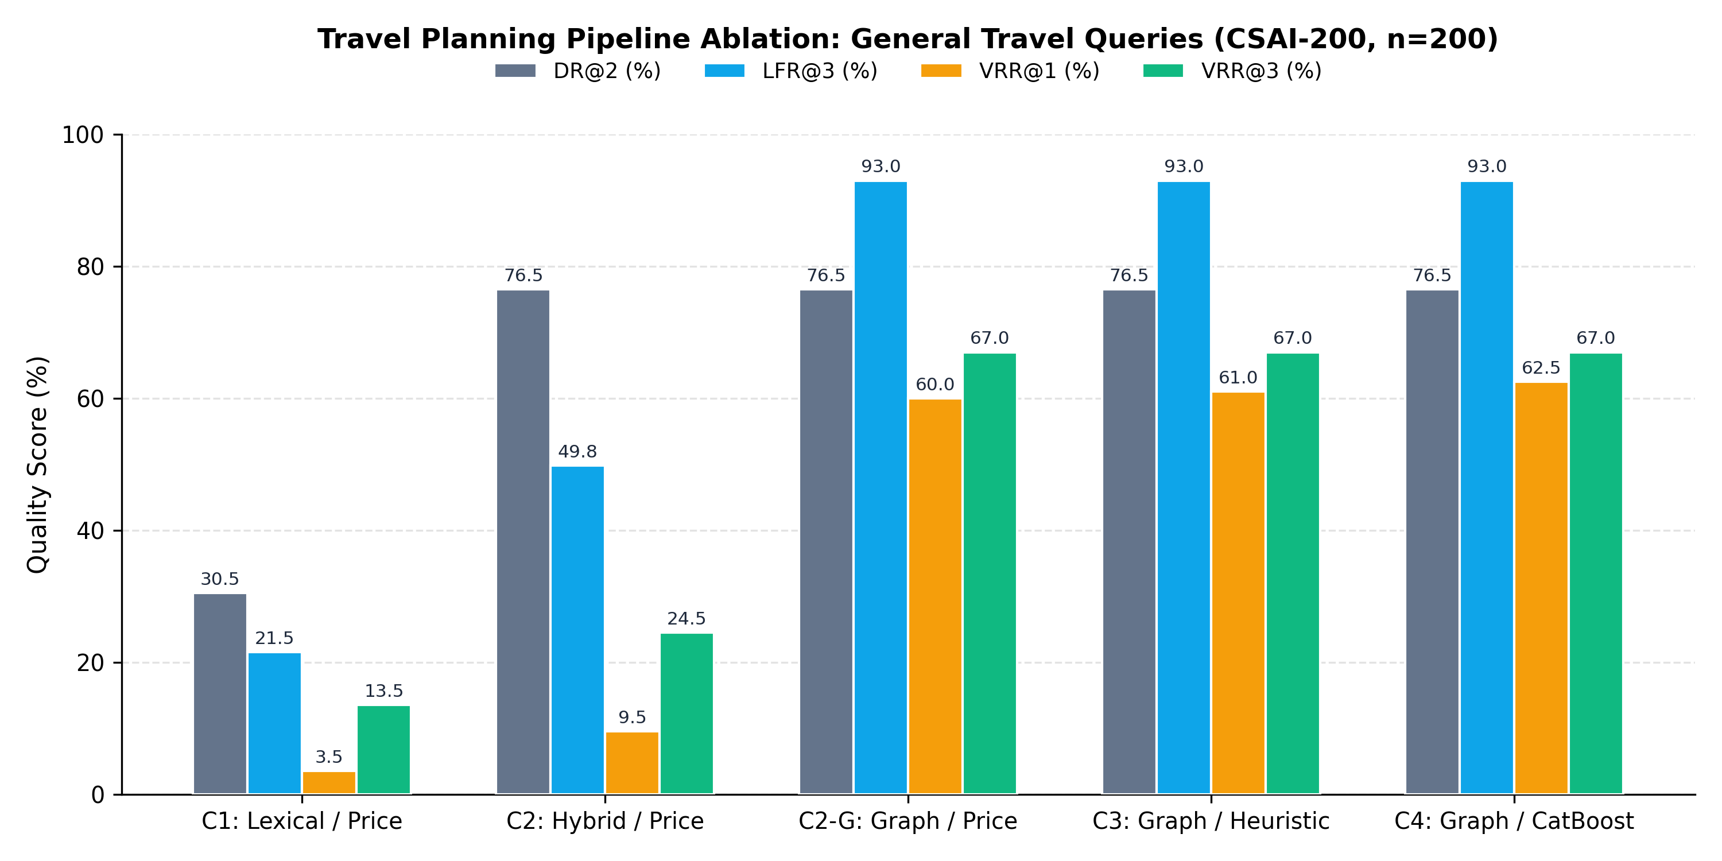
Figure 2. Pipeline performance metrics on the primary set of general queries (CSAI-200, n = 200).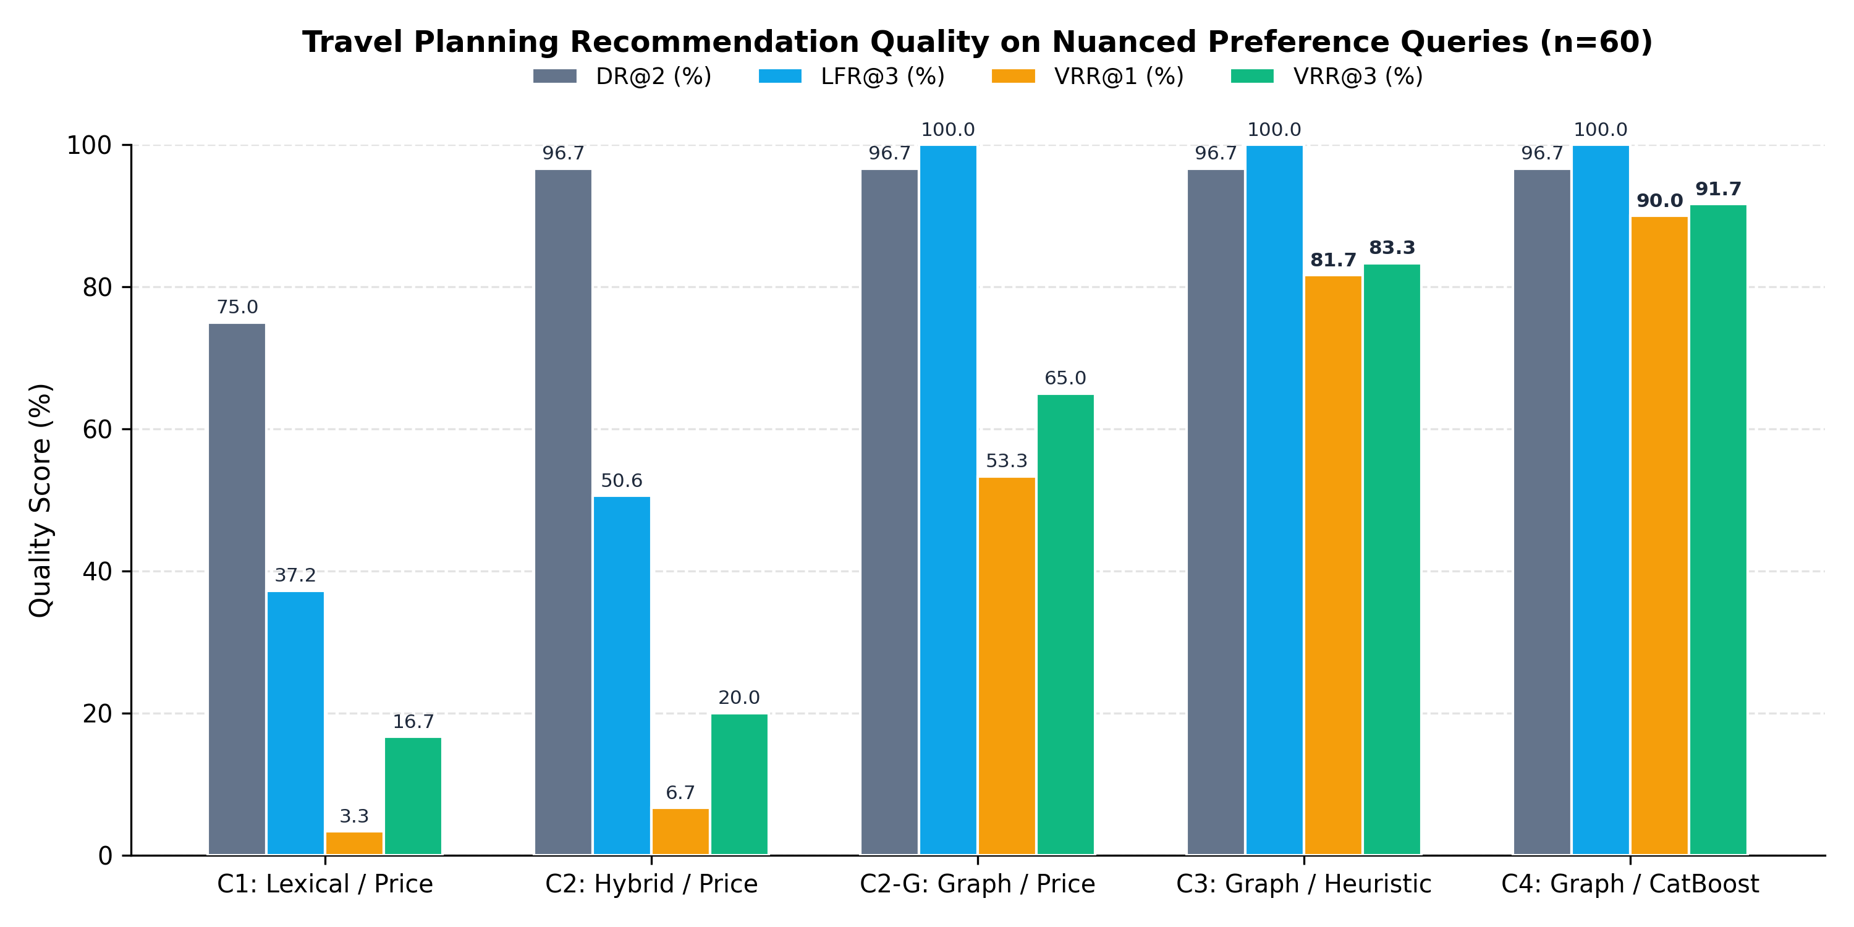
Figure 3. Pipeline performance metrics on the sample of queries with soft preferences (n = 60). Ranking. Because configurations C2-G, C3, and C4 operate on a shared pool of feasible packages, their comparison reflects ranking quality exclusively. On general queries without soft preferences (Figure 2), the differences among them are minimal; however, on the preference sample (Figure 3), price sorting in C2-G underperforms the other methods (VRR@1 = 53.3%) because it ignores comfort preferences. The weighted heuristic C3 improves the result, while the CatBoostRanker V2 model in configuration C4 achieves the highest quality both at the top position (VRR@1 = 90.0%) and within the top three (VRR@3 = 91.7%). On the control set of pairwise trade-offs (Table 3, Figure 4), price sorting always selects the cheaper option, whereas the static heuristic C3, due to its fixed weights, fails to account for the user-specified surcharge limit; consequently, both methods yield an overall accuracy of PPA = 50.0%. Model C4 reliably separates justified and overpriced surcharges, achieving a mean accuracy of 96.2%. 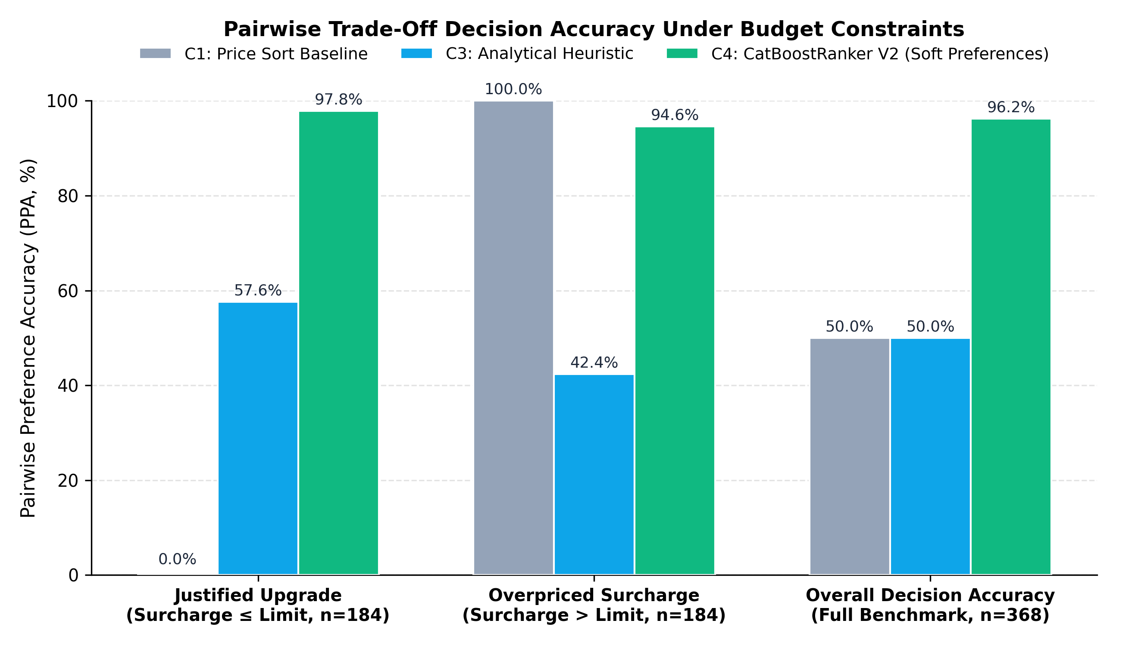
Figure 4. Pairwise Preference Accuracy (PPA) under surcharge constraints (n = 368). Limitations. Three limitations should be considered when interpreting the results. First, in the primary sample, each query is mapped to only one ground-truth destination; therefore, selecting another resort with similar characteristics lowers the formal DR@2 score, even though graph-based configurations find a valid solution for all physically feasible queries where a destination is retrieved. Second, hard trip parameters were passed from the ground-truth annotation, meaning the results characterize pipeline performance under known input constraints. Third, both the catalog and the pairwise preference annotations were generated synthetically; consequently, the obtained estimates reflect the approximation quality of the specified selection policy and require validation on real user data.

