SensiBloxTM Programming Introduction

This curriculum provides an elementary introduction to the Arduino and its use and applications. Arduino is an open-source electronics prototyping platform based on flexible, easy-to-use hardware and software. SensiBotsTM and the SensiBloxTM uses an Arduino as its brains! Let’s explore the code that makes SensiBotsTM and SensiBloxTM work.

Hardware

Arduino boards come in all shapes and sizes. They are Printed Wiring Assemblies (PWAs), which are mostly made of fiberglass and epoxy. Copper pathways run through the fiberglass material to connect electronic components together in a permanent fashion.

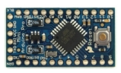
Figure 1. Arduino Pro Mini w/ ATmega328

The SensiBloxTM electronics module consists of an Arduino, an LCD, a Bluetooth Low Energy module, a 9v battery, up to four analog sensors, and a PCB to tie them all together. The BLE module allows the SensiBloxTM module to communicate wirelessly with an iPad app. The sensors measure physical phenomena in the environment around the module – sound, light, temperature, and 3-axis acceleration.

PICTURE HERE

Arduino IDE & Program Structure

Arduino programs are called sketches and are written in a variation of the C programming language. The Arduino Integrated Development Environment (IDE) is the free, downloadable software used to develop Arduino sketches and upload them to the Arduino board.
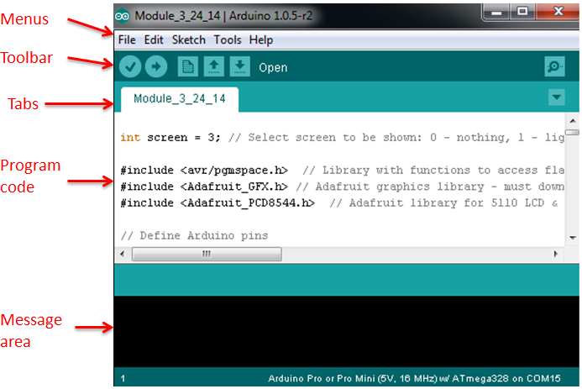
Figure 2. Arduino IDE

An Arduino sketch only requires two basic elements – a setup function and a loop function. The setup function runs once when the Arduino is first powered on. Then the program loop runs and repeats itself until the Arduino is powered off. Figure 3 shows the required syntax for the setup and loop functions, as well as how to comment and declare variables.

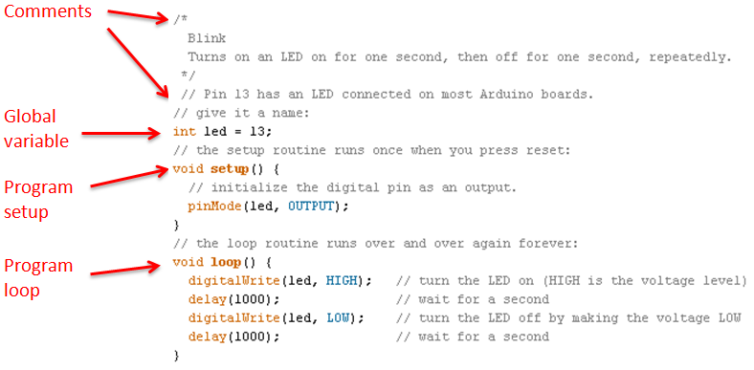
Figure 3. Arduino Program Structure

SensiBloxTM software

This guide will divide the code by function, rather than in the order that the code appears in the sketch.
The SensiBots module software has four main functions:

- Read sensor data, with calibration
- Display sensor data on LCD
- Receive instructions via BLE
- Transmit sensor data via BLE
First, we must set up our program. Setup and loop functions are created, and global variables and library calls are created outside of these loops.

This software makes use of several software libraries - collections of code, usually from an outside source, which provide commonly-used functionality to save the programmer time and effort. Figure 4 demonstrates how to include libraries.

Figure 4. Using libraries

Variables defined outside of all the functions are global variables. These variables can be used by any function, and they retain their data between function calls. Local variables, in contrast, are created within a function and are not visible to other functions. This property is called scope.

The individual pins on the Arduino should be assigned to variables. Figure 5 shows how to assign Arduino pins using const int (constant integer) variables. Const is used because these variables will not be changed once assigned. Figure 5 also shows how to assign Arduino pins for the LCD using an included library.

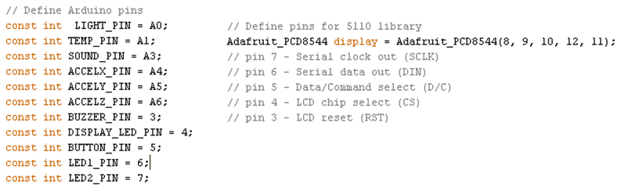
Figure 5. Defining Arduino pins & calling LCD library

This sketch uses a separate function to read data from each sensor. Each sensor has unique requirements, and therefore may have varying numbers of variables needed. The global variables used in these functions are shown in Figure 6. int is used for integers only; float allows floating point decimals; unsigned long stores large, positive numbers.
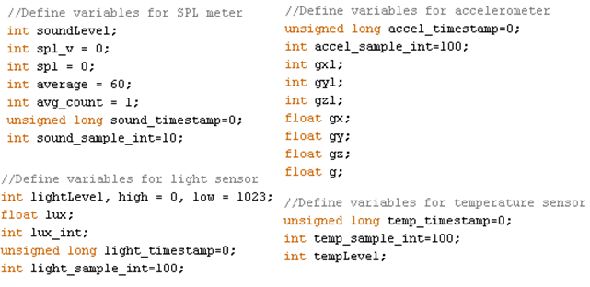
Figure 6. Defining global variables for analog sensors

The function that transmits data to the BLE module uses some new variable types. uint16_t is a variable that is always exactly 16 bits. boolean is a variable used for logic functions that only stores a true or false value.

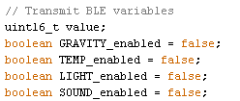
Figure 7. Defining variables for BLE transmission

With global variables defined, we can now write our setup function. This is where we run Arduino configurations that only need to be set up once. The pins are set to the appropriate mode – OUTPUT for things like LEDs which require a voltage output, and INPUT for pins which will be reading analog signals. The setup function also initializes the LCD and begins serial communication with the BLE module.

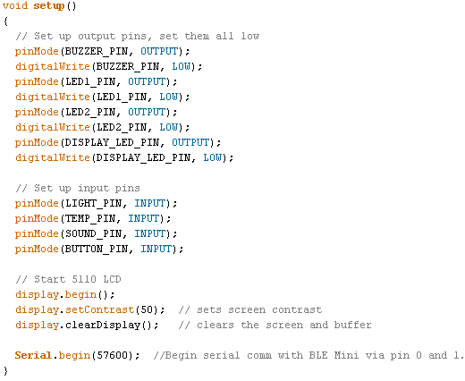
Figure 8. Setup function
The loop function will repeat endlessly after the setup function has run. This is where main program functionality usually resides. The first section of the loop function reads each sensor by calling a separate function for each. These functions reside outside of the loop function, so we will explain them before continuing to explain the loop function.

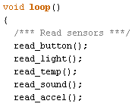
Figure 9. First section of loop function

The button is attached to a pin that is normally pulled low (i.e. to ground / 0V) by a 10kΩ resistor. When the button is pressed, that pin is connected directly to 5V. This function has some local variables that are not accessible to the rest of the sketch. static ensures that they are only initialized once. buttonState is used to make a spring-loaded button into an on-off switch. Each time the button is pressed, buttonState switches from true to false or vice versa. You might think that a button press could be detected simply by checking if the button is high. But this would not provide smooth operations. Me also must check that the button has gone low since the last time it was detected high, and that enough time has passed. This is called button debouncing. millis() is a built-in Arduino function that queries the internal timer, which measures time in milliseconds from the start of the program. It can be used along with a timestamp variable to measure how much time has passed since an event occurred. This technique is used in every sensor-reading function in this sketch to dictate how often a sensor should be read.

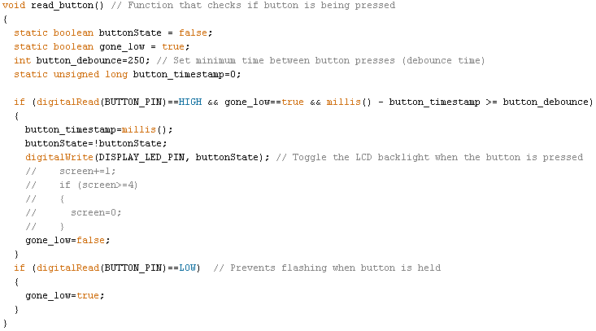
Figure 10. Button function

The light sensor read function simply uses analogRead to measure the voltage at the analog input pin that the photoresistor is attached to. The Arduino reads analog signals at a value between 0 and 1023 for 0 to 5V. To convert this reading to lux, a calibration formula must be implemented. This formula was determined by exposing the photoresistor to varying levels of light intensity, then exposing a high-quality lux meter to identical levels and calibrating the values to match. The temperature and SPL read functions are very similar, but with different calibration formulas and techniques. The SPL meter is prone to very rapid changes, so a moving average formula is implemented to smooth out the signal for readability. The accelerometer read functions operates like all the others, except it reads from three pins to get acceleration about the X, Y, and Z axes. A simple formula is used to combine the three axis acceleration into magnitude.
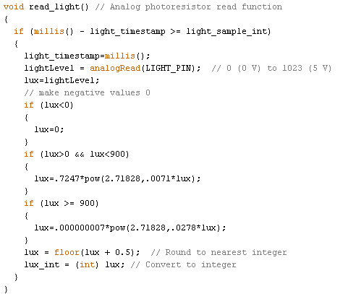
Figure 11. Light sensor read function

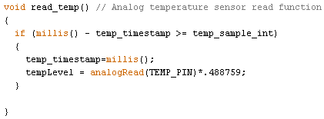
Figure 12. Temperature sensor read function
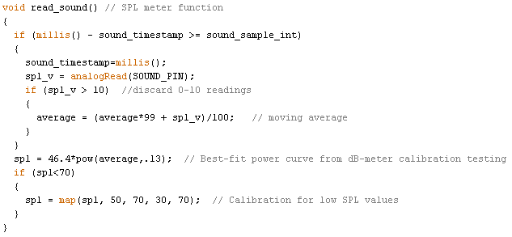
Figure 13. SPL Meter read function

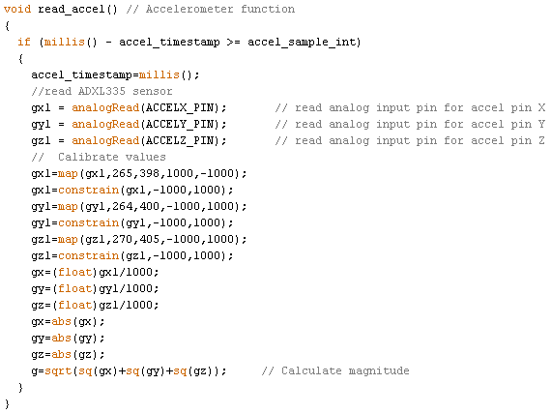
Figure 14. Accelerometer read function

After acquiring data from all four analog sensors, the sketch checks to see if serial data from the BLE module is available. If it is, the sketch reads the available data into three 8-bit byte variables. The sketch then processes this data according to the readme file which is distributed with the sketch. The relevant section is shown in Figure 15. Figure 16 shows the code which executes this protocol.
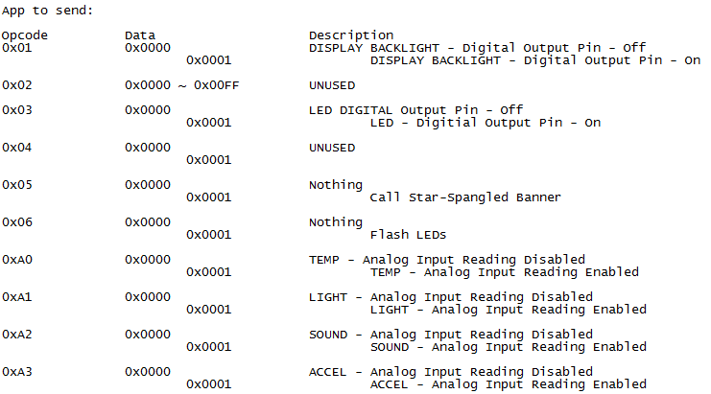

Figure 15. BLE Receive protocol

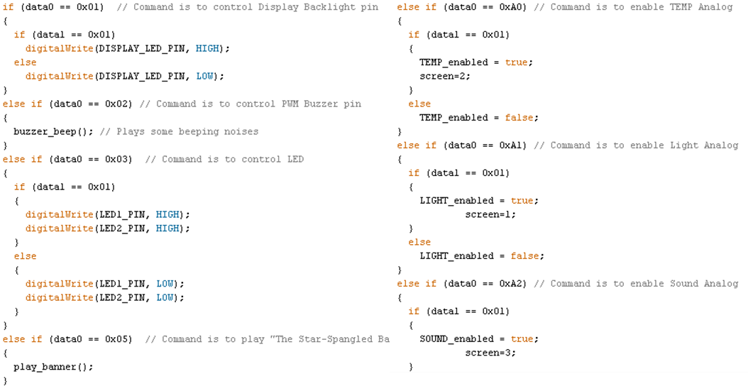
Figure 16. Executing BLE Receive protocol

Several commands simply execute an external function. The play_banner() function, shown in Figure 17, plays “The Star-Spangled Banner” via the piezoelectric buzzer. Variables followed by two square brackets, such as tones[] are called arrays. These variables can store multiple values. In this case, the character array holds the notes in order, the beats array is the corresponding length of each note, and the tones array holds the frequency of each note. Frequencies must be adjusted to play songs that are in a different key!
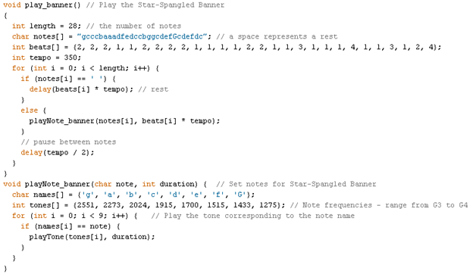
Figure 17. Star-Spangled Banner

The sketch will continue running through the while(serial.available()) loop until there is no more data left in the serial buffer. Once exiting this loop, the sketch will attempt to transmit data via BLE - but only for the sensors that have been enabled by the iOS app. If no sensors have been enabled, no data will be transferred. Again, the protocol from the readme file is followed for data transmission. Figure 18 shows the BLE Transmit protocol and Figure 19 shows how data is transmitted to the BLE module via serial connection. This is repeated for each sensor.

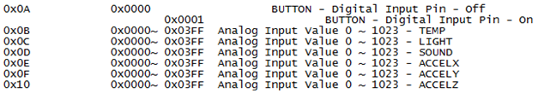
Figure 18. BLE Transmit protocol

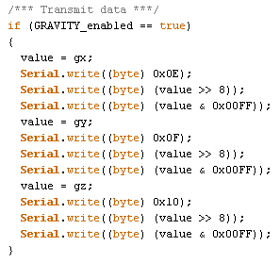
Figure 19. Transmit accelerometer data

After data has been transmitted for all the enabled sensors, the sketch enters the final section – displaying data on the LCD. Fortunately, there is a library that makes communication with the LCD very simple. The screen setup for each sensor is split into separate functions. A variable called screen determines which sensor screen is displayed. The millis() and timestamp technique is implemented again – this time to ensure that the screen doesn’t update too rapidly. Figure 21 shows one of the sensor display functions.

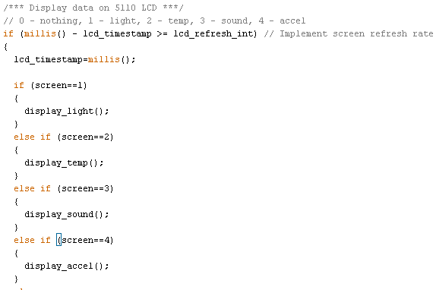
Figure 20. LCD display logic

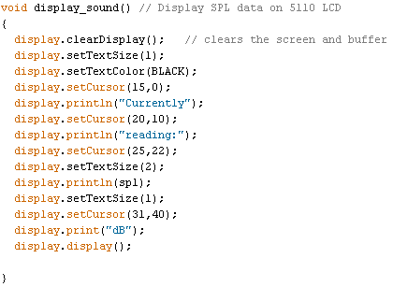
Figure 21. LCD display - SPL Meter

The main loop function will repeat indefinitely in the read-receive-transmit-display cycle.

To learn more, go to www.arduino.cc!

Make something cool with your SensiBlox?
Please send us a shout out - @Dynepic and @SensiBots

