1. ER Diagram (Database Design)
Design decisions applied: Services are physical gym areas. Every member may use every area, regardless of membership plan, so there is no PLAN–SERVICE relationship. Operating hours and date-specific overrides belong to each area. A member’s current plan is recorded through MEMBERSHIP; payments retain a record of the plan paid for.
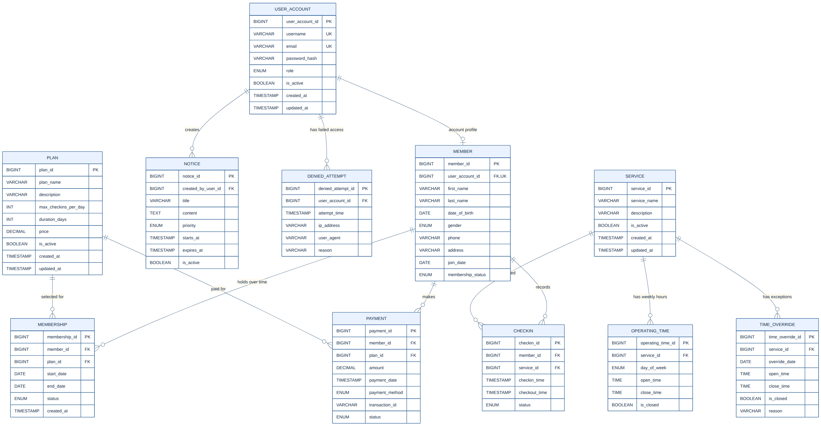
Figure 1: Entity-relationship diagram of the Gym Management System

2. UML Class Diagram
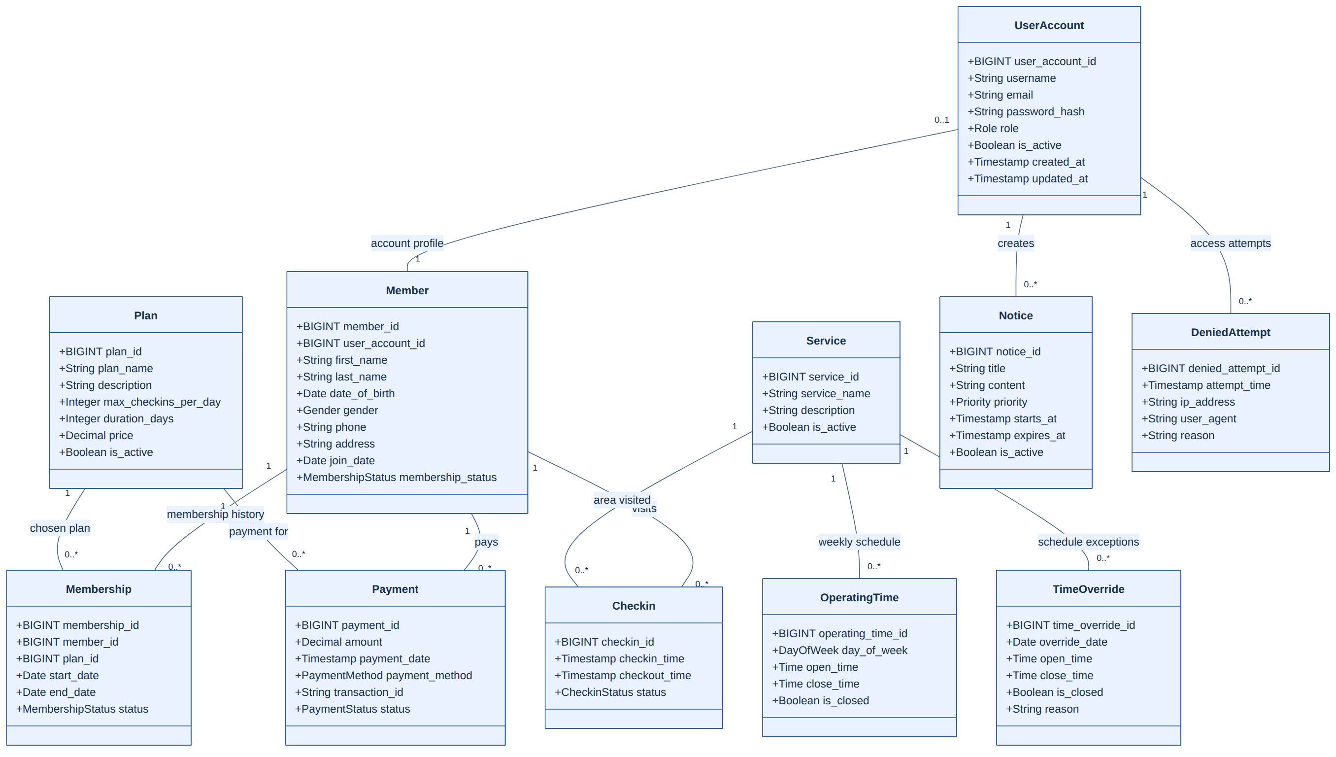
Figure 2: UML class diagram of the Gym Management System

