
University of Eswatini
Practices In Software Engineering II – CSC491
SOFTWARE DESIGN DOCUMENT
Gym Management System
Version 1.0 – 17 October 2026
Based on the Software Requirements Specification, version 1.0 (9 October 2026)
Group members
Name | Student number | Role
[Insert name] | [Insert number] | Team Manager
[Insert name] | [Insert number] | System Architect
[Insert name] | [Insert number] | UI/UX Designer
[Insert name] | [Insert number] | Programmer (Backend & Integration)
Revision history
Version | Date | Description
1.0 | 17 October 2026 | First release. Derived from SRS version 1.0 and Project Plan version 2.0.
Contents
1. Introduction………………………………………………………………………………………………. 3
1.1 Purpose…………………………………………………………………………………………………...3
1.2 Scope…………………………………………………………………………………………………….. 3
1.3 Definitions, Acronyms and Abbreviations…………………………………………………………….. 3
1.4 References………………………………………………………………………………………………. 3
1.5 Overview of this Document…………………………………………………………………………….. 3
2. Design Overview…………………………………………………………………………………………. 4
2.1 Stakeholders and Design Concerns………………………………………………………………….. 4
2.2 Design Goals……………………………………………………………………………………………. 4
2.3 Constraints and Assumptions…………………………………………………………………………. 4
2.4 Key Design Decisions………………………………………………………………………………… 4
3. Architectural Design…………………………………………………………………………………….4-5
3.1 Architectural Style………………………………………………………………………………………..5
3.2 Subsystem Decomposition……………………………………………………………………………...6
3.3 Deployment View……………………………………………………………………………………….. .7
3.4 Configuration…………………………………………………………………………………………….. .7
4. Data Design………………………………………………………………………………………………...7
4.1 Entity–Relationship Model……………………………………………………………………………….7
4.2 Table Definitions……………………………………………………………………………………........8
4.3 Integrity and Immutability Rules……………………………………………………………………….,.11
4.4 Indexes…………………………………………………………………………………………………....11
4.5 Photo Storage…………………………………………………………………………………………… 11
4.6 Backup…………………………………………………………………………………………………… 12
5. Component Design………………………………………………………………………………………. 12
5.1 Shared Services………………………………………………………………………………………… 12
5.2 Authentication and Accounts (auth)…………………………………………………………………... 12
5.3 Members (members)…………………………………………………………………………………… 12
5.4 Plans and Payments (plans, payments)……………………………………………………………… 12
5.5 Check-in and Check-out (checkins)……………………………………………………………………13
5.6 History (history)…………………………………………………………………………………………. 13
5.7 Notices and Operating Times (notices, hours)………………………………………………………. 13
5.8 Public Status Page (public)……………………………………………………………………………. 14
5.9 Member Portal (portal)…………………………………………………………………………………..14
5.10 Manager Dashboard (dashboard)…………………………………………………………………….14
6. Interface Design…………………………………………………………………………………………...14
6.1 API Conventions………………………………………………………………………………………….14
7. Security and Privacy Design……………………………………………………………………………...14
7.1 Authentication……...……………………………………………………………………………………..14
7.2 Sessions ………………………………………………………………………………………………15
7.3 Authorisation……………………………………………………………………………………………...15
7.4 Member Data Isolation…………………………………………………………………………………..15
7.5 Privacy…………………………………………………………………………………………………….15
7.6 Input and Transport Security …………………………………………………………………………...15
8. Non-Functional Requirements Designs………………………………………………………………....15
9. Requirements Traceability………………………………………………………………………………..16
9.1 Requirement Groups to Design Elements……………………………………………………………. 16
Appendix A: Design Assumptions and Open Issues……………………………………………………..17

1. Introduction
1.1 Purpose
This Software Design Document (SDD) describes how the Gym Management System (GMS) will be built. The Software Requirements Specification (SRS, version 1.0) states what the system must do; this document turns each of those requirements into an architecture, a database design, module designs, an API, screen designs and security measures that the team can implement and test.
It is written for the System Architect and Programmer (to build the system), the UI/UX Designer (to build the screens), the Team Manager (to plan and track the work), and the course lecturer (to assess the design). It follows the structure of IEEE Std 1016-2009 (Software Design Descriptions), adapted to the size of this project.
1.2 Scope
The design covers the whole GMS as scoped in SRS Section 1.2: staff, manager and member logins; member registration with ID and photo; membership plans; cash payment recording and renewal; check-in and check-out; history and denied attempts; notices and operating times; the public status page; the member portal; and the manager dashboard.
Items listed as out of scope in SRS Appendix B (mobile app, email and SMS, online or card payments, biometric or card-reader entry, equipment booking and class scheduling) are not designed here. Section 2.3 notes where the design leaves room to add them later.

1.3 Definitions, Acronyms and Abbreviations
All terms defined in SRS Section 1.3 (Member, Staff, Manager, Plan, Active / Expired, lapsed member, Check-in, denied attempt, Notice and others) keep the same meaning here. The following terms are added for design.
Term | Meaning
API | Application Programming Interface. Here, the set of HTTP endpoints the backend offers to the React front end.
REST | Representational State Transfer: an API style using HTTP methods (GET, POST, PATCH, PUT) on resources identified by URLs.
SPA | Single-page application: the React front end loads once and then changes screens without full page reloads.
RBAC | Role-based access control: permissions are granted by role (public, member, staff, manager).
Middleware | An Express function that runs before a route handler, for example to check the session or the role.
Transaction | A group of database statements that either all succeed (COMMIT) or all fail (ROLLBACK).
Session | Server-side record of a logged-in user, identified by a secure cookie in the browser.
DDL | Data Definition Language: SQL statements that create tables, constraints and indexes.
Gym time zone | Africa/Mbabane (UTC+2). All "today", weekday and closing-time calculations use this time zone.
Current expiry | The resulting expiry date of a member's most recent payment (SRS Section 3.5). Derived, never stored separately.
1.4 References
- Gym Management System – Software Requirements Specification, version 1.0, 9 October 2026 (CSC491 group project).
- Gym Management System – Project Plan, version 2.0 (CSC491 group project).
- IEEE Std 1016-2009, Standard for Information Technology – Systems Design – Software Design Descriptions.
- IEEE Std 830-1998 and ISO/IEC/IEEE 29148:2018 (referenced by the SRS).
1.5 Overview of this Document
Section 2 gives the design goals, constraints and key decisions. Section 3 describes the architecture and how it is split into modules. Section 4 gives the database design. Section 5 describes each module in detail, including the main algorithms. Section 6 defines the REST API. Section 7 shows dynamic behaviour with sequence and state diagrams. Section 8 covers the user interface. Section 9 covers security and privacy. Section 10 shows how each non-functional requirement is met. Section 11 covers error handling and logging, and Section 12 the test design. Section 13 traces every SRS requirement to design elements. The appendices list design assumptions linked to the SRS open issues and give the full database script.
2. Design Overview

2.1 Stakeholders and Design Concerns
Stakeholder | Main design concerns | Where addressed
Gym manager | Notices and hours appear immediately; dashboard numbers are correct; staff cannot reach manager tools. | Sections 5.7, 5.10, 9.3
Front-desk staff | Fast search with photo; few clicks to check in or renew; clear warnings. | Sections 5.5, 8, 10
Members | See own membership on a phone; nobody else can see their data. | Sections 5.9, 9.4
Public visitors | See hours and closures without logging in, quickly, on a phone. | Section 5.8
Project team | Fits five weeks and four people; one module per requirement area; easy to test. | Sections 2.2, 3.2, 12
Lecturer | Design traces clearly to the SRS and follows a recognised structure. | Section 13

2.2 Design Goals
- Stop impersonation at entry. Make it impossible to record a check-in without a photo match confirmed by a named staff member (BR4), and log every refusal.
- Stop unannounced closures. Notices and operating times are stored once and read live by the public page and the member portal, so a change is visible on the next page load.
- One source of truth. The current expiry date is derived from the latest payment, and one shared function calculates new expiry dates (FR-PAY-07).
- Nothing is lost. Members, payments, check-ins and denied attempts are never deleted (BR5), and every save runs in a database transaction (NFR-09).
- Security on the server. Every permission is checked by the API on every request, not only by hiding buttons (FR-AUT-07, NFR-03).
- Simple to build. Use a conventional three-tier design with well-known libraries so the team can finish in five weeks.
2.3 Constraints and Assumptions
The design keeps every constraint from SRS Section 2.5: React, Node.js with Express, PostgreSQL, Git and GitHub; five weeks and four team members; cash-only payments recorded by staff; no email or SMS; dummy data only during development; hashed passwords and minimal personal data.
Design assumptions that depend on the open questions in SRS Appendix A are listed in Appendix A of this document. Each one is a configuration value or a nullable column, so the design does not change if the gym answers differently.
Extension points for out-of-scope features: a notification service interface could later send email or SMS for notices and expiry warnings; the payment module records a method value fixed to cash, so other methods could be added; and the check-in module accepts a member id, so a card reader could later supply it.

2.4 Key Design Decisions
No. | Decision | Choice | Reason | Requirements
D1 | Architecture style | Three tiers: React SPA, Express REST API, PostgreSQL | Fixed by the course; clear split between screens, rules and data. | SRS 2.1, 2.5
D2 | Login sessions | Server-side sessions (express-session with a PostgreSQL store), httpOnly cookie, 30-minute rolling idle timeout | Logout and disabling a staff account take effect at once; no tokens stored in the browser. | FR-AUT-05, 10
D3 | Password hashing | bcrypt, cost factor 12 | Standard, slow hash designed for passwords. | FR-AUT-03, NFR-03
D4 | Current expiry | Derived from the latest payment through the view member_status | No second copy that could disagree with the payments. | SRS 3.5, FR-PAY
D5 | Expiry calculation | One pure function calculateNewExpiry() in expiryService | Used by preview, payment and registration; easy to unit test. | FR-PAY-03, 04, 07, NFR-13
D6 | One open check-in per member | Partial unique index on checkin(member_id) WHERE check_out_at IS NULL | The database itself blocks a second check-in, even under concurrent requests. | FR-CHK-06
D7 | History never deleted | No DELETE endpoints; database triggers block DELETE (and UPDATE where required) | Protects the record even if code has a bug. | BR5, FR-HIS-01, FR-MEM-09
D8 | Photo storage | Files in a private server folder; only the path is stored; served by an authenticated endpoint | Required by SRS 3.1.3 and NFR-06. | FR-MEM-04, NFR-06
D9 | Notice expiry | Notices filtered by date in the query; no clean-up job | A notice disappears after its end date with no action. | FR-NOT-03
D10 | Time zone | All date logic uses Africa/Mbabane | Avoids off-by-one expiry and closing-time errors on a UTC server. | BR1, FR-CHK-09

3. Architectural Design
3.1 Architectural Style
The GMS uses a three-tier client-server architecture (Figure 1). The presentation tier is a React single-page application running in the browser. The application tier is a Node.js and Express service that exposes a REST API returning JSON and holds all business rules. The data tier is a PostgreSQL database plus a private folder for member photos.
Inside the API, each request passes through a fixed middleware chain (security headers, rate limiting, session check, role check, input validation) before reaching a route handler. Route handlers call services, and services call the database through parameterised SQL. Business rules live only in the services, never in the React code, so every rule is enforced on the server.
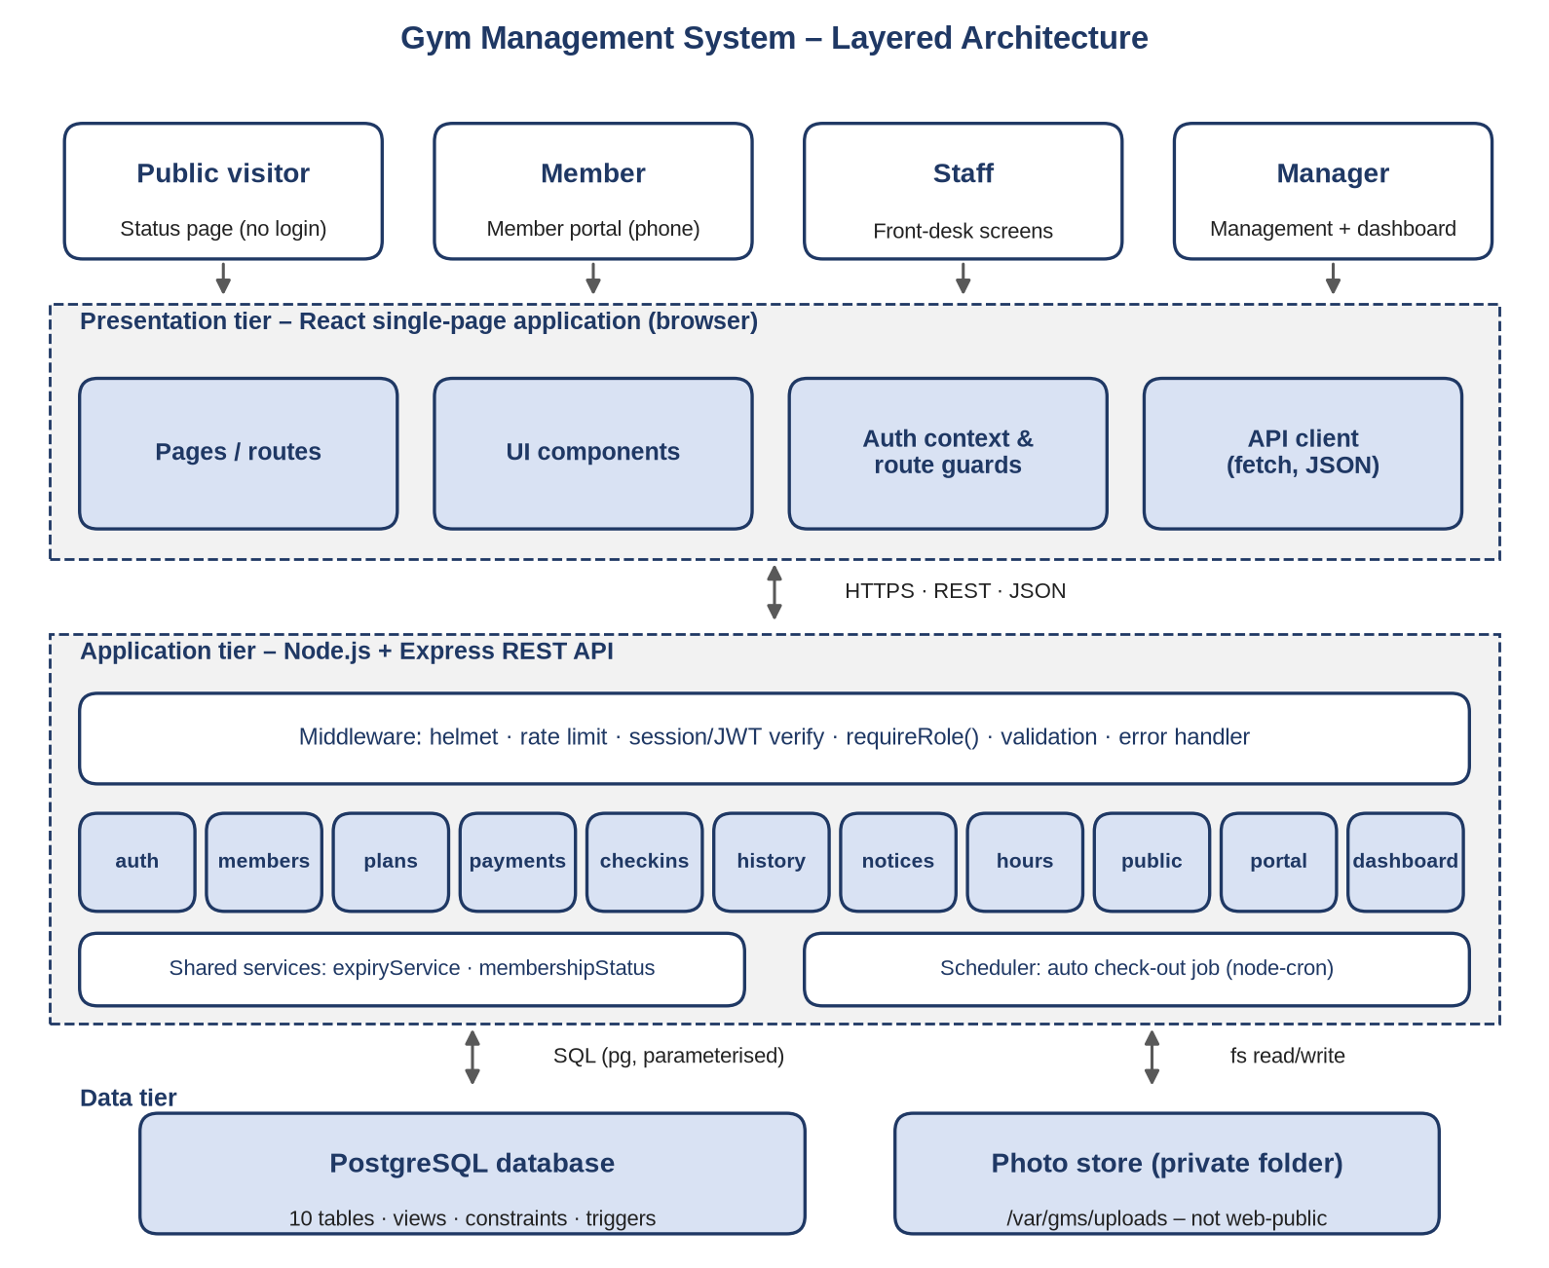
Figure 1: Layered architecture of the Gym Management System
3.2 Subsystem Decomposition
The backend has one module per requirement area in SRS Section 3.3 (NFR-12). Each module has its own routes, service and SQL queries. Table 1 maps modules to requirements and to the processes in the SRS Level 1 data flow diagram.

Table 1: Backend modules
Module | Responsibility | SRS group | DFD process | Tables used
Auth | Staff, manager and member login and logout; sessions; lockout; staff account management. | FR-AUT | 1.0 | user account, member, session
members | Register, search, view, edit and change status of members; photo upload and delivery; ID masking. | FR-MEM | 2.0 | member, payment
Plans | Create, edit and retire membership plans. | FR-PLN | 3.0 | plan
payments | Preview and record cash payments; renewal; receipt numbers. | FR-PAY | 3.0 | payment, plan, member
check-ins | Lookup, confirmed check-in, check-out, denied attempts, auto check-out job. | FR-CHK | 4.0 | check-in, denied attempt
History | Member payment and check-in history; denied-attempt log. | FR-HIS | 4.0 | payment, check-in, denied attempt
Notices | Post, edit and cancel notices. | FR-NOT | 5.0 | notice, service
Hours | Weekly operating times and one-off overrides; today's times. | FR-NOT | 5.0 | Operating time, time override, service
Public | Public status page data (no login). | FR-PUB | 6.0 | notice, operating time, time override, plan
Portal | Logged-in member's own membership view. | FR-POR | 6.0 | member, payment, notice, hours
dashboard | Live counts and charts for the manager. | FR-DSH | 7.0 | member, payment, checkin
Shared | expiry Service, membership Status, time-zone helpers, mask_Id, audit fields, error types. | All | – | –
3.3 Deployment View
For the demonstration the whole system runs on one server (Figure 2). A reverse proxy terminates HTTPS, serves the built React files and forwards /API requests to the Node.js process. PostgreSQL and the photo folder are on the same server and are not reachable from the internet.
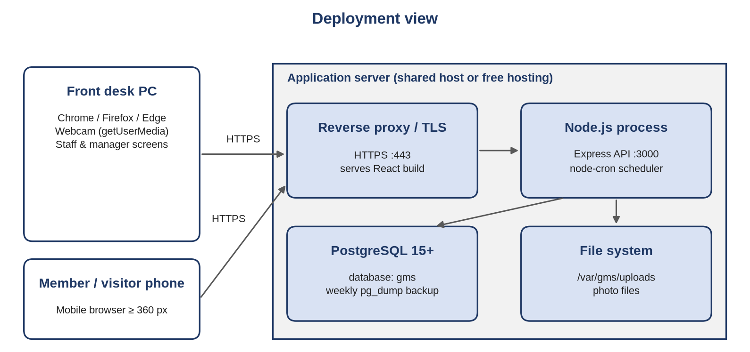
Figure 2: Deployment view

3.4 Configuration
All settings are read from environment variables so that no secrets are stored in Git.
Setting | Default | Purpose
DATABASE_URL | – | PostgreSQL connection string.
SESSION_SECRET | – | Secret used to sign the session cookie.
GYM_TIMEZONE | Africa/Mbabane | Time zone for all date and time rules (D10).
SESSION_IDLE_MINUTES | 30 | Inactivity logout (FR-AUT-10).
MEMBER_MAX_FAILED_LOGINS | 5 | Failed logins before lock (FR-AUT-09).
MEMBER_LOCK_MINUTES | 15 | Length of the "short time" lock (FR-AUT-09).
EXPIRY_WARNING_DAYS | 10 | Warning threshold (BR6, FR-MEM-08, FR-POR-03).
UPLOAD_DIR | /var/gms/uploads | Private photo folder (NFR-06).
PHOTO_MAX_BYTES | 2 MB | Largest photo accepted at upload.
AUTO_CHECKOUT_CRON | */5 * * * * | How often the auto check-out job runs (FR-CHK-09).
4. Data Design

4.1 Entity–Relationship Model
Figure 3 shows the physical data model. It implements every entity in the SRS data dictionary (Section 3.5) as one table, plus the session table managed by the session library. Foreign keys to user_account that record who did an action are listed in Section 4.2 but left out of the diagram for clarity.
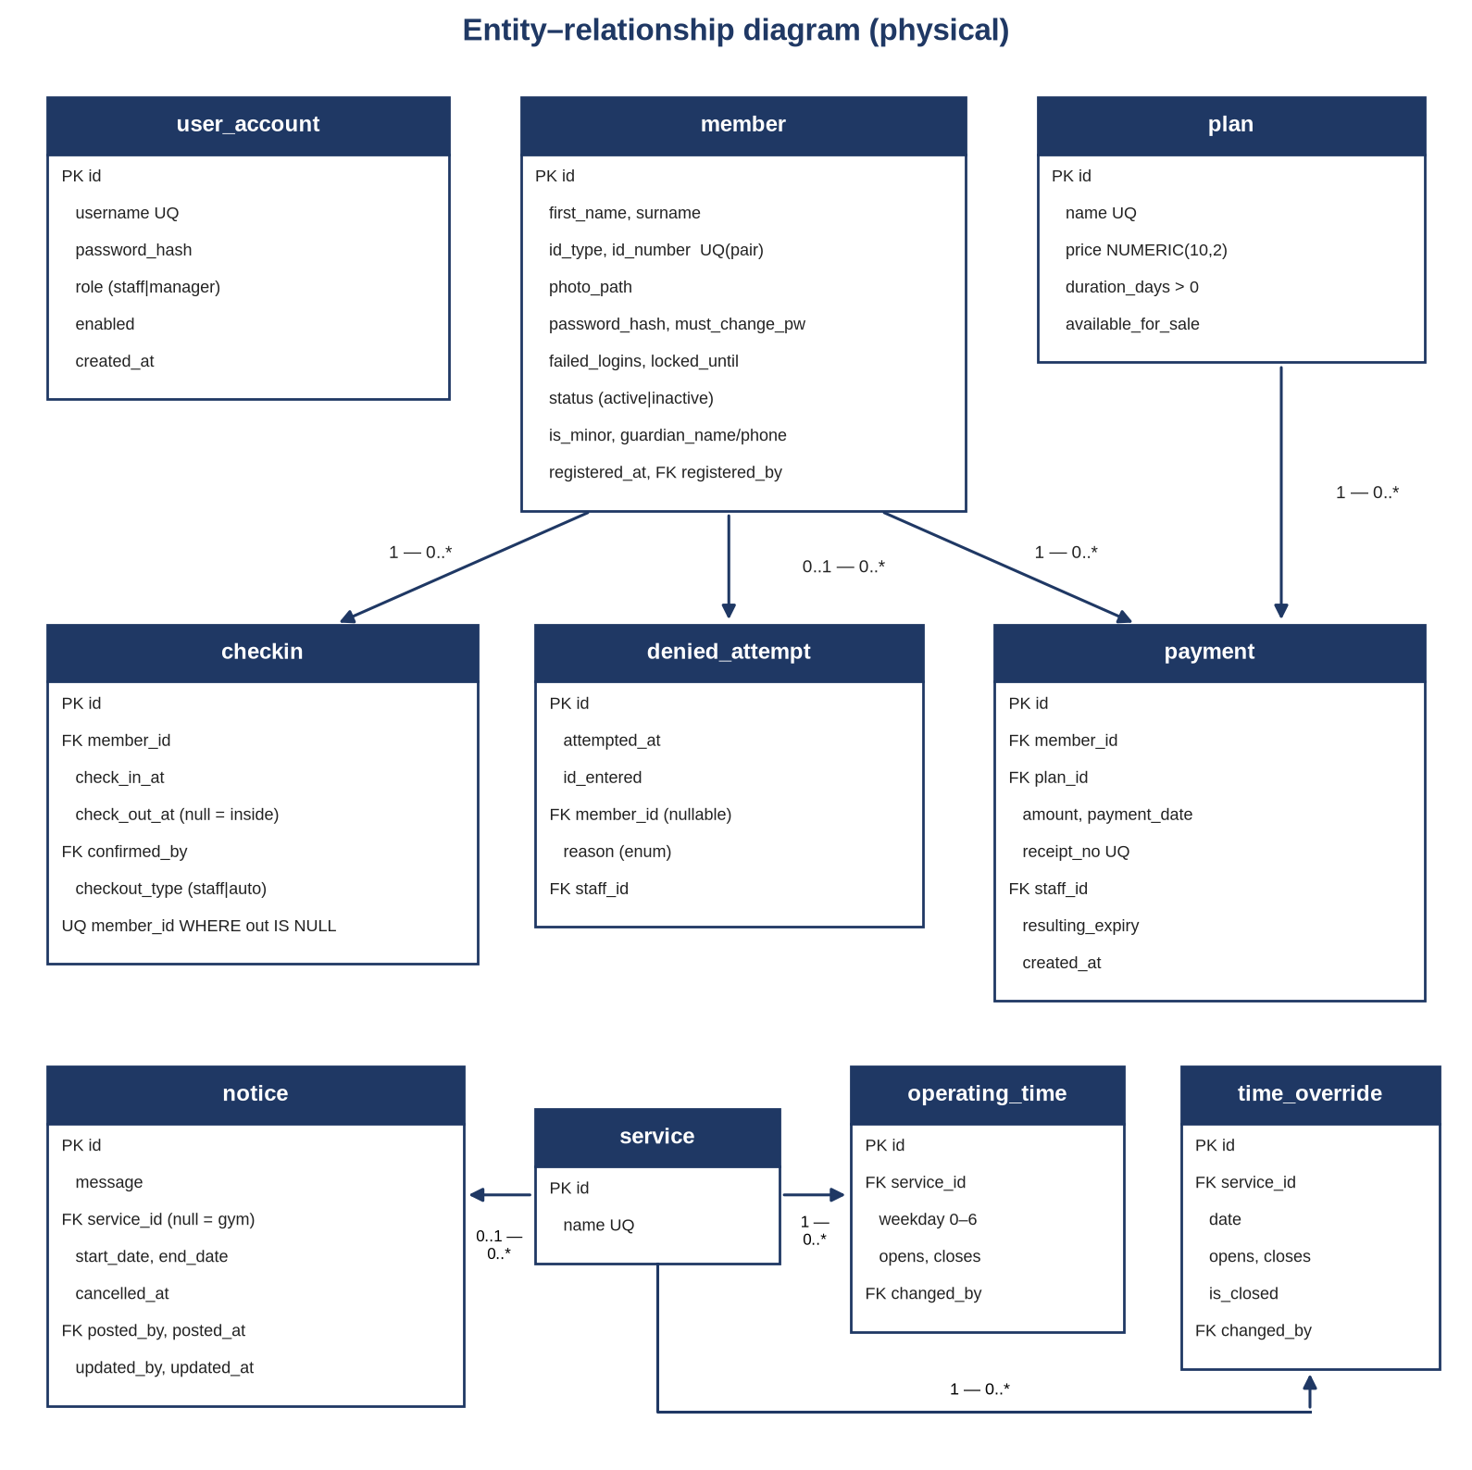
Figure 3: Entity–relationship diagram. service_id NULL means the whole gym.
4.2 Table Definitions
Types are PostgreSQL types. PK = primary key, FK = foreign key, UQ = unique, NN = not null. Every id is BIGINT GENERATED ALWAYS AS IDENTITY. All timestamps are TIMESTAMPTZ; dates that follow the gym calendar are DATE. The full script is in Appendix B.

Table 2: user account – Staff and manager logins (FR-AUT-02, BR8).
Column | Type | Constraints | Notes
Id | BIGINT | PK
username | VARCHAR (50) | NN, UQ (case-insensitive) | Login name; never shared.
password hash | VARCHAR (100) | NN | bcrypt hash; never returned by the API.
Role | user role | NN | Enum: 'staff', 'manager'.
enabled | BOOLEAN | NN, default TRUE | Disabled accounts cannot log in (FR-AUT-05).
must_change_pw | BOOLEAN | NN, default FALSE | Set after a password reset.
Created at | TIMESTAMPTZ | NN, default now ()
Created by | BIGINT | FK user account | Manager who created it.

Table 3: member – Registered gym users (FR-MEM). Never deleted.
Column | Type | Constraints | Notes
Id | BIGINT | PK
first name, surname | VARCHAR (80) | NN
Id_type | id_type | NN | Enum: 'student_id', 'national_id', 'passport', 'birth_certificate' (FR-MEM-02).
id_number | VARCHAR (40) | NN; UQ with id_type | Stored trimmed and upper-case (FR-MEM-03, BR3).
photo_path | VARCHAR (255) | NN | Relative path inside UPLOAD_DIR (FR-MEM-04).
password_hash | VARCHAR (100) | NN | bcrypt hash.
must_change_pw | BOOLEAN | NN, default FALSE | TRUE when staff set a temporary password (FR-MEM-05).
failed_logins | SMALLINT | NN, default 0 | Consecutive failures (FR-AUT-09).
locked_until | TIMESTAMPTZ | nullable | Login refused until this time.
Status | member_status_t | NN, default 'active' | Enum 'active', 'inactive' (FR-MEM-09). Not the same as membership expiry.
is_minor | BOOLEAN | NN, default FALSE | Pending SRS open issue 1.
guardian_name, guardian_phone | VARCHAR (120), VARCHAR (20) | Required when is_minor | CHECK constraint.
registered_at | TIMESTAMPTZ | NN, default now () | Used for "new members this month".
registered_by | BIGINT | NN, FK user_account | Staff member (FR-AUT-06).
updated_at, updated_by | TIMESTAMPTZ, BIGINT | nullable | Last edit and who made it.

Table 4: plan – Membership types (FR-PLN).
Column | Type | Constraints | Notes
Id | BIGINT | PK
Name | VARCHAR (60) | NN, UQ | For example, "Monthly – student".
Price | NUMERIC (10,2) | NN, CHECK ≥ 0 | In Emalangeni (E).
duration_days | INTEGER | NN, CHECK > 0 | Whole days.
available_for_sale | BOOLEAN | NN, default TRUE | FALSE = retired (FR-PLN-02).
updated_at, updated_by | TIMESTAMPTZ, BIGINT

Table 5: payment – One row per cash payment. Never updated or deleted (FR-PAY-06).
Column | Type | Constraints | Notes
Id | BIGINT | PK
member_id | BIGINT | NN, FK member
plan_id | BIGINT | NN, FK plan ON DELETE RESTRICT | Blocks deleting a used plan.
Amount | NUMERIC (10,2) | NN, CHECK ≥ 0 | Copied from the plan at the time of payment.
days_added | INTEGER | NN, CHECK > 0 | Copied from the plan; history stays correct if the plan changes.
payment_date | DATE | NN | Gym date of the payment.
receipt_no | VARCHAR (30) | NN, UQ | Entered or generated (open issue 4).
Method | VARCHAR (10) | NN, CHECK = 'cash' | BR7; extension point.
previous_expiry | DATE | nullable | Shown in the calculation and kept for audit.
resulting_expiry | DATE | NN | New expiry date.
staff_id | BIGINT | NN, FK user_account | Who recorded it.
created_at | TIMESTAMPTZ | NN, default now ()

Table 6: checkin – One row per visit (FR-CHK).
Column | Type | Constraints | Notes
Id | BIGINT | PK
member_id | BIGINT | NN, FK member | Partial UQ where check_out_at IS NULL (D6).
check_in_at | TIMESTAMPTZ | NN, default now ()
confirmed_by | BIGINT | NN, FK user_account | Staff who confirmed the photo (FR-CHK-04).
check_out_at | TIMESTAMPTZ | nullable | NULL = still inside.
checkout_type | VARCHAR (5) | CHECK IN ('staff','auto')
checked_out_by | BIGINT | FK user_account, nullable | NULL for automatic check-out.

Table 7: denied_attempt – Refused check-ins. Never updated or deleted (FR-HIS-03).
Column | Type | Constraints | Notes
Id | BIGINT | PK
attempted_at | TIMESTAMPTZ | NN, default now ()
id_entered | VARCHAR (80) | NN | What staff typed.
member_id | BIGINT | FK member, nullable | Set when a member was found.
Reason | denied_reason | NN | Enum 'expired', 'unknown_id', 'already_inside', 'photo_not_confirmed'.
staff_id | BIGINT | NN, FK user_account

Table 8: service – Areas of the gym (SRS 3.5).
Column | Type | Constraints | Notes
Id | BIGINT | PK
Name | VARCHAR (60) | NN, UQ | For example, weights area, cardio equipment.
Active | BOOLEAN | NN, default TRUE | Hide a service without deleting it.

Table 9: notice – Closures and service messages (FR-NOT-01 to 03, 06).
Column | Type | Constraints | Notes
Id | BIGINT | PK
message | VARCHAR (500) | NN
service_id | BIGINT | FK service, nullable | NULL = whole gym.
start_date, end_date | DATE | NN, CHECK end ≥ start | Shown only in this range.
cancelled_at, cancelled_by | TIMESTAMPTZ, BIGINT | nullable | Cancelled notices stop showing.
posted_by, posted_at | BIGINT, TIMESTAMPTZ | NN
updated_by, updated_at | BIGINT, TIMESTAMPTZ | nullable

Table 10: operating_time – Weekly schedule (FR-NOT-04).
Column | Type | Constraints | Notes
Id | BIGINT | PK
service_id | BIGINT | FK service, nullable | NULL = whole gym.
weekday | SMALLINT | NN, CHECK 0–6 | 0 = Sunday.
opens, closes | TIME | nullable; CHECK closes > opens | Both NULL = closed that weekday.
changed_by, changed_at | BIGINT, TIMESTAMPTZ | NN | FR-NOT-06.
(constraint) |  | UQ (service_id, weekday) NULLS NOT DISTINCT | One row per weekday per service.

Table 11: time_override – One-off change for a date (FR-NOT-05).
Column | Type | Constraints | Notes
Id | BIGINT | PK
service_id | BIGINT | FK service, nullable | NULL = whole gym.
Date | DATE | NN
is_closed | BOOLEAN | NN, default FALSE | TRUE = closed all day.
opens, closes | TIME | required unless is_closed
changed_by, changed_at | BIGINT, TIMESTAMPTZ | NN
(constraint) |  | UQ (service_id, date) NULLS NOT DISTINCT

4.3 Integrity and Immutability Rules
Rule | Database mechanism | Application mechanism | SRS
ID type + number unique | UNIQUE (id_type, id_number); values normalised (trim, upper-case) | Friendly 409 error showing the existing member | FR-MEM-03, BR3
Photo required | photo_path NOT NULL | Register endpoint rejects a request without a photo file | FR-MEM-04
Members never deleted | Trigger raises an error on DELETE from member | No DELETE route; status changed instead | FR-MEM-09, BR5
Payments never edited or deleted | Trigger raises an error on UPDATE or DELETE of payment | No PATCH or DELETE route | FR-PAY-06, BR5
Denied attempts never edited or deleted | Trigger on UPDATE or DELETE of denied_attempt | No PATCH or DELETE route | FR-HIS-03, BR5
Check-ins never deleted | Trigger on DELETE of checkin; UPDATE allowed only to set check-out fields once | Check-out route only | BR5
One open check-in per member | Partial unique index (D6) | Rejects with reason already_inside | FR-CHK-06
Used plan cannot be deleted | FK payment plan_id ON DELETE RESTRICT | No delete route; retire with available_for_sale | FR-PLN-02
Who did it | NOT NULL staff and user FKs on every action table | Taken from the session, never from the request body | FR-AUT-06, FR-NOT-06
4.4 Indexes
- member (lower(surname), lower(first_name)) and a trigram index on name for fast partial search (NFR-01).
- member (id_number) for search by ID number; the unique index covers (id_type, id_number).
- payment (member_id, created_at DESC) so the member_status view finds the latest payment quickly.
- checkin (check_in_at) for weekly and monthly dashboard charts; partial unique index on open check-ins.
- notice (start_date, end_date) WHERE cancelled_at IS NULL for the public page.

4.5 Photo Storage
Photos are captured in the browser (webcam or phone camera through getUserMedia, or an uploaded image file, SRS 3.1.2) and sent with the registration request as multipart form data. The server checks that the file is JPEG or PNG and no larger than 2 MB, resizes it to at most 600 pixels wide, removes metadata, and saves it as members/<random-uuid>.jpg inside UPLOAD_DIR. Only this relative path is stored in member. photo_path.
4.6 Backup
A scheduled pg_dump runs weekly and before the demonstration, together with an archive of UPLOAD_DIR (NFR-10). Backups are kept off the application server and contain only dummy data during development.

5. Component Design
This section describes each backend module: what it does, its main functions, and the rules it applies. Pseudocode is given for the algorithms that carry the most risk.
5.1 Authentication and Accounts (auth)
- Staff and manager login checks username and password with bcrypt. It refuses disabled accounts with the same generic error message, so the response does not reveal which accounts exist.
- Member login uses ID type, ID number and password (FR-AUT-08) and applies the lockout rule below.
- Session stores { userType: "staff" | "member", id, role }. On every request the middleware reloads the user and rejects the session if a staff account has been disabled, so disabling takes effect at once (FR-AUT-05).
- Logout destroys the session (FR-AUT-10). Sessions expire after 30 minutes without activity (rolling expiry).
- Staff accounts: the manager can create, disable, enable and reset passwords. A reset sets must_change_pw, and the user must change the password at the next login.
- First manager account is created by a one-time seed script, not through the API.

5.2 Members (members)
- Register (UC-03) accepts the member fields, the photo, a password (or a request for a temporary one), the chosen plan and the receipt number. In one transaction it inserts the member, saves the photo and records the first payment through the payments service. If any step fails, nothing is saved and the photo file is removed.
- Duplicate ID (UC-03 A1): the unique constraint is caught and the API returns 409 with the existing member's id, name and photo URL, so staff can open that record.
- Temporary password: when staff choose this, the server generates an 8-character password, shows it once, and sets must_change_pw (FR-MEM-05).
- Search by name (partial, case-insensitive) or ID number, returning at most 20 results with photo URL, plan and membership state (FR-MEM-07).
- Edit details and change status (active or inactive). There is no delete (FR-MEM-09). Changing the ID type or number is checked for uniqueness again.
- Masking (FR-MEM-10): maskId("0102035500123") returns ••••••••••123. Full ID numbers are returned only by the register, search and check-in lookup endpoints used by staff.
5.3 Plans and Payments (plans, payments)
- Plans: the manager creates and edits name, price, length and availability. Retired plans stay linked to old payments but are hidden from sale (FR-PLN-02).
- Preview (UC-06 step 3, FR-PAY-05) returns current expiry, days added and new expiry, and writes nothing.
- Record payment recalculates the expiry on the server inside a transaction. It never trusts a value sent by the browser.
Locking the member row stops two staff members renewing the same member at the same moment from both reading the same current expiry. Receipt numbers come from a database sequence, so they are unique even under load.
5.4 Check-in and Check-out (checkins)
Check-in has two steps so that a check-in can never be recorded from a name or ID number alone (FR-CHK-03).
- Lookup – staff enter a name or ID number. The server returns every match with photo URL, name, plan, membership state, days remaining, warning flag and whether the member is inside (FR-CHK-01, 02). If nothing matches, the server records a denied attempt with reason unknown_id and returns 404 (FR-CHK-07, UC-04 A2).
- Confirm – staff compare the person with the photo and press Confirm. The browser sends { memberId, photoConfirmed: true }. Requests without photoConfirmed are rejected.
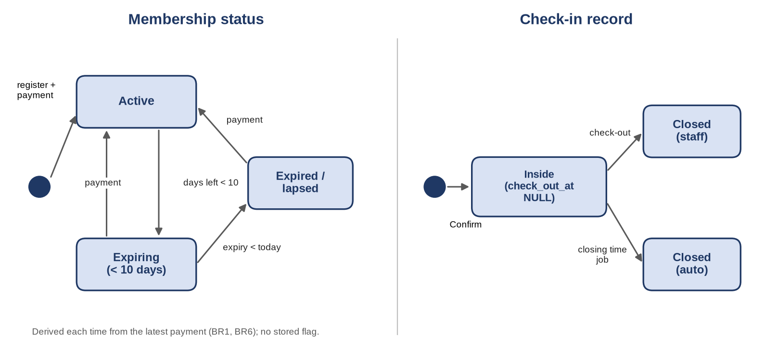
- Not this person – if the photo does not match, staff press "Photo does not match", which records a denied attempt with reason photo_not_confirmed (UC-04 A3).
If two requests race past the "already inside" check, the partial unique index rejects the second insert; the service catches that error and records it as already_inside. The denied attempt is written in its own short transaction so that it is kept even when the check-in is refused.
- Check-out sets check_out_at, checkout_type = 'staff' and checked_out_by (FR-CHK-08). The check-in screen also lists members currently inside, for quick check-out.
- Automatic check-out (FR-CHK-09): the job below runs every five minutes.
Open check-ins left over from earlier days (for example if the server was off at closing time) are also closed by this job, using the closing time of the day they started.
5.5 History (history)
- Member history returns details, all payments (newest first) and all check-ins for one member, including lapsed and inactive members (FR-HIS-01, 02).
- The denied-attempt log is manager only, with filters for date range and reason, and paging of 50 rows (FR-HIS-04).
- All history queries are read-only and use the indexes in Section 4.5.
5.6 Notices and Operating Times (notices, hours)
- Only the manager can write notices or hours (FR-NOT-07); the routes use requireManager.
- A notice is current when cancelled_at IS NULL AND start_date <= today AND end_date >= today. This filter is used by the public page, the portal and the manager list, so a notice disappears after its end date without any job (FR-NOT-03, D9).
- Edits and cancellations are saved at once. The public page and portal read live data with no caching longer than 60 seconds, so changes show on the next load (FR-NOT-02).
- Every write records changed_by or posted_by from the session, and a timestamp (FR-NOT-06).
A service is also shown as closed if a current notice covers that service or the whole gym. Because overrides apply to one date only, the weekly times return automatically the next day.
5.7 Public Status Page (public)
GET /api/v1/public/status needs no login and returns, in one response: today's date, the gym's and each service's hours for today, all current notices with the services they affect, and the plans available for sale with name, price and length (FR-PUB-01 to 03). It returns no personal data. The response is small (well under 20 KB) and may be cached for 60 seconds to meet NFR-02.

5.8 Member Portal (portal)
GET /api/v1/portal/me returns the logged-in member's name, masked ID number, current plan, expiry date, days remaining, membership state, banner type (expiring or expired), payment history, current notices and today's hours (FR-POR-01 to 03). The member id is always taken from the session and never from the URL or request body, so a member cannot ask for another member's data (FR-POR-04, NFR-04). The photo is not included.
5.9 Manager Dashboard (dashboard)
All figures are calculated from the database each time the dashboard is opened (FR-DSH-06). The queries are:
Figure | Query outline | SRS
Members currently subscribed | COUNT(*) FROM member_status WHERE membership_state IN ('active','expiring') | FR-DSH-02
Lapsed members | COUNT(*) FROM member_status WHERE membership_state = 'expired' | FR-DSH-03
Check-ins per week | date_trunc('week', check_in_at AT TIME ZONE gym), COUNT(*) FROM checkin – last 12 weeks; denied attempts are not counted | FR-DSH-04
Check-ins per month | date_trunc('month', …), COUNT(*) FROM checkin – last 12 months | FR-DSH-04
New members this month | COUNT(*) FROM member WHERE registered_at is in the current gym month | FR-DSH-05
Expiring within 10 days | COUNT(*) FROM member_status WHERE membership_state = 'expiring' | FR-DSH-07 (S)
Peak hours | extract(hour from check_in_at AT TIME ZONE gym), COUNT(*) – last 30 days | FR-DSH-07 (S)
The dashboard shows counts only. It never returns names, photos or ID numbers (NFR-06). Charts are drawn in the browser with Chart.js.
6. Interface Design
6.1 API Conventions
- Base path /api/v1. Requests and responses use JSON (SRS 3.1.3), except member registration, which uses multipart form data for the photo.
- Dates use YYYY-MM-DD; timestamps use ISO 8601 with offset; money is a string with two decimals, for example "250.00".
- Session cookie: gms.sid, httpOnly, Secure, SameSite=Strict. State-changing requests must also send the X-CSRF-Token header returned by GET /auth/me.
- Errors always use the same shape:

Status | Used when
200 / 201 | Success / record created.
400 | Input fails validation (missing field, wrong type, photo too large).
401 | Not logged in, or wrong login details.
403 | Logged in but the role is not allowed (for example staff on a manager route).
404 | Record not found (including check-in lookup with no match).
409 | Business rule refused the action: duplicate ID, expired member, already inside.
423 | Member account locked after failed logins.
429 | Too many requests (rate limit on login routes).
500 | Unexpected server error; details are logged, not returned.
7. Security and Privacy Design
7.1 Authentication
- Passwords are hashed with bcrypt (cost 12) and never logged, displayed or returned (FR-AUT-03, NFR-03). Minimum length is 8 characters.
- Login routes are rate limited (10 requests per minute per IP address) in addition to the member lockout (FR-AUT-09).
- A new session id is issued at login, which prevents session fixation.
7.2 Sessions
Sessions are stored in PostgreSQL. The cookie is httpOnly (JavaScript cannot read it), Secure (sent only over HTTPS) and SameSite=Strict. A CSRF token is required for every POST, PUT and PATCH request. Sessions end after 30 minutes without activity or on logout (FR-AUT-10).
7.3 Authorisation
Every route declares its required role with middleware: requireStaff (staff or manager), requireManager, or requireMember. The middleware runs on the server for every request, so hiding a button in the browser is never the only protection (FR-AUT-07). Member sessions cannot call staff routes and staff sessions cannot call the portal route.
7.4 Member Data Isolation
The portal has exactly one data route, and it reads the member id from the session. There is no portal route that accepts a member id, so there is nothing to tamper with. An automated test logs in as member A and tries every member-related URL with member B's id, expecting 401 or 403 (NFR-04).
7.5 Privacy
- Photos and full ID numbers are visible only to staff and the manager (NFR-06). They are never sent to the portal, the public page or the dashboard.
- ID numbers are masked except on staff registration, search and check-in screens (FR-MEM-10).
- Only the data listed in SRS Section 3.5 is collected. Guardian details are collected only for under-18 members if the gym confirms open issue 1.
- Only dummy data is used in development and testing. The seed script creates fictional members and generated face placeholders.
7.6 Input and Transport Security
- All SQL uses parameterised queries through the pg library, which prevents SQL injection.
- Every request body is validated against a schema (zod). Unknown fields are removed.
- React escapes output by default; the app never inserts raw HTML, which limits cross-site scripting.
- Uploaded files are checked by content type and size, re-encoded and renamed, so the original file is never served.
- helmet sets security headers. HTTPS is required in deployment (NFR-05, SRS 3.1.4).

8. Non-Functional Requirements Design
NFR | Requirement (summary) | Design measures
NFR-01 | Member search with photo and status under 2 s | Indexed search (4.5); at most 20 results; photos resized to 600 px and loaded separately; status from an indexed view.
NFR-02 | Public page under 3 s on a phone | One small JSON request; 60-second cache; no images; small JavaScript bundle loaded first for the public route.
NFR-03 | Hashed passwords; role checked on every request | bcrypt (D3); role middleware (9.3).
NFR-04 | No member can read another's data | Session-based member id; isolation test (9.4).
NFR-05 | HTTPS when deployed | TLS at the reverse proxy; Secure cookies (3.5, 9.2).
NFR-06 | Photos and ID numbers private | Private folder and authenticated photo route (4.6); masking; dashboard counts only.
NFR-07 | New staff productive after 15 minutes | Check-in as home screen; two clear buttons; plain-language messages (8.1, 8.3).
NFR-08 | Usable from 360 px wide | Mobile-first CSS; single-column layout; tested at 360 px.
NFR-09 | No partial saves | withTransaction() for every multi-step write; photo file removed on rollback (5.3, 5.4).
NFR-10 | Weekly backup | pg_dump and photo archive (4.7).
NFR-11 | Chrome, Firefox, Edge | Standard React and CSS; getUserMedia with file-upload fallback; tested in all three.
NFR-12 | Modular, documented, reviewed code | One module per SRS area (3.2); JSDoc on services; pull requests on GitHub.
NFR-13 | Expiry dates follow Section 3.7 | Single expiryService with unit tests for every example (12.1).
NFR-14 | Available during opening hours | Process manager restarts Node.js on failure; planned downtime announced with a notice.

9. Requirements Traceability
9.1 Requirement Groups to Design Elements
SRS requirements | Module(s) | Tables | Endpoints | Screens | SDD sections
FR-AUT-01 to 10 | auth | user_account, member, session | /auth/*, /staff/* | Logins, Staff accounts | 5.2, 9.1–9.3
FR-MEM-01 to 10 | members, payments | member, payment | /members/* | Register, Member record, Check-in | 4.6, 5.3
FR-PLN-01, 02 | plans | plan | /plans/* | Plans management | 5.4
FR-PAY-01 to 07 | payments, shared | payment | /payments/* | Renew, Register | 5.1, 5.4, 7.2
FR-CHK-01 to 10 | checkins, jobs | checkin, denied_attempt | /checkins/*, /denied-attempts | Check-in | 5.5, 7.1, 8.3
FR-HIS-01 to 04 | history, checkins | payment, checkin, denied_attempt | /members/:id/history, /denied-attempts | Member record, Denied log | 4.4, 5.6
FR-NOT-01 to 07 | notices, hours | notice, service, operating_time, time_override | /notices/*, /hours/*, /services | Notices and operating times | 5.7, 7.4
FR-PUB-01 to 04 | public | notice, hours tables, plan | /public/status | Public status page | 5.8
FR-POR-01 to 05 | portal | member, payment, notice | /portal/me | Member portal | 5.9, 9.4
FR-DSH-01 to 07 | dashboard | member_status, checkin, member | /dashboard/* | Dashboard | 5.10
BR1, BR2, BR6 | shared | member_status view | – | All status displays | 4.3, 5.1
BR3, BR4, BR5 | members, checkins | constraints and triggers | – | Register, Check-in | 4.4, 5.5
BR7, BR8 | payments, auth | payment.method, user_account | – | – | 4.2, 5.2
9.2 Use Cases to Design Elements
Use case | Main design elements
UC-01 Log in | auth module; POST /auth/staff/login, /auth/member/login; Section 5.2
UC-02 Manage staff accounts | /staff endpoints; Staff accounts screen
UC-03 Register a member | POST /members; Section 7.3; PhotoCapture component
UC-04 Check in a member | POST /checkins/lookup, /checkins, /denied-attempts; Figure 4; Section 8.3
UC-05 Check out a member | POST /checkins/:id/checkout; autoCheckout job; Figure 6
UC-06 Record a payment / renew | POST /payments/preview, /payments; expiryService; Figure 5
UC-07 Manage membership plans | /plans endpoints; Plans screen
UC-08 Post or cancel a notice | /notices endpoints; Section 7.4
UC-09 Change operating times | /hours endpoints; hoursFor(); Section 5.7
UC-10 View the public status page | GET /public/status; Section 5.8
UC-11 View my membership | GET /portal/me; Sections 5.9 and 9.4
UC-12 View the dashboard | /dashboard endpoints; Section 5.10
UC-13 View a member's history | GET /members/:id/history; Section 5.6
9.3 Problem Statement to Design
Problem (SRS 4.1) | Design response
Impersonation at entry | Photo required at registration; two-step lookup and confirm; Confirm button only on a photo card; denied attempts for every refusal; staff id on every check-in.
Closures with no notice | Live notices and hours read by the public page and portal; date-based expiry of notices; one-off overrides.
Paper records and missed expiries | Permanent tables with no delete; derived expiry; single expiry function; warnings at check-in and in the portal.
Manager has no overview | Live dashboard queries.
Staff accountability | Individual accounts; user id from the session stored on every action.

Appendix A: Design Assumptions and Open Issues
The SRS open issues are still waiting for the gym's answers. The design applies the SRS default for each one and isolates it so that a different answer needs only a small change.
SRS issue | SRS default | How the design handles it | Change needed if the answer differs
1 Under-18 members | Allowed; guardian name and phone recorded | is_minor flag and guardian columns with a CHECK constraint | Remove the columns, or add a consent field.
2 Days paid in advance | No limit | No limit in expiryService | Add a MAX_ADVANCE_DAYS check in recordPayment.
3 Hours and services | Entered by the manager after launch | service, operating_time and time_override tables start empty; hoursFor returns NOT_SET | None.
4 Receipt numbers | System generates a receipt number | Receipt field optional; if blank, the server generates R-YYYY-NNNNNN | Make the field required.
5 Who sees photos and ID numbers | Staff and manager only | requireStaff on the photo route; masking elsewhere | Change the role on one route.
6 Closing time for auto check-out | Set by the manager in operating times | autoCheckout reads the gym's hours for today | None.
Additional design assumptions: the lock time for member accounts is 15 minutes (the SRS says "a short time"); the inactivity logout is 30 minutes; the warning threshold of 10 days is configurable; and an inactive member is treated like an expired member at check-in.

