
University of Eswatini
Practices In Software Engineering II – CSC491
SOFTWARE REQUIREMENTS SPECIFICATION
Gym Management System
Version 1.0 – 9 October 2026
Group members
Name | Student number | Role
[Insert name] | [Insert number] | Team Manager
[Insert name] | [Insert number] | System Architect
[Insert name] | [Insert number] | UI/UX Designer
[Insert name] | [Insert number] | Programmer (Backend & Integration)

Revision history
Version | Date | Description
1.0 | 9 October 2026 | First release. Derived from Project Plan version 2.0.

1. Introduction

1.1 Purpose
This Software Requirements Specification (SRS) describes what the Gym Management System must do. It is written for the project team (to design, build and test the system), for the course lecturer (to assess the work), and for the gym manager and staff (to confirm that the system will solve their problems). It follows the structure of IEEE 830 / ISO/IEC/IEEE 29148, adapted to the size of this project.
It builds on the Project Plan (version 2.0). The plan says how the work will be organised; this document says exactly what is to be built.

1.2 Scope
The Gym Management System (GMS) is a website for the University of Eswatini gym. It replaces the pen-and-paper process used to add members, create memberships and track attendance.
The system is built to solve two problems:
- Impersonation at entry. Nothing ties a person entering the gym to a member record, so people can enter using another member's name. The GMS registers each member against a physical identity document and a photo, and records an entry only after a staff member confirms the person matches the photo.
- Unannounced closures. Equipment or services have been closed with no notice, and members, including non-students, have travelled to the gym and been turned away. The GMS lets the manager post closures and change operating times, which members see on a public web page before they leave home.
The GMS includes: staff, manager and member logins; member registration with ID and photo; membership plans; cash payment recording and renewal; check-in and check-out; a history of members, payments and check-ins; notices and operating times; a public status page; a member portal; and a manager dashboard.
The GMS does not include: a mobile app, email or SMS messages, online or card payments, biometric or card-reader entry hardware, or equipment booking and class scheduling.

1.3 Definitions, Acronyms and Abbreviations
Term | Meaning
GMS | Gym Management System, the software described in this document.
Member | A person registered at the gym who has (or had) a membership.
Staff | A security officer or general worker on duty who uses the system at the front desk.
Manager | The gym manager, who has all staff functions plus management functions.
Public visitor | Anyone using the public status page without logging in.
Plan | A type of membership offered, with a name, price and length in days.
Active / Expired | A membership is active if its expiry date is today or later; otherwise it is expired.
Lapsed member | A member who has had a membership before but is not active now.
ID type / ID number | The kind of identity document shown (student ID, national ID, passport or birth certificate) and the number on it.
Check-in / Check-out | Recording that a member has entered, or left, the gym.
Denied attempt | A check-in attempt that is refused, with the reason recorded.
Notice | A message from the manager that a service is unavailable or the gym is closed for a period.
DFD | Data flow diagram.
FR / NFR | Functional requirement / non-functional requirement.
Hashing | A one-way transformation used to store passwords so that the original cannot be read.

1.4 References
- Gym Management System – Project Plan, version 2.0 (CSC491 group project).
- IEEE Std 830-1998, Recommended Practice for Software Requirements Specifications.
- ISO/IEC/IEEE 29148:2018, Requirements engineering.

1.5 Overview of this Document
Section 2 describes the product and its users in general terms. Section 3 gives the specific requirements: interfaces, use cases, functional requirements, data flow, data, non-functional requirements and business rules. Section 4 explains how each requirement will be verified. The appendices list open questions and trace requirements back to the project plan.

2. Overall Description

2.1 Product Perspective
The GMS is a new, self-contained web application. It does not connect to any existing system. It has one web front end (React), one backend service (Node.js with Express), and one database (PostgreSQL). Users reach it through a web browser. Figure 1 shows the system and the four kinds of people who exchange data with it.
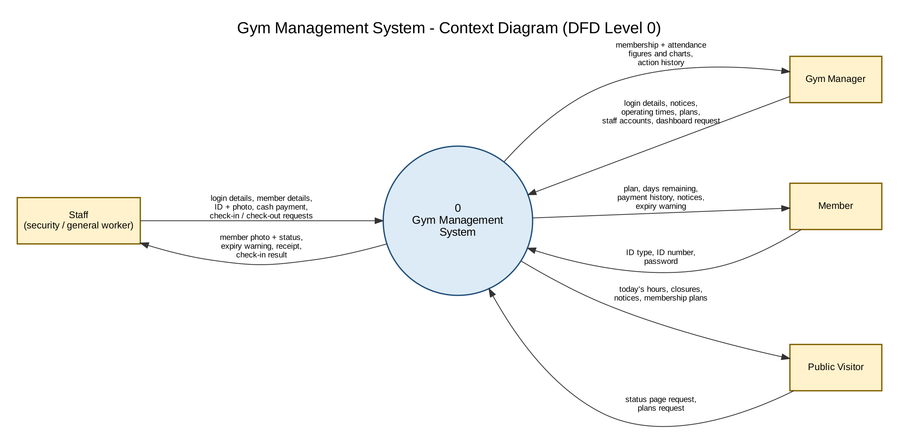
Figure 1: Context diagram (Level 0 data flow diagram)

2.2 Product Functions
No. | Function | Summary
F1 | Accounts and login | Staff, manager and member logins; the manager creates and disables staff accounts.
F2 | Member registration | Staff register a member in person with name, ID type and number, photo and password.
F3 | Plans and payments | The manager maintains plans; staff record cash payments and renew memberships; days add up.
F4 | Check-in and check-out | Staff find the member, compare the person with the photo, and confirm; denied attempts are logged.
F5 | History | Permanent record of members, payments, check-ins and denied attempts.
F6 | Notices and operating times | The manager posts notices and changes hours; they show on the public page and member portal.
F7 | Public status page and member portal | Public: hours, closures, plans. Member (logged in): plan, days left, payments, notices.
F8 | Manager dashboard | Active, lapsed and new member counts; weekly and monthly check-in charts.

2.3 User Classes and Characteristics
User class | Description | Needs and constraints
Member | Students and non-students who use the gym. Technical skill varies; most will use a phone. | Simple pages that work on a phone; must see only their own data.
Staff | Security officers and general workers at the front desk, with changing duty rosters. | Fast screens that need little training; each person has their own account.
Manager | The gym manager. Not a technical user. | Easy forms for notices and hours; clear numbers on the dashboard.
Public visitor | Anyone, including people who are not yet members. | No login; a page that loads quickly on a phone.

2.4 Operating Environment
- Server: Node.js and PostgreSQL on a host chosen by the team (a shared server or free hosting service) for the demonstration.
- Client: current versions of common desktop browsers (Chrome, Firefox, Edge) for staff and manager; the public page and member portal must also work on phone browsers.
- Front desk: a computer with a webcam (or a phone camera) for photos at registration, and an internet or network connection to the server.

2.5 Design and Implementation Constraints
- Technology is fixed by the course plan: React, Node.js with Express, PostgreSQL, Git and GitHub.
- The project has five weeks and four team members (Project Plan, Section 6).
- Payments are cash only and are recorded by staff; the system does not process money.
- No email or SMS service is used. Members are told about expiry and closures through the website and in person.
- Only dummy data is used during development and testing; no real ID numbers or photos.
- Passwords must be stored hashed, and personal data must be limited to what is needed.

2.6 Assumptions and Dependencies
- The gym will register members in person at the front desk and will have a working camera there.
- Every member can show one accepted identity document: student ID, national ID, passport or birth certificate.
- The gym manager and staff are available for the Week 1 interview and for testing feedback.
- The answers to the open questions in Appendix A will be confirmed by the gym. Until then the stated defaults apply.
- The server and network at the gym are available during opening hours.

3. Specific Requirements

3.1 External Interface Requirements

3.1.1 User Interfaces
All screens are web pages in one application. The interface shall use clear labels and consistent layout across screens. The main screens are:
Screen | Used by | Main content
Staff / manager login | Staff, manager | Username and password fields; error message on failure.
Member login | Member | ID type, ID number and password fields.
Register member | Staff | Name, ID type and number, photo capture, password, plan and first payment.
Check-in | Staff | Search box; results with photo, name, plan and status; Confirm button; check-out button.
Renew membership | Staff | Member summary, plan choice, calculation (current expiry, days added, new expiry), confirm.
Member records and history | Staff, manager | Details, payments, check-ins and denied attempts for one member.
Plans management | Manager | List, add and edit plans.
Staff accounts | Manager | Create, disable and reset staff accounts.
Notices and operating times | Manager | Post, edit and cancel notices; edit weekly and one-off times.
Dashboard | Manager | Figures and charts (see FR-DSH).
Public status page | Public visitor | Today's hours, closures, active notices and plans.
Member portal | Member | Plan, expiry date, days remaining, payment history, notices and expiry banner.

3.1.2 Hardware Interfaces
The system has no special hardware interface. The registration screen shall use the browser to take a photo from a webcam or phone camera, and shall also accept an image file.

3.1.3 Software Interfaces
- The frontend communicates with the backend through a REST API over HTTP(S), exchanging JSON data.
- The backend stores data in a PostgreSQL database and member photos as files on the server, with only the file location stored in the database.

3.1.4 Communications Interfaces
All communication between the browser and the server shall use HTTPS when the system is deployed beyond a development laptop.

3.2 Use Cases
Actors: Member, Staff, Manager (who can do everything Staff can), and Public Visitor.
ID | Use case | Actor | Related requirements
UC-01 | Log in | Staff, Manager, Member | FR-AUT
UC-02 | Manage staff accounts | Manager | FR-AUT-04 to 06
UC-03 | Register a member | Staff | FR-MEM
UC-04 | Check in a member | Staff | FR-CHK
UC-05 | Check out a member | Staff | FR-CHK-08 to 10
UC-06 | Record a payment / renew membership | Staff | FR-PAY
UC-07 | Manage membership plans | Manager | FR-PLN
UC-08 | Post or cancel a notice | Manager | FR-NOT
UC-09 | Change operating times | Manager | FR-NOT
UC-10 | View the public status page | Public Visitor, Member | FR-PUB
UC-11 | View my membership | Member | FR-POR
UC-12 | View the dashboard | Manager | FR-DSH
UC-13 | View a member's history | Staff, Manager | FR-HIS

UC-03: Register a member
Actor | Staff
Precondition | Staff are logged in. The person is present with an identity document.
Main flow | 1. Staff open Register member.  2. Staff enter first name, surname, ID type and ID number from the document.  3. Staff check the document against the person, then capture the person's photo.  4. The member chooses a password (or staff set a temporary one).  5. Staff choose a plan and the system goes to payment (UC-06).  6. The system saves the member and shows the new expiry date.
Alternative flows | A1. The ID type and number already exist: the system rejects the registration and shows the existing member.  A2. No photo is captured: the system will not save the member.  A3. The document does not match the person: staff do not register the person.
Postcondition | A new member record exists with photo, plan, payment and expiry date.

UC-04: Check in a member
Actor | Staff
Precondition | Staff are logged in. The person is at the desk and gives a name or ID number.
Main flow | 1. Staff type the name or ID number.  2. The system lists matching members with photo, name, plan and status (active or expired, and a warning if fewer than 10 days remain).  3. Staff compare the person with the photo and select the member.  4. Staff press Confirm.  5. The system records the check-in with the time and the staff member, and shows the days remaining.  6. If fewer than 10 days remain, staff tell the member.
Alternative flows | A1. The member is expired: the system blocks the check-in, logs a denied attempt, and offers renewal (UC-06).  A2. No match: the system logs a denied attempt (unknown ID).  A3. The photo does not match the person: staff do not confirm; the attempt is logged as a denied attempt (photo not confirmed).  A4. The member is already checked in: the system rejects the check-in.
Postcondition | A check-in record exists, or a denied attempt is logged with its reason.

UC-06: Record a payment / renew membership
Actor | Staff
Precondition | Staff are logged in. The member has paid cash at the desk.
Main flow | 1. Staff find the member and choose Renew.  2. Staff choose the plan.  3. The system shows the calculation: current expiry, days added, new expiry.  4. Staff enter the receipt number and confirm.  5. The system saves the payment and updates the expiry date.
Alternative flows | A1. The membership is active: new expiry = current expiry + plan days (8 days left + 30 = 38).  A2. The membership is expired or new: new expiry = payment date + plan days.  A3. Staff cancel before confirming: nothing is saved.
Postcondition | A payment record exists with staff member and receipt number; the member's expiry date is updated.

UC-08: Post or cancel a notice
Actor | Manager
Precondition | The manager is logged in.
Main flow | 1. The manager opens Notices.  2. The manager enters a message, chooses the service affected (or the whole gym), and sets a start and end date.  3. The manager saves.  4. The notice appears on the public status page and the member portal from the start date.
Alternative flows | A1. The manager edits or cancels the notice: the change appears on both pages straight away.  A2. The end date passes: the notice disappears automatically.
Postcondition | The notice is stored with who posted it and when.

UC-11: View my membership
Actor | Member
Precondition | The member has an account created at registration.
Main flow | 1. The member opens the member login and enters ID type, ID number and password.  2. The system shows plan, expiry date, days remaining, payment history and current notices.  3. If fewer than 10 days remain, or the membership is expired, a banner is shown.
Alternative flows | A1. Wrong password: error shown; after five failures the account is locked for a short time.  A2. Account locked: the member is told to try again later or ask staff.
Postcondition | The member has seen only their own data.

3.3 Functional Requirements
Each requirement is a statement of what the system shall do. Priority: M = Must (needed to solve the stated problems), S = Should (included if time allows). "Plan ref." gives the matching requirement (R1 to R8) in the Project Plan.

3.3.1 Accounts and Login (FR-AUT)
ID | Requirement | Priority | Plan ref.
FR-AUT-01 | The system shall require login for all staff and manager functions. | M | R1
FR-AUT-02 | The system shall identify each staff member and the manager by a unique username and a password. | M | R1
FR-AUT-03 | The system shall store passwords hashed and shall never display or return them. | M | R1
FR-AUT-04 | The manager shall be able to create a staff account (username, password). | M | R1
FR-AUT-05 | The manager shall be able to disable a staff account and reset its password. A disabled account shall not be able to log in. | M | R1
FR-AUT-06 | The system shall not allow shared accounts: every action recorded shall carry the username of the person who did it. | M | R1
FR-AUT-07 | The system shall prevent staff from opening manager-only functions, enforced on the server and not only by hiding buttons. | M | R1
FR-AUT-08 | The system shall let a member log in with ID type, ID number and password. | M | R4
FR-AUT-09 | The system shall lock a member account for a short time after five consecutive failed logins. | M | R4
FR-AUT-10 | The system shall log users out after a period of inactivity and on request. | S | R1

3.3.2 Member Registration and Records (FR-MEM)
ID | Requirement | Priority | Plan ref.
FR-MEM-01 | Staff shall be able to register a member by entering first name, surname, ID type and ID number. | M | R3
FR-MEM-02 | The accepted ID types shall be student ID, national ID, passport and birth certificate. | M | R3
FR-MEM-03 | The combination of ID type and ID number shall be unique. The system shall reject a duplicate. | M | R3
FR-MEM-04 | The system shall require a photo of the member, taken at registration, before a member can be saved. | M | R3
FR-MEM-05 | The member shall set a password at registration, or receive a temporary password that must be changed at first login. | M | R3
FR-MEM-06 | The system shall store the plan, payment date and expiry date for each membership. | M | R3
FR-MEM-07 | Staff shall be able to search members by name or ID number and view and edit member details. | M | R3
FR-MEM-08 | The system shall show a warning on the check-in screen when a member has fewer than 10 days remaining, and shall mark expired members as expired. | M | R3
FR-MEM-09 | The system shall never delete a member. A member shall have a status (active or inactive) that staff or the manager can change. | M | R3, R6
FR-MEM-10 | The system shall mask ID numbers on screen, showing only the last digits, except on the registration and search screens used by staff. | S | R3

3.3.3 Membership Plans (FR-PLN)
ID | Requirement | Priority | Plan ref.
FR-PLN-01 | The manager shall be able to create and edit plans, each with a name, price and length in days. | M | R4
FR-PLN-02 | The system shall not let a plan with existing payments be deleted; it shall be possible to retire it from new sales. | S | R4

3.3.4 Payment and Renewal (FR-PAY)
ID | Requirement | Priority | Plan ref.
FR-PAY-01 | Staff shall be able to record a cash payment for a member and choose a plan. | M | R5
FR-PAY-02 | Renewing shall not require registering the member again. | M | R5
FR-PAY-03 | If the membership is active, the system shall set the new expiry date to the current expiry date plus the plan's days. | M | R5
FR-PAY-04 | If the membership is expired or new, the system shall set the new expiry date to the payment date plus the plan's days. | M | R5
FR-PAY-05 | The system shall show the calculation (current expiry, days added, new expiry) before staff confirm. | M | R5
FR-PAY-06 | Each payment shall be stored as its own record with date, amount, plan, receipt number, staff member and resulting expiry date. | M | R5
FR-PAY-07 | The expiry calculation shall be made by one function used everywhere in the system. | M | R5

3.3.5 Check-in and Check-out (FR-CHK)
ID | Requirement | Priority | Plan ref.
FR-CHK-01 | Staff shall be able to search by name or ID number to find a member for check-in. | M | R7
FR-CHK-02 | The results shall show the member's photo, name, plan and expiry status. If several members match, all shall be listed with photos. | M | R7
FR-CHK-03 | The system shall record a check-in only after staff press Confirm, to say the person matches the photo. Name or ID number alone shall not be accepted as proof of identity. | M | R7
FR-CHK-04 | The system shall record the time and the confirming staff member with each check-in. | M | R7
FR-CHK-05 | The system shall refuse to check in an expired member and shall direct staff to renewal. | M | R7
FR-CHK-06 | The system shall refuse a check-in for a member who is already checked in. | M | R7
FR-CHK-07 | The system shall refuse a check-in if no member matches the ID entered. | M | R7
FR-CHK-08 | Staff shall be able to record a check-out for a member who is inside. | M | R7
FR-CHK-09 | The system shall check out automatically any member still inside at the gym's closing time. | S | R7
FR-CHK-10 | The system shall show, on the check-in screen, how many days the member has left after a successful check-in. | S | R7

3.3.6 History and Logging (FR-HIS)
ID | Requirement | Priority | Plan ref.
FR-HIS-01 | The system shall keep all members, payments and check-ins permanently, including for expired members, who shall be shown as lapsed. | M | R6
FR-HIS-02 | Staff and the manager shall be able to view a member's full payment history and check-in history. | M | R6
FR-HIS-03 | The system shall record every denied check-in attempt with time, ID entered, reason (expired, unknown ID, already inside, photo not confirmed) and staff member. | M | R6
FR-HIS-04 | The manager shall be able to view the log of denied attempts. | M | R6

3.3.7 Notices and Operating Times (FR-NOT)
ID | Requirement | Priority | Plan ref.
FR-NOT-01 | The manager shall be able to post a notice with a message, the service affected (or the whole gym), a start date and an end date. | M | R2
FR-NOT-02 | The manager shall be able to edit and cancel a notice. Changes shall appear on the public page and member portal immediately. | M | R2
FR-NOT-03 | A notice shall stop showing after its end date without any action. | M | R2
FR-NOT-04 | The manager shall be able to set the weekly operating times of the gym and of each service. | M | R2
FR-NOT-05 | The manager shall be able to set a one-off change to the times for a particular day, which overrides the weekly times for that day only. | M | R2
FR-NOT-06 | The system shall record who posted or changed each notice or time, and when. | M | R2
FR-NOT-07 | Only the manager shall be able to post notices or change times. | M | R2

3.3.8 Public Status Page (FR-PUB)
ID | Requirement | Priority | Plan ref.
FR-PUB-01 | The system shall provide a page that needs no login and shows today's operating times of the gym and its services. | M | R2, R4
FR-PUB-02 | The page shall show all current notices and which services they affect. | M | R2
FR-PUB-03 | The page shall list the membership plans with name, price and length in days. | M | R4
FR-PUB-04 | The page shall be readable on a phone screen. | M | R4

3.3.9 Member Portal (FR-POR)
ID | Requirement | Priority | Plan ref.
FR-POR-01 | A logged-in member shall see their plan, expiry date, days remaining and payment history. | M | R4
FR-POR-02 | The portal shall also show current notices and operating times. | M | R4
FR-POR-03 | The portal shall show a banner when fewer than 10 days remain and when the membership has expired. | M | R4
FR-POR-04 | A member shall be able to see only their own data. The portal shall not show the member's photo, and the ID number shall be partly masked. | M | R4
FR-POR-05 | The portal shall be readable on a phone screen. | M | R4

3.3.10 Manager Dashboard (FR-DSH)
ID | Requirement | Priority | Plan ref.
FR-DSH-01 | The dashboard shall be available only to the manager. | M | R8
FR-DSH-02 | It shall show the number of members currently subscribed (active memberships). | M | R8
FR-DSH-03 | It shall show the number of lapsed members (subscribed before, not active now). | M | R8
FR-DSH-04 | It shall show a chart of check-ins per week and a chart of check-ins per month. Only recorded check-ins shall be counted, not denied attempts. | M | R8
FR-DSH-05 | It shall show the number of new members registered this month. | M | R8
FR-DSH-06 | It shall calculate its figures from the database each time it is opened. | M | R8
FR-DSH-07 | It should show the number of memberships expiring within 10 days and a peak-hours chart. | S | R8

3.4 Data Flow
Figure 2 shows how data moves through the system. Each process is described in the table after it. Some data stores appear more than once to keep the diagram readable; each copy is the same store.
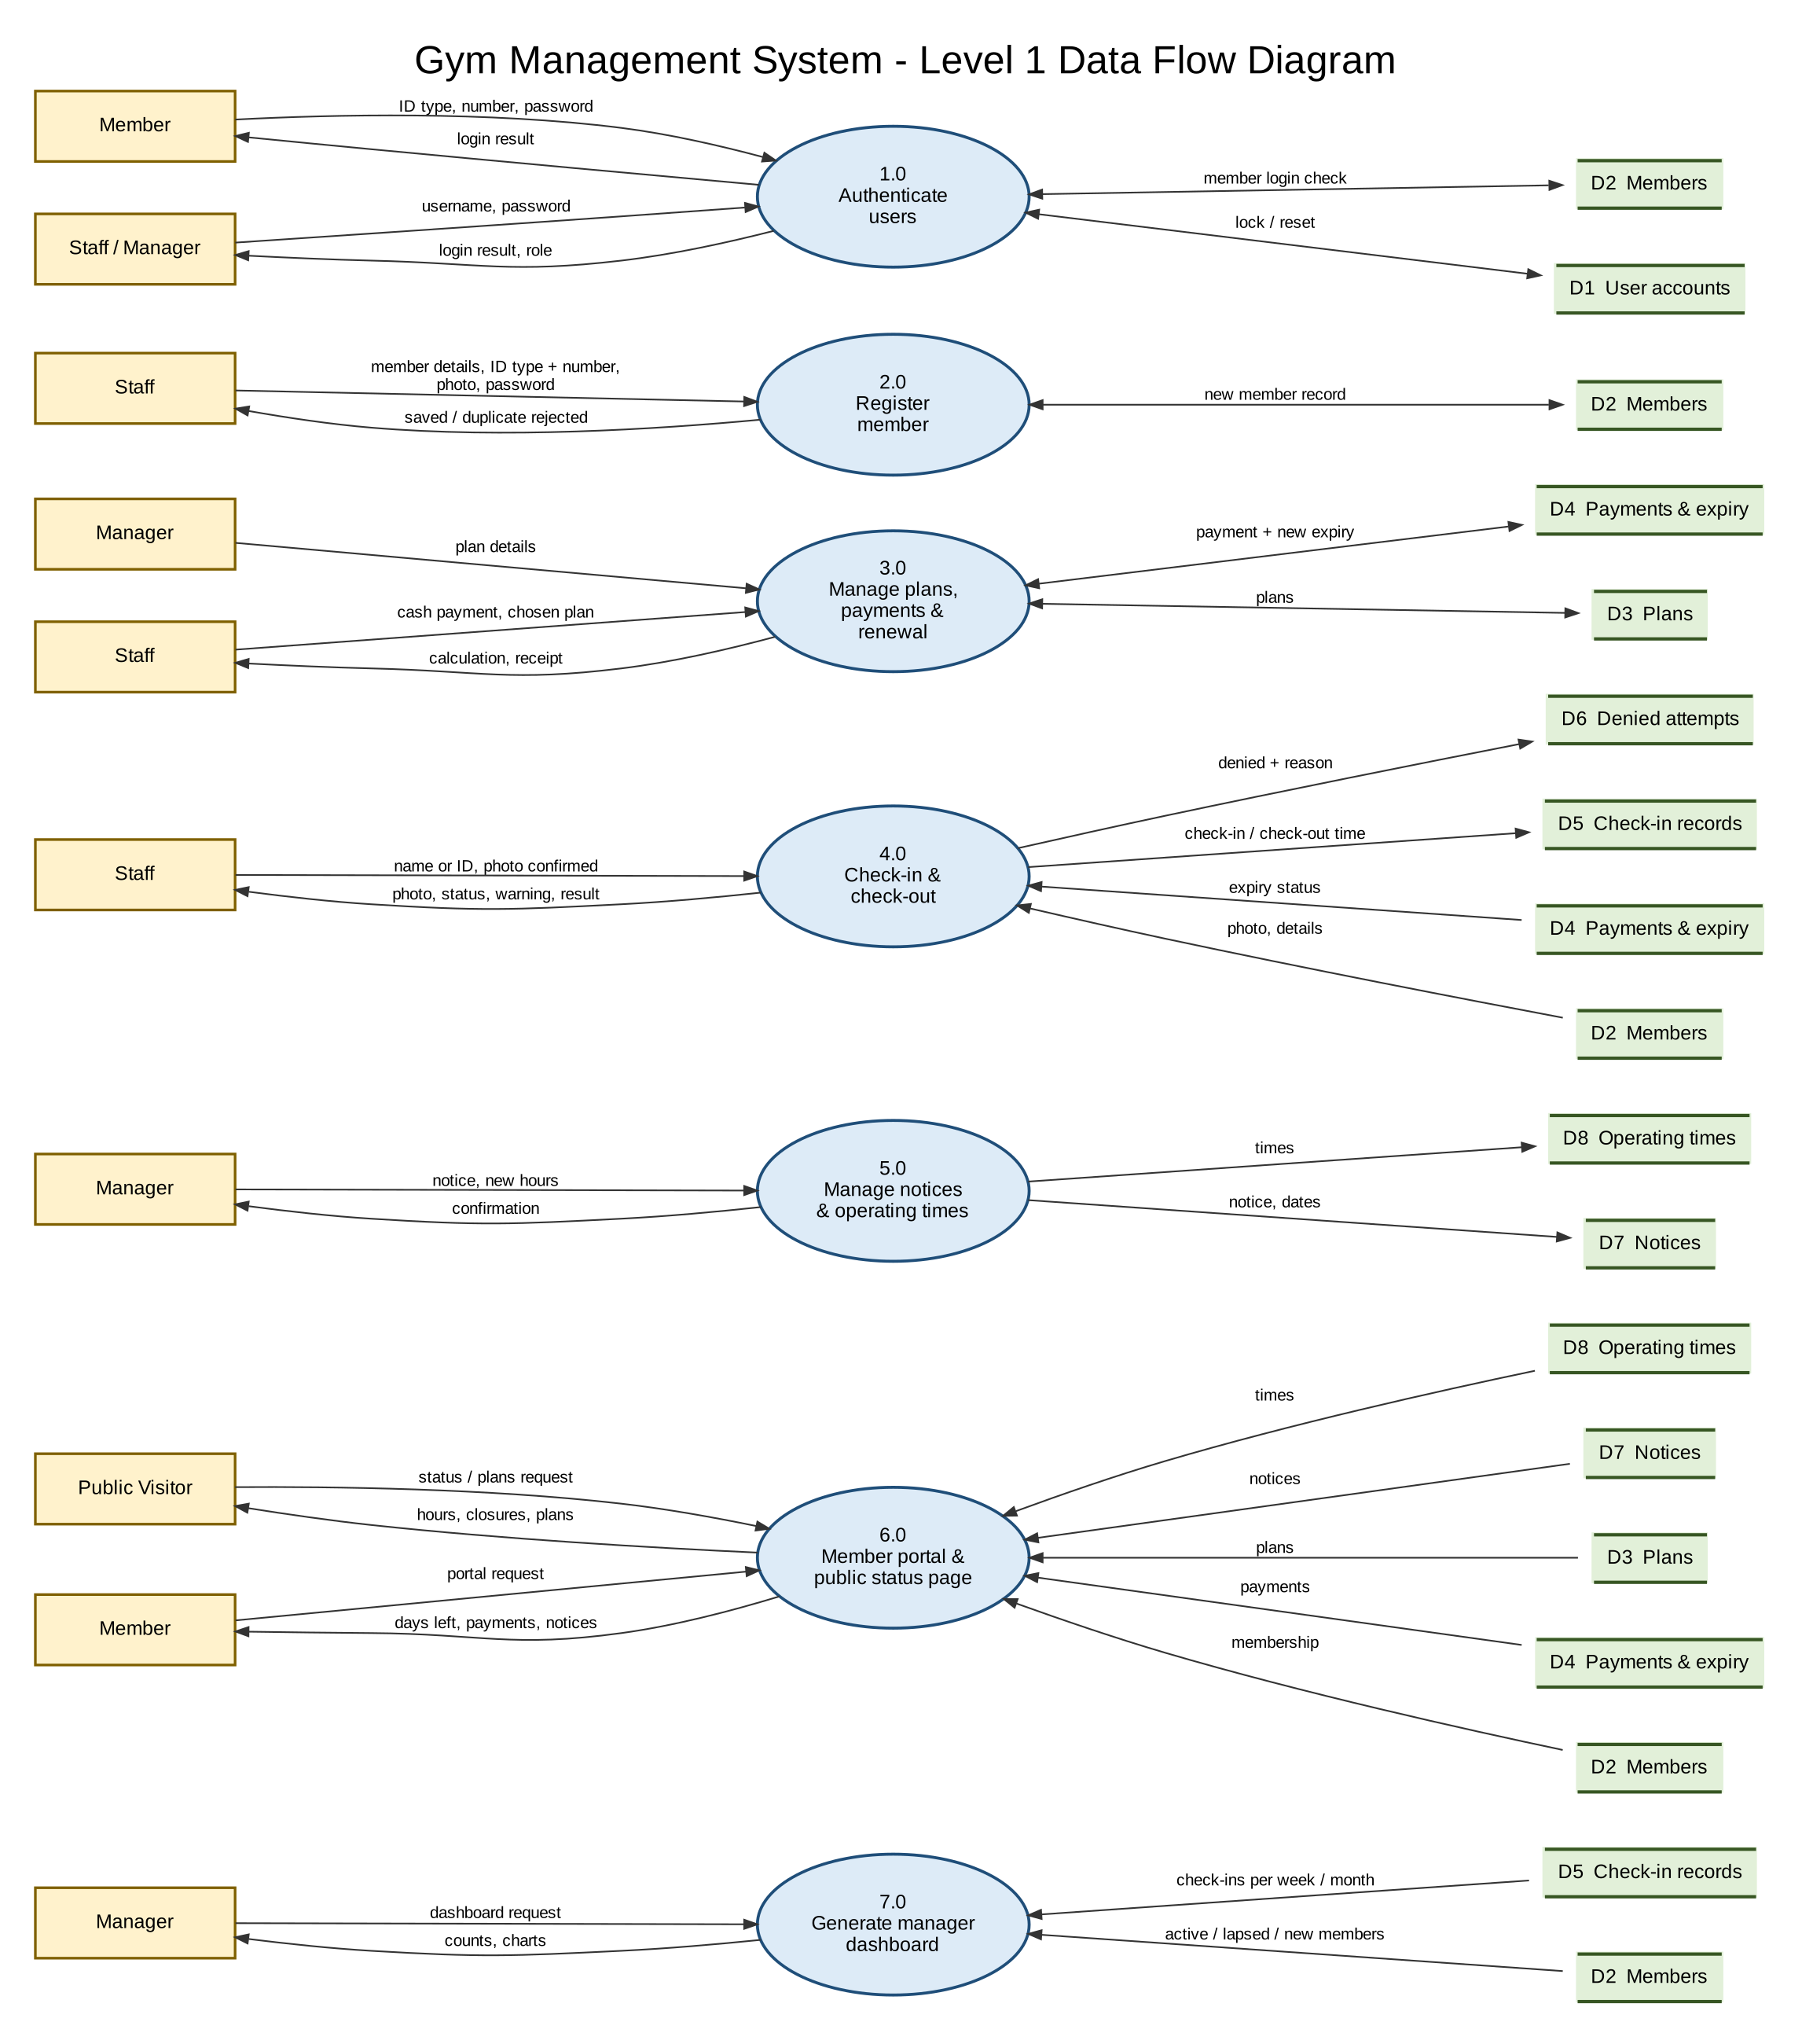
Figure 2: Level 1 data flow diagram
No. | Process | Reads / writes | Requirements
1.0 | Authenticate users | D1 User accounts, D2 Members | FR-AUT
2.0 | Register member | Writes D2 Members | FR-MEM
3.0 | Manage plans, payments and renewal | D3 Plans, D4 Payments and expiry | FR-PLN, FR-PAY
4.0 | Check-in and check-out | Reads D2, D4; writes D5 Check-in records, D6 Denied attempts | FR-CHK, FR-HIS
5.0 | Manage notices and operating times | Writes D7 Notices, D8 Operating times | FR-NOT
6.0 | Member portal and public status page | Reads D2, D3, D4, D7, D8 | FR-PUB, FR-POR
7.0 | Generate manager dashboard | Reads D2, D5 | FR-DSH

3.5 Data Requirements
This is the logical data dictionary. Exact column types are decided in the database design (Project Plan, Week 2).
Entity | Attributes | Rules
User account | id, username, password hash, role (staff or manager), enabled, created date | Username unique.
Member | id, first name, surname, ID type, ID number, photo file location, password hash, failed-login count, locked-until time, status, registration date | ID type + ID number unique. Never deleted.
Plan | id, name, price, duration in days, available for new sales | Duration is a whole number of days.
Payment | id, member, plan, amount, payment date, receipt number, staff member, resulting expiry date | One row per payment; never edited or deleted.
Check-in record | id, member, check-in time, check-out time, confirming staff member | At most one open record per member.
Denied attempt | id, time, ID entered, member (if found), reason, staff member | Never edited or deleted.
Notice | id, message, service affected (or whole gym), start date, end date, posted by, posted at | Shown only between start and end dates.
Service | id, name | Examples: weights area, cardio equipment.
Operating times | id, service (or gym), weekday, opening time, closing time | Weekly schedule.
Time override | id, service (or gym), date, opening time, closing time or closed, changed by | Applies to that date only.
The current expiry date of a member is the expiry date of that member's most recent payment. The system derives it and does not keep a second copy that could disagree with the payments.

3.6 Non-Functional Requirements
ID | Category | Requirement
NFR-01 | Performance | Searching for a member and showing the photo and status shall take less than 2 seconds under normal use (up to 5 staff users and 50 members searching a minute).
NFR-02 | Performance | The public status page shall load in under 3 seconds on a typical phone connection.
NFR-03 | Security | Passwords shall be hashed with a standard password-hashing method. All management functions shall require login and the server shall check the user's role on every request.
NFR-04 | Security | A member shall never be able to read another member's data, tested by trying to request another member's record while logged in.
NFR-05 | Security | The deployed system shall use HTTPS.
NFR-06 | Privacy | Photos and ID numbers shall be visible only to staff and the manager. They shall not appear in reports or on the dashboard. Photo files shall not be stored in a publicly accessible folder.
NFR-07 | Usability | A new staff member shall be able to register a member and check one in after about 15 minutes of guidance, without a manual.
NFR-08 | Usability | The public page and member portal shall be usable on screens from 360 px wide upward.
NFR-09 | Reliability | No payment or check-in shall be lost if the user refreshes the page or loses connection part-way through a save: a save either completes fully or not at all.
NFR-10 | Reliability | The database shall be backed up (exported) at least weekly during development and before the demonstration.
NFR-11 | Compatibility | The system shall work in current versions of Chrome, Firefox and Edge.
NFR-12 | Maintainability | The code shall be modular (one module per area in Section 3.3), documented, and reviewed through pull requests.
NFR-13 | Accuracy | Expiry dates shall follow the rules in Section 3.7 for every test example.
NFR-14 | Availability | The system shall be available during gym opening hours. Planned downtime shall be announced with a notice.

3.7 Business Rules
ID | Rule
BR1 | A membership is active when its expiry date is today or later; otherwise it is expired.
BR2 | Each payment adds the plan's number of days. If the membership is active, the new expiry is the current expiry plus those days (8 days left + 30 days = 38). If it is expired or new, the new expiry is the payment date plus those days.
BR3 | Each member is identified by ID type and ID number together, which must be unique.
BR4 | A check-in is recorded only after a staff member confirms that the person matches the member's photo.
BR5 | Members, payments, check-ins and denied attempts are never deleted.
BR6 | When fewer than 10 days remain, the check-in screen and member portal show a warning, and staff tell the member after confirming identity.
BR7 | Payment is in cash at the front desk, recorded by staff.
BR8 | Every staff member and the manager has an individual account; shared accounts are not allowed.

4. Verification
Each requirement is checked by at least one test, run during Week 5 (and during development for each module). A requirement is met when its test passes. The main acceptance tests, taken from the Project Plan, are below.
Requirements | Acceptance test | Method
FR-AUT-04 to 07 | A staff user cannot open the notices page or dashboard; a disabled account cannot log in; each recorded action shows a username. | System test
FR-AUT-09 | Five wrong member passwords lock the account for a short time. | System test
FR-MEM-03, 04 | A duplicate ID type and number is rejected; a member cannot be saved without a photo. | Unit + system test
FR-MEM-08, BR6 | A member with 9 days remaining shows the warning at check-in and on the portal. | System test
FR-PAY-03, 04, NFR-13 | 8 days left + 30-day plan gives 38 days remaining; an expired member renewing gets 30 days from the payment date. | Unit test
FR-PAY-06 | A payment record shows the staff member and receipt number. | System test
FR-CHK-03, 05, 06 | No check-in without Confirm; an expired member is blocked; a second check-in while inside is refused. | System test
FR-HIS-03 | Each refused check-in produces a denied-attempt record with the right reason. | System test
FR-HIS-01 | An expired member's record, payments and check-ins can still be found. | System test
FR-NOT-01 to 03, FR-PUB-01, 02 | A closure posted for tomorrow shows on the public page without login, and disappears after its end date. | System test
FR-NOT-05 | A one-off change shows for that day only; the weekly times return afterwards. | System test
FR-POR-04, NFR-04 | A logged-in member cannot read another member's record. | Security test
FR-DSH-02 to 05 | Dashboard figures match a manual count of the test data; charts change after new check-ins. | System test
NFR-01, 02 | Search and public page timings are measured with test data. | Performance check
NFR-07 | A team member unfamiliar with the system registers and checks in a member after a short walkthrough. | Usability test

4.1 Requirements Traceability to the Problem Statement
Problem or objective | Requirements that address it
Impersonation at entry | FR-MEM-03, FR-MEM-04, FR-CHK-03, FR-CHK-05, FR-HIS-03, BR3, BR4
Closures with no notice | FR-NOT-01 to 07, FR-PUB-01 to 04, FR-POR-02
Paper records and missed expiries | FR-MEM, FR-PAY, FR-HIS-01, BR1, BR2, BR6
Manager has no overview | FR-DSH-01 to 07
Staff accountability | FR-AUT-02, FR-AUT-06, FR-CHK-04, FR-PAY-06, BR8

Appendix A: Open Issues
These points need confirmation from the gym. The default is used in this SRS until the gym answers.
No. | Question | Default | Affects
1 | May people under 18 join (a birth certificate suggests this)? Is a parent or guardian's consent needed? | Allowed; guardian name and phone recorded for under-18s | FR-MEM-01
2 | Should there be a limit on days paid in advance? | No limit | FR-PAY-03
3 | What are the opening hours, and which services and equipment have a status shown? | Entered by the manager after launch | FR-NOT-04
4 | Does the gym already use receipt numbers for cash payments? | System generates a receipt number | FR-PAY-06
5 | Who may see member photos and ID numbers? | Staff and manager only | NFR-06
6 | What is the gym's closing time for automatic check-out? | Set by the manager in operating times | FR-CHK-09

Appendix B: Out of Scope
- Mobile app (the website works on phones).
- Email and SMS notifications.
- Online and card payments.
- Biometric or card-reader entry.
- Equipment booking and class scheduling.

Appendix C: Mapping to Project Plan Requirements
Plan ref. | Title in the Project Plan | SRS requirement groups
R1 | Staff Accounts and Access | FR-AUT-01 to 07, FR-AUT-10
R2 | Manager Tools: Notices and Operating Hours | FR-NOT, FR-PUB-01, 02
R3 | Member Registration and Records | FR-MEM
R4 | Membership Plans and Member Portal | FR-PLN, FR-PUB-03, 04, FR-POR, FR-AUT-08, 09
R5 | Payment and Renewal | FR-PAY
R6 | History of Members, Payments and Check-ins | FR-HIS, FR-MEM-09
R7 | Check-in and Check-out | FR-CHK
R8 | Manager Dashboard | FR-DSH

