GYM MANAGEMENT SYSTEM
  - Reconciled ER Diagram and UML Class Diagram
Version 3.0 (proposed review update) | 18 October 2026 | CSC491 | Design baseline: Project Plan V2 and SRS V1.0

Purpose of this revision
The attached original two-page diagram document was checked against the existing Project Plan V2 (15 pages) and Software Requirements Specification V1.0 (16 pages). The diagrams were revised to express the specified member identity, gym-level attendance, cash receipts, membership expiry, notices, staff permissions and audit requirements. The underlying Project Plan and SRS have not themselves been edited.

Key changes to the original models
Model area | Correction applied
Authentication | Member credentials live in MEMBER; STAFF_ACCOUNT is for staff and manager roles only.
Member identity | Added required ID type/number, photo, password hashing and failed-login lock fields.
Membership / payments | Removed duplicate MEMBERSHIP expiry storage; plan and expiry are derived from immutable payments.
Check-in / denial | Added confirming staff, checkout metadata, member-level entry, and denial reason/actor.
Manager communication | Whole-gym and service-specific notices, weekly hours, one-day overrides and audit events.
Scope control | Removed daily check-in limits and plan-to-service access restrictions not specified in the SRS.
Integrity | One open check-in per member; unique ID pair and receipts; immutable payment/attendance history.

How to read the following diagrams
The ER model is divided into two coordinated views to keep database fields legible: (A) identity, memberships and access logs and (B) services, notices and opening hours. The UML class model is likewise presented in two domain views. STAFF_ACCOUNT and AUDIT_EVENT appear in both views for readability; they represent the same underlying entities, not duplicate tables.
PK = primary key; FK = foreign key; NULL = optional; 1 / 0..* = cardinality. A nullable SERVICE reference means “whole gym”. Fields marked * are optional or awaiting client policy confirmation.
Approval status: Technical reconciliation proposed. Client decisions and coordinated SRS/plan wording changes are listed on the final pages.

1. Entity–relationship diagram: Identity, payments and attendance
One member has many payments and check-ins. A valid check-in must be confirmed by an identifiable staff user; payment history is the authoritative source for the member’s current plan and expiry.
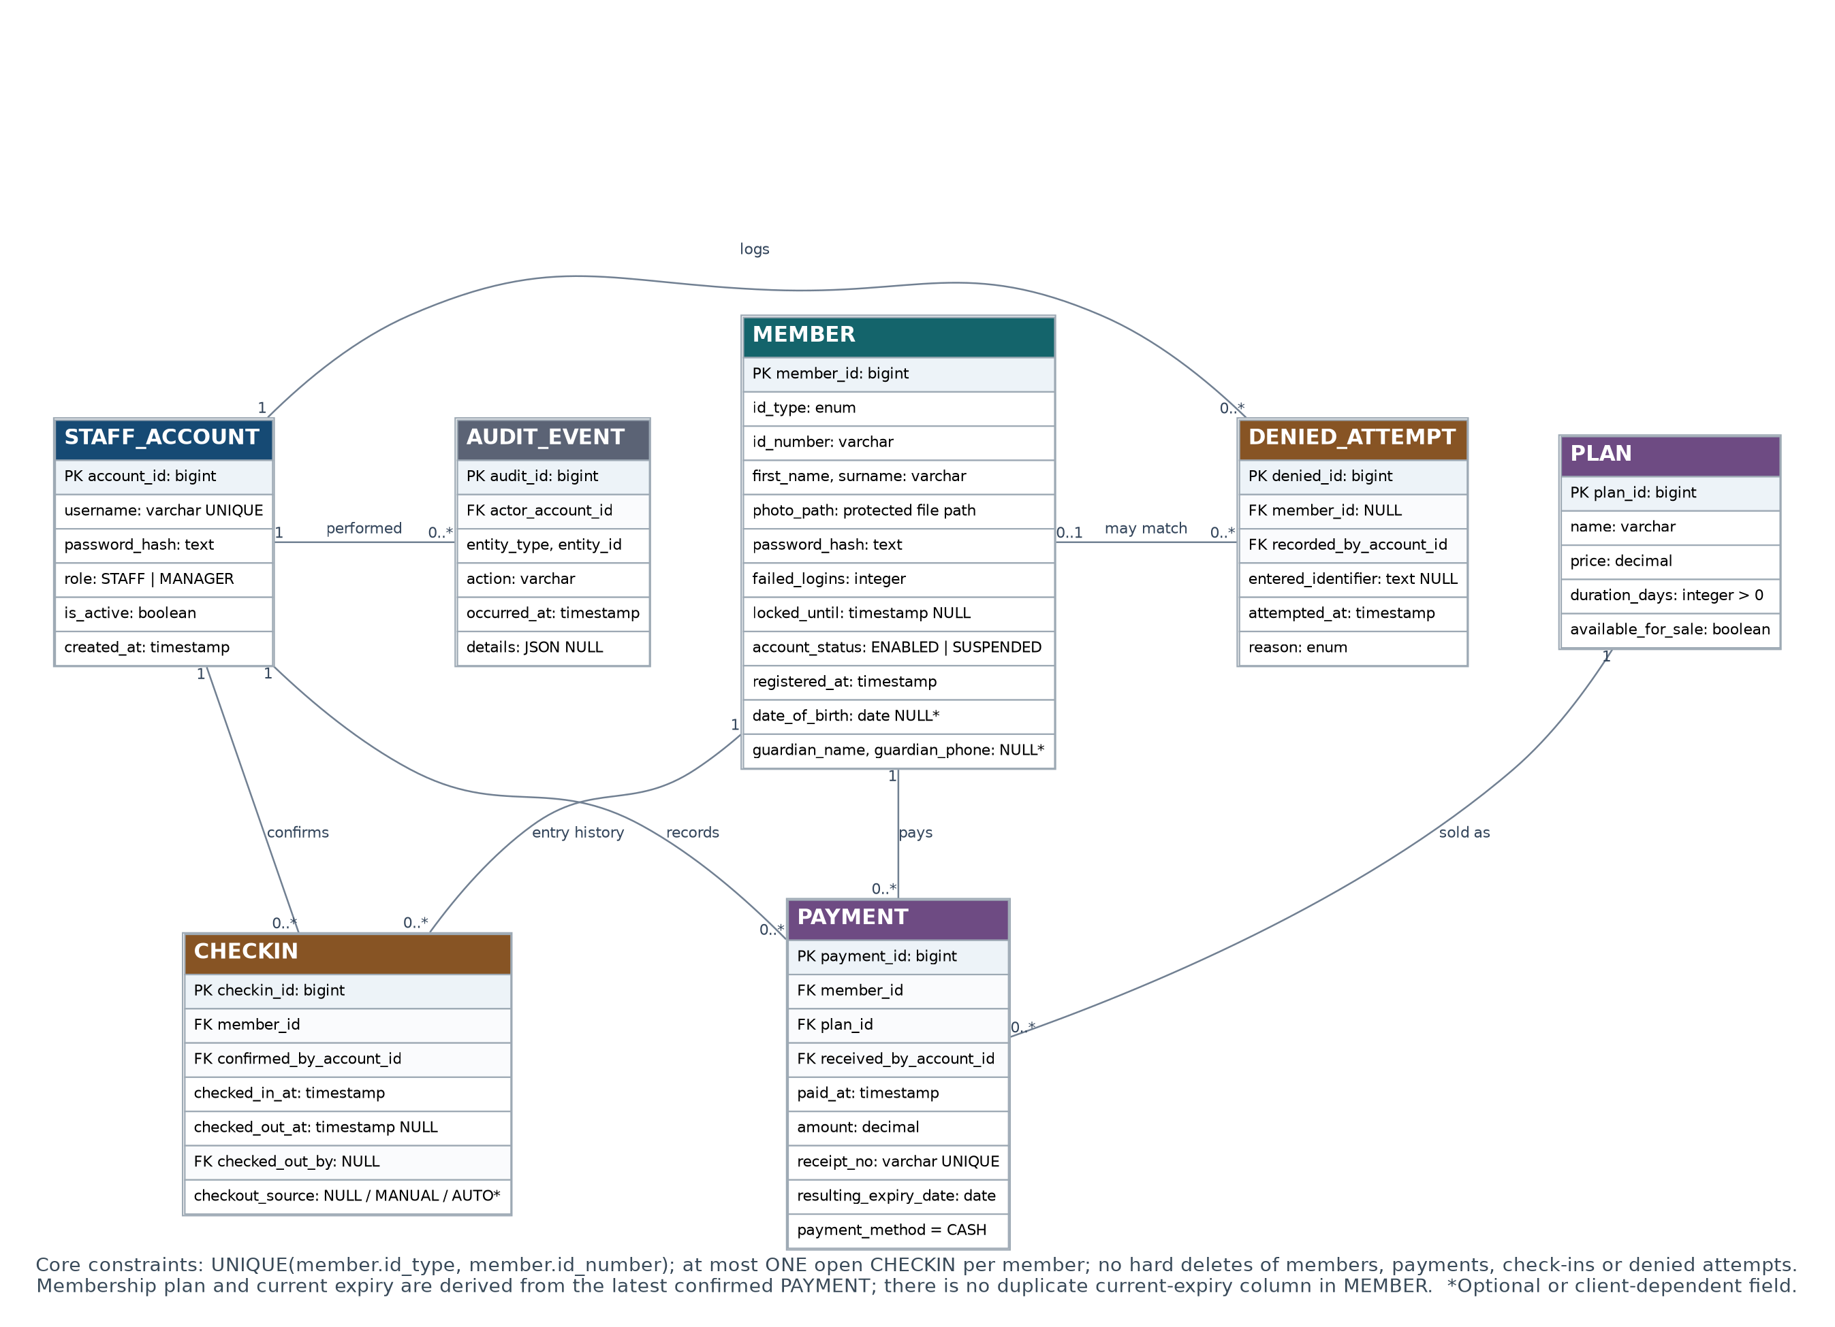
Figure 1A. Logical ER model — identity, membership payments, check-in and denial history.
Security/integrity: member photos must be held in protected storage. A check-in is permitted only when the member account is enabled and the derived membership is active. Member, payment, check-in and denied-attempt records must not be hard-deleted.

2. Entity–relationship diagram: Notices and opening hours
SERVICE means a physical gym area. A NULL service reference scopes a notice or schedule to the gym as a whole. This model does not impose any plan-to-service restrictions.
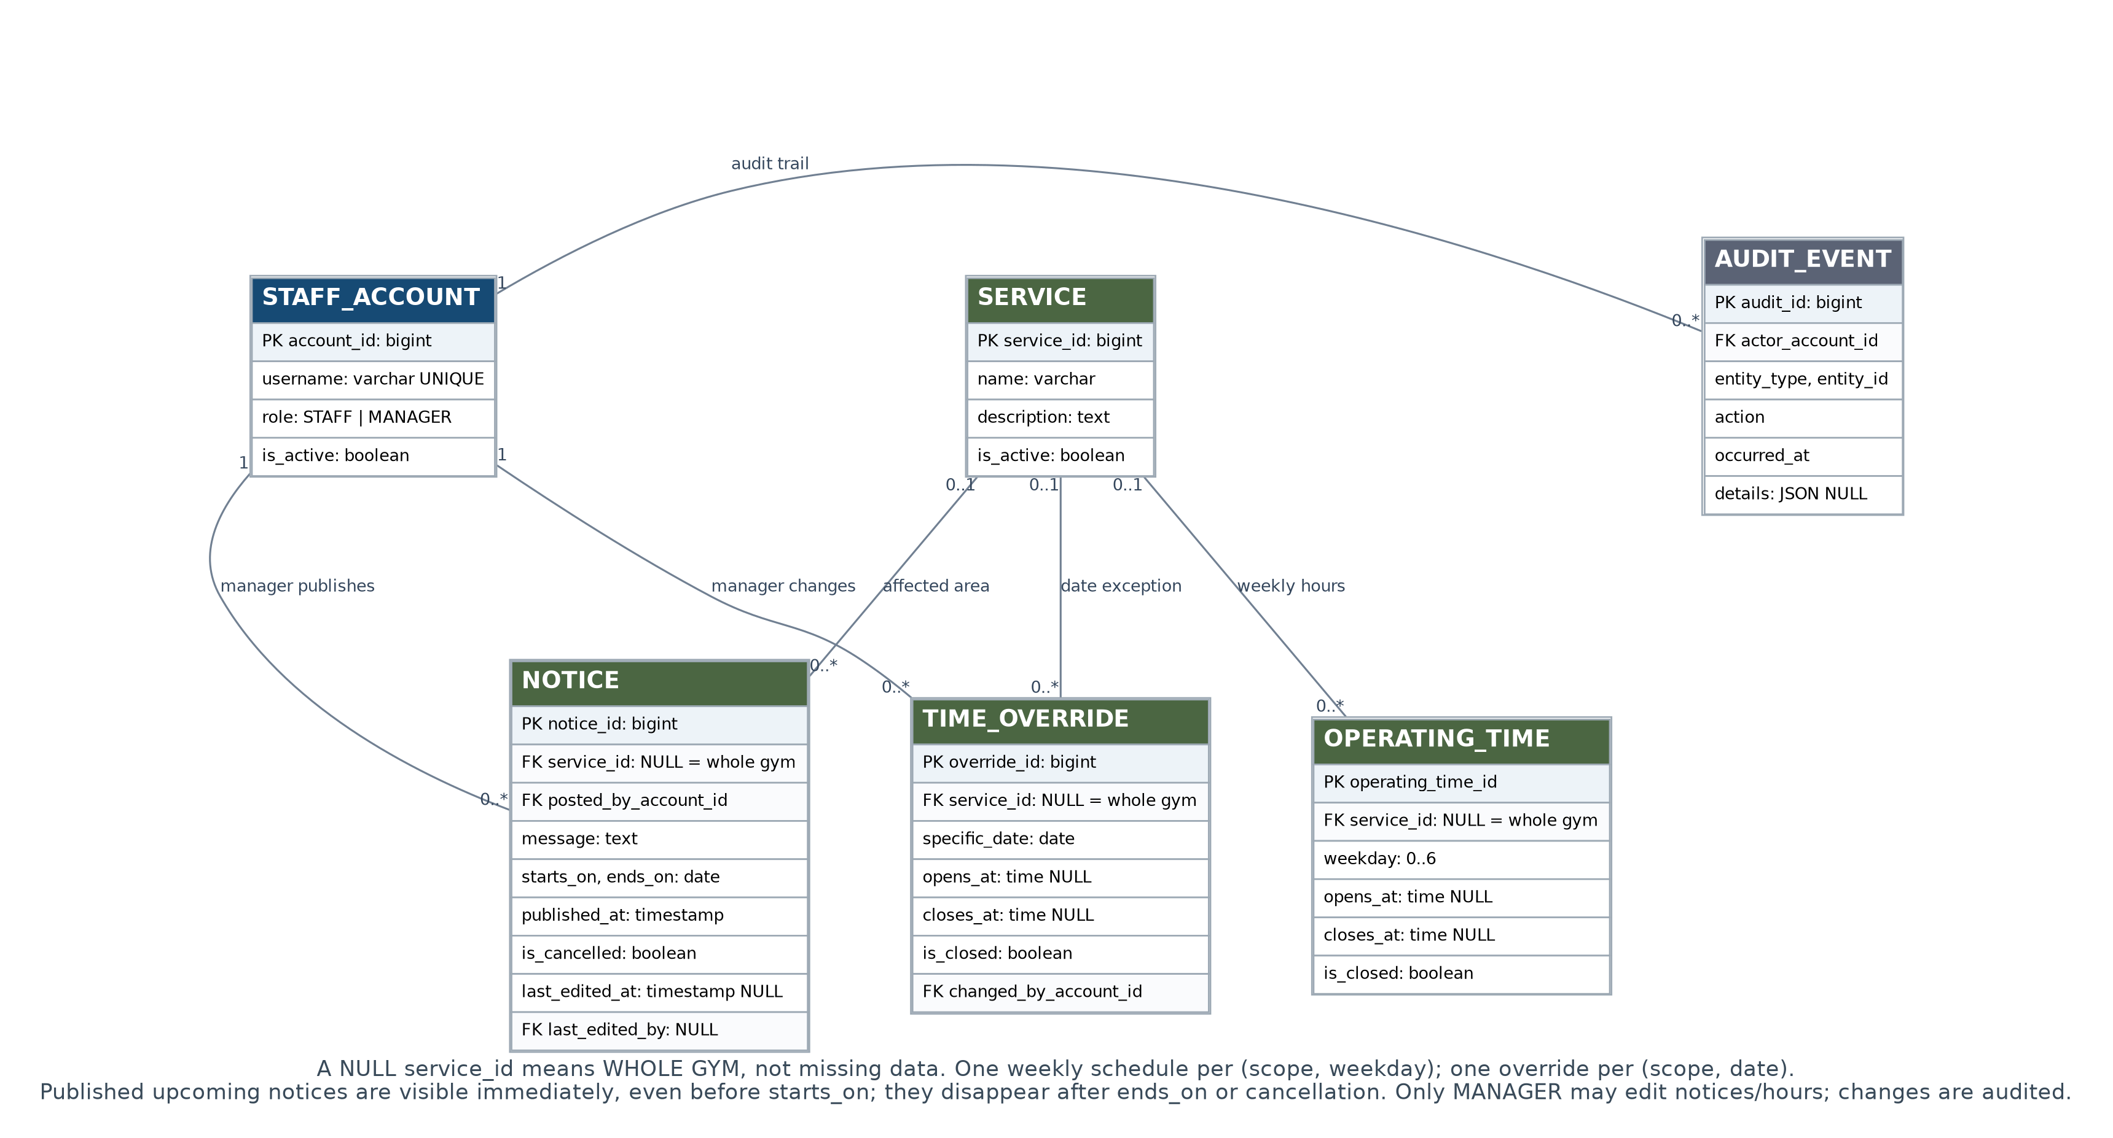
Figure 1B. Logical ER model — whole-gym and service-level notices, schedules and changes.
Public notices: a future-dated closure is published immediately but labelled “upcoming”; it becomes “in effect” on its start date and disappears after its end date or cancellation. All changes to notice and operating hours must create AUDIT_EVENT entries.

3. UML class diagram: Identity and membership workflows
Domain classes are separate from application services. MembershipPolicy centralises expiry arithmetic; CheckInService enforces explicit staff photo confirmation and records both successful and refused entry attempts.
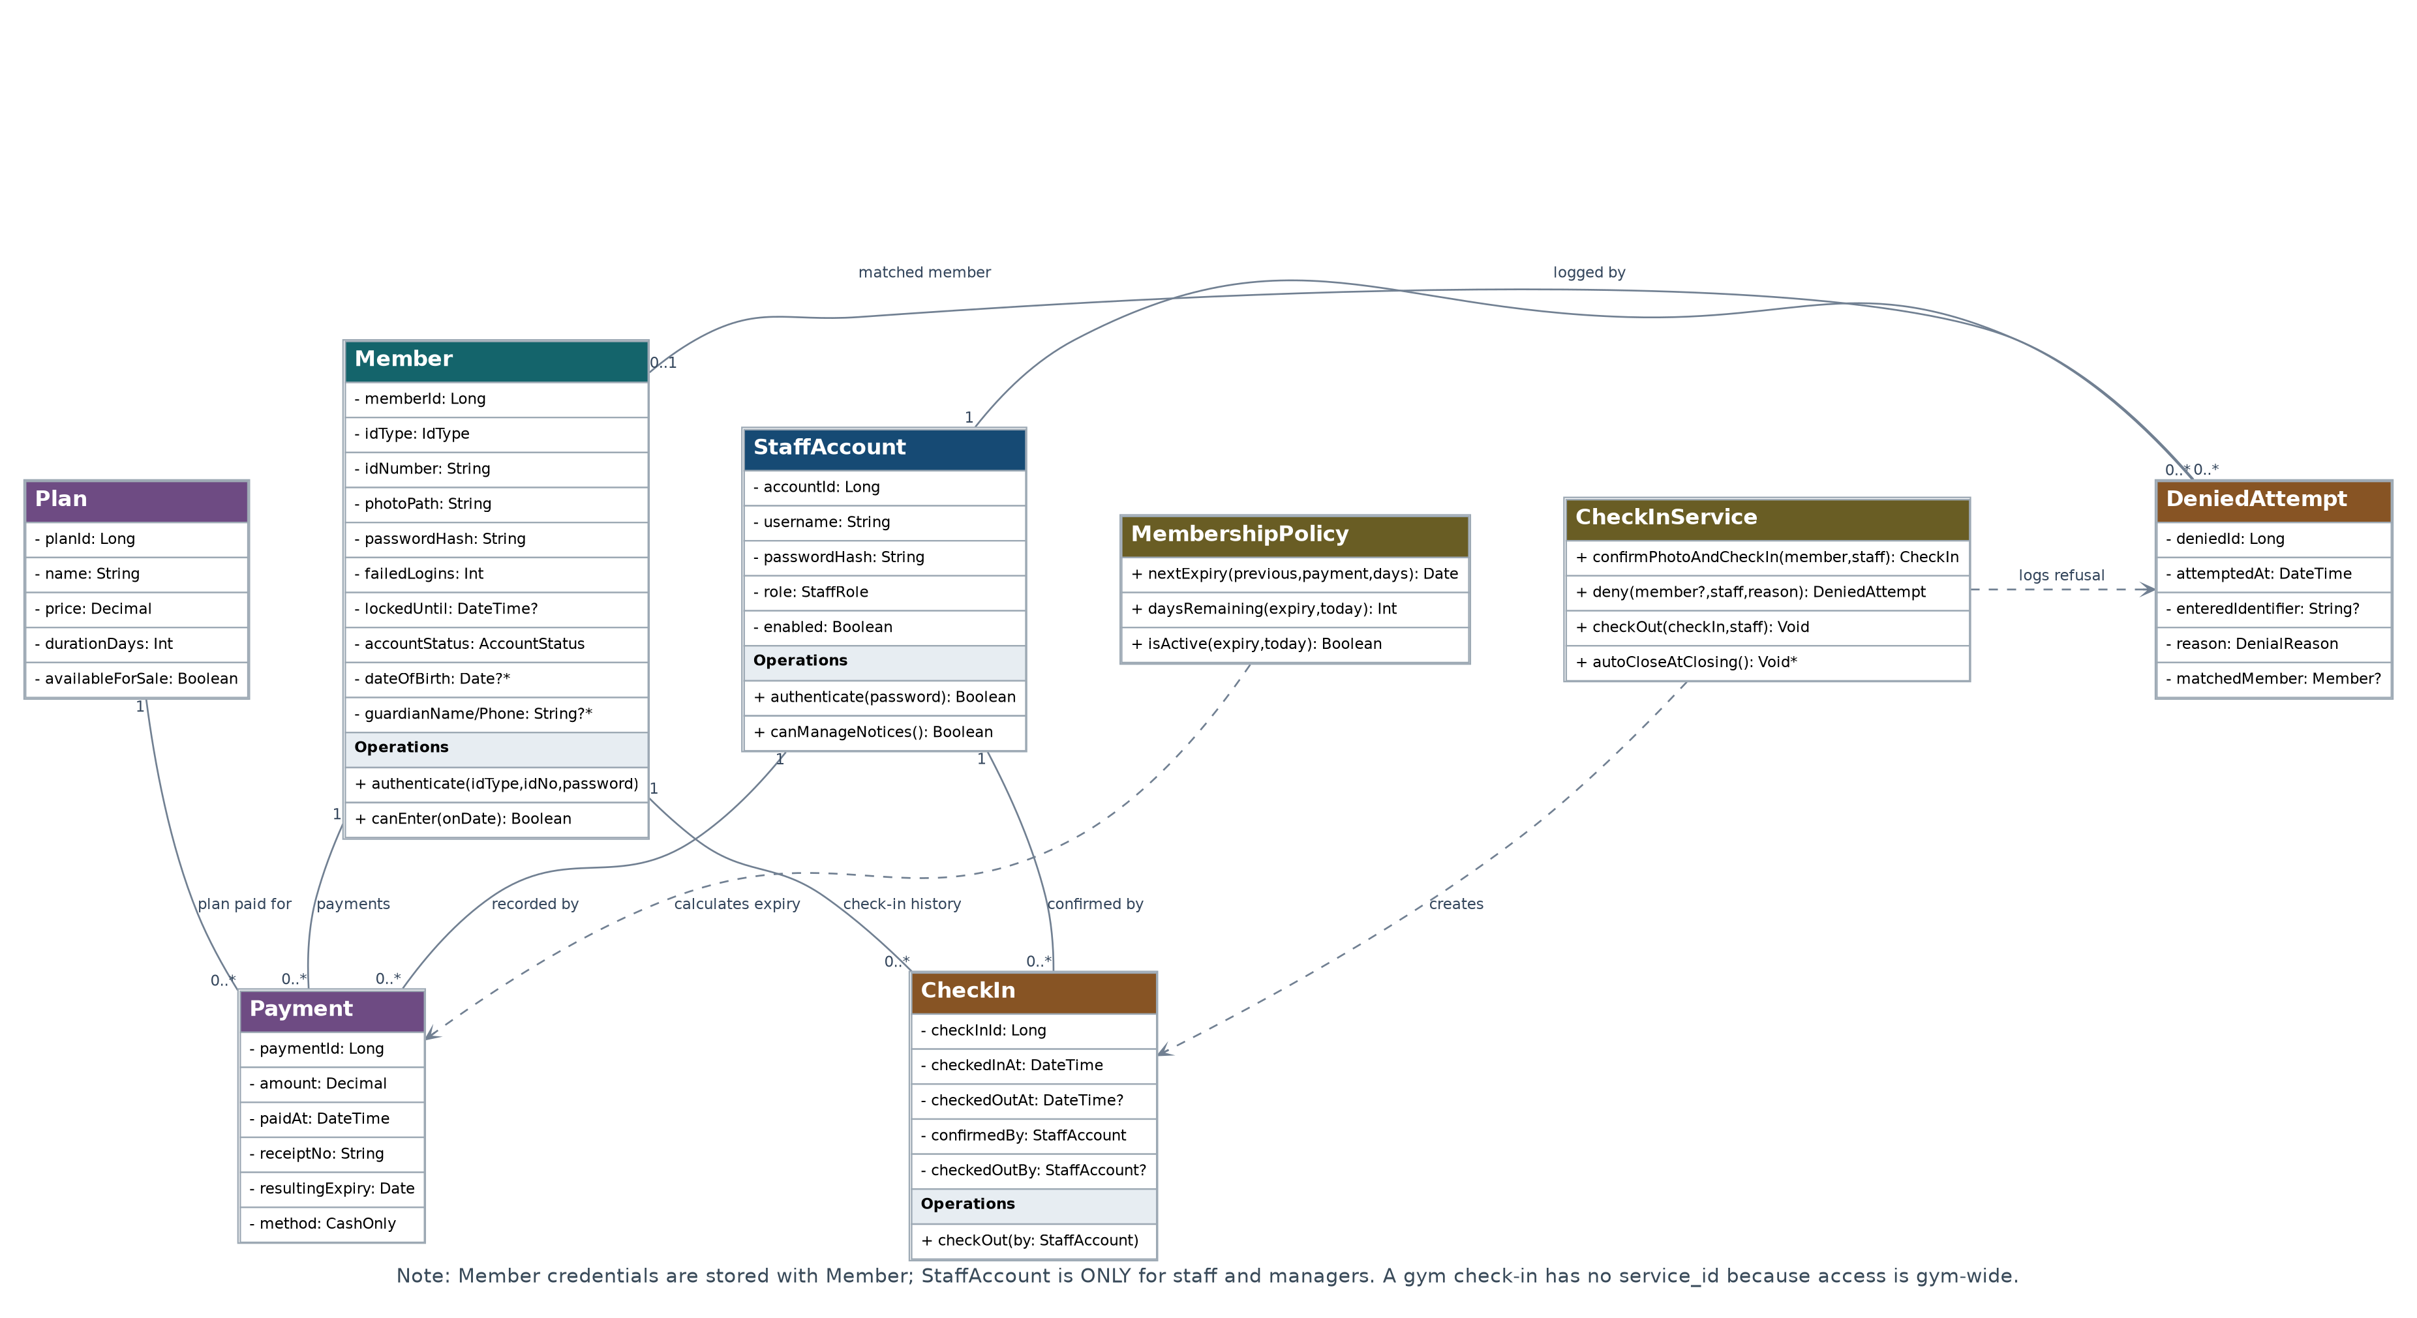
Figure 2A. UML class relationships — member identity, membership payments and entry control.
Automatic closing-time checkout is modelled as optional (*) in accordance with SRS FR-CHK-09 (“Should”), until the Project Plan completion criterion is updated.

4. UML class diagram: Communications and operating hours
NoticeService publishes and lists both current and future announcements. OperatingTime represents normal weekly hours; TimeOverride changes one named calendar date only.
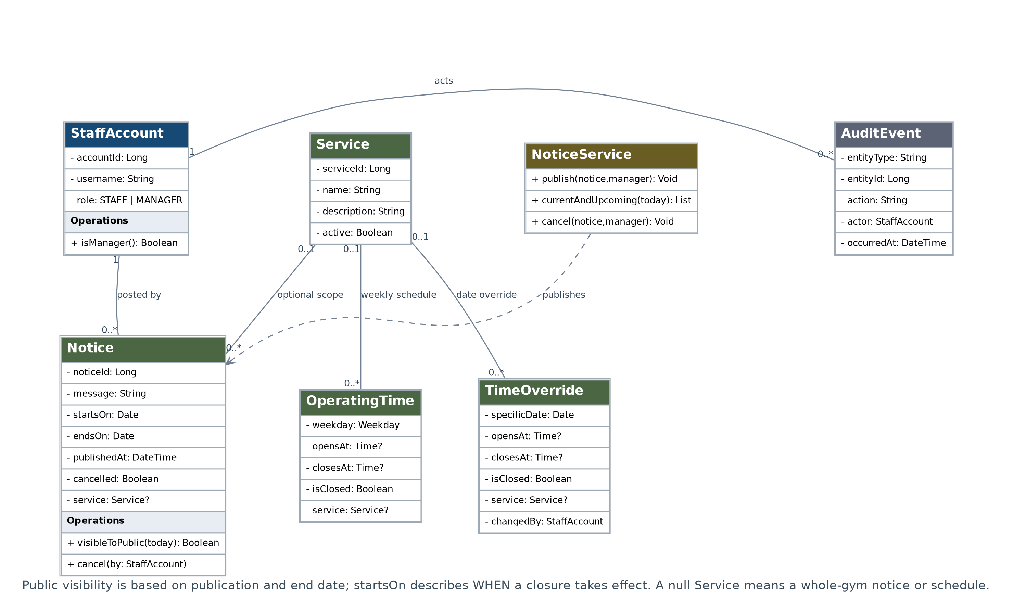
Figure 2B. UML class relationships — published gym status, service hours and manager auditing.
Managers can post/cancel notices and change hours; front-desk staff cannot manage notices. Everyone, including staff, may read the public status page without authentication.

5. Required alignment with Project Plan V2 and SRS V1.0
These are proposed text changes needed so that the revised diagrams and existing documents express the same behaviour. They are not claims that the client has already agreed to a new business rule.
Issue / references | Recommended exact rule to add or amend
Future closure notices (Plan R2; SRS UC-08, FR-NOT) | A published notice is visible immediately, even for a future closure. Show whether the interruption is upcoming or currently effective; hide it after its end date or cancellation.
Single authoritative expiry (Plan R3; SRS §3.5) | MEMBER does not store a second current-expiry value. The latest confirmed PAYMENT stores resulting_expiry_date and its PLAN. All current membership views derive their status from payment history.
Expiry-day counting (BR1, BR2, FR-PAY-04) | Proposed inclusive-date policy: for a new/expired membership, expiry = local payment date + duration_days − 1. For an active renewal, expiry = current expiry + duration_days. Days left = max(0, expiry − today + 1). Client approval required.
Manual account status (Plan R3; SRS FR-MEM-09) | Account status ENABLED/SUSPENDED is stored separately from derived membership ACTIVE/EXPIRED. Only enabled accounts with active membership can enter.
Automatic checkout priority (Plan R7; FR-CHK-09) | Mark automatic closing-time checkout optional in the Plan (“Should”), or promote it to “Must” in the SRS; both must match. This design supports optional automatic checkout.
Minors/guardian fields (open issue A1) | Guardian name and phone are provisionally nullable. Confirm age verification, parental consent and permitted collection before requiring or deploying them.
Receipt numbers (open issue A4) | Each cash payment has a unique receipt number. Either staff enter a gym-issued number or the system generates it after client confirmation.

Acceptance checks for the corrected diagrams
- Entry cannot be saved without a staff confirmation; rejected attempts retain reason and actor.
- A member with a duplicate (ID type, ID number) cannot be registered.
- One member cannot have two simultaneous open check-ins.
- New/renewed memberships derive days left consistently from payment records.
- An upcoming closure is visible to public visitors before it starts.
- Whole-gym and per-service schedules, including dated overrides, resolve correctly.

6. Implementation notes and scope safeguards

Relational constraints
- Unique identities — Add a composite unique constraint on MEMBER(id_type, id_number). Enforce NOT NULL for mandatory registration fields, including the protected photo path.
- Single open check-in — Use a partial unique index on CHECKIN(member_id) where checked_out_at IS NULL. Record staff identity on creation; an automatic checkout may have no checkout staff.
- Whole-gym hours — For schedule rows with NULL service_id, use separate partial uniqueness constraints so duplicate gym-wide weekday/date rows are rejected.
- Payment history — Store each cash payment with a unique receipt and staff actor. Use a transaction for the initial registration/payment and for renewals. Retain payment records without hard deletion.
- Audit — For notice/operating-time changes, record the actor, affected record, action and timestamp in AUDIT_EVENT; ensure only a MANAGER account can perform these modifications.
- Protected member photo — Use access-controlled photo URLs/paths and upload validation. Photos must not be public, visible in member portal, or placed in reports.
- No plan-to-service join — All active memberships grant gym-wide access, as stated in the uploaded diagram’s design note. Revisit only if the client explicitly requests tiered gym-area restrictions.

Outstanding client confirmations
Confirm rules for minors and guardian details; allowable prepaid renewal length; actual opening hours and service list; receipt-number policy; photo/ID access; and closing-time check-out operations. Until approved, these remain documented assumptions, not completed requirements.

Scope and traceability
ER/UML identity classes address R1, R3, R4 and SRS FR-AUT/FR-MEM/FR-POR; payment and expiry classes address R5 and FR-PAY/BR1–BR2; attendance and denials address R6–R7 and FR-CHK/FR-HIS; notices and schedule classes address R2 and FR-NOT/FR-PUB; reporting (R8/FR-DSH) is computed from MEMBER and CHECKIN records rather than stored as an entity.
Source baseline: Gym Management System Project Plan Version 2.0, Sections 6–9 and 13; Gym Management System SRS Version 1.0, Sections 3.3–3.7, 4, and Appendices A–C; uploaded Gym Management System – Corrected Diagrams (2 pages).
Document status: Revised diagrams are suitable as a proposed design baseline after the listed business-rule approvals and SRS/plan consistency edits.

