FORENSIC ANALYSIS REPORT
Post-Separation Abuse Pattern Analysis
& Court Case Review

Case: Cales v. Cales
Case Number: 2020-DR-32-1949
Jurisdiction: Lexington, SC

Report Date: April 07, 2026

CONFIDENTIAL — ATTORNEY-CLIENT PRIVILEGED

Table of Contents
[This table of contents should be updated after final report generation. Right-click and select 'Update Field' in Microsoft Word.]

1. Executive Summary
Case Name: Cales v. Cales
Case Number: 2020-DR-32-1949
Jurisdiction: Lexington, SC
Report Date: 2026-04-07 05:17
Data Sources: 8
Total Incidents Analyzed: 46

Case Duration
Case Start: 1996-08-09
Most Recent Filing: 2022-02-04
Duration Days: 9310
Duration Months: 305.8
Duration Years: 25.49
Total Filings: 12
Filings Per Month: 0.04

Abuse Severity Summary
Avg Severity: 6.26
Max Severity: 9.18
Escalation Trend: STABLE
Case Outcome Score: 50.9/100 (MODERATE risk)
Violations Found: 1
Officials Tracked: 12
Connections Found: 10

2. Post-Separation Abuse Analysis

2.1 Classification Methodology
Incidents were classified using a standardized taxonomy of post-separation abuse categories, each with defined behavioral traits and severity weights. The classification system is aligned with definitions from the Violence Against Women Act (VAWA) and established domestic violence research.

2.2 Composite Abuse Severity Index (CASI)
Formula: CASI = Σ(Wi × Ti × Fi × Ei) × Rm × Cp
Wi — Category Severity Weight: Pre-assigned weight based on abuse category severity
Ti — Trait Match Ratio: Proportion of category traits matched in incident
Fi — Frequency Multiplier: Normalized frequency of incidents per month. Fi = (incidents_this_month / avg_monthly_incidents)
Ei — Evidence Strength Factor: Strength of supporting evidence: 0.2=self-report only, 0.4=witness corroboration, 0.6=documented communication, 0.8=official record, 1.0=court-verified evidence
Rm — Recency Multiplier: Exponential decay based on time since incident. Rm = e^(-λ × days_since), λ=0.01
Cp — Cumulative Pattern Factor: Measures escalation trend. >1.0 indicates escalation, <1.0 indicates de-escalation. Calculated via linear regression slope of severity over time.

2.3 Incident Classification Results
Date | Behavior Description | Evidence Type | Evidence Strength | Children Present | Substance Use Noted | Police Called | Court Date Proximity | Category | Primary Abuse Type | Severity Score | Severity Level | Categories Matched | All Types | Matched Traits | Frequency Multiplier | Days Since | Recency Multiplier | Pattern Factor | Casi Score
2020-11-04 00:00:00 | Filed divorce complaint - Megan initiated separation | court_record | 0.8 | no | none | no | 0 | legal_abuse | Legal/Litigation Abuse | 6.41 | SEVERE | 5 | Legal/Litigation Abuse; Psychological/Emotional Abuse; Substance Abuse Related; Coercive Control; Financial Abuse | discovery_abuse; court_shopping; misrepresentation_to_court; minimizing_abuse; denying_abuse; alcohol_abuse_present; weaponizing_court_system; running_up_legal_fees | 0.32608695652173914 | 721 | 0.0007391571554628196 | 0.9988350292938636 | 0.001
2020-12-15 00:00:00 | Defendant filed counterclaim and proposed parenting plan within days of being served | court_record | 0.9 | no | none | no | 1 | coercive_control | Legal/Litigation Abuse | 3.48 | MODERATE | 3 | Legal/Litigation Abuse; Substance Abuse Related; Coercive Control | court_shopping; misrepresentation_to_court; driving_impaired_with_children; weaponizing_court_system | 0.6521739130434783 | 680 | 0.0011137751478448032 | 0.9988350292938636 | 0.002
2020-12-17 00:00:00 | Consent temporary order issued - initial custody arrangement | court_record | 1.0 | yes | none | no | 0 | legal_abuse | Substance Abuse Related | 8.48 | CRITICAL | 5 | Substance Abuse Related; Legal/Litigation Abuse; Coercive Control; Psychological/Emotional Abuse; Financial Abuse | alcohol_abuse_present; substance_during_custody; discovery_abuse; court_shopping; misrepresentation_to_court; threatening_custody_loss; weaponizing_court_system; minimizing_abuse; denying_abuse; runni | 0.6521739130434783 | 678 | 0.0011362748983197658 | 0.9988350292938636 | 0.006
2021-01-07 00:00:00 | GAL Emily Hinson appointed to case | court_record | 1.0 | yes | none | no | 0 | legal_abuse | Legal/Litigation Abuse | 6.41 | SEVERE | 5 | Legal/Litigation Abuse; Psychological/Emotional Abuse; Substance Abuse Related; Coercive Control; Financial Abuse | discovery_abuse; court_shopping; misrepresentation_to_court; minimizing_abuse; denying_abuse; alcohol_abuse_present; weaponizing_court_system; running_up_legal_fees | 0.32608695652173914 | 657 | 0.0014017974121366744 | 0.9988350292938636 | 0.003
2021-05-18 00:00:00 | GAL filed first affidavit - Emily Hinson | court_record | 0.8 | yes | none | no | 0 | legal_abuse | Legal/Litigation Abuse | 6.41 | SEVERE | 5 | Legal/Litigation Abuse; Psychological/Emotional Abuse; Substance Abuse Related; Coercive Control; Financial Abuse | discovery_abuse; court_shopping; misrepresentation_to_court; minimizing_abuse; denying_abuse; alcohol_abuse_present; weaponizing_court_system; running_up_legal_fees | 0.32608695652173914 | 526 | 0.005195304718705231 | 0.9988350292938636 | 0.009
2021-12-16 00:00:00 | Defendant filed motion for temporary relief and motion to extend 365 day rule | court_record | 0.9 | yes | none | no | 28 | legal_abuse | Legal/Litigation Abuse | 6.41 | SEVERE | 5 | Legal/Litigation Abuse; Psychological/Emotional Abuse; Substance Abuse Related; Coercive Control; Financial Abuse | discovery_abuse; court_shopping; misrepresentation_to_court; minimizing_abuse; denying_abuse; alcohol_abuse_present; weaponizing_court_system; running_up_legal_fees | 0.6521739130434783 | 314 | 0.043282797901965896 | 0.9988350292938636 | 0.163
2021-12-20 00:00:00 | Plaintiff attorney Hawkins filed motion to relieve counsel - leaving mother unrepresented | court_record | 0.9 | yes | none | no | 36 | legal_abuse | Substance Abuse Related | 7.58 | SEVERE | 5 | Substance Abuse Related; Legal/Litigation Abuse; Psychological/Emotional Abuse; Coercive Control; Financial Abuse | alcohol_abuse_present; drug_use_present; discovery_abuse; court_shopping; misrepresentation_to_court; minimizing_abuse; denying_abuse; weaponizing_court_system; running_up_legal_fees | 0.6521739130434783 | 310 | 0.0450492023935578 | 0.9988350292938636 | 0.2
2022-01-13 00:00:00 | Motion for supplemental relief hearing - defendant seeking changed custody | court_record | 0.8 | yes | none | no | 0 | coercive_control | Coercive Control | 4.38 | HIGH | 3 | Coercive Control; Legal/Litigation Abuse; Substance Abuse Related | threatening_custody_loss; weaponizing_court_system; court_shopping; misrepresentation_to_court; substance_during_custody | 0.6521739130434783 | 286 | 0.05726876026546736 | 0.9988350292938636 | 0.131
2022-01-25 00:00:00 | Motion hearing - plaintiff unrepresented after attorney withdrawal | court_record | 0.8 | yes | none | no | 0 | legal_abuse | Substance Abuse Related | 8.74 | CRITICAL | 5 | Substance Abuse Related; Legal/Litigation Abuse; Psychological/Emotional Abuse; Coercive Control; Financial Abuse | alcohol_abuse_present; drug_use_present; driving_impaired_with_children; discovery_abuse; court_shopping; misrepresentation_to_court; minimizing_abuse; denying_abuse; weaponizing_court_system; running | 0.6521739130434783 | 274 | 0.06457034689316847 | 0.9988350292938636 | 0.294
2022-02-24 00:00:00 | New attorney Turner appeared for plaintiff - mother finally represented | court_record | 0.8 | yes | none | no | 6 | legal_abuse | Substance Abuse Related | 7.58 | SEVERE | 5 | Substance Abuse Related; Legal/Litigation Abuse; Psychological/Emotional Abuse; Coercive Control; Financial Abuse | alcohol_abuse_present; drug_use_present; discovery_abuse; court_shopping; misrepresentation_to_court; minimizing_abuse; denying_abuse; weaponizing_court_system; running_up_legal_fees | 0.32608695652173914 | 244 | 0.0871608514619813 | 0.9988350292938636 | 0.172
2022-03-02 00:00:00 | Turner immediately filed motion to relieve counsel - 2nd attorney abandoning mother | court_record | 0.9 | yes | none | no | 1 | legal_abuse | Legal/Litigation Abuse | 7.36 | SEVERE | 6 | Legal/Litigation Abuse; Psychological/Emotional Abuse; Substance Abuse Related; Stalking/Surveillance; Coercive Control; Financial Abuse | discovery_abuse; court_shopping; misrepresentation_to_court; minimizing_abuse; denying_abuse; alcohol_abuse_present; social_media_monitoring; weaponizing_court_system; running_up_legal_fees | 1.6304347826086956 | 238 | 0.09255057751034329 | 0.9988350292938636 | 0.998
2022-03-03 00:00:00 | Supplemental relief hearing - mother losing representation again | court_record | 0.8 | yes | none | no | 0 | coercive_control | Substance Abuse Related | 4.65 | HIGH | 3 | Substance Abuse Related; Legal/Litigation Abuse; Coercive Control | alcohol_abuse_present; drug_use_present; court_shopping; misrepresentation_to_court; weaponizing_court_system | 1.6304347826086956 | 237 | 0.09348072627805847 | 0.9988350292938636 | 0.566
2022-03-04 00:00:00 | GAL filed second affidavit - defendant filed hearing notebook with exhibits | court_record | 0.8 | yes | none | no | 1 | legal_abuse | Substance Abuse Related | 7.58 | SEVERE | 5 | Substance Abuse Related; Legal/Litigation Abuse; Psychological/Emotional Abuse; Coercive Control; Financial Abuse | alcohol_abuse_present; driving_impaired_with_children; discovery_abuse; court_shopping; misrepresentation_to_court; minimizing_abuse; denying_abuse; weaponizing_court_system; running_up_legal_fees | 1.6304347826086956 | 236 | 0.09442022319630235 | 0.9988350292938636 | 0.932
2022-03-09 00:00:00 | Order relieving counsel Turner at 365 benchmark - mother now pro se | court_record | 1.0 | yes | none | no | 0 | legal_abuse | Legal/Litigation Abuse | 6.41 | SEVERE | 5 | Legal/Litigation Abuse; Psychological/Emotional Abuse; Substance Abuse Related; Coercive Control; Financial Abuse | discovery_abuse; court_shopping; misrepresentation_to_court; minimizing_abuse; denying_abuse; alcohol_abuse_present; weaponizing_court_system; running_up_legal_fees | 1.6304347826086956 | 231 | 0.09926125155964566 | 0.9988350292938636 | 1.036
2022-03-24 00:00:00 | Supplemental temporary order issued - custody arrangement modified | court_record | 1.0 | yes | none | no | 0 | coercive_control | Coercive Control | 4.38 | HIGH | 3 | Coercive Control; Legal/Litigation Abuse; Substance Abuse Related | threatening_custody_loss; weaponizing_court_system; court_shopping; misrepresentation_to_court; substance_during_custody | 1.6304347826086956 | 216 | 0.11532512103806251 | 0.9988350292938636 | 0.823
2022-04-07 00:00:00 | Megan emailed Judge Crouch - GAL filed emergency motion same day | email | 0.7 | yes | none | no | 1 | legal_abuse | Legal/Litigation Abuse | 4.8 | HIGH | 4 | Legal/Litigation Abuse; Psychological/Emotional Abuse; Substance Abuse Related; Financial Abuse | discovery_abuse; emergency_motions_without_emergency; minimizing_abuse; denying_abuse; alcohol_abuse_present; running_up_legal_fees | 2.608695652173913 | 202 | 0.13265546508012172 | 0.9988350292938636 | 1.161
2022-04-07 00:00:00 | GAL Emily Hinson filed Motion for Emergency Hearing - granted for next day | court_record | 1.0 | yes | none | no | 0 | child_abuse_enablement | Legal/Litigation Abuse | 6.32 | SEVERE | 4 | Legal/Litigation Abuse; Psychological/Emotional Abuse; Substance Abuse Related; Coercive Control | discovery_abuse; emergency_motions_without_emergency; court_shopping; misrepresentation_to_court; minimizing_abuse; denying_abuse; alcohol_abuse_present; weaponizing_court_system | 2.608695652173913 | 202 | 0.13265546508012172 | 0.9988350292938636 | 2.185
2022-04-08 00:00:00 | Emergency hearing held - continued to 4/11 | court_record | 1.0 | yes | none | no | 0 | legal_abuse | Legal/Litigation Abuse | 7.12 | SEVERE | 5 | Legal/Litigation Abuse; Psychological/Emotional Abuse; Substance Abuse Related; Coercive Control; Financial Abuse | discovery_abuse; emergency_motions_without_emergency; court_shopping; misrepresentation_to_court; minimizing_abuse; denying_abuse; alcohol_abuse_present; weaponizing_court_system; running_up_legal_fee | 2.608695652173913 | 201 | 0.13398867466880493 | 0.9988350292938636 | 2.486
2022-04-11 00:00:00 | Ex parte bench order issued - child seized from mother without full hearing | court_record | 1.0 | yes | none | no | 0 | coercive_control | Legal/Litigation Abuse | 5.09 | HIGH | 3 | Legal/Litigation Abuse; Coercive Control; Substance Abuse Related | emergency_motions_without_emergency; court_shopping; misrepresentation_to_court; isolating_from_support; weaponizing_court_system; driving_impaired_with_children | 2.608695652173913 | 198 | 0.13806923731089282 | 0.9988350292938636 | 1.831
2022-04-11 00:00:00 | Judge Crouch threatened Amber Alert if mother did not comply with ex parte order | court_record | 0.9 | yes | none | no | 0 | coercive_control | Legal/Litigation Abuse | 3.48 | MODERATE | 3 | Legal/Litigation Abuse; Substance Abuse Related; Coercive Control | court_shopping; misrepresentation_to_court; driving_impaired_with_children; weaponizing_court_system | 2.608695652173913 | 198 | 0.13806923731089282 | 0.9988350292938636 | 1.127
2022-04-12 00:00:00 | Emergency hearing rescheduled - return filed for motion for emergency relief | court_record | 0.9 | yes | none | no | 1 | legal_abuse | Legal/Litigation Abuse | 7.12 | SEVERE | 5 | Legal/Litigation Abuse; Psychological/Emotional Abuse; Substance Abuse Related; Coercive Control; Financial Abuse | discovery_abuse; emergency_motions_without_emergency; court_shopping; misrepresentation_to_court; minimizing_abuse; denying_abuse; alcohol_abuse_present; weaponizing_court_system; running_up_legal_fee | 2.608695652173913 | 197 | 0.13945685621505094 | 0.9988350292938636 | 2.329
2022-04-13 00:00:00 | Email between Megan and Judge's Secretary filed | email | 0.7 | yes | none | no | 2 | legal_abuse | Psychological/Emotional Abuse | 4.09 | HIGH | 4 | Psychological/Emotional Abuse; Substance Abuse Related; Financial Abuse; Legal/Litigation Abuse | minimizing_abuse; denying_abuse; alcohol_abuse_present; running_up_legal_fees; discovery_abuse | 2.608695652173913 | 196 | 0.140858420921045 | 0.9988350292938636 | 1.051
2022-04-29 00:00:00 | Affidavits from Donna Afman and Jon Afman filed in support of mother | court_record | 0.8 | yes | none | no | 0 | legal_abuse | Legal/Litigation Abuse | 8.11 | CRITICAL | 5 | Legal/Litigation Abuse; Coercive Control; Financial Abuse; Psychological/Emotional Abuse; Substance Abuse Related | discovery_abuse; court_shopping; misrepresentation_to_court; isolating_from_support; weaponizing_court_system; refusing_support_payments; running_up_legal_fees; minimizing_abuse; denying_abuse; alcoho | 2.608695652173913 | 180 | 0.16529888822158653 | 0.9988350292938636 | 2.794
2022-05-06 00:00:00 | Order relieving counsel - mother fully unrepresented again | court_record | 1.0 | yes | none | no | 0 | legal_abuse | Substance Abuse Related | 7.58 | SEVERE | 5 | Substance Abuse Related; Legal/Litigation Abuse; Psychological/Emotional Abuse; Coercive Control; Financial Abuse | alcohol_abuse_present; drug_use_present; discovery_abuse; court_shopping; misrepresentation_to_court; minimizing_abuse; denying_abuse; weaponizing_court_system; running_up_legal_fees | 0.9782608695652173 | 173 | 0.1772844099698778 | 0.9988350292938636 | 1.313
2022-05-23 00:00:00 | Emergency temporary order (Pendente Lite) issued - custody to father | court_record | 1.0 | yes | none | no | 0 | coercive_control | Legal/Litigation Abuse | 5.09 | HIGH | 3 | Legal/Litigation Abuse; Coercive Control; Substance Abuse Related | emergency_motions_without_emergency; court_shopping; misrepresentation_to_court; threatening_custody_loss; weaponizing_court_system; substance_during_custody | 0.9782608695652173 | 156 | 0.21013607120076472 | 0.9988350292938636 | 1.045
2022-05-25 00:00:00 | Patricia Morr appeared for mother - not on official record | court_record | 0.5 | yes | none | no | 2 | legal_abuse | Legal/Litigation Abuse | 6.41 | SEVERE | 5 | Legal/Litigation Abuse; Psychological/Emotional Abuse; Substance Abuse Related; Coercive Control; Financial Abuse | discovery_abuse; court_shopping; misrepresentation_to_court; minimizing_abuse; denying_abuse; alcohol_abuse_present; weaponizing_court_system; running_up_legal_fees | 0.9782608695652173 | 154 | 0.21438110142697794 | 0.9988350292938636 | 0.671
2022-06-16 00:00:00 | Consent order filed by Mueller but NOT SIGNED | court_record | 0.8 | yes | none | no | 0 | legal_abuse | Legal/Litigation Abuse | 6.41 | SEVERE | 5 | Legal/Litigation Abuse; Psychological/Emotional Abuse; Substance Abuse Related; Coercive Control; Financial Abuse | discovery_abuse; court_shopping; misrepresentation_to_court; minimizing_abuse; denying_abuse; alcohol_abuse_present; weaponizing_court_system; running_up_legal_fees | 1.3043478260869565 | 132 | 0.26713530196585034 | 0.9988350292938636 | 1.785
2022-06-21 00:00:00 | Certificate of service filed by Turner (already relieved) - procedural irregularity | court_record | 0.7 | yes | none | no | 0 | legal_abuse | Legal/Litigation Abuse | 6.41 | SEVERE | 5 | Legal/Litigation Abuse; Psychological/Emotional Abuse; Substance Abuse Related; Coercive Control; Financial Abuse | discovery_abuse; court_shopping; misrepresentation_to_court; minimizing_abuse; denying_abuse; alcohol_abuse_present; weaponizing_court_system; running_up_legal_fees | 1.3043478260869565 | 127 | 0.2808316217783798 | 0.9988350292938636 | 1.642
2022-06-23 00:00:00 | GAL Hinson filed Motion to Compel and paid fee | court_record | 0.9 | yes | none | no | 0 | legal_abuse | Legal/Litigation Abuse | 6.41 | SEVERE | 5 | Legal/Litigation Abuse; Psychological/Emotional Abuse; Substance Abuse Related; Coercive Control; Financial Abuse | discovery_abuse; court_shopping; misrepresentation_to_court; minimizing_abuse; denying_abuse; alcohol_abuse_present; weaponizing_court_system; running_up_legal_fees | 1.3043478260869565 | 125 | 0.2865047968601901 | 0.9988350292938636 | 2.153
2022-06-30 00:00:00 | Order substituting attorney for GAL - change in GAL representation | court_record | 0.8 | yes | none | no | 0 | legal_abuse | Substance Abuse Related | 7.58 | SEVERE | 5 | Substance Abuse Related; Legal/Litigation Abuse; Psychological/Emotional Abuse; Coercive Control; Financial Abuse | alcohol_abuse_present; drug_use_present; discovery_abuse; court_shopping; misrepresentation_to_court; minimizing_abuse; denying_abuse; weaponizing_court_system; running_up_legal_fees | 1.3043478260869565 | 118 | 0.30727873860113125 | 0.9988350292938636 | 2.428
2022-07-01 00:00:00 | Affidavit from Tanya Jones filed | court_record | 0.7 | yes | none | no | 7 | legal_abuse | Legal/Litigation Abuse | 7.31 | SEVERE | 5 | Legal/Litigation Abuse; Coercive Control; Psychological/Emotional Abuse; Substance Abuse Related; Financial Abuse | discovery_abuse; court_shopping; misrepresentation_to_court; isolating_from_support; weaponizing_court_system; minimizing_abuse; denying_abuse; alcohol_abuse_present; running_up_legal_fees | 3.260869565217391 | 117 | 0.31036694126548503 | 0.9988350292938636 | 5.173
2022-07-07 00:00:00 | 3rd party McManus filed affidavit and motion for expedited hearing | court_record | 0.8 | yes | none | no | 1 | coercive_control | Legal/Litigation Abuse | 2.32 | MODERATE | 2 | Legal/Litigation Abuse; Coercive Control | court_shopping; misrepresentation_to_court; weaponizing_court_system | 3.260869565217391 | 111 | 0.329558961075189 | 0.9988350292938636 | 1.992
2022-07-07 00:00:00 | Order granting expedited hearing filed by Mueller for McManus | court_record | 0.9 | yes | none | no | 0 | legal_abuse | Legal/Litigation Abuse | 6.41 | SEVERE | 5 | Legal/Litigation Abuse; Psychological/Emotional Abuse; Substance Abuse Related; Coercive Control; Financial Abuse | discovery_abuse; court_shopping; misrepresentation_to_court; minimizing_abuse; denying_abuse; alcohol_abuse_present; weaponizing_court_system; running_up_legal_fees | 3.260869565217391 | 111 | 0.329558961075189 | 0.9988350292938636 | 6.192
2022-07-08 00:00:00 | Order of continuance to July 15 | court_record | 0.8 | yes | none | no | 7 | legal_abuse | Legal/Litigation Abuse | 6.41 | SEVERE | 5 | Legal/Litigation Abuse; Psychological/Emotional Abuse; Substance Abuse Related; Coercive Control; Financial Abuse | discovery_abuse; court_shopping; misrepresentation_to_court; minimizing_abuse; denying_abuse; alcohol_abuse_present; weaponizing_court_system; running_up_legal_fees | 3.260869565217391 | 110 | 0.33287108369807955 | 0.9988350292938636 | 5.56
2022-07-08 00:00:00 | Emergency hearing - special appearance to request priority of official record | court_record | 0.8 | yes | none | no | 0 | legal_abuse | Legal/Litigation Abuse | 7.12 | SEVERE | 5 | Legal/Litigation Abuse; Psychological/Emotional Abuse; Substance Abuse Related; Coercive Control; Financial Abuse | discovery_abuse; emergency_motions_without_emergency; court_shopping; misrepresentation_to_court; minimizing_abuse; denying_abuse; alcohol_abuse_present; weaponizing_court_system; running_up_legal_fee | 3.260869565217391 | 110 | 0.33287108369807955 | 0.9988350292938636 | 6.176
2022-07-15 00:00:00 | Third party defendants return filed - hearing continued to 7/27 | court_record | 0.8 | yes | none | no | 12 | legal_abuse | Legal/Litigation Abuse | 7.36 | SEVERE | 6 | Legal/Litigation Abuse; Psychological/Emotional Abuse; Substance Abuse Related; Stalking/Surveillance; Coercive Control; Financial Abuse | discovery_abuse; court_shopping; misrepresentation_to_court; minimizing_abuse; denying_abuse; alcohol_abuse_present; using_third_parties_to_monitor; weaponizing_court_system; running_up_legal_fees | 3.260869565217391 | 103 | 0.3570069605691474 | 0.9988350292938636 | 6.847
2022-07-21 00:00:00 | Certificate of service to Pozsik and Mueller - notice of motion | court_record | 0.7 | yes | none | no | 6 | legal_abuse | Legal/Litigation Abuse | 6.41 | SEVERE | 5 | Legal/Litigation Abuse; Psychological/Emotional Abuse; Substance Abuse Related; Coercive Control; Financial Abuse | discovery_abuse; court_shopping; misrepresentation_to_court; minimizing_abuse; denying_abuse; alcohol_abuse_present; weaponizing_court_system; running_up_legal_fees | 3.260869565217391 | 97 | 0.37908303810339883 | 0.9988350292938636 | 5.54
2022-07-27 00:00:00 | Megan filed affidavit requesting to move jurisdiction - denied | court_record | 0.8 | yes | none | no | 0 | legal_abuse | Legal/Litigation Abuse | 6.41 | SEVERE | 5 | Legal/Litigation Abuse; Psychological/Emotional Abuse; Substance Abuse Related; Coercive Control; Financial Abuse | discovery_abuse; court_shopping; misrepresentation_to_court; minimizing_abuse; denying_abuse; alcohol_abuse_present; weaponizing_court_system; running_up_legal_fees | 3.260869565217391 | 91 | 0.40252422403363597 | 0.9988350292938636 | 6.723
2022-07-27 00:00:00 | Plaintiff memorandum of law filed | court_record | 0.8 | yes | none | no | 0 | legal_abuse | Legal/Litigation Abuse | 6.41 | SEVERE | 5 | Legal/Litigation Abuse; Psychological/Emotional Abuse; Substance Abuse Related; Coercive Control; Financial Abuse | discovery_abuse; court_shopping; misrepresentation_to_court; minimizing_abuse; denying_abuse; alcohol_abuse_present; weaponizing_court_system; running_up_legal_fees | 3.260869565217391 | 91 | 0.40252422403363597 | 0.9988350292938636 | 6.723
2022-07-29 00:00:00 | Multiple filings - defendant return with exhibits - GAL affidavit - attorney fees affidavit | court_record | 0.8 | yes | none | no | 0 | legal_abuse | Legal/Litigation Abuse | 9.18 | CRITICAL | 5 | Legal/Litigation Abuse; Substance Abuse Related; Coercive Control; Psychological/Emotional Abuse; Financial Abuse | frivolous_filings; discovery_abuse; court_shopping; misrepresentation_to_court; alcohol_abuse_present; driving_impaired_with_children; weaponizing_court_system; filing_frivolous_motions; minimizing_ab | 3.260869565217391 | 89 | 0.4106557527523455 | 0.9988350292938636 | 9.823
2022-08-05 00:00:00 | Hearing notice for final trial 10/25-10/26/2022 | court_record | 0.8 | yes | none | no | 81 | legal_abuse | Legal/Litigation Abuse | 6.41 | SEVERE | 5 | Legal/Litigation Abuse; Psychological/Emotional Abuse; Substance Abuse Related; Coercive Control; Financial Abuse | discovery_abuse; court_shopping; misrepresentation_to_court; minimizing_abuse; denying_abuse; alcohol_abuse_present; weaponizing_court_system; running_up_legal_fees | 0.9782608695652173 | 82 | 0.44043165450599925 | 0.9988350292938636 | 2.207
2022-08-19 00:00:00 | John and Jane McManus filed counterclaim and crossclaim against mother | court_record | 0.9 | yes | none | no | 67 | coercive_control | Legal/Litigation Abuse | 2.32 | MODERATE | 2 | Legal/Litigation Abuse; Coercive Control | court_shopping; misrepresentation_to_court; weaponizing_court_system | 0.9782608695652173 | 68 | 0.5066169923655895 | 0.9988350292938636 | 1.034
2022-08-26 00:00:00 | Defendant filed motion for supplemental temporary relief | court_record | 0.8 | yes | none | no | 60 | legal_abuse | Legal/Litigation Abuse | 6.41 | SEVERE | 5 | Legal/Litigation Abuse; Psychological/Emotional Abuse; Substance Abuse Related; Coercive Control; Financial Abuse | discovery_abuse; court_shopping; misrepresentation_to_court; minimizing_abuse; denying_abuse; alcohol_abuse_present; weaponizing_court_system; running_up_legal_fees | 0.9782608695652173 | 61 | 0.5433508690744998 | 0.9988350292938636 | 2.723
2022-09-13 00:00:00 | Motion to compel hearing - order for lack of appearance | court_record | 0.8 | yes | none | no | 42 | legal_abuse | Legal/Litigation Abuse | 6.41 | SEVERE | 5 | Legal/Litigation Abuse; Psychological/Emotional Abuse; Substance Abuse Related; Coercive Control; Financial Abuse | discovery_abuse; court_shopping; misrepresentation_to_court; minimizing_abuse; denying_abuse; alcohol_abuse_present; weaponizing_court_system; running_up_legal_fees | 0.32608695652173914 | 43 | 0.6505090947233165 | 0.9988350292938636 | 1.086
2022-10-25 00:00:00 | Final hearing day 1 - mother pro se against multiple attorneys | court_record | 0.9 | yes | none | no | 0 | legal_abuse | Legal/Litigation Abuse | 6.41 | SEVERE | 5 | Legal/Litigation Abuse; Psychological/Emotional Abuse; Substance Abuse Related; Coercive Control; Financial Abuse | discovery_abuse; court_shopping; misrepresentation_to_court; minimizing_abuse; denying_abuse; alcohol_abuse_present; weaponizing_court_system; running_up_legal_fees | 0.6521739130434783 | 1 | 0.990049833749168 | 0.9988350292938636 | 3.721
2022-10-26 00:00:00 | Final hearing day 2 | court_record | 0.9 | yes | none | no | 0 | legal_abuse | Legal/Litigation Abuse | 6.41 | SEVERE | 5 | Legal/Litigation Abuse; Psychological/Emotional Abuse; Substance Abuse Related; Coercive Control; Financial Abuse | discovery_abuse; court_shopping; misrepresentation_to_court; minimizing_abuse; denying_abuse; alcohol_abuse_present; weaponizing_court_system; running_up_legal_fees | 0.6521739130434783 | 0 | 1.0 | 0.9988350292938636 | 3.758

3. Abuse Cycle Prediction
Data points analyzed: 46
Date range: 2020-11-04 00:00:00 to 2022-10-26 00:00:00
Method: Cycle peak detection with linear trend extrapolation

3.1 Predicted Cycles
Predicted Date | Earliest Date | Latest Date | Predicted Severity | Severity Level | Confidence | Window Days | Cycle Number
2022-11-04 | 2022-09-29 | 2022-12-10 | 6.2 | SEVERE | 0.839 | 36.1 | 1
2022-11-14 | 2022-10-02 | 2022-12-27 | 6.2 | SEVERE | 0.739 | 43.3 | 2
2022-11-24 | 2022-10-04 | 2023-01-13 | 6.2 | SEVERE | 0.639 | 50.5 | 3
2022-12-04 | 2022-10-07 | 2023-01-30 | 6.2 | SEVERE | 0.539 | 57.8 | 4
2022-12-14 | 2022-10-10 | 2023-02-16 | 6.2 | SEVERE | 0.439 | 65.0 | 5
2022-12-23 | 2022-10-12 | 2023-03-06 | 6.19 | SEVERE | 0.339 | 72.2 | 6
2023-01-02 | 2022-10-15 | 2023-03-23 | 6.19 | SEVERE | 0.239 | 79.4 | 7
2023-01-12 | 2022-10-17 | 2023-04-09 | 6.19 | SEVERE | 0.139 | 86.6 | 8
2023-01-22 | 2022-10-20 | 2023-04-26 | 6.19 | SEVERE | 0.1 | 93.9 | 9
Disclaimer: These predictions are statistical projections based on historical patterns and should not be used as the sole basis for legal decisions. They are intended to supplement professional assessment and safety planning.

4. Court Case Analysis

4.1 Case Duration
Case Start: 1996-08-09
Most Recent Filing: 2022-02-04
Duration Days: 9310
Duration Months: 305.8
Duration Years: 25.49
Total Filings: 12
Filings Per Month: 0.04

4.2 Filing Patterns
Filings By Year: {1996: 2, 2001: 1, 2011: 2, 2014: 1, 2020: 2, 2021: 1, 2022: 1}
Filings By Month: {'November': 2, 'July': 2, 'December': 2, 'June': 1, 'February': 1, 'August': 1, 'September': 1}
Avg Days Between Filings: 1034.4
Min Days Between Filings: 13
Rapid Filings Count: 0
Rapid Filing Ratio: 0.0

5. Court Officials Analysis

5.1 Officials Involved
Name | Role | Total Appearances | Total Filings Involved | Num Actions
Hon. Tonya Newton | Judge | 0 | 0 | 0
Hon. Donna Seigler Crouch | Judge | 0 | 0 | 0
Hon. Seigler | Judge | 0 | 0 | 0
Hon. Zimmerman | Judge | 0 | 0 | 0
Hon. Hurley | Judge | 0 | 0 | 0
Suzanne L. Hawkins | Attorney (Plaintiff) | 0 | 0 | 0
Lawrence Dale Turner | Attorney (Plaintiff) | 0 | 0 | 0
Joshua Edwin Noah Pozsik | Attorney (Defendant) | 0 | 0 | 0
Patricia Morr | Attorney (3rd Party) | 0 | 0 | 0
Amanda Smith Mueller | Attorney (3rd Party) | 0 | 0 | 0
Emily Hinson | Guardian Ad Litem | 0 | 0 | 0
Kailyn Slice | Unknown | 0 | 0 | 0

5.2 Estimated Earnings from Case
Name | Role | Appearances | Estimated Hourly Rate | Estimated Hours | Estimated Earnings
Hon. Tonya Newton | Judge | 0 | 0 | 0 | 0
Hon. Donna Seigler Crouch | Judge | 0 | 0 | 0 | 0
Hon. Seigler | Judge | 0 | 0 | 0 | 0
Hon. Zimmerman | Judge | 0 | 0 | 0 | 0
Hon. Hurley | Judge | 0 | 0 | 0 | 0
Suzanne L. Hawkins | Attorney (Plaintiff) | 0 | 250 | 0 | 0
Lawrence Dale Turner | Attorney (Plaintiff) | 0 | 250 | 0 | 0
Joshua Edwin Noah Pozsik | Attorney (Defendant) | 0 | 250 | 0 | 0
Patricia Morr | Attorney (3rd Party) | 0 | 250 | 0 | 0
Amanda Smith Mueller | Attorney (3rd Party) | 0 | 250 | 0 | 0
Emily Hinson | Guardian Ad Litem | 0 | 250 | 0 | 0
Kailyn Slice | Unknown | 0 | 250 | 0 | 0

5.3 Official Scorecards

Hon. Tonya Newton — Judge (Grade: F)
Judge Hon. Tonya Newton — Overall Grade: F (0.0/100). Performance indicators suggest potential issues with judicial conduct that may warrant formal review or complaint filing.

Hon. Donna Seigler Crouch — Judge (Grade: F)
Judge Hon. Donna Seigler Crouch — Overall Grade: F (0.0/100). Performance indicators suggest potential issues with judicial conduct that may warrant formal review or complaint filing.

Hon. Seigler — Judge (Grade: F)
Judge Hon. Seigler — Overall Grade: F (0.0/100). Performance indicators suggest potential issues with judicial conduct that may warrant formal review or complaint filing.

Hon. Zimmerman — Judge (Grade: F)
Judge Hon. Zimmerman — Overall Grade: F (0.0/100). Performance indicators suggest potential issues with judicial conduct that may warrant formal review or complaint filing.

Hon. Hurley — Judge (Grade: F)
Judge Hon. Hurley — Overall Grade: F (0.0/100). Performance indicators suggest potential issues with judicial conduct that may warrant formal review or complaint filing.

Suzanne L. Hawkins — Attorney (Grade: F)
Attorney Suzanne L. Hawkins — Overall Grade: F (0.0/100). Performance indicators suggest attorney involvement may be adversely affecting case outcomes.

Lawrence Dale Turner — Attorney (Grade: F)
Attorney Lawrence Dale Turner — Overall Grade: F (0.0/100). Performance indicators suggest attorney involvement may be adversely affecting case outcomes.

Joshua Edwin Noah Pozsik — Attorney (Grade: F)
Attorney Joshua Edwin Noah Pozsik — Overall Grade: F (0.0/100). Performance indicators suggest attorney involvement may be adversely affecting case outcomes.

Patricia Morr — Attorney (Grade: F)
Attorney Patricia Morr — Overall Grade: F (0.0/100). Performance indicators suggest attorney involvement may be adversely affecting case outcomes.

Amanda Smith Mueller — Attorney (Grade: F)
Attorney Amanda Smith Mueller — Overall Grade: F (0.0/100). Performance indicators suggest attorney involvement may be adversely affecting case outcomes.

Emily Hinson — Guardian ad Litem (Grade: F)
GAL Emily Hinson — Overall Grade: F (0.0/100). Performance indicators suggest gal involvement may be adversely affecting case outcomes.

Kailyn Slice — Attorney (Grade: F)
Attorney Kailyn Slice — Overall Grade: F (0.0/100). Performance indicators suggest attorney involvement may be adversely affecting case outcomes.

6. Procedural Violations
Total violations identified: 1

Violation #1: EXCESSIVE_DURATION
Description: Case has been ongoing for 25.49 years (9310 days)
Applicable Law: Right to Timely Resolution
Citation: U.S. Const. amend. XIV
Severity: HIGH

7. Financial Analysis
Total documented costs: $4,642.46

7.1 Costs by Party
- Cales IV Robert K: $429.54
- Cales Robert Kent IV: $154.41
- Defendant: $75.00
- GAL: $50.00
- McManus Joe R Jr: $299.41
- McManus Johnny Alton Jr: $311.08
- Plaintiff: $225.00
- Robert Kent Cales IV: $3,048.02
- Third Party: $50.00

7.2 Payments to Officials
- Court Filing Fees: $400.00
- Court Fines: $120.00
- Lexington County: $583.95
- Richland County: $610.49
- SAFE Judgment: $2,928.02

8. Official Connections Analysis
Hon. Tonya Newton (Judge) ↔ Hon. Donna Seigler Crouch (Judge)
- Connection: SHARED_LAW_FIRM — Both affiliated with: lexington family court
Hon. Tonya Newton (Judge) ↔ Hon. Seigler (Judge)
- Connection: SHARED_LAW_FIRM — Both affiliated with: lexington family court
Hon. Tonya Newton (Judge) ↔ Hon. Zimmerman (Judge)
- Connection: SHARED_LAW_FIRM — Both affiliated with: lexington family court
Hon. Tonya Newton (Judge) ↔ Hon. Hurley (Judge)
- Connection: SHARED_LAW_FIRM — Both affiliated with: lexington family court
Hon. Donna Seigler Crouch (Judge) ↔ Hon. Seigler (Judge)
- Connection: SHARED_LAW_FIRM — Both affiliated with: lexington family court
Hon. Donna Seigler Crouch (Judge) ↔ Hon. Zimmerman (Judge)
- Connection: SHARED_LAW_FIRM — Both affiliated with: lexington family court
Hon. Donna Seigler Crouch (Judge) ↔ Hon. Hurley (Judge)
- Connection: SHARED_LAW_FIRM — Both affiliated with: lexington family court
Hon. Seigler (Judge) ↔ Hon. Zimmerman (Judge)
- Connection: SHARED_LAW_FIRM — Both affiliated with: lexington family court
Hon. Seigler (Judge) ↔ Hon. Hurley (Judge)
- Connection: SHARED_LAW_FIRM — Both affiliated with: lexington family court
Hon. Zimmerman (Judge) ↔ Hon. Hurley (Judge)
- Connection: SHARED_LAW_FIRM — Both affiliated with: lexington family court

9. Case Outcome Prediction

Case Rating
- Overall Score: 50.9
- Max Possible: 100
- Interpretation: NEUTRAL — Case could go either way. Multiple factors pulling in different directions. Strategic adjustments recommended.
- Risk Level: MODERATE
- Factor Breakdown: {'case_duration': {'raw_score': 0, 'weight': 0.1, 'weighted_score': 0.0}, 'filing_volume': {'raw_score': 88.0, 'weight': 0.1, 'weighted_score': 8.8}, 'judge_history': {'raw_score': 50.0, 'weight': 0.2, 'weighted_score': 10.0}, 'attorney_experience': {'raw_score': 50.0, 'weight': 0.1, 'weighted_score': 5.0}, 'gal_involvement': {'raw_score': 50.0, 'weight': 0.1, 'weighted_score': 5.0}, 'abuse_severity': {'raw_score': 37.4, 'weight': 0.15, 'weighted_score': 5.61}, 'financial_disparity': {'raw_score': 50.0, 'weight': 0.1, 'weighted_score': 5.0}, 'children_involved': {'raw_score': 50.0, 'weight': 0.05, 'weighted_score': 2.5}, 'violation_count': {'raw_score': 90.0, 'weight': 0.1, 'weighted_score': 9.0}}
- Recommendations: ['Case is excessively long. File motion for expedited resolution or raise with presiding judge.', 'High abuse severity documented. Ensure all incidents are formally reported and seek protective orders.']

Court Projection
- Case Duration: {'case_start': '1996-08-09', 'most_recent_filing': '2022-02-04', 'duration_days': 9310, 'duration_months': 305.8, 'duration_years': 25.49, 'total_filings': 12, 'filings_per_month': 0.04}
- Filing Rate Trend: 1.908
- Trajectory: ACCELERATING — case activity increasing
- Projected Additional Months: 22
- Projected End Date: 2028-01-27
- Current Filing Rate Per Month: 0.04
- Historical Outcome Distribution: {}
- Disclaimer: Predictions are statistical projections and do not constitute legal advice. Actual outcomes depend on judicial discretion, legal arguments, and evidence.

Appendix A: Visual Analysis
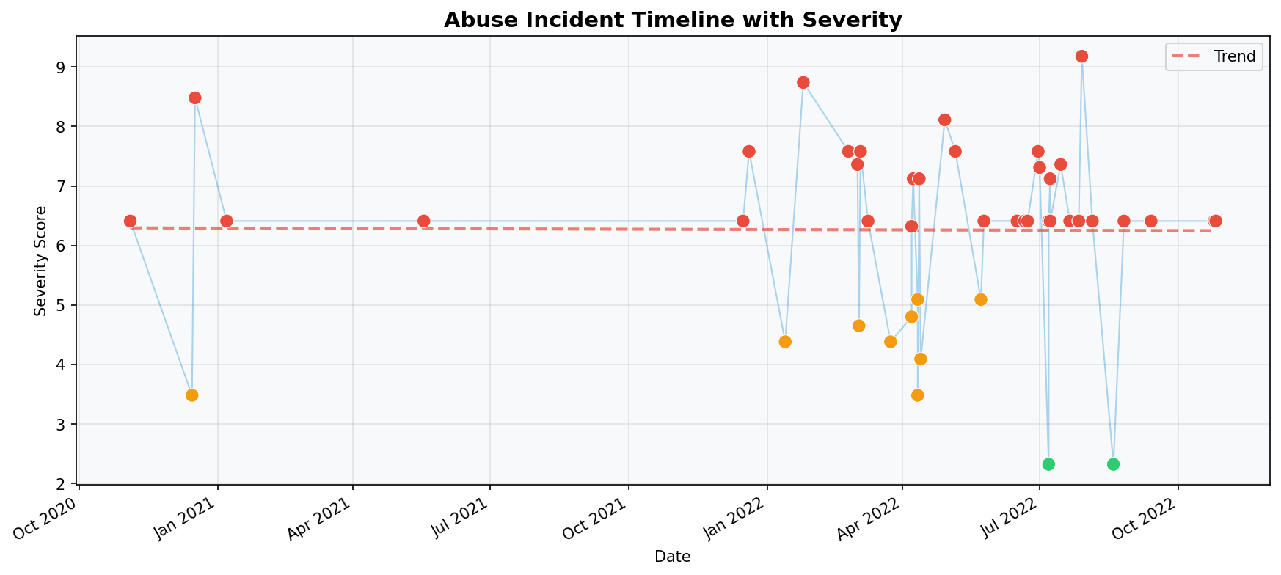

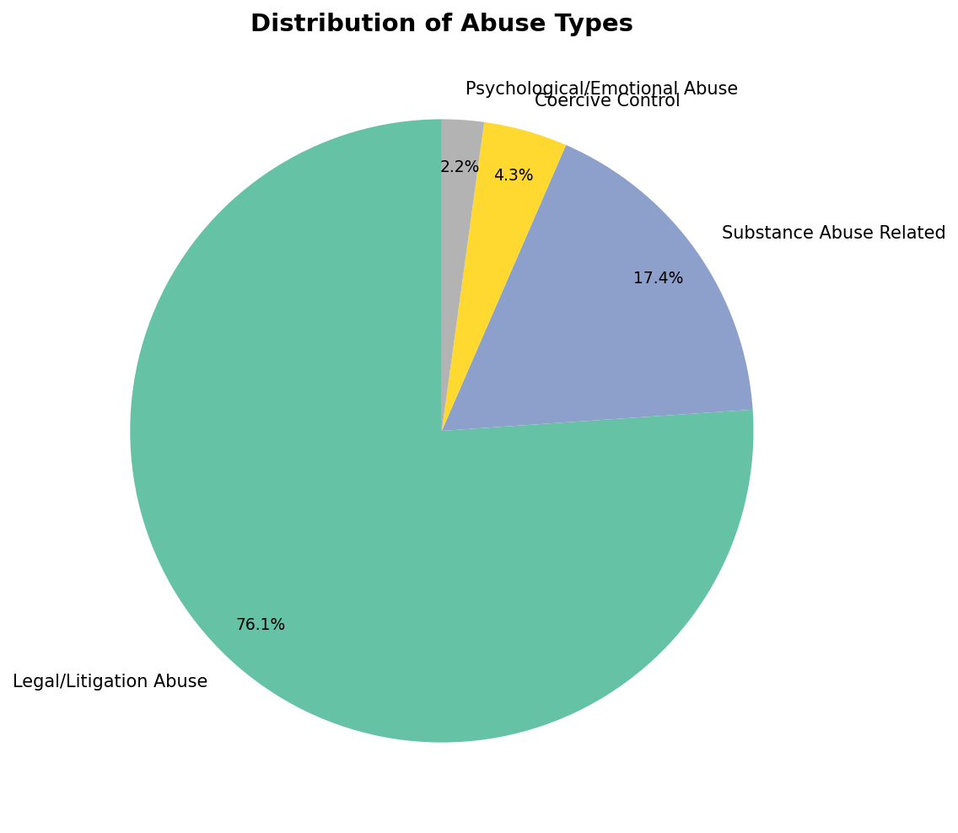

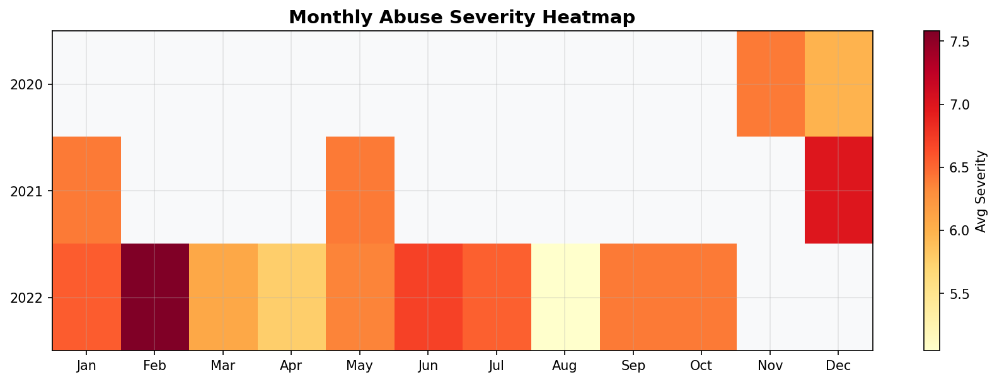

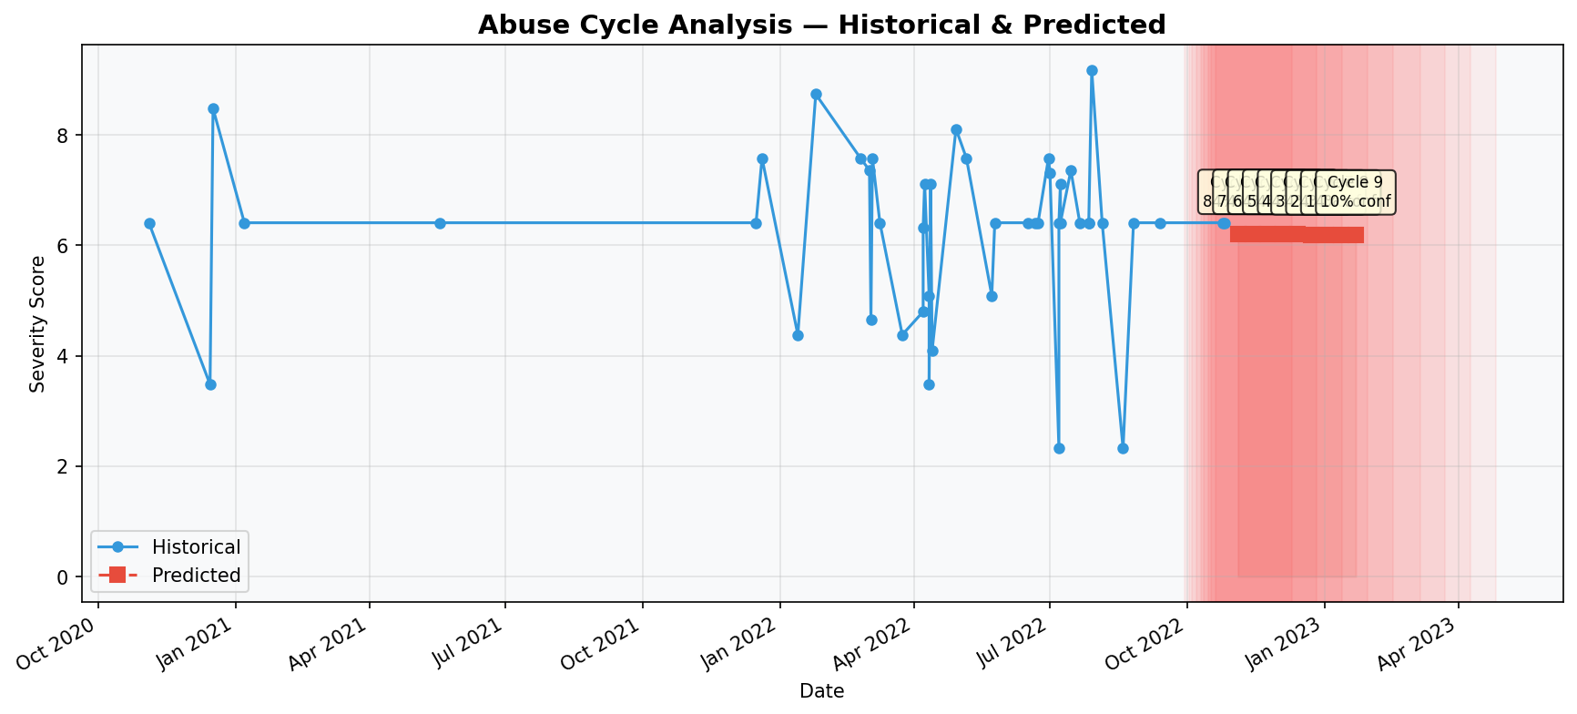

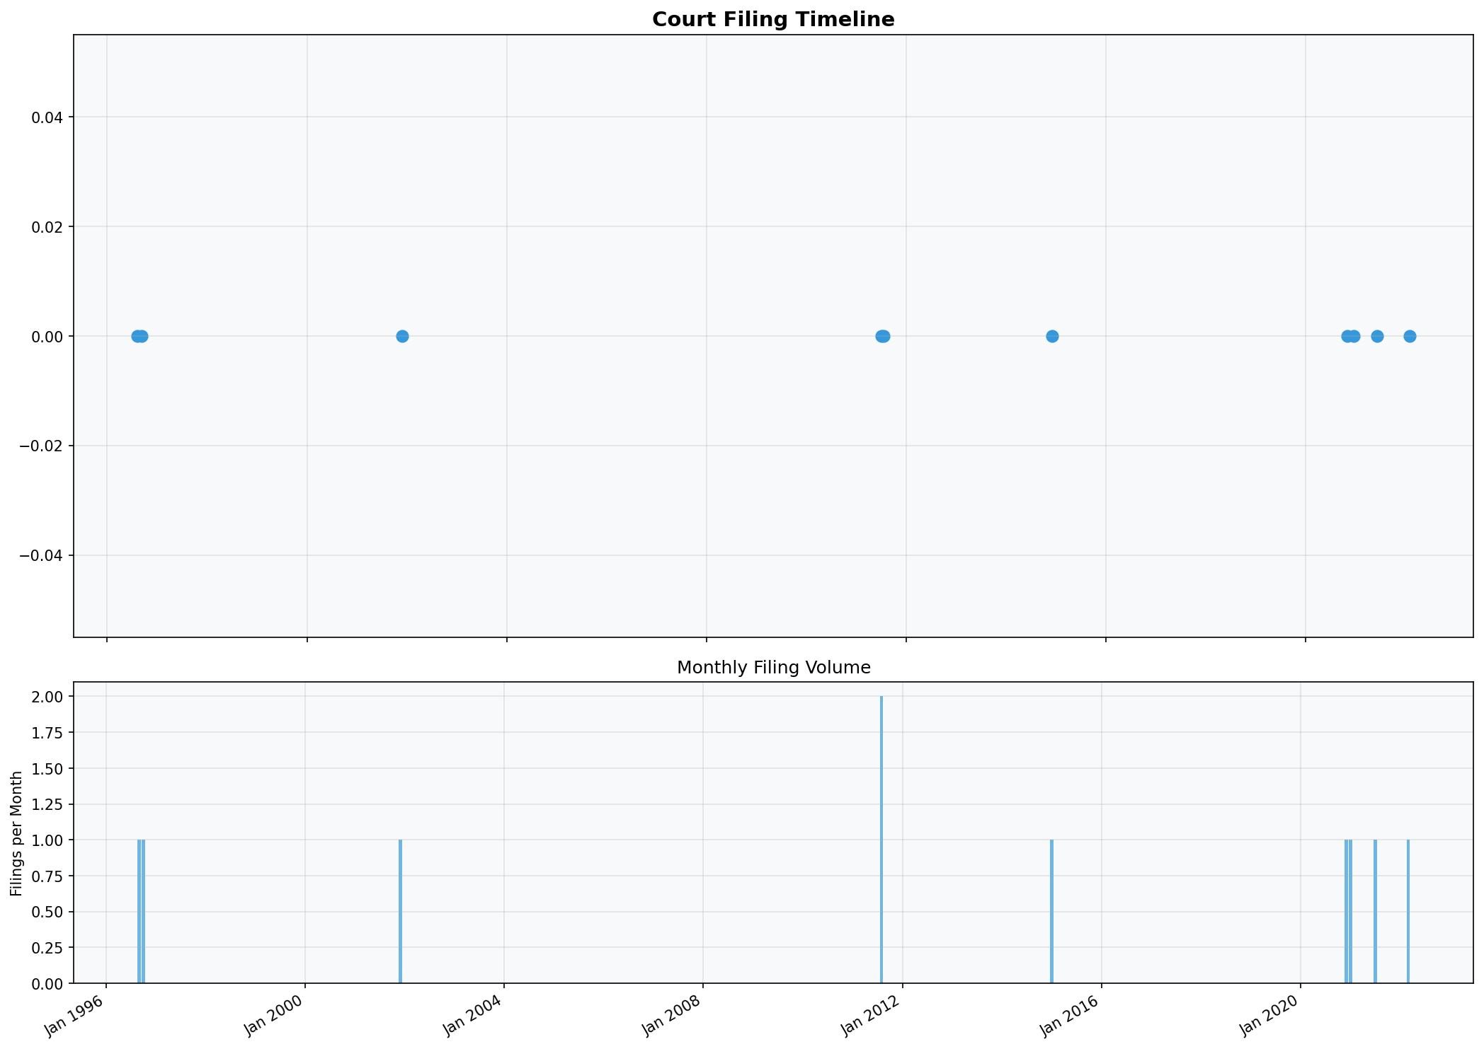

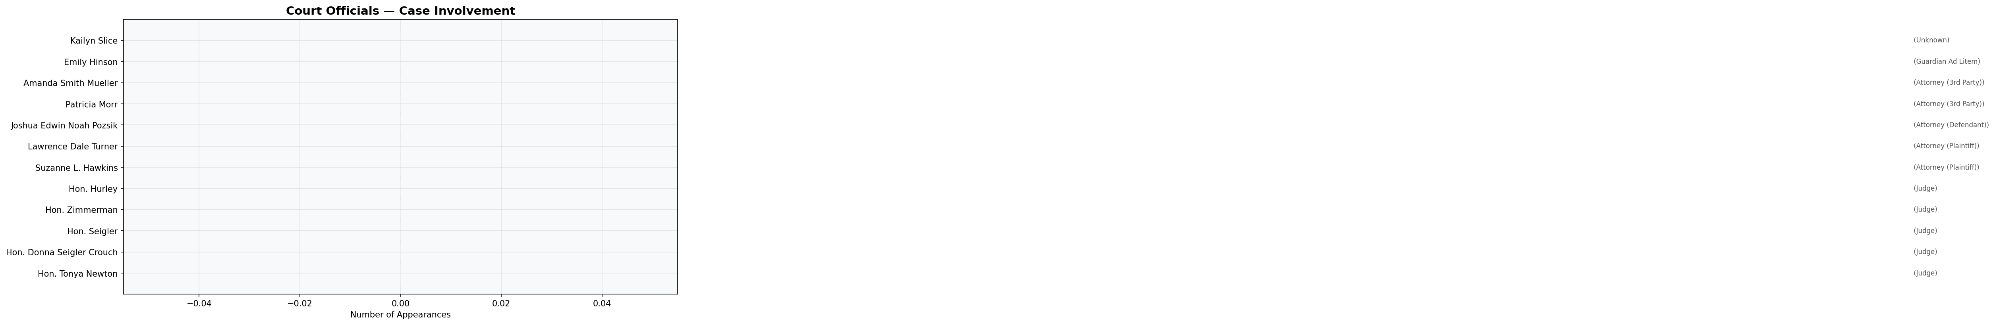

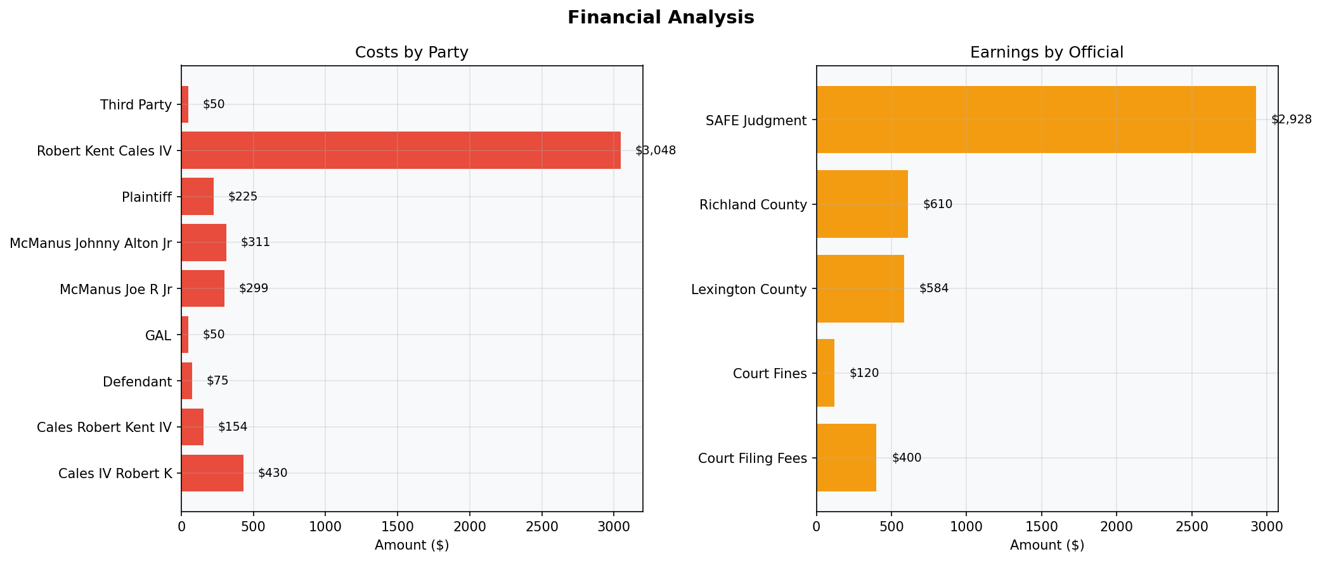

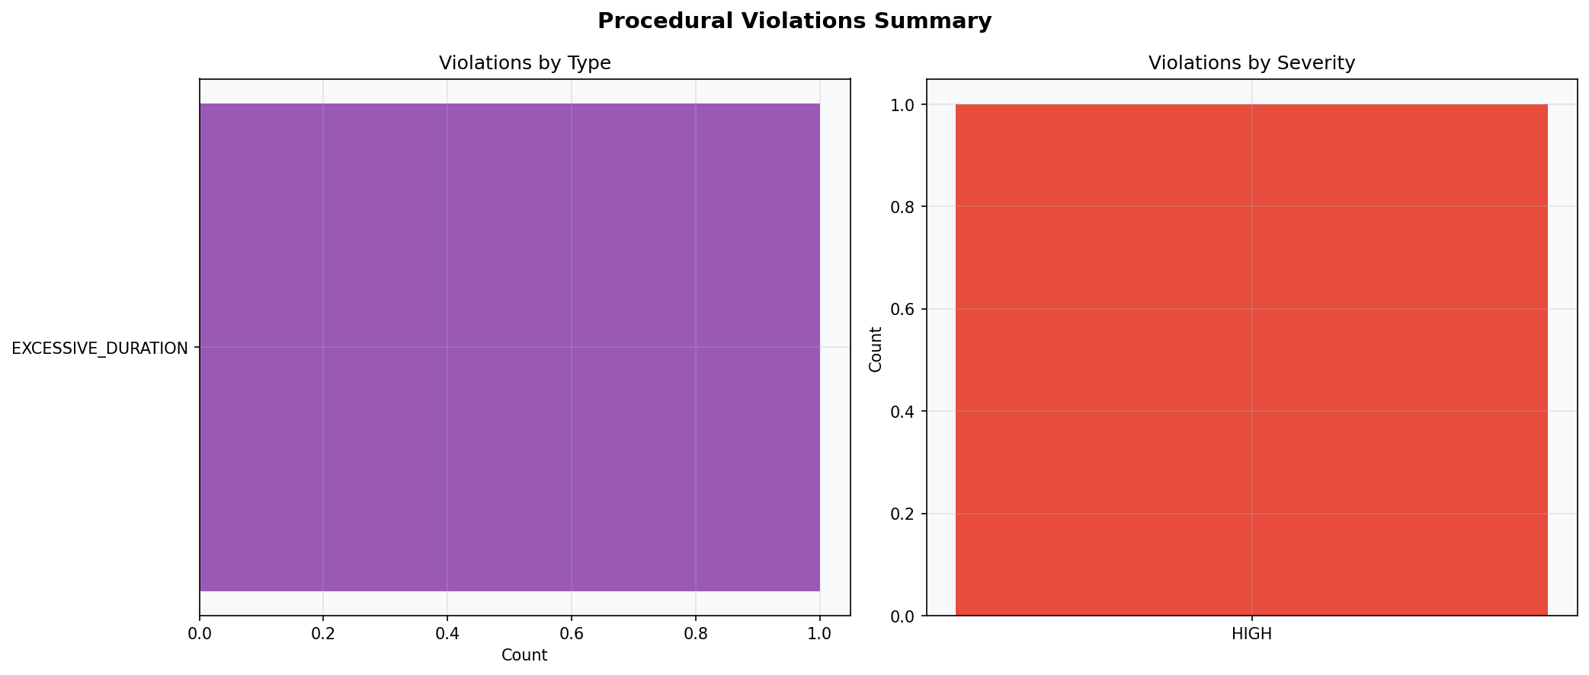

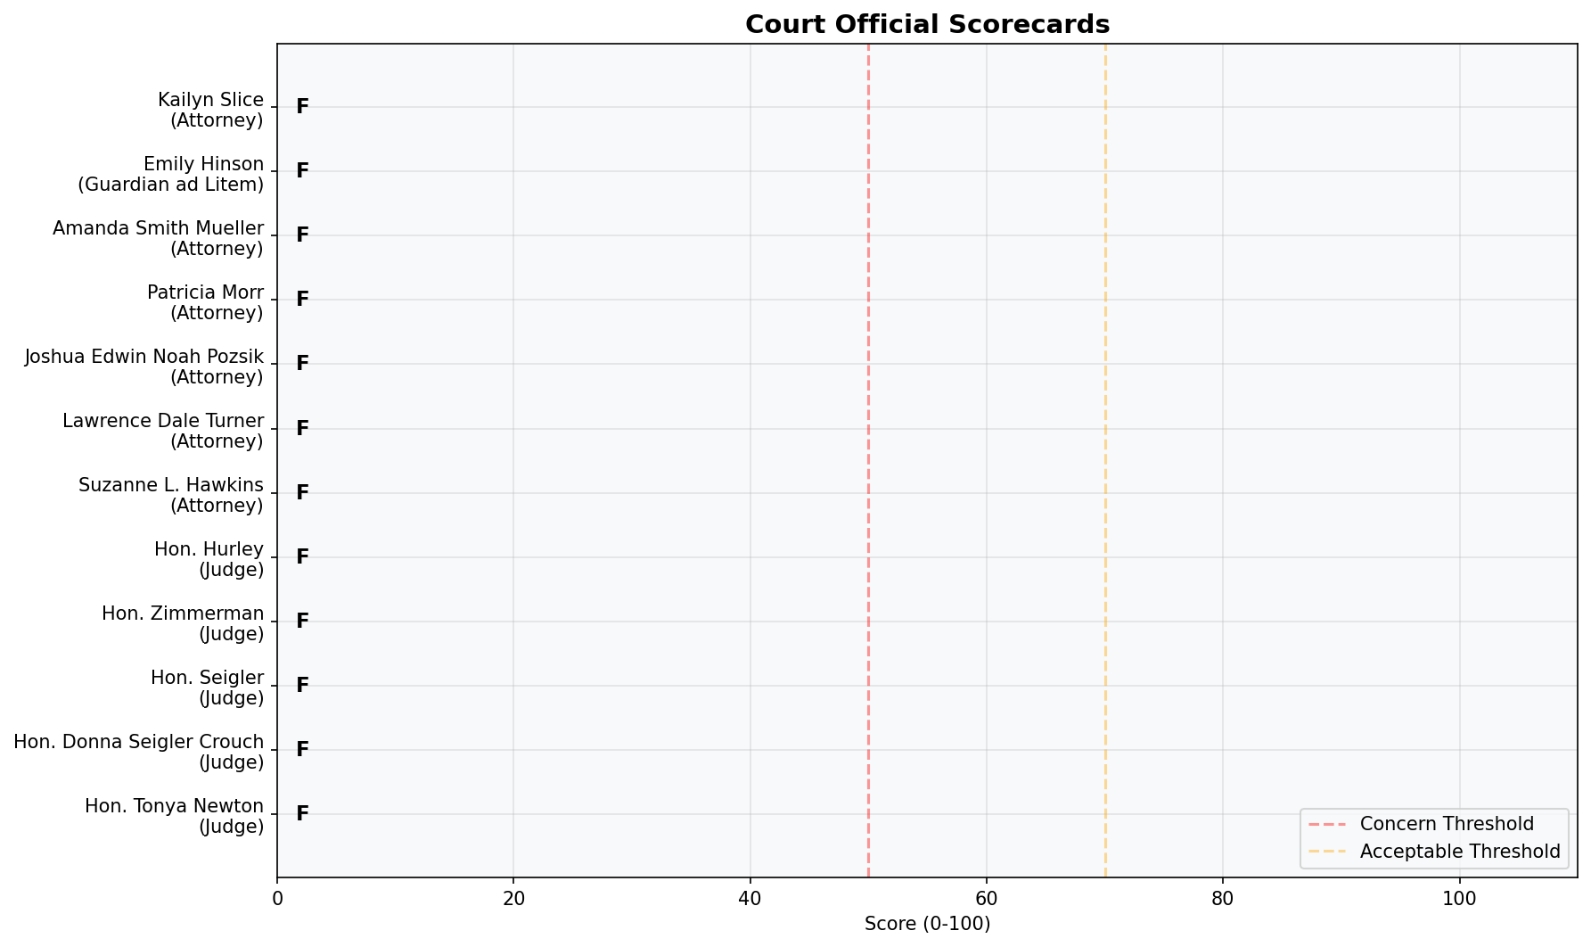

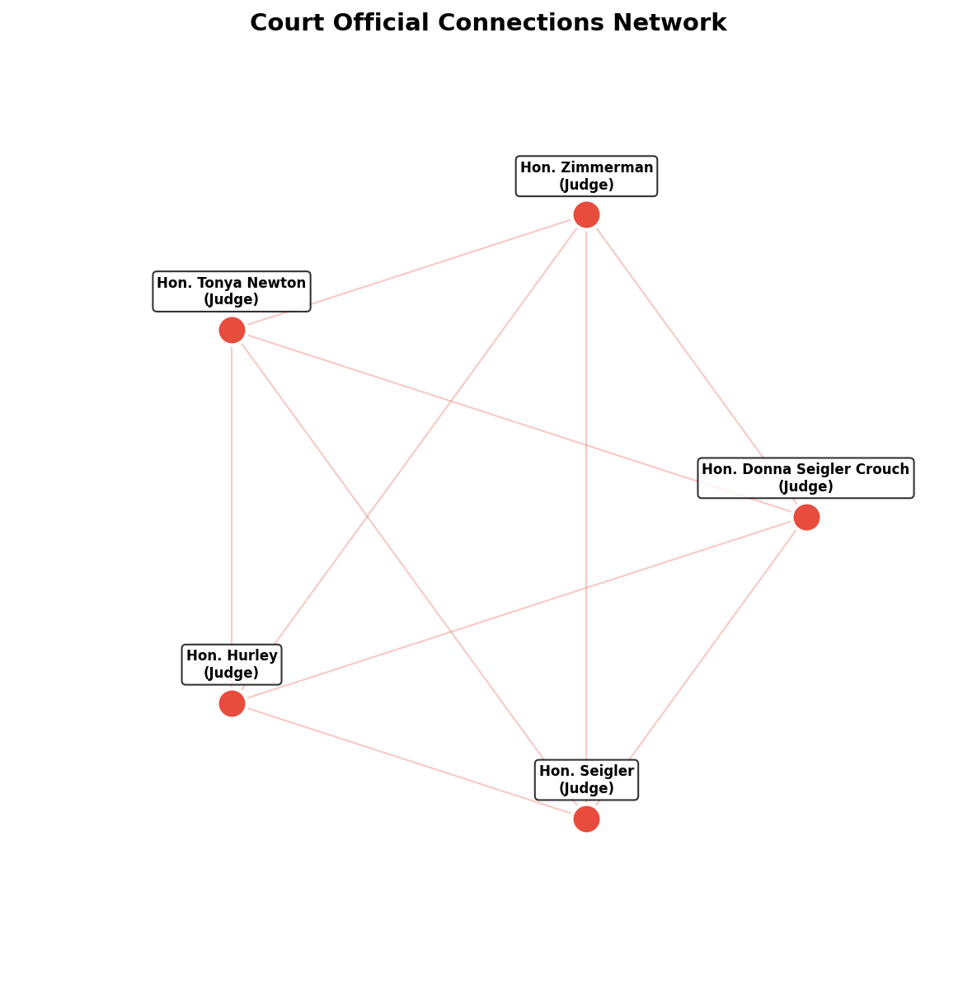

Appendix B: Methodology

Data Collection
All data analyzed in this report was sourced from court records, documented communications, official filings, and evidence provided by the submitting party. No data was fabricated or assumed.

Classification Methodology
Abuse incidents were classified using a standardized taxonomy of post-separation abuse categories. Each category includes defined behavioral traits with pre-assigned severity weights. Classification is performed by matching documented behaviors against trait definitions.

Statistical Methods
- Time-series analysis for temporal pattern identification
- Pearson correlation testing for variable relationships
- Linear regression for trend analysis and escalation detection
- Peak detection algorithms for cycle identification
- ANOVA testing for categorical variable significance

Limitations
This analysis is limited by the completeness and accuracy of the source data. Statistical predictions are probabilistic in nature and should not be treated as certainties. This report does not constitute legal advice and should be reviewed by qualified professionals.

Reproducibility
All calculations in this report are deterministic and fully reproducible from the source data using the documented methodology. The analysis software version and parameters are recorded for verification purposes.

