Table of contents
1.Sync 2
1.1. Can not bi-directionally sync? 2
1.2. How to sync specific files such as PDF and Excel 2
1.3. The last update time of the sync file is rewritten 3
1.4. The file copied on PC on SDCARD will be overwritten 4
1.5. Unable to start sync during sleep 4
1.6. Unable to start sync android8.1 or higher 6
1.7. Can't turn WiFi on and off on Android 10 6
2.Archive 7
2.1. How to store photos and videos in the shooting year / month folder 7
3. Cooperation with external applications 8
3.1. How do I synchronize from an external application? 8
3.1.1.Tasker example 8
3.1.2.AutoMagic Example 9
4.SDCARD/USB 10
4.1. Applications do not recognize SDCARD or USB media 10
5. Network related 11
5.1. Unable to connect to SMB server with hostname 11
6. System setting related 12
6.1. I do not want to enable the location. 12
7.Misc 13
7.1. Task List backup and restore 13

1.Sync

1.1. Can not bi-directionally sync?
Bidirectional sync is not implemented because it is difficult to judge conflicting files (files updated on both sides, which file is new or unknown). In the future I am planning to implement it.

1.2. How to sync specific files such as PDF and Excel
After selecting the "Select file" of the synchronization task, tap the file filter and add the filter. Please describe the filter like * .pdf or * .xlsx.
- Edit sync task screen

- Edit file filter

- Save file filter

- Finished
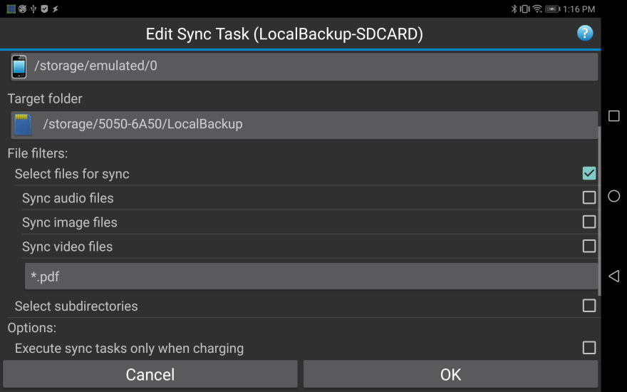

1.3. The last update time of the sync file is rewritten
For most models, you can change the last modification time of the file, but on some models it changes to synchronized time because the last modification time of the file can not be changed due to system limitation. The last update time of SDCARD and USB media is always rewritten at the synchronized time on Android 5/6, On Android 7 and higher models the time can not be rewritten, but on some models the time is rewritten.

1.4. The file copied on PC on SDCARD will be overwritten
For models that can not change the last update time of the file, the file list is saved in the management file and the last update time is maintained. Therefore, if the file does not exist in the management file, it is treated as a difference file and it is overwritten. Since the management file matches the real file in the second and subsequent times, overwriting is not performed.

1.5. Unable to start sync during sleep
If your device is sleeping and you can't start syncing from a schedule or an external app, try the following methods.
- Do not optimize the battery (App menu-> display battery optimization).
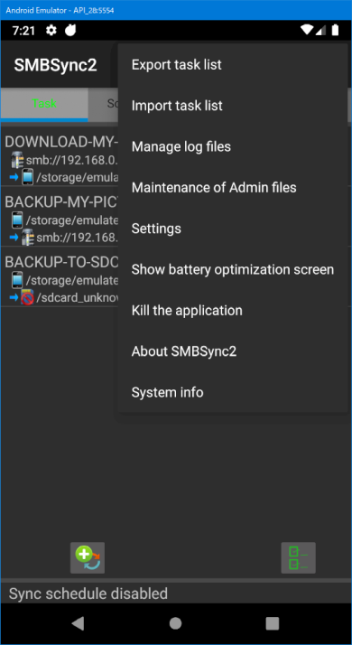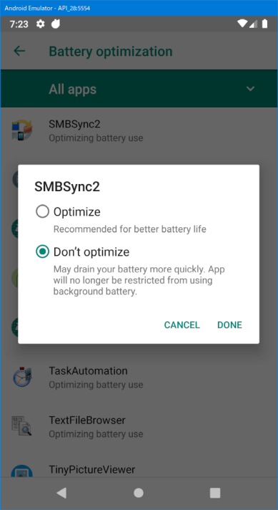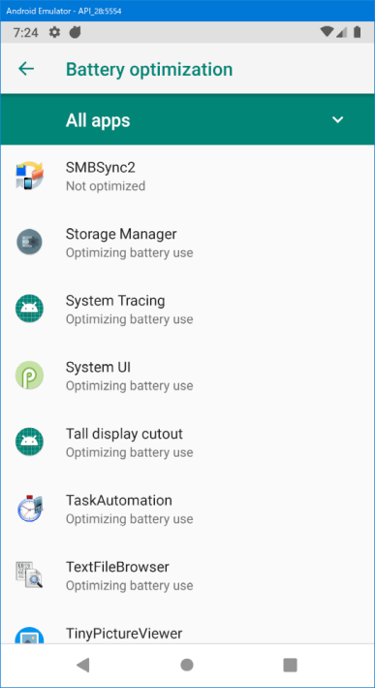
- Allow the app to start automatically when the device restarts (System settings on some models-> battery).
- Allow background start (System settings on some models-> battery).
- Give your app permission to turn on WiFi (some models require you to allow WiFi privileges).
- Enable Wi-Fi locking and enable “Prevent delay of start sync during sleep” (App Settings Sync tab).
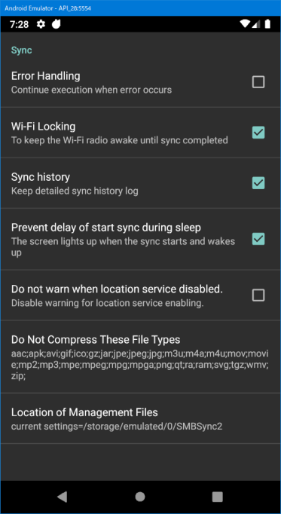

1.6. Unable to start sync android8.1 or higher
If you have specified the "Access point list" in the sync option, it is now mandatory to enable location services from Android 8.1. Enable Location service on Android 9 (System Settings-> Security)

If you do not want to enable the location, see “I do not want to enable the location”.

1.7. Can't turn WiFi on and off on Android 10
Some Android 10 models may not be able to turn on or off WiFi from the app, so please consider turning on WiFi.

2.Archive

2.1. How to store photos and videos in the shooting year / month folder
Tap the target folder in the Archive task and display the options. Please enable the following option.
- Create a directory to change the filename and store when archiving
- Create a directory based on the date taken archiving and store the file
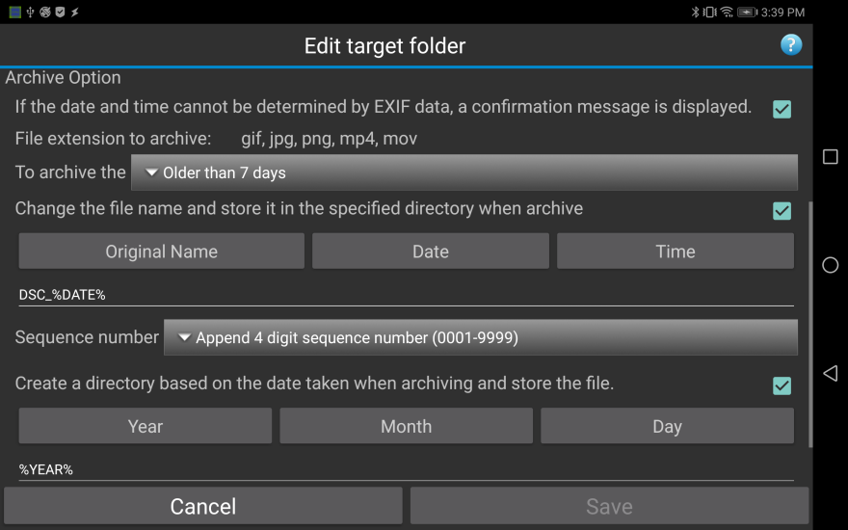

3. Cooperation with external applications

3.1. How do I synchronize from an external application?
For details, refer to PDF "5. Linkage with other applications" on the following link.
https://drive.google.com/file/d/0B77t0XpnNT7OSzBzcV9SemEwbkE/view?usp=sharing

3.1.1.Tasker example
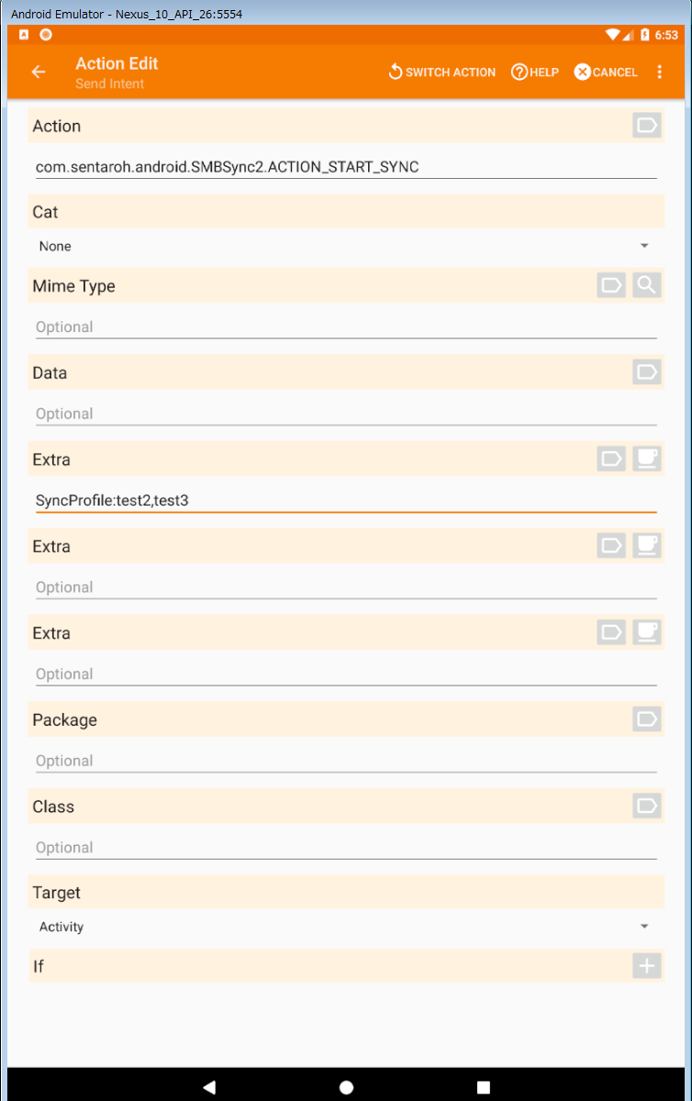
- Action : com.sentaroh.android.SMBSync2.ACTION_START_SYNC
- Extra : SyncProfile:prof1, prof2
- Target : Activity

See the link below for sample tasks.
https://drive.google.com/file/d/1AV1pIXlaR9yXlam3TTXBR85m-g22SXSr/view?usp=sharing

3.1.2.AutoMagic Example
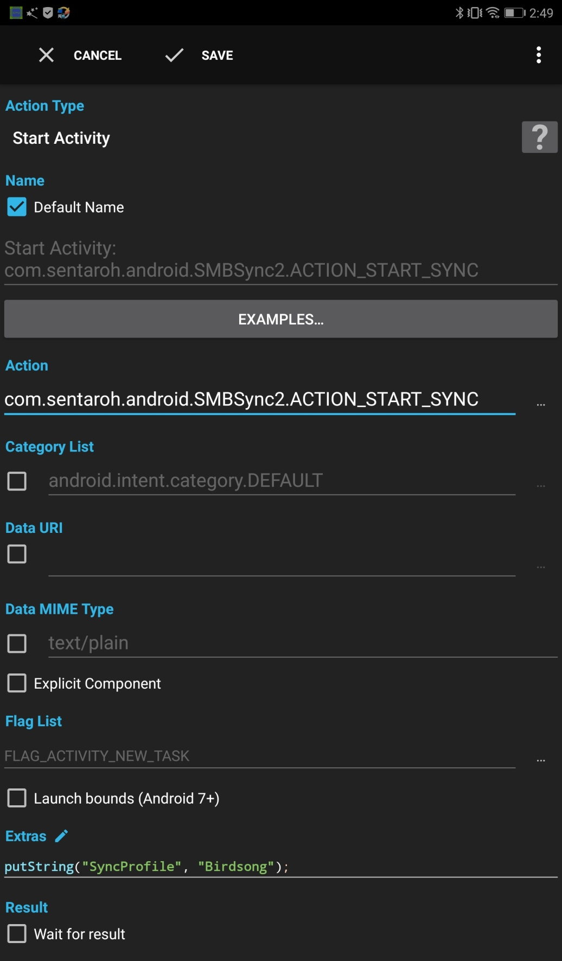
- Action type : Start Activity
- Action : com.sentaroh.android.SMBSync2.ACTION_START_SYNC
- Extra : putString(“SyncProfile”,”prof1, prof2”);

See the link below for sample flows.
https://drive.google.com/file/d/1-0uQtq9tpnGTDWmv7_BfNo2PFvmte8h8/view?usp=sharing

4.SDCARD/USB

4.1. Applications do not recognize SDCARD or USB media
For SMBSync 2 SDCARD or USB media must be mounted at /storage/xxxx-xxxx. (xxxx-xxxx is a UUID and a combination of love numbers)
Mount correctly on the mount point and give SDCARD permission.
If SDCARD permission is not given, please send information to the developer from the system information in the application menu.

5. Network related

5.1. Unable to connect to SMB server with hostname
If the host name is specified on the SMB server, and the virtual network is enabled in a virtual machine environment such as VirtualBox, the host name will fail to address resolution.
It can be solved by one of the following methods.
- Start virtual machine
- Disable virtual network adapter
- If any of the above methods can not be used, use an IP address instead of a host name

6. System setting related

6.1. I do not want to enable the location.
To start the synchronization on a specific network without enabling location in more than Android8.1, change your wireless LAN to "Has private address" or "IP address List".
- Has private address
You can initiate synchronization if the IP address assigned to WiFi is 10.0.0.0 - 10.255.255.255 or 172.16.0.0 - 172.31.255.255 or 192.168.0.0 - 192.168.255.255.
- IP address list
You can start syncing when the WiFi IP address matches one of the specified addresses.
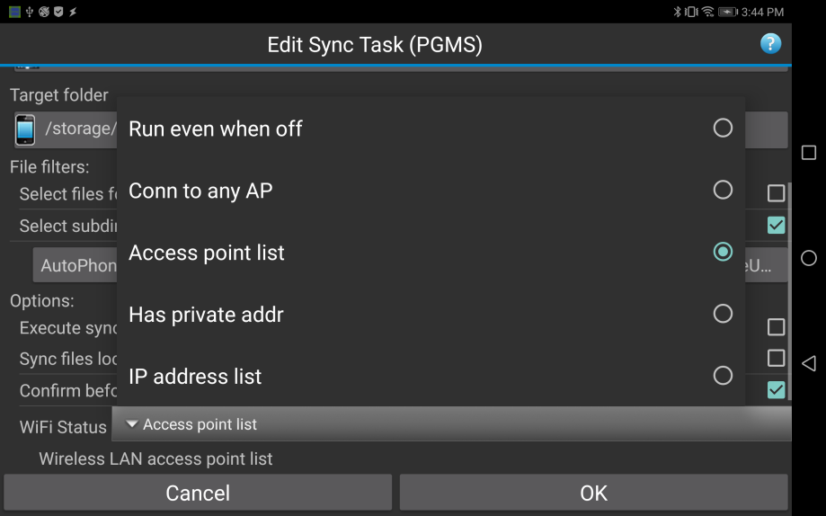

7.Misc

7.1. Task List backup and restore
You can save the task list to internal storage/SDCARD/USB media. You can also restore the saved task list.
- Save task list
In the App menu, tap Export Task List to specify the destination. When you tap the mount point, the available storage list will be displayed, so please select it.
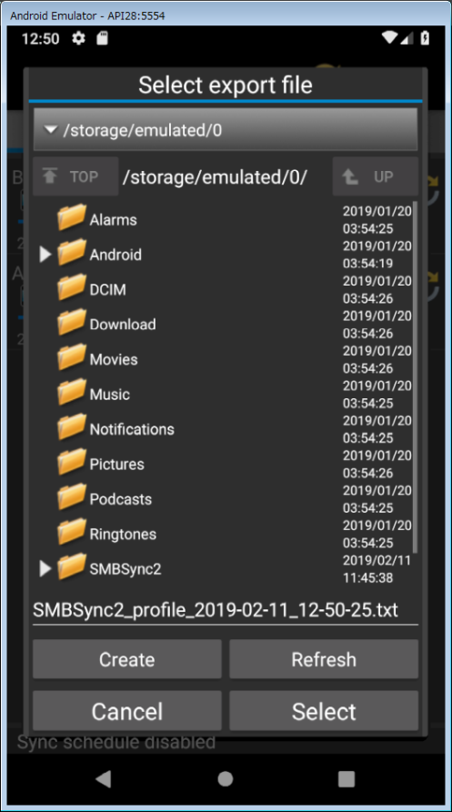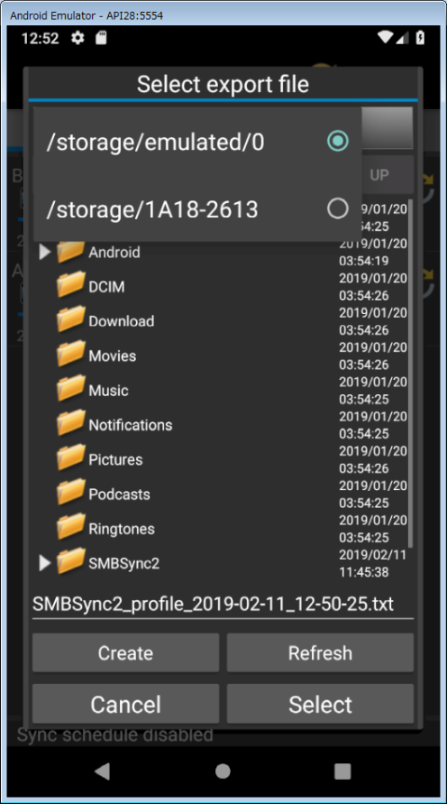
Tap here
Please select
- Restore task list
In the App menu, tap Import Task List to specify the destination.

