**GOVERNMENT COLLEGE OF ENGINEERING ERODE**



B.E Electronics and Communication Engineering

TAMILNADU MARGINAL WORKERS

**Name of the Students: University Register no:**

**Team Leader:**

Karthick Raj . M 731121106021

**Team Members:**

Aatham Anari . B 731121106001

Selvaragavan . K 731121106042

Senthamil Selvan . V 731121106043

Gowtham . R 731121106016

Under the mentor of

**Dr.M.Sathiyakala**

**Department of Information Technology(IT)**

**Department of Electronics and Communication Engineerin**

Government College of Engineering

Erode ,PO ,near Vasavi College,TamilNadu-638316,Affiliated to Anna University ,Chennai.

**PROJECT DESCRIPTION:**

Data Source – The data for data analytics with cognos is based on the Census 2011 Data for districts in Tamil Nadu has been downloaded from the link which has been provided by Nan Mudhalvan and IBM .

The raw data is first being downloaded and then data cleaning operation being performed to get the data on which Advanced Data analytics can be performed.

This analysis is about the gender classification among the different industrial categories given in the dataset.

**INDUSTRIALCATEGORIES-A [Plantation,livestock,forestry,hunting,fishing and hunting activities]:**

Plantations are farms specializing in cash crops, usually mainly planting a single crop, with perhaps ancillary areas for vegetables for eating and so on. Livestock are the domesticated animals raised in an agricultural setting in order to provide labour and produce diversified products for consumption.

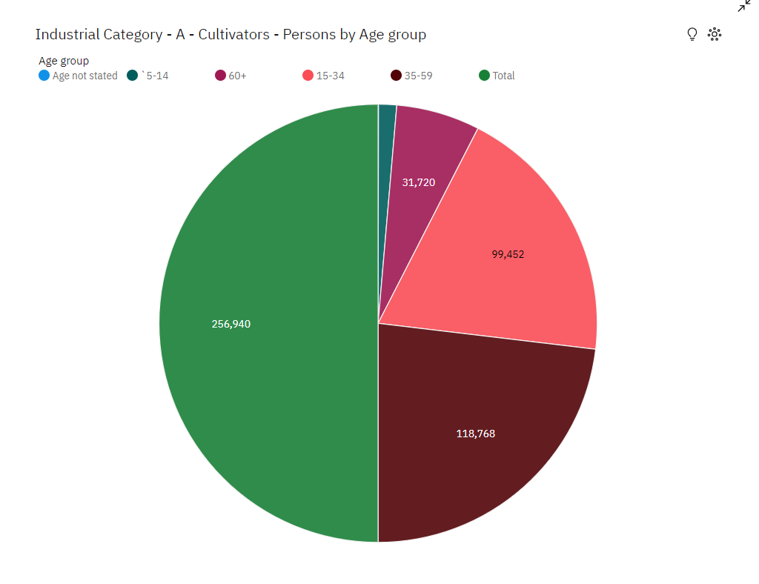

**Findings:**

* Workers with age group between [35-59] are the highest among all the

workers in industrial category-A.

**INDUSTRIAL CATEGORIES-B [Mining and Quarrying]:**

Mining is the process of extracting buried material below the earth surface. Quarrying refers to extracting materials directly from the surface. In mining and quarrying, water is used and gets polluted in a range of activities, including mineral processing, dust suppression, and slurry transport.

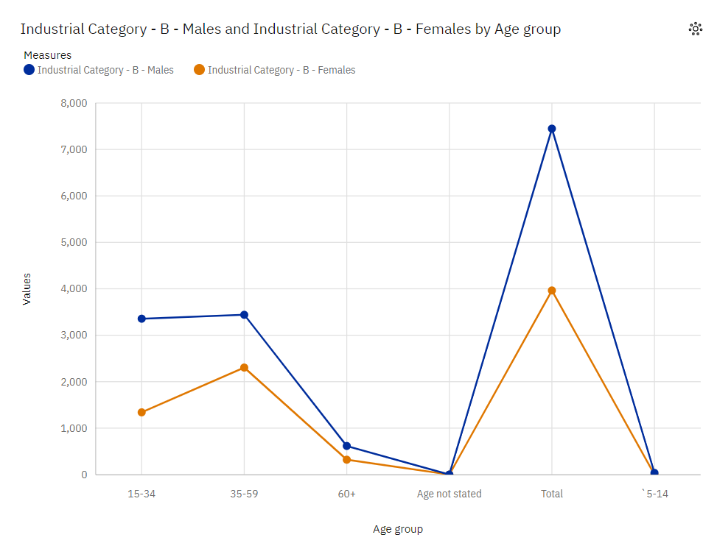

**Findings:**

* Workers with age group between [35-59] are the highest among all the workers in industrial category-B.
* Workers with age group between [60+] are the lowest among all the workers in industrial category-B.

**INDUSTRIAL CATEGORIES-C [Manufacturing]:**

A manufacturing job involves the creation of new products either from raw materials or by assembling different components through physical, chemical or mechanical means. Manufacturing can exist on a large scale for items such as phones, cars, computers and food and beverages.

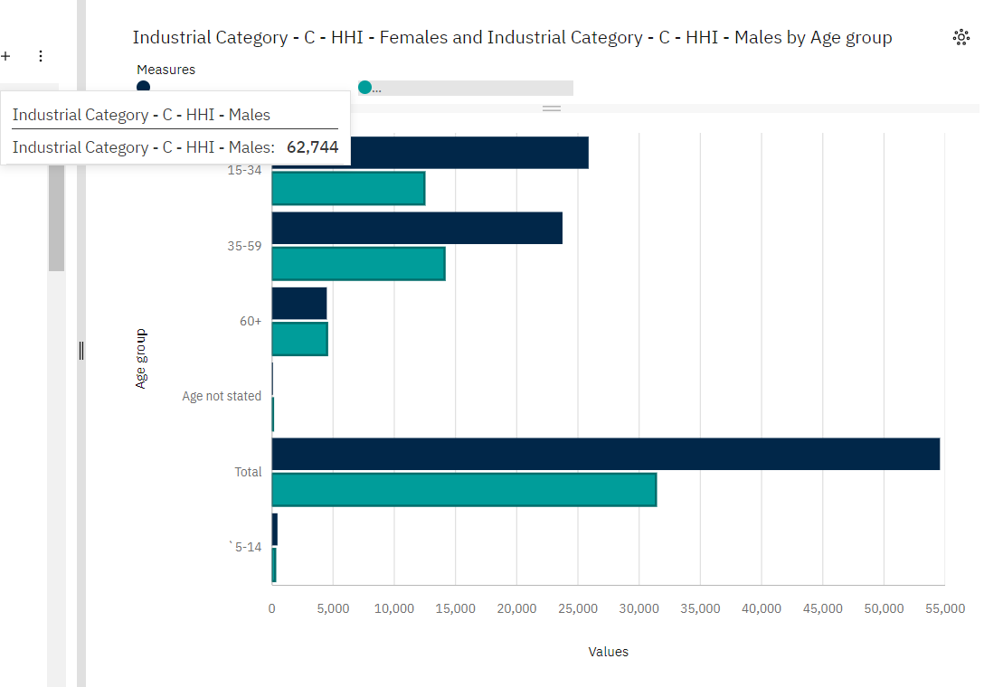

**Findings:**

* Workers with age group between [15-34] are the highest among all the workers in industrial category-C
* Workers with age group between [5-14] are the lowest among all the workers in industrial category-C

**INDUSTRIAL CATEGORIES-D and E :[Electricity ,Gas, Steam and air conditioning]:**

HVACR technicians install, maintain, and repair heating, cooling, and refrigeration systems. Heating, air conditioning, and refrigeration mechanics and installers—often called HVACR technicians—work on heating, ventilation, cooling, and refrigeration systems that control the temperature and air quality in buildings.

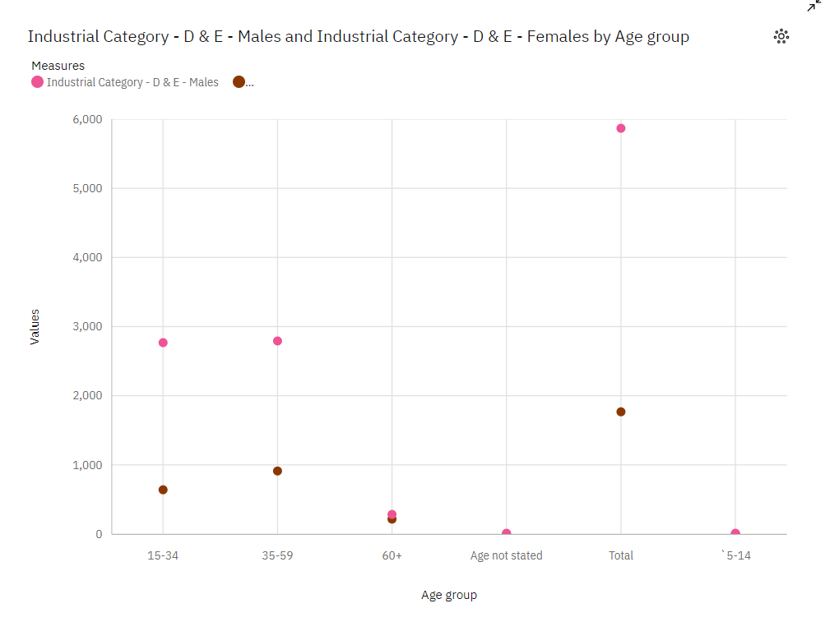

**Findings:**

* Workers with age group between [35-59] are the highest among all the workers in industrial category-D&E
* Workers with age group between [5-14] are the lowest among all the workers in industrial category-D&E

**INDUSTRIAL CATEGORIES-F[Construction]:**

A construction worker is someone who is employed as part of a construction crew and will perform many tasks that often involve physical labour on construction sites. However, there are plenty of roles that don't involve being on a construction site.

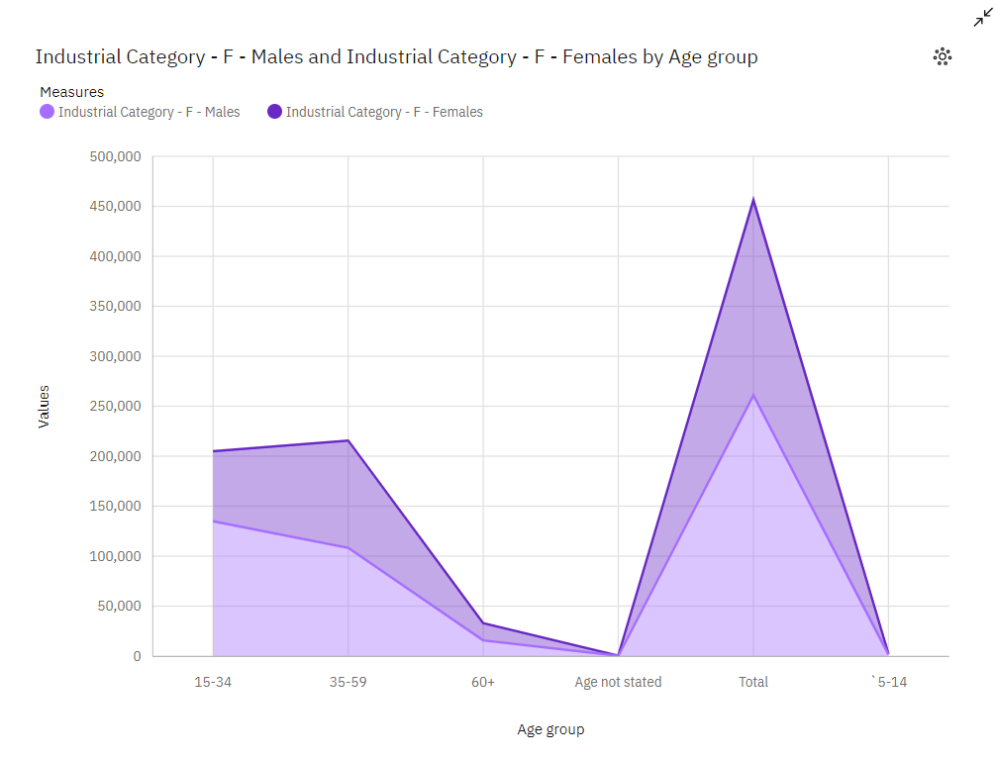

**FINDINGS:**

* Workers with age group between [35-59] are the highest among all the workers in industrial category-F
* Workers with age group between [60+] are the lowest among all the workers in industrial category-F

**INDUSTRIAL CATEGORY-G**:

Wholesale trade consists of purchasing and selling goods, generally to retailers, professional (industrial or commercial) users or authorities, or to other wholesalers or intermediaries, regardless of the quantities sold.

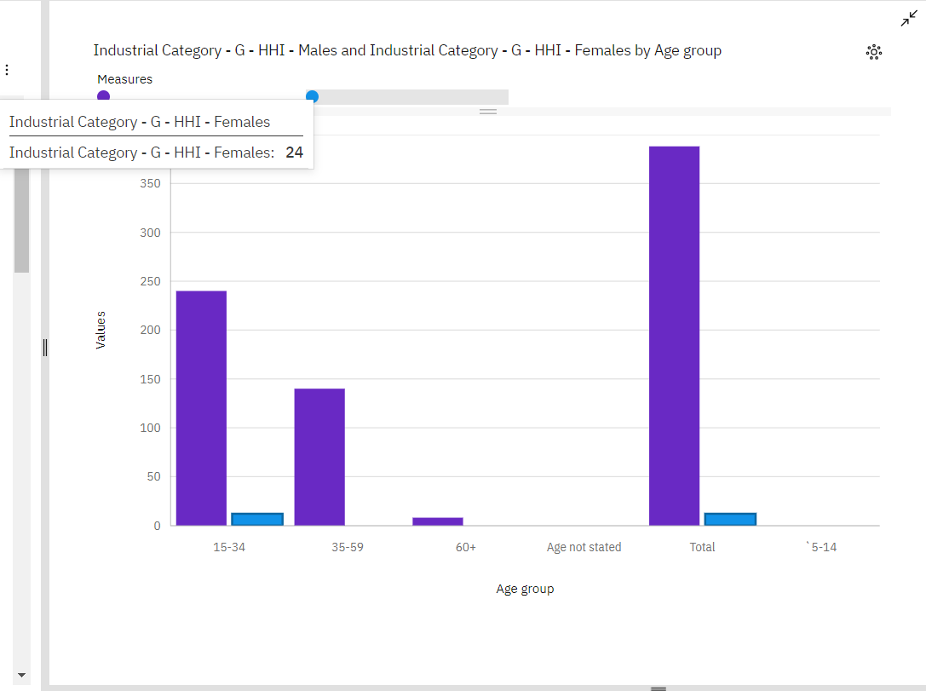

**FINDINGS:**

* Workers with age group between [15&34] are the highest among all the workers in industrial category-G
* Workers with age group between [60+] are the lowest among all the workers in industrial category-G

**INDUSTRIAL CATEGORY-H:**

Transportation workers in marginal areas face unique challenges and play crucial roles in ensuring that people in these regions have access to essential services and goods. Marginal areas can include remote, rural, or underserved locations.

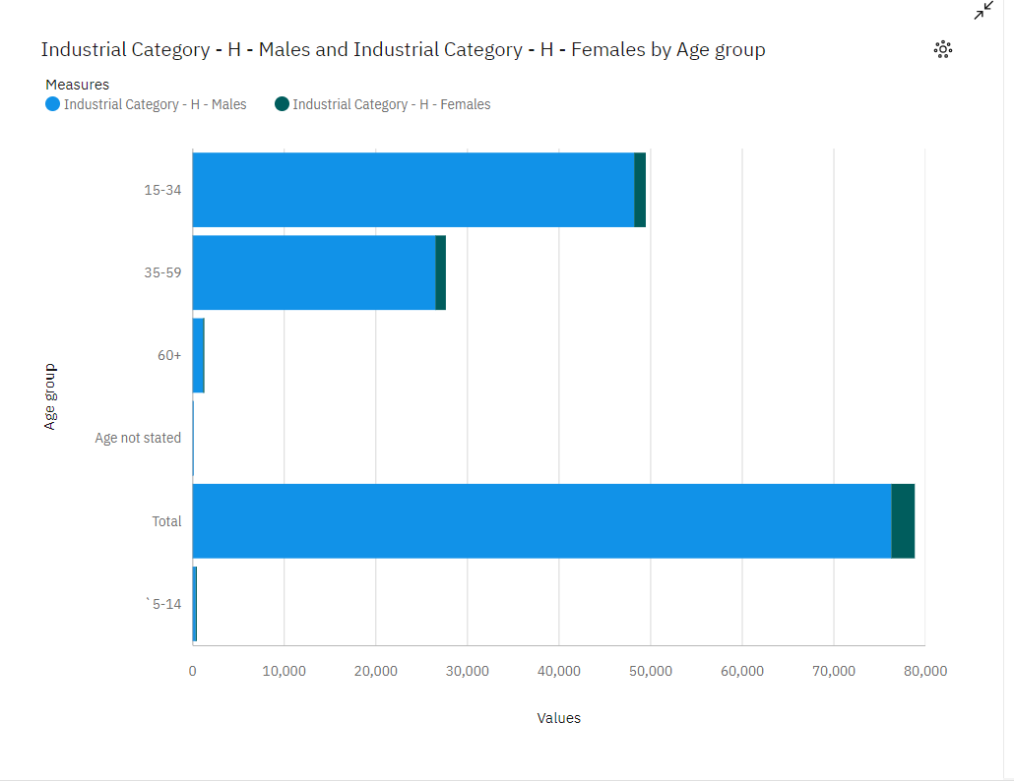

**FINDINGS:**

* Workers with age group between [15-34] are the highest among all the workers in industrial category-H
* Workers with age group between [60+] are the lowest among all the workers in industrial category-H.

**INDUSTRIAL CATEGORIES –I:**

Accommodation and food service activities in marginal areas are essential for the well-being of residents and for attracting tourists and travelers to these often remote or underserved regions. These activities provide lodging and dining options, contributing to the local economy and promoting tourism.

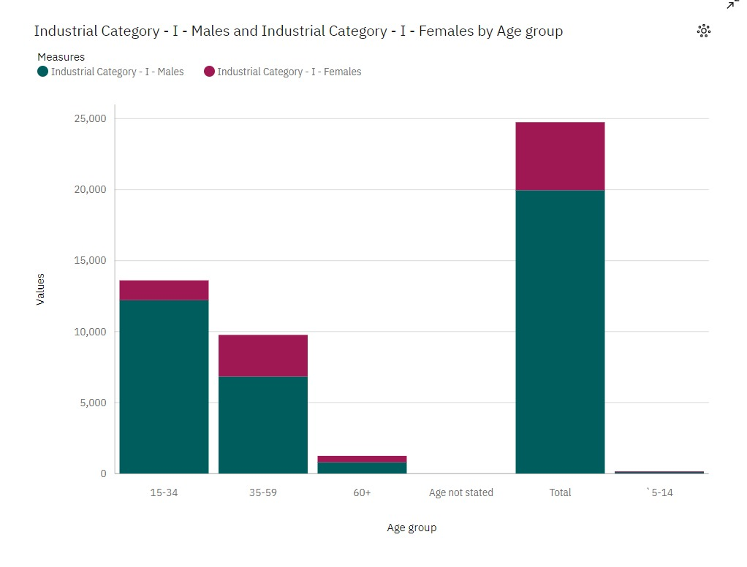

**FINDINGS:**

* Workers with age group between [15-34] are the highest among all the workers in industrial category-H
* Workers with age group between [60+] are the lowest among all the workers in industrial category-H.

**CONCLUSION:**

This overall analysis shows that workers with age group between [5-19] known as child labours are engaged mostly in industrial categories-c [manufacturing ].