Day1

Leetcode Solution

Problem 1:

Link:https://leetcode.com/problems/two-sum/description/

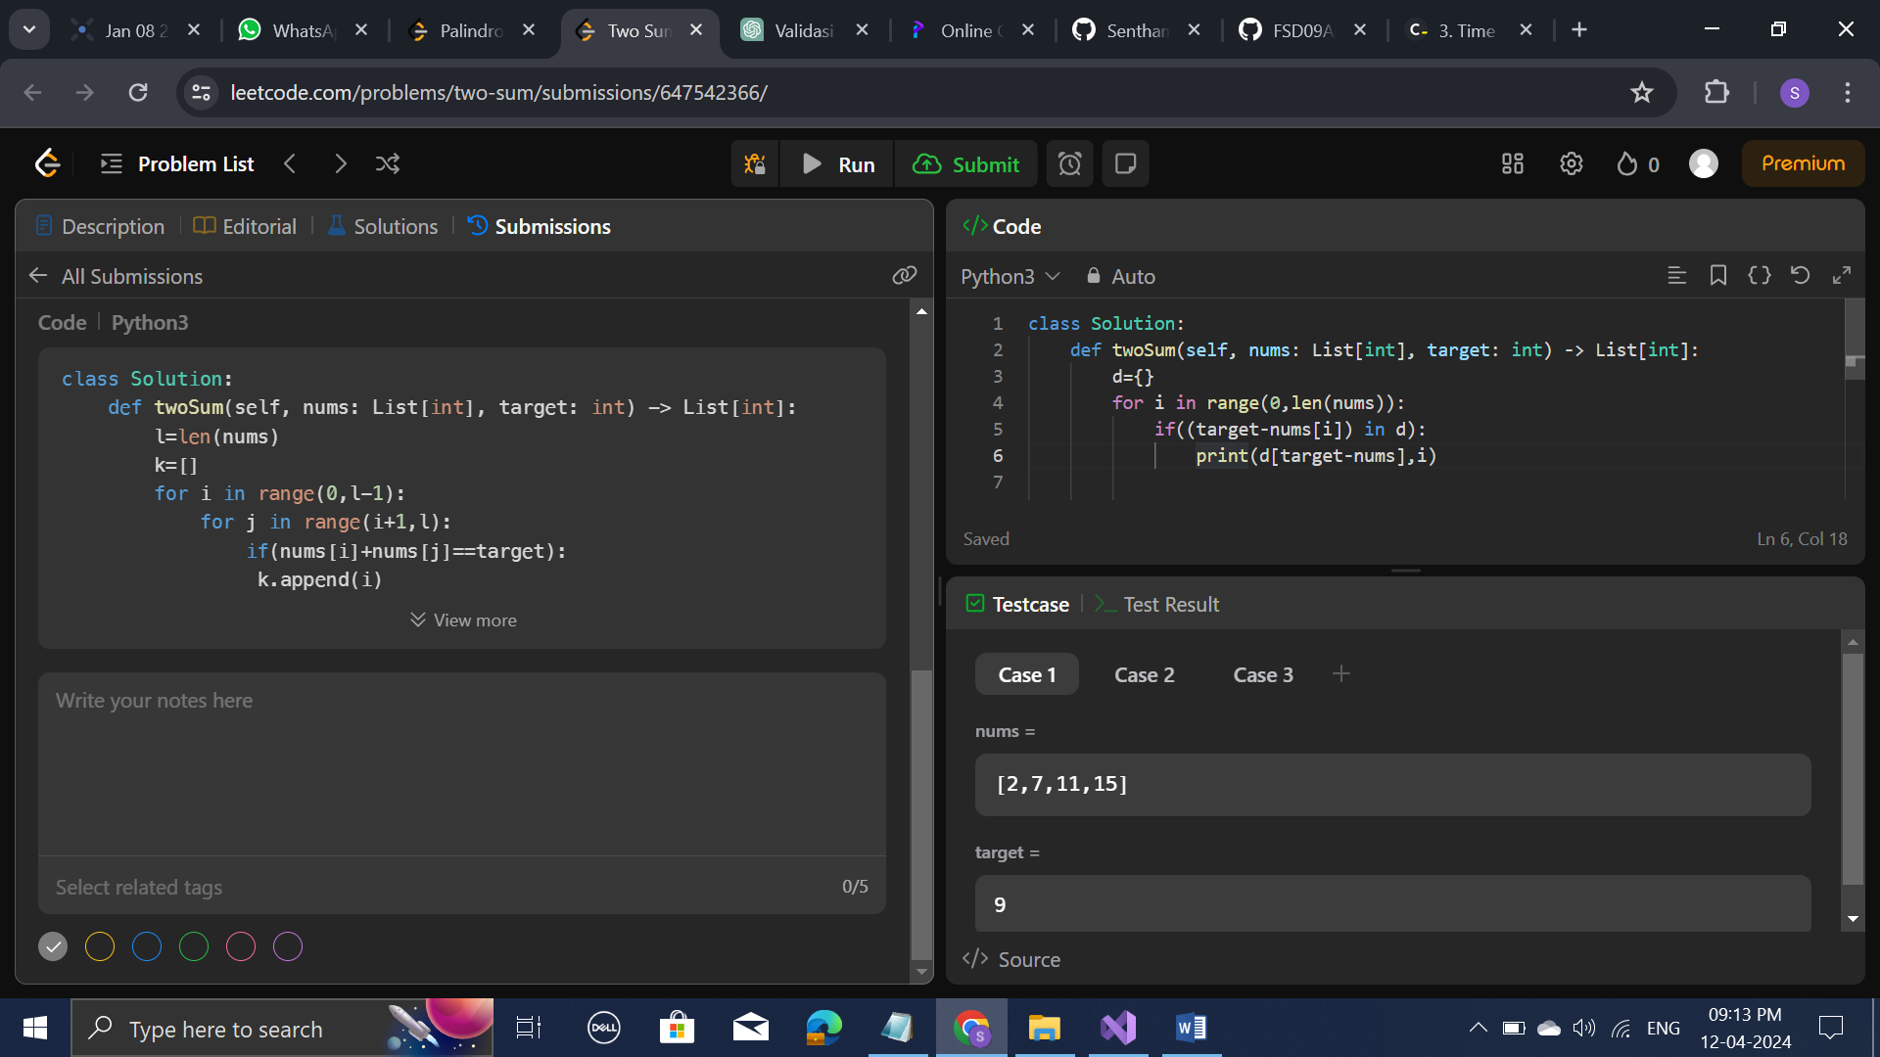

Problem 2:

Link: https://leetcode.com/problems/palindrome-number/description/

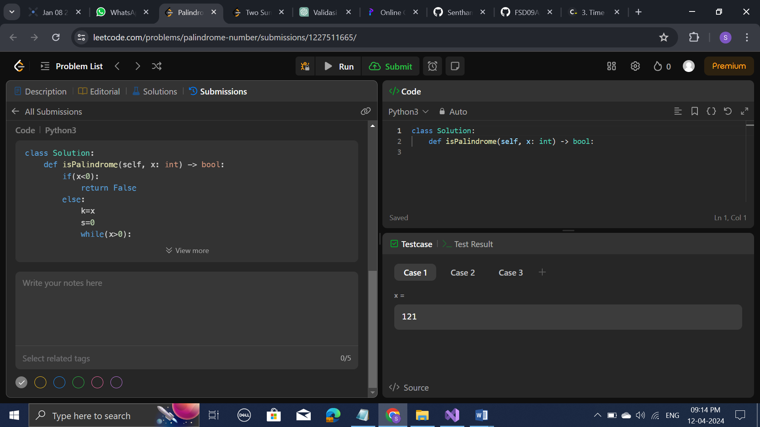

Problem 3

Link: https://leetcode.com/problems/longest-palindromic-substring/

