**Day 3**

**Codility Programms**

Lesson 1:

ResultLink :https://app.codility.com/demo/results/trainingWZ7HGU-DWA/

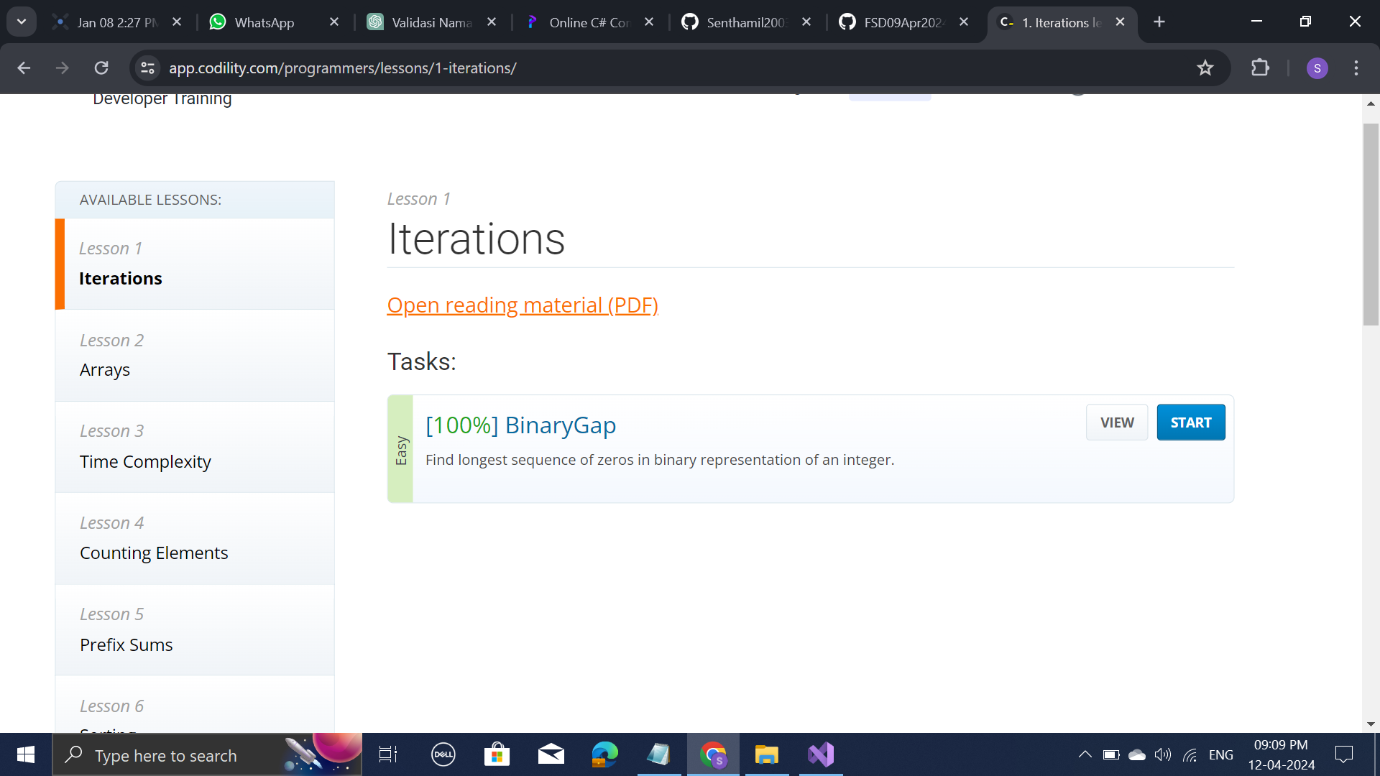

Lesson 2:

CyclicRotation: <https://app.codility.com/demo/results/trainingWZ7HGU-DWA/>

OddOccurenceArray: https://app.codility.com/demo/results/training9CRGYU-WMD/

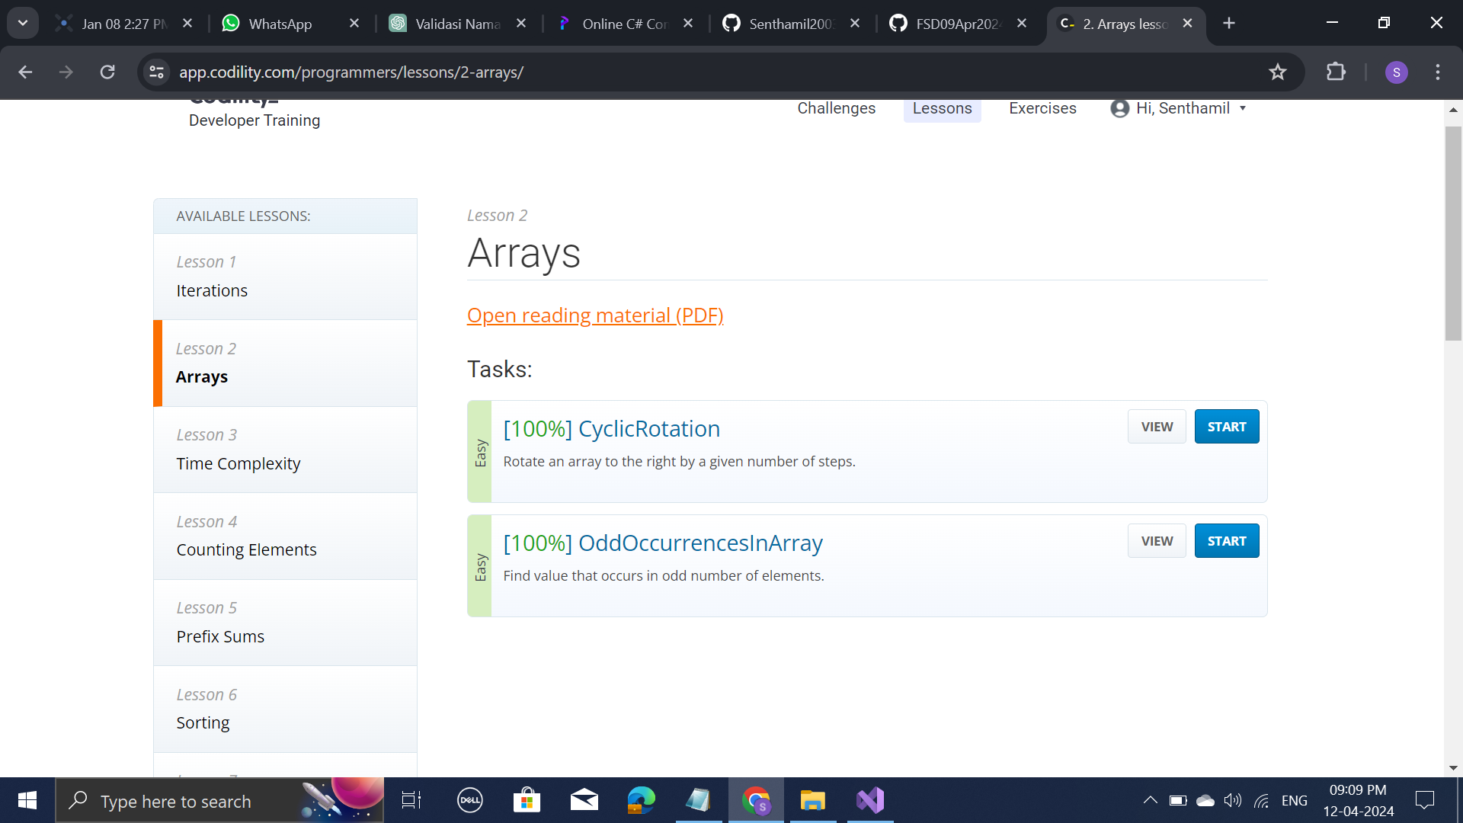

Lesson 3:

FrogJump: <https://app.codility.com/demo/results/trainingCF7PKW-Y74/>

PermissingElem: <https://app.codility.com/demo/results/training7UFWWH-PBH/>

TapeEquilibrium: <https://app.codility.com/demo/results/trainingSQNB4Y-WHF/>

